Install firewall on linux

Installation Steps :
- Enable Firewalld to start upon boot:
sudo systemctl enable firewalld
- Ensure Firewalld is running:
sudo firewall-cmd --state
- If UFW is installed, disable it to make Firewalld your primary firewall:
sudo ufw disable
- Open the https service:
sudo firewall-cmd --permanent --add-service=https
- Reload Firewalld to apply your changes:
sudo firewall-cmd --reload
- Ensure your changes were applied:
sudo firewall-cmd --list-services
The results should resemble:dhcp6-client https ssh.
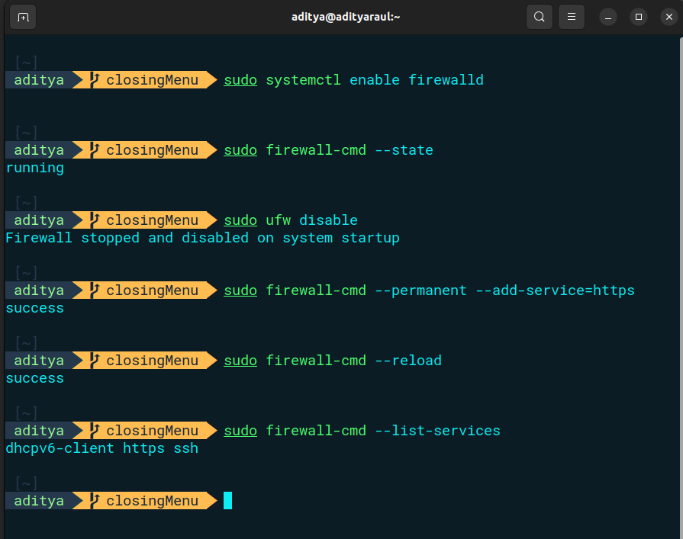

Configure Steps:
1. Firewall status :
sudo systemctl status firewalld
sudo systemctl start firewalld
sudo systemctl enable firewalld
2. Current Configuration :
sudo firewall-cmd –list-all –zone=public
3. Display open ports :
sudo firewall-cmd --list-ports
4. Open a port :
sudo firewall-cmd –zone=public –add-service=http
sudo firewall-cmd –zone=public –add-port=80/tcp
5. Close a port :
sudo firewall-cmd –zone=public –remove-service=http
sudo firewall-cmd –zone=public –remove-port=80/tcp

