Puppet Learning (part-1)
Practical 1: Installation and Verification of Puppet Agent on
Ubuntu 24.04 (AWS EC2)
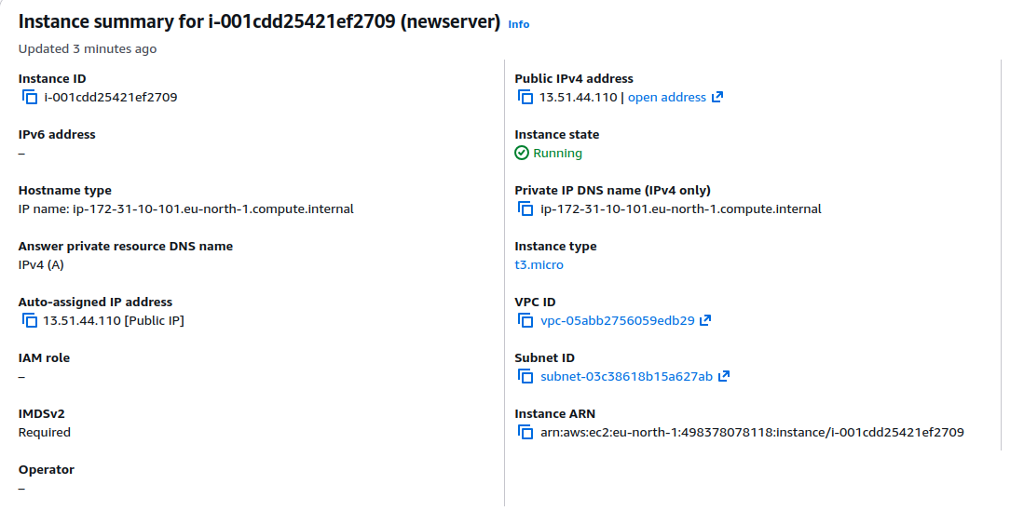
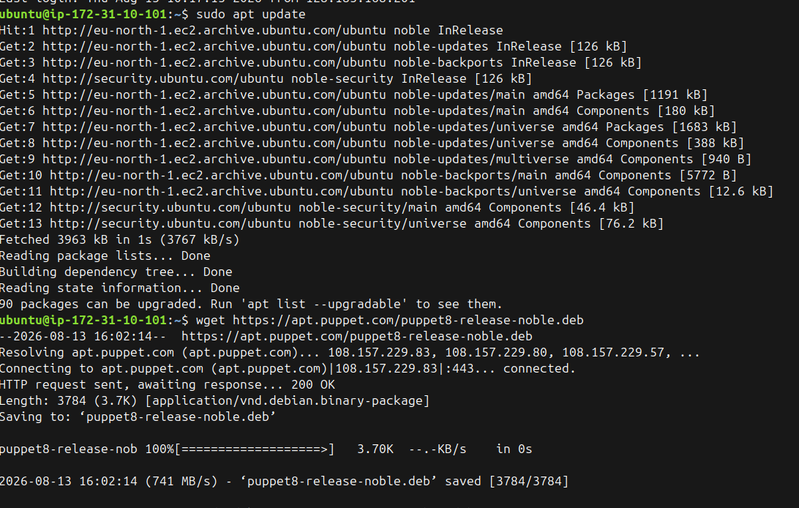
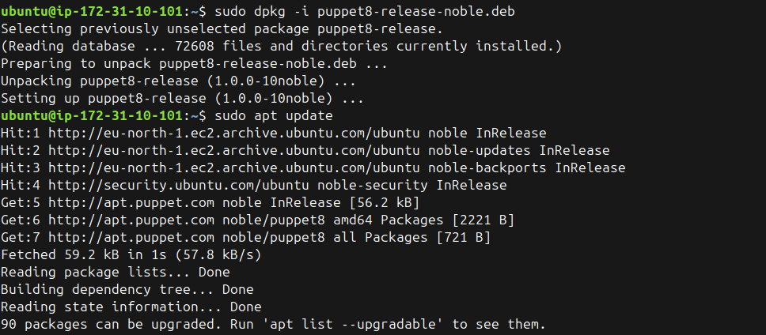
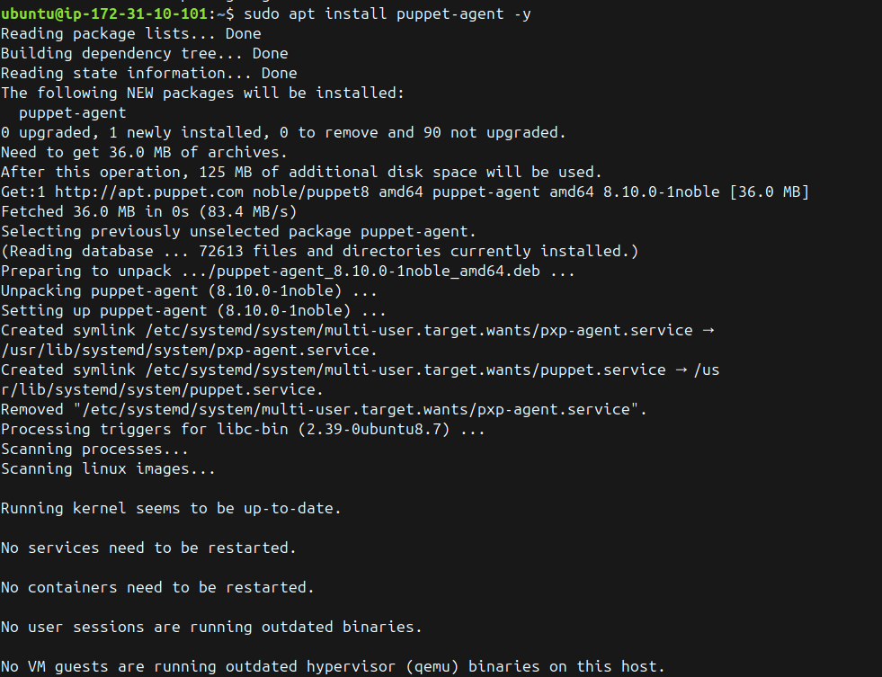
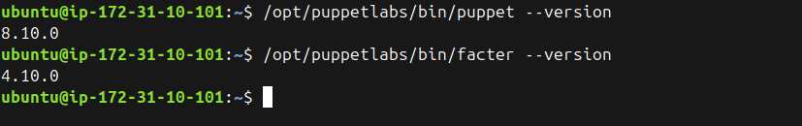

1. Why wget and dpkg? (The Repository Bootstrapping Problem)
When you run a command like apt install nodejs or apt install tree, Ubuntu looks at a specific list of trusted servers (repositories) stored in its /etc/apt/ directory. By default, Ubuntu only knows about Canonical's (Ubuntu's parent company) official servers.
While Canonical does keep a version of Puppet in its default repositories, it is often older or modified. In a production environment, you want the official, latest enterprise release directly from the vendor (Puppet). But your Ubuntu machine doesn't know apt.puppet.com exists yet.
Here is how wget and dpkg solve this:
- wget [https://apt.puppet.com/puppet8-release-noble.deb](https://apt.puppet.com/puppet8-release-noble.deb): This simply downloads a small file from the internet to your current directory.
- dpkg -i puppet8-release-noble.deb: The dpkg command is the low-level package installer for Debian/Ubuntu. This specific .deb package does not install Puppet. Instead, it is a "release package." Its only job is to drop a new repository URL into your /etc/apt/sources.list.d/ directory and install Puppet's cryptographic GPG security keys so your system trusts them.
Once dpkg finishes, you run apt update. Your machine reads the newly added file, contacts Puppet's servers, and updates its internal catalog. Now, when you run apt install puppet-agent, apt knows exactly where to go to get the official, latest version.

2. Why the Absolute Path? (The $PATH Dilemma)
When you type a standard command like ls, nano, or apt into your terminal and hit Enter, Linux doesn't search your entire hard drive to find that program—that would take far too long.
Instead, it relies on an environment variable called $PATH. This is a strict list of directories (like /usr/bin/, /bin/, /usr/local/bin/) that the shell checks, in order, to find the executable.
Here is why Puppet is different:
- The /opt/ Directory: In the Linux filesystem hierarchy, /opt/ stands for "optional" or "add-on" software. Massive enterprise software suites (like Puppet, Splunk, or Oracle databases) install themselves here because they bundle their own specific versions of Ruby, Python, or OpenSSL. They isolate themselves in /opt/ so they don't break the rest of the operating system.
- The Problem: Out of the box, Ubuntu does not include /opt/puppetlabs/bin/ in your user's $PATH.
- The Result: When you type puppet, the shell checks /usr/bin/, checks /bin/, doesn't find it, and immediately throws a command not found error, even though Puppet is perfectly installed.
By typing /opt/puppetlabs/bin/puppet, you bypass the $PATH search entirely. You are giving the shell the absolute path, telling it exactly where the file lives on the hard drive.
(Note: In a persistent server setup, DevOps engineers usually fix this by modifying the ~/.bashrc or ~/.profile file to permanently add /opt/puppetlabs/bin/ to the $PATH, so they can just type puppet normally).
Practical 2: Puppet Development in Isolation Using Local Manifests
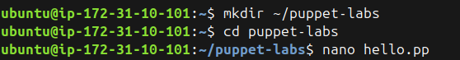
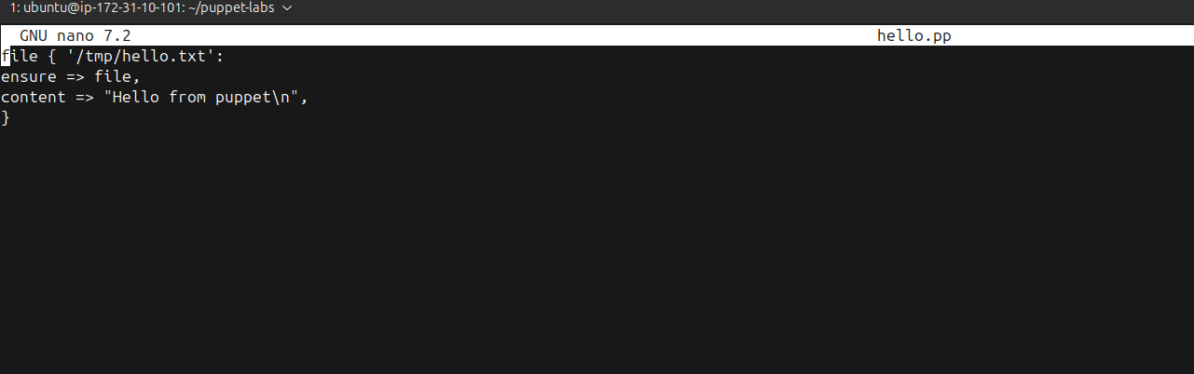
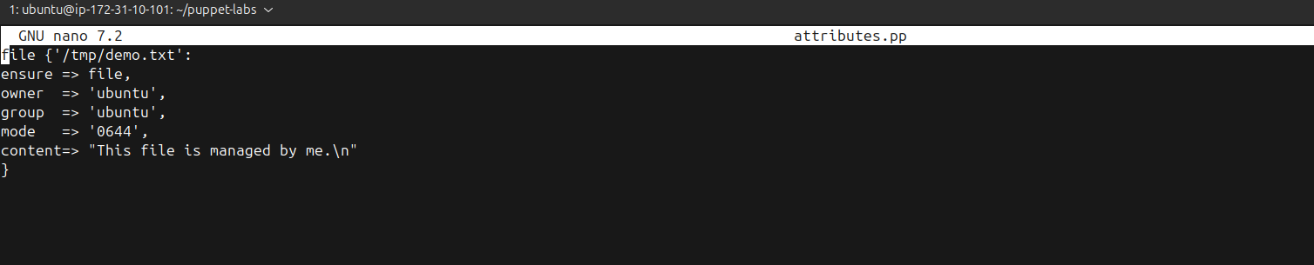
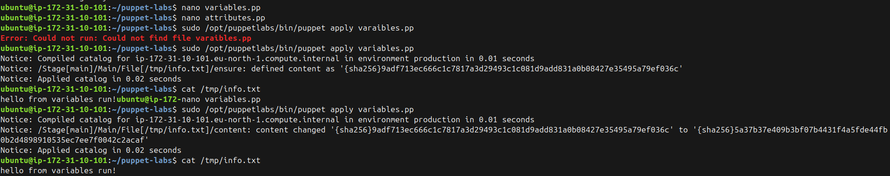
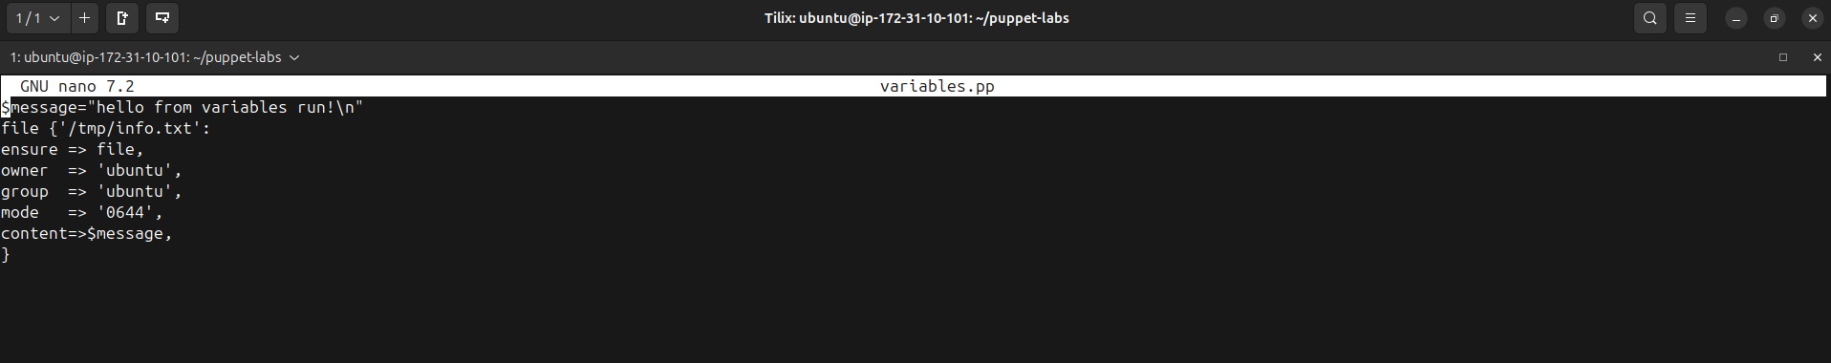
We are using /tmp/ right now purely as a sandbox for one critical DevOps concept: Controlling the Blast Radius.
Here is why all foundational configuration management tutorials start there:
- Zero Risk of System Breakage: If you are learning the syntax and accidentally write a manifest that completely overwrites a file in /etc/ (like /etc/passwd or /etc/ssh/sshd_config), you will instantly lock yourself out of your EC2 instance and destroy the server. Overwriting /tmp/demo.txt is completely harmless.
- Ephemeral Storage: The /tmp/ directory stands for "temporary." By default, Linux wipes this directory clean every time the server reboots. It ensures we aren't leaving permanent garbage files scattered across your hard drive while you experiment.
- Permission Testing: It is the easiest place to safely test Linux ownership and read/write permissions (owner => 'ubuntu', mode => '0644') without accidentally breaking the strict permissions required by the operating system's root directories.
hello.pp, attributes.pp, and variables.pp act as self-contained, independent blueprints. If you run hello.pp, Puppet only looks at /tmp/hello.txt and completely ignores the other two files. This perfectly demonstrates how Puppet Resources work: they maintain their own isolated state and don't interfere with each other unless you explicitly map out a dependency.
However, the primary significance of Practical 2 goes slightly beyond just isolation. It is about Syntax Progression.
By running these isolated configs, you are learning the atomic building blocks of the Puppet language step-by-step before you combine them into massive enterprise modules:

1. The Core Action (hello.pp)
This taught you the absolute minimum requirement to enforce a state. You learned the syntax structure: resource_type { 'title': attribute => value }. It proved that Puppet could create a file and enforce its content.

2. Granular Control (attributes.pp)
In the real world, just creating a file isn't enough; security is paramount. This isolated config introduced the concept of metadata. You learned how to enforce Linux ownership (ubuntu) and strict read/write permissions (0644) on a resource.

3. Dynamic Inputs (variables.pp)
This is the bridge to advanced configuration. By introducing the $message variable, this isolated file proved that you don't have to hardcode your infrastructure. It showed that Puppet can take outside data and inject it into a state enforcement run.
In short, Practical 2 strips away the network, the Master server, and the complex module directories so you can focus 100% on how the Puppet engine reads and executes declarative syntax.

Practical 3: Advanced Puppet: Understanding and Configuring puppet.conf

