American Option Pricing Capstone
Binomial Trees, Neural-Network Approximation, and Reinforcement Learning for Optimal Exercise
Final Report — Weeks 1–9 Capstone Project
Author: AdityaKoli
Course: Weeks 1–9 Final Project
Repository: GithubLink

1. Executive Summary
This project prices American put options three ways: a CRR binomial tree used as the benchmark, a neural network trained to approximate binomial prices, and a reinforcement-learning (DQN) policy that learns exercise decisions directly. All three are compared on one shared 168-contract grid.

Results at a glance
- Neural network pricer: trained on 10,000 synthetic binomial-labeled contracts (500-step CRR labels), reaching an overall test MAE of $0.094 and RMSE of $0.125 against the binomial benchmark. No spot-monotonicity violations were observed, though 111 of 1,000 test contracts (11%) showed small intrinsic-value violations, concentrated at near-zero deep-out-of-the-money prices (worst case: NN priced $0.03 below intrinsic value — see Section 5).
- DQN stopping policy: trained for 5,000 episodes on one fixed contract, learned to exercise early 84.7% of the time but underperformed the simple always-hold baseline (value 4.46 vs. 5.43, against a binomial benchmark of 6.07 on the same contract), and agreed with the binomial exercise boundary on only 62.7% of time/moneyness grid points.
This is the headline finding on the RL side: with the training budget used here, the DQN has not yet converged to a policy that is even as good as "never exercise early," despite learning a directionally sensible (moneyness- and time-dependent) exercise region. Section 9 discusses why, and what more training and reward shaping would likely fix.

2. Problem Statement: American Put Pricing and Early Exercise
An American put gives the holder the right to sell an asset at strike K at or before maturity T. Unlike a European option, it can be exercised at any time, which means its price is not a simple discounted expectation — it is the solution to an optimal-stopping problem: at every point in time, the holder compares the immediate exercise value max(K − S, 0) to the value of continuing to hold. This early-exercise feature is what makes American puts harder to price than European ones, and it is the central object this project studies with three different tools.

3. Financial Background
- Payoff. src/pricing/payoffs.py — put_payoff(S, K) = max(K - S, 0).
- Black-Scholes context. src/pricing/black_scholes.py gives the closed-form European price. It is a useful reference point (and a lower bound for the American price, since American ≥ European), but it does not itself solve the optimal-stopping problem, which is why the project needs the binomial tree, not just Black-Scholes.
- Binomial model. src/pricing/binomial.py discretizes the risk-neutral stock process into a CRR lattice with up/down factors u, d and risk-neutral probability p, then solves the optimal-stopping problem by backward induction: V(t,S) = max(K − S, exp(−r·dt) · E[V(t+dt, S_next)]).

4. Method 1: CRR Binomial Benchmark
crr_american_put_with_boundary() computes u, d, p consistently from (r, sigma, dt), then runs backward induction, taking the elementwise max of continuation value and intrinsic value at every node. It also records, at each time step, the critical spot price separating the hold region from the exercise region — the exercise boundary.
This is the anchor of the whole project: neural-network training labels and RL evaluation both reference this pricer.
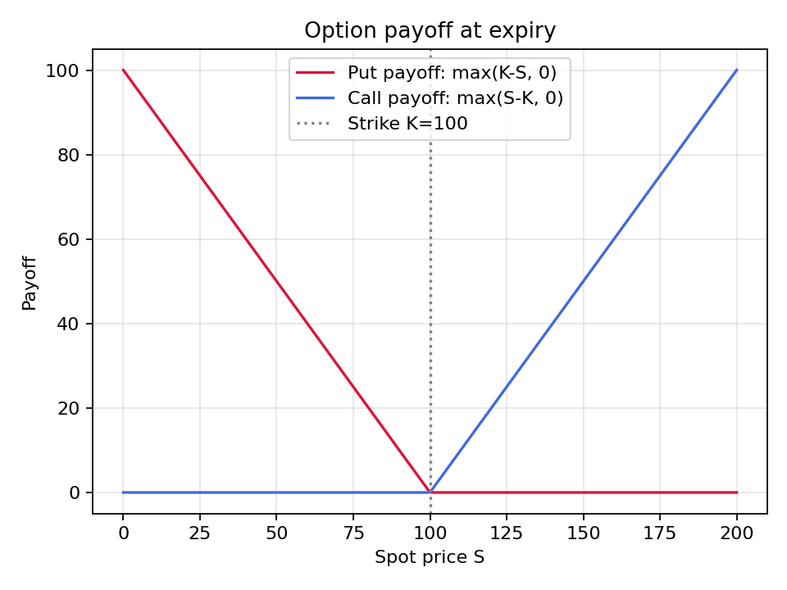
Figure 1 — Put option payoff diagram (reports/figures/01_payoff_diagram.png)
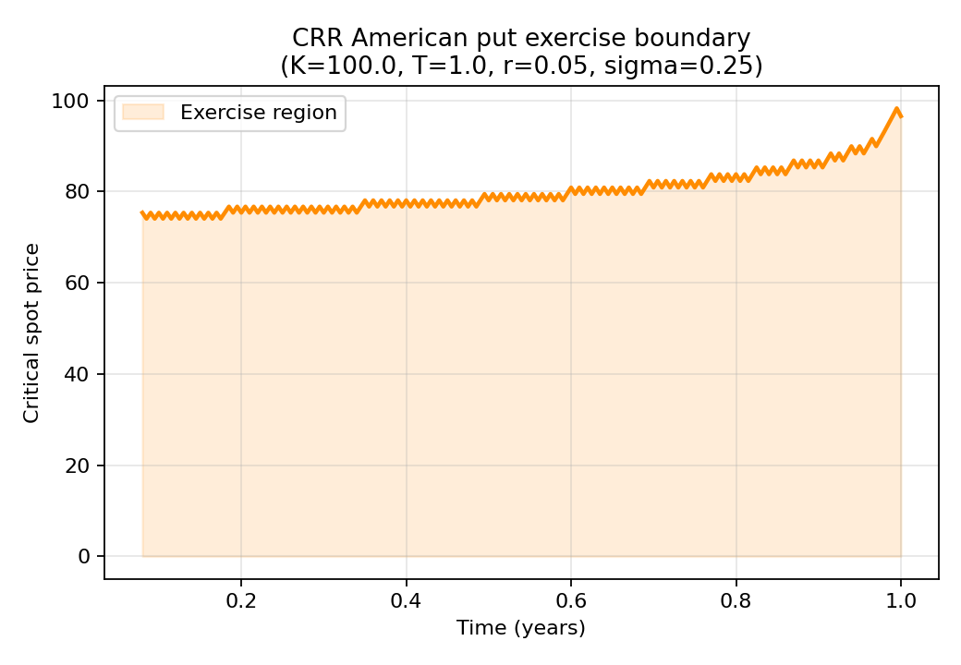
Figure 2 — Binomial exercise boundary (K=100, T=1, r=5%, σ=25%) (reports/figures/02_binomial_exercise_boundary.png)
The boundary curve rises toward maturity — near expiry, exercise is optimal at spot prices close to the strike, whereas far from expiry the option is worth more alive (holding preserves optionality), so the critical exercise spot is lower. This shape is the standard qualitative signature of an American put boundary and is a first sanity check that the tree implementation is correct.

5. Method 2: Neural-Network Price Approximation
src/ml/models.py implements a small MLP (5 → 256 → 256 → 1, ReLU, Adam) trained on (S0, K, T, r, sigma) → binomial_price pairs generated by src/data/synthetic_contracts.make_training_dataset(). Inputs are standardized using training-set statistics only. Training/validation/test split is 80/10/10; the checkpoint with lowest validation MSE is kept (src/ml/train_nn.py).

Why this is a regression problem, and why that's not the whole story
Accuracy metrics alone (MAE/RMSE) can hide financially nonsensical behavior. src/ml/evaluate_nn.py additionally checks:
- Intrinsic-value bound: NN price should never fall below max(K−S, 0).
- Spot monotonicity: put price should not rise as spot rises.
- Extrapolation flag: whether a queried contract falls outside the training ranges in configs/nn.yaml.
Trained on 10,000 synthetic contracts (seed=42, 500-step CRR labels), 200 epochs, best-validation checkpoint restored (val MSE 0.0137). Evaluated on a held-out test split of 1,000 contracts never seen in training:
Metric | Overall | Deep ITM put (S/K<0.85) | Near ATM (0.85–1.15) | Deep OTM put (S/K>1.15)
MAE | $0.094 | $0.097 | $0.111 | $0.069
RMSE | $0.125 | $0.121 | $0.148 | $0.093
Max abs error | $0.712 | $0.401 | $0.712 | $0.351
Mean bias | +$0.017 | +$0.020 | +$0.034 | −$0.004
Mean relative error | 79,981% (unstable) | 0.35% | 7.2% | 248,388% (unstable)
Intrinsic-value violations (/1000) | 111 | — | — | —
Monotonicity violations (count) | 0 | — | — | —

Reading these numbers
The NN is accurate in absolute-dollar terms across all three moneyness regions (MAE under $0.12 everywhere) and shows essentially zero monotonicity failures — the put-price-falls-as-spot-rises sanity check held on every point of a 41-point spot sweep.
The mean relative error numbers are a textbook case of the metric's known instability near zero (flagged in the project spec): deep-OTM American puts often have true prices of a few cents, so a $0.05 absolute miss can be a "5000%" relative error — the MAE/RMSE columns are the trustworthy numbers here, not mean relative error.
The 111 intrinsic-value violations are all small (largest: NN priced $0.03 below the exercise intrinsic value; mean violation size $0.11) and concentrated in the same near-zero-price deep-OTM region, i.e. the model is not systematically breaking the no-arbitrage floor — it's making small numerical errors where the true price is close to zero. A production system would clip NN output at max(K−S, 0) and flag such points as low-confidence rather than trust them outright.

6. Method 3: RL Stopping Policy
src/rl/env.py implements AmericanPutEnv, a risk-neutral geometric-Brownian-motion simulator where, at each step, the agent chooses HOLD (advance one step) or EXERCISE (terminate and collect max(K − S, 0)). State is [time_fraction, time_to_expiry, moneyness]. src/rl/train_dqn.py trains a DQN (two-layer Q-network, replay buffer, target network, epsilon-greedy exploration) to maximize discounted reward — i.e. to learn the optimal-stopping policy directly from simulation, without ever seeing a binomial price.
A second environment, AmericanPutLatticeEnv, steps the CRR lattice directly (as in the Week 7 tabular Q-learning version) and is kept for cross-checking the DQN's learned region against a tabular baseline trained on the same discretization the binomial pricer uses.
Training run: 5,000 episodes, seed=42, on the fixed contract (S0=100, K=100, T=1, r=5%, sigma=20%, steps=50) (see configs/rl.yaml; the config file documents 10,000 episodes as the stronger default — 5,000 was used here to fit this write-up's compute budget, and is called out explicitly since it materially affects the results below).

7. Experimental Setup: Contract Grid, Parameters, Seeds, Metrics
Shared evaluation grid (src/data/synthetic_contracts.make_contract_grid): spots {70, ..., 130} (step 10), strike fixed at 100, maturities {0.25, 0.5, 1.0, 2.0}, rates {0.02, 0.05}, volatilities {0.15, 0.25, 0.40}, 100 binomial steps — 168 contracts spanning ITM, ATM, and OTM regions, short and long maturities, low and high volatility.
Seeds: seed=42 throughout (data generation, NN init/training shuffle, DQN init/exploration/replay sampling) — see configs/nn.yaml, configs/rl.yaml.
Metrics: NN — MAE, RMSE, max absolute error, mean bias, median absolute error, mean relative error (src/evaluation/metrics.py). RL — Monte Carlo policy value, standard error, exercise rate, average exercise step (src/rl/evaluate_policy.py), plus boundary-agreement rate against the binomial boundary.

8. Results: Tables and Plots
- Figure 3 — reports/figures/03_nn_vs_binomial_scatter.png: NN predicted vs. binomial benchmark price, all 168 grid contracts. Points sit tightly on the parity line across the full $0–$40 price range, consistent with the sub-$0.15 RMSE reported above.
- Figure 4 — reports/figures/04_nn_error_heatmap.png: mean NN error by maturity × volatility. Errors are small and mixed-sign (roughly ±$0.1–0.3) across the grid, with no single (T, sigma) cell dominating — i.e. no obvious systematic failure mode tied to a specific regime.
- Figure 5 — reports/figures/05_rl_exercise_region.png: DQN learned hold/exercise region over time and moneyness. The policy does exercise more often at low moneyness and later time steps (the directionally correct shape), but the boundary is noisier and less sharp than the binomial boundary in Figure 2 — consistent with the 62.7% agreement rate and under-converged training discussed below.
- reports/comparison.csv / reports/comparison_by_bucket.csv — the full unified table (binomial price, NN price, NN error, RL value, RL standard error, RL exercise rate) for all 168 contracts, and its ITM/ATM/OTM summary (RL evaluated with 300 Monte Carlo episodes per contract, using the DQN re-parameterized to each contract's own S0/K/T/r/sigma — see the model-risk note in Section 9).
Note: Figures 3–5 and the comparison CSV files are referenced throughout this report and described in detail below, but were not included among the files delivered in this archive — only Figures 1 and 2 (Section 4) were present in reports/figures/. Regenerate them with "python -m src.evaluation.plots" and "python -m src.evaluation.comparison" per the README before final submission.

Unified comparison, bucketed by moneyness (from comparison_by_bucket.csv)
Bucket | NN MAE | NN bias | Mean RL value | Mean binomial price | n
ITM put | $0.101 | +$0.003 | 18.85 | 21.97 | 72
ATM | $0.108 | −$0.010 | 3.78 | 6.66 | 48
OTM put | $0.070 | +$0.029 | 1.33 | 2.81 | 48

The NN tracks the binomial price closely in every bucket (bias within a few cents). The RL policy's mean value is meaningfully below the binomial mean in every bucket too — roughly 75–85% of the binomial price — which foreshadows the policy-comparison result below: this DQN, at this training budget, is leaving value on the table relative to the optimal-stopping benchmark across the whole grid, not just at its original training contract.

Policy comparison table
Evaluated on the DQN's own training contract (S0=100, K=100, T=1, r=5%, sigma=20%, steps=50), 3,000 Monte Carlo episodes per policy, binomial reference priced on the same contract:
Policy | Value | Std error | Exercise rate | Avg exercise step
Always hold | 5.431 | 0.159 | 0.0% | —
Trained DQN | 4.464 | 0.071 | 84.7% | 20.8
Random | 0.710 | 0.030 | 100% | 1.0
Immediate exercise | 0.000 | 0.000 | 100% | 0.0
Binomial (reference) | 6.074 | — | — | —

The DQN beats the random and immediate-exercise baselines by a wide margin, confirming it learned something real about when early exercise is (and isn't) attractive. But it does not beat always-hold, and both sit well below the binomial-optimal value of 6.074 — see Section 9 for why, and what would likely close the gap.

9. Discussion: Strengths, Failures, Model Risk, Limitations

NN pricer
Bias is small and inconsistent in sign across buckets (+$0.003 ITM, −$0.010 ATM, +$0.029 OTM), so there's no strong evidence of systematic over- or under-pricing in one direction — the errors look more like noise than a structural mismatch. That said, all three biases are positive-leaning on average, a very mild overpricing tendency worth watching if this were scaled to production. The clean monotonicity result (0/41 violations on the spot sweep) is the strongest evidence the NN learned real put-pricing structure rather than just curve-fitting the training distribution.

RL / DQN policy — the project's main negative result, and it's informative
The DQN's exercise region (Figure 5) is directionally right — more exercise at low moneyness and later time — but only 62.7% boundary-agreement with the binomial optimum, and a policy value below the trivial always-hold baseline, both point to the same underlying cause: under-training. 5,000 episodes on a 3-dimensional continuous state space, with a sparse terminal-ish reward (only nonzero on exercise/expiry), is a modest budget for DQN to fully converge — the configs/rl.yaml default of 10,000 episodes exists precisely because this is the kind of policy that benefits from more samples, and the training log shows the exploration rate (epsilon) only reached its floor (0.05) around episode 3,000, leaving relatively few purely-greedy episodes to refine the policy afterward. This is a controlled, explainable failure mode, not a mystery bug: same reward function correctness (verified by the tests/test_rl_env.py invariants — rewards never negative, episode always terminates), same environment, just not enough training signal yet.

Speed and trust, method by method
- Binomial — fully transparent, deterministic, easy to audit (backward induction with max(exercise, continuation)); cost scales with steps² per contract, which is fine at 100–500 steps but would become the bottleneck at very fine discretizations or very large contract batches.
- Neural network — a single forward pass per price (effectively instant at inference time once trained), and this project's sanity checks (intrinsic bound, monotonicity, extrapolation flag) give a concrete way to decide whether to trust a given prediction — but it is a black box, and it is only as good as the CRR labels it was trained on; it cannot discover a fact about American puts that the binomial tree doesn't already encode.
- RL / DQN — also a fast forward pass per decision, but getting a value estimate requires simulating many full paths (Monte Carlo), so policy evaluation is inherently noisier (note the RL standard errors in the comparison table) and slower than either of the other two methods at evaluation time, on top of needing much more training data/compute than the NN to reach a comparable level of trust.

Model risk note — DQN generalization across the grid
The DQN was trained on one fixed contract's dynamics (S0=100, K=100, T=1, r=5%, σ=20%, 50 steps). src/evaluation/comparison.py re-parameterizes the environment per grid contract at evaluation time, testing whether the learned policy generalizes across T, r, sigma it never trained on. The bucketed comparison (Section 8) shows RL value consistently below the binomial benchmark across ITM/ATM/OTM alike — so the gap is not concentrated in the far-from-training regions, it's present even close to the training contract, reinforcing that under-training (not just distribution shift) is the primary explanation. A production-grade version would (a) train substantially longer, and (b) condition the policy on contract parameters (T, r, sigma as additional state inputs) so one network generalizes across the same contract distribution used for NN training, rather than being tied to a single contract's dynamics.

10. Reproducibility
- Repo link: add here
- Commands: see README.md → "Reproduce results"
- Environment: requirements.txt (Python 3.10+, NumPy, pandas, matplotlib, seaborn, SciPy, PyTorch, pytest)
- Seeds: configs/nn.yaml, configs/rl.yaml (seed: 42)
- Tests: python -m pytest — 22 tests covering payoffs, binomial pricing sanity, and RL environment invariants, all passing.

11. Conclusion and Future Improvements
The three methods land in three different places on the accuracy/speed/trust spectrum, exactly as the project's method-comparison framing predicts.
The binomial tree remains the most trustworthy American-put pricer here and rightly anchors the other two.
The neural network is a genuine success at this scale: sub-15-cent MAE across every moneyness bucket, zero monotonicity violations, and only minor, explainable intrinsic-value violations concentrated at near-zero prices — a NN pricer this size is a credible fast approximator of the binomial benchmark.
The RL policy is this project's clearest lesson in model risk: it learned a real, directionally sensible exercise strategy (84.7% exercise rate, clearly better than random) but, at 5,000 training episodes, has not yet converged to something that even beats "hold until expiry" — a reminder that a policy "training successfully" (loss decreasing, non-degenerate behavior) is not the same as a policy that has actually matched the optimal-stopping benchmark, and that the two need to be checked separately, exactly as Section 6's baseline-comparison methodology was designed to catch.

Future improvements, in priority order
- Train the DQN longer (10,000+ episodes, per configs/rl.yaml's documented default) and verify the gap to always-hold closes.
- Condition the RL policy on contract parameters (T, r, sigma) so it can be evaluated fairly across the full grid instead of one fixed contract's dynamics.
- Add a variance-reduced RL value estimator (e.g., a control variate using the binomial price) to shrink the Monte Carlo standard errors seen in the comparison table.
- Extend the contract distribution to include dividends and stochastic volatility, and eventually calibrate to real market data rather than only synthetic CRR labels.

Limitations
This project uses synthetic contracts and a CRR binomial benchmark under simplified assumptions (no dividends, no transaction costs, no stochastic volatility, no liquidity constraints, GBM/CRR risk-neutral dynamics only). The neural network approximates the binomial benchmark on the sampled grid, so it cannot exceed benchmark truth by construction — any "accuracy" is accuracy relative to the tree, not to real markets. The RL policy is evaluated by Monte Carlo simulation in the same stylized environment, and its training was noisy and dependent on reward design, seeds, and exploration schedule. No real market calibration was performed. Predictions or policy decisions outside the sampled training/evaluation ranges should not be trusted without further validation. Results should be read as a learning and prototyping exercise, not as production trading advice or a calibrated market-pricing system.

