**Name:- Aditya Sudhakar Shinde**

**PRN:- 2124UCEM2046**

**Q1. Write a c++ program for consturcyion of a binary tree. Print the inorder of the binary tree.**

**Ans:**

#include<iostream>

using namespace std;

class node

{

public:

int data;

node* left;

node* right;

node(int value)

{

data=value;

left=nullptr;

right=nullptr;

}

};

void inorder(node*root)

{

if(root)

{

inorder(root->left);

cout << root->data << " ";

inorder(root->right);

}

}

int main()

{

node*root = new node(15);

root -> left = new node(10);

root -> right = new node(20);

root -> left -> right = new node (11);

cout<<"Binary Tree constructed using In-Order: ";

inorder(root);

cout<<endl;

return 0;

}

**OUTPUT:-**

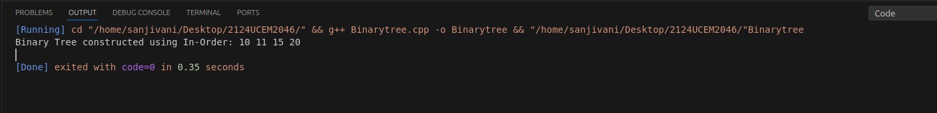

**Q4. Write a c++ program to store a directed graph using adjacency list.**

**Ans:**

#include<iostream>

#include<vector>

using namespace std;

int main()

{

int vertices, edges, u, v;

cin>>vertices>>edges;

vector<int>adj[vertices];

for(int i=0;i<edges;i++)

{

cin>>u>>v;

adj[u].push_back(v);

adj[v].push_back(u);

}

for(int i=0;i<vertices;i++)

{

cout<<i<<" ";

for(int neighbour : adj[i])

{

cout<<neighbour<<" ";

}

cout<<endl;

}

return 0;

}

**OUTPUT:-**

