 | 


CampusPulse
COLLEGE PLACEMENT ANALYTICS SYSTEM
Subject: Python Programming (26CAH-606)
Academic Year 2026 – 2027

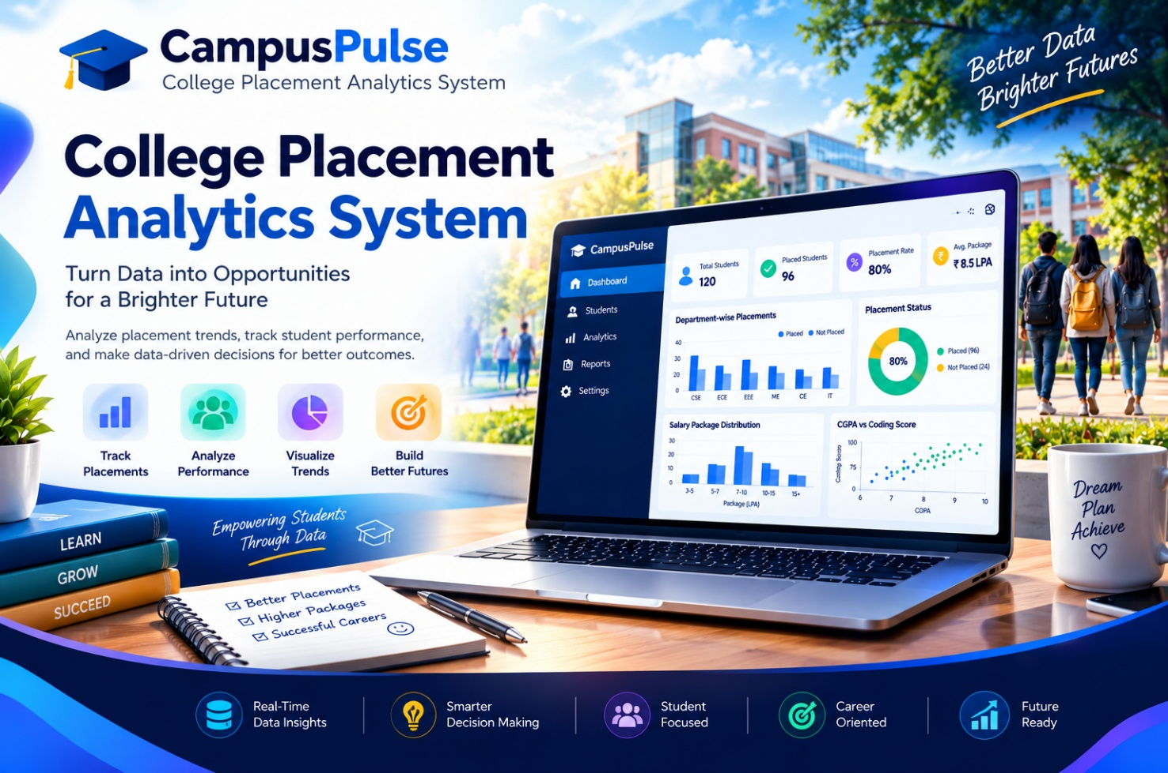

Submitted by  ADITYA MANGALAM  UID: 26MCC20078 | Submitted to  Ms. NISHA SHARMA  (E2915)
CERTIFICATE
This is to certify that the mini project report entitled “CampusPulse” using Python is a Bonafide work carried out by ADITYA MANGALAM, UID: 26MCC20078, in partial fulfilment of the requirements of the course Python, in Master of Computer Application, Department of Cloud Computing & DevOps, Chandigarh University, during the academic year 2026–2027.
The project work has been completed under my guidance and supervision. The work embodied in this report is original and has not been submitted elsewhere for the award of any degree, diploma or certificate.
Project Guide Head of Department
Ms. Nisha Sharma (E2915) Dr. Amanpreet Kaur Sandhu
Date: 23-10-2026
ACKNOWLEDGEMENT
I express my sincere gratitude to my project guide, Ms. Nisha Sharma, for the constant guidance, encouragement and valuable suggestions throughout the development of this mini project. I am also thankful to the Head of the Department and all faculty members of the Department of Computer Science and Engineering for providing the laboratory facilities and a supportive environment. Finally, I thank my family and friends for their continuous motivation.
ADITYA MANGALAM

ABSTRACT

Campus placement is one of the most important outcomes of a college’s academic performance, yet placement records are often stored as plain lists or spreadsheets that are hard to study. The College Placement Analytics System is a desktop application developed in Python that converts such raw records into clear, useful information. It is built with only four libraries, NumPy, Pandas, Matplotlib and Tkinter, and is organised using classes and objects.

The system works on a dataset of student records covering department, batch year, CGPA, backlogs, internships, projects, skill scores, placement status, company and package. A data-handling class loads the records and calculates key figures such as placement percentage, average package and highest package, along with department-wise, company-wise, year-wise and CGPA-wise summaries. A chart class uses Matplotlib to draw nine charts, including pie, bar, histogram, line and scatter plots, which are shown inside the Tkinter window. A predictor class takes a student’s academic and skill details and estimates the chance of placement, with suggestions for improvement.

The Tkinter interface has five tabs: Dashboard, Charts, Departments & Companies, Predictor and Student Records. Users can filter by batch year and department, save charts as images, search student records and export them to CSV. Because the program is split into separate classes, it is easy to read, test and extend.

The project shows how object-oriented programming and a small set of free Python libraries can produce a practical, user-friendly analytics tool. It can help placement officers plan training, help faculty find weak areas, and help students judge their own readiness for recruitment.

Keywords: Placement Analytics, Python, Tkinter, Pandas, NumPy, Matplotlib, Object-Oriented Programming, Data Visualization

Table of Contents
1. Aim………………………………………………………………………………………………………………………4
2. Objectives..………………………………………………………………………………………………………….4
3. Tools & Technologies Used………………………………………………………………………………….5
4. System Requirements………………………………………………………………………………………….5
5. System Design (Classes & Objects) ……………………………………………………………………..5
6. Source Code………………………………………………………………………………………………………..7
7. Screenshots of the Application…………………………………………………………………………..15
8. Charts and Analysis……………………………………………………………………………………………17
9. Output Images…………………………………………………………………………………………………..20
10. Results & Conclusion……………………………………………………………………………………….21
11. References………………………………………………………………………………………………………21

1. Aim

To develop a simple, easy-to-understand desktop application, the College Placement Analytics System, using Python classes and objects with only NumPy, Pandas, Matplotlib and Tkinter. The application analyses student placement data, shows it through charts and tables, and predicts a student’s chance of getting placed.

2. Objectives

- To create a sample dataset of student academic records and placement results.
- To calculate placement percentage, average package and highest package.
- To analyse placements department-wise, company-wise, year-wise and CGPA-wise.
- To display nine different charts using Matplotlib inside a Tkinter window.
- To predict the placement chance of a student and give improvement tips.
- To allow searching, filtering and exporting of student records.
- To apply Object-Oriented Programming (classes, objects, methods, inheritance) in a real project.

3. Tools & Technologies Used
Tool / Library | Purpose
Python 3.9+ | Programming language
Tkinter (ttk) | Graphical User Interface – windows, tabs, buttons, sliders, tables
NumPy | Random data generation and mathematical calculations
Pandas | Reading CSV, filtering, grouping and summaries
Matplotlib | Drawing charts and embedding them in Tkinter
OOP – Classes & Objects | Organising the code into reusable blocks
VS Code / IDLE / PyCharm | Code editor

4. System Requirements

Hardware Requirements
Component | Minimum | Recommended
Processor | Intel i3 / equivalent | Intel i5 or better
RAM | 2 GB | 4 GB
Storage | 200 MB free | 500 MB free
Display | 1280 × 720 | 1366 × 768 or higher

Software Requirements
Software | Requirement
Operating System | Windows 10/11, macOS or Linux
Python | Version 3.9 or higher (Tkinter is included in the standard installer)
Libraries | numpy, pandas, matplotlib (pip install -r requirements.txt)

5. System Design (Classes & Objects)
- DataGenerator creates 600 student records and saves them in data/placement_data.csv.
- PlacementData loads the CSV and calculates all summaries (the data object).
- ChartMaker uses PlacementData to create Matplotlib figures (the chart object).
- Predictor calculates the placement probability from the student’s details.
- PlacementApp (inherits from tk.Tk) builds the window and connects all the objects together.

5.1 Classes Used
Class | File | Main Methods
DataGenerator | data_generator.py | generate()
PlacementData | analysis.py | apply_filter(), kpis(), dept_summary(), company_summary(), year_summary(), cgpa_band_summary()
ChartMaker | analysis.py | status_pie(), dept_bar(), package_hist(), top_companies(), year_trend(), cgpa_band(), cgpa_scatter(), skill_bar(), catalog()
Predictor | analysis.py | probability(), tips()
PlacementApp (tk.Tk) | app.py | build_dashboard(), build_charts_tab(), build_dept_tab(), build_predictor_tab(), build_records_tab(), refresh_all()

5.2 OOP Concepts Demonstrated
- Class and Object – PlacementData(), ChartMaker(), Predictor() are objects created in PlacementApp.
- Constructor (__init__) – used to load data and set up the window.
- Encapsulation – each class keeps its own data and methods together.
- Inheritance – PlacementApp inherits from tkinter.Tk.
- Abstraction – the GUI only calls simple methods like kpis() without knowing the calculation.

5.3 Application Tabs
Tab | Description
Dashboard | Five coloured KPI cards, placement pie chart and package histogram
Charts | Dropdown of 9 charts and a button to save the chart as PNG
Departments & Companies | Department and company tables with a department chart
Predictor | Sliders for student details → probability, progress bar and tips
Student Records | Search by ID/company, filter by status, export to CSV

5.4 Dataset Columns
Column | Meaning
StudentID, Department, BatchYear | Identity, branch and passing-out year (2022–2025)
CGPA, Backlogs, Internships, Projects | Academic and practical profile
Aptitude, Communication, Technical | Skill scores out of 100
Placed, Company, Package | Result (Yes/No), recruiter and package in LPA

5.5 Project Folder Structure
Placement_Tkinter/
app.py
analysis.py
data_generator.py
save_charts.py
requirements.txt
README.md
data/placement_data.csv
charts/
screenshots/

5.6 How to Run
- pip install -r requirements.txt
- python data_generator.py
- python app.py

6. Source Code

6.1 Data Generator (data_generator.py)
"""
data_generator.py
Creates a sample (random) placement dataset using only numpy + pandas.
Run: python data_generator.py -> data/placement_data.csv
"""
import os
import numpy as np
import pandas as pd

class DataGenerator:
"""Generates fake but realistic student placement records."""

DEPARTMENTS = ["CSE", "IT", "ECE", "EEE", "Mechanical", "Civil", "MBA"]
# company: (min package, max package) in LPA
COMPANIES = {"TCS": (3.5, 4.5), "Infosys": (3.6, 4.8), "Wipro": (3.5, 4.5),
"Cognizant": (4.0, 5.0), "Accenture": (4.5, 7.0), "Deloitte": (6.0, 9.0),
"L&T": (4.5, 7.5), "Bosch": (5.0, 8.0), "Amazon": (14.0, 32.0),
"Microsoft": (16.0, 38.0), "Google": (20.0, 45.0)}
BOOST = {"CSE": 0.9, "IT": 0.8, "ECE": 0.4, "EEE": 0.2, "Mechanical": 0.0, "Civil": -0.2, "MBA": 0.3}
DREAM = ["Amazon", "Microsoft", "Google"]
MID = ["Accenture", "Deloitte", "L&T", "Bosch"]
MASS = ["TCS", "Infosys", "Wipro", "Cognizant"]

def __init__(self, n=600, seed=42):
self.n = n
self.rng = np.random.default_rng(seed)

def generate(self):
r, n = self.rng, self.n
dept = r.choice(self.DEPARTMENTS, n, p=[0.24, 0.16, 0.16, 0.10, 0.12, 0.08, 0.14])
year = r.choice([2022, 2023, 2024, 2025], n)
cgpa = np.clip(r.normal(7.4, 1.0, n), 5.0, 9.9).round(2)
backlogs = r.choice([0, 1, 2, 3], n, p=[0.70, 0.17, 0.08, 0.05])
intern = r.choice([0, 1, 2, 3], n, p=[0.35, 0.37, 0.20, 0.08])
projects = r.choice([0, 1, 2, 3, 4, 5], n)
aptitude = np.clip(r.normal(65, 14, n) + (cgpa - 7.4) * 5, 20, 100).round(0)
comm = np.clip(r.normal(64, 15, n), 20, 100).round(0)
tech = np.clip(r.normal(60, 16, n) + (cgpa - 7.4) * 4, 15, 100).round(0)

# hidden rule that decides who gets placed
z = (-6.9 + 0.6 * cgpa + 0.012 * aptitude + 0.01 * comm + 0.015 * tech
+ 0.35 * intern + 0.12 * projects - 0.55 * backlogs
+ np.array([self.BOOST[d] for d in dept]) + r.normal(0, 0.5, n))
placed = r.random(n) < 1 / (1 + np.exp(-z))

company, package = [], []
for i in range(n):
if not placed[i]:
company.append("Not Placed"); package.append(0.0); continue
strength = (cgpa[i] - 5) / 5 * 0.5 + tech[i] / 100 * 0.3 + aptitude[i] / 100 * 0.2
if strength > 0.68 and dept[i] in ("CSE", "IT", "ECE") and r.random() < 0.5:
pool = self.DREAM
elif strength > 0.55:
pool = self.MID + self.MASS
else:
pool = self.MASS
c = r.choice(pool)
lo, hi = self.COMPANIES[c]
company.append(c); package.append(round(float(r.uniform(lo, hi)), 2))

return pd.DataFrame({
"StudentID": [f"STU{1000 + i}" for i in range(n)],
"Department": dept, "BatchYear": year, "CGPA": cgpa, "Backlogs": backlogs,
"Internships": intern, "Projects": projects, "Aptitude": aptitude,
"Communication": comm, "Technical": tech,
"Placed": np.where(placed, "Yes", "No"), "Company": company, "Package": package})

if __name__ == "__main__":
os.makedirs("data", exist_ok=True)
df = DataGenerator().generate()
df.to_csv("data/placement_data.csv", index=False)
print(f"Saved {len(df)} student records to data/placement_data.csv")
print(df.head())

6.2 Analysis, Charts and Predictor Classes (analysis.py)
"""
analysis.py
Classes that do the number work (PlacementData), draw charts (ChartMaker)
and predict placement chance (Predictor). Uses only numpy, pandas, matplotlib.
"""
import numpy as np
import pandas as pd
from matplotlib.figure import Figure

class PlacementData:
"""Holds the dataset and gives summaries (an 'object' that knows its data)."""

def __init__(self, path="data/placement_data.csv"):
self.full = pd.read_csv(path)
self.df = self.full.copy() # currently filtered data

# ---------- filtering ----------
def apply_filter(self, year="All", dept="All"):
d = self.full
if year != "All":
d = d[d["BatchYear"] == int(year)]
if dept != "All":
d = d[d["Department"] == dept]
self.df = d
return len(d)

def placed(self):
return self.df[self.df["Placed"] == "Yes"]

# ---------- summaries ----------
def kpis(self):
p = self.placed()
total = len(self.df)
return {
"Total Students": total,
"Placed": len(p),
"Placement %": round(len(p) / total * 100, 1) if total else 0,
"Avg Package (LPA)": round(float(p["Package"].mean()), 2) if len(p) else 0,
"Highest Package (LPA)": round(float(p["Package"].max()), 2) if len(p) else 0,
}

def dept_summary(self):
g = self.df.groupby("Department")
out = pd.DataFrame({"Students": g.size(),
"Placed": g["Placed"].apply(lambda s: (s == "Yes").sum())})
out["Placement %"] = (out["Placed"] / out["Students"] * 100).round(1)
out["Avg Package"] = self.placed().groupby("Department")["Package"].mean().round(2)
return out.fillna(0).sort_values("Placement %", ascending=False)

def company_summary(self):
return (self.placed().groupby("Company")["Package"]
.agg(Hired="count", AvgPackage="mean").round(2)
.sort_values("Hired", ascending=False))

def year_summary(self):
g = self.df.groupby("BatchYear")
out = pd.DataFrame({"Students": g.size(),
"Placed": g["Placed"].apply(lambda s: (s == "Yes").sum())})
out["Placement %"] = (out["Placed"] / out["Students"] * 100).round(1)
return out

def cgpa_band_summary(self):
bands = pd.cut(self.df["CGPA"], [0, 6, 7, 8, 9, 10], right=False,
labels=["<6", "6-7", "7-8", "8-9", "9+"])
flag = (self.df["Placed"] == "Yes").astype(int)
return (flag.groupby(bands, observed=False).mean() * 100).round(1)

class ChartMaker:
"""Creates matplotlib Figure objects (they are shown inside Tkinter)."""
COLORS = ["#4F46E5", "#06B6D4", "#10B981", "#F59E0B", "#EF4444", "#8B5CF6", "#EC4899"]

def __init__(self, data: PlacementData):
self.data = data

def _fig(self, size=(5.4, 3.6)):
fig = Figure(figsize=size, dpi=100)
ax = fig.add_subplot(111)
ax.spines["top"].set_visible(False)
ax.spines["right"].set_visible(False)
return fig, ax

def status_pie(self, size=(5.4, 3.6)):
fig, ax = self._fig(size)
p = len(self.data.placed()); t = len(self.data.df)
ax.pie([p, t - p], labels=["Placed", "Not Placed"], autopct="%1.1f%%", startangle=90,
colors=["#10B981", "#EF4444"], wedgeprops=dict(width=0.45))
ax.set_title("Placement Status", fontweight="bold")
fig.tight_layout(); return fig

def dept_bar(self, size=(5.4, 3.6)):
fig, ax = self._fig(size)
d = self.data.dept_summary()
bars = ax.bar(d.index, d["Placement %"], color=self.COLORS[0])
ax.bar_label(bars, fmt="%.0f%%", fontsize=8)
ax.set_ylim(0, 100); ax.set_ylabel("Placement %")
ax.set_title("Department-wise Placement %", fontweight="bold")
ax.tick_params(axis="x", labelrotation=30, labelsize=8)
fig.tight_layout(); return fig

def package_hist(self, size=(5.4, 3.6)):
fig, ax = self._fig(size)
ax.hist(self.data.placed()["Package"], bins=20, color=self.COLORS[1], edgecolor="white")
ax.set_xlabel("Package (LPA)"); ax.set_ylabel("Students")
ax.set_title("Package Distribution", fontweight="bold")
fig.tight_layout(); return fig

def dept_package(self, size=(5.4, 3.6)):
fig, ax = self._fig(size)
d = self.data.dept_summary()
mx = self.data.placed().groupby("Department")["Package"].max().reindex(d.index).fillna(0)
x = np.arange(len(d))
ax.bar(x - 0.2, d["Avg Package"], 0.4, label="Average", color=self.COLORS[0])
ax.bar(x + 0.2, mx, 0.4, label="Highest", color=self.COLORS[3])
ax.set_xticks(x); ax.set_xticklabels(d.index, rotation=30, fontsize=8)
ax.set_ylabel("LPA"); ax.legend(); ax.set_title("Average vs Highest Package", fontweight="bold")
fig.tight_layout(); return fig

def top_companies(self, size=(5.4, 3.6)):
fig, ax = self._fig(size)
c = self.data.company_summary().head(8).iloc[::-1]
bars = ax.barh(c.index, c["Hired"], color=self.COLORS[2])
ax.bar_label(bars, fontsize=8); ax.set_xlabel("Students hired")
ax.set_title("Top Recruiters", fontweight="bold")
fig.tight_layout(); return fig

def year_trend(self, size=(5.4, 3.6)):
fig, ax = self._fig(size)
y = self.data.year_summary()
ax.plot(y.index, y["Placement %"], marker="o", lw=3, color=self.COLORS[0])
for x_, v in zip(y.index, y["Placement %"]):
ax.annotate(f"{v}%", (x_, v + 2), ha="center", fontsize=8)
ax.set_xticks(list(y.index)); ax.set_ylim(0, 100); ax.set_ylabel("Placement %")
ax.set_title("Year-wise Placement Trend", fontweight="bold")
fig.tight_layout(); return fig

def cgpa_band(self, size=(5.4, 3.6)):
fig, ax = self._fig(size)
b = self.data.cgpa_band_summary()
bars = ax.bar(b.index.astype(str), b.values, color=self.COLORS[5])
ax.bar_label(bars, fmt="%.0f%%", fontsize=8)
ax.set_ylim(0, 110); ax.set_xlabel("CGPA band"); ax.set_ylabel("Placement %")
ax.set_title("Placement % by CGPA", fontweight="bold")
fig.tight_layout(); return fig

def cgpa_scatter(self, size=(5.4, 3.6)):
fig, ax = self._fig(size)
p = self.data.placed()
ax.scatter(p["CGPA"], p["Package"], c=self.COLORS[4], alpha=0.6, s=18)
ax.set_xlabel("CGPA"); ax.set_ylabel("Package (LPA)")
ax.set_title("CGPA vs Package", fontweight="bold")
fig.tight_layout(); return fig

def skill_bar(self, size=(5.4, 3.6)):
fig, ax = self._fig(size)
cols = ["Aptitude", "Communication", "Technical"]
d = self.data.df
yes = d[d.Placed == "Yes"][cols].mean(); no = d[d.Placed == "No"][cols].mean()
x = np.arange(3)
ax.bar(x - 0.2, yes, 0.4, label="Placed", color="#10B981")
ax.bar(x + 0.2, no, 0.4, label="Not Placed", color="#EF4444")
ax.set_xticks(x); ax.set_xticklabels(cols); ax.set_ylim(0, 100); ax.legend()
ax.set_title("Average Skill Scores", fontweight="bold")
fig.tight_layout(); return fig

# name -> method (used by the dropdown in the app)
def catalog(self):
return {"Placement Status (Pie)": self.status_pie, "Department Placement %": self.dept_bar,
"Package Distribution": self.package_hist, "Avg vs Highest Package": self.dept_package,
"Top Recruiters": self.top_companies, "Year-wise Trend": self.year_trend,
"CGPA Band Analysis": self.cgpa_band, "CGPA vs Package": self.cgpa_scatter,
"Skill Comparison": self.skill_bar}

class Predictor:
"""Very simple scoring model: weights x student values -> probability (0-1)."""
WEIGHTS = {"CGPA": 0.6, "Backlogs": -0.55, "Internships": 0.35, "Projects": 0.12,
"Aptitude": 0.012, "Communication": 0.01, "Technical": 0.015}
BIAS = -6.5

def probability(self, s: dict) -> float:
z = self.BIAS + sum(self.WEIGHTS[k] * s[k] for k in self.WEIGHTS)
return float(1 / (1 + np.exp(-z)))

def tips(self, s: dict):
t = []
if s["CGPA"] < 7: t.append("Raise your CGPA above 7.0.")
if s["Backlogs"] > 0: t.append("Clear all backlogs.")
if s["Internships"] == 0: t.append("Do at least one internship.")
if s["Projects"] < 2: t.append("Build 2-3 good projects.")
if s["Aptitude"] < 60: t.append("Practise aptitude questions daily.")
if s["Communication"] < 60: t.append("Join mock interviews / GDs.")
if s["Technical"] < 60: t.append("Revise DSA, DBMS and OS.")
return t or ["Great profile! Keep practising and apply widely."]

6.3 Tkinter Application (Main File) (app.py)
"""
College Placement Analytics System (Tkinter GUI)
Libraries : numpy, pandas, matplotlib, tkinter (nothing else!)
Run : python app.py
"""
import tkinter as tk
from tkinter import ttk, filedialog, messagebox

from matplotlib.backends.backend_tkagg import FigureCanvasTkAgg

from analysis import PlacementData, ChartMaker, Predictor

# ---------- colours / fonts used everywhere ----------
BG, DARK, PRIMARY = "#F1F5F9", "#1E293B", "#4F46E5"
CARD_COLORS = ["#4F46E5", "#10B981", "#06B6D4", "#F59E0B", "#EF4444"]

class PlacementApp(tk.Tk):
"""Main window. Every tab is built by its own method."""

def __init__(self):
super().__init__()
self.title("College Placement Analytics System")
self.geometry("1180x720")
self.configure(bg=BG)

self.data = PlacementData() # object that holds the data
self.charts = ChartMaker(self.data) # object that draws charts
self.predictor = Predictor() # object that predicts placement
self.canvases = {} # remember chart canvases so we can replace them

self.setup_style()
self.build_header()
self.build_filter_bar()
self.build_tabs()
self.refresh_all()

# ------------------------------------------------------------------ style
def setup_style(self):
st = ttk.Style(self)
st.theme_use("clam")
st.configure("TNotebook", background=BG, borderwidth=0)
st.configure("TNotebook.Tab", font=("Segoe UI", 11, "bold"), padding=(18, 8))
st.map("TNotebook.Tab", background=[("selected", PRIMARY)], foreground=[("selected", "white")])
st.configure("Treeview", rowheight=24, font=("Segoe UI", 10))
st.configure("Treeview.Heading", font=("Segoe UI", 10, "bold"), background=PRIMARY, foreground="white")
st.configure("TButton", font=("Segoe UI", 10, "bold"), padding=6)
st.configure("TLabelframe.Label", font=("Segoe UI", 11, "bold"))

# ----------------------------------------------------------------- header
def build_header(self):
head = tk.Frame(self, bg=PRIMARY, height=70)
head.pack(fill="x")
tk.Label(head, text="🎓 College Placement Analytics System", bg=PRIMARY, fg="white",
font=("Segoe UI", 20, "bold")).pack(side="left", padx=20, pady=14)
tk.Label(head, text="Analyse • Visualise • Predict", bg=PRIMARY, fg="#C7D2FE",
font=("Segoe UI", 11)).pack(side="right", padx=20)

def build_filter_bar(self):
bar = tk.Frame(self, bg=BG)
bar.pack(fill="x", padx=15, pady=(10, 0))
tk.Label(bar, text="Batch Year:", bg=BG, font=("Segoe UI", 10, "bold")).pack(side="left")
self.year_var = tk.StringVar(value="All")
years = ["All"] + [str(y) for y in sorted(self.data.full["BatchYear"].unique())]
ttk.Combobox(bar, textvariable=self.year_var, values=years, width=8, state="readonly").pack(side="left", padx=(5, 15))
tk.Label(bar, text="Department:", bg=BG, font=("Segoe UI", 10, "bold")).pack(side="left")
self.dept_var = tk.StringVar(value="All")
depts = ["All"] + sorted(self.data.full["Department"].unique())
ttk.Combobox(bar, textvariable=self.dept_var, values=depts, width=12, state="readonly").pack(side="left", padx=(5, 15))
ttk.Button(bar, text="Apply Filter", command=self.refresh_all).pack(side="left")
ttk.Button(bar, text="Reset", command=self.reset_filters).pack(side="left", padx=6)
self.count_label = tk.Label(bar, text="", bg=BG, fg="#64748B", font=("Segoe UI", 10))
self.count_label.pack(side="right")

def build_tabs(self):
self.tabs = ttk.Notebook(self)
self.tabs.pack(fill="both", expand=True, padx=15, pady=10)
self.tab_dash = tk.Frame(self.tabs, bg=BG)
self.tab_charts = tk.Frame(self.tabs, bg=BG)
self.tab_dept = tk.Frame(self.tabs, bg=BG)
self.tab_pred = tk.Frame(self.tabs, bg=BG)
self.tab_rec = tk.Frame(self.tabs, bg=BG)
for tab, name in [(self.tab_dash, " Dashboard "), (self.tab_charts, " Charts "),
(self.tab_dept, " Departments & Companies "),
(self.tab_pred, " Predictor "), (self.tab_rec, " Student Records ")]:
self.tabs.add(tab, text=name)
self.build_dashboard()
self.build_charts_tab()
self.build_dept_tab()
self.build_predictor_tab()
self.build_records_tab()

# ------------------------------------------------------------ small helpers
def show_figure(self, key, fig, parent):
"""Put a matplotlib figure inside a Tk frame (replacing the old one)."""
if key in self.canvases:
self.canvases[key].get_tk_widget().destroy()
canvas = FigureCanvasTkAgg(fig, master=parent)
canvas.draw()
canvas.get_tk_widget().pack(fill="both", expand=True)
self.canvases[key] = canvas

def reset_filters(self):
self.year_var.set("All"); self.dept_var.set("All")
self.refresh_all()

# ------------------------------------------------------------- 1. dashboard
def build_dashboard(self):
self.card_row = tk.Frame(self.tab_dash, bg=BG)
self.card_row.pack(fill="x", pady=10)
self.card_labels = {}
for i, name in enumerate(["Total Students", "Placed", "Placement %", "Avg Package (LPA)", "Highest Package (LPA)"]):
card = tk.Frame(self.card_row, bg=CARD_COLORS[i], padx=12, pady=10)
card.pack(side="left", expand=True, fill="x", padx=6)
tk.Label(card, text=name, bg=CARD_COLORS[i], fg="white", font=("Segoe UI", 10)).pack()
val = tk.Label(card, text="0", bg=CARD_COLORS[i], fg="white", font=("Segoe UI", 22, "bold"))
val.pack()
self.card_labels[name] = val
row = tk.Frame(self.tab_dash, bg=BG)
row.pack(fill="both", expand=True)
self.dash_left = tk.Frame(row, bg="white"); self.dash_left.pack(side="left", fill="both", expand=True, padx=6)
self.dash_right = tk.Frame(row, bg="white"); self.dash_right.pack(side="left", fill="both", expand=True, padx=6)

def update_dashboard(self):
for name, value in self.data.kpis().items():
self.card_labels[name].config(text=str(value))
self.show_figure("d1", self.charts.status_pie(), self.dash_left)
self.show_figure("d2", self.charts.package_hist(), self.dash_right)

# ---------------------------------------------------------------- 2. charts
def build_charts_tab(self):
top = tk.Frame(self.tab_charts, bg=BG)
top.pack(fill="x", pady=8)
tk.Label(top, text="Choose a chart:", bg=BG, font=("Segoe UI", 11, "bold")).pack(side="left", padx=8)
self.chart_var = tk.StringVar(value="Department Placement %")
box = ttk.Combobox(top, textvariable=self.chart_var, values=list(self.charts.catalog()),
width=30, state="readonly", font=("Segoe UI", 11))
box.pack(side="left")
box.bind("<<ComboboxSelected>>", lambda e: self.update_charts_tab())
ttk.Button(top, text="💾 Save Chart as PNG", command=self.save_chart).pack(side="left", padx=12)
self.chart_frame = tk.Frame(self.tab_charts, bg="white")
self.chart_frame.pack(fill="both", expand=True, padx=6, pady=4)

def update_charts_tab(self):
maker = self.charts.catalog()[self.chart_var.get()]
self.current_fig = maker(size=(8.5, 4.6))
self.show_figure("chart", self.current_fig, self.chart_frame)

def save_chart(self):
path = filedialog.asksaveasfilename(defaultextension=".png", filetypes=[("PNG image", "*.png")])
if path:
self.current_fig.savefig(path, dpi=150)
messagebox.showinfo("Saved", f"Chart saved to:\n{path}")

# -------------------------------------------------- 3. departments / companies
def build_dept_tab(self):
left = ttk.LabelFrame(self.tab_dept, text=" Department Summary ")
left.pack(side="left", fill="both", expand=True, padx=6, pady=6)
cols = ("Department", "Students", "Placed", "Placement %", "Avg Package")
self.dept_tree = ttk.Treeview(left, columns=cols, show="headings", height=8)
for c in cols:
self.dept_tree.heading(c, text=c); self.dept_tree.column(c, width=95, anchor="center")
self.dept_tree.pack(fill="x", padx=6, pady=6)
self.dept_chart_frame = tk.Frame(left, bg="white")
self.dept_chart_frame.pack(fill="both", expand=True, padx=6, pady=6)

right = ttk.LabelFrame(self.tab_dept, text=" Company Summary ")
right.pack(side="left", fill="both", expand=True, padx=6, pady=6)
cols2 = ("Company", "Hired", "Avg Package")
self.comp_tree = ttk.Treeview(right, columns=cols2, show="headings", height=12)
for c in cols2:
self.comp_tree.heading(c, text=c); self.comp_tree.column(c, width=100, anchor="center")
self.comp_tree.pack(fill="both", expand=True, padx=6, pady=6)

def fill_tree(self, tree, df, with_index=True):
tree.delete(*tree.get_children())
for idx, row in df.iterrows():
tree.insert("", "end", values=([idx] if with_index else []) + list(row.values))

def update_dept_tab(self):
self.fill_tree(self.dept_tree, self.data.dept_summary())
self.fill_tree(self.comp_tree, self.data.company_summary())
self.show_figure("dept", self.charts.dept_bar(size=(5.2, 3.0)), self.dept_chart_frame)

# ------------------------------------------------------------- 4. predictor
def build_predictor_tab(self):
left = ttk.LabelFrame(self.tab_pred, text=" Enter Student Details ")
left.pack(side="left", fill="y", padx=10, pady=10)
self.sliders = {}
spec = [("CGPA", 5.0, 10.0, 7.5, 0.1), ("Backlogs", 0, 4, 0, 1), ("Internships", 0, 3, 1, 1),
("Projects", 0, 5, 2, 1), ("Aptitude", 20, 100, 65, 1),
("Communication", 20, 100, 65, 1), ("Technical", 15, 100, 60, 1)]
for name, lo, hi, default, step in spec:
tk.Label(left, text=name, font=("Segoe UI", 10, "bold")).pack(anchor="w", padx=10, pady=(8, 0))
s = tk.Scale(left, from_=lo, to=hi, resolution=step, orient="horizontal", length=300,
troughcolor="#C7D2FE", highlightthickness=0, command=lambda v: self.update_prediction())
s.set(default); s.pack(padx=10)
self.sliders[name] = s
right = tk.Frame(self.tab_pred, bg=BG)
right.pack(side="left", fill="both", expand=True, padx=10, pady=10)
self.pred_label = tk.Label(right, text="", font=("Segoe UI", 44, "bold"), bg=BG)
self.pred_label.pack(pady=(30, 0))
self.pred_msg = tk.Label(right, text="", font=("Segoe UI", 15, "bold"), bg=BG)
self.pred_msg.pack()
self.pred_bar = ttk.Progressbar(right, length=420, maximum=100)
self.pred_bar.pack(pady=15)
tk.Label(right, text="Suggestions to improve", font=("Segoe UI", 13, "bold"), bg=BG, fg=DARK).pack(pady=(20, 4))
self.tips_box = tk.Label(right, text="", font=("Segoe UI", 11), bg="#EEF2FF", fg=DARK,
justify="left", anchor="w", padx=15, pady=12, wraplength=480)
self.tips_box.pack(fill="x", padx=30)

def update_prediction(self):
if not hasattr(self, "tips_box"):
return
s = {k: v.get() for k, v in self.sliders.items()}
p = self.predictor.probability(s) * 100
color, msg = ("#10B981", "High chance of placement ✅") if p >= 70 else \
("#F59E0B", "Moderate chance ⚠️") if p >= 40 else ("#EF4444", "Low chance ❌")
self.pred_label.config(text=f"{p:.1f}%", fg=color)
self.pred_msg.config(text=msg, fg=color)
self.pred_bar["value"] = p
self.tips_box.config(text="\n".join("➜ " + t for t in self.predictor.tips(s)))

# --------------------------------------------------------------- 5. records
def build_records_tab(self):
top = tk.Frame(self.tab_rec, bg=BG)
top.pack(fill="x", pady=8)
tk.Label(top, text="Search (ID / company):", bg=BG, font=("Segoe UI", 10, "bold")).pack(side="left", padx=6)
self.search_var = tk.StringVar()
e = ttk.Entry(top, textvariable=self.search_var, width=22)
e.pack(side="left")
e.bind("<KeyRelease>", lambda ev: self.update_records())
tk.Label(top, text="Status:", bg=BG, font=("Segoe UI", 10, "bold")).pack(side="left", padx=(15, 4))
self.status_var = tk.StringVar(value="All")
sb = ttk.Combobox(top, textvariable=self.status_var, values=["All", "Placed", "Not Placed"], width=10, state="readonly")
sb.pack(side="left")
sb.bind("<<ComboboxSelected>>", lambda ev: self.update_records())
ttk.Button(top, text="⬇ Export CSV", command=self.export_csv).pack(side="left", padx=15)
self.rec_count = tk.Label(top, text="", bg=BG, fg="#64748B")
self.rec_count.pack(side="right", padx=6)
cols = list(self.data.full.columns)
frame = tk.Frame(self.tab_rec); frame.pack(fill="both", expand=True)
self.rec_tree = ttk.Treeview(frame, columns=cols, show="headings")
for c in cols:
self.rec_tree.heading(c, text=c); self.rec_tree.column(c, width=90, anchor="center")
sb_y = ttk.Scrollbar(frame, orient="vertical", command=self.rec_tree.yview)
self.rec_tree.configure(yscrollcommand=sb_y.set)
self.rec_tree.pack(side="left", fill="both", expand=True); sb_y.pack(side="right", fill="y")

def records_view(self):
d = self.data.df
if self.status_var.get() != "All":
d = d[d["Placed"] == ("Yes" if self.status_var.get() == "Placed" else "No")]
q = self.search_var.get().strip().lower()
if q:
d = d[d["StudentID"].str.lower().str.contains(q) | d["Company"].str.lower().str.contains(q)]
return d

def update_records(self):
d = self.records_view()
self.rec_tree.delete(*self.rec_tree.get_children())
for _, row in d.head(300).iterrows():
self.rec_tree.insert("", "end", values=list(row.values))
self.rec_count.config(text=f"Showing {min(len(d), 300)} of {len(d)} records")

def export_csv(self):
path = filedialog.asksaveasfilename(defaultextension=".csv", filetypes=[("CSV file", "*.csv")])
if path:
self.records_view().to_csv(path, index=False)
messagebox.showinfo("Exported", f"Saved {len(self.records_view())} records to:\n{path}")

# ------------------------------------------------------------- refresh all
def refresh_all(self):
n = self.data.apply_filter(self.year_var.get(), self.dept_var.get())
if n == 0:
messagebox.showwarning("No data", "No records match this filter.")
return
self.count_label.config(text=f"{n} students selected")
self.update_dashboard()
self.update_charts_tab()
self.update_dept_tab()
self.update_prediction()
self.update_records()

if __name__ == "__main__":
PlacementApp().mainloop()

6.4 Chart Saver (save_charts.py)
"""Saves every chart as a PNG into the charts/ folder. Run: python save_charts.py"""
import os
from analysis import PlacementData, ChartMaker

os.makedirs("charts", exist_ok=True)
maker = ChartMaker(PlacementData())
for i, (name, func) in enumerate(maker.catalog().items(), start=1):
file = f"charts/{i:02d}_{name.split('(')[0].strip().replace(' ', '_').replace('%', 'pct')}.png"
func(size=(7, 4.2)).savefig(file, dpi=130)
print("saved", file)

7. Screenshots of the Application
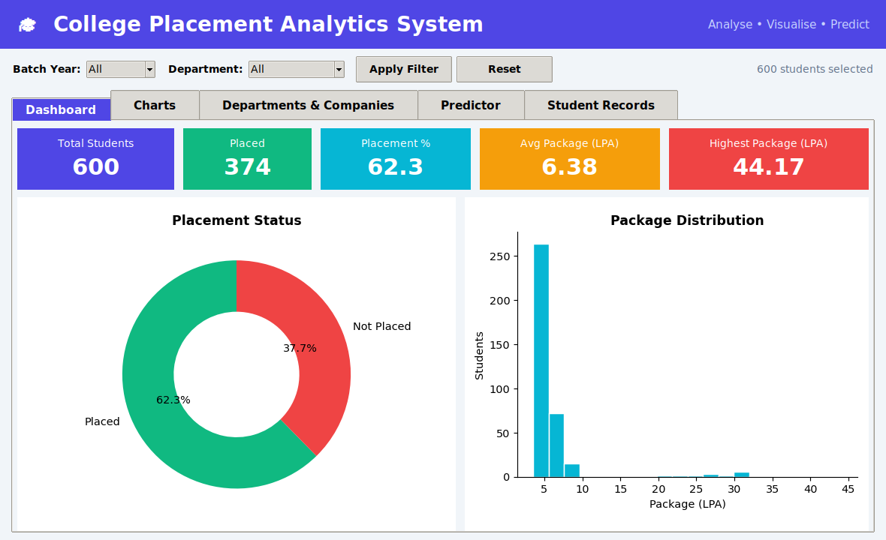
Figure 7.1: Dashboard tab with KPI cards
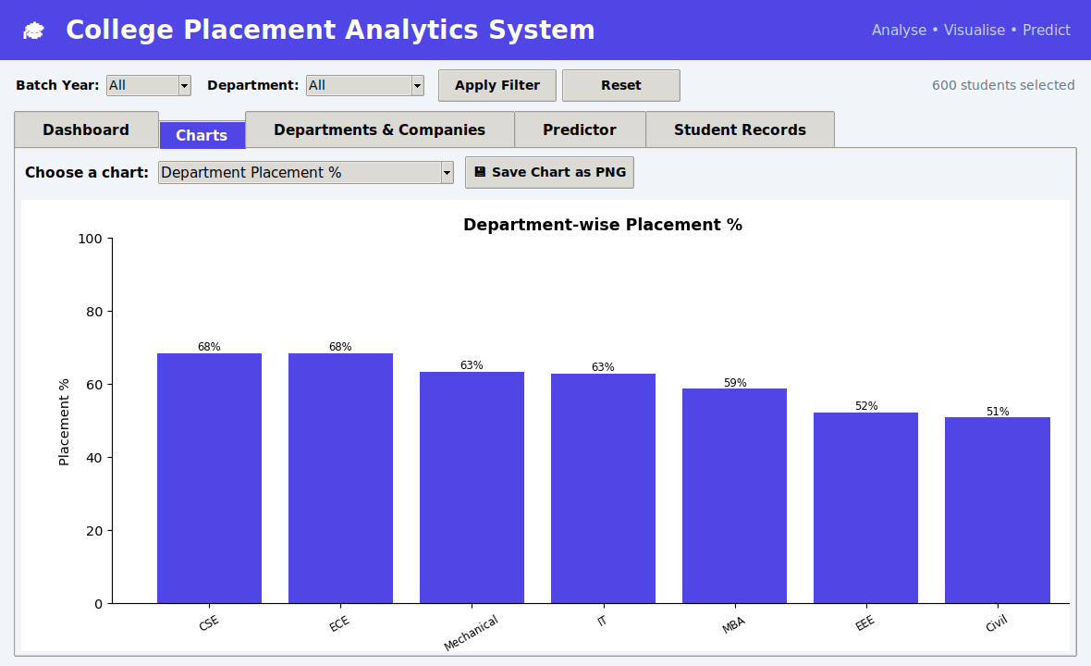
Figure 7.2: Charts tab – department-wise placement
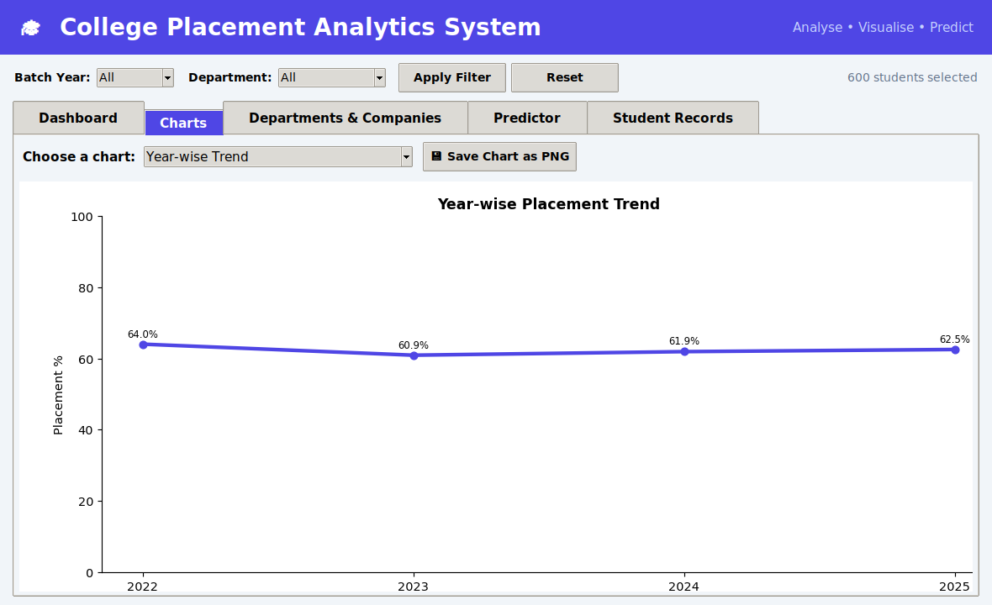
Figure 7.3: Charts tab – year-wise trend
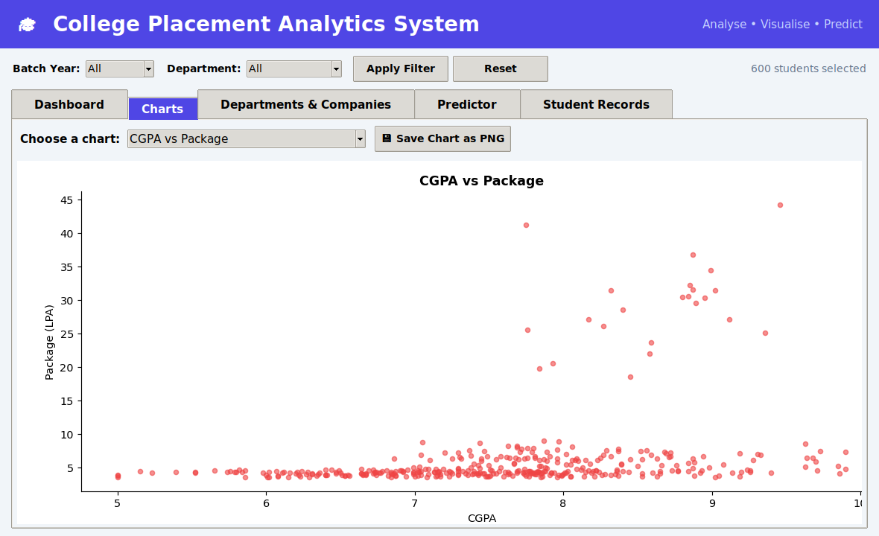
Figure 7.4: Charts tab – CGPA vs package
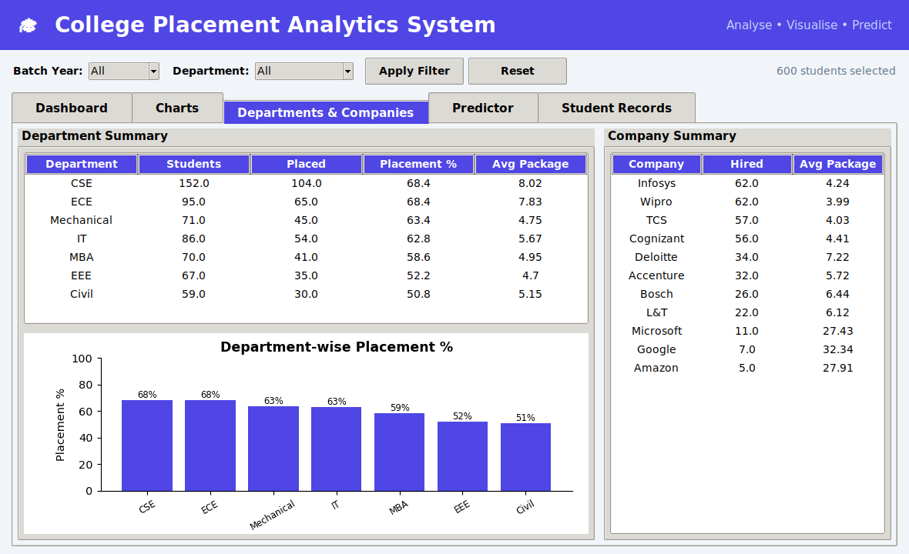
Figure 7.5: Departments & Companies tab
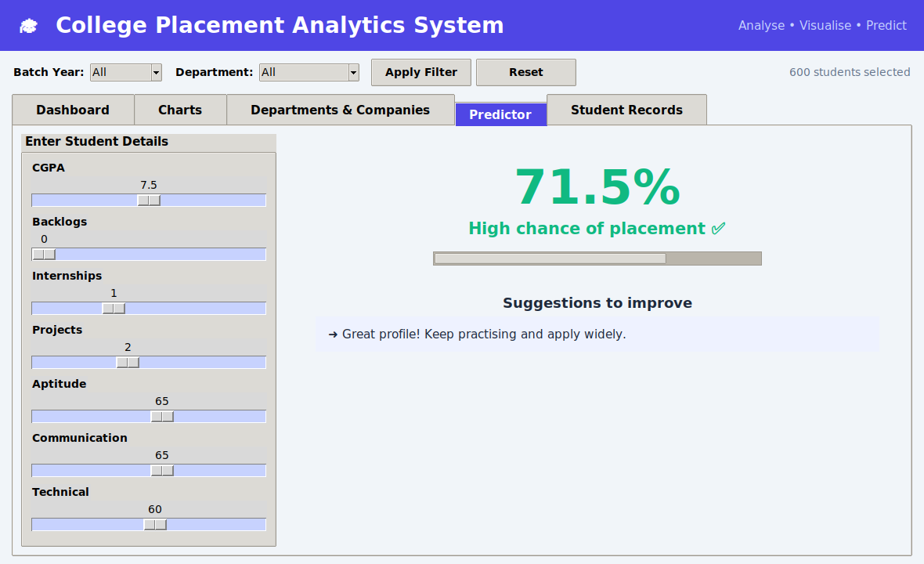
Figure 7.6: Predictor tab with sliders and suggestions
8. Charts and Analysis
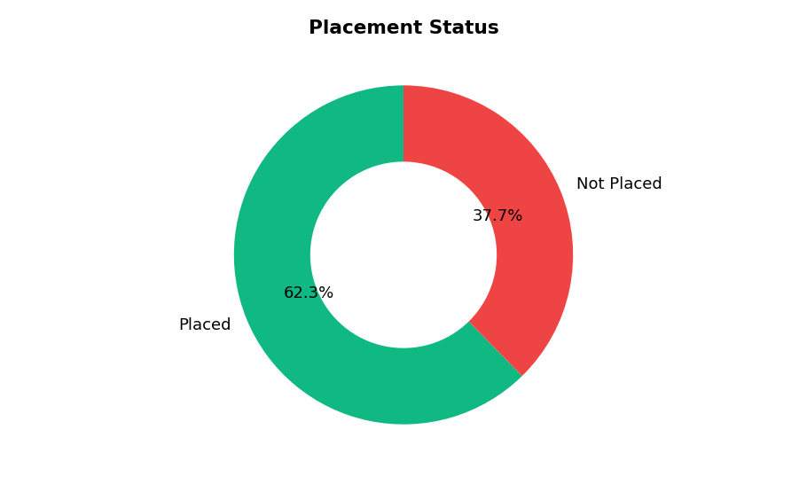
Figure 8.1: Placement status
Observation: About 62% of the students in the sample data are placed.
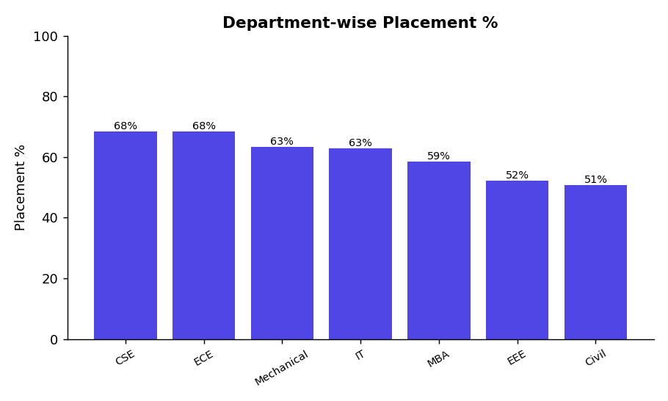
Figure 8.2: Department-wise placement %
Observation: CSE and ECE show the highest placement percentage, Civil and EEE the lowest.
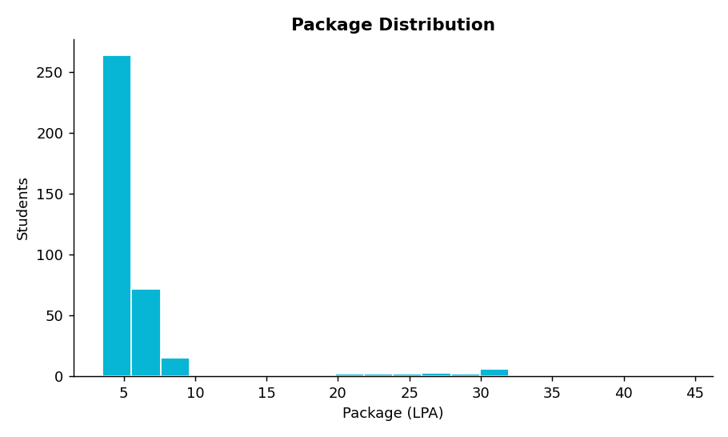
Figure 8.3: Package distribution
Observation: Most packages lie between 3.5 and 8 LPA; a few dream offers go above 30 LPA.
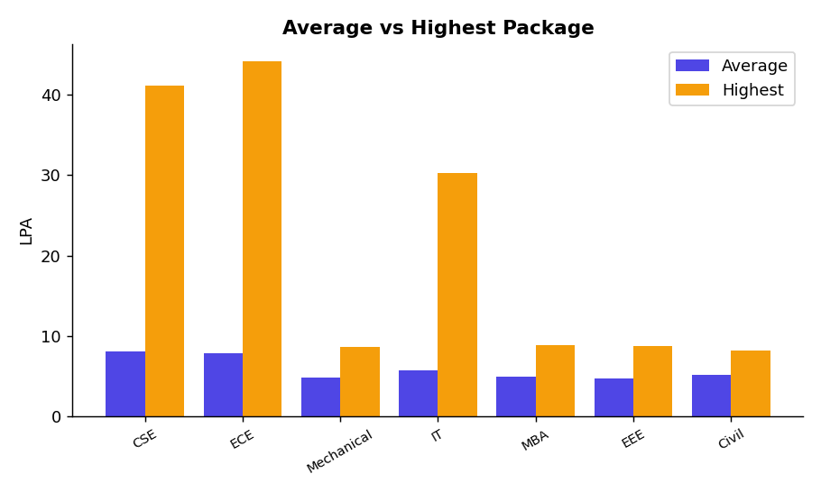
Figure 8.4: Average vs highest package
Observation: CSE, IT and ECE get the highest packages because of dream-company offers.
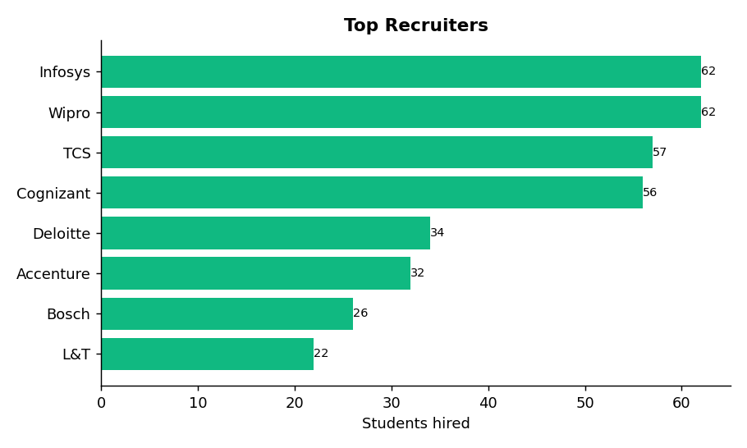
Figure 8.5: Top recruiters
Observation: Mass recruiters hire the largest number of students.
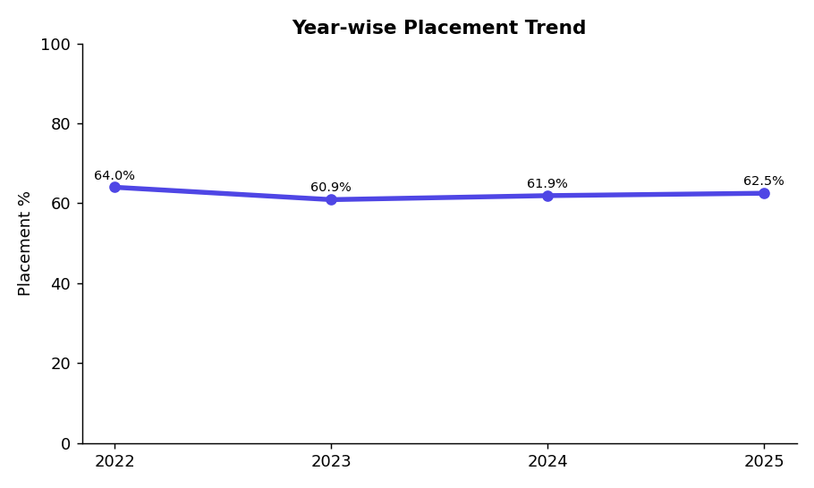
Figure 8.6: Year-wise placement trend
Observation: Shows how the placement percentage changes in each batch.
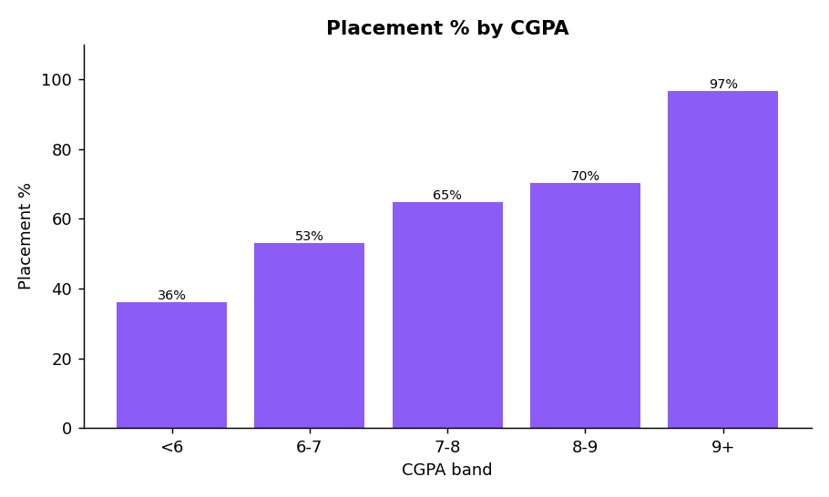
Figure 8.7: Placement % by CGPA band
Observation: Placement chance rises steadily with higher CGPA.
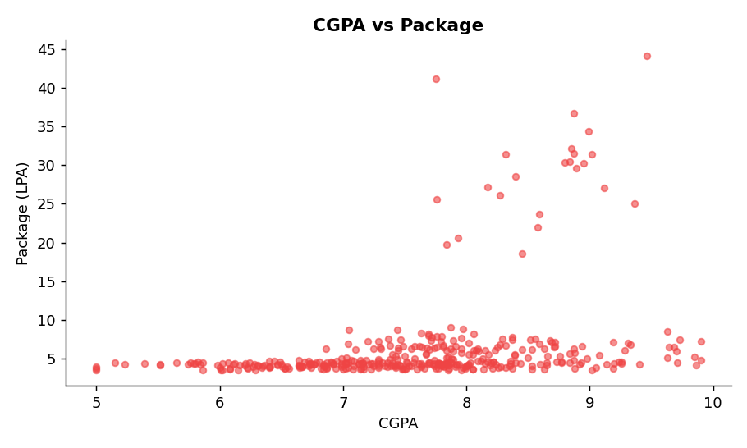
Figure 8.8: CGPA vs package
Observation: Students with higher CGPA are more likely to receive higher packages.
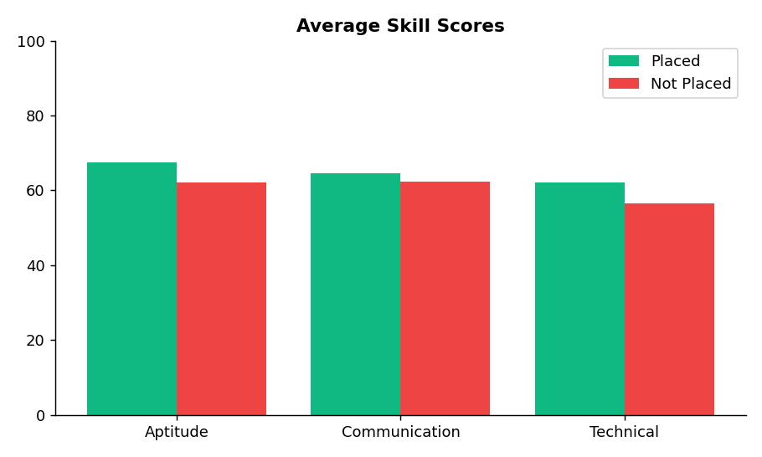
Figure 8.9: Skill comparison
Observation: Placed students have higher average aptitude and technical scores.
9. Output Images
Console outputs of the main classes are shown below.
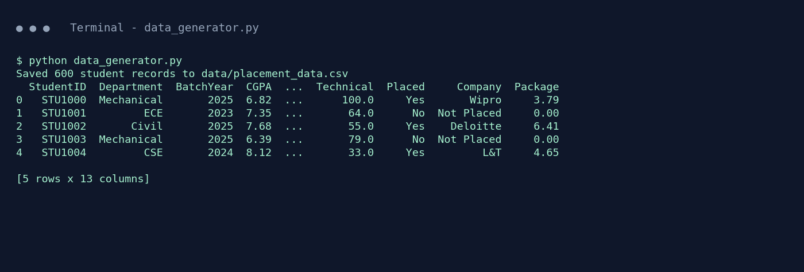
Figure 9.1: DataGenerator output
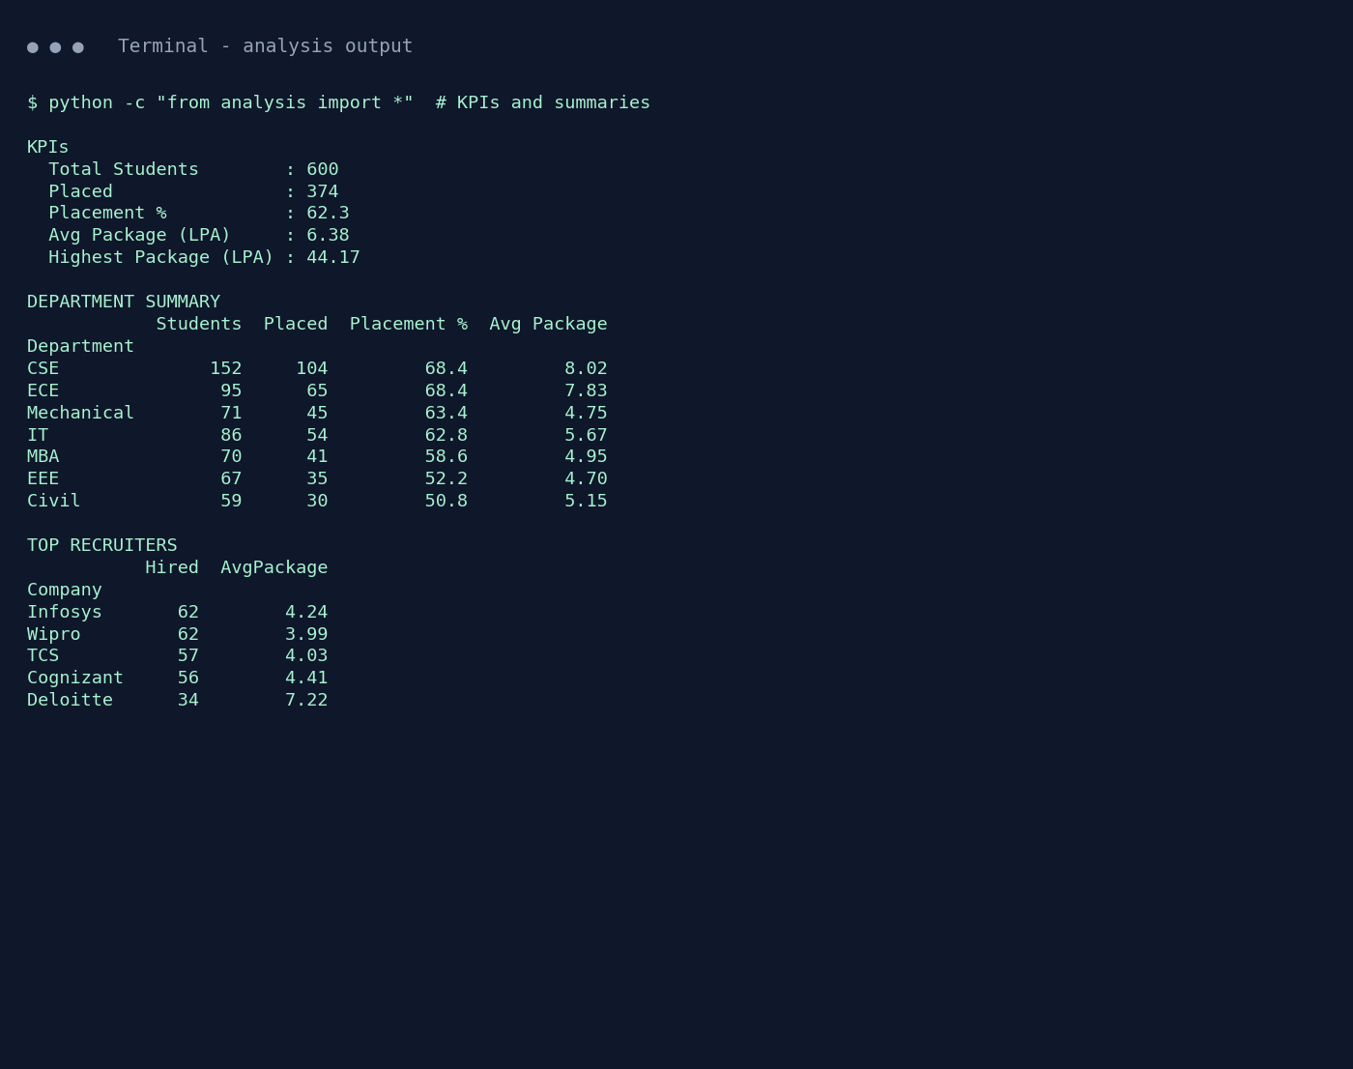
Figure 9.2: PlacementData summaries
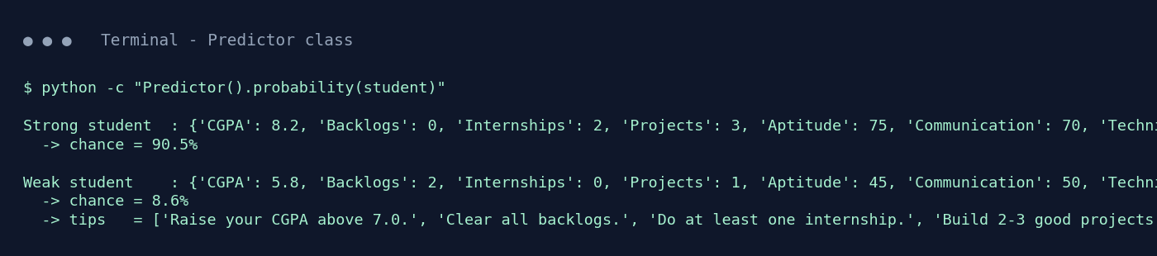
Figure 9.3: Predictor output

10. Results & Conclusion
- The sample data shows an overall placement rate of about 62% with an average package of about 6.4 LPA.
- CSE and ECE perform better than other departments.
- Higher CGPA, internships, projects, skills and zero backlogs increase placement chances.
- The Predictor class gives instant probability and suggestions for any student profile.
The project shows how a useful analytics tool can be created with just four libraries and clean object-oriented code. The Tkinter interface is simple for users, and the separate classes make the program easy to read, test and extend.

Limitations
- The dataset is randomly generated, so the results are for demonstration only.
- The Predictor uses fixed weights instead of a trained machine-learning model.

Future Scope
- Connect to a SQLite / MySQL database and add login.
- Train a real ML model for prediction.
- Add student resume upload and company eligibility checking.
- Export a PDF report from the application.

11. References
- Python Tkinter – https://docs.python.org/3/library/tkinter.html
- NumPy – https://numpy.org/doc
- Pandas – https://pandas.pydata.org/docs
- Matplotlib – https://matplotlib.org

