


TECH MART
INTEGRATED BANKING AND ORDER MANAGEMENT SYSTEM
Subject: PL/SQL (Database Programming)
Academic Year 2026 – 2027

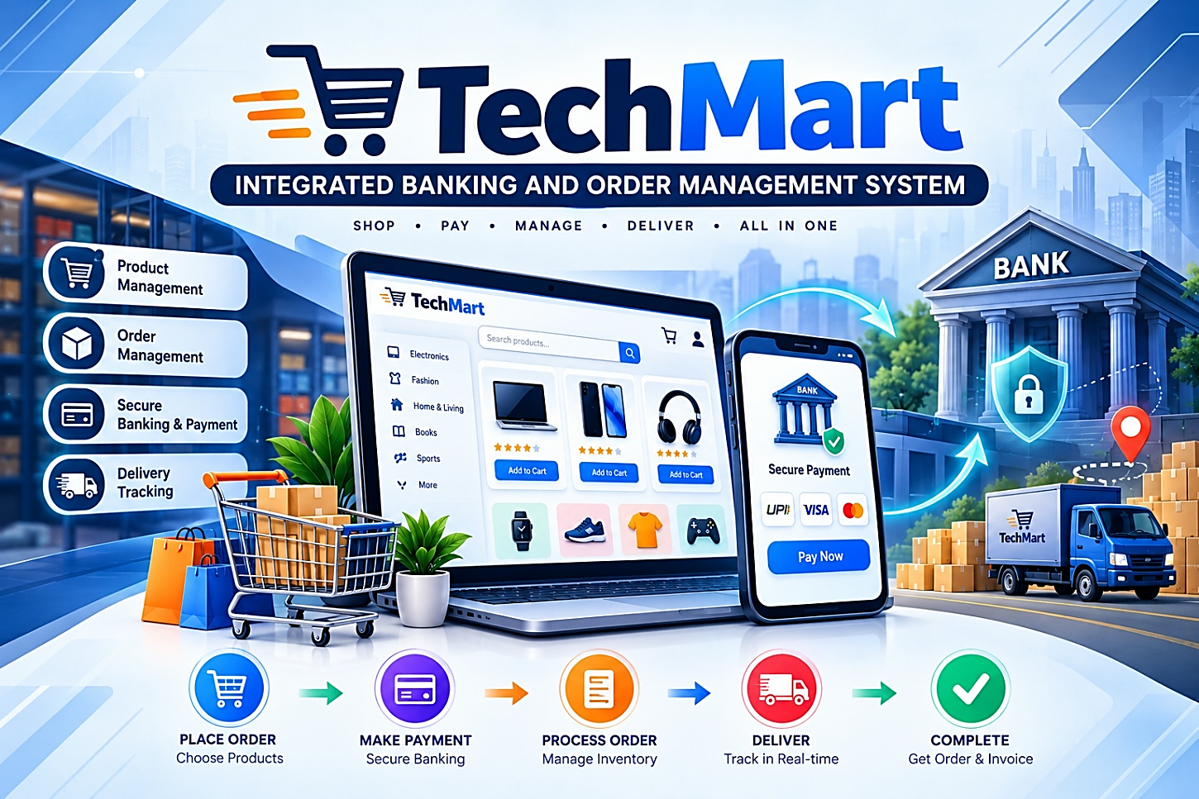
Submitted by  ADITYA MANGALAM  UID: 26MCC20078 | Submitted to  Ms. TANISHA  (E20679
CERTIFICATE
This is to certify that the mini project report entitled “Tech Mart” using PL/SQL is a Bonafide work carried out by ADITYA MANGALAM, UID: 26MCC20078, in partial fulfilment of the requirements of the course PL/SQL, in Master of Computer Application, Department of Cloud Computing & DevOps, Chandigarh University, during the academic year 2026–2027.
The project work has been completed under my guidance and supervision. The work embodied in this report is original and has not been submitted elsewhere for the award of any degree, diploma or certificate.
Project Guide Head of Department
Ms. Tanisha (E20679) Dr. Amanpreet Kaur Sandhu
Date: 22-10-2026
ACKNOWLEDGEMENT
I express my sincere gratitude to my project guide, Ms. Tanisha, for the constant guidance, encouragement and valuable suggestions throughout the development of this mini project. I am also thankful to the Head of the Department and all faculty members of the Department of Computer Science and Engineering for providing the laboratory facilities and a supportive environment. Finally, I thank my family and friends for their continuous motivation.
ADITYA MANGALAM
ABSTRACT
Tech Mart is a database-centred system in which a shop and its customers share one Oracle database. Customers open bank accounts, choose products from a live stock list and pay for orders from their balance. Every business rule (minimum balance, stock check, discount, payment check and audit logging) is implemented as PL/SQL procedures, functions and triggers, so the database itself keeps the data correct.
The system contains six modules which map one-to-one with the PL/SQL syllabus:
(1) account creation with minimum-balance validation,
(2) a low-stock inventory report using an explicit cursor,
(3) a user-defined discount function,
(4) a stored procedure that processes customer orders and updates product stock,
(5) a fund-transfer program with exception handling,
(6) a database trigger that maintains an audit log of account changes.
Transactions are controlled with COMMIT and ROLLBACK so that the database is never left in an inconsistent state. The report documents the design, complete source code, test cases and sample output of every module.
Keywords: PL/SQL, Stored Procedure, Function, Cursor, Trigger, Exception Handling, Oracle, Banking, Inventory.

TABLE OF CONTENTS
1. Introduction 5
1.1 Background and Problem Statement 5
1.2 Objectives 5
1.3 Scope of the Project 5
2. System Requirements 5
3. System Design 6
3.1 Level 0 DFD 6
3.2 Level 1 DFD 6
3.3 Level 2 DFD 6
3.4 ER Diagram 7
4. Data Dictionary & Flowchart 8
4.1 Data Dictionary 8
4.2 Flowchart 9
5. Implementation and Screenshots 10
5.1 Screenshot 1: Account Creation with Validation 10
5.2 Screenshot 2: Account List 10
5.3 Screenshot 3: Product details with stock 10
5.4 Screenshot 4: Product and buyer menu 10
5.5 Screenshot 5: Order details, discount and payment 10
5.6 Screenshot 6: Successful Order placed 11
5.7 Screenshot 7: Updated Balances and stock after order 11
5.8 Screenshot 8: Low Stock Report (Explicit Cursor) 11
5.9 Screenshot 9: Fund transfer Cases with output 11
5.10 Screenshot 10: Updated Account Balance 11
6. Results and Charts 12
7. Syllabus Mapping 13
8. Conclusion & Future Scope 13

1. Introduction

1.1 Background and Problem Statement
PL/SQL (Procedural Language extensions to SQL) is Oracle’s block-structured programming language. It lets a developer combine SQL with procedural constructs such as variables, conditions, loops, cursors and exception handlers, and store the resulting program inside the database as procedures, functions and triggers. Because the code runs next to the data, network traffic is reduced, performance improves and business rules are applied uniformly to every application that uses the database.
Banks and retail stores share a common need: they must validate input, update several tables together and keep a trustworthy history of what changed. A bank must refuse to open an account with too little money, must never allow a transfer that overdraws an account, and must record every balance change. A shop must know which products are running out, must price an order correctly and must reduce stock when an order is placed. Doing all of this manually or only in application code is error-prone. The problem addressed by this project is to implement these rules directly in the database using PL/SQL.

1.2 Objectives
- To design a relational schema for a combined banking and order-management database.
- To implement validation of business rules (minimum balance, stock availability) before data is inserted.
- To use explicit cursors, user-defined functions and stored procedures for reporting and processing.
- To handle errors with predefined and user-defined exceptions and to keep data consistent using COMMIT and ROLLBACK.
- To use a database trigger to maintain an automatic audit trail of account changes.

1.3 Scope of the Project
The project is a database-level system; it has no graphical front end. All operations are executed from SQL*Plus or SQL Developer by calling stored program units. The scope covers account opening, inventory monitoring, discount calculation, order processing, fund transfer between accounts and audit logging. Features such as interest calculation, loan processing, multi-item shopping carts and user authentication are outside the scope and are listed under future enhancements.

2. System Requirements
Hardware / Software | Specification
Computer | Any PC or laptop with internet
Browser | Chrome / Edge
Database | Oracle FreeSQL (free account)
Scripts | Script1_Setup.sql, Script2_Place_Order.sql, Script3_Fund_Transfer_Demo.sql
Table 2: Requirements

3. System Design

3.1 Level 0 DFD (Context Diagram)
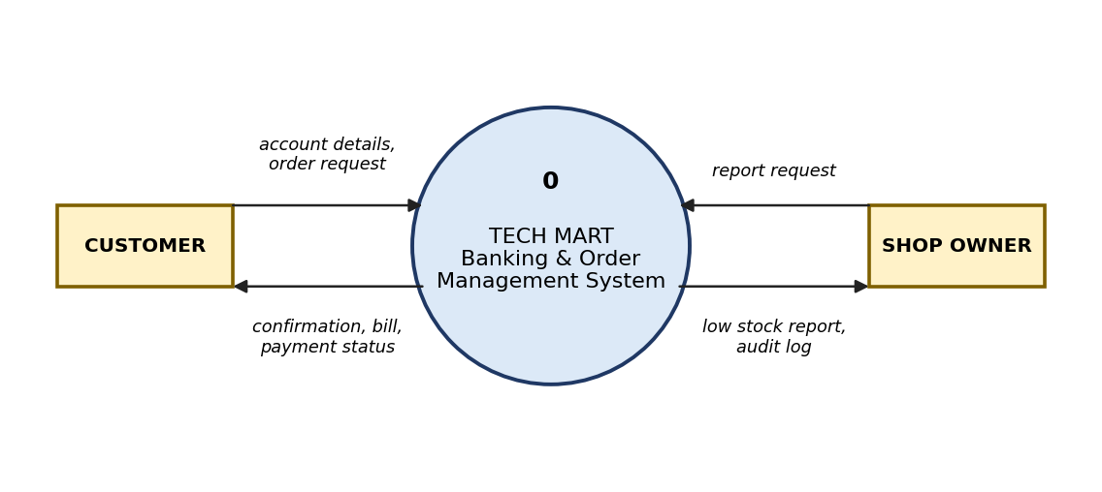
Figure 1: Level 0 DFD

3.2 Level 1 DFD
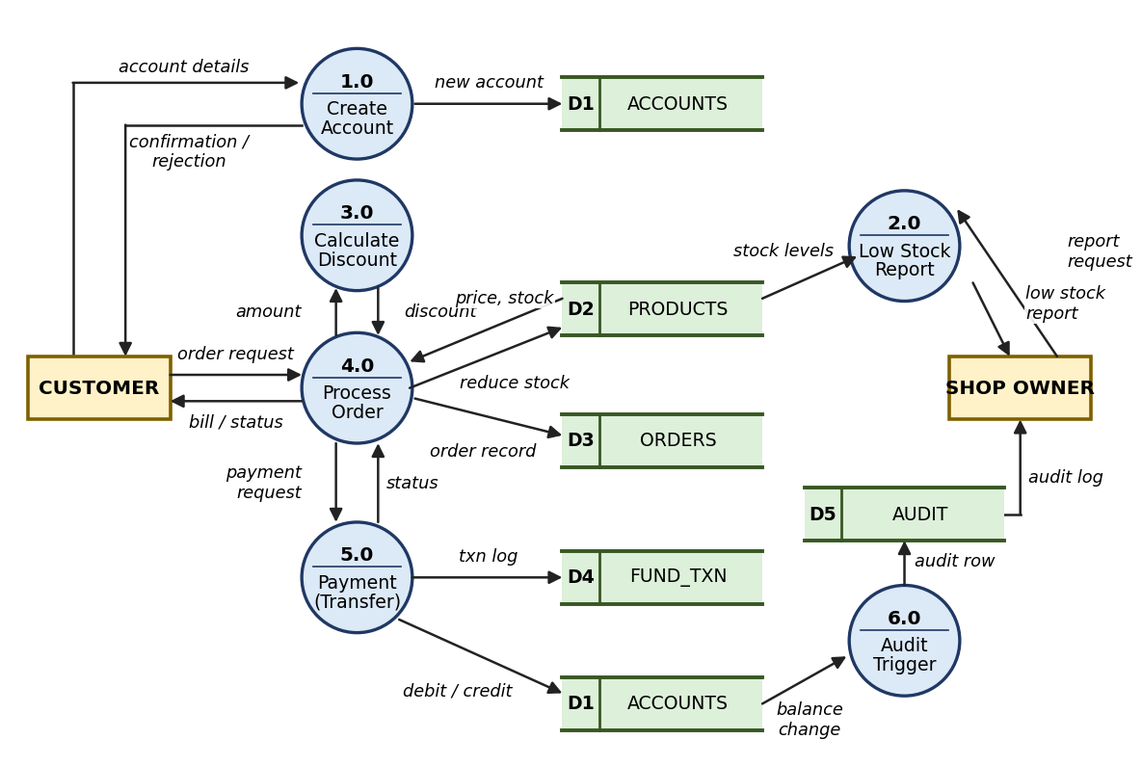
Figure 2: Level 1 DFD

3.3 Level 2 DFD (Process 4.0 – Order Processing)
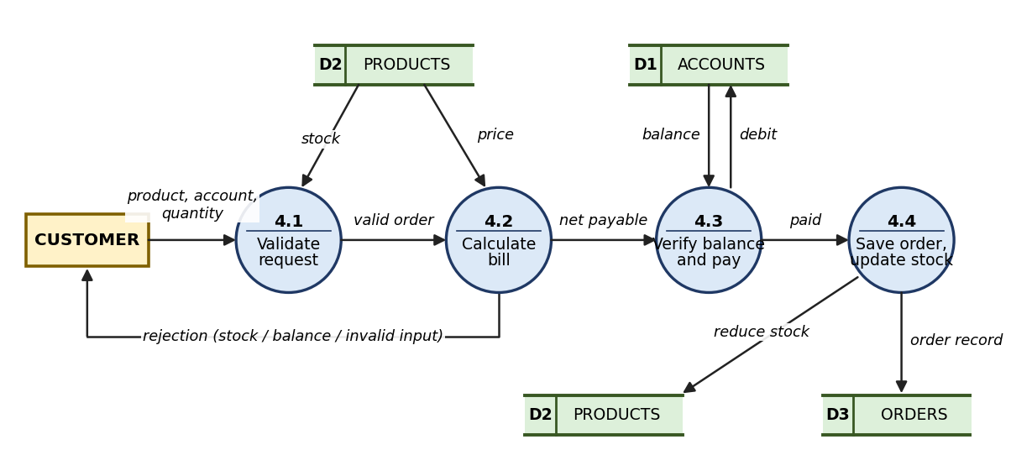
Figure 3: Level 2 DFD of process 4.0

3.4 ER Diagram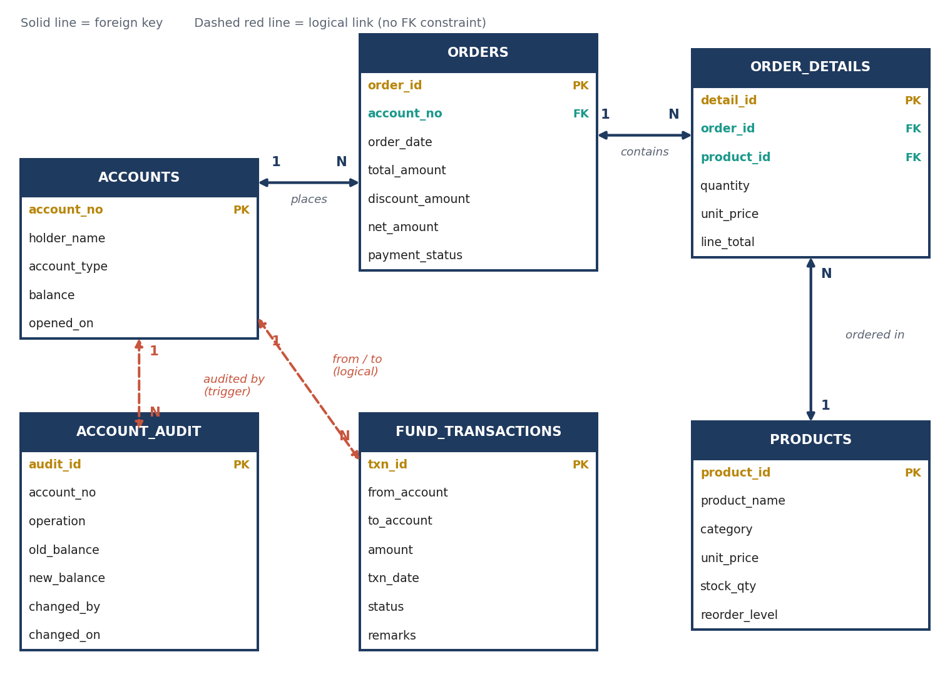
Fig 4.1 - Entity-relationship diagram (6 tables)
Parent table | Child table | Type | Linked by
ACCOUNTS | ORDERS | 1 : N | orders.account_no (FOREIGN KEY)
ORDERS | ORDER_DETAILS | 1 : N | order_details.order_id (FOREIGN KEY)
PRODUCTS | ORDER_DETAILS | 1 : N | order_details.product_id (FOREIGN KEY)
ACCOUNTS | FUND_TRANSACTIONS | 1 : N | from_account / to_account (logical)
ACCOUNTS | ACCOUNT_AUDIT | 1 : N | account_no (filled by trigger)

4. Data Dictionary and Flowchart

4.1 Data Dictionary
Column | Datatype | Constraint
TABLE: ACCOUNTS
account_no | NUMBER | PRIMARY KEY
holder_name | VARCHAR2(60) | NOT NULL
account_type | VARCHAR2(10) | NOT NULL, CHECK (SAVINGS / CURRENT)
balance | NUMBER(12,2) | NOT NULL, CHECK (>= 0)
opened_on | DATE | DEFAULT SYSDATE
TABLE: PRODUCTS
product_id | NUMBER | PRIMARY KEY
product_name | VARCHAR2(60) | NOT NULL
category | VARCHAR2(30) | -
unit_price | NUMBER(10,2) | NOT NULL, CHECK (> 0)
stock_qty | NUMBER | NOT NULL, CHECK (>= 0)
reorder_level | NUMBER | DEFAULT 10, NOT NULL
TABLE: ORDERS
order_id | NUMBER | PRIMARY KEY
account_no | NUMBER | NOT NULL, FK -> accounts
order_date | DATE | DEFAULT SYSDATE
total_amount | NUMBER(12,2) | -
discount_amount | NUMBER(12,2) | -
net_amount | NUMBER(12,2) | -
payment_status | VARCHAR2(10) | -
TABLE: ORDER_DETAILS
detail_id | NUMBER | PRIMARY KEY
order_id | NUMBER | NOT NULL, FK -> orders
product_id | NUMBER | NOT NULL, FK -> products
quantity | NUMBER | NOT NULL, CHECK (> 0)
unit_price | NUMBER(10,2) | NOT NULL
line_total | NUMBER(12,2) | NOT NULL
TABLE: FUND_TRANSACTIONS
txn_id | NUMBER | PRIMARY KEY
from_account | NUMBER | -
to_account | NUMBER | -
amount | NUMBER(12,2) | -
txn_date | DATE | DEFAULT SYSDATE
status | VARCHAR2(10) | SUCCESS / FAILED
remarks | VARCHAR2(100) | -
TABLE: ACCOUNT_AUDIT
audit_id | NUMBER | PRIMARY KEY
account_no | NUMBER | -
operation | VARCHAR2(10) | INSERT / UPDATE / DELETE
old_balance | NUMBER(12,2) | -
new_balance | NUMBER(12,2) | -
changed_by | VARCHAR2(30) | USER
changed_on | DATE | DEFAULT SYSDATE

4.2 Flowchart
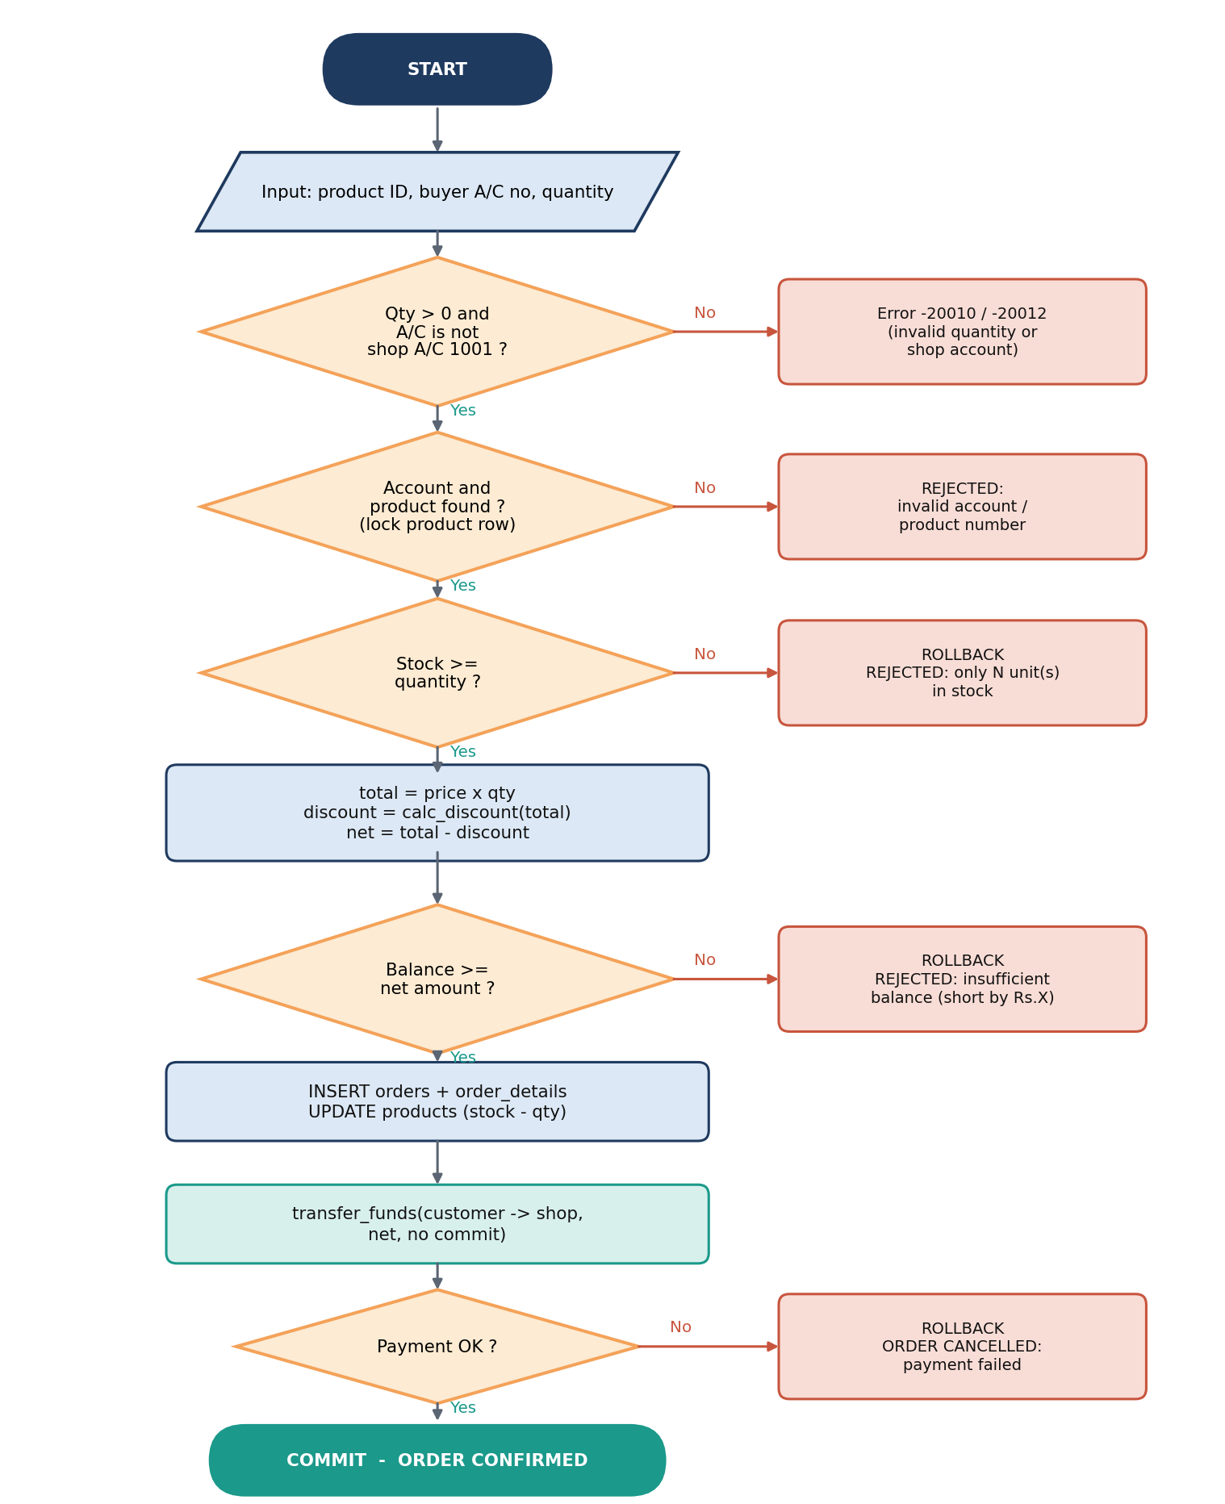
Figure 5: Order processing flowchart

5. Implementation and Screenshots
The system is run in three scripts. Each screenshot below must be taken from your own FreeSQL DBMS Output or Query Result tab.

5.1 Script 1: Setup
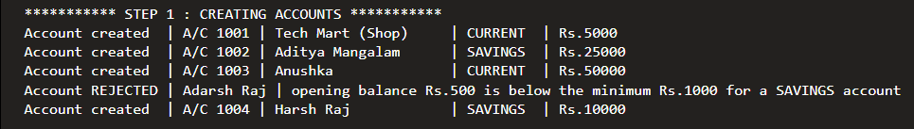
Screenshot 1: Account creation output (DBMS Output)
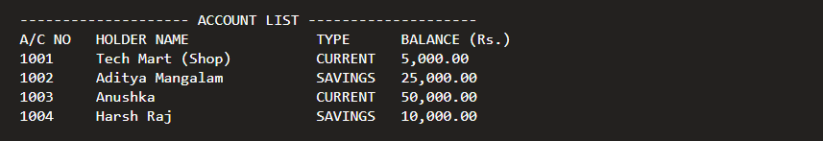
Screenshot 2: Account list
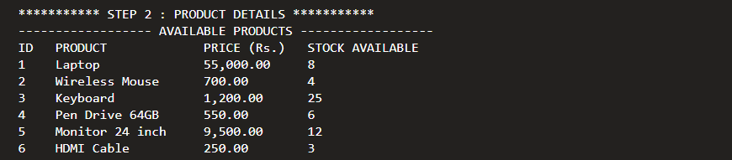
Screenshot 3: Product details with stock
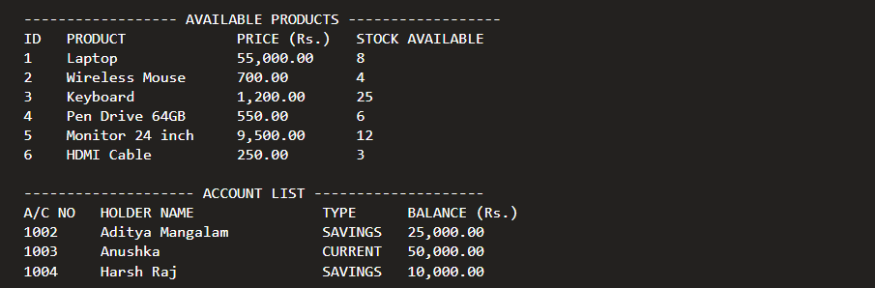
Screenshot 4: Product and buyer menu
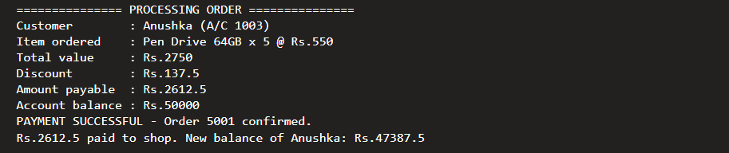
Screenshot 5: Order details, discount and payment
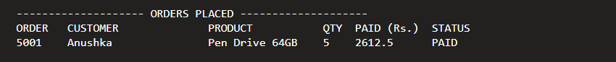
Screenshot 6: Successful Order placed
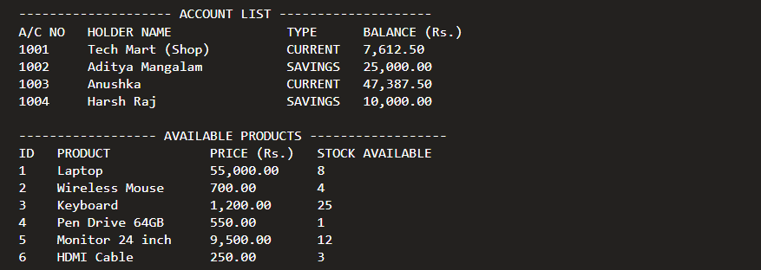
Screenshot 7: Updated Balances and stock after order
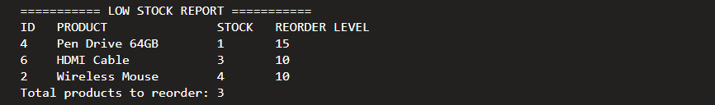
Screenshot 8: Low stock log
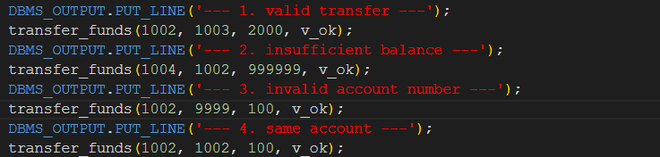
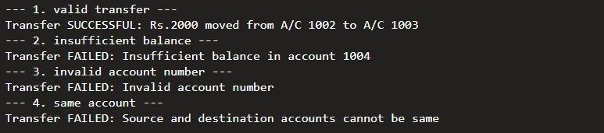
Screenshot 9: Fund transfer Cases with output
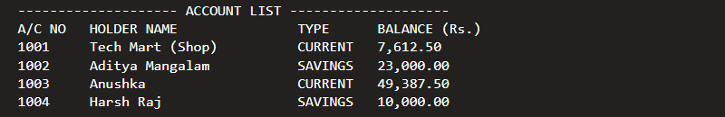
Screenshot 10: Updated Account after fund transfer

6. Results and Charts
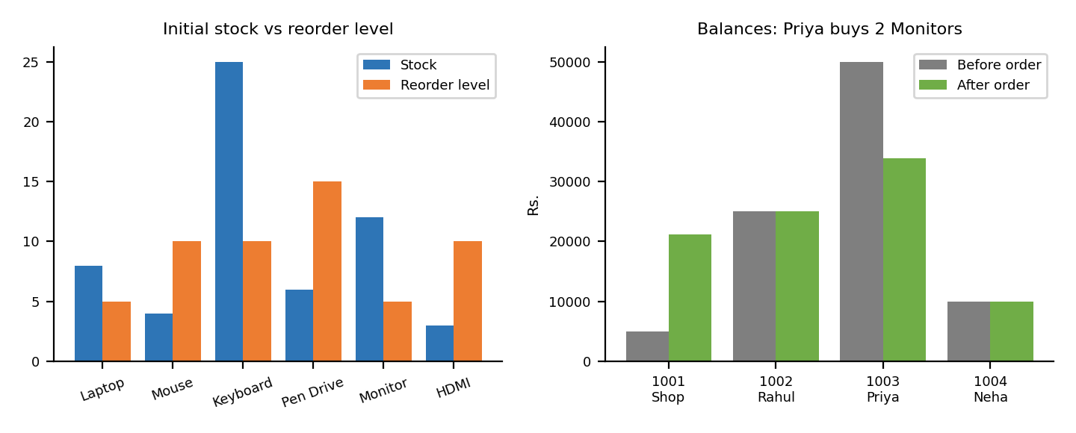
Figure 6: Stock vs reorder level and balances before and after order
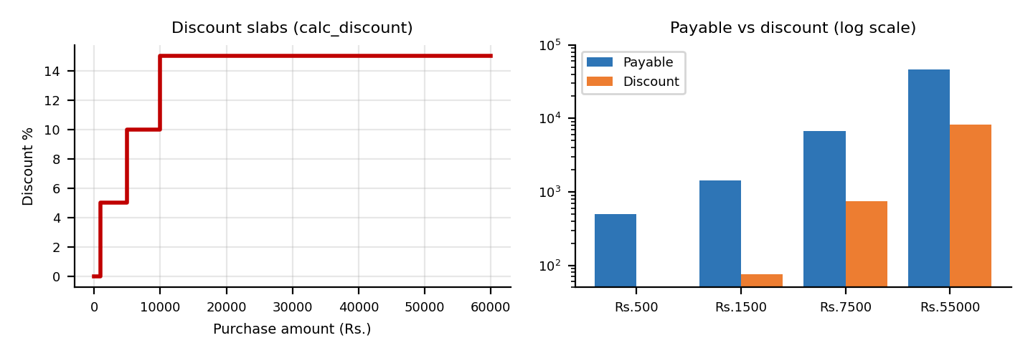
Figure 7: Discount slabs and payable amount
Order | Product | Qty | Total (Rs.) | Discount | Net paid
5001 | Keyboard | 2 | 2400 | 120 | 2280
5002 | Monitor | 1 | 9500 | 950 | 8550
5003 | Laptop | 1 | 55000 | 8250 | 46750
Table 5: Sample order results
Test | Input | Expected | Status
New account, low balance | Rs.500 savings | Rejected | Pass
Order within stock | Product 5, qty 2 | Paid | Pass
Order above stock | Product 2, qty 10 | Rejected | Pass
Order above balance | Product 1, account 1004 | Rejected | Pass
Invalid account | Account 9999 | Rejected | Pass
Table 6: Test summary

7. Syllabus Mapping
Exp. | Implementation | Unit | CO
1 | create_account | 1 | CO1, CO2
2 | low_stock_report (cursor) | 1 | CO1, CO2
3 | calc_discount | 2 | CO2, CO3
4 | place_order | 2 | CO3, CO4
5 | transfer_funds | 3 | CO4
6 | trg_account_audit | 3 | CO4, CO5
Table 7: Syllabus mapping

8. Conclusion and Future Scope
The Tech Mart project links account creation, product stock, ordering and payment in one PL/SQL system. All rules are enforced in the database, and the audit trigger records every balance change.
This project successfully shows how PL/SQL can be used to implement real business rules inside the database. Account opening is guarded by a minimum-balance check, inventory shortages are reported through an explicit cursor, discounts are computed by a reusable function, orders update several tables atomically, fund transfers are protected by exception handling, and a trigger records every change to account balances automatically. Working on the project gave practical experience of writing, compiling, testing and debugging PL/SQL program units and of designing a normalised schema with integrity constraints.
Future scope:
- Support multi-item orders using a collection or a cursor FOR loop over a shopping cart.
- Add interest calculation and monthly statements using packages and scheduled DBMS_SCHEDULER jobs.
- Add minimum-balance retention and daily transfer limits to the fund-transfer procedure.
- Build a web or Java front end that calls the stored procedures.
- Use an autonomous transaction in the trigger for audit entries that must survive a rollback.

References
[1] Oracle Corporation, “Oracle Database PL/SQL Language Reference”, Oracle Documentation, docs.oracle.com.
[2] Steven Feuerstein and Bill Pribyl, “Oracle PL/SQL Programming”, O’Reilly Media.
[3] Ivan Bayross, “SQL, PL/SQL: The Programming Language of Oracle”, BPB Publications.
[4] Oracle Corporation, “Oracle Database SQL Language Reference”, docs.oracle.com.

