Experiment no.3
1.Write a program to find length of a string.
string = input("Enter a string: ")
length = len(string)
print(f"Length of the string '{string}' is: {length}")
Output: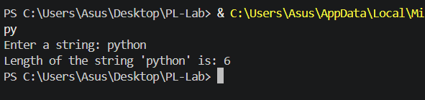

2.Write a program to reverse a string.
string = input("Enter a string: ")
reversed_string = string[::-1]
print(f"Original string : {string}")
print(f"Reversed string : {reversed_string}")
Output:
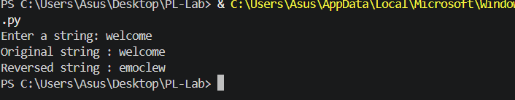
3.Write a program to check whether a string is palindrome.
string = input("Enter a string: ")
cleaned = string.replace(" ", "").lower()
if cleaned == cleaned[::-1]:
print(f"'{string}' is a Palindrome.")
else:
print(f"'{string}' is NOT a Palindrome.")
Output:
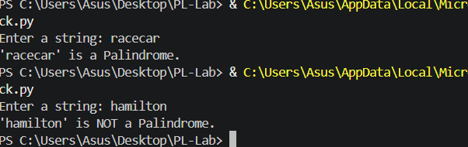
4.Write a program to count vowels and consonants in a string.
string = input("Enter a string: ")
vowels = 0
consonants = 0
for ch in string.lower():
if ch.isalpha():
if ch in "aeiou":
vowels += 1
else:
consonants += 1
print(f"String : {string}")
print(f"Vowels : {vowels}")
print(f"Consonants: {consonants}")
Output:
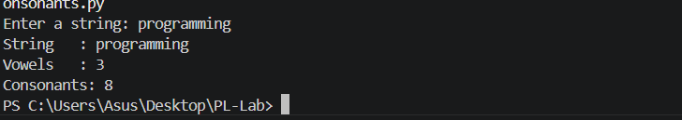
5.Write a program to convert string to upper and lower case.
string = input("Enter a string: ")
print(f"Original string : {string}")
print(f"Uppercase : {string.upper()}")
print(f"Lowercase : {string.lower()}")
output:
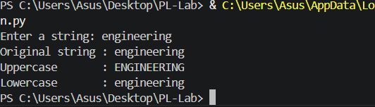
6.Write a program to count frequency of characters in a string.
string = input("Enter a string: ")
frequency = {}
for ch in string:
frequency[ch] = frequency.get(ch, 0) + 1
print(f"\nCharacter frequencies in '{string}':")
for char, count in sorted(frequency.items()):
print(f" '{char}' : {count}")
Output:
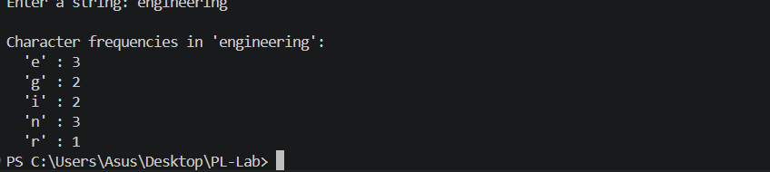
7.Write a program to remove spaces from a string.
string = input("Enter a string: ")
no_spaces = string.replace(" ", "")
print(f"Original string : '{string}'")
print(f"String without spaces : '{no_spaces}'")
Output:
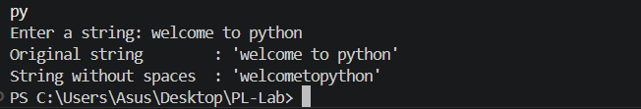
8.Write a program to replace a word in a string.
string = input("Enter a string: ")
old_word = input("Enter the word to replace: ")
new_word = input("Enter the new word: ")
result = string.replace(old_word, new_word)
print(f"Original string : {string}")
print(f"Modified string : {result}")
Output:
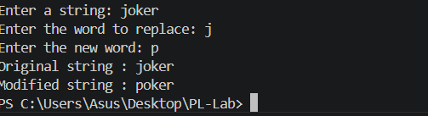

9.Write a program to split and join strings.
string = input("Enter a sentence: ")

words = string.split()
print(f"\nOriginal string : {string}")
print(f"After split() : {words}")

joined_hyphen = "-".join(words)
print(f"After join('-') : {joined_hyphen}")

joined_space = " ".join(words)
print(f"After join(' ') : {joined_space}")
Output:
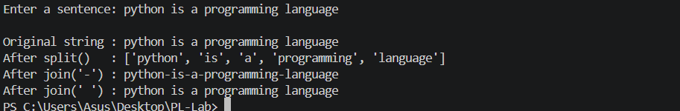
10.Write a program to check whether two strings are anagrams.
str1 = input("Enter first string : ")
str2 = input("Enter second string: ")

clean1 = sorted(str1.replace(" ", "").lower())
clean2 = sorted(str2.replace(" ", "").lower())

if clean1 == clean2:
print(f"'{str1}' and '{str2}' ARE anagrams.")
else:
print(f"'{str1}' and '{str2}' are NOT anagrams.")
Output:
