EXPERIMENT NO. 8
Q. Write a program to create a class and object.
class Person:
# Constructor (initializer)
def __init__(self, name, age):
self.name = name
self.age = age

# Method to display details
def display(self):
print("Name:", self.name)
print("Age:", self.age)

# Create an object of the class
p1 = Person("Virat", 18)

# Call the method using the object
p1.display()

OUTPUT :-
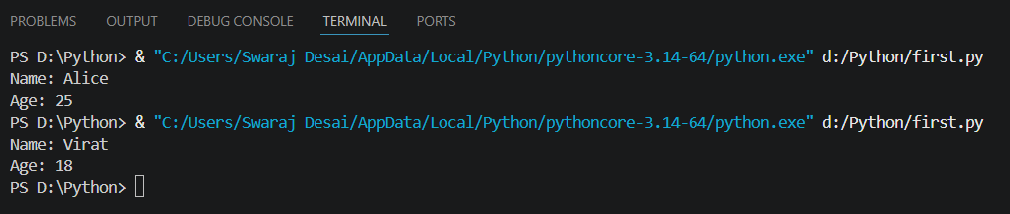

Q. Write a program to demonstrate constructor.
# Class with constructor
class Student:
# Constructor
def __init__(self, name, marks):
print("Constructor is called")
self.name = name
self.marks = marks

# Method to display details
def display(self):
print("Name:", self.name)
print("Marks:", self.marks)

# Creating objects
s1 = Student("Rahul", 85)
s2 = Student("Priya", 90)

# Calling methods
s1.display()
print()
s2.display()

OUTPUT :-

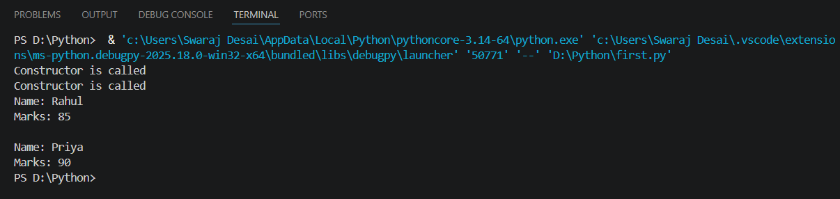
Q. Write a program to demonstrate instance and class variables.
# Class demonstrating class and instance variables
class Student:
# Class variable (common for all objects)
school_name = "ABC School"

# Constructor
def __init__(self, name, marks):
# Instance variables (unique for each object)
self.name = name
self.marks = marks

# Method to display details
def display(self):
print("Name:", self.name)
print("Marks:", self.marks)
print("School:", Student.school_name)

# Creating objects
s1 = Student("Rahul", 85)
s2 = Student("Priya", 90)

# Display details
s1.display()
print()
s2.display()

# Changing class variable
Student.school_name = "XYZ School"

print("\nAfter changing class variable:\n")
s1.display()
s2.display()
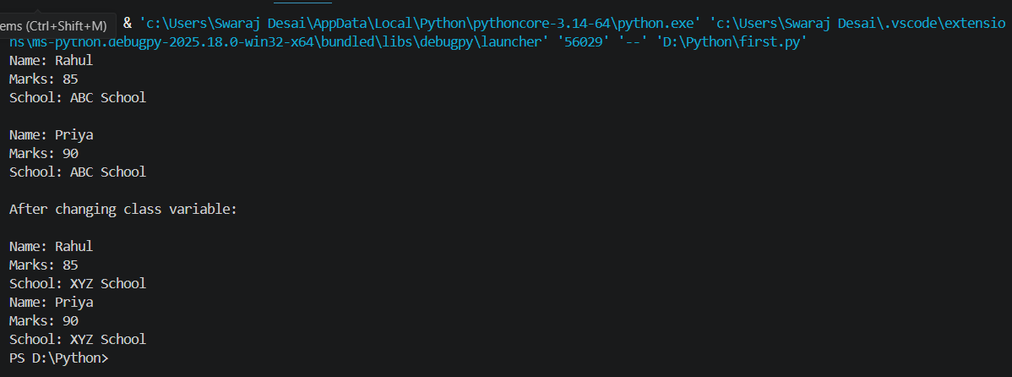

Q. Write a program to demonstrate single inheritance.
# Base class (Parent)
class Animal:
def eat(self):
print("Animal is eating")

# Derived class (Child)
class Dog(Animal):
def bark(self):
print("Dog is barking")

# Create object of child class
d = Dog()

# Access methods
d.eat() # Inherited from Animal
d.bark() # Defined in Dog

OUTPUT :-
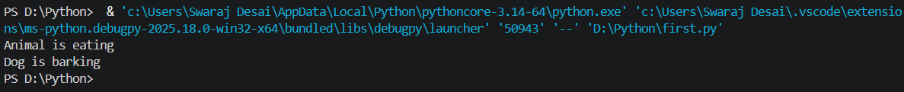

Q. Write a program to demonstrate multiple inheritance.
# Parent class 1
class Father:
def skills_father(self):
print("Father: Gardening, Driving")

# Parent class 2
class Mother:
def skills_mother(self):
print("Mother: Cooking, Painting")

# Child class inheriting from both Father and Mother
class Child(Father, Mother):
def skills_child(self):
print("Child: Playing, Studying")

# Create object of Child
c = Child()

# Access methods from both parents and child
c.skills_father()
c.skills_mother()
c.skills_child()

OUTPUT :-
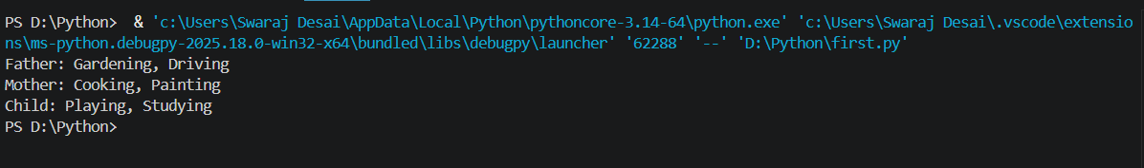

Q. Write a program to demonstrate multilevel inheritance.
# Grandparent class
class Grandfather:
def show_grandfather(self):
print("I am Grandfather")

# Parent class inheriting from Grandfather
class Father(Grandfather):
def show_father(self):
print("I am Father")

# Child class inheriting from Father
class Son(Father):
def show_son(self):
print("I am Son")

# Create object of Son
s = Son()

# Access methods from all levels
s.show_grandfather()
s.show_father()
s.show_son()

OUTPUT :-
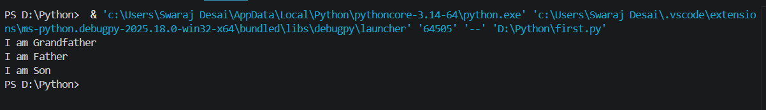

Q. Write a program to demonstrate method overriding.
# Parent class
class Animal:
def sound(self):
print("Animal makes a sound")

# Child class
class Dog(Animal):
# Overriding the parent method
def sound(self):
print("Dog barks")

# Create object
d = Dog()

# Call method
d.sound()

OUTPUT :-
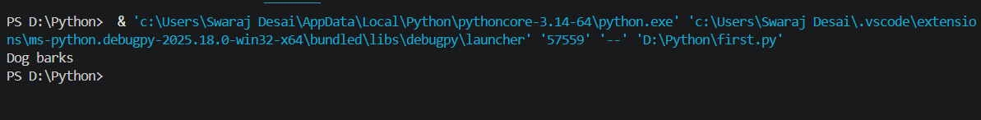

Q. Write a program to calculate area of shapes using inheritance.
# Base class
class Shape:
def area(self):
print("Area calculation")

# Derived class for Rectangle
class Rectangle(Shape):
def __init__(self, length, breadth):
self.length = length
self.breadth = breadth

def area(self):
print("Area of Rectangle:", self.length * self.breadth)

# Derived class for Circle
class Circle(Shape):
def __init__(self, radius):
self.radius = radius

def area(self):
print("Area of Circle:", 3.14 * self.radius * self.radius)

# Derived class for Triangle
class Triangle(Shape):
def __init__(self, base, height):
self.base = base
self.height = height

def area(self):
print("Area of Triangle:", 0.5 * self.base * self.height)

# Create objects
r = Rectangle(10, 5)
c = Circle(7)
t = Triangle(6, 4)

# Call area methods
r.area()
c.area()
t.area()

OUTPUT :-
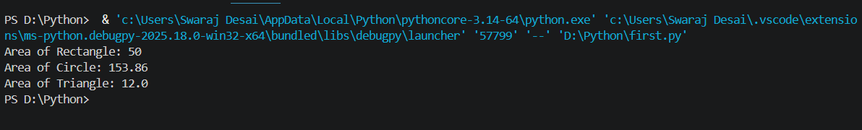

Q. Write a program to demonstrate encapsulation.
# Class demonstrating encapsulation
class Student:
def __init__(self, name, marks):
self.name = name # public variable
self.__marks = marks # private variable

# Getter method
def get_marks(self):
return self.__marks

# Setter method
def set_marks(self, marks):
if marks >= 0 and marks <= 100:
self.__marks = marks
else:
print("Invalid marks!")

# Create object
s = Student("Rahul", 85)

# Access public variable
print("Name:", s.name)

# Access private variable using getter
print("Marks:", s.get_marks())

# Modify private variable using setter
s.set_marks(90)
print("Updated Marks:", s.get_marks())

# Trying to access private variable directly (not recommended)
# print(s.__marks) # This will give error
OUTPUT :-
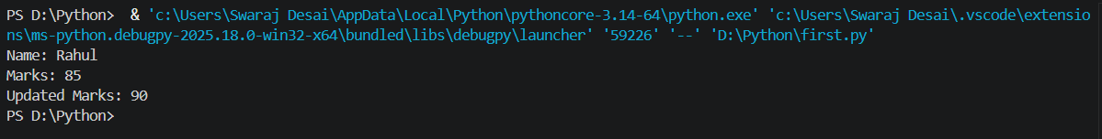

Q. Write a program to demonstrate polymorphism.
class Animal:
def sound(self):
print("Animal makes a sound")

class Dog(Animal):
def sound(self):
print("Dog barks")

class Cat(Animal):
def sound(self):
print("Cat meows")

# Polymorphism in action
animals = [Dog(), Cat()]

for a in animals:
a.sound()

OUTPUT :-
