EXPERIMENT NO. 9

Q. Write a program to create and write data into a file.

PROGRAM :-

# Data to write into the file
data = """Name: Swaraj
Role: Developer
Language: Python
"""

# Create (or overwrite) a file and write data into it
with open("output.txt", "w") as file:
file.write(data)

print("Data written successfully to output.txt")

OUTPUT :-

Q. Write a program to read data from a file.
PROGRAM :-
# read_file.py

# Open the file in read mode and print its contents
with open("output.txt", "r") as file:
data = file.read()

print("File contents:")
print(data)

OUTPUT :-
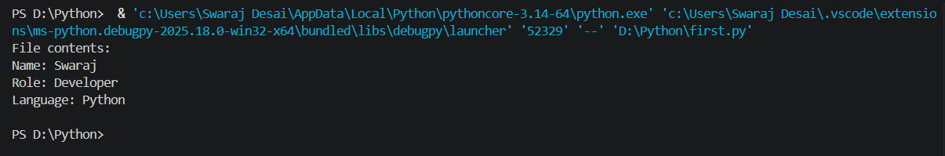

Q. Write a program to append data into a file.
PROGRAM :-
# append_file.py

# New data to append
new_data = "Experience: 3 years\n"

# Open file in append mode and add data
with open("output.txt", "a") as file:
file.write(new_data)

print("Data appended successfully to output.txt")

OUTPUT :-
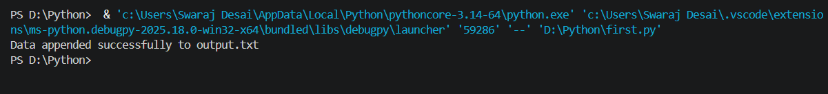

Q. Write a program to count lines, words and characters in a file.

PROGRAM :-
# count_file_stats.py

with open("output.txt", "r") as file:
data = file.read()

lines = len(data.splitlines())
words = len(data.split())
characters = len(data)

print("Lines:", lines)
print("Words:", words)
print("Characters:", characters)

OUTPUT :-
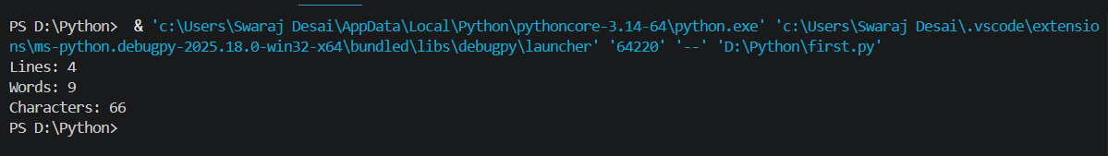
Q. Write a program to copy contents from one file to another.
PROGRAM :-
# copy_file.py

source_file = "output.txt"
destination_file = "copy_output.txt"

with open(source_file, "r") as src:
content = src.read()

with open(destination_file, "w") as dest:
dest.write(content)

print(f"Contents copied from {source_file} to {destination_file}")

OUTPUT :-
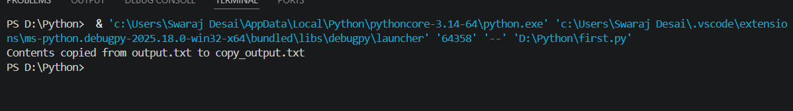

Q. Write a program to handle division by zero exception.
PROGRAM :-
# divide_by_zero_handling.py

try:
num1 = float(input("Enter numerator: "))
num2 = float(input("Enter denominator: "))

result = num1 / num2
print("Result:", result)

except ZeroDivisionError:
print("Error: Division by zero is not allowed.")

except ValueError:
print("Error: Please enter valid numbers.")

OUTPUT :-
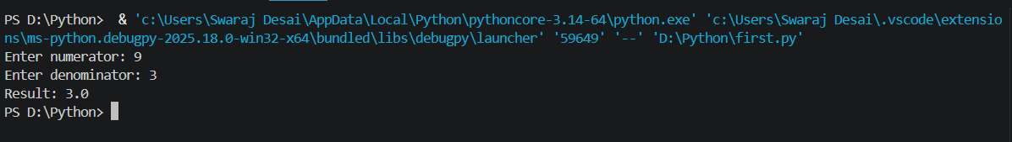

Q. Write a program to handle invalid input exception.

PROGRAM :-
# invalid_input_handling.py

try:
number = int(input("Enter an integer: "))
print("You entered:", number)

except ValueError:
print("Error: Invalid input. Please enter a valid integer.")

OUTPUT :-
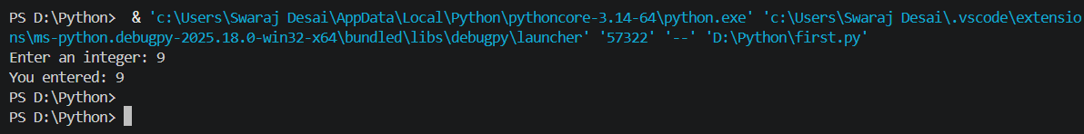

Q. Write a program to use try–except–finally block.
PROGRAM :-
# try_except_finally_example.py

try:
a = int(input("Enter first number: "))
b = int(input("Enter second number: "))
result = a / b
print("Result:", result)

except ValueError:
print("Error: Please enter valid integers.")

except ZeroDivisionError:
print("Error: Cannot divide by zero.")

finally:
print("Program execution completed.")

OUTPUT :-
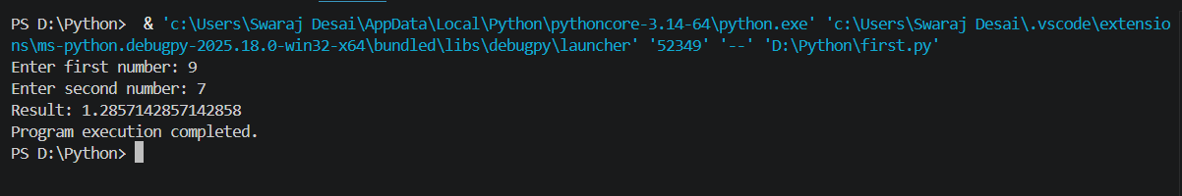

Q. Write a program to create user-defined exception.

PROGRAM :-
# user_defined_exception.py

class NegativeNumberError(Exception):
"""Custom exception for negative numbers."""
pass

try:
num = int(input("Enter a positive number: "))

if num < 0:
raise NegativeNumberError("Negative numbers are not allowed.")

print("You entered:", num)

except NegativeNumberError as e:
print("Custom Exception:", e)

except ValueError:
print("Error: Please enter a valid integer.")

OUTPUT :-
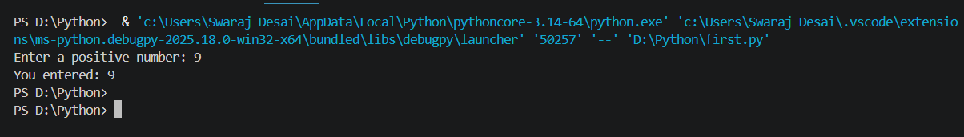

Q. Write a program to demonstrate file exception handling.

PROGRAM :-
# file_exception_handling.py

file_name = "sample.txt"

try:
with open(file_name, "r") as file:
content = file.read()
print("File content:")
print(content)

except FileNotFoundError:
print(f"Error: '{file_name}' does not exist.")

except PermissionError:
print(f"Error: Permission denied to read '{file_name}'.")

except Exception as e:
print("Unexpected error:", e)

finally:
print("File operation finished.")

OUTPUT :-
