OBJECT-ORIENTED DESIGN OF A
C++ / Qt CHESS ENGINE
College Project Report — OOP Concepts, Development Workflow & Game Rules
TEAM BATMAN
Member Name | Roll Number
Aditya Soni | BT25CSE143
Amitesh Chhipiye | BT25CSE166
Atman Patel | BT25CSE180
Vinay Kumrawat | BT25CSE159

OBJECT-ORIENTED DESIGN OF A
C++ / Qt CHESS ENGINE
College Project Report — OOP Concepts, Development Workflow & Game Rules

1. Development Workflow & OOP Design Overview
The diagram below summarizes the complete build pipeline of the chess engine — from the initial OOP design decisions through to the live game runtime loop that handles player input, move validation, and checkmate detection.
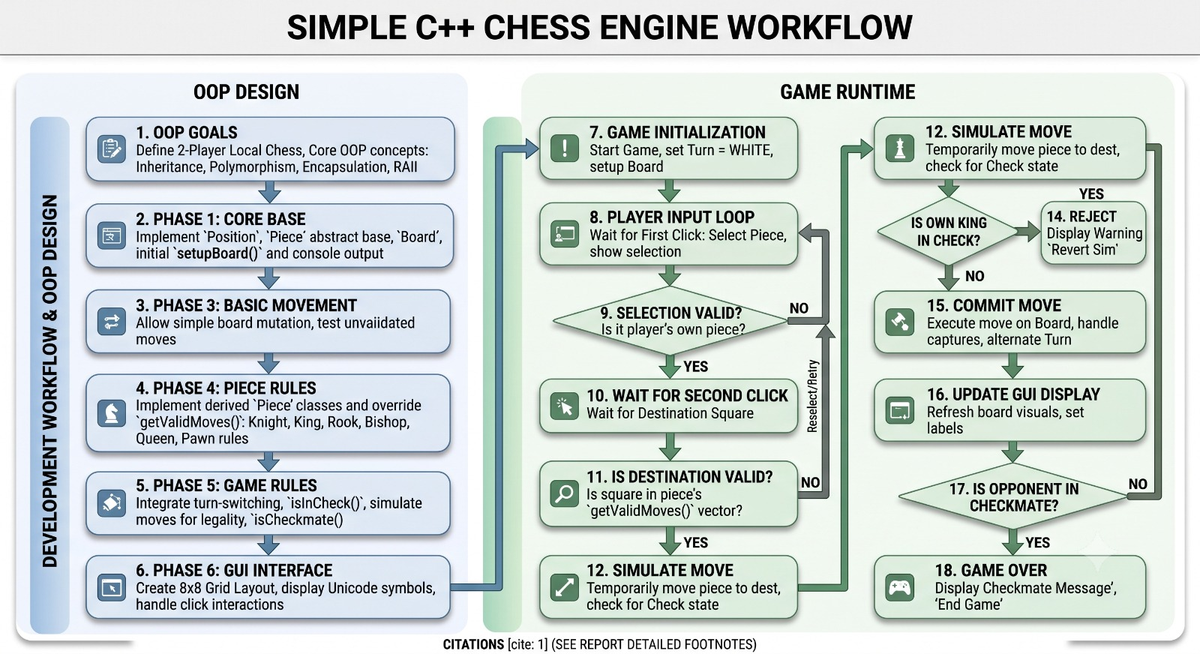

2. The Four Pillars of OOP in the Chess Project
This project is built around the four core principles of Object-Oriented Programming. The table below is a quick reference for where each pillar is applied in the codebase, followed by a short explanation with code for each.

2.1 Encapsulation — Data Hiding & Bundling
Every chess piece bundles its own data (color, position, hasMoved flag) together with the functions that operate on that data, inside one class, with private/protected access specifiers.
class Piece {
private:
Color color;
QPoint position;
bool hasMoved;
public:
bool isValidMove(QPoint target); // controlled access
};
Where it applies: Piece, Board and Player classes never let their internal state be modified directly from outside; all access goes through controlled public methods.

2.2 Abstraction — Hiding Complexity
The rest of the program (and the user) never needs to know how validation, capturing, or check-detection are implemented internally — they only call one clean, high-level function.
// Caller only needs to know this:
board.movePiece(selectedSquare, targetSquare);
// Validation, capture logic and check-detection
// all happen internally and are hidden from the caller.
Where it applies: Board::movePiece() exposes a simple, high-level interface, while the ChessEngine class hides the complex move-validation rules behind it (much like Qt hides its event loop behind a simple signal-slot connect() call).

2.3 Inheritance — Reusability & Hierarchy
All six piece types (King, Queen, Rook, Bishop, Knight, Pawn) inherit from a common base class Piece. Shared properties (color, position) live in the base class, while each derived class overrides the move-logic specific to that piece.
class Piece {
virtual bool isValidMove(QPoint target) = 0;
};
class Rook : public Piece {
bool isValidMove(QPoint target) override;
};
class Knight : public Piece {
bool isValidMove(QPoint target) override;
};
Where it applies: Every concrete piece class derives from Piece. On the Qt side, a custom board-square widget would similarly derive from QWidget.

2.4 Polymorphism — Same Interface, Different Behaviour
While looping over the board, the program never needs to know in advance whether a square holds a Rook or a Knight — calling piece->isValidMove(target) automatically runs the correct override via runtime (virtual-function) polymorphism.
Piece* piece = board.getPieceAt(pos);
piece->isValidMove(target); // Rook's or Knight's logic —
// decided at runtime
Where it applies: Base-class pointer/reference resolving to derived-class behaviour at runtime — this is the core mechanism behind chess move validation. Qt's signal-slot system relies on the same idea for polymorphic connections.

2.5 Bonus: Qt-Specific Angle
Qt Feature | Description | Related Pillar(s)
Signal–Slot mechanism | Loose coupling / observer pattern between UI events and game logic | Encapsulation + Abstraction
QGraphicsView / QGraphicsScene | Each piece is drawn as a QGraphicsItem-derived object | Inheritance
paint() override | Each piece renders itself differently on the board | Polymorphism

3. Special Chess Moves Implemented
Beyond the standard per-piece movement rules, three special moves add legal-move edge cases that the Piece and Board classes must handle explicitly. Each is a good example of extending the same OOP structure (state flags in Piece, extra validation in Board/ChessEngine) rather than special-casing the whole engine.

3.1 Pawn's Initial Two-Square Advance
A pawn that has not yet moved is allowed to advance either one or two squares forward in a single move (instead of the usual one-square limit).
bool Pawn::isValidMove(QPoint target) {
int dir = (color == WHITE) ? -1 : 1;
int dx = target.x() - position.x();
int dy = target.y() - position.y();
if (dx == 0 && dy == dir) return true; // 1-step
if (!hasMoved && dx == 0 && dy == 2 * dir)
return isPathClear(position, target); // 2-step
return false;
}
- Relies on the hasMoved flag encapsulated inside Piece — set to true after the pawn's first move.
- Board must additionally verify both squares in the two-step path are empty.

3.2 Castling (King + Rook special move)
A one-time move where the King moves two squares toward a Rook on the same rank, and that Rook jumps to the square the King crossed. It is legal only under strict conditions.
bool ChessEngine::canCastle(King* king, Rook* rook) {
return !king->hasMoved() && !rook->hasMoved()
&& isPathClear(king->pos(), rook->pos())
&& !isSquareAttacked(king->pos()) // not in check
&& !isSquareAttacked(kingPassThroughSquare)
&& !isSquareAttacked(kingDestinationSquare);
}
- Neither the King nor the chosen Rook may have moved before.
- All squares between them must be empty.
- The King must not be in check, and must not pass through or land on a square attacked by an opponent piece.
- Implemented in ChessEngine/Board as a compound move — updates two pieces' positions in one turn.

3.3 En Passant (Pawn Special Capture)
If an opponent pawn advances two squares from its start and lands beside your pawn, your pawn may capture it as though it had moved only one square — but only on the very next move.
bool Pawn::canEnPassant(Pawn* enemyPawn, int lastMoveTurn) {
return enemyPawn->justMovedTwoSquares()
&& lastMoveTurn == currentTurn - 1
&& abs(position.x() - enemyPawn->position().x()) == 1
&& position.y() == enemyPawn->position().y();
}
- Board must track the move history to know which pawn just advanced two squares, and on which turn.
- The captured pawn is removed from a square the capturing pawn does not land on — handled as a special case in Board::commitMove().
- Opportunity expires if not taken on the immediately following move.

4. Why We Choose This Project
A chess engine is chosen for this project because it maps directly to the core pillars of Object-Oriented Programming (OOP) without needing artificial or forced code design.

Inheritance & Abstraction
A generic Piece acts as an abstract base class, while each specific piece (Pawn, Knight, Rook, Bishop, Queen, King) inherits from it. You define the concept of a piece once and specialize its behavior in derived classes.

Polymorphism (Virtual Functions)
Every piece moves differently, but the board treats them uniformly. Declaring a pure virtual function getValidMoves() in Piece allows the Board to call piece->getValidMoves() at runtime without needing long switch or if-else blocks for each piece type.

Encapsulation & Data Hiding
The internal state of the 8×8 grid is stored as private data inside the Board class. External classes cannot modify pieces arbitrarily; all updates pass through defined public member functions like movePiece() and setupBoard().

Operator Overloading
It demonstrates compile-time polymorphism by redefining standard operators to work with custom types, such as operator== to check if two Position objects match and operator<< to print the Board directly.

Clean Real-World Modeling
OOP is meant to model real-world entities into classes. Chess pieces, coordinates, the board, and game turns translate naturally into distinct classes (Piece, Position, Board, Game) rather than raw global arrays.

