**Ques4.** Implement monoalphabetic and polyalphabetic cipher substitution operation..

Ans ---Monoalphabetic cipher substitution

# CSC/20/50 Bharat_Sharma Univ_Roll_No:20059570040

from itertools import permutations

def Monoalphabatic(Plaintext):

permutation_List=permutations(Plaintext)

for temp in list(permutation_List):

print(''.join(temp))

Plaintext=input("Enter a Plain text :- ")

print("Appling Mono alphabtic cipher substituion---------> Possible Cipher text :- ")

Monoalphabatic(Plaintext)

_________________________________________________________________________________________________________________OUTPUT:- 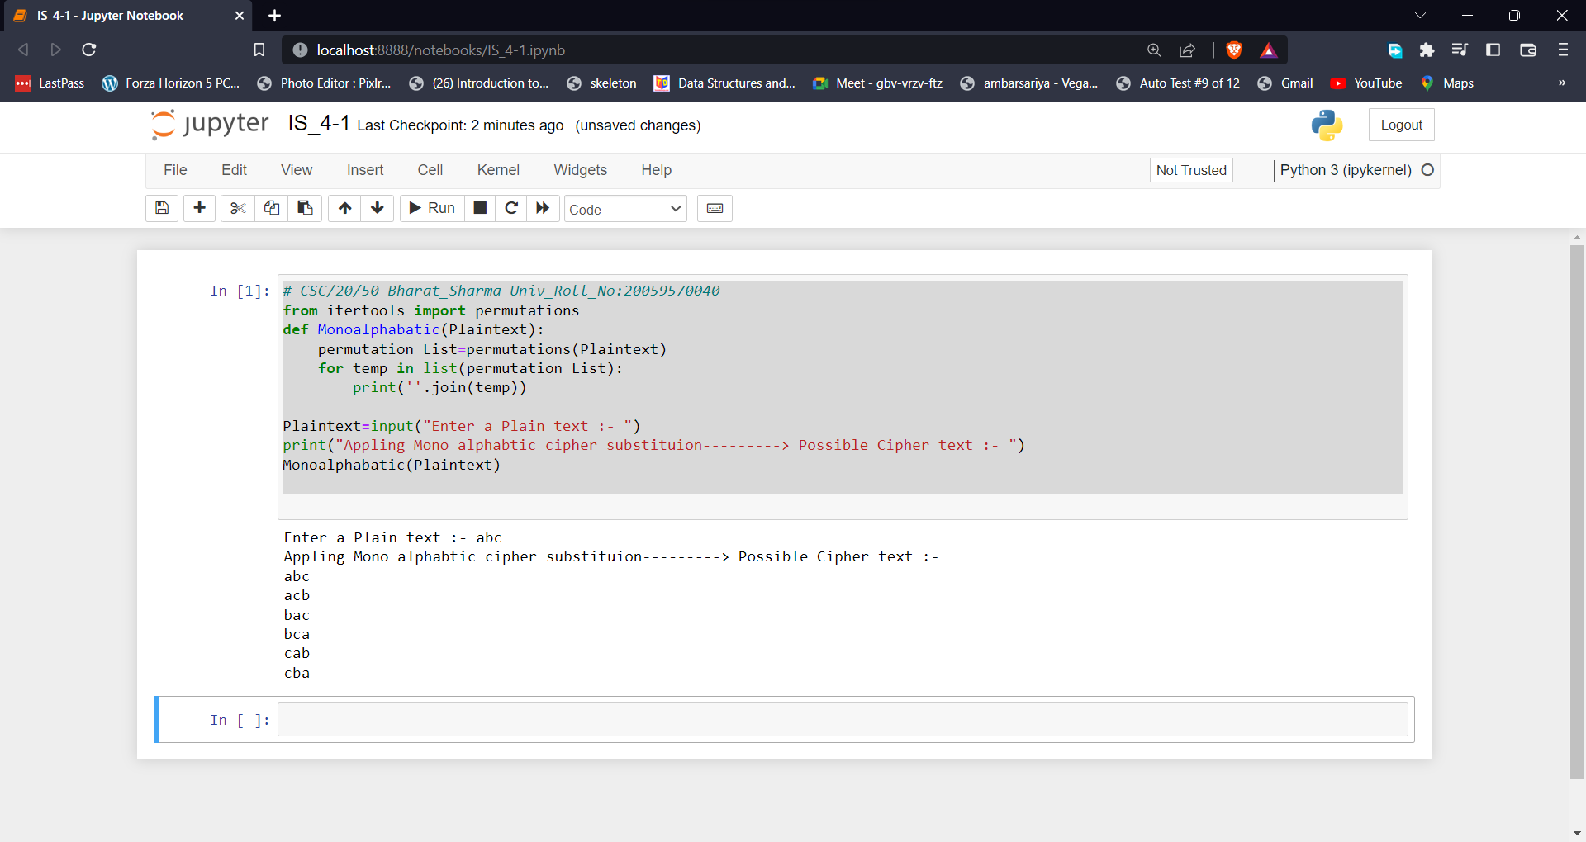

Ans ---Polyalphabetic cipher substitution

# CSC/20/50 Bharat_Sharma Univ_Roll_No:20059570040

from itertools import permutations

def polyalphabatic(Plaintext,key):

result = []

for i in range(len(Plaintext)):

x = (ord(Plaintext[i]) +ord(key[i % len(key)])) % 26

x += ord('A')

result.append(chr(x))

print("" . join(result))

Plaintext=input("Enter a Plain text :- ")

key=input("Enter a Key :- ")

print("Appling Poly alphabtic cipher substituion---------> Possible Cipher text :- ")

polyalphabatic(Plaintext,key)

_________________________________________________________________________________________________________________OUTPUT:-

