A
PROJECT REPORT ON
“ROOMATE AI”



SUBMITTED BY:
CHAVDA ADITYASINH (2303466160070)
MEET AGRAWAL (2303466160046)
KRISHNA SHARMA (2303466160252)

GUIDED BY:
Prof. POONAM FALDU

DIPLOMA IN COMPUTER ENGINEERING
SUBMITTED TO:
PARUL POLYTECHNIC INSTITUTE POST – LIMDA, WAGHODIA – 391760

PARUL POLYTECHNIC INSTITUTE
COMPUTER ENGINEERING DEPARTMENT
LIMDA, WAGHODIA, VADODARA



CERTIFICATE

This is to certify that Chavda Adityasinh students of Computer Engineering, Enrolment No: 2303466160070 have satisfactorily completed their project work as a part of course curriculum in Diploma in 6th Semester having a project title “ROOMATE AI”.

Signature of Guide
PROF.POONAM
FALDU

Head of Department
PROF. POONAM
FALDU

PARUL POLYTECHNIC INSTITUTE
COMPUTER ENGINEERING DEPARTMENT
LIMDA, WAGHODIA, VADODARA



CERTIFICATE
This is to certify that CHAVDA ADITYASINH students of Computer Engineering, Enrolment No: 2303466160070 have satisfactorily completed their project work as a part of course curriculum in Diploma in 6th Semester having a project title ROOMATE AI.

DATE:

INTERNAL JURY: EXTERNAL JURY:
ACKNOWLEDGEMENT

We take this opportunity to express our profound sense of gratitude and respect to all those who helped us throughout the duration of this project.

Firstly, we are extremely grateful to Parul Polytechnic Institute, for providing us the excellent working environment to undergo our project.

We devote our success in this effort to our project guide Prof. Poonam Faldu for giving us the opportunity to undertake the project and providing crucial feedbacks that influenced us and provided opportunity to undertake the project work in the esteemed concern.

We are also deeply thankful to Prof. Poonam Faldu, Head of Computer Engineering Department, whose useful suggestions, gentle soothing attitude and right
directions helped us a lot to learn in this project and also for her constant encouragement and support throughout the project.

Last, but not the least, we would like to extend our profound thanks to all our esteemed colleagues and friends at college level who helped us in the specific areas of this project.

Yours Sincerely,

Chavda Adityasinh (2303466160070)

Meet Agrawal (2303466160046)

Krishna Sharma (2303466160252)

ABSTRACT

ROOMATE AI is an intelligent and adaptive smart room assistant designed to provide secure, convenient, and personalized room automation. The system integrates computer vision, IoT, and machine learning techniques to create a unified platform for smart living. It features a gesture- controlled interface using OpenCV and MediaPipe, allowing users to manage appliances such as lights, fans, and media systems without physical switches.
The hardware backbone is powered by ESP32 microcontrollers with relay modules, enabling reliable wireless IoT control of connected devices. Beyond manual control, ROOMATE AI incorporates a rule-based behavior learning engine that observes user habits, predicts routine activities, and automates repetitive tasks like switching off unused devices or controlling home appliances. A real-time dashboard further enhances usability by displaying device status, usage logs, and system alerts, ensuring transparency and remote accessibility.
To enhance safety and flexibility, the system also integrates a gas leakage detection module that provides instant alerts during hazardous situations, along with a web-based application that allows users to manually control appliances, access camera-based gesture control through a smartphone, and monitor system performance remotely.
The system is designed to be low-cost, scalable, and energy-efficient, making it suitable for deployment in homes, hostels, and office environments. By combining gesture recognition, behavior learning, IoT integration, robust security, and safety monitoring, ROOMATE AI represents a step toward creating intelligent environments that adapt to human needs, reduce energy wastage, and improve overall quality of life.

INDEX
Sr.no |  | Description | Page No
Chapter 1 |  | Introduction | 1
 | 1.1 | Project Summary | 2
 | 1.2 | Purpose | 3
 | 1.3 | Scope | 4
 | 1.4 | Benefits | 5
Chapter 2 |  | System requirement study | 6
 | 2.1 | Hardware Requirements | 7
 | 2.2 | Software Requirements | 8
 | 2.3 | Functional Requirements | 9
Chapter 3 |  | System Analysis | 10
 | 3.1 | Problem and Weakness of Existing Systems | 11-12
 | 3.2 | Requirement of New System | 13-15
 | 3.3 | Feasibility Study | 16-17
Chapter 4 |  | Platform Detail | 18-21
Chapter 5 |  | System Design | 22
 | 5.1 | Use Case | 23
 | 5.2 | DFD | 24-26
 | 5.3 | Circuit Diagram | 27-28
Chapter 6 |  | User Manual | 29
 | 6.1 | Sample Code | 30
 | 6.2 | Result | 31
 | 6.3 | Test Cases | 32
Chapter 7 |  | Limitations & Future Enhancement | 33-36
Chapter 8 |  | Conclusion | 37-38

CHAPTER 1: INTRODUCTION

• | 1.1 | Project Summary
• | 1.2 | Purpose
• | 1.3 | Scope
• | 1.4 | Benefits

  - Project Summary

ROOMATE AI is a smart room automation system designed to provide intelligent, adaptive, and secure control of a room’s environment. It combines computer vision, IoT, and sensor technologies to deliver a user-friendly, efficient, and safe smart living experience. The key aspects of the project include:
Gesture-Controlled Appliance Management: Users can control lights, fans, and other appliances using hand gestures, captured via a smartphone camera and processed using OpenCV and MediaPipe.

    - Gas Leakage Detection: A gas sensor continuously monitors for hazardous gas levels, sending instant alerts through the system to prevent accidents.
    - IoT-Based Automation: ESP32 microcontrollers with relay modules enable wireless control of connected devices, ensuring reliable and responsive automation.
    - Web Application Integration: The system includes a web-based dashboard allowing manual control of appliances, real- time monitoring, gesture control via camera, and alert notifications.
    - Behavior Learning Engine: ROOMATE AI can learn user habits over time to automate repetitive tasks like turning off unused devices.
    - Energy Efficiency: Automated control of devices reduces unnecessary power consumption, contributing to sustainable living.
    - Enhanced Security: By minimizing manual interaction with switches and incorporating real-time monitoring, the system reduces human error and potential hazards.
    - Modular and Scalable Design: The hardware and software are designed for easy expansion, allowing integration of additional sensors, appliances, or AI features in the future.
    - User-Friendly Experience: Combining gesture-based control, web access, and real-time alerts ensures a seamless and convenient interface for users of all ages.
    - Deployment Versatility: Suitable for homes, hostels, offices, and small commercial spaces, making it adaptable to various environments.
    - Cost-Effective Solution: Uses affordable hardware while providing advanced automation and safety features, making smart living accessible.

  - Purpose

The primary purpose of ROOMATE AI is to develop an intelligent, adaptive, and user-friendly room automation system that enhances safety, convenience, and energy efficiency in modern living spaces. The system aims to combine gesture-based control, IoT automation, and real-time monitoring to offer a comprehensive solution for both daily convenience and emergency situations.
    - Hands-Free Control of Appliances: Enable users to operate lights, fans, and other electrical
appliances without physical switches, using natural hand gestures captured via a smartphone camera. This reduces manual effort and makes the system accessible to individuals with mobility challenges.
    - Enhancing Safety: Integrate a gas sensor module to detect hazardous gas leaks and immediately trigger alerts. The system ensures timely preventive measures, reducing the risk of accidents and improving user safety.
    - Flexible Control Options: Provide a web application interface that allows users to manually control appliances, monitor device status, and access gesture control remotely, ensuring flexibility and convenience.
    - Automation and Behavior Adaptation: Incorporate a rule-based behavior learning engine that observes usage patterns and automates repetitive tasks such as switching off idle devices, adjusting fan speeds, or managing room lighting according to user preferences.
    - Real-Time Monitoring and Alerts: Maintain a dashboard that displays device status, usage logs, safety alerts, and system notifications to ensure users have complete awareness and control over their environment.
    - Affordable and Scalable Smart Solution: Design a cost-effective, modular system that can be deployed in homes, hostels, offices, or small commercial spaces, and easily upgraded with additional appliances, sensors, or features in the future.
    - Energy Efficiency and Sustainability: Optimize energy consumption by automating device operations based on usage patterns, reducing unnecessary power wastage, and promoting environmentally responsible living.
    - Modernizing Everyday Living: Enhance the quality of life by combining convenience, safety, adaptability, and intelligence in a single system, demonstrating how technology can create a smarter and more comfortable living environment.

Scope

The scope of ROOMATE AI encompasses the design, development, and deployment of a smart room automation system that combines gesture-based control, IoT hardware, safety monitoring, and software integration to improve convenience, security, and energy efficiency. The system is designed to cater to homes, hostels, offices, and other small-scale environments.
    - Gesture-Based Appliance Control: Using OpenCV and MediaPipe, the system allows users to control electrical appliances such as lights and fans through hand gestures captured by a smartphone camera, reducing the need for physical interaction.
    - IoT Integration: Employs ESP32 microcontrollers and relay modules for reliable wireless control of connected devices, ensuring real-time and responsive automation.
    - Gas Leakage Detection: Incorporates a gas sensor module that monitors the room environment for hazardous gas leaks and triggers instant alerts, contributing to occupant safety.
    - Web Application Interface: Includes a user-friendly web-based dashboard that allows users to: o Manually control appliances
- Access real-time device status and activity logs o View alerts from the gas sensor
- Control devices remotely and interact with gesture-based controls via mobile camera
    - Behavior Learning and Automation: Supports rule-based automation that can adapt to user habits over time, such as:
- Switching off unused devices automatically
- Adjusting fan speed or lighting based on user patterns
- Reducing energy consumption and enhancing comfort
    - Real-Time Monitoring: Provides a comprehensive dashboard for monitoring device operation, safety alerts, and system performance, ensuring transparency and control for the user.

Benefits
ROOMATE AI offers a comprehensive smart room solution by integrating gesture recognition, IoT automation, and intelligent safety mechanisms. The system enhances convenience, safety, energy efficiency, and adaptability, making it suitable for modern living environments.
- Hands-Free Operation:
- The system enables gesture-based control of electrical appliances such as lights and fans, eliminating the need for physical switches. This feature enhances accessibility and is especially beneficial for elderly users and individuals with physical disabilities.
- Enhanced Safety:
- ROOMATE AI incorporates a gas leakage detection module that continuously monitors the environment and provides immediate alerts in hazardous situations. This proactive safety mechanism helps prevent accidents and improves overall indoor safety.
- Flexible Control Options:
- The system provides multiple control modes, including a web-based dashboard, manual switching, and camera-based gesture control. Users can remotely monitor and manage devices, ensuring convenience and flexibility.
- Energy Efficiency:
- By implementing automation and habit-based learning, the system minimizes unnecessary power consumption. Devices are intelligently controlled based on usage patterns, contributing to energy conservation and sustainable living.
- Automation and Habit Learning:
- ROOMATE AI observes user behavior over time and automates repetitive tasks such as turning off unused appliances or adjusting fan speed and lighting levels. This adaptive behavior enhances comfort while reducing manual intervention.
- Cost-Effective Implementation:
- The system is designed using affordable and easily available hardware components, making advanced smart room automation accessible and economically feasible for widespread adoption.
- Scalability and Modularity:
- ROOMATE AI follows a modular architecture, allowing easy integration of additional sensors, devices, and AI features in the future. This ensures long-term adaptability and system expansion.
- Enhanced User Experience:
- By combining comfort, convenience, and security into a unified platform, the system delivers a seamless and user-friendly smart living experience.
      - Versatile Deployment:
- The proposed system can be deployed in various environments such as homes, hostels, offices, and small commercial spaces, demonstrating its flexibility and broad applicability.
- Educational and Research Value:
  - ROOMATE AI serves as an effective learning and research platform for students and developers, offering practical exposure to IoT, computer vision, automation, and artificial intelligence technologies

Chapter 2: System requirement study
      - 2.1 Hardware Requirement
      - 2.2 Software Requirements
      - 2.3 Functional Requirements

Chapter 2: System Requirement Study

Hardware Requirements
The hardware forms the backbone of ROOMATE AI, enabling gesture-based control, IoT automation, and safety monitoring. Each component is carefully selected to ensure reliable operation, cost- effectiveness, and scalability.
    - ESP32 Microcontroller: Acts as the central processing unit for the entire system.
    - Handles communication between the web application, relay modules, sensors, and gesture inputs. Supports Wi-Fi and Bluetooth, making it suitable for wireless IoT control.
    - Lightweight and low-power, allowing efficient energy usage.
    - Relay Module: Serve as switching interfaces between the microcontroller and high-power appliances like lights and fans. Convert the low-voltage control signal from ESP32 into ON/OFF switching for electrical devices. Ensure safe operation without damaging sensitive electronics.
    - Gas Sensor (MQ-2 / MQ-5): Monitors the room for hazardous gases such as LPG, methane, or smoke. Triggers instant alerts via the web application when gas concentration crosses safe levels. Ensures user safety and prevents potential accidents in the room.
    - Smartphone / Camera: Provides the visual input for gesture recognition. Captures real-time hand movements for controlling lights and fans via OpenCV and MediaPipe. Allows portable and flexible operation without additional cameras.
    - Power Supply: Provides regulated voltage to ESP32, sensors, and relay modules. Ensures stable system operation and prevents hardware damage due to voltage fluctuations.
    - Breadboard, Wires, and Connectors: Used for prototyping and connecting hardware components. Enables easy reconfiguration and debugging during development.
    - LED Indicators: Provide visual feedback for device status, relay switching, and gas alerts. Enhance user understanding and interaction with the system.

Software Requirements
The software for ROOMATE AI provides the intelligence, automation, and user interface of the system. It integrates gesture recognition, IoT control, web-based management, and real-time monitoring. Each software component is carefully chosen to ensure efficient performance, scalability, and user-friendly operation.
    - Python: Used as the primary programming language for gesture recognition. Handles image processing, gesture detection, and real-time analysis from the smartphone camera. Works in conjunction with OpenCV and MediaPipe libraries to process visual input and translate gestures into control signals.
    - OpenCV (Open-Source Computer Vision Library): Provides tools for real-time image and video processing. Detects hand movements and tracks gestures with high accuracy. Supports integration with Python for smooth execution of computer vision tasks.
    - MediaPipe: Framework designed for real-time gesture and pose recognition. Converts camera input into actionable data for controlling appliances. Works alongside OpenCV to map hand gestures to specific commands (e.g. turning Appliances on/off)
    - Arduino IDE: Used to program the ESP32 microcontroller. Allows uploading firmware to ESP32 to control relay modules, read sensor data, and communicate with the web app. Supports multiple programming languages (C/C++) for microcontroller operations.
    - Web Application (HTML, CSS, JavaScript): Provides a user interface for manual control of appliances. Displays real-time device status, sensor readings, and alerts. Enables users to control lights, fans, and monitor gas levels remotely via a browser.
    - Backend Server (Flask / Node.js): Handles communication between the ESP32 hardware and the web application. Manages real-time updates, device commands, and sensor data transmission. Ensures smooth interaction between hardware inputs and software interface.
    - Browser / Mobile Device: Acts as the interface for the web application and gesture control. Captures video input for gesture recognition. Enables remote monitoring and control from anywhere.

Functional Requirements (Detailed)
The functional requirements of ROOMATE AI define the capabilities and behavior of the system, ensuring that it meets the objectives of smart room automation, safety, and user convenience. These requirements describe how hardware and software components interact to perform specific tasks.
    - Gesture-Controlled Appliance Operation: Users can turn ON/OFF lights and fans using hand gestures captured through a smartphone camera. The system uses OpenCV and MediaPipe to recognize gestures in real-time. Gesture commands are mapped to specific appliance actions for intuitive and hands-free control.
    - IoT-Based Device Control: ESP32 microcontrollers, in combination with relay modules, enable wireless control of appliances. Provides reliable communication between the microcontroller and the web application, ensuring devices respond accurately to user commands. Supports simultaneous control of multiple appliances, maintaining real-time responsiveness.
    - Gas Leakage Detection and Alerts: The system continuously monitors the room using a gas sensor (e.g., MQ-2 or MQ-5). When gas levels exceed a safe threshold, instant alerts are sent to the web application and optionally via notifications. Ensures user safety by providing timely warning of hazardous conditions.
    - Web Application Functionality: Users can manually control appliances using the web dashboard. Displays real- time device status, sensor readings, and safety alerts. Supports remote monitoring and control, allowing users to interact with their room from any location.
    - Real-Time Monitoring and Feedback: The system provides continuous monitoring of all connected devices and sensors. Users can view logs of appliance usage, gas sensor readings, and alert history on the web interface. Provides visual and optional audio indicators for status updates and safety warnings.
    - Automation and Behavior Adaptation: Observes patterns of user activity, such as routine switching of lights or fans. Automatically performs repetitive tasks based on learned habits, such as turning off idle appliances or adjusting fan speeds. Helps reduce energy consumption and enhance user convenience.

Chapter 3: System Analysis

3.1 Problem and Weakness of Existing Systems
3.2 Requirement of New System
3.3 Feasibility Study

Problem and Weakness of Existing Systems
Smart home automation has become increasingly popular, but current systems face several challenges and limitations that affect usability, efficiency, and safety. These limitations form the basis of the problem statement that ROOMATE AI addresses. The primary issues are described below:
1. Lack of Integrated Automation
Most existing home automation systems either focus on isolated functionalities—such as light control, fan operation, or temperature regulation—or require multiple separate devices to achieve full automation. This fragmentation makes the system complex to manage, often requiring multiple apps or interfaces.
Weakness: Users must manually operate several devices or manage multiple applications, which reduces convenience and increases the likelihood of errors in controlling appliances.
2. Limited Safety Features
Traditional home automation systems often lack real-time safety monitoring, such as gas leakage detection or motion alerts. This limitation can compromise user safety, especially in unattended scenarios.
Weakness: Without integrated safety sensors, systems cannot proactively prevent accidents or alert users to hazardous situations.
3. Minimal User Interaction Flexibility
Many existing solutions do not support gesture-based control or intuitive human interaction. Users are restricted to manual switches or mobile apps for operation, which may not always be convenient or accessible.
Weakness: Systems fail to provide a natural, hands-free, or touchless interface, reducing accessibility for differently-abled individuals and limiting ease of use.
4. Poor Data Management and Traceability

Current systems often do not log appliance usage, sensor readings, or automation events in a structured manner. Lack of systematic data storage limits the ability to analyze usage patterns, optimize automation, or troubleshoot errors effectively.
Weakness: Without proper data logging, system performance analysis, predictive automation, and historical tracking become difficult.
5. Energy Inefficiency
Many home automation systems do not incorporate intelligent automation rules based on sensor data, leading to energy wastage. For example, lights or fans may remain ON even when not needed, due to the absence of motion detection or automated scheduling.
Weakness: Users incur higher energy costs, and the system cannot contribute to sustainable energy use.
6. Cost and Scalability Constraints
High-end commercial smart home systems are often expensive and not easily scalable for small homes, hostels, or offices. Integration of additional sensors or devices may require specialized hardware or significant configuration.
Weakness: Existing solutions are not cost-effective for widespread adoption and may not support easy expansion or integration of new devices.

- Requirement of New System

The limitations of existing home automation and smart room systems highlight the need for a new, integrated, and intelligent solution. The proposed system, ROOMATE AI, is designed to overcome these challenges by providing an efficient, secure, and user-friendly smart room automation framework. The following requirements define the essential features and capabilities of the new system.
1. Integrated Smart Room Automation
The new system must provide a unified platform to monitor and control multiple room appliances such as lights and fans. All components should work together under a single controller to avoid fragmented operation and improve user convenience.
Requirement:
- Centralized control using a single microcontroller (ESP32)
- Seamless integration of sensors, actuators, and control logic

2. Real-Time Environmental Monitoring
ROOMATE AI must continuously monitor environmental conditions to ensure comfort and safety within the room.
Requirement:
- Motion detection using a PIR sensor
- Gas leakage monitoring using an MQ-2 gas sensor
- Temperature and humidity monitoring using DHT sensors
- Real-time data acquisition and processing

3. Enhanced Safety and Alert Mechanism
The system must ensure user safety by detecting hazardous conditions and responding immediately.
Requirement:
- Automatic activation of alarms (buzzer) in case of gas leakage
- Automatic control of ventilation (fan) during unsafe conditions
- Electrical isolation using relay modules for safe appliance control

4. Multiple User Interaction Methods
The system should allow users to interact with devices in a flexible and intuitive manner.
Requirement:
- Mobile application for remote device control and scheduling
- Camera-based hand gesture recognition for touchless operation
- Real-time execution of user commands

5. Reliable Wireless Communication
The system must support wireless connectivity to enable remote monitoring and control.
Requirement:
- Wi-Fi-based communication using the ESP32
- Stable and secure data transmission between devices and user interface

6. Structured Data Storage and Logging
The system should maintain well-organized records of all operations for monitoring, analysis, and troubleshooting.
Requirement:
- Logging of sensor readings, device states, and user actions
- Storage of data in structured formats such as CSV and JSON
- Timestamped records for traceability and historical analysis

7. Energy Efficiency
The new system should optimize energy usage by controlling devices based on real-time data and predefined rules.
Requirement:
- Automatic switching of appliances based on motion detection
- Rule-based control to prevent unnecessary power consumption

8. Scalability and Expandability
The system must be designed in a modular way to allow future enhancements.
Requirement:
- Easy integration of additional sensors or appliances

- Software architecture that supports feature expansion

9. Cost-Effectiveness
The system should be affordable and suitable for widespread adoption.
Requirement:
- Use of low-cost and easily available hardware components
- Minimal maintenance and operational costs

Feasibility Study

1. Technical Feasibility
Technical feasibility examines whether the required technology and technical resources are available to develop and implement the proposed system.

ROOMATE AI is technically feasible as it is built using widely available and proven technologies. The system uses the ESP32 microcontroller, which provides sufficient processing power, built-in Wi-Fi connectivity, and compatibility with various sensors and actuators. Sensors such as PIR motion sensors, MQ-2 gas sensors, and DHT temperature/humidity sensors are commonly used in IoT applications and are well-supported by existing libraries.

The software implementation is developed using Python (MicroPython), along with computer vision libraries such as OpenCV and MediaPipe for gesture recognition. These tools are open-source, well-documented, and suitable for real-time processing. Wireless communication through Wi-Fi enables reliable remote control via a mobile application.

Since all hardware components, development tools, and libraries are readily available and tested, the system is considered technically feasible.

2. Economic Feasibility
Economic feasibility evaluates whether the system can be developed within a reasonable cost and whether it is affordable for end users.

ROOMATE AI is designed using low-cost and easily available hardware components, such as ESP32, relay modules, and basic sensors. The total hardware cost is significantly lower compared to commercial smart home automation systems. Additionally, the software tools and programming environments used in the project are open-source, eliminating licensing costs.

Maintenance costs are minimal as the system uses durable components and requires only occasional updates or sensor replacements. Due to its cost-effective design, the system is economically feasible and suitable for adoption in homes, hostels, offices, and small commercial spaces.

3. Operational Feasibility
Operational feasibility determines whether the system will function effectively in a real-world environment and be accepted by users.

ROOMATE AI offers a user-friendly mobile application and gesture-based control, making interaction intuitive and accessible. Automation features reduce the need for manual operation, improving user convenience. Safety features such as gas leakage detection and alert mechanisms enhance trust and reliability.

The system operates autonomously once configured, requiring minimal user intervention. Logs and structured data storage assist in monitoring and troubleshooting, further improving operational reliability. Therefore, the system is operationally feasible and practical for daily use.

4. Schedule Feasibility
Schedule feasibility assesses whether the project can be completed within the given time frame.

The development of ROOMATE AI follows a modular approach, allowing hardware setup, software development, sensor integration, and testing to be completed in parallel. Since the project uses standard components and well-known development tools, the implementation can be completed within the academic schedule.

Testing and debugging were conducted alongside development, ensuring timely completion without major delays. Hence, the project is schedule feasible.

Chapter 4: Platform Detail

Chapter 4: Platform Detail

The ROOMATE AI system is developed using a combination of hardware and software platforms that support real-time sensing, processing, communication, and automation. The selected platform ensures reliability, scalability, ease of development, and cost-effectiveness for smart room applications.

1. Hardware Platform
The hardware platform forms the foundation of the ROOMATE AI system and is responsible for sensing environmental conditions and controlling electrical appliances.

1.1 ESP32 Microcontroller
The ESP32 serves as the central processing and control unit of the system. It is chosen due to its built-in Wi-Fi module, low power consumption, high processing capability, and multiple GPIO pins. The ESP32 collects data from sensors, processes automation logic, and controls actuators through relay modules.
Key features:
- Dual-core processor with high-speed performance
- Built-in Wi-Fi for wireless communication
- Multiple ADC and digital GPIO pins
- Low power and cost-effective
1.2 Sensors
ROOMATE AI integrates multiple sensors to monitor the room environment:
- PIR Motion Sensor (HC-SR501): Detects human movement for automatic lighting and activity logging.
- MQ-2 Gas Sensor: Monitors harmful gases such as LPG, smoke, and carbon monoxide to ensure safety.
- Temperature and Humidity Sensor (DHT11/DHT22): Measures ambient temperature and humidity for comfort-based automation.
1.3 Actuators
- Relay Module: Provides safe electrical isolation between low-voltage ESP32 signals and high-voltage appliances.

- Electrical Appliances: Lights and fans are connected through relay outputs.
- Buzzer: Generates audible alerts during critical events such as gas leakage.

2. Software Platform
The software platform handles data processing, automation logic, user interaction, and system monitoring.
2.1 Firmware and Programming Environment
The ESP32 runs firmware developed using MicroPython, which enables Python-based development on embedded systems. This simplifies coding, improves readability, and allows faster prototyping.
Functions implemented in software include:
- Sensor data acquisition and filtering
- Automation rule execution
- Relay and buzzer control
- Wi-Fi communication and API handling
2.2 Computer Vision Platform
Gesture recognition is implemented using:
- OpenCV: For image processing and frame handling
- MediaPipe: For accurate hand landmark detection and gesture classification
These tools allow real-time gesture-based control without physical contact.
2.3 Web / Application Interface
ROOMATE AI provides a web-based dashboard or mobile application for:
- Manual control of appliances
- Real-time sensor monitoring
- Viewing system status and logs
Communication between the ESP32 and the user interface is handled through HTTP-based APIs over Wi-Fi.

3. Data Management Platform
The system uses structured data storage to maintain logs, sensor readings, and configuration settings:
- CSV Files: Store time-stamped sensor data
- JSON Files: Store user settings and automation thresholds
- Log Files: Record system events, device usage, and alerts
This organized approach ensures traceability, analysis, and debugging support.

4. Networking Platform
Wireless communication is enabled through the ESP32’s built-in Wi-Fi module. The system operates over a local network, allowing secure and real-time communication between the ESP32 controller and the user interface.

Chapter – 5: System Design

5.1 Use Case

5.2 DFD

5.3 Circuit Diagram

Chapter 5: System Design
  - Use Case
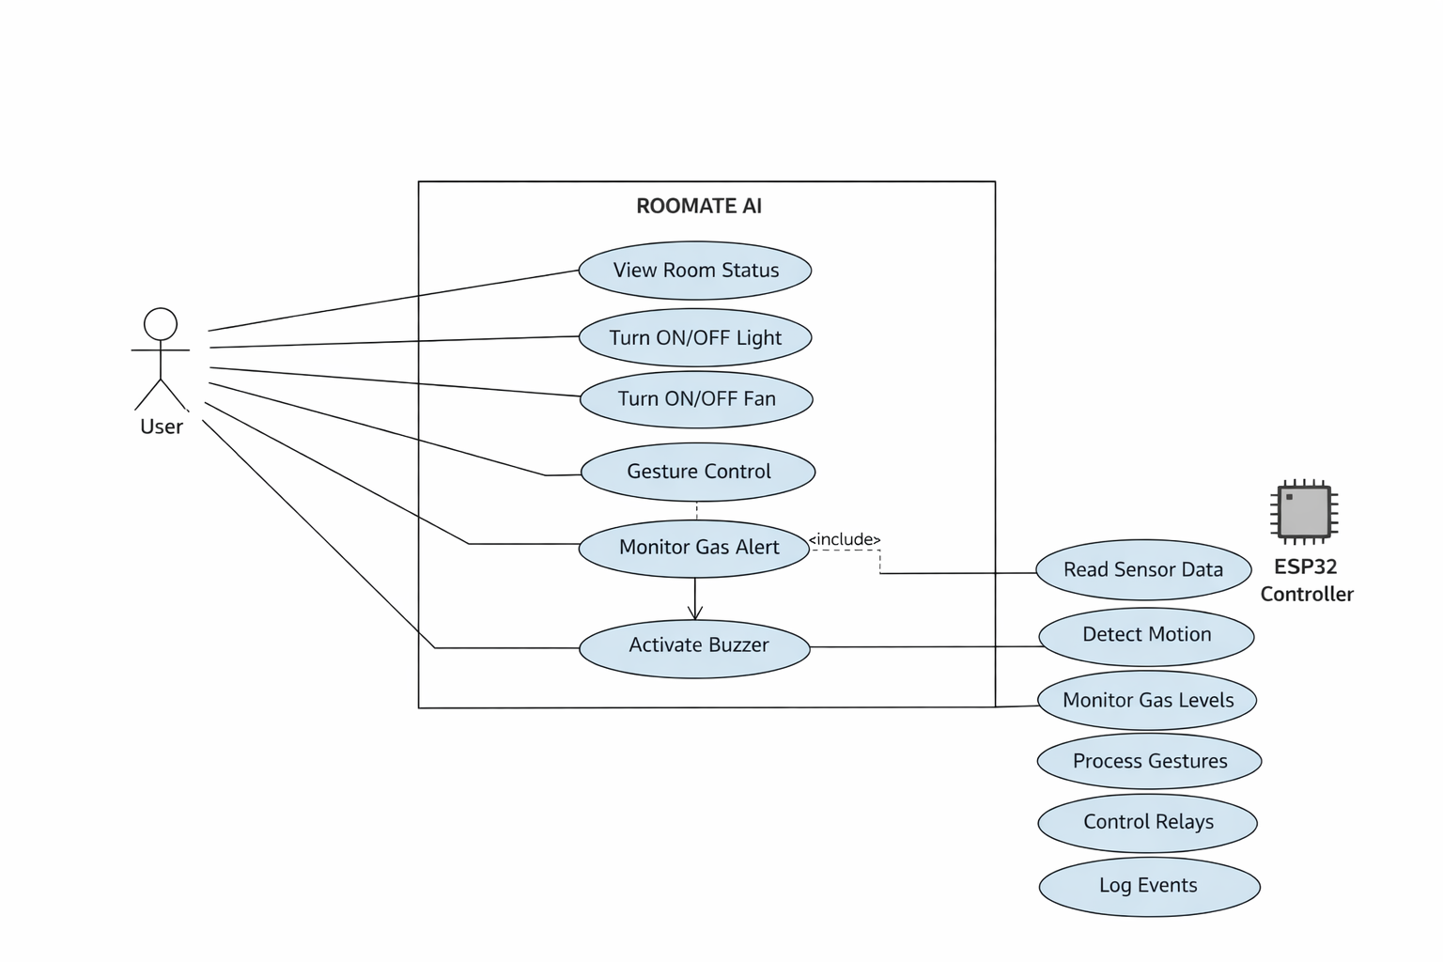

The Use Case Diagram represents the interaction between the user and the ROOMATE AI system. The primary actor is the user, who interacts with the system through a web or mobile interface and gesture-based controls. The user can monitor room conditions, control appliances such as lights and fans, receive gas alerts, and view system logs.
The ESP32 controller acts as the core system component responsible for reading sensor data, detecting motion, monitoring gas levels, processing gesture inputs, and controlling actuators through relay modules. Safety actions such as activating the buzzer during gas leakage are automatically handled by the system without user intervention.
This diagram provides a high-level overview of system functionality and clearly illustrates how ROOMATE AI integrates sensing, processing, and actuation to achieve smart room automation.

  - DFD
- Data Flow Diagram (DFD) – Level 0 (Context Diagram)
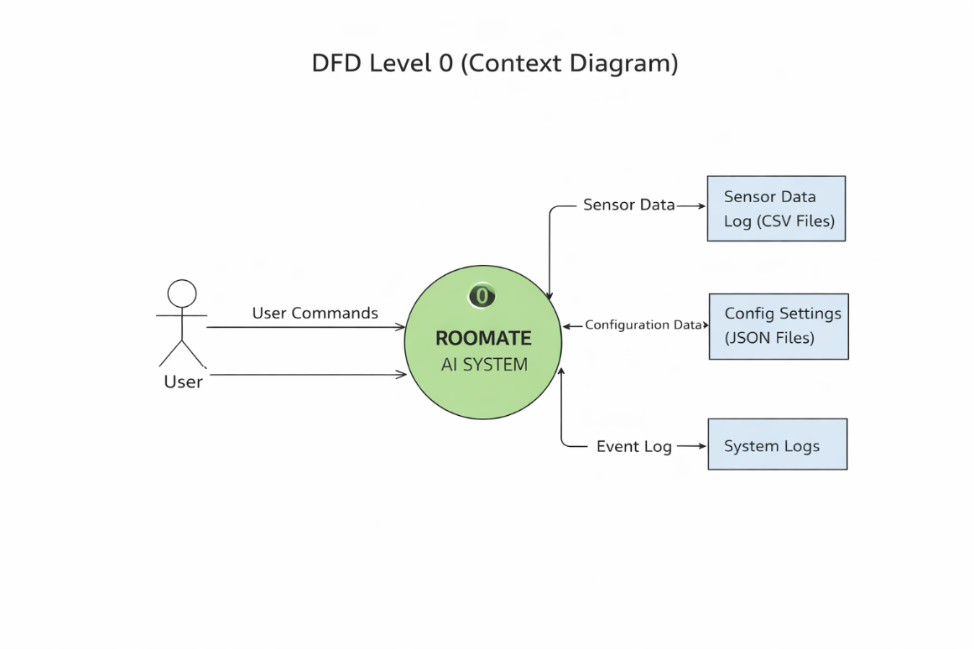

- Description
The DFD Level 0, also known as the Context Diagram, represents the ROOMATE AI system as a single high-level process and shows its interaction with external entities.
In this level, ROOMATE AI System is treated as one unified process that communicates with the User and connected hardware devices. The user interacts with the system through a web dashboard or manual controls to monitor the room status and control appliances. Sensor inputs such as motion detection (PIR sensor) and gas leakage data (MQ-2 sensor) are received by the system for safety monitoring and automation.

Based on the received inputs and user commands, the system sends control signals to output devices such as the relay module (for controlling lights and fans) and the buzzer (for gas leakage alerts). The system also maintains operational logs for monitoring and analysis.
The Level 0 DFD provides a clear overview of system boundaries, showing how ROOMATE AI interacts with users and external components without revealing internal processing details.

- Data Flow Diagram (DFD) – Level 1
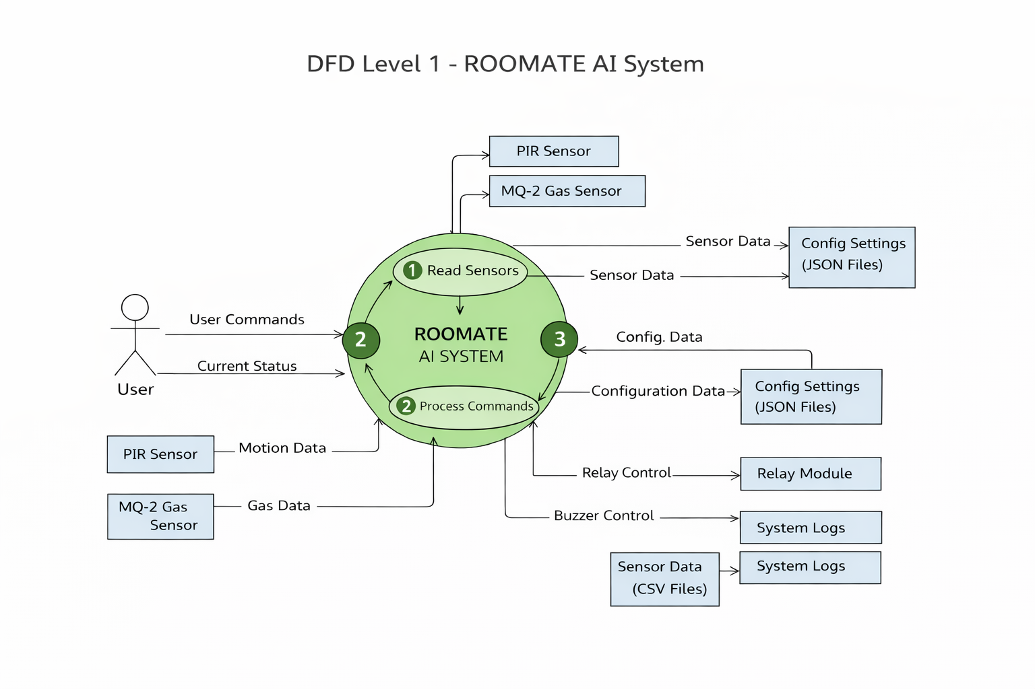
- Description
The DFD Level 1 expands the ROOMATE AI system into detailed internal processes, explaining how data flows between system components to perform automation and monitoring tasks.
The system is divided into the following main processes:
- Read Sensors
This process collects real-time data from the PIR motion sensor and MQ-2 gas sensor. Motion data is used to detect room occupancy, while gas sensor data is continuously monitored to identify unsafe gas levels.
- Process Commands
User commands received through the web dashboard are processed in this stage. The system also evaluates sensor data against predefined rules and configuration settings stored in JSON files.
- Perform Automation and Control
Based on processed inputs, the system triggers actions such as switching appliances ON/OFF through the relay module or activating the buzzer in case of gas leakage. This process ensures both comfort and safety within the room.
Additionally, important events, sensor readings, and system actions are stored as system logs (CSV or text files) for future reference and troubleshooting.
The Level 1 DFD clearly illustrates the internal working of ROOMATE AI, showing how sensor data, user inputs, configuration settings, and output controls interact to deliver an intelligent and automated smart room environment.

- Circuit Diagram

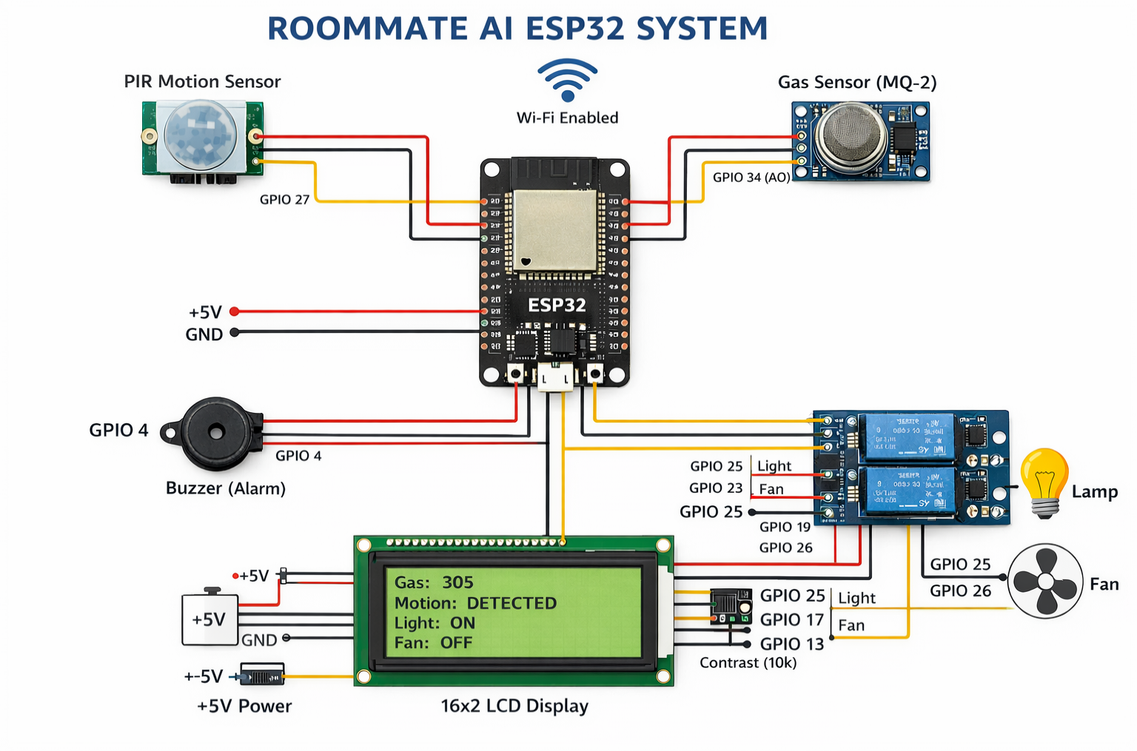

- Description
The ROOMATE AI system is designed around the ESP32 microcontroller, which serves as the central processing and control unit. All sensors and actuators are interfaced with the ESP32 through its GPIO pins, enabling real-time data acquisition and intelligent control. A regulated 5 V DC power supply is used to power the ESP32, sensors, LCD display, relay module, and peripheral components. To ensure reliable operation, a common ground is maintained across all system components.
- Sensors
  - PIR Motion Sensor:
The PIR (Passive Infrared) motion sensor is connected to a digital GPIO pin of the ESP32. It detects human presence by sensing infrared radiation changes in the surrounding environment. This sensor is primarily used for occupancy detection, automation of lighting, and activity logging.

  - MQ-2 Gas Sensor:
The MQ-2 gas sensor is interfaced with the ESP32 via an analog-to-digital converter (ADC) pin. It continuously monitors the concentration of combustible gases such as LPG, methane, and smoke. When the sensed gas level exceeds a predefined threshold, the sensor data is processed by the ESP32 to trigger safety alerts.
- Actuators
  - Relay Module:
A multi-channel relay module is connected to the ESP32 through digital output pins. It enables safe control of high-voltage electrical appliances by electrically isolating the low-voltage control circuitry from the high-power load. The relay is used to switch appliances such as lights and fans ON or OFF.
  - Fan (DC Motor / AC Load):
The fan is connected to the relay output terminals, allowing the ESP32 to control ventilation automatically or manually. The fan can be activated in response to motion detection or gas leakage conditions.
  - Buzzer:
An active buzzer is connected to a dedicated GPIO pin of the ESP32. It serves as an audible alert mechanism and is activated during critical events such as gas leakage detection or system warnings.
- System Operation
  - The sensors continuously monitor environmental conditions and send real-time data to the ESP32.
  - The ESP32 processes the incoming sensor data using predefined logic and threshold values.
  - Based on the processed information, the ESP32 controls the actuators by switching the relay module or activating the buzzer.
  - For instance, detection of human motion by the PIR sensor can automatically turn ON the room light, while detection of unsafe gas levels by the MQ-2 sensor triggers the buzzer and activates the ventilation fan.

- Safety Considerations
  - The relay module provides electrical isolation between the low-voltage ESP32 circuitry and high-voltage appliances, ensuring user and system safety.
  - All high-voltage connections are kept separate from the low-voltage control circuitry and should never be routed through a breadboard.
  - Proper insulation, secure wiring, and regulated power supply are essential to prevent electrical hazards.

Chapter – 6: User Manual

Chapter 6: User Manual

- Sample Code
from machine import Pin, ADC
import time

# GPIO Pin Configuration
pir_sensor = Pin(14, Pin.IN) # PIR Motion Sensor
relay_light = Pin(26, Pin.OUT) # Relay for Light
relay_fan = Pin(27, Pin.OUT) # Relay for Fan
buzzer = Pin(25, Pin.OUT) # Buzzer
gas_sensor = ADC(Pin(34)) # MQ-2 Gas Sensor
gas_sensor.atten(ADC.ATTN_11DB)

GAS_THRESHOLD = 200

while True:
# Motion Detection
if pir_sensor.value() == 1:
relay_light.value(1) # Turn ON light
else:
relay_light.value(0) # Turn OFF light

# Gas Detection
gas_value = gas_sensor.read()
if gas_value > GAS_THRESHOLD:
buzzer.value(1) # Alert ON
relay_fan.value(1) # Fan ON
else:
buzzer.value(0)
relay_fan.value(0)

time.sleep(1)

- Result
The ROOMATE AI system was successfully implemented and tested to automate and monitor room appliances using an ESP32 microcontroller. The system integrates hardware components such as relay modules, motion sensors, gas sensors, and a buzzer, along with software developed using Python (MicroPython). The obtained results confirm that the system performs reliably and meets the defined project objectives.
- Appliance Control Results
The ESP32 was able to control electrical appliances such as lights and fans through relay modules. Each appliance responded accurately to control logic executed on the microcontroller. When motion was detected by the PIR sensor, the light was automatically turned ON, and it was turned OFF in the absence of motion. This demonstrated effective automation and reduced unnecessary power usage.
- Gas Leakage Detection Results
The MQ-2 gas sensor continuously monitored the environment for gas concentration. When the gas level crossed the predefined threshold, the system immediately activated the buzzer and turned ON the exhaust fan. This real-time response confirmed the system’s capability to detect hazardous conditions and provide timely alerts, enhancing room safety.
- System Responsiveness
The system showed fast and reliable response to sensor inputs. The ESP32 processed sensor data and executed control actions with minimal delay. The relay switching, buzzer alerts, and fan activation occurred almost instantaneously after detecting motion or gas leakage.
- Reliability and Stability
During continuous testing, the system operated stably without crashes or unexpected behavior. The wireless connectivity of the ESP32 remained consistent, and the control logic executed correctly over extended periods of operation.
- Overall Performance Evaluation
The results demonstrate that the ROOMATE AI system effectively automates room appliances and enhances safety using low-cost hardware and simple control logic. Although advanced features such as behavior learning and voice input were not implemented, the system achieved its primary goals of automation, monitoring, and safety. The project proves that a cost-effective and scalable smart room solution can be developed using ESP32 and Python.

- Test Cases

Test Case ID | Description | Input | Expected Output | Actual Result | Status
TC-01 | Light control via motion detection | Move hand in front of PIR sensor | Light turns ON | Light turned ON immediately | Pass
TC-02 | Light turns OFF when no motion | No motion for 5 minutes | Light turns OFF | Light turned OFF after 5 minutes | Pass
TC-03 | Gas detection alert | MQ-2 sensor exposed to LPG | Buzzer ON, Fan ON | Buzzer and Fan activated instantly | Pass
TC-04 | Relay module control via web dashboard | Click Light ON/OFF | Relay switches appliance accordingly | Relay toggled correctly | Pass
TC-05 | Relay module control via web dashboard | Click Fan ON/OFF | Relay switches appliance accordingly | Relay toggled correctly | Pass
TC-06 | Gesture-based light control | Swipe Up gesture | Light ON | Light turned ON | Pass
TC-07 | Gesture-based light control | Swipe Down gesture | Light OFF | Light turned OFF | Pass
TC-08 | Logging system | Perform appliance actions | Log file updated with timestamp and action | Logs updated correctly | Pass
TC-09 | System stability | Continuous operation for 24 hours | No crashes, correct appliance control | System stable and responsive | Pass
TC-10 | Web status check | Open dashboard status page | Correct device and sensor readings displayed | Status matched real-time readings | Pass

Chapter – 7: Limitations & Future Enhancement

Chapter 7: Limitation & Future Enhancement Limitations
- Hardware Dependence:
ROOMATE AI relies heavily on sensors, cameras, and relay modules to gather environmental data and control devices. Any hardware malfunction, such as a faulty gas sensor or a camera with poor resolution, can affect the system’s accuracy, responsiveness, and overall reliability. Regular maintenance is required to ensure consistent performance.
- Limited Gesture Recognition:
The hand gesture detection module depends on camera clarity, lighting conditions, and predefined gestures. Complex gestures or subtle hand movements may not be recognized correctly, leading to incorrect device control.
- Connectivity Issues:
The mobile app and AI modules require a stable WiFi connection. Network interruptions or latency can delay
commands, prevent remote access, or cause synchronization issues between devices.
- Scalability Constraints:
Currently, ROOMATE AI is optimized for a single-room setup. Expanding the system to multiple rooms or large spaces requires additional sensors, relays, and possibly multiple ESP32 controllers, which can increase complexity and cost.
- Limited AI Learning Capability:
The behavior-learning module is rule-based. While it can automate simple routines, it cannot dynamically learn
complex or irregular user habits without manual configuration. This limits personalization and adaptive intelligence.
- Data Storage Limitations:
Continuous logging of sensor data, multimedia from gesture recognition, and system logs can consume significant memory over time. Without regular backups, archival, or cloud integration, storage limitations can affect long-term data retention and historical analysis.

- Environmental Limitations:
Extreme environmental conditions, such as poor lighting, smoke, or dust, can affect sensor accuracy and gesture recognition. The system may not function optimally under such conditions.

Future Enhancements
Advanced AI Integration:
Implement machine learning algorithms to predict user behavior and preferences. The system could learn when a user typically adjusts the lights or fan and automate actions without manual scheduling.
Multi-Room Expansion:
Extend the system to manage multiple rooms or an entire home. This would involve integrating centralized control dashboards, multi-node communication, and coordinated automation between rooms.
Enhanced Gesture Recognition:
Improve the gesture recognition module to detect more complex gestures and operate accurately under varying lighting conditions. Integration of infrared or depth cameras could further improve recognition reliability.
Voice Command Improvements:
Incorporate advanced natural language processing (NLP) for multi-language support, context-aware responses, and more natural conversational interactions with the AI assistant.
Cloud Storage & Analytics:
Integrate cloud storage to store sensor readings, logs, and multimedia data. Cloud-based analytics can provide historical trends, energy consumption reports, and predictive maintenance alerts.
Energy Efficiency Features:
Implement intelligent energy-saving suggestions. For example, the system could turn off lights or fans automatically when a room is unoccupied or optimize device usage based on environmental conditions and user habits.
Integration with IoT Ecosystem:
Enable interoperability with other smart home devices and platforms, such as smart thermostats, security cameras, or voice assistants, creating a fully connected and automated home ecosystem.

Robust Security Features:
Enhance data and network security with encryption, secure authentication, and regular updates to prevent unauthorized access and ensure user privacy.
Mobile App Enhancements:
Improve the mobile app interface for easier device management, real-time alerts, and remote control

Chapter – 8: Conclusion

Conclusion
ROOMATE AI is a comprehensive smart room assistant designed to combine IoT technology, artificial intelligence, and user-friendly interfaces to create an intelligent, adaptive, and automated living environment. The system integrates multiple hardware components, including sensors (temperature, humidity, motion, gas), relay modules, and cameras, along with software modules for gesture recognition, voice commands, and automation logic. Together, these components enable real-time monitoring, intelligent decision-making, and seamless control of devices such as lights, fans, and alarms.
The project demonstrates the ability of ROOMATE AI to respond intelligently to environmental changes and user preferences. Through the collection of numerical, binary, textual, and multimedia data, the system is capable of analyzing patterns, triggering automated responses, and maintaining detailed logs for system monitoring and future analysis. The integration of behavior-learning modules allows the system to follow pre-defined routines and adjust device operation based on observed user habits, thereby improving comfort and efficiency.
One of the key achievements of the project is the successful implementation of gesture-based control and mobile app integration, which offers a natural and intuitive interface for users. This ensures that users can control their environment even without direct interaction with devices, increasing accessibility and convenience. Additionally, the systematic organization of data in CSV, JSON, and multimedia formats, along with secure backups, ensures that ROOMATE AI maintains high reliability, data integrity, and traceability.
Despite its successes, the project has certain limitations. Hardware dependence, limited scalability, connectivity constraints, and rule-based AI learning restrict the system’s full potential. Gesture recognition accuracy can vary under different lighting conditions, and continuous data logging may require careful management to prevent storage overflow. Recognizing these limitations has provided valuable insights into how future improvements can enhance the system’s intelligence, reliability, and adaptability.
Looking forward, the system can be enhanced by integrating advanced machine learning algorithms, expanding to multi-room or full-home automation, implementing cloud-based storage and analytics,
improving gesture and voice recognition, and enabling energy-efficient operation. These enhancements will allow ROOMATE AI to learn and adapt dynamically to user behavior, optimize energy consumption, provide predictive insights, and integrate with other smart home devices for a fully connected and intelligent environment.
In conclusion, ROOMATE AI successfully demonstrates the practical application of IoT, AI, and automation technologies to create a smart, adaptive, and efficient room environment. The project highlights the potential for future development in smart home systems, showcasing how technology can enhance daily life by improving comfort, safety, convenience, and energy efficiency. ROOMATE AI serves as a strong foundation for further research and development in the field of intelligent home automation.

