Module-1

1) What is software? What is software engineering?

- Software is a set of instructions, data or commands used in computers and execute specific tasks. Software engineering is the process of developing, testing, analyzing and deploying computer applications.

2) Explain types of software?

- Application Software

- System Software

- Driver software

- Middleware

- Programming Software

3) What is SDLC? Explain each phase of SDLC.

- SDLC is referred to as Software Development Life cycle, it’s a methodology with clear defined processes for creating High-Quality software.

- Phases of SDLC are mentioned below:

- Requirement Gathering

- Analysis

- Designing

- Implementation

- Testing

- Maintenance

4) What is DFD? Create a DFD diagram on Flipkart.

- A data flow diagram is a way of representing a flow of data through a process or a system.

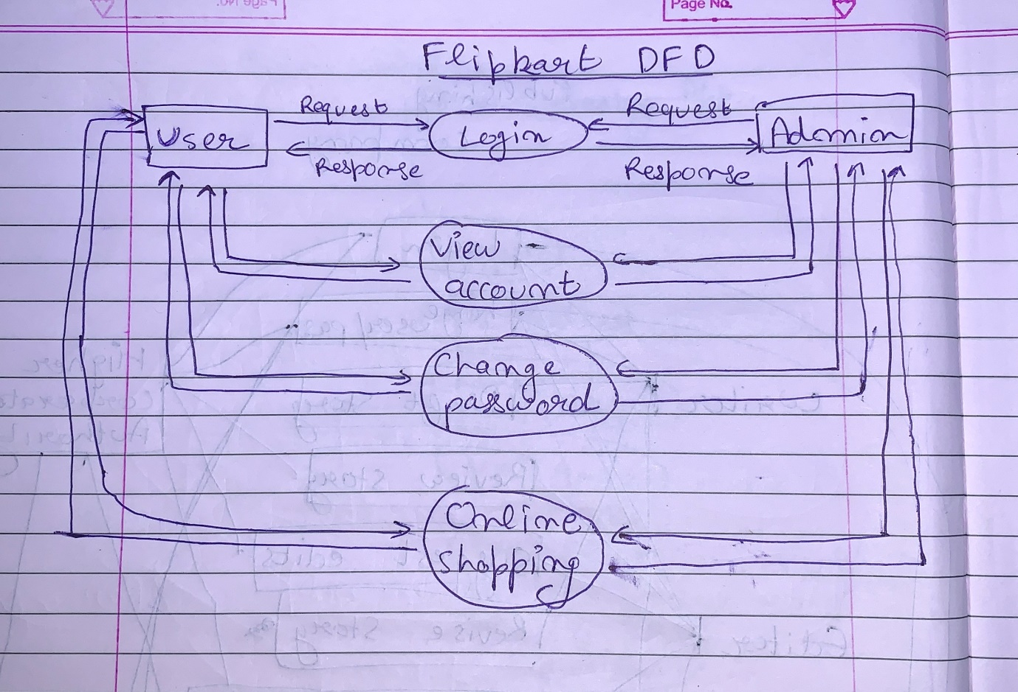

5) What is Flow chart? Create a flowchart to make addition of two numbers.

- Flow chart is a type of Diagram that represents a work flow or a process.

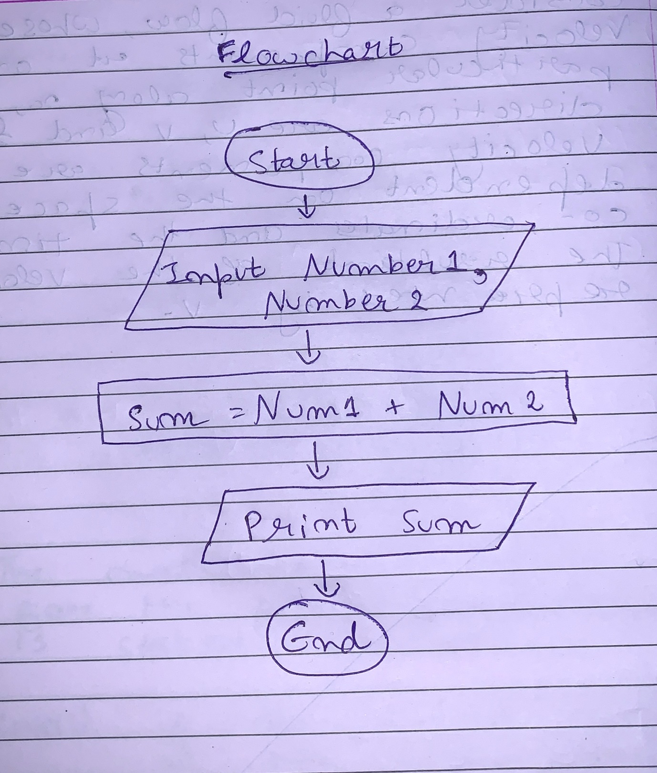

6) What is Use case Diagram? Create a use-case on bill payment on paytm.

- A use case diagram is a graphical depiction of a user’s possible interactions with a system.

