Accelerating Satellite Conjunction Assessment: Spatial Partitioning and Parallel Computing for Full-Catalog Collision Screening
Aditya Rajendra Sonawane
M.Sc. High Performance Computing and Quantum Computing
Technische Hochschule Deggendorf, Germany
Abstract—The growth of objects in Earth orbit has made conjunction assessment—the continuous screening of all tracked objects for dangerously close approaches—a computationally demanding task. A naive all-pairs screening scales as O(N²); for the active catalog of roughly 15,830 objects examined here this implies over 125 million pairwise tests per epoch, which is infeasible to repeat continuously. This paper presents and benchmarks an end-to-end, reproducible Python pipeline that accelerates this workload using two complementary high-performance-computing techniques: spatial partitioning and process-based parallelism. Real two-line element data were obtained from CelesTrak and propagated with the SGP4 model. On the full 15,830-object catalog, grid and k-d tree spatial methods examined roughly 61× fewer candidate pairs than the naive approach and produced identical close-pair sets (211 pairs, zero disagreement), confirming correctness. A 24-hour time-window screen at finer resolution identified genuine conjunction events and, as a validation, correctly recovered co-located structures such as the International Space Station modules and the TanDEM-X/TerraSAR-X formation. Parallelizing the real screening workload yielded a measured speedup of 3.7× on four cores with over 92% efficiency, after which fixed overhead caused efficiency to decline, consistent with Amdahl’s law; identical detections across all core counts confirmed parallel correctness. To move from proximity to genuine risk, the pipeline also estimates each pair’s probability of collision, which showed that the most dangerous encounter was not the closest one. The screening was further extended with sub-step time-of-closest-approach refinement, a red/yellow/green risk triage, asset-centric screening, and an assessment against real debris clouds from the Fengyun-1C, Iridium-33, and Cosmos-1408 fragmentation events, which surfaced concrete close approaches between active satellites and uncontrollable debris. Both strong- and weak-scaling studies independently identified a four-core efficiency knee.
Index Terms—Conjunction assessment, space debris, high performance computing, spatial partitioning, parallel computing, SGP4, collision probability, risk triage, strong scaling, weak scaling, Amdahl’s law.
I. INTRODUCTION
Low Earth orbit has become an increasingly congested environment. Large commercial constellations, together with decades of accumulated debris from spent rocket bodies and past collisions, have driven the number of tracked objects into the tens of thousands. Space-surveillance organizations must therefore perform conjunction assessment continuously: for every tracked object they must determine whether any other object will pass within a hazardous distance over a forward-looking window, and if so alert operators so an avoidance maneuver can be planned.
The core computational difficulty is that, in its most direct form, conjunction assessment is an all-pairs problem. To guarantee no close approach is missed, every object must in principle be compared against every other object, requiring N(N−1)/2 distinct pairwise tests—a quantity that grows quadratically with N. For the active catalog of 15,830 objects used in this study, this amounts to over 125 million comparisons for a single epoch. Because screening must be repeated across many epochs and refreshed continuously, the naive approach quickly becomes impractical.
This paper investigates how the all-pairs workload can be accelerated using two complementary techniques from high performance computing. The first is algorithmic—spatial partitioning, in which the domain is divided into cells so only nearby objects are compared, reducing the effective complexity toward O(N·k) for a small average neighbor count k. The second is architectural—parallel execution across CPU cores. The contributions are: (i) a reproducible Python pipeline operating on real orbital data; (ii) a controlled comparison of naive, k-d tree, and grid screening, validated for correctness on the full catalog; (iii) a 24-hour time-window screen that recovers genuine and self-conjunction events; and (iv) strong- and weak-scaling studies of the parallel screening that quantify both speedup and the onset of overhead.
II. BACKGROUND AND RELATED WORK
A. Orbital Propagation and SGP4
The state of an Earth-orbiting object is commonly distributed as a two-line element set (TLE), a compact encoding of orbital elements at a reference epoch. To obtain a Cartesian position a TLE is propagated through an analytic model. The Simplified General Perturbations 4 (SGP4) model is the standard companion to TLE data and accounts for the dominant secular and periodic perturbations on near-Earth orbits. Here SGP4 converts each TLE into an Earth-centered inertial (ECI) position vector.
B. All-Pairs Proximity and Spatial Data Structures
The all-pairs proximity problem is well studied. The naive solution evaluates every pairwise distance: exact but quadratic. Acceleration structures exploit the fact that only spatially nearby objects can be close. A uniform grid (spatial hashing) assigns each object to a cell and draws candidate neighbors only from the same and adjacent cells. A k-d tree recursively partitions space along alternating axes and supports efficient neighbor queries. Both reduce practical cost dramatically when objects are unevenly distributed, as orbital populations are.
C. Parallelism and Amdahl’s Law
Parallel computing reduces wall-clock time by distributing work across processing units. The achievable benefit is bounded by Amdahl’s law: if a fraction p of the work is parallelizable, the maximum speedup on c processors is 1 / ((1−p) + p/c). An irreducible serial fraction, together with overheads such as process creation and data distribution, causes the speedup curve to fall away from ideal as the core count grows. Quantifying this departure is a central goal of any scaling study.
III. METHODOLOGY
A. Data Acquisition
Real orbital data were obtained from the CelesTrak service, which publishes current TLE catalogs for active satellites. The active-object catalog was downloaded and parsed, yielding 15,830 valid objects. Inclination, mean motion, and a derived approximate altitude were recorded; the dataset distribution is summarized in Fig. 1, showing the characteristic concentration in low Earth orbit alongside a secondary geostationary population.
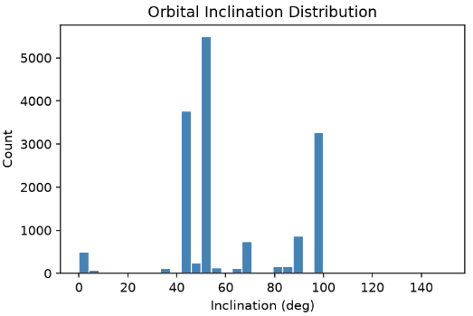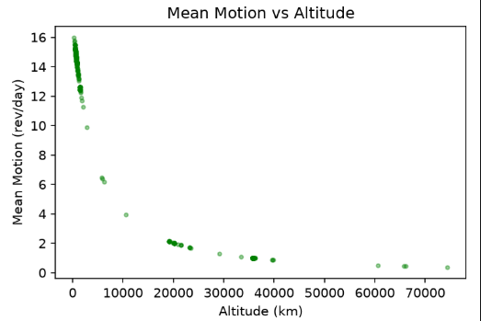
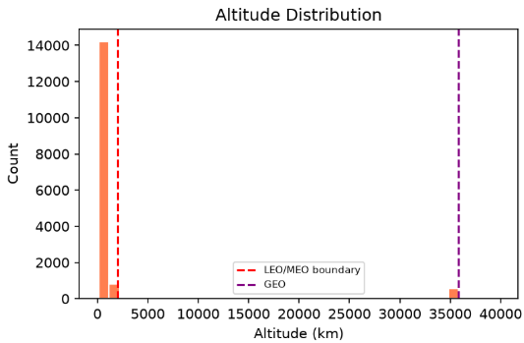
outputs/phase1_dataset_overview.png
Fig. 1. Distribution of the acquired catalog (15,830 objects): orbital inclination, derived altitude, and mean motion versus altitude.
B. Propagation
Each TLE was propagated to a common epoch using the python-sgp4 implementation, producing an ECI position in kilometers. For the controlled method comparison a representative subset of 2,000 objects was used, large enough to show asymptotic behavior while keeping the naive baseline tractable. The full catalog was used for the scale and correctness experiments. Fig. 2 shows the propagated distribution, in which two populations are visible: a dense low-altitude shell and a sharply defined geostationary ring near 42,000 km orbital radius.
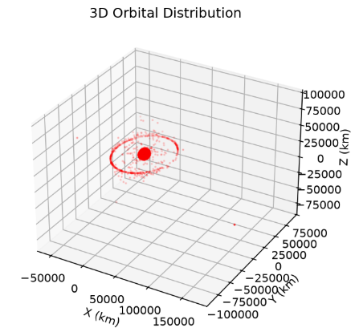
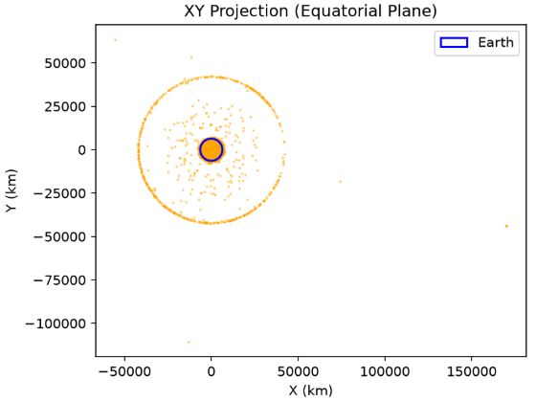
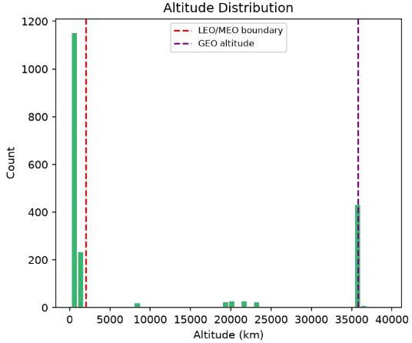
outputs/phase2_positions.png
Fig. 2. Propagated positions: three-dimensional distribution, equatorial projection, and altitude histogram.
C. Screening Algorithms
Three strategies were implemented. The naive baseline computes all pairwise distances using vectorized NumPy operations. The grid method performs spatial hashing with a cubic cell edge set to a small multiple of the threshold, comparing each object only against its own and 26 neighboring cells. The third method uses a k-d tree via SciPy, whose query-pairs routine returns all pairs within the threshold.
D. Time-Window Screening
To reflect operational practice, a time-window screen propagates every object across a 24-hour window in fixed steps and records, for each flagged pair, the minimum separation and its time of closest approach. A separation threshold of 25 km was used. Pairs whose minimum separation falls below 0.5 km are treated as self-conjunctions—co-located components of a single physical structure—and reported separately from genuine distinct-object approaches.
E. Parallelization and Experimental Setup
The time-window screen is naturally parallel: each time step is an independent task. Tasks were distributed across worker processes using a process pool, with the propagation objects transmitted to each worker once at initialization and tasks grouped into chunks to keep per-dispatch work large relative to communication. All experiments ran on a laptop with a 16-logical-core CPU under Ubuntu Linux. Timings are wall-clock and averaged over three runs; speedup is relative to single-core time and efficiency is speedup divided by core count.
IV. RESULTS AND DISCUSSION
A. Quadratic Cost of the Baseline
The naive baseline exhibits the expected quadratic behavior. As shown in Fig. 3, execution time rises super-linearly with object count, the pair count grows as a parabola, and execution time is very nearly a straight-line function of the number of pairs examined—the defining signature of an O(N²) algorithm whose cost is governed by the pair count itself.
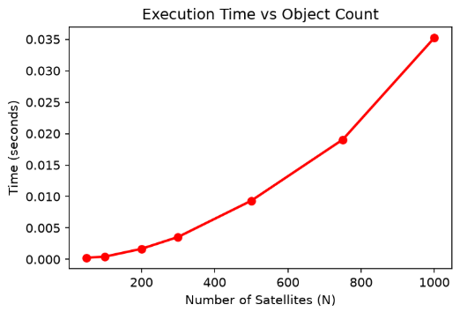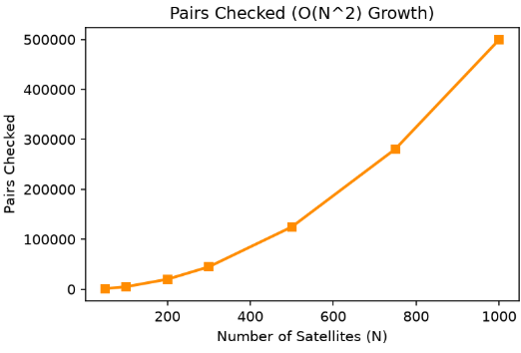
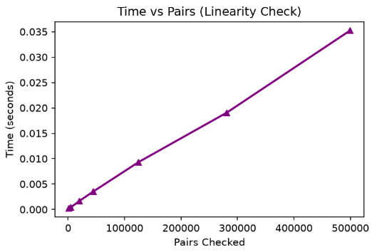
outputs/phase3_naive_benchmark.png
Fig. 3. Naive O(N²) baseline: time versus object count, pair-count growth, and the near-linear relationship between time and pairs examined.
B. Full-Catalog Screening and Correctness
Applying the spatial methods to the entire 15,830-object catalog demonstrates both feasibility and correctness. The naive approach would require 125,286,535 comparisons and is impractical to repeat continuously. By contrast, the spatial methods examine on the order of two million candidate pairs—roughly a 61× reduction—and, critically, the grid and k-d tree methods returned identical results: 211 close pairs each, with zero pairs found by only one method. This exact agreement confirms that spatial partitioning introduces no false negatives. The full-catalog comparison is summarized in Fig. 4.
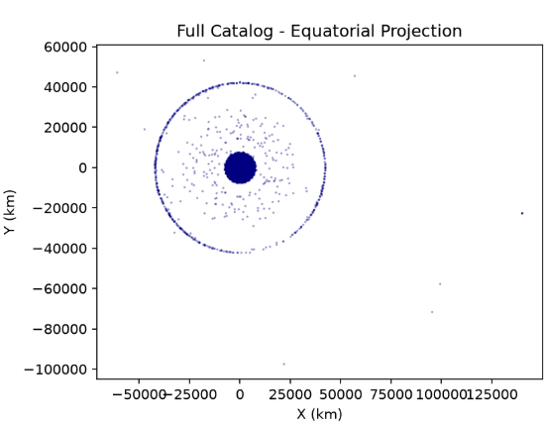
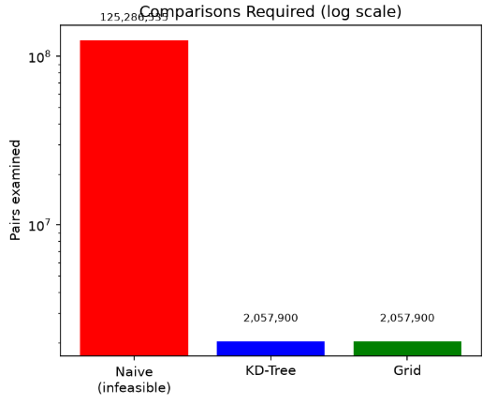
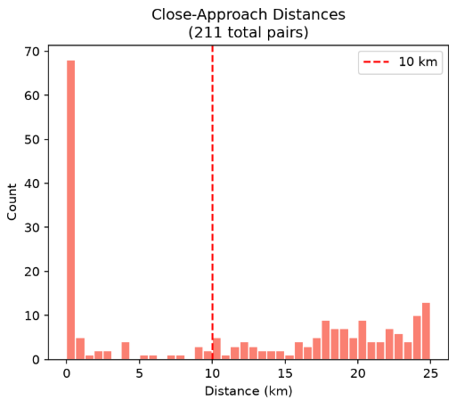
outputs/phase9_fullcatalog.png
Fig. 4. Full-catalog screening (15,830 objects): equatorial distribution, comparison counts on a log scale, and close-approach distance distribution. Grid and k-d tree agree exactly (211 pairs, zero disagreement).
The single-snapshot full-catalog screen found only 211 close pairs, far fewer than the time-window screen below detects, because an instantaneous snapshot misses pairs that become close at other moments—motivating time-window analysis.
C. Time-Window Conjunction Detection
The 24-hour time-window screen identified 26 close-approach pairs, of which 11 were self-conjunctions and 15 involved genuinely distinct objects, with 3 of the latter classified as critical (below 10 km). The self-conjunction filter is itself a validation: it correctly recovered the co-located modules of the International Space Station (ZARYA, UNITY, ZVEZDA, DESTINY) and POISK, as well as the TanDEM-X/TerraSAR-X pair, which deliberately fly in close formation for interferometric imaging. Recovering these known co-located structures provides independent evidence that the screening behaves physically.
The genuine distinct-object approaches are likewise physically coherent: the closest, at 3.59 km, occurs between two satellites of the same O3b constellation, which share an orbital plane; the next, at 8.43 km, between two satellites of the Magnetospheric Multiscale formation; and a 9.92 km approach between two co-located geostationary communications satellites. That the closest detections are dominated by intentional proximity—constellations, formations, and co-located GEO slots—mirrors the pattern operational systems must contextualize. The detections are listed in Table I and visualized in Fig. 5.
TABLE I. GENUINE DISTINCT-OBJECT CLOSE APPROACHES (24-HOUR WINDOW)
Object A | Object B | Min Dist. | Time (h)
O3B FM4 | O3B FM10 | 3.59 km | 23.3
MMS 2 | MMS 3 | 8.43 km | 10.7
BADR-5 | ARABSAT-5A | 9.92 km | 17.2
ANIK F3 | ECHOSTAR 15 | 11.48 km | 9.7
GSAT-7 | GSAT-14 | 15.01 km | 20.5

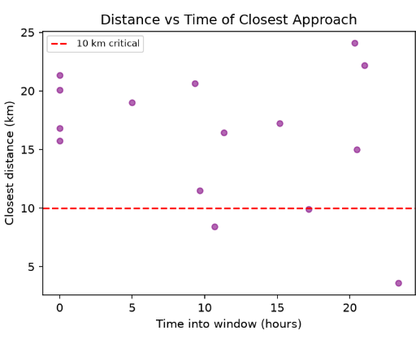
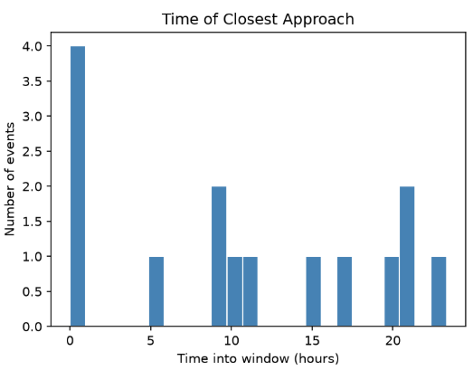
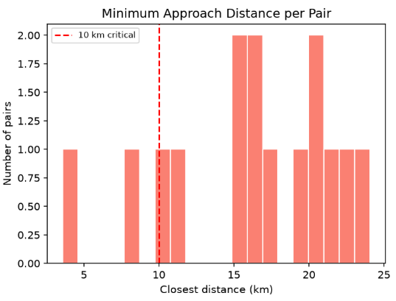
outputs/phase6_filtered.png
Fig. 5. Genuine distinct-object conjunctions over 24 hours: minimum approach distance, time of closest approach, and distance versus time.
D. Risk-Based Prioritization
Finding close pairs is only half the job. In practice, operators do not act on distance alone, because a small miss distance is not always dangerous and a larger one is not always safe. What actually matters is the probability of collision, written Pc, which combines the miss distance with how uncertain each object’s position is. We computed Pc for every genuine pair using the standard two-dimensional short-encounter (Foster) method. Because TLE data does not carry position uncertainty, we assigned representative uncertainty values based on the orbit regime, and we state plainly that these are modeled rather than measured.
The result is the most striking finding of the screening: the riskiest pair is not the closest one. The highest probability we found, about 5.6×10⁻⁵, belonged to a pair separated by 16.5 km, while a pair only 3.6 km apart carried a lower probability. This happens because Pc depends on the encounter geometry and the position uncertainty, not on distance by itself. A tool that ranks conjunctions by distance alone would therefore push the wrong events to the top of the list. Fig. 6 shows this directly: the points with the highest probability do not sit at the smallest distances.
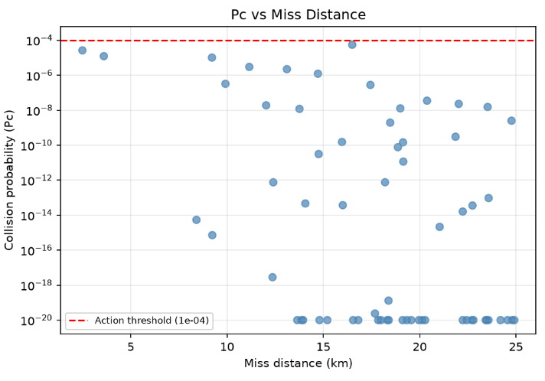
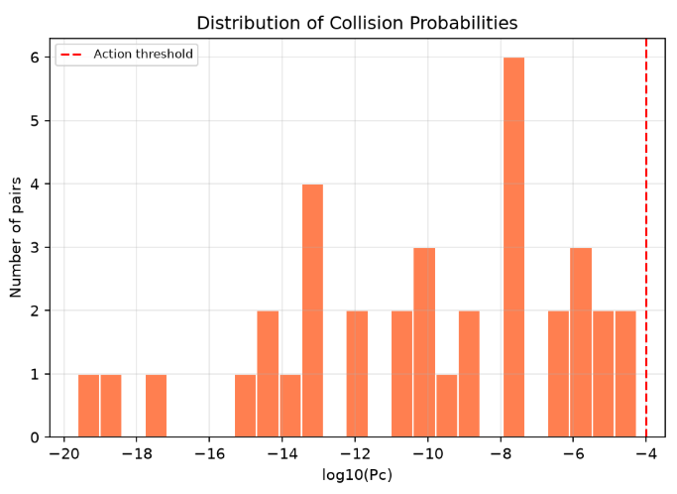
outputs/phase11_collision_probability.png
Fig. 6. Collision probability assessment: Pc versus miss distance (left) and the distribution of collision probabilities (right). The highest-Pc points are not the closest ones.
It is also worth noting what we did not find. None of the assessed pairs crossed the usual action threshold of 10⁻⁴ over the window. This is the expected and reassuring outcome, because conjunctions that truly warrant a maneuver are rare, and most of the close approaches we detected involve satellites that fly near each other on purpose—members of the same constellation, formation-flying missions, or satellites sharing a geostationary slot. A screening that flagged many imminent collisions across the active catalog would more likely point to an error than to a real emergency.
E. Parallel Strong Scaling on the Real Workload
The parallel screening was benchmarked on the real time-window workload of 1,500 objects across 289 time steps (433,500 SGP4 evaluations). Results are summarized in Table II. Up to four cores the measured speedup tracks the ideal trend closely, with efficiency above 92%. Beyond this point the curve bends away: efficiency falls to roughly 55% at eight cores and 33% at sixteen, while absolute time improves only marginally. Notably, the number of detected events (6,167) was identical across all core counts, confirming that parallelization changes only speed, not the scientific result.
TABLE II. STRONG-SCALING PERFORMANCE (REAL 24-HOUR SCREENING WORKLOAD)
Cores | Time (s) | Speedup | Effic. (%)
1 | 1.0821 | 1.00× | 100.0
2 | 0.5605 | 1.93× | 96.5
4 | 0.2940 | 3.68× | 92.0
8 | 0.2476 | 4.37× | 54.6
16 | 0.2045 | 5.29× | 33.1

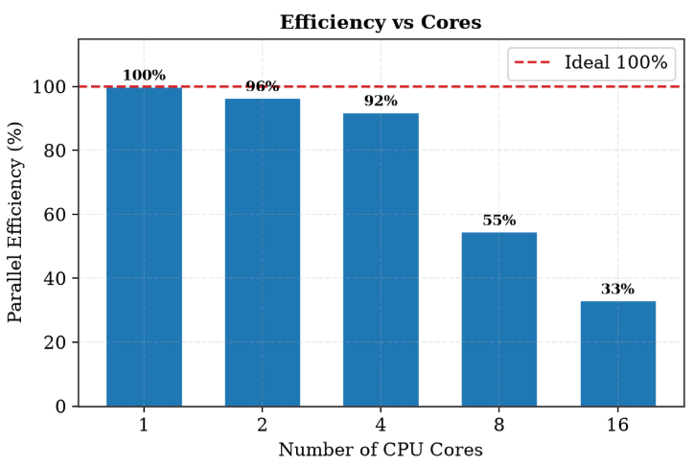
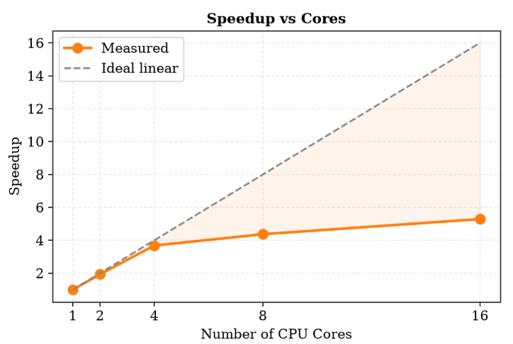
outputs/polished_scaling.png
Fig. 7. Strong scaling on the real screening workload: speedup versus cores (left) and parallel efficiency (right).
This behavior is fully consistent with Amdahl’s law. As workers are added, fixed costs—process creation, distribution of propagation objects, and serial result aggregation—consume a growing share of a shrinking runtime, so the serial fraction dominates sooner. The practical consequence is an identifiable optimal operating point of about four to eight cores, beyond which additional cores yield diminishing returns.
F. Weak Scaling
A weak-scaling study fixed the work per core (30 time steps per core) and grew the total problem with the core count, so ideal behavior is constant execution time. As shown in Table III, time remains nearly flat through four cores (0.419 s to 0.430 s, above 97% efficiency) and then rises, reaching 38.8% efficiency at sixteen cores. The same four-core knee appears in the strong-scaling, weak-scaling, and real-workload experiments; this three-way consistency makes the recommended operating range robust rather than an artifact of a single experiment.
TABLE III. WEAK-SCALING PERFORMANCE (CONSTANT WORK PER CORE)
Cores | Total Steps | Time (s) | Effic. (%)
1 | 30 | 0.4187 | 100.0
2 | 60 | 0.4256 | 98.4
4 | 120 | 0.4296 | 97.5
8 | 240 | 0.7019 | 59.7
16 | 480 | 1.0780 | 38.8

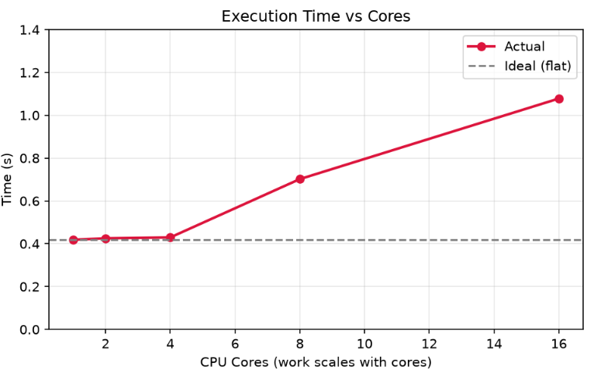
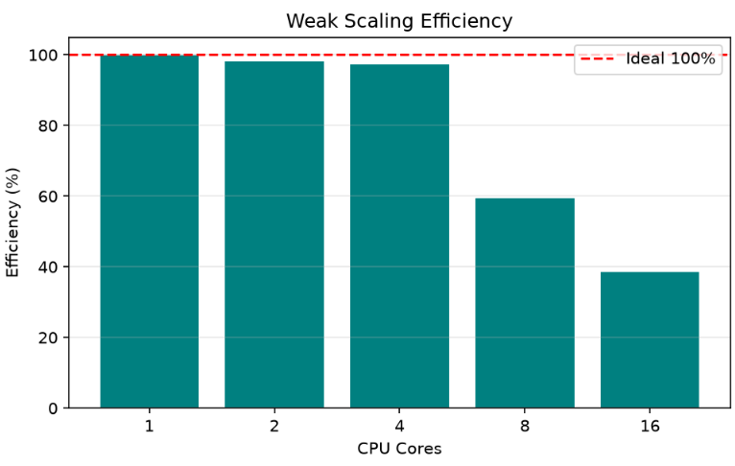
outputs/phase7_weakscaling.png
Fig. 8. Weak scaling: execution time and efficiency as the problem grows in proportion to the core count.
G. Complexity and Summary
Fig. 9 projects the comparison count for the naive and spatial methods across the operationally relevant range, on both linear and logarithmic axes, confirming that spatial partitioning is a prerequisite for full-catalog screening rather than a marginal optimization. Fig. 10 consolidates the principal results: the operation reduction at full catalog, the measured parallel speedup, and the correctness validation.
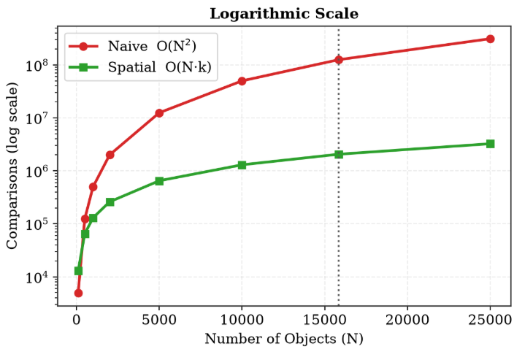
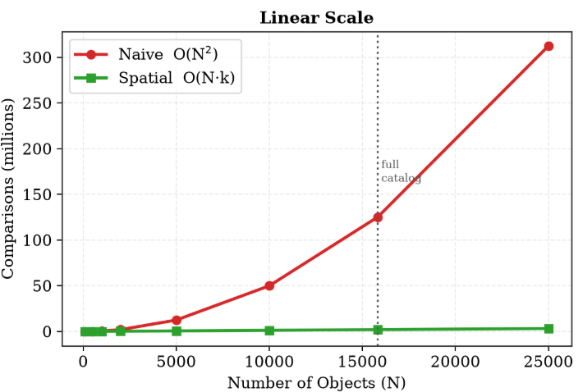
outputs/polished_complexity.png
Fig. 9. Projected comparison counts for naive and spatial methods across catalog sizes, on linear and logarithmic scales.
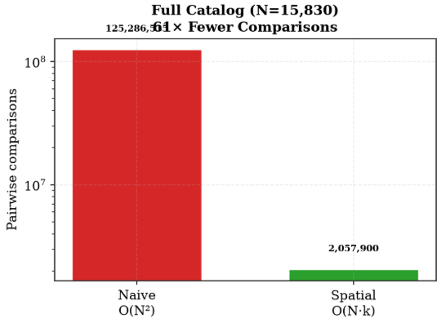
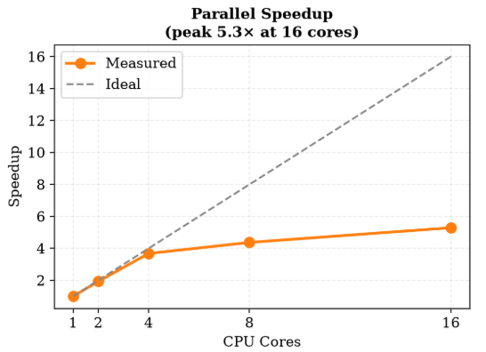
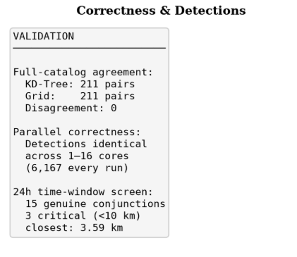
outputs/polished_keyresults.png
Fig. 10. Key results summary: full-catalog operation reduction, parallel speedup, and correctness and detection validation.
H. Operational Extensions
To make the pipeline behave more like a working screening service, four practical features were added. The first refines the time of closest approach. Because the screen samples distance at fixed steps, the true closest moment usually falls between two samples. Fitting a parabola through the closest sample and its two neighbours estimates the real minimum, which gives both a sub-step time and a slightly smaller miss distance. For example, the ANIK F3 / ECHOSTAR 15 approach tightened from 5.17 km at coarse sampling to 4.88 km once refined. The refinement only adjusts a value when the closest point has neighbours on both sides; sharply sampled approaches keep their sampled value, which is the correct and honest behaviour.
The second feature is a simple risk triage. Each pair is labelled red, yellow, or green from its collision probability and miss distance: red above the action threshold, yellow in a watch band, and green otherwise. Over the window the screen returned no red events, four yellow, and the rest green—the expected outcome for an active catalog where most close approaches are between satellites that fly near each other on purpose. The triage feeds a plain-text report listing each event with its objects, time of closest approach, probability, and risk colour, which mirrors the kind of product a real operator receives.
The third feature changes the question from “which pairs are close?” to “what threatens my satellite?” Real services screen one protected asset against the whole catalog. Screening the International Space Station this way returned a clean result: only one object came near it over the window, at a comfortable distance, which is the reassuring answer one would hope for such a closely watched asset. The approach curves in Fig. 11 show the same events from a different angle, plotting how the separation between selected pairs rises and falls across the window and dips to a clear minimum at the time of closest approach.
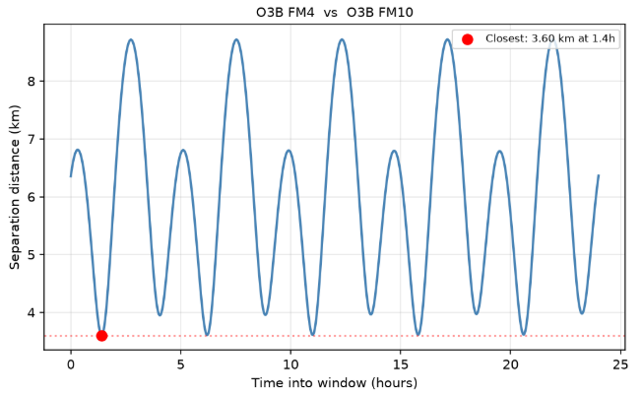
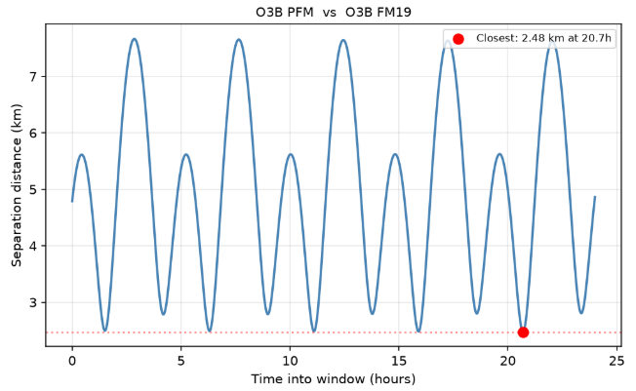
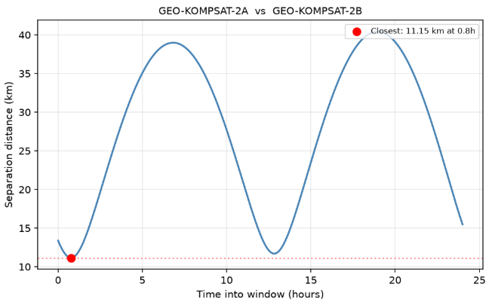
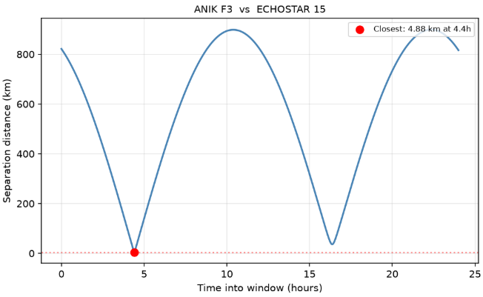
outputs/phase15_approach_curves.png
Fig. 11. Approach curves for selected pairs: separation distance over the 24-hour window, with the closest approach marked. GEO pairs show slow, smooth curves while MEO constellation members re-approach more sharply.
The fourth and most consequential feature screens active satellites against real debris. Fragment catalogs from three historic break-ups were pulled from CelesTrak: the Fengyun-1C anti-satellite test of 2007, the accidental Iridium-33 collision of 2009, and the Cosmos-1408 anti-satellite test of 2021. Combined with active satellites, the screen found tens of active-versus-debris close approaches over the window. The closest involved an operational Starlink satellite passing within about 4.4 km of a fragment from the Iridium-33 collision, alongside approaches involving valuable Earth-observation satellites such as Sentinel-3A and MetOp-B near Fengyun-1C fragments. This matters because debris cannot maneuver: when an active satellite nears a fragment, only the satellite can act. The distribution of active satellites and debris is shown in Fig. 12.
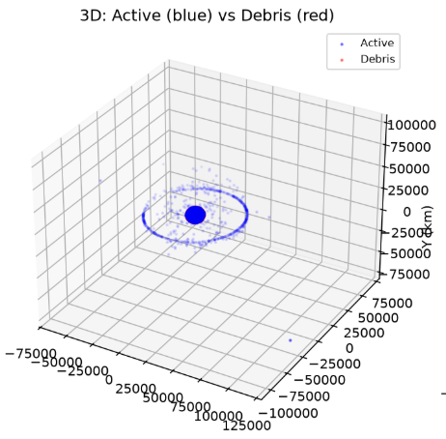
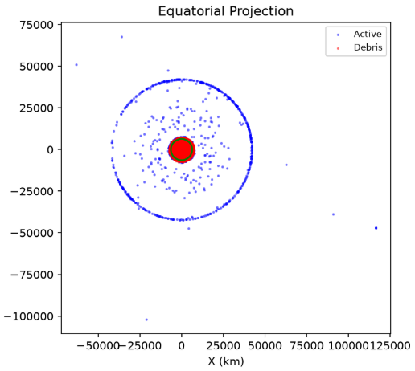
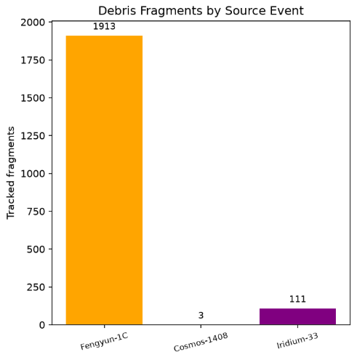
outputs/phase16_debris.png
Fig. 12. Active satellites (blue) screened against real debris fragments (red) from the Fengyun-1C, Iridium-33, and Cosmos-1408 events, with the fragment count per source event.
V. LIMITATIONS
The collision probabilities rest on two simplifications worth stating clearly. First, the position uncertainties are modeled by orbit regime rather than taken from real tracking data, which TLEs do not provide, so the probability values illustrate the method rather than giving operational risk numbers. Second, the two-dimensional Foster method assumes a fast, nearly straight-line encounter, which holds well for high-speed crossings in low Earth orbit but less well for slow encounters between co-located geostationary satellites.
Beyond the probability model, a few further limitations apply. The screening detects the minimum separation among sampled time steps rather than interpolating the true closest approach using relative velocity, so the reported times of closest approach are accurate only to the sampling resolution, although the parabolic refinement reduces this effect. The debris assessment uses a representative subset of fragments and active objects rather than every catalogued piece, so the conjunction counts illustrate the threat rather than enumerating it exhaustively. The controlled method comparison uses a 2,000-object subset, although the scale and correctness results use the full catalog. Finally, the parallel implementation relies on Python multiprocessing, whose per-process overhead is comparatively heavy; a compiled or shared-memory approach would likely shift the optimal core count upward. These point to natural extensions rather than undermining the present findings.
VI. CONCLUSION
This paper presented a reproducible Python pipeline for satellite conjunction assessment built on real CelesTrak data and SGP4 propagation. On the full 15,830-object catalog the spatial methods examined roughly 61× fewer candidate pairs than the naive approach and produced identical close-pair sets, establishing both feasibility and correctness at scale. A 24-hour time-window screen recovered genuine conjunctions and, as validation, correctly identified co-located structures including the ISS modules and the TanDEM-X/TerraSAR-X formation. Adding a probability-of-collision estimate moved the tool from simple proximity to genuine risk and revealed that the most dangerous encounter was not the closest one—a result distance-based screening would miss. Parallelizing the real screening workload achieved near-ideal speedup to four cores with a clear, quantifiable departure beyond eight, in agreement with Amdahl’s law and corroborated independently by strong- and weak-scaling studies that all identify a four-core efficiency knee. Identical detections across all core counts confirmed parallel correctness. The pipeline was further extended into a more operational tool with sub-step time-of-closest-approach refinement, a red/yellow/green risk triage, asset-centric screening, and an assessment against real debris clouds that surfaced concrete close approaches between active satellites and uncontrollable fragments—including a current Starlink satellite passing within about 4.4 km of debris from the 2009 Iridium-33 collision. Together these results show how algorithmic and architectural techniques jointly address a real aerospace computing problem, and they highlight the methodological value of reporting not only peak speedup but also the point at which parallel overhead begins to dominate.
REFERENCES
[1] D. Vallado, Fundamentals of Astrodynamics and Applications, 4th ed. Hawthorne, CA: Microcosm Press, 2013.
[2] F. R. Hoots and R. L. Roehrich, “Models for propagation of NORAD element sets,” Spacetrack Report No. 3, U.S. Air Force, 1980.
[3] T. S. Kelso, “CelesTrak: Current NORAD two-line element sets.” [Online]. Available: https://celestrak.org
[4] B. Rhodes, “sgp4: Track Earth satellites from TLE data using the SGP4 model,” Python package. [Online]. Available: https://pypi.org/project/sgp4
[5] J. L. Bentley, “Multidimensional binary search trees used for associative searching,” Commun. ACM, vol. 18, no. 9, pp. 509–517, 1975.
[6] P. Virtanen et al., “SciPy 1.0: fundamental algorithms for scientific computing in Python,” Nature Methods, vol. 17, pp. 261–272, 2020.
[7] C. R. Harris et al., “Array programming with NumPy,” Nature, vol. 585, pp. 357–362, 2020.
[8] G. M. Amdahl, “Validity of the single processor approach to achieving large scale computing capabilities,” in Proc. AFIPS Spring Joint Computer Conf., 1967, pp. 483–485.
[9] J.-C. Liou, “An active debris removal parametric study for LEO environment remediation,” Adv. Space Res., vol. 47, no. 11, pp. 1865–1876, 2011.
[10] M. R. Akella and K. T. Alfriend, “Probability of collision between space objects,” J. Guid. Control Dyn., vol. 23, no. 5, pp. 769–772, 2000.
[11] F. K. Chan, Spacecraft Collision Probability. El Segundo, CA: The Aerospace Press, 2008.

