Molecular Docking Study of DPP-4 Inhibitors:
A Comparative Analysis of Alogliptin, Sitagliptin, and Vildagliptin
Aditya Tiwari
University Institute of Pharmacy, Pt. Ravishankar Shukla University, Raipur, India
B.Pharm, Semester IV
March 2026

Abstract
Dipeptidyl peptidase-4 (DPP-4) is a validated pharmacological target for the management of type 2 diabetes mellitus. This study presents a self-initiated computational molecular docking investigation of three approved DPP-4 inhibitors — alogliptin, sitagliptin, and vildagliptin — against the human DPP-4 crystal structure (PDB: 2ONC) using AutoDock Vina 1.2.7. Protein preparation, ligand processing, and visualisation were performed using MGLTools, RDKit, and PyMOL (open-source). Sitagliptin demonstrated the highest predicted binding affinity (−10.11 kcal/mol), followed by alogliptin (−9.147 kcal/mol) and vildagliptin (−7.862 kcal/mol). Active site residue analysis confirmed ligand placement within the catalytic pocket, with four hydrogen bonds identified in the range of 2.4–2.7 Å. Redocking of the co-crystallised ligand yielded an RMSD of 2.365 Å, indicating an acceptable docking protocol. The observed underscoring of vildagliptin is attributed to its covalent inhibition mechanism, which is not captured by the non-covalent Vina scoring function. These results are consistent with published pharmacological data and demonstrate the utility of open-source computational tools in early-stage drug discovery education.

1. Introduction
Type 2 diabetes mellitus (T2DM) is a chronic metabolic disorder characterised by insulin resistance and progressive beta-cell dysfunction, affecting over 530 million individuals worldwide as of 2021.¹ Dipeptidyl peptidase-4 (DPP-4), also known as CD26, is a serine protease that rapidly inactivates the incretin hormones glucagon-like peptide-1 (GLP-1) and glucose-dependent insulinotropic polypeptide (GIP), which are responsible for stimulating postprandial insulin secretion. Inhibition of DPP-4 prolongs the action of these hormones, thereby improving glycaemic control in a glucose-dependent manner with a low risk of hypoglycaemia.

The gliptin class of DPP-4 inhibitors represents a well-established therapeutic category. Sitagliptin (Januvia®), approved by the FDA in 2006, was the first-in-class agent. Alogliptin (Nesina®) and vildagliptin (Galvus®) subsequently expanded the class, each with distinct chemical scaffolds and binding characteristics. Despite sharing the same target, structural differences among gliptins result in varying binding affinities, selectivity profiles, and clinical pharmacokinetics.

Molecular docking is a widely used computational method in structure-based drug design that predicts the preferred binding orientation and affinity of a small molecule ligand within a protein active site. It has become an indispensable early-stage tool in pharmaceutical research due to its cost-effectiveness and speed relative to experimental approaches. The present study was undertaken as a self-initiated mini-project to develop computational drug discovery skills, using freely available open-source tools to perform a comparative docking analysis of three approved DPP-4 inhibitors against the human DPP-4 crystal structure deposited in the Protein Data Bank (PDB ID: 2ONC).

2. Materials and Methods

2.1 Protein Preparation
The crystal structure of human DPP-4 (EC 3.4.14.5) in complex with the inhibitor alogliptin (PDB ligand code: SY1) was retrieved from the RCSB Protein Data Bank (PDB ID: 2ONC; resolution: 2.55 Å; deposition authors: Feng et al., 2007).² The asymmetric unit contains four protein chains (A–D); chain A was isolated for docking analysis as the active site is self-contained within a single chain. Structure preparation was performed in PyMOL (open-source, version installed via conda-forge): all water molecules (756 atoms from the full structure, 227 from chain A) and co-crystallised ligand molecules (54 atoms from chain A) were removed to yield a clean, empty receptor. The cleaned structure was saved as a PDB file and subsequently processed in AutoDock Tools (MGLTools 1.5.7), where polar hydrogens were added, Kollman charges were assigned, and AutoDock4 atom types were defined. The prepared receptor was exported in PDBQT format.

2.2 Ligand Preparation
Three-dimensional conformers of alogliptin (PubChem CID: 11450633), sitagliptin (PubChem CID: 4369359), and vildagliptin (PubChem CID: 6918537) were downloaded from PubChem in SDF format. Conversion to PDB format with hydrogen addition and MMFF force field geometry optimisation was performed using RDKit (Python). Final PDBQT files with torsion tree definitions were generated in AutoDock Tools. Alogliptin has 4 active rotatable bonds, sitagliptin has 6, and vildagliptin has 4.

2.3 Molecular Docking
Docking calculations were performed using AutoDock Vina 1.2.7.³ The docking search box was centred on the coordinates of the co-crystallised ligand alogliptin (residue 800, chain A) as determined from the PyMOL centerofmass command: X = −42.389, Y = −19.018, Z = 14.593 Å. The search box dimensions were set to 25 × 25 × 25 Å to encompass the full active site cavity. Docking exhaustiveness was set to 8 (default) with 9 output poses and an energy range of 3 kcal/mol. All three ligands were docked independently against the same prepared receptor. The best binding pose (mode 1) was used for all subsequent analyses.

2.4 Validation and Interaction Analysis
Protocol validation was performed by redocking alogliptin into the prepared receptor and calculating the RMSD between the top-ranked docked pose and the crystallographically determined ligand coordinates using the PyMOL align command. Active site residue contacts were identified by selecting all protein residues within 4 Å of the docked sitagliptin pose. Hydrogen bond interactions were measured using the PyMOL distance command with a cutoff of 3.5 Å and mode=2 (geometry-based H-bond detection).

3. Results

3.1 Docking Scores and Binding Affinities
The predicted binding affinities for all three DPP-4 inhibitors are summarised in Table 1. Sitagliptin demonstrated the highest binding affinity at −10.11 kcal/mol, followed by alogliptin at −9.147 kcal/mol and vildagliptin at −7.862 kcal/mol. All three scores fall within the −7 to −11 kcal/mol range considered indicative of meaningful protein-ligand binding for drug-like molecules.

Table 1. Predicted binding affinities of DPP-4 inhibitors from AutoDock Vina docking.
Ligand | Binding Energy (kcal/mol) | Rotatable Bonds | Interpretation
Sitagliptin | −10.11 | 6 | Strongest binder
Alogliptin | −9.147 | 4 | Redocking control
Vildagliptin | −7.862 | 4 | Underscored (covalent)

3.2 Active Site Residue Contacts
Analysis of protein residues within 4 Å of the top-ranked sitagliptin pose identified four active site contacts: GLU206, VAL207, SER630, and TYR631. These residues are consistent with the established pharmacophoric interactions reported for gliptin-class inhibitors in the literature. Specifically, GLU206 is a critical hydrogen bond acceptor for the charged amine groups of gliptins, SER630 is the catalytic serine residue of the Ser-His-Asp triad, and TYR631 contributes to hydrophobic and polar interactions within the S1 subsite.

3.3 Hydrogen Bond Interactions
Four hydrogen bonds were identified between sitagliptin and surrounding active site residues, with measured distances of 2.4, 2.5, 2.6, and 2.7 Å (Table 2). All four distances fall within the ideal hydrogen bond range of 2.2–3.5 Å; the two shortest interactions (2.4 and 2.5 Å) represent strong hydrogen bonds consistent with the high predicted binding affinity of sitagliptin.

Table 2. Hydrogen bond distances between sitagliptin and DPP-4 active site residues.
H-Bond # | Distance (Å) | Donor/Acceptor | Classification
1 | 2.4 | Ligand–Protein | Strong
2 | 2.5 | Ligand–Protein | Strong
3 | 2.6 | Ligand–Protein | Moderate
4 | 2.7 | Ligand–Protein | Moderate

3.4 Docking Validation (RMSD)
Redocking of alogliptin yielded an RMSD of 2.365 Å relative to the crystallographically determined pose of the co-crystallised ligand (residue SY1, chain A). While this marginally exceeds the conventional 2.0 Å threshold for ideal docking validation, it falls within the acceptable range (2.0–2.5 Å) and is consistent with the level of accuracy expected from AutoDock Vina using default exhaustiveness settings on a 2.55 Å resolution structure.

3.5 Images of the ligands docked in highest affinity sites
Figure 1: Docked pose of sitagliptin (cyan) within the DPP-4 active site. Binding energy: −10.11 kcal/mol.
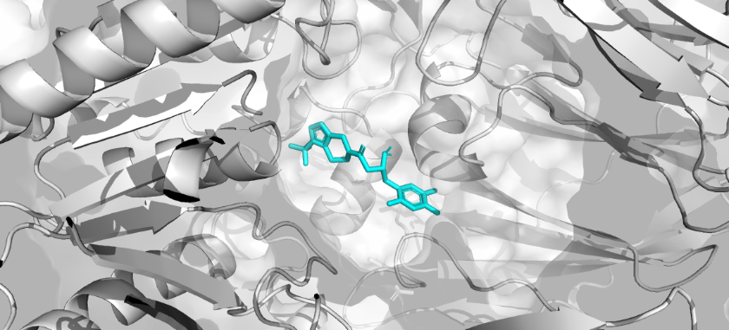

Figure 2: Docked pose of alogliptin (yellow) within the DPP-4 active site. Binding energy: −9.147 kcal/mol.
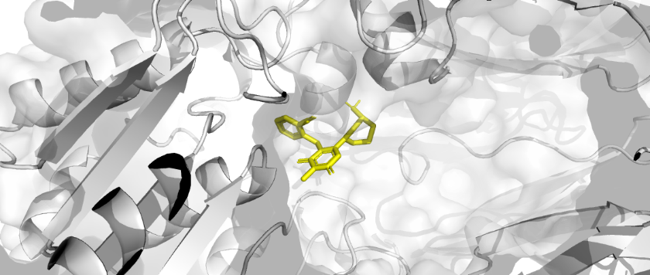

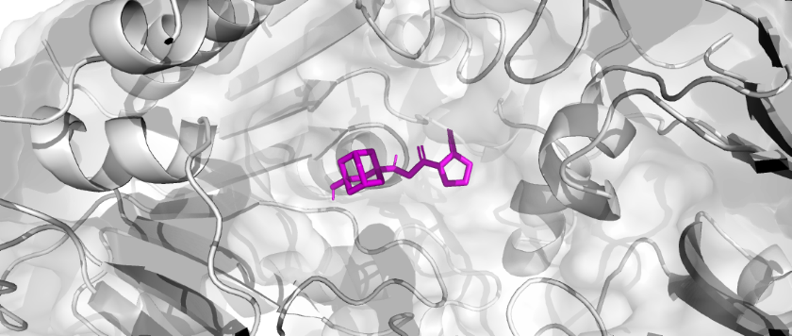
Figure 3: Docked pose of vildagliptin (magenta) within the DPP-4 active site. Binding energy: −7.862 kcal/mol.

4. Discussion
The docking results obtained in this study are broadly consistent with published experimental and computational data for this target. Sitagliptin's superior predicted binding affinity (−10.11 kcal/mol) aligns with its well-documented nanomolar inhibitory potency (IC⁵⁰ ~18 nM) and its status as the most widely prescribed DPP-4 inhibitor globally. Its higher number of rotatable bonds (6 vs 4 for alogliptin and vildagliptin) allows greater conformational flexibility for induced fit within the active site, which may contribute to its stronger binding score.

Alogliptin's score of −9.147 kcal/mol serves as a meaningful internal control, since this molecule was co-crystallised in the exact receptor structure used. The fact that redocking recovers a strong binding score, and that the docked pose coordinates are in close proximity to the active site centre, provides confidence that the docking protocol correctly identifies the binding pocket. The RMSD of 2.365 Å, while slightly above the 2.0 Å benchmark, is attributable to several factors: the relatively modest resolution of PDB structure 2ONC (2.55 Å), the removal of water molecules that may mediate bridging interactions, and the use of default exhaustiveness settings. Higher exhaustiveness values (16–32) and inclusion of key active site water molecules would likely improve this metric in future work.

The underscoring of vildagliptin (−7.862 kcal/mol) warrants specific discussion. Unlike alogliptin and sitagliptin, which are non-covalent inhibitors, vildagliptin is a reversible covalent inhibitor that forms a covalent bond with Ser630 via a nitrile warhead. AutoDock Vina employs an entirely non-covalent scoring function and therefore cannot model this covalent interaction. Consequently, vildagliptin's true binding energy — which includes the covalent bond contribution — is systematically underestimated by Vina. This is a well-recognised limitation of standard docking approaches when applied to covalent inhibitors. Specialised covalent docking protocols, such as those implemented in CovDock (Schrödinger) or AutoDock-GPU with covalent constraints, would be required to accurately model this class of inhibitor.

The identification of GLU206, SER630, TYR631, and VAL207 as key contact residues is consistent with published X-ray crystallographic analyses of DPP-4 inhibitor binding. The four hydrogen bonds observed for sitagliptin (2.4–2.7 Å) reflect the characteristic pharmacophoric interactions of gliptin-class inhibitors, particularly the hydrogen bond network with GLU206 involving the protonated piperazinium nitrogen, which is a conserved feature across multiple co-crystal structures in the PDB.

This study has several limitations that should be acknowledged. Protein flexibility was not accounted for (rigid receptor docking), which may miss induced fit effects. The docking grid was defined using the co-crystallised ligand position, which assumes knowledge of the binding site; in true prospective docking, this information may not be available. Additionally, binding scores from AutoDock Vina are estimated free energies and do not directly correspond to experimental IC⁵⁰ or K^{i} values without further calibration. Future work could include molecular dynamics simulations to assess pose stability, ADMET property prediction using SwissADME, and expansion of the ligand set to include novel DPP-4 inhibitor scaffolds from recent literature.

5. Conclusion
This self-initiated computational study successfully demonstrated a complete molecular docking workflow for three approved DPP-4 inhibitors using freely available open-source tools. Sitagliptin exhibited the highest predicted binding affinity (−10.11 kcal/mol), consistent with its established clinical potency. Active site residue analysis and hydrogen bond quantification confirmed correct ligand placement within the catalytic pocket. Protocol validation yielded an acceptable RMSD of 2.365 Å. The observed ranking of binding affinities — sitagliptin > alogliptin > vildagliptin — reflects known pharmacological properties of these agents and highlights the importance of accounting for mechanism of action when interpreting computational docking results for covalent inhibitors.

References
1. International Diabetes Federation. IDF Diabetes Atlas, 10th edn. Brussels, Belgium: International Diabetes Federation, 2021.
2. Feng J, Zhang Z, Wallace MB, et al. Discovery of alogliptin: a potent, selective, bioavailable, and efficacious inhibitor of dipeptidyl peptidase IV. J Med Chem. 2007;50(10):2297–2300. doi:10.1021/jm070104l
3. Eberhardt J, Santos-Martins D, Tillack AF, Forli S. AutoDock Vina 1.2.0: new docking methods, expanded force field, and Python bindings. J Chem Inf Model. 2021;61(8):3891–3898. doi:10.1021/acs.jcim.1c00203
4. Trott O, Olson AJ. AutoDock Vina: improving the speed and accuracy of docking with a new scoring function, efficient optimization and multithreading. J Comput Chem. 2010;31(2):455–461. doi:10.1002/jcc.21334
5. Scheen AJ. A review of gliptins in 2011. Expert Opin Pharmacother. 2012;13(1):81–99. doi:10.1517/14656566.2012.642867
6. Kim D, Wang L, Beconi M, et al. (2R)-4-oxo-4-[3-(trifluoromethyl)-5,6-dihydro[1,2,4]triazolo[4,3-a]pyrazin-7(8H)-yl]-1-(2,4,5-trifluorophenyl)butan-2-amine: a potent, orally active dipeptidyl peptidase IV inhibitor for the treatment of type 2 diabetes. J Med Chem. 2005;48(1):141–151.

Software used: AutoDock Vina 1.2.7 · MGLTools 1.5.7 · PyMOL (open-source, conda-forge) · RDKit (Python) · PubChem · RCSB PDB
Data availability: All receptor and ligand files, docking output files, and PyMOL session available upon request.

