**Name: Aditya**

**Student I’D: 224277942**

**SIT333 – Software Quality and Testing  
Task 6.1P – Code Coverage  
_________________________________________________________________________________**

***A screenshot of your Eclipse IDE’s***

1. ***JUnit tab which shows test statistics including Runs,Errors and Failures and***

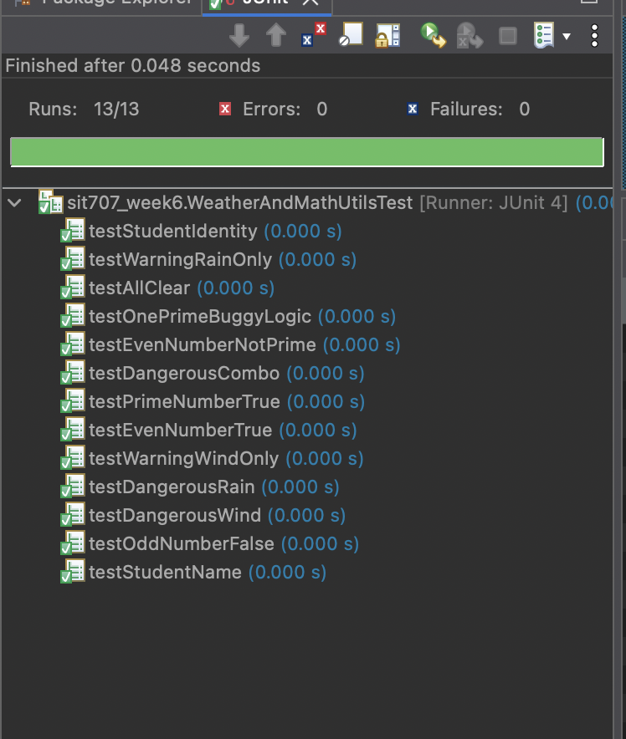

1. ***Emma coverage output which shows coverage statistics including percentage coverage per java file and corresponding number of instructions covered/missed.***

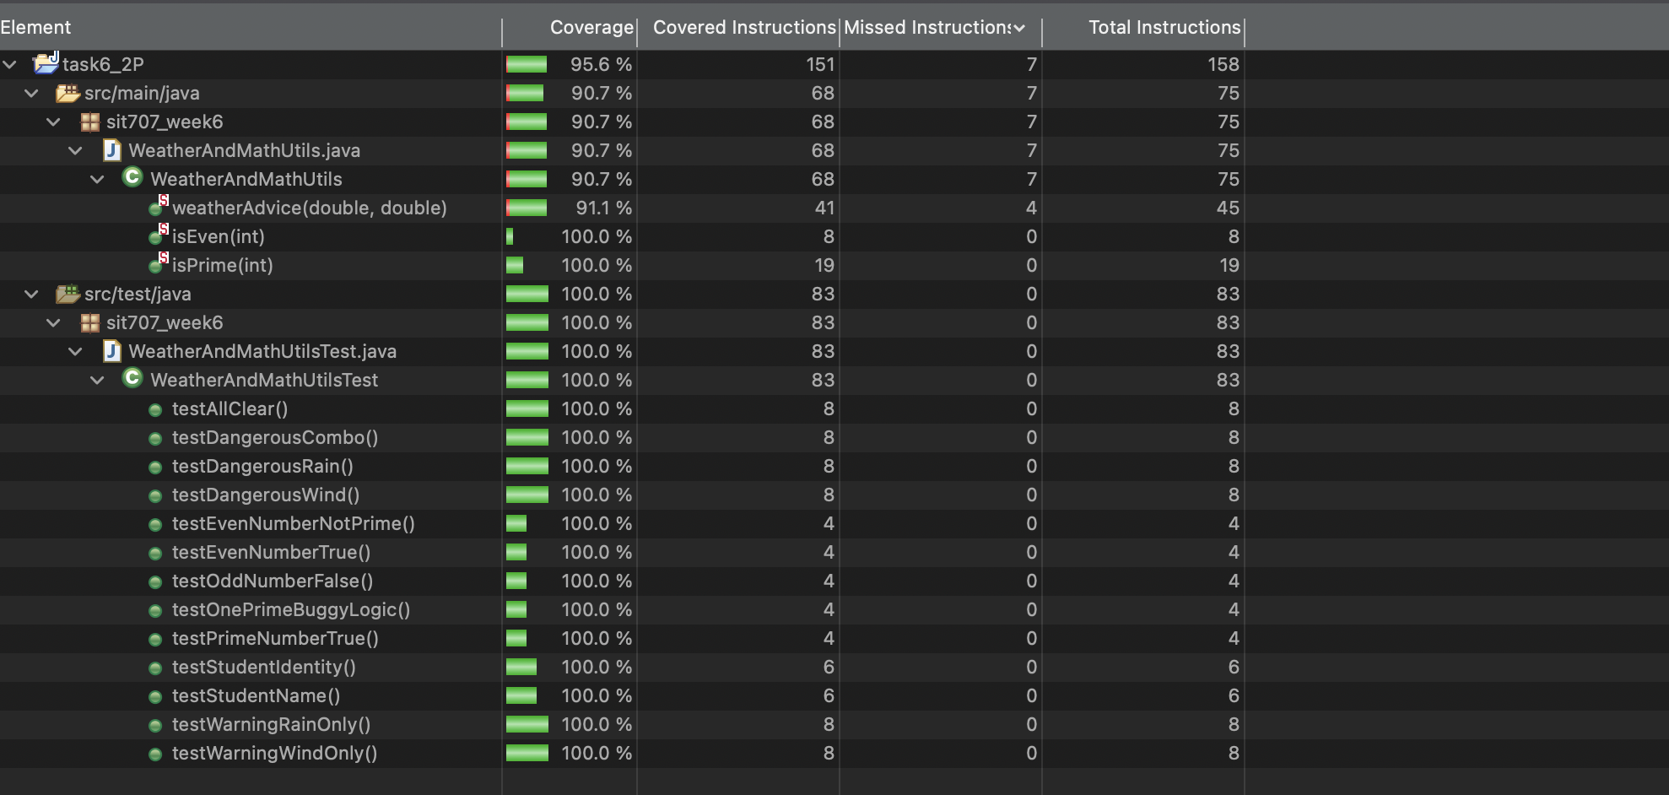

***• Your program’s source code for tests WeatherAndMathUtilsTest.java***

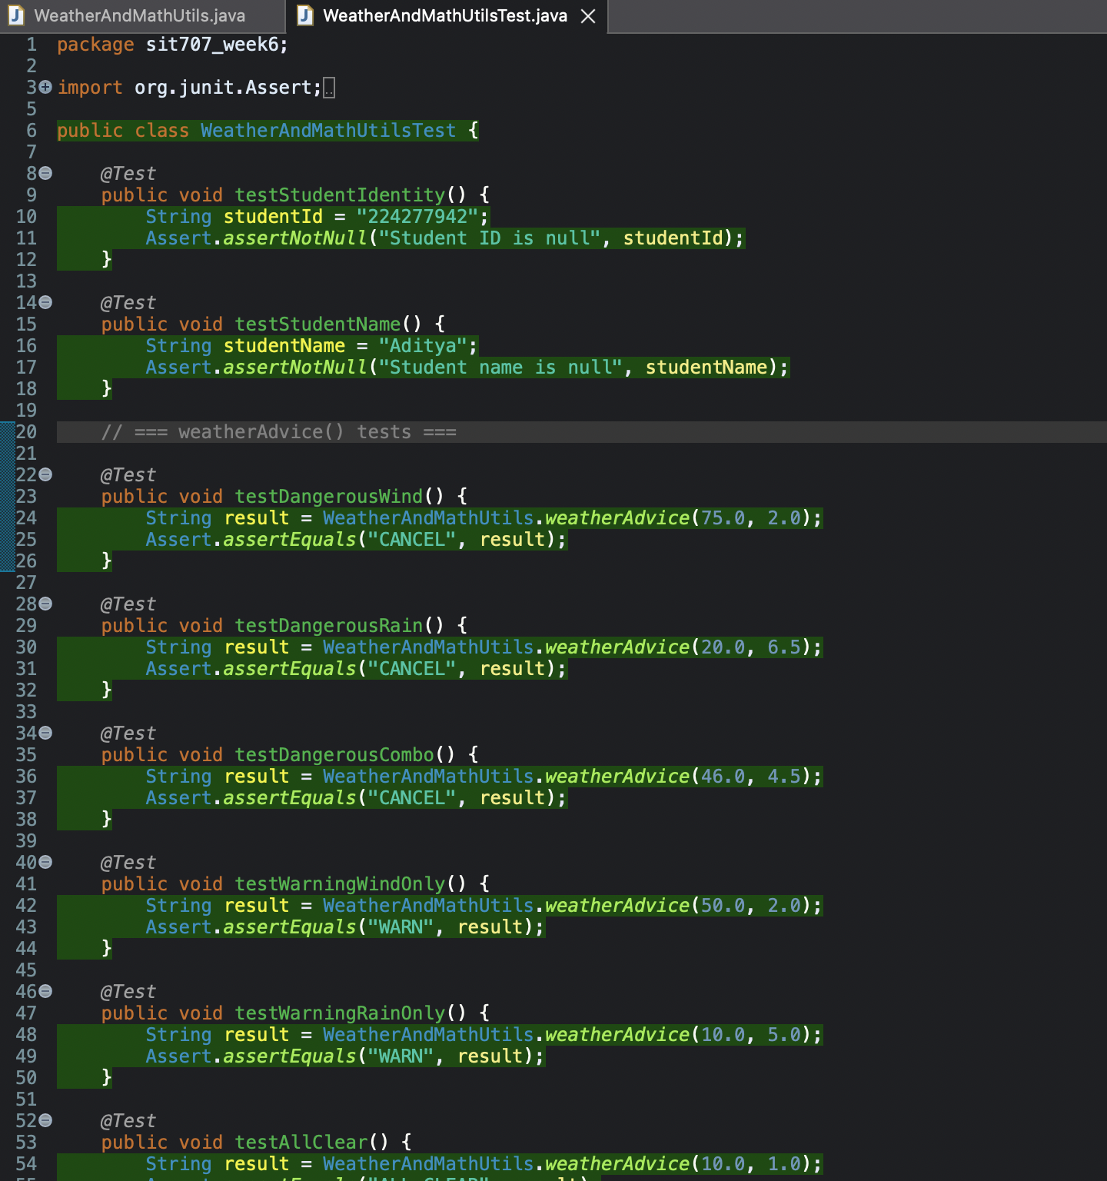

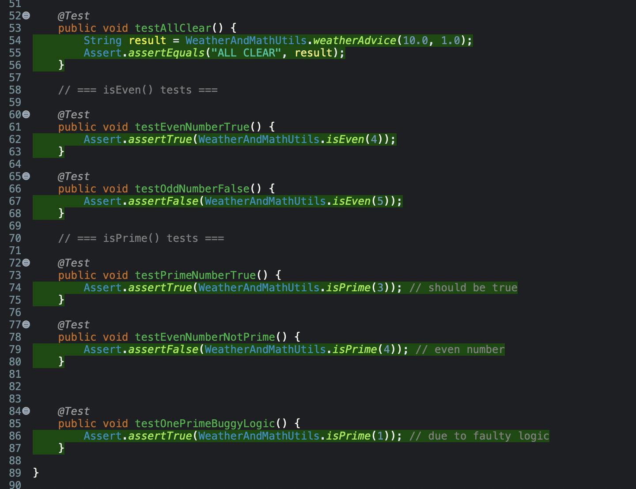

***• A screenshot of your GitHub page where your latest project folder is pushed.***

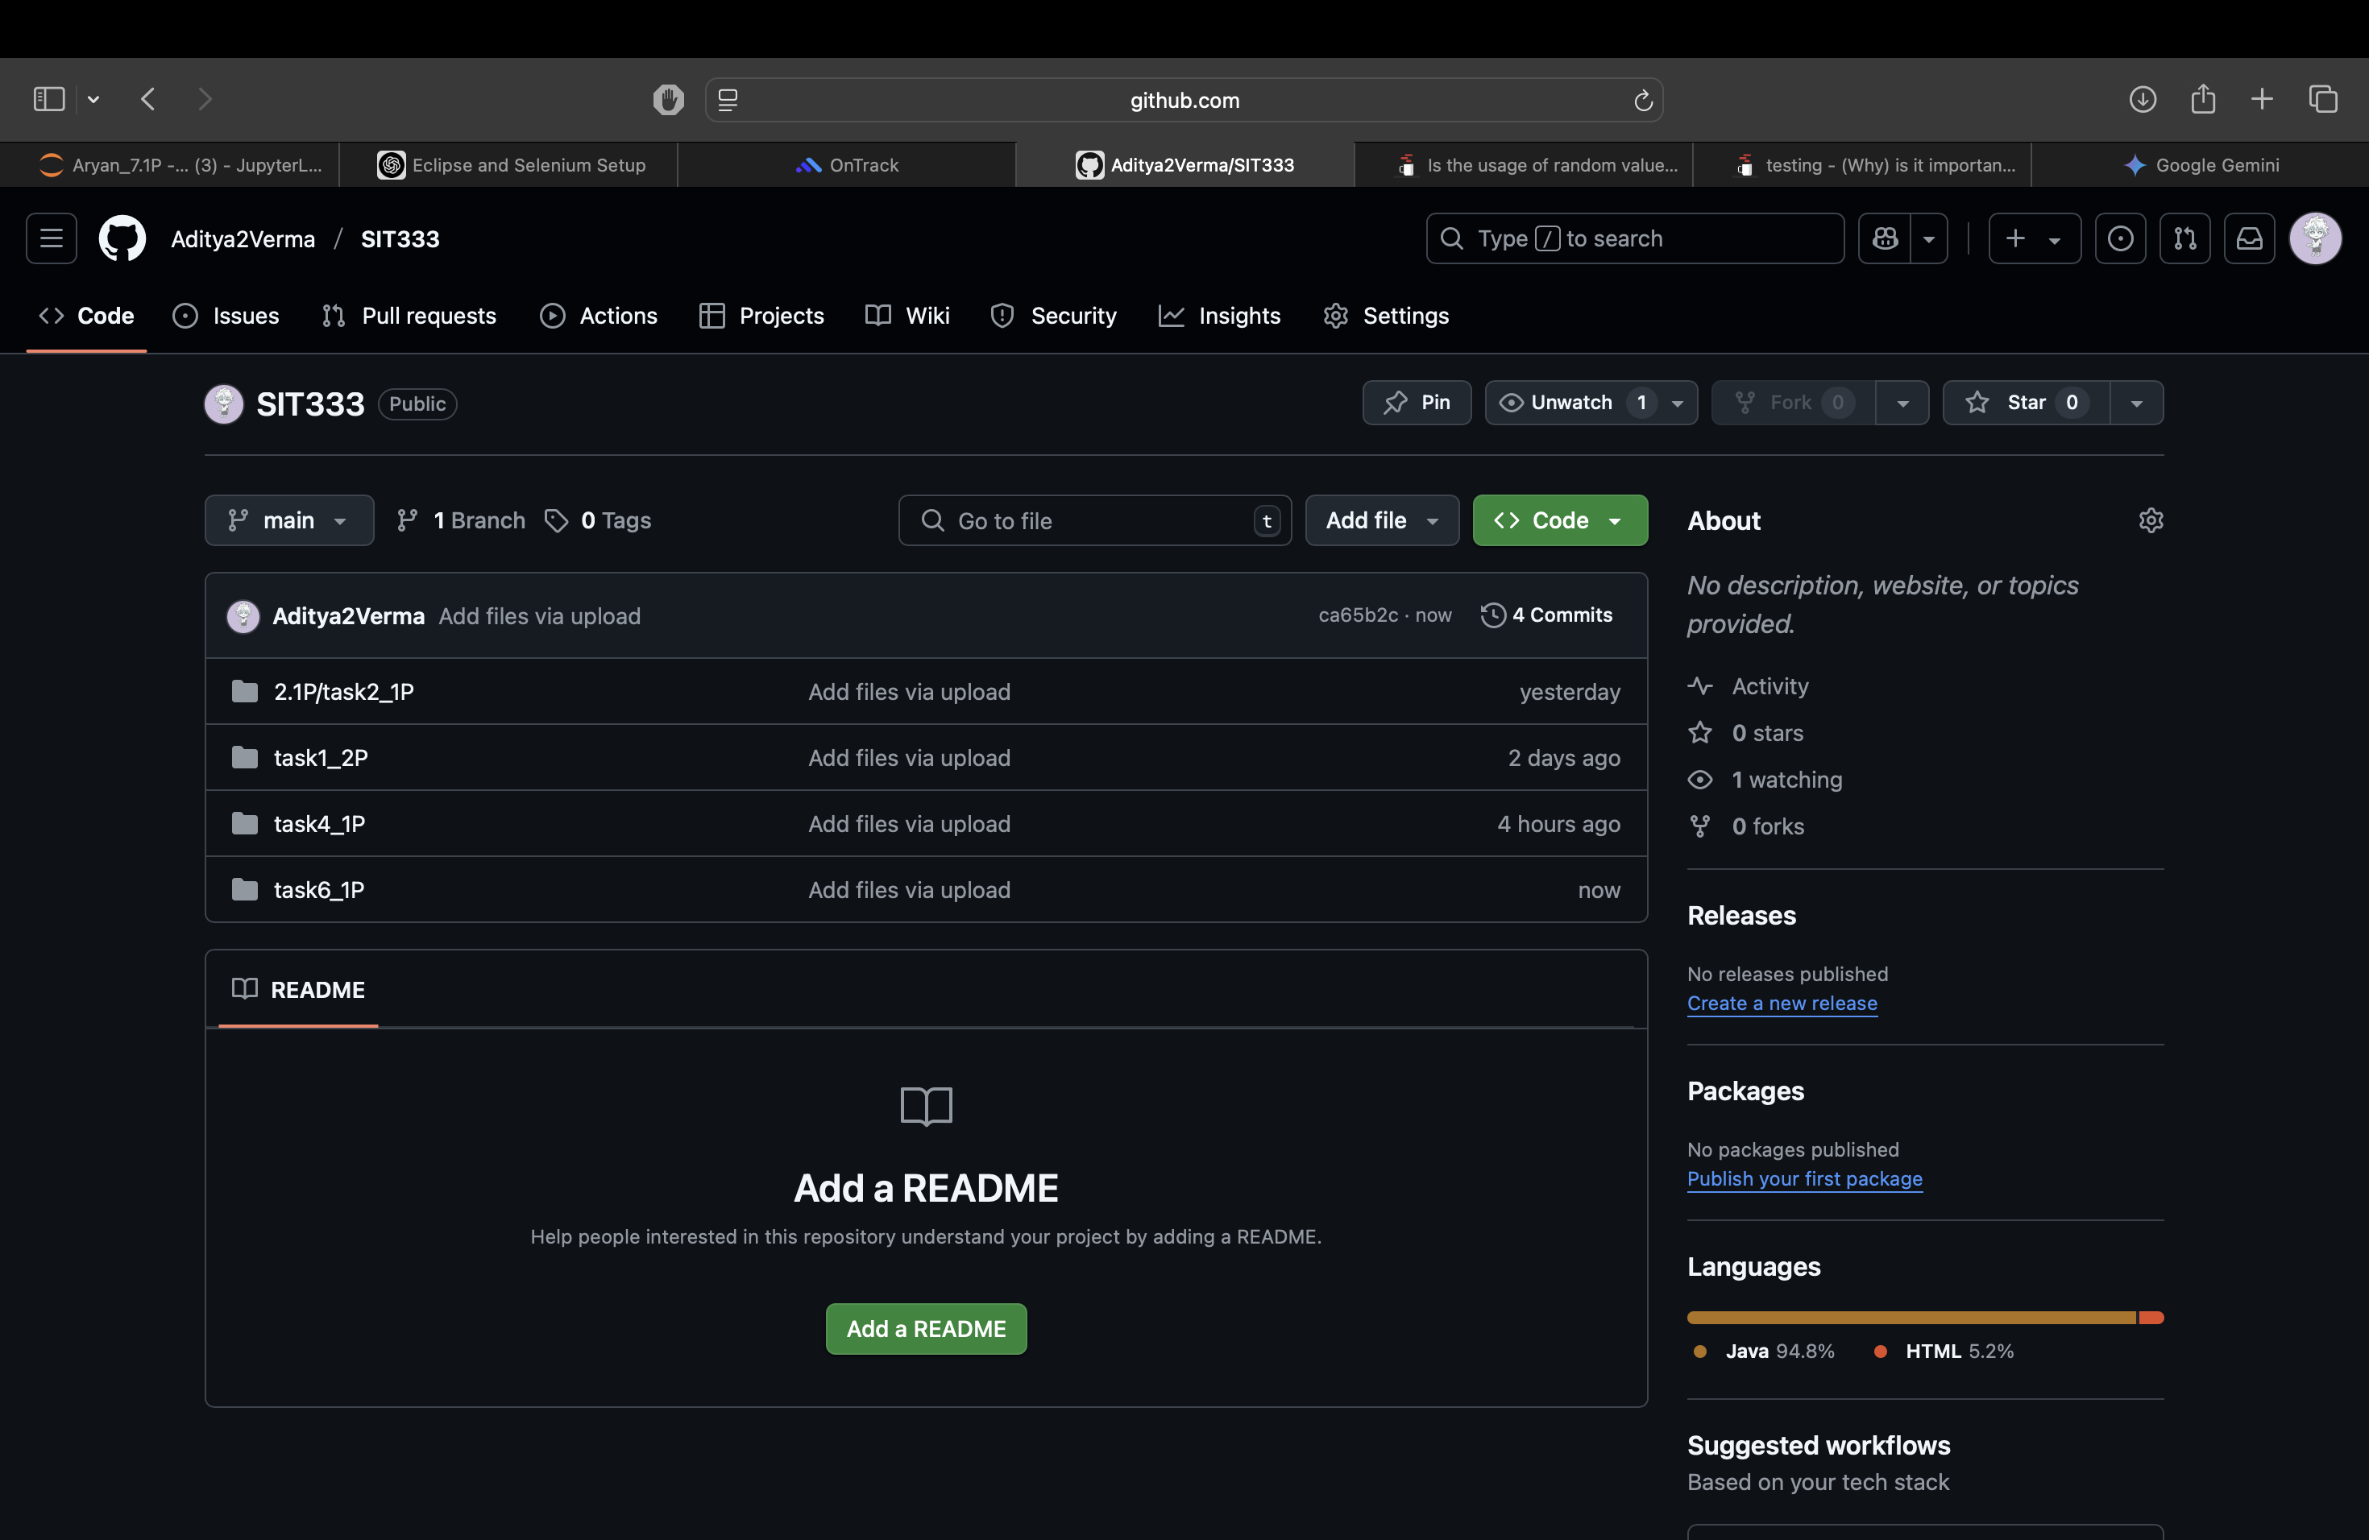

***Github link:***[**https://github.com/Aditya2Verma/SIT333**](https://github.com/Aditya2Verma/SIT333)