
Lovely Professional University
School of Computer Science and Engineering
B. Tech Project Report
on
World Economic Indicators Report
Submitted by:
ADITYA RAJ
Reg. No: 12322625
INT217
Under the Guidance of:
Mrs. Baljinder Kaur
Designation: Assistant Professor
Date: 18th April 2025

Declaration
I, Aditya raj, a student of B.Tech Computer Science and Engineering at Lovely Professional University, hereby declare that the project report titled “World Economic Indicators” is the outcome of my independent work under the guidance of Mrs. Baljinder Kaur This work has not been submitted to any other institution for any academic or non-academic purpose.

Certificate

This is to certify that the project report titled “World Economic Indicators” submitted by Aditya Raj Reg. No: 12322625 in partial fulfilment of the requirements for the award of the degree of Bachelor of Technology in Computer Science and Engineering is a record of the student’s original work carried out under my supervision.

Acknowledgement

I would like to express my sincere gratitude to my project guide, Mrs. Baljinder Kaur, for their invaluable guidance and constant support throughout this project. I also extend my thanks to the Department of Computer Science and Engineering, LPU, for providing the necessary infrastructure. Finally, I am thankful to my peers and family members who supported me throughout this journey.

Table of Contents
1. Introduction
2. Source of Dataset
3. Dataset Preprocessing
4. Analysis on Dataset
i. General Description
ii. Specific Requirements
iii. Analysis Results
iv. Visualization
5. Conclusion
6. Future Scope
7. References

1. Introduction

This project offers a comprehensive analysis of global development indicators using data sourced from the World Bank, focusing on economic, social, and environmental metrics across various countries and regions. Built using Microsoft Excel, this dashboard translates complex, multi-dimensional data into visually engaging and interactive formats, enabling users to explore trends, compare nations, and uncover insights that reflect the progress and challenges in global development.
The dataset contains a wide range of variables—such as GDP growth, life expectancy, literacy rates, population dynamics, and access to clean energy—collected over several years. By Analyzing these indicators, the project seeks to illuminate patterns of growth, inequality, and sustainability across different income groups and geographic regions.
The dashboard opens with an overview of key indicators, supported by line graphs and bar charts that track changes over time. For instance, GDP trends can be analyzed across continents or economic categories (low-income vs. high-income countries), offering a macroeconomic perspective on development. Pie charts and column charts are used to represent population distribution, energy consumption, or education enrollment by region, revealing disparities and progress in human development.
A time-series visualization enables the tracking of specific indicators (such as CO₂ emissions or healthcare access) across decades, uncovering long-term trends and the impact of global policies or events. These visualizations help contextualize development outcomes in response to interventions like international aid, policy reforms, or climate initiatives.
Interactive slicers and dropdown filters are integrated to allow users to customize the dashboard by selecting specific countries, years, or development themes, enhancing the depth and usability of the analysis. Data tables provide additional granularity, displaying country-wise or year-wise values for selected indicators.
A clean, modern, and consistent visual design enhances the clarity of the dashboard, ensuring that the data is not only informative but also accessible to a broad audience. Whether for academic research, policy review, or public understanding, this World Bank Data Dashboard acts as a powerful analytical tool—enabling users to derive meaningful insights, support informed decision-making, and contribute to conversations on sustainable development and global equity.

2. Source of Dataset
The dataset utilized for this project is sourced from the "Maven Analytics Data Playground," publicly accessible on the Maven Analytics platform at Free Data Sets & Dataset Samples | Maven Analytics (World Economic Indicators)
(https://mavenanalytics.io/dataplayground?page=3&pageSize=5)
a well-established hub for data enthusiasts, professionals, and learners seeking high-quality datasets for analytical and research purposes. Maven Analytics has emerged as a leading platform providing diverse, real-world datasets that support skill development in business intelligence, data analysis, and data visualization.
This particular dataset was selected for its relevance and structured presentation of real-world data, aligning with the project’s objectives of deriving actionable insights from comprehensive data sources. The platform’s curated collection ensures that the datasets are clean, well-documented, and tailored for educational and professional applications.
Maven Analytics fosters a community-driven approach where data practitioners engage with datasets through projects, challenges, and shared insights, enhancing the practical applicability and credibility of the datasets hosted. This collaborative environment promotes transparency, innovation, and knowledge sharing, making it a trusted source for analytics projects.
The dataset is made available under Maven Analytics’ user-friendly data sharing policies, promoting free access for educational and non-commercial research purposes. The platform’s emphasis on real-world scenarios ensures that the dataset is suitable for developing data-driven solutions, dashboards, and reports that reflect industry practices.
For this project, the dataset’s structure, accuracy, and relevance to real-life scenarios provide a reliable foundation for analysis, supporting data-driven decision-making and visualization. The dataset's adaptability, combined with Maven Analytics’ commitment to data quality and community engagement, makes it an ideal resource for this study.

3. Dataset Preprocessing
1. Data Cleaning and Structuring
- The dataset has been cleaned and formatted for proper analysis.
  - Uniform column naming conventions have been used.
  - Missing or null values have been handled appropriately (either removed or marked as NaN).
  - Year-wise data (2000–2022) is structured in a tidy tabular form.

2. Selection of Key Development Indicators
- Specific development indicators were selected out of a larger dataset.
  - Indicators such as GDP per capita, Life Expectancy, Literacy Rate, Urban Population, CO₂ Emissions, and others were isolated for focused analysis.
  - Non-essential columns or irrelevant indicators were excluded to maintain clarity.

3. Region-Wise Grouping and Aggregation
- Data was grouped by regions (East Asia & Pacific, Europe & Central Asia)
  - Average values of indicators per region were calculated.
  - This allows region-to-region comparison and helps understand broader development trends.

4. Time-Series Analysis of Indicators
- Tracked how each indicator changed over the years from 2000 to 2022.
  - Year-over-year changes were examined for individual countries and regions.
  - This helps in identifying growth patterns or decline over time, e.g., improvement in literacy rate.

5. Cross-Country Comparisons
- Compared selected countries across specific indicators.
  - For instance, GDP per capita or Life Expectancy of India, China, and USA were compared.
  - This allows identification of which country is performing better in which area.

6. Visualization-Ready Data Structuring
- Data has been arranged in a format ready for charts/graphs.
  - Each indicator’s data is sorted in a way that line charts, bar graphs, and regional heatmaps.
  - This structure supports building dashboards or visual stories around the data.

Pivot Table’s :-
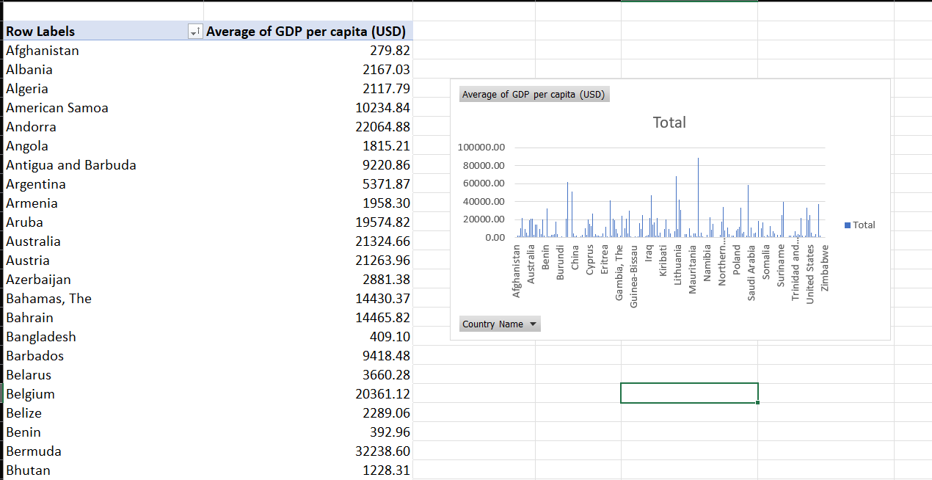
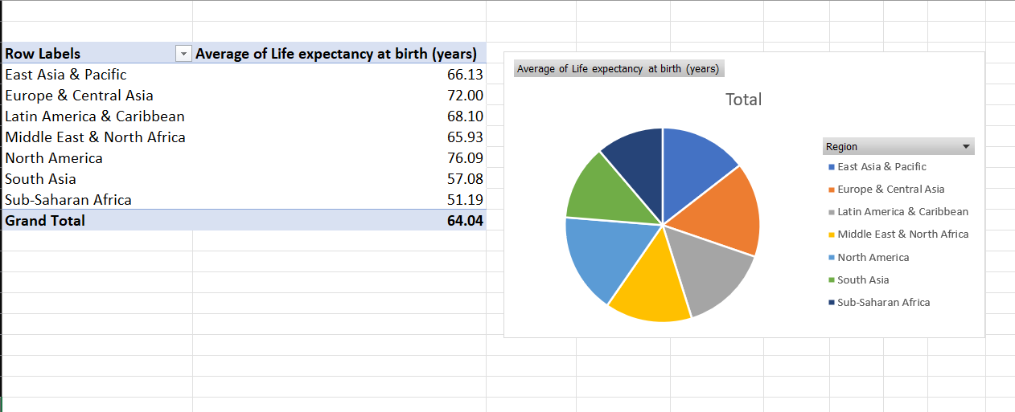
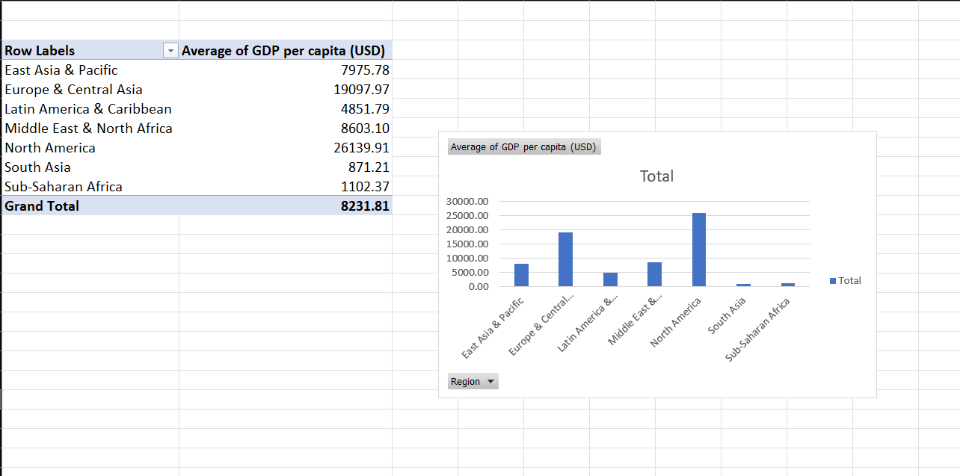
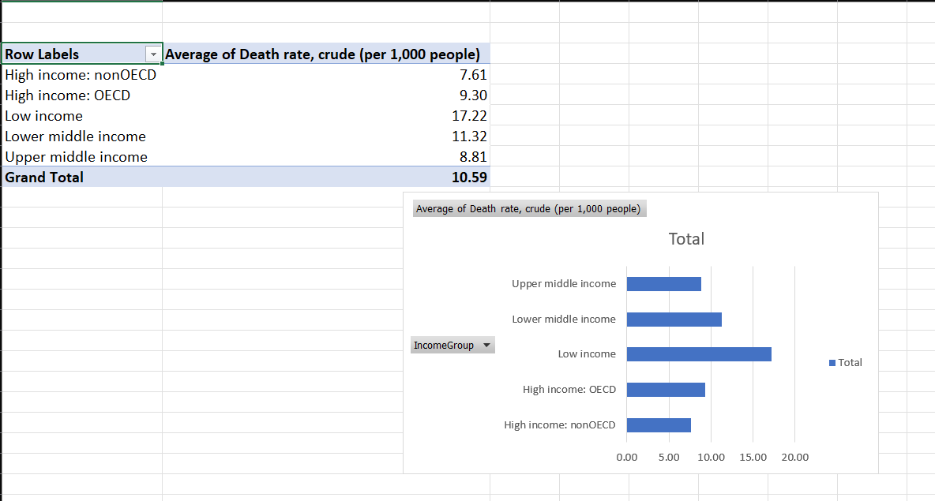
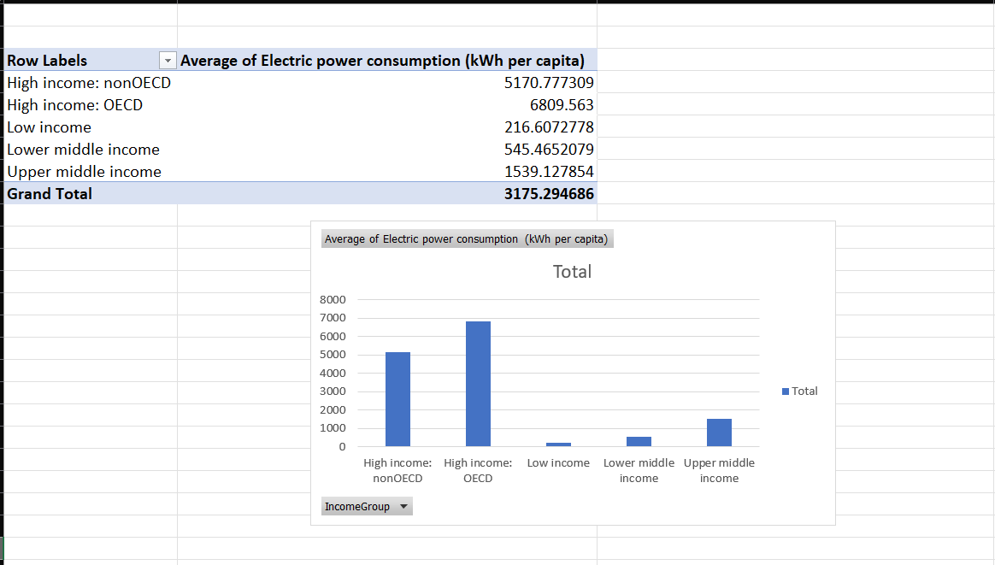
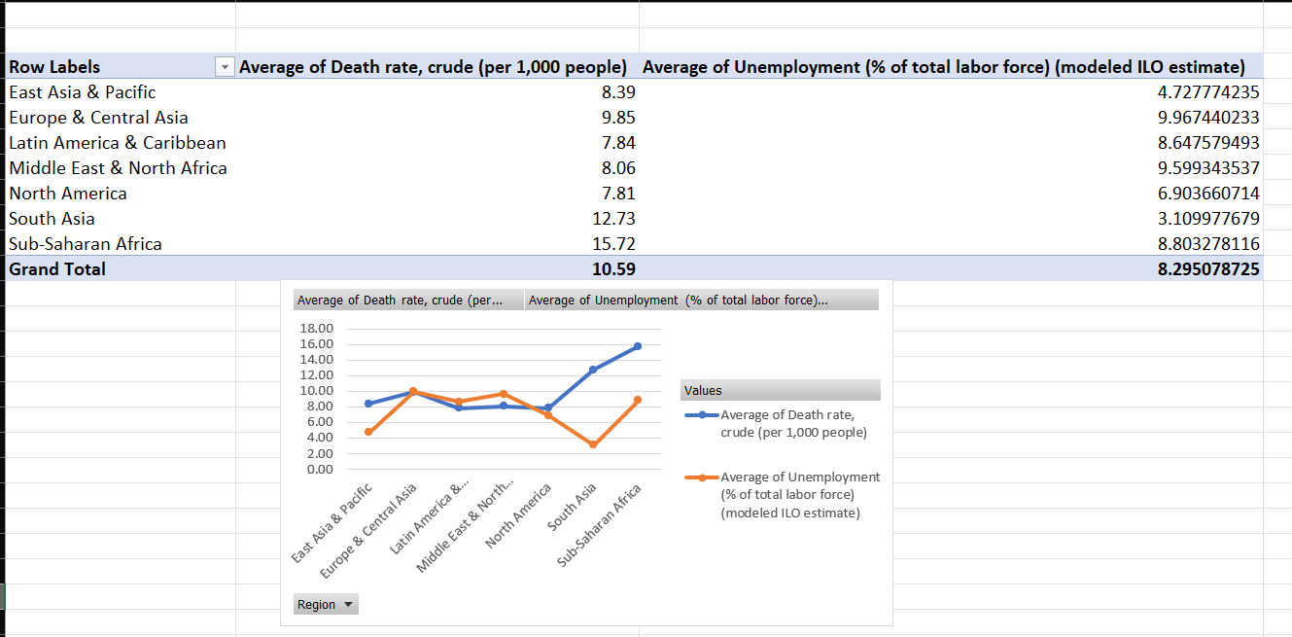
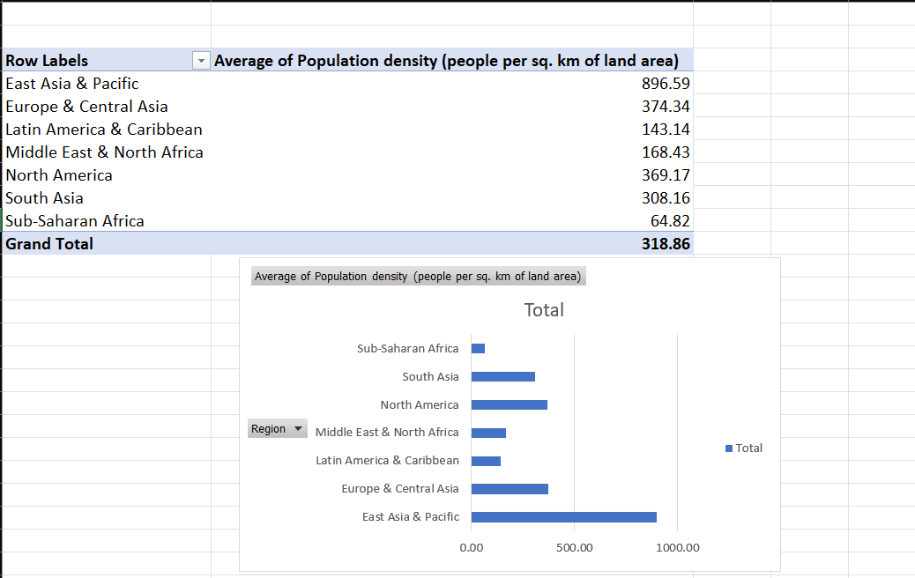

5. Conclusion
- Global Development Trends Identified:
  - The dashboard effectively showcases long-term trends (2000–2022) across key World Bank development indicators such as GDP per capita, life expectancy, and urban population growth.
  - These trends help identify which regions are progressing and which are lagging behind, supporting the World Bank’s mission of reducing global poverty and inequality.
- Regional Inequality Clearly Visualized:
  - Using regional groupings (e.g., South Asia, Sub-Saharan Africa, Europe & Central Asia), the dashboard makes disparities in development visually apparent.
  - This aligns with the World Bank's strategy of region-specific policy intervention.
- Data-Driven Insights for Policymakers:
  - The structured and filtered data enables comparative analysis between countries and indicators, empowering policymakers to target specific areas such as education or health.
  - For example, lower life expectancy in certain regions can be linked to gaps in healthcare infrastructure.
- Supports Monitoring of SDG Progress:
  - Many of the selected indicators (e.g., literacy rate, CO₂ emissions) directly tie into Sustainable Development Goals (SDGs) tracked by the World Bank and UN.
  - The dashboard acts as a monitoring tool for countries to evaluate their development targets.
- Foundation for Economic and Social Planning:
  - The insights provided can guide economic planning, international aid distribution, and social development programs — all key focus areas of World Bank-backed projects.
- Transparent and Reliable Use of Open Data:
  - The use of open-access, clean, and structured datasets mirrors the World Bank’s emphasis on open development data and transparency in global development monitoring.

Future Scope
1. Integration with Real-Time World Bank APIs
- Connect the dashboard directly with World Bank Open Data APIs to ensure automatic updates.
- This will make the dashboard dynamic and up-to-date, useful for ongoing policy decisions and reports.
2. Predictive Analytics and Forecasting
- Use machine learning models to forecast future trends in indicators like GDP, CO₂ emissions, or literacy rate.
- This would help policymakers anticipate future challenges and prepare proactive strategies.
3.Interactive Geospatial Visualizations
- Implement world maps and regional heatmaps to display data visually.
- Users can click on a country/region to view detailed development profiles — similar to the World Bank’s online data portals.
4. Deeper Indicator Breakdown
- Include sub-indicators like male/female literacy rates, urban/rural life expectancy, or sector-specific GDP contributions.
- This enables more nuanced and inclusive development analysis.
5.Personalized Dashboards for Stakeholders
- Add role-based views for policymakers, researchers, NGOs, or educators, each showing data relevant to their goals.
- Custom dashboards support targeted insights and decision-making.
6. Case Study Integration
- Link indicators with real-world case studies, e.g., how a rise in literacy in Bangladesh impacted economic growth.
- This makes the dashboard not just statistical but story-driven and impactful.
7. Policy Simulation Tools
- Integrate simple simulators where users can adjust variables (e.g., increase education spending) and see predicted outcomes.
- A great tool for understanding the impact of development policies before implementation.
8. Alignment with Sustainable Development Goals (SDGs)
- Highlight progress of countries toward the 17 UN SDGs, mapping each indicator to relevant goals.
- Helps global organizations track and accelerate sustainable development.

References
World Economic Indicators
Open Data DC - Free Data Sets & Dataset Samples | Maven Analytics (World Economic Indicators)
(https://mavenanalytics.io/dataplayground?page=3&pageSize=5)

Tools Used: Microsoft Excel (Pivot Tables, Charts, Slicers, Conditional Formatting)
Techniques Applied: Data Cleaning, Time Series Analysis, Revenue Analysis, Dashboard Design

DASHBOARD SCREENSHOT:
