Aditya Saxena
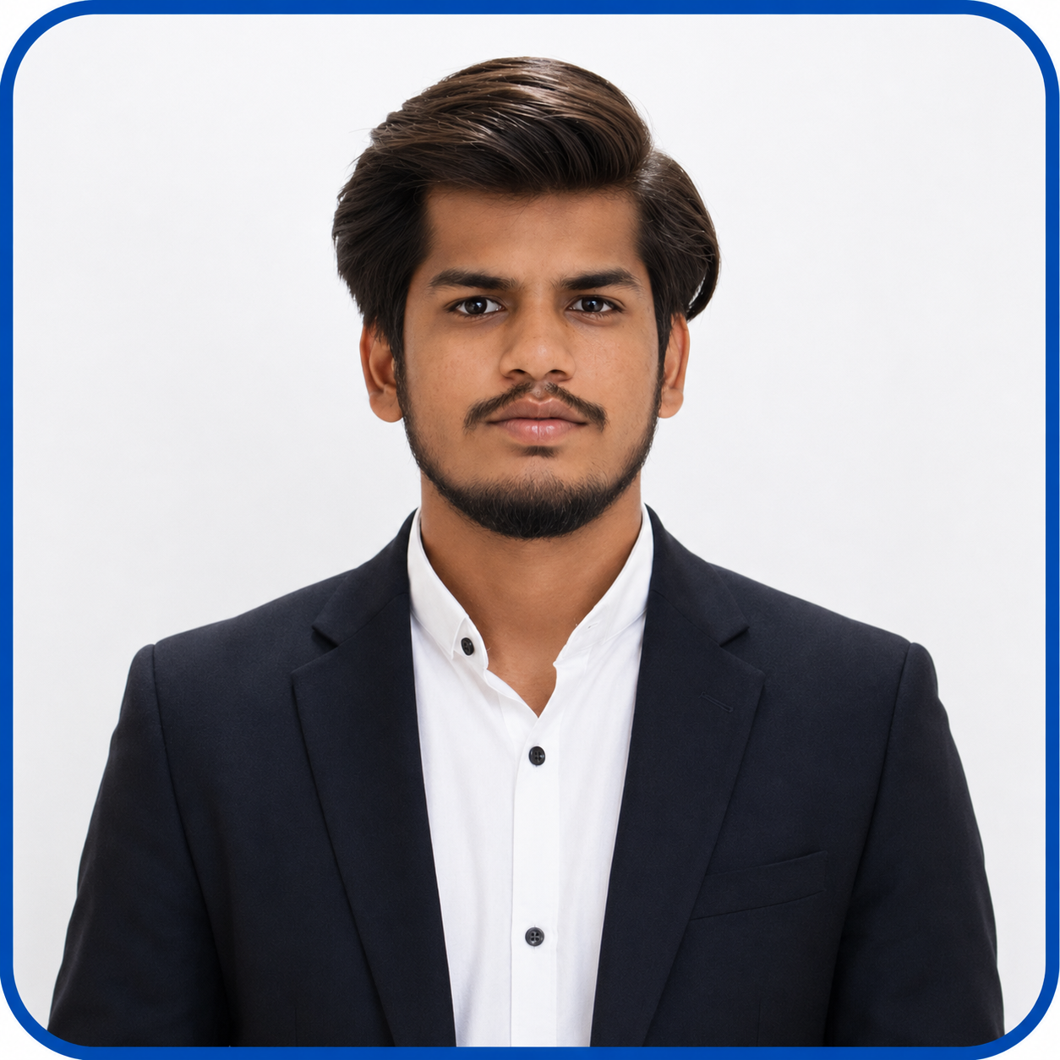Paste your professional he ad shot picture inside
Mainpuri, +91 6398767385, adityasaxena1_cs23@gla.ac.in
Linkedin: https://www.linkedin.com/in/aditya-saxena-00bba4296/
Github: https://github.com/Aditya2saxena

EDUCATION

Bachelor of Technology in Computer Science, GLA University, Mathura, 72.2% May 2027
Intermediate, Paradise Public Senior Secondary School, Mainpuri, 80% May 2023
High School, Paradise Public Senior Secondary School, Mainpuri, 88% May 2021

SKILLS
Technical Skills Professional Skills

• Java, Python • Problem Solving

• HTML, CSS, JavaScript, Bootstrap • Effective Communication

• Node.js , Express.js, • Teamwork and Collaboration

• MongoDB, MySQL • Time Management

• OOPs, Data Structures and Algorithms

• Git, GitHub, VS Code

PROJECTS
WanderLust – Full Stack Listing Platform
- Developed a full-stack property listing web application using Node.js, Express.js, MongoDB, Mongoose, EJS, and Bootstrap.
- Implemented RESTful CRUD APIs with server-side validation, dynamic routing, and efficient data management using Express.js and MongoDB.
- Enhanced application reliability by adding custom error handling, reusable layouts, and a responsive user interface with Bootstrap.
Event-Sourced Task Management System
- Developed an event-driven task management system using Node.js, Express.js, and MongoDB to efficiently manage task lifecycle operations.
- Implemented immutable event storage for task creation, updates, completion, and deletion, ensuring complete event history and data consistency.
- Designed replay-based state reconstruction and snapshot mechanisms to improve application recovery performance, scalability, and fault tolerance.

CERTIFICATIONS & ACHIEVEMENTS
• Leadership and Team Effectiveness – NPTEL (IIT Roorkee)
• Full Stack Development Using Java – KVCH & GLA University
• Flutter – Cisco thingQbator & NASSCOM Foundation
• Digital Marketing Fundamentals – SMstudy

CO-CURRICULAR ACTIVITIES

• Regularly practice Data Structures and Algorithms through coding platforms like LeetCode and GeeksforGeeks.
• Participated in school-level cricket competitions, demonstrating teamwork and leadership.

DECLARATION________________________________________________________________________________________

I hereby declare that all the above mentioned information is true and correct to the best of my knowledge.

