Task

Drive-by-Wire:

Normally the vehicle’s control system consists of mechanical and hydraulic systems. Using these control systems made the machine heavy. So, these control systems are replaced by Drive-by-wire technology, also known as x-by-wire. In these control systems, the controlling is done by wires rather than hydraulic or mechanical systems. Because of this, the weight of the vehicle is reduced significantly. It reduced the weight and made it safer as there could be less reliance on liquid and mechanical support for braking or changing the gears, which could be a potential problem for fluid leakage and mechanical failures.

It mainly consists of four parts:

1. Sensors: These are responsible for taking the input from driver, and are also used to get the condition of the road. Its consists of acceleration pedal angle, steering wheel angle, speed of vehicle, road condition, etc.
2. Electronic control unit (ECU): This is the brain of the system, these process the input from sensors and give commands to the actuators.
3. Actuators: These are the devices which follow the command given by the ECU, like turning the wheel, braking, accelerating, etc.
4. Wiring and communication system: These connect the above three, sensors to ECU to actuators. These mostly use Controller Area Network (CAN) or FlexRay.

This drive-by-wire is divided into types for easier and more efficient working. They are:

1. Throttle-by-wire: This system takes the input from the angle of acceleration and sends it to ECU. ECU then adjusts the throttle according to the acceleration pedal position. This system replaces the mechanical linkage between the acceleration pedal and throttle.

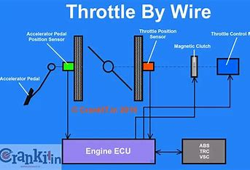

1. Brake-by-wire: This system is similar to throttle-by-wire, where it takes the input from the position of brake pedal and sends it to the ECU, and the ECU commands the brakes. This system replaces the hydraulic control system for braking. Using this system makes it easier to integrate with latest technologies like ABS into the system.
2. Steer-by-wire: This system is also similar to the above systems. This system replaces the mechanical linkage between the steering system and the steering wheel. It takes input from the driver by using sensors on the steering wheel. It reduces the weight of vehicles and more flexible designs are possible with this system.

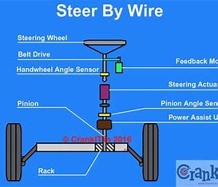

1. Shift-by-wire: This system replaces the mechanical linkage between the gearbox and the gear shift. The gear if shifted using electronic signals given by the ECU.

Advantages of this system:

1. Less weight: It is less heavy as most of the mechanical components are replaced by the electronic components which are lighter in weight.
2. Design flexibility: Allows more freedom in vehicle design and interior layout.
3. Reduced maintenance: There are less mechanical components, which means there will be less wear and tear, thereby reducing the maintenance.