A PROJECT REPORT ON
MAAN SARATHI
AI-POWERED MENTAL WELLNESS PLATFORM WITH
HOLISTIC HEALING AND EMOTIONAL SUPPORT
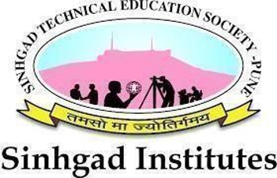
SUBMITTED TO THE SAVITRIBAI PHULE PUNE UNIVERSITY, PUNE
IN THE PARTIAL FULFILLMENT OF THE REQUIREMENTS FOR THE AWARD OF THE
DEGREE
OF
BACHELOR OF ENGINEERING
IN
INFORMATION TECHNOLOGY
SUBMITTED BY
MR. ADITYA SHIRSAT | EXAM NO: B400430407
MR. ATHARVA LOLE | EXAM NO: B400430382
MS. NEHA KAMBLE | EXAM NO: B400430371
MR. SOURABH SHIRKANDE | EXAM NO: B400430406

UNDER THE GUIDANCE OF
PROF. R. R. YADAV
DEPARTMENT OF INFORMATION TECHNOLOGY
STES'S SINHGAD ACADEMY OF ENGINEERING
KONDHWA BK, PUNE 411048
ACADEMIC YEAR 2025-26

