COMP 7003

Assignment 2

Testing

Aditya Singh Attri

A01276335

Oct 5th,2024

|  |  |  |  |
| --- | --- | --- | --- |
| **Test No.** | **Test** | **Expected** | **Actual** |
| 1 | Running ARP normally once | pass | pass |
| 2 | Running ipv4 normally once | pass | pass |
| 3 | Running TCP normally once | pass | pass |
| 4 | Running UDP normally once | pass | pass |
| 5 | Running with invalid interface name | fail | fail |
| 6 | Running with invalid filter | fail | fail |

# Test 1

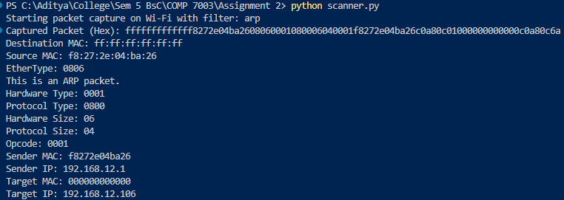

# Test 2

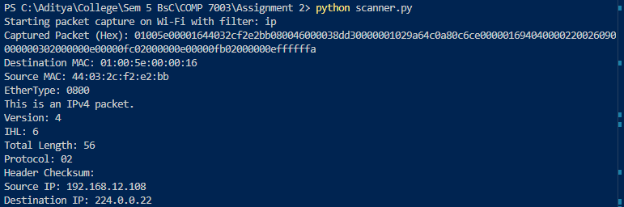

# Test 3

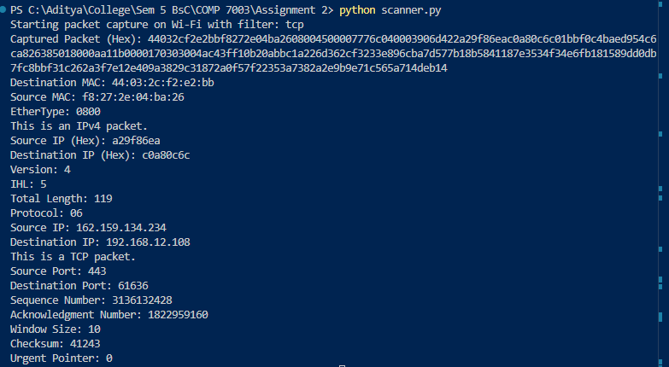

# Test 4

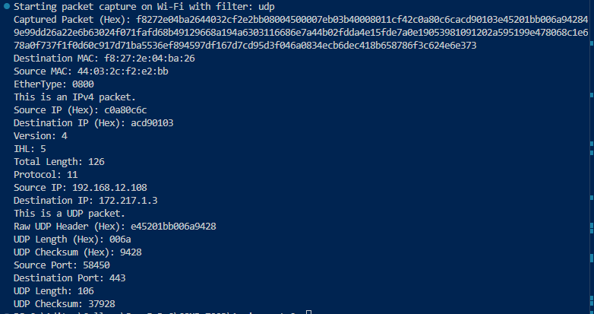

# Test 5



# Test 6

