COMP 7005

Assignment 1

Testing

Aditya Singh Attri

A01276335

Sept 22nd,2024

|  |  |  |  |  |  |
| --- | --- | --- | --- | --- | --- |
| Test No. | Expected | Client | | Server | |
| Expected | Actual | Expected | Actual |
| 1 | No arguments - Client | Fail | Fail | - | - |
| 2 | No arguments - Server | - | - | Fail | Fail |
| 3 | Different socket paths | Fail | Fail | Pass | Pass |
| 4 | Invalid command - client | Fail | Fail | - | - |
| 5 | WRITE text to a new file on the server | Pass | Pass | Pass | Pass |
| 6 | READ from file present on the server | Pass | Pass | Pass | Pass |
| 7 | READ from file not present on the server | Fail | Fail | Pass | Pass |
| 8 | WRITE empty message to a new file on the server | Fail | Fail | Pass | Pass |
| 9 | READ from file present where server does not have permission | Fail | Fail | Pass | Pass |
| 10 | WRITE text to file on server with special characters in its name | Fail | Pass | Pass | Pass |

# Test 1



# Test 2



# Test 3

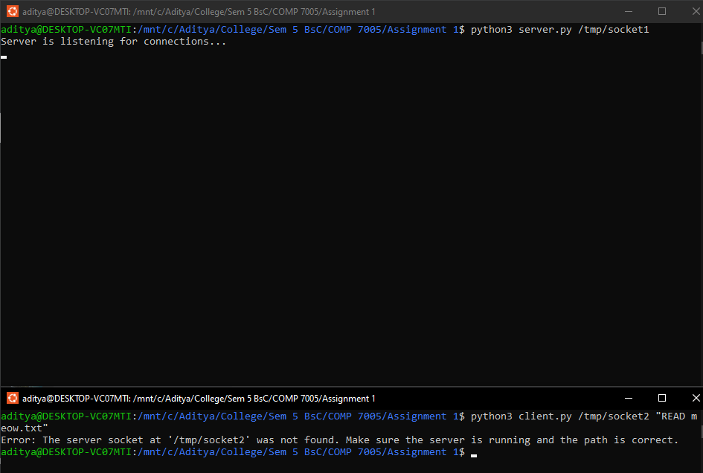

# Test 4

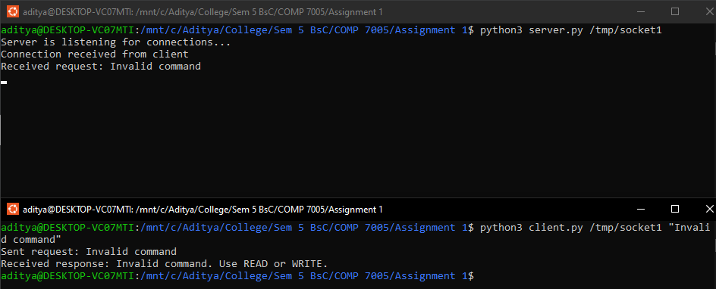

# Test 5

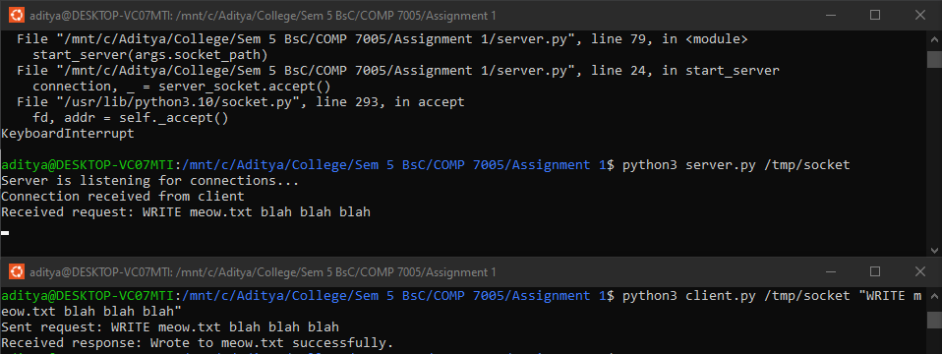

# Test 6

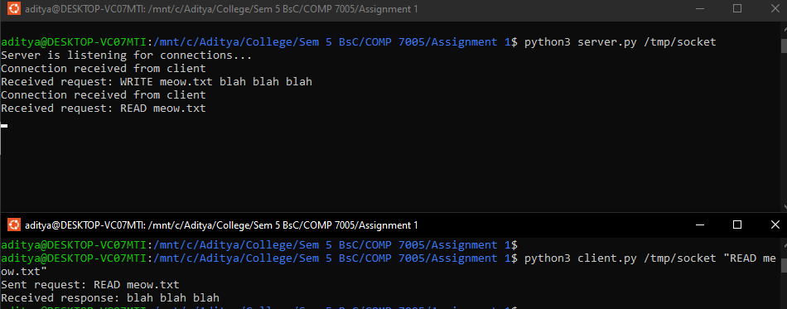

# Test 7

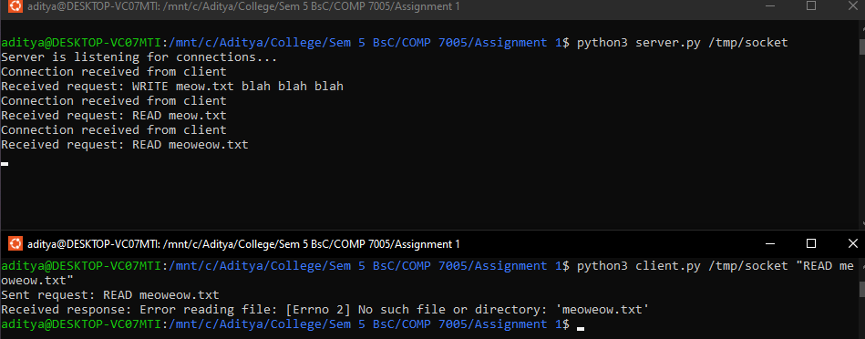

# Test 8

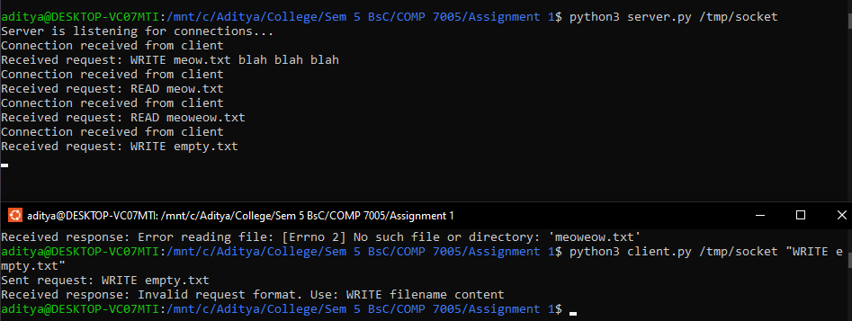

# Test 9

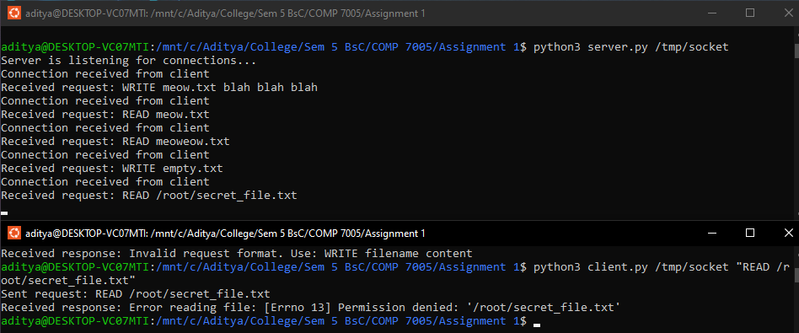

# Test 10

