COMP 7005

Assignment 2

Testing

Aditya Singh Attri

A01276335

Oct 6th, 2024

|  |  |  |  |  |  |
| --- | --- | --- | --- | --- | --- |
| Test No. | Expected | Client | | Server | |
| Expected | Actual | Expected | Actual |
| 1 | No arguments - Client | Fail | Fail | - | - |
| 2 | No arguments - Server | - | - | Fail | Fail |
| 3 | Wrong IP address – Client | Fail | Fail | - | - |
| 4 | Wrong Port number – Client | Fail | Fail | - | - |
| 5 | Sending file normally | Pass | Pass | Pass | Pass |
| 6 | Sending empty file | Pass | Pass | Pass | Pass |
| 7 | Sending file with no alphabets | Pass | Pass | Pass | Pass |
| 8 | Invalid file path/File does not exist | Pass | Pass | - | - |
| 9 | Multiple Clients | Pass | Pass | Pass | Pass |
| 10 | Huge file | Pass | Fail | Pass | Pass |

# Test 1



# Test 2



# Test 3



# Test 4



# Test 5



# Test 6



# Test 7



# Test 8



# Test 9

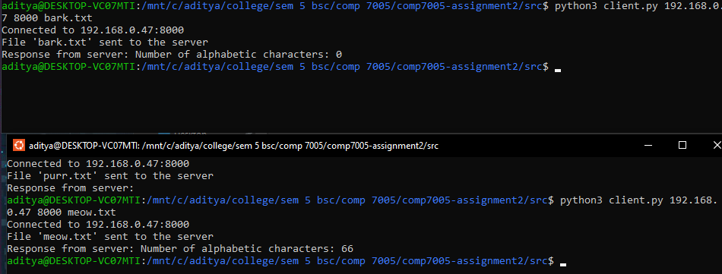

# Test 10

