COMP 7005

Assignment 3

Testing

Aditya Singh Attri

A01276335

Nov 9th, 2024

|  |  |  |  |
| --- | --- | --- | --- |
| Test No. | Test | Expected | Actual |
| 1 | Run program code example from assignment | Pass | Pass |
| 2 | Run program with open ports visible | Pass | Pass |
| 3 | Run program with 5 second delay | Pass | Pass |
| 4 | Run program with no delay | Pass | Pass |
| 5 | Run program without end parameter | Pass | Pass |
| 6 | Run program without start parameter | Pass | Pass |
| 7 | Run program without start and end parameter | Pass | Pass |
| 8 | Run program with negative parameter | Fail | Fail |
| 9 | Run program with start parameter greater than end parameter | Fail | Fail |
| 10 | Run program without number inside start parameter | Fail | Fail |
| 11 | Run program without number inside end parameter | Fail | Fail |
| 12 | Same start and end port number | Pass | Pass |
| 13 | Change IP address to invalid format | Fail | Fail |

# Test 1

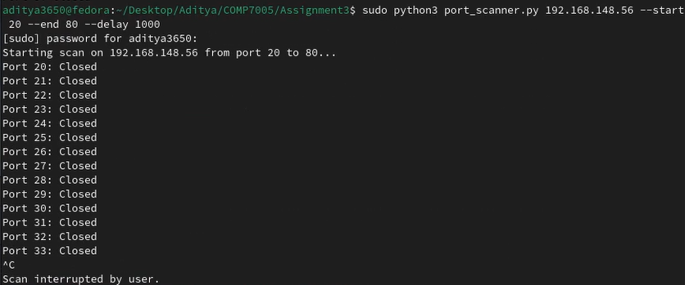

# Test 2

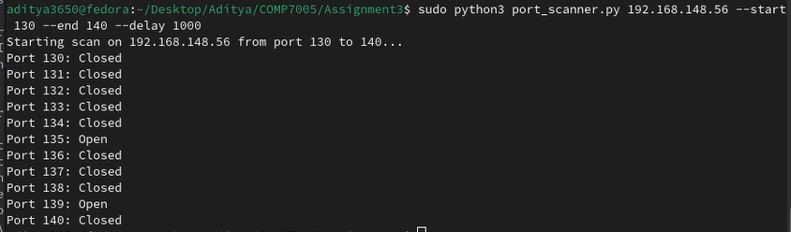

# Test 3

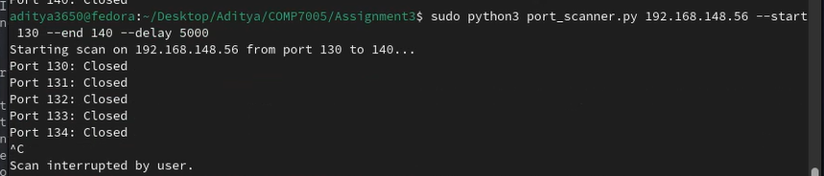

# Test 4

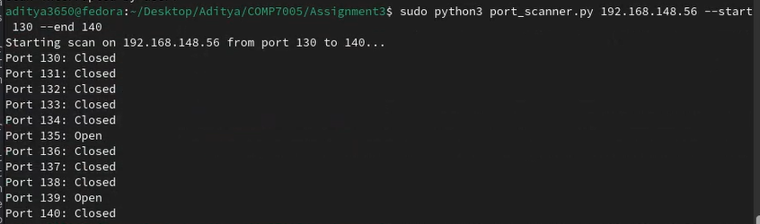

# Test 5

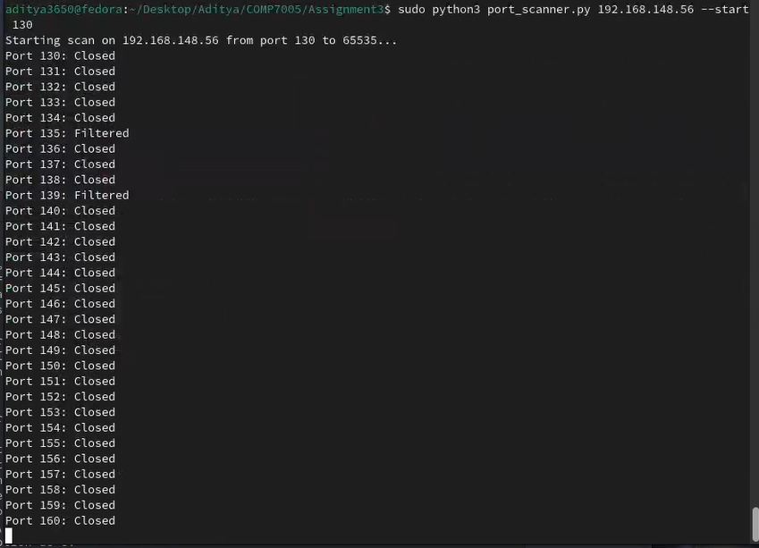

# Test 6

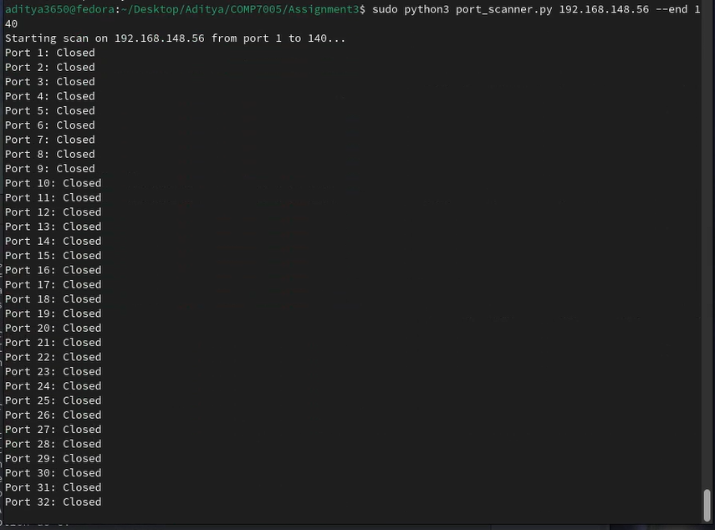

# Test 7

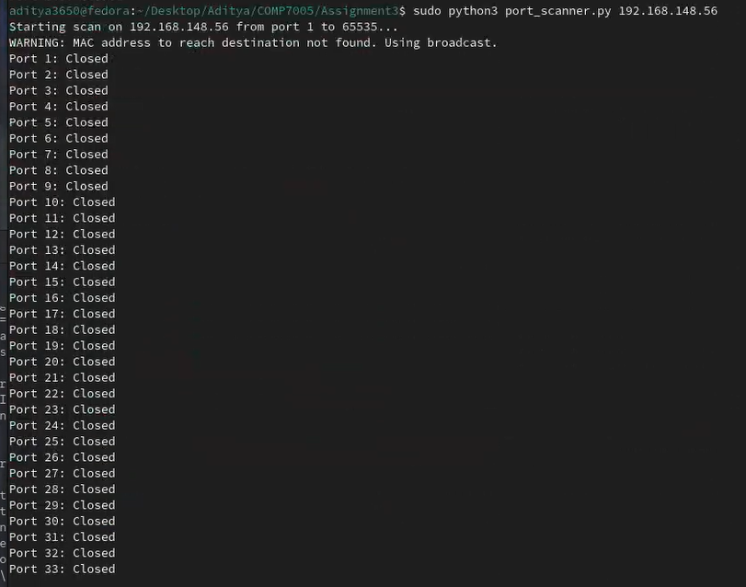

# Test 8



# Test 9



# Test 10



# Test 11



# Test 12



# Test 13

