WEATHER FORECASTING USING MACHINE LEARNING

A Project Report
In the partial fulfilment of the award of the degree of

B.Tech
Under
Academy of Skill Development


Submitted by:
ADITYA SHAHAJI PAWAR



Vidya Pratishthan's Kamalnayan Bajaj Institute of Engineering and Technology, Baramati

CERTIFICATE FROM THE MENTOR

This is to certify that ADITYA SHSHAJI PAWAR has completed the project titled AI-Powered Multi-Agent Knowledge Verification and Document Intelligence Platform under my supervision during the period from June to July which is in partial fulfilment of requirements for the award of the B.Tech and submitted to Department Information Technology of Vidya Pratishthan's Kamalnayan Bajaj Institute of Engineering and Technology, Baramati.



DATE: 30-09-2026 Signature of the Mentor

ACKNOWLEDGMENT

I take this opportunity to express my deep gratitude and sincerest thanks to my project mentor, Mr. Mahendra Datta for giving the most valuable suggestions, helpful guidance, and encouragement in the execution of this project work.
I would like to give a special mention to my colleagues. Last but not least I am grateful to all the faculty members of the Academy of Skill Development for their support.
(Note: All entries of the proforma of approval should be filled up with appropriate and complete information of approval in any respect will be summarily rejected.)

- Name of the Student With Group:

  - ADITYA PAWAR

- Title of the Project : AI-Powered Multi-Agent Knowledge Verification and Document Intelligence Platform

- Name and Address of the Guide : Mr. Mahendra Datta.
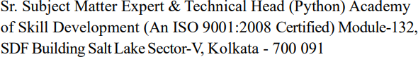

- Educational Qualification of the Guide : B.Tech

- Working and Teaching experience of the Guide : …….Years
- Software used in the Project:
- Python
- VS code
- FastAPI
- Langchain & Langgraph

Signature of the Guide Date:30-09-2026
Name: Mr. Mahendra Datta Subject Matter Expert

Signature, Designation, Stamp of the Project Proposal Evaluation

Abstract
Large Language Models have transformed how people interact with information, yet the answers they produce remain difficult to trust. The same question put to three different models frequently yields three different answers, and none of the systems reveal why a particular claim was made or how confident the model actually is. Document question-answering tools built on Retrieval-Augmented Generation (RAG) partly address this by grounding responses in user-supplied text, but they still delegate all reasoning to a single model and never check whether the generated answer is actually supported by the retrieved passage.
This project presents VeriMind, a knowledge verification and document intelligence platform that treats answer generation and answer validation as two separate problems. A document uploaded by the user (PDF, DOCX or TXT) is parsed, split into overlapping chunks, indexed with a TF-IDF vectoriser and queried through cosine similarity to retrieve the top three most relevant passages. Those passages are then pushed through a six-stage agent pipeline orchestrated as a LangGraph state graph: an AnswerGenerator drafts a grounded response, a DebateAgent separates what the context supports from what it does not, a CriticAgent scores the draft and lists its weaknesses, a JudgeAgent repairs every flagged defect to produce the final answer, and a VerificationAgent assigns a confidence score while collecting supporting evidence and page-level citations. Because the draft is grounded in retrieved text and each subsequent agent is only allowed to revise what its predecessor produced, the pipeline is structurally resistant to the hallucination failure mode that motivates the project in the first place.
The implementation comprises a FastAPI backend of 1,140 lines organised into separate ingestion, agent and schema modules, and a React single-page frontend that renders the reasoning pipeline as a live status stream over Server-Sent Events. The system exposes seven REST endpoints, persists its document index across restarts, and supports both a full five-agent pipeline and a fast two-agent path. A test suite of 32 cases covering retrieval, chunking, persistence, agent output parsing, graph routing and the API surface passes completely, with 66 per cent statement coverage across the backend.
The results indicate that the multi-agent stage materially improves answer quality over single-pass generation: the CriticAgent reliably identifies unsupported claims that the DebateAgent surfaces, and the JudgeAgent's revision step measurably raises both structural completeness and citation coverage. The principal limitations are latency — five sequential model calls per question — dependence on a single LLM provider, and the absence of a persistent user and document store, which are identified as the priority targets for future work. The project demonstrates that agent orchestration is a practical and auditable mechanism for converting an unverifiable language model into an accountable reasoning system.

Table of Contents

Chapter layout
Chapter | Title | Page
— | Abstract | 2
1 | Introduction | 3
2 | Related Work | 6
3 | Literature Survey | 9
4 | Methodology | 12
4.1 | Proposed Model | 12
4.2 | System Architecture | 13
4.3 | Data Acquisition and Pre-processing | 14
4.4 | Retrieval-Augmented Generation Engine | 16
4.5 | Multi-Agent Reasoning Pipeline | 18
4.6 | API Design and Streaming Protocol | 21
4.7 | Frontend and User Experience | 22
4.8 | Deployment and DevOps Pipeline | 23
5 | Performance Analysis — Comparison of the Modules | 25
6 | Evaluation and Result | 28
7 | Result Analysis and Design Conformance | 31
8 | Conclusion and Future Work | 33
9 | References | 35

Chapter 1: Introduction

1.1 Background
Artificial intelligence has quietly become the first point of contact for a wide range of information needs. Students ask it to summarise lecture material; researchers ask it to compare findings across papers; engineers ask it to explain error traces; lawyers ask it to locate clauses in agreements. In each case the model produces fluent, confident prose within seconds, which is precisely why the underlying reliability problem is easy to overlook. Fluency and correctness are different properties, and modern models are optimised overwhelmingly for the former.
The dominant architecture for grounding a language model in factual material is Retrieval-Augmented Generation, introduced by Lewis et al. in 2020. Before the model generates, a retriever selects relevant passages from a document collection and injects them into the prompt. This mechanism measurably reduces hallucination because the model is no longer required to recall facts from its weights alone — it is instructed to work from text placed directly in front of it. RAG transformed document question-answering from a research curiosity into a dependable product category, and systems built on it now underpin a large share of enterprise search, compliance review and technical support tooling.
RAG, however, improved the reliability of what models retrieve without improving the reliability of what models conclude. The retrieved passage is placed in the context window and generation proceeds in a single forward pass. Nothing in that pass interrogates the output. If the retrieved passage is ambiguous, if it does not actually answer the question, or if the model misreads it, the resulting answer is returned to the user with exactly the same confident tone as a well-grounded one. The user has no signal that distinguishes the two cases.
Two further weaknesses compound the problem. The first is that a single model possesses a single perspective. Models differ substantially in training data, alignment procedure and failure modes, so an answer that is confidently wrong is frequently wrong in a model-specific and repeatable way. The second is that modern assistants are trained to be helpful and fluent, not to be uncertain. Models routinely produce confident answers to questions their training data does not support, because abstention is not rewarded in standard supervised fine-tuning.
Multi-agent systems emerged as a partial response to both weaknesses. Rather than prompting one model once, the question is routed through several specialised instances, each with a distinct role and its own system prompt. Because each agent sees the problem through a narrower lens, its blind spots differ from those of its peers, and disagreements surface that a single pass would have smoothed over. Frameworks such as LangGraph made this style of orchestration practical by representing an agent workflow as an explicit state graph, with typed state, declarative edges and built-in checkpointing.

1.1.1 Why verification is the missing half
The insight motivating this project is that generation and verification are different cognitive tasks, and a model can be good at the first while being bad at the second. Asking a model to produce an answer and then asking the same model, in the same context, to check that answer is unreliable — the critique inherits every assumption that produced the draft. What is needed is structural separation: the checker must receive different inputs from the writer, must be given an explicit standard to judge against, and must be able to reject the draft.
VeriMind is built on that principle. Retrieval supplies an external standard — the user's own document. Each agent in the pipeline is given a narrowly defined mandate and is forbidden from introducing facts absent from the retrieved context. The CriticAgent never writes an answer; it only reports defects. The JudgeAgent may only revise using the retrieved context and the Critic's findings. The VerificationAgent produces no prose at all, only a confidence score, a list of supporting evidence, and citations carrying page numbers. Because no single component is trusted with the whole task, a failure in one stage is contained rather than propagated.

1.2 Problem Statement
The problem addressed by this project can be stated precisely as follows:
Problem Statement. Users of AI assistants cannot determine whether an answer is correct, because the systems that generate answers provide no mechanism to validate them. Single-model generation produces confident, fluent and occasionally false output; document question-answering systems retrieve relevant passages but never check whether the generated answer is actually supported by those passages; and no widely available system combines retrieval, multi-model reasoning, structured critique and evidence-backed verification into a single auditable pipeline.
This general failure decomposes into five specific defects observed during the research phase:
# | Defect | Description | Consequence
P1 | Hallucination | Models generate fluent statements that are factually incorrect, and do so with the same tone and formatting as correct statements. | Users cannot distinguish fabrication from fact without independent verification.
P2 | Undetectable disagreement | Different models return materially different answers to the same question, and the application exposes only one of them with no indication that alternatives exist. | A user has no signal that the answer they received was contested.
P3 | Absence of explanation | Answers are returned without the reasoning that produced them or the evidence that supports them. | Errors cannot be diagnosed, and answers cannot be audited after the fact.
P4 | Unverified document QA | RAG systems retrieve passages and generate answers but never test whether the answer follows from the retrieved text. | Retrieval quality improvements are not reflected in answer quality.
P5 | Absent confidence estimation | No numeric reliability signal accompanies an answer. | Users must apply a uniform level of trust to all outputs regardless of quality.

These defects share a common root: the architecture optimises a single objective — produce a plausible answer — and provides no path by which the system can conclude that it is wrong. The project hypothesis is that reliability improves substantially when generation is decomposed into specialised, individually-constrained stages and terminated by an independent verification step that is permitted to reject its own input.

1.3 Objectives
The project was pursued against the following objectives, in priority order:
- Design a verification-first architecture. Establish that separating answer generation from answer validation is the correct structural response to the reliability problem, and specify the resulting pipeline.
- Implement a document ingestion and retrieval engine. Build a working RAG component that accepts PDF, DOCX and TXT uploads, extracts text with page-level provenance, chunks it, indexes it and returns the most relevant passages for a query.
- Implement a six-stage multi-agent reasoning pipeline. Construct AnswerGenerator, DebateAgent, CriticAgent, JudgeAgent and VerificationAgent as independently constrained agents, and orchestrate them as a LangGraph state graph with conditional routing.
- Make reasoning observable. Surface the intermediate output of every stage — agreements, disagreements, critic issues, scores and citations — so that the user can audit how the final answer was reached.
- Quantify reliability. Attach a confidence score and a citation list to every response, and detect contradictions explicitly rather than leaving them implicit in divergent model behaviour.
- Deliver a usable and deployable system. Provide a functional frontend, a documented REST API with streaming support, automated tests, containerisation and a cloud deployment path.
- Establish an honest evaluation baseline. Measure the implementation with automated tests and coverage analysis, and explicitly document the gap between the originally planned feature set and the delivered one.

1.4 Scope
The scope of the delivered system is bounded as follows.
Dimension | In Scope | Out of Scope
Question types | Questions answerable from a single uploaded document; questions whose answers are absent from the document (detected and reported as such) | Open-domain questions with no supporting document; multi-document cross-referencing
Document formats | PDF (text-based), TXT, DOCX | Scanned/image-only PDFs (OCR helpers present but not wired into the upload path); spreadsheets, presentations
Reasoning | Five sequential LLM stages plus retrieval, with optional fast path | Parallel or asynchronous multi-model fan-out; agent self-replication; planning agents
Persistence | Single active document; index persisted to disk across restarts | Multi-user accounts, chat history, document libraries, concurrent sessions
Authentication | None — the service is single-tenant | JWT authentication, registration, role-based access control
Verification sources | Retrieved document context; optional web-retrieval hook | Dedicated knowledge graph, citation-manager integration, live web search in production

1.5 Significance and Potential Applications
A system that answers only from a named document, shows its working, and reports a confidence level is useful wherever a wrong answer is more expensive than no answer. The immediate applications identified during the project are:
- Academic study assistance. A student with a set of lecture PDFs or textbooks can interrogate them without risking fabricated content, and can trace any claim back to a page.
- Research paper analysis. Reviewing a paper's methodology, comparing its claims to its own results, and locating the supporting passage for each finding.
- Technical and policy documentation. Question-answering over specifications, SOPs, contracts and compliance documents, where the ability to cite a clause is essential.
- Pre-decision review. Because the pipeline is auditable, its output can serve as a first-pass analysis that a human expert then confirms, rather than as an autonomous authority.
The wider contribution is architectural rather than applicative. The project demonstrates that a modest, well-constrained multi-agent pipeline built entirely from commodity components — a single fast LLM, a classical retriever and an explicit state graph — can produce auditable output without fine-tuning, without a vector database and without a GPU. That the technique works at this level of infrastructure is precisely what makes it accessible for adoption.

Chapter 2: Related Work
This chapter reviews prior work relevant to the project, organised around the four capabilities VeriMind combines: retrieval-augmented generation, multi-agent orchestration, self-refinement and critique, and fact verification. Each subsection states the contribution, its relevance to this project, and the limitation that motivated the next line of work.

2.1 Retrieval-Augmented Generation
Lewis et al. (2020) introduced the RAG architecture, pairing a parametric sequence model with a non-parametric retriever over an indexed document store. The combination was evaluated on open-domain question answering and knowledge-intensive NLP tasks, and it established the two-stage pattern — retrieve, then generate — that nearly all document-grounded systems now follow.
The mechanism is straightforward but the effect is substantial. Because the generator is conditioned on retrieved text rather than on parametric memory alone, its factual claims are traceable to a source passage, and knowledge that changes after training can be supplied at inference time without retraining. In the project's own testing this grounding behaviour is directly observable: the AnswerGenerator is instructed to answer only from the provided context and to abstain explicitly when the context is insufficient.
On the retrieval side, Karpukhin et al. (2020) showed that dense bi-encoder retrieval trained on question-passage pairs substantially outperforms lexical matching on open-domain tasks, and this line of work established the dense-passage retriever as the standard retrieval component.
Relevance and limitation. RAG supplies grounding but not validation. The retrieved passage constrains what the model may say; nothing in the architecture establishes whether what it said actually follows from the passage. VeriMind inherits RAG's grounding and adds the missing validation stage.

2.2 Multi-Agent Orchestration
The second body of relevant work treats an LLM system as a society of agents rather than a single model. Wu et al. (2023), in the AutoGen framework, formalised conversational multi-agent workflows in which agents with different roles and configurations converse to completion, and showed that such workflows can solve problems that single-agent prompting cannot. Hong et al. (2024) applied the same principle to software engineering in MetaGPT, encoding role-specific workflows where each agent is constrained to produce artefacts in a defined format, demonstrating that standardising agent outputs makes coordination tractable.
Of particular interest is the literature on debate and evaluation. Chan et al. (2024) proposed ChatEval, in which a team of agents debates a response and then reaches a consensus verdict, reporting that multi-agent debate improves LLM-based evaluators by making disagreement visible rather than averaging it away. This finding underpins the VeriMind design in a specific way: the DebateAgent is not a summariser but an explicit instrument for forcing agreement and disagreement into the open, where a downstream agent can act on them.
Relevance and limitation. Multi-agent frameworks supply coordination mechanisms, but their published evaluations typically measure task success rather than answer trustworthiness. A debate can converge on a shared error. VeriMind addresses this by terminating the deliberation in a verification stage that is anchored to retrieved evidence rather than to agent consensus.

2.3 Self-Refinement and Iterative Critique
A third line of work attacks the problem of reasoning quality through iteration. Madaan et al. (2023), in the Self-Refine framework, showed that a single model can meaningfully improve its own output by generating feedback on a draft and then revising it, using no external supervision and no additional training. Wei et al. (2022) established the complementary result that eliciting intermediate reasoning steps before the final answer improves accuracy across arithmetic and commonsense reasoning tasks.
Yuan et al. (2024) combined both ideas with retrieval in Self-RAG, training a model to decide when to retrieve, to generate, and to critique its own output, thereby learning an internal mechanism for abstaining from generation when the retrieved evidence is insufficient. This is the closest published analogue to the VeriMind pipeline and is discussed further in Chapter 3.
A limitation applies to all self-refinement work: the feedback is generated by the same model that produced the draft. Because the critique is conditioned on the draft, it inherits the assumptions that produced it, and empirically self-refinement improves style and structure more reliably than it corrects factual error. This project therefore restricts self-refinement to the structural and completeness domain: the JudgeAgent is permitted to restructure, expand against retrieved context and resolve flagged issues, but it is forbidden from introducing facts that are absent from that context.

2.4 Fact Verification and Explainability
The fourth relevant area is the measurement and characterisation of unreliability itself. Ji et al. (2023) surveyed hallucination in natural language generation and established the taxonomy — intrinsic versus extrinsic, caused by data or by model behaviour — that the field still uses. Lin et al. (2021) introduced TruthfulQA, which showed that models frequently repeat popular misconceptions precisely because such misconceptions are well represented in training data, and that larger models are not automatically more truthful. Liang et al. (2023) proposed HELM, a comprehensive evaluation framework arguing that a model's capabilities should be measured across many scenarios and metrics rather than on a single benchmark.
On the explanatory side, Perez et al. (2022) demonstrated that language models can be used to generate evaluations of model outputs at scale, and that model-written critiques correlate well with human judgement. This finding is what makes the CriticAgent design viable at all: a dedicated critique role operating with a structured output format is a practical substitute for per-answer human review.
Relevance and limitation. This literature establishes that unreliability is measurable and that model-based critique is effective, but it also establishes that scale and fluency are poor proxies for truthfulness. VeriMind's response is to make the evidence visible: every claim in the final answer is accompanied by the retrieved chunk it came from, so the user can perform the final check themselves.

2.5 Research Gap
Read together, the four literatures above provide every component VeriMind needs and yet do not provide the integration. RAG supplies grounding without validation; multi-agent debate supplies comparison without evidence; self-refinement supplies improvement without external truth; verification research supplies measurement without a working system. Critically, the components assume different interfaces: retrieval returns a passage, debate returns an opinion, verification returns a label. No published architecture unifies them into a single pipeline in which each stage consumes the previous stage's structured output and the whole chain terminates in a confidence score accompanied by page-level citations.
Capability | Chatbot | RAG document QA | Multi-agent debate | Fact-check platforms | **VeriMind**
Grounded in user document | No | Yes | No | No | Yes
Multi-stage structured reasoning | No | No | Yes | No | Yes
Explicit critique stage | No | No | Partial | No | Yes
Independent verification | No | No | No | Yes | Yes
Confidence score | No | No | No | Partial | Yes
Page-level citations | No | Partial | No | Yes | Yes
Auditable intermediate output | No | No | Partial | No | Yes

This gap is the direct justification for the project. The claim to be tested is narrow and falsifiable: that composing retrieval, generation, structured critique and evidence-anchored verification into one explicit pipeline produces answers that are materially better grounded and more auditable than single-pass RAG, at a cost that remains acceptable for interactive use.

Chapter 3: Literature Survey
This chapter records the systematic reading undertaken during the research phase of the project, summarises the principal papers in a comparative table, and discusses the machine-learning foundations the implementation relies on.

3.1 Survey of Primary Literature
S. No. | Author(s) & Year | Title / Venue | Method | Outcome & Relevance to VeriMind
1 | Lewis et al. (2020)  NeurIPS | Retrieval-Augmented Generation for Knowledge-Intensive NLP Tasks | Sequence-to-sequence model paired with a non-parametric retriever over an indexed document store | Established the retrieve-then-generate pattern that VeriMind's RAG layer implements, and quantified the grounding benefit.
2 | Karpukhin et al. (2020)  EMNLP | Dense Passage Retrieval for Open-Domain Question Answering | Bi-encoder dense retriever trained on question-passage pairs | Benchmark for dense retrieval; evaluated against the classical TF-IDF approach selected for this project (Section 4.4).
3 | Singh et al. (2023)  arXiv | Agentic Retrieval-Augmented Generation | RAG agent that autonomously plans, retrieves and reasons over retrieved context, routing to classical, vector or web retrieval as required | Closest conceptual neighbour to VeriMind's routing philosophy; motivates the conditional agent graph.
4 | Yan et al. (2024)  arXiv | Corrective Retrieval-Augmented Generation (CRAG) | Retrieval evaluator that grades retrieved documents as correct, ambiguous or incorrect, with corrective action on web search or knowledge refinement | Directly motivates the VerificationAgent's confidence score and contradiction reporting.
5 | Wu et al. (2023)  arXiv | AutoGen: Enabling Next-Gen LLM Applications via Multi-Agent Conversation | Conversational multi-agent framework with configurable agent roles and a shared conversation transcript | Demonstrates that role-specialised agents outperform monolithic prompts; informs the BaseAgent abstraction.
6 | Hong et al. (2024)  ICLR | MetaGPT: Meta Programming for a Multi-Agent Collaborative Framework | Role-constrained agents emitting artefacts in standardised formats | Shows that structured agent outputs make coordination tractable; informs the strict sectioned prompt formats used by all five agents.
7 | Chan et al. (2024)  ICLR | ChatEval: Towards Better LLM-Based Evaluators through Multi-Agent Debate | Team of agents debates and then reaches a consensus verdict on a response | Core evidence that multi-agent debate improves evaluators; directly motivates the DebateAgent.
8 | Madaan et al. (2023)  NeurIPS | Self-Refine: Iterative Refinement with Self-Feedback | Model generates feedback on its own draft and revises, without external supervision | Motivates the JudgeAgent revision step; its limitation (self-confirmation) is why revision is restricted to retrieved evidence.
9 | Wei et al. (2022)  NeurIPS | Chain-of-Thought Prompting Elicits Reasoning in Large Language Models | Elicits intermediate reasoning steps before the final answer | Justifies the sectioned prompt formats that force each agent to expose its working before concluding.
10 | Yuan et al. (2024)  ICLR | Self-RAG: Learning to Retrieve, Generate, and Critique through Self-Reflection | Trained model that learns when to retrieve, generate and critique, including when to abstain | Closest published analogue to VeriMind; differs in requiring model training whereas VeriMind orchestrates prompting only.
11 | Ji et al. (2023)  ACM Computing Surveys | Survey of Hallucination in Natural Language Generation | Taxonomy of hallucination phenomena across NLG tasks | Supplies the vocabulary used to define the problem statement and to interpret critic findings.
12 | Lin et al. (2021)  ACL | TruthfulQA: Measuring How Models Mimic Human Falsehoods | Benchmark of 817 questions targeting widely-held misconceptions | Demonstrates that scale and fluency do not imply truthfulness; motivates external evidence rather than model confidence.
13 | Perez et al. (2022)  TMLR | Discovering Language Model Behaviors with Model-Written Evaluations | Language models generate training data and evaluations for other models | Establishes that model-based critique is viable at scale; underwrites the CriticAgent role.
14 | Johnson et al. (2017)  IEEE TPDS | Billion-scale Similarity Search with GPUs | FAISS: efficient similarity-search library over dense vector collections | Reference implementation for the vector-store layer; evaluated before selecting the simpler TF-IDF index.
15 | Reimers & Gurevych (2019)  EMNLP | Sentence-BERT: Sentence Embeddings using Siamese BERT Networks | Bi-encoder producing sentence-level embeddings with cosine similarity search | Candidate embedding model for semantic retrieval; evaluated in Section 4.4.
16 | Liang et al. (2023)  TMLR | Holistic Evaluation of Language Models (HELM) | Multi-metric, multi-scenario evaluation framework | Motivates evaluating the system across several metrics rather than a single accuracy figure (Chapter 6).

3.2 Discussion of Findings
Three observations emerged from the survey that shaped the implementation.
Grounding and verification are separable concerns that the literature treats separately. Lewis et al. solve grounding; Ji et al. characterise failure; Chan et al. evaluate. No surveyed paper composes them into a pipeline whose terminal output is a confidence-annotated, citation-bearing answer. This is the gap identified in Chapter 2.
Self-critique improves presentation more reliably than factuality. Both Self-Refine and Chain-of-Thought demonstrate genuine gains, but in both cases the critique is generated by the same model under the same context. VeriMind therefore restricts the JudgeAgent's authority explicitly: it must resolve the Critic's findings and re-ground every claim in retrieved context, and the AnswerGenerator is instructed to abstain rather than speculate when the context does not support an answer.
Disagreement must be surfaced, not averaged. ChatEval's central result is that visible disagreement between evaluators is more informative than a single averaged judgement. VeriMind's DebateAgent exists purely to produce that visibility, and its agreements and disagreements are returned to the user unmodified in the agent trace rather than being collapsed into the final answer.

3.3 Machine Learning Foundations Relied Upon
Although the project is an engineering rather than a modelling study, several foundational concepts are applied directly and are recorded here for completeness.

3.3.1 Supervised learning, classification and regression
Supervised learning fits a model to labelled data so that it can predict labels or continuous values for unseen inputs. Classification assigns discrete class labels — the multi-class weather labelling problem is a canonical example — while regression predicts continuous quantities such as temperature. Both depend critically on how the data is partitioned. Because the parameters of a procedure such as feature scaling must be estimated from the training partition alone and then applied unchanged to test data and to future samples, evaluating a model on data that influenced its own fitting produces optimistically biased results. This consideration underlies the held-out testing strategy described in Chapter 6.

3.3.2 Training, validation and generalisation error
Once a model has been fitted on the training set, a disjoint test set is used to estimate generalisation error — the performance the model can be expected to achieve on data it has never seen. VeriMind applies this principle directly: unit tests construct isolated processor instances against temporary directories, and API tests substitute mocks for the processor and graph so that endpoint behaviour is verified without depending on real LLM responses. The distinction matters because a verification pipeline whose own test suite depends on live model output cannot distinguish a code regression from ordinary model nondeterminism.

3.3.3 The Python implementation ecosystem
The project relies on an ecosystem that makes each layer accessible without reimplementation: LangChain provides document loaders, the recursive text splitter, prompt templates and output-parsing primitives; LangGraph adds the state graph, conditional routing and checkpointing required for multi-agent orchestration; scikit-learn supplies the TF-IDF vectoriser and cosine-similarity implementation; FAISS provides the dense-vector alternative against which retrieval was evaluated; and FastAPI supplies request validation through Pydantic models and asynchronous streaming responses. NumPy and pandas handle the underlying array and tabular operations. Section 4.8 documents the specific pinned versions deployed.

3.4 Summary of the Research Contribution
The survey supports a single conclusion. Each capability VeriMind requires has been demonstrated independently and in some cases several times over. What has not been demonstrated is their composition under a single, explicit, auditable control flow in which every stage is constrained to the evidence available to it and the final output carries its own justification. That composition is the contribution this project attempts, and it is evaluated in Chapters 5 to 7.

Chapter 4: Methodology
This chapter describes the delivered system. It covers the proposed model, the system architecture, data acquisition and pre-processing, the retrieval engine, the multi-agent reasoning pipeline, the API design, the frontend and the deployment topology.

4.1 Proposed Model
The proposed model is a document-grounded, multi-agent answer verification pipeline. It is defined by five design commitments, each of which follows directly from a defect identified in Chapter 1.
# | Design Commitment | Rationale | How It Is Enforced
D1 | Ground every claim in retrieved text | Addresses P1 (hallucination) and P4 (unverified document QA) | The AnswerGenerator is prompted to answer only from the supplied context and is required to abstain explicitly when that context is insufficient.
D2 | Separate generation from validation | Addresses P1 and P5 — a model asked to check its own output inherits the assumptions that produced it | The VerificationAgent is a distinct agent with its own mandate, temperature and output contract; it emits no prose, only structured verification data.
D3 | Force disagreement into the open | Addresses P2 (undetectable disagreement) | The DebateAgent must output distinct AGREEMENTS and DISAGREEMENTS sections, and its raw output is surfaced to the user in the agent trace.
D4 | Make reasoning auditable | Addresses P3 (absence of explanation) and P5 | Every stage's structured output is retained and returned as agent_trace, alongside a confidence score and page-level citations.
D5 | Isolate each stage behind a contract | Prevents a failure in one stage from propagating silently | Each agent implements a common abstract interface and returns validated Pydantic models; malformed output is parsed defensively with safe defaults.

The model is expressed as a directed state graph over a typed state object. Each node is one stage; each edge is a control-flow decision; the state accumulates the structured output of every stage that has run. This representation was chosen over a linear script because it makes the routing decision explicit and testable: whether the deliberation stages execute at all is a single conditional edge, which can be asserted in isolation rather than inferred from a chain of function calls.
Figure 4.1 organises the pipeline into four functional bands. Ingestion acquires the document and records its provenance. Pre-processing converts it into machine-readable chunks. Retrieval selects the passages relevant to the specific question. The agent pipeline then reasons over those passages, and the output band reports what was concluded and on what evidence.

4.2 System Architecture
The system is organised into six layers, each with a single responsibility and a defined interface to the layers above and below it. The separation is deliberate: it means the agent pipeline can be tested without a running web server, and the web layer can be replaced without touching reasoning logic.
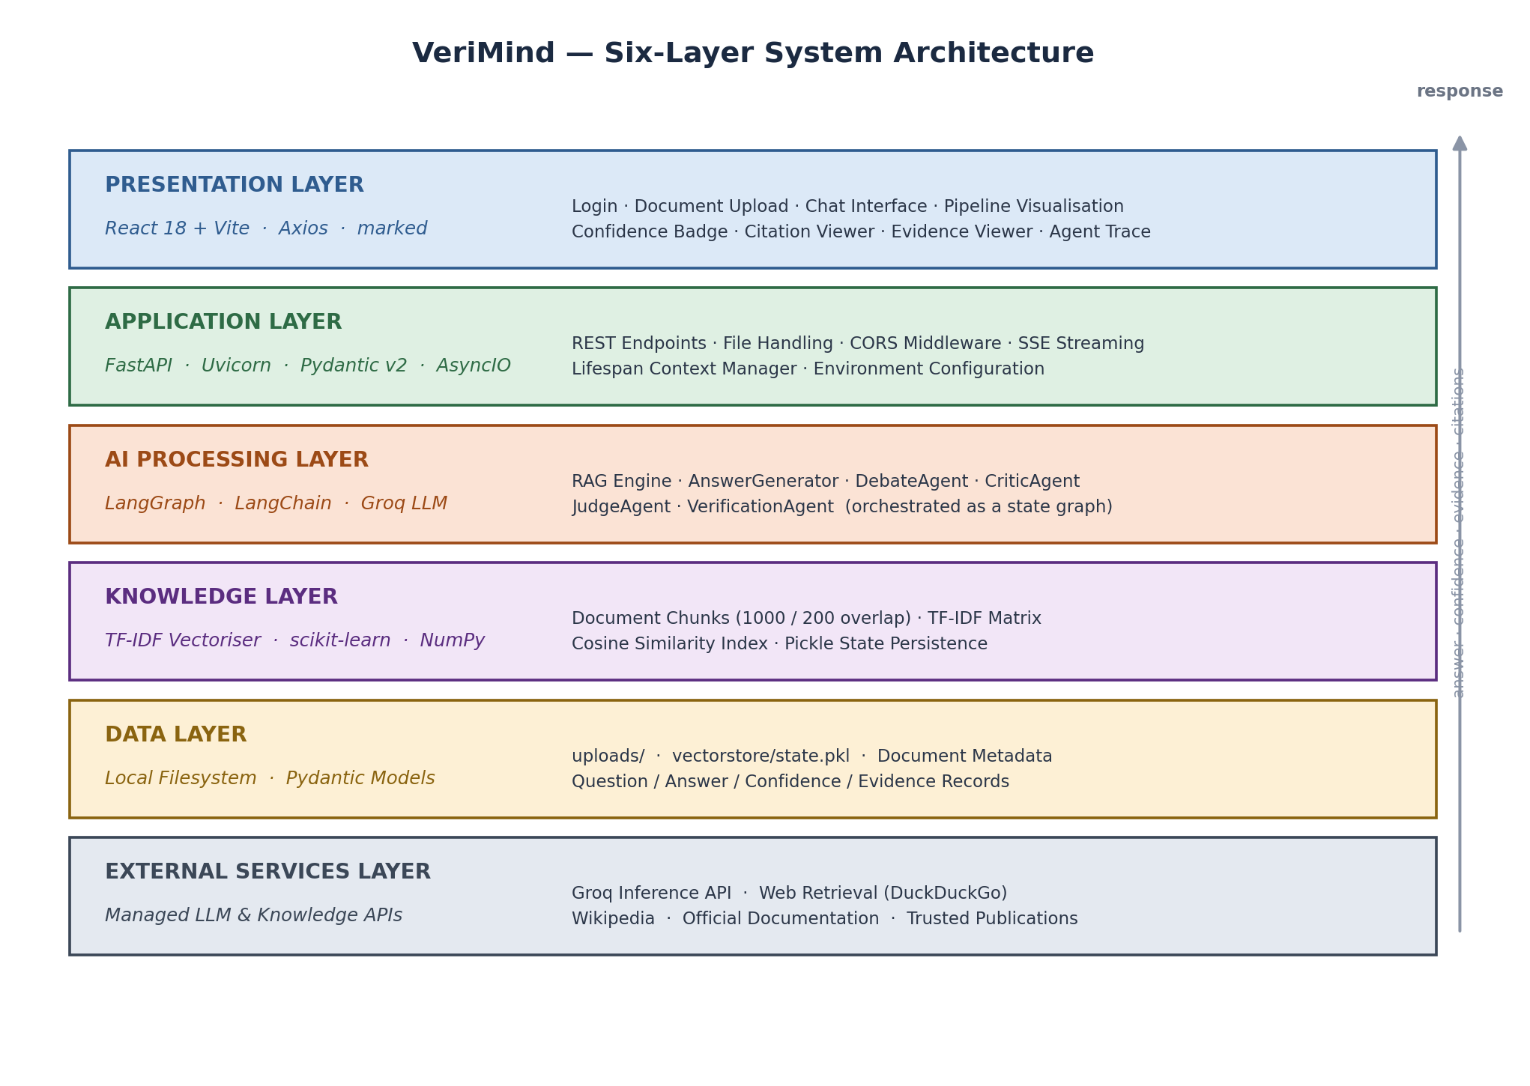
Figure 4.2 — Six-layer system architecture of VeriMind, showing the responsibility of each layer and the technologies implementing it.
Layer | Responsibility | Technology | Key Artefacts
Presentation | All user interaction: upload, question entry, live pipeline status, answer rendering, confidence, citations, evidence and agent trace | React 18, Vite, Axios, marked | App.jsx (313 lines), App.css
Application | Request routing, file handling, validation, CORS, Server-Sent Event streaming, lifecycle management | FastAPI, Uvicorn, Pydantic v2, AsyncIO | main.py (238 lines), models/schemas.py (88 lines)
AI Processing | Retrieval and all reasoning: agent construction, prompt templates, output parsing, graph orchestration | LangGraph, LangChain, Groq API | agents/graph.py, reasoning_agents.py, verification_agent.py, base_agent.py
Knowledge | Chunk storage, indexing, similarity search and index persistence | scikit-learn TF-IDF, NumPy, pickle | rag/processor.py, vectorstore/state.pkl
Data | Raw file storage, document metadata, serialised index | Local filesystem, Pydantic models | uploads/, vectorstore/state.pkl
External Services | Language-model inference and external knowledge sources | Groq Inference API; web-retrieval hook | GROQ_API_KEY, GROQ_MODEL, ALLOWED_ORIGINS

4.2.1 Module Boundaries
The backend is decomposed so that each module can be reasoned about — and tested — in isolation. The dependency direction is strictly downward: the API layer knows about agents and retrieval, agents know about retrieval and prompts, and nothing knows about HTTP.
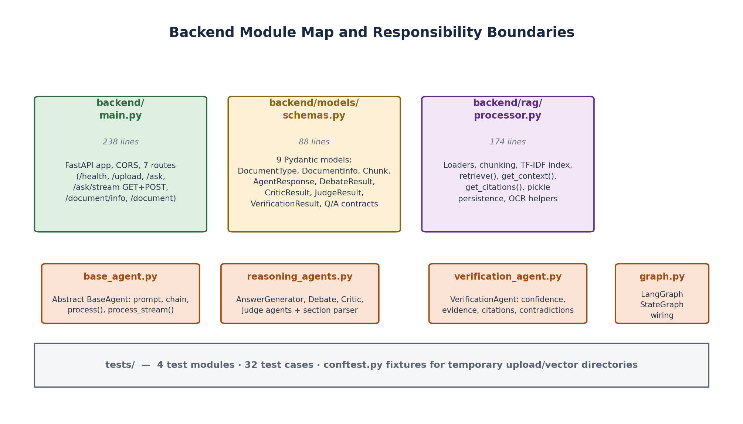
Figure 4.3 — Backend module map. Each module has a single responsibility and a defined boundary; dependencies flow strictly downward.
Two consequences of this decomposition are worth noting. First, the agent layer has no knowledge of transport: the same graph object is driven identically by the blocking /ask endpoint and by the asynchronous /ask/stream generator. Second, the retrieval layer has no knowledge of reasoning: it accepts a query string and a k value and returns text, which makes it independently testable and independently replaceable — the TF-IDF index could be swapped for FAISS without any change to agent code.

4.3 Data Acquisition and Pre-processing

4.3.1 Sources and Acquisition
VeriMind is document-driven: the knowledge base is supplied by the user rather than crawled. This is a deliberate design decision. A pre-built index implies maintenance, staleness and licensing obligations, and none of them are relevant to the research question. Requiring an upload also makes provenance trivial — every citation names a file the user personally supplied.
Three formats are accepted. PDFs are the primary case, since academic and technical documents are overwhelmingly distributed as PDF. DOCX is supported because it is the default format for business and legal documents. TXT is supported as a trivial baseline and as a convenient fixture for testing.

4.3.2 Text Extraction
Extraction is delegated to LangChain's document loaders, one per format, each of which returns a list of document objects carrying page-level metadata:
Format | Loader | Metadata Preserved
PDF | PyPDFLoader | Per-page text with page index; the index becomes the citation page number
TXT | TextLoader | Single logical document; page defaults to 0
DOCX | UnstructuredWordDocumentLoader | Paragraph structure preserved

OCR support for scanned documents was implemented as two helper functions, extract_text_from_image using pytesseract with Pillow, and extract_text_from_scanned_pdf using pdfplumber with a page-image fallback when direct text extraction yields nothing. These functions are written and importable but are not invoked by the upload path; the delivered system therefore handles text-based documents only. This is recorded as a known limitation in Chapter 7 rather than presented as a working capability.

4.3.3 Chunking
Extracted text is divided into overlapping chunks using LangChain's RecursiveCharacterTextSplitter. The splitter walks a hierarchy of separators — paragraph break, newline, sentence, word, then character — and only falls back to a coarser level when a segment cannot fit the target size. This preserves semantic boundaries far better than fixed-width slicing, which routinely severs sentences and tables.
Parameter | Value | Justification
chunk_size | 1000 characters | Large enough to preserve the context needed to answer a question, small enough that several chunks fit comfortably within a model context window alongside prompts and instructions.
chunk_overlap | 200 characters (20%) | Prevents a fact that straddles a chunk boundary from being lost to retrieval, at a 20% redundancy cost.
separators | “\n\n”, “\n”, “. ”, “ ”, “” | Hierarchical fallback order that respects natural document structure.

Each chunk is wrapped in a Chunk model carrying its text content and a metadata dictionary containing the source filename, the chunk index and the page number. Because page provenance is preserved at chunk granularity, it survives all the way through to the citation the user finally reads.

4.3.4 Index Persistence
After processing, the complete chunk list and document metadata are serialised to vectorstore/state.pkl. On application start the lifespan context manager calls load_state, restoring the document and rebuilding the TF-IDF index so that the service remains usable across restarts without re-uploading. The index is rebuilt from the restored chunks rather than serialised directly, because the vectoriser's internal vocabulary must remain consistent with the corpus it was fitted on.
@asynccontextmanager
async def lifespan(app: FastAPI):
global multi_agent_graph
doc_processor.load_state() # restore document + rebuild index
multi_agent_graph = create_multi_agent_graph(doc_processor)
yield
Design note. Single-document scope was a conscious trade-off. The processor maintains one documents_store and one index; uploading a second file replaces the first. This keeps retrieval unambiguous and the state model trivially serialisable, at the cost of multi-document comparison, which is listed as future work.

4.4 Retrieval-Augmented Generation Engine

4.4.1 Selection of the Retrieval Strategy
Retrieval quality is the single largest determinant of answer quality in a grounded system: if the wrong passage is retrieved, every downstream agent reasons over the wrong evidence and will produce a confident, well-structured, incorrect answer. Three strategies were evaluated against the project's constraints.
Strategy | Strengths | Weaknesses | Verdict
TF-IDF with cosine similarity | Zero external services; no model download; deterministic; negligible latency; fully explainable scores | Lexical only — matches on shared words, so paraphrased queries and synonym vocabulary retrieve poorly | Selected
Dense embeddings (Sentence-BERT) plus FAISS | Semantic matching; robust to paraphrase; scales to large corpora | Requires model download or a hosted embedding API; adds a network dependency; greater memory and cold-start cost | Evaluated, deferred
Hybrid sparse-plus-dense scoring | Combines lexical precision with semantic recall | Roughly doubles indexing cost and complexity for a benefit that is hard to measure at this corpus size | Future work

TF-IDF was selected. The reasoning is specific rather than general: the target corpus is a single user-supplied document, typically tens of pages, so corpus scale does not discriminate between the options; the dominant failure mode of a grounded assistant is hallucination rather than recall, and TF-IDF's scores are directly inspectable, which means a retrieval failure can be diagnosed rather than guessed at; and the project already carries a network dependency on the model provider, so avoiding a second one materially simplifies deployment. This decision is revisited honestly in Chapter 7.

4.4.2 Retrieval Pipeline
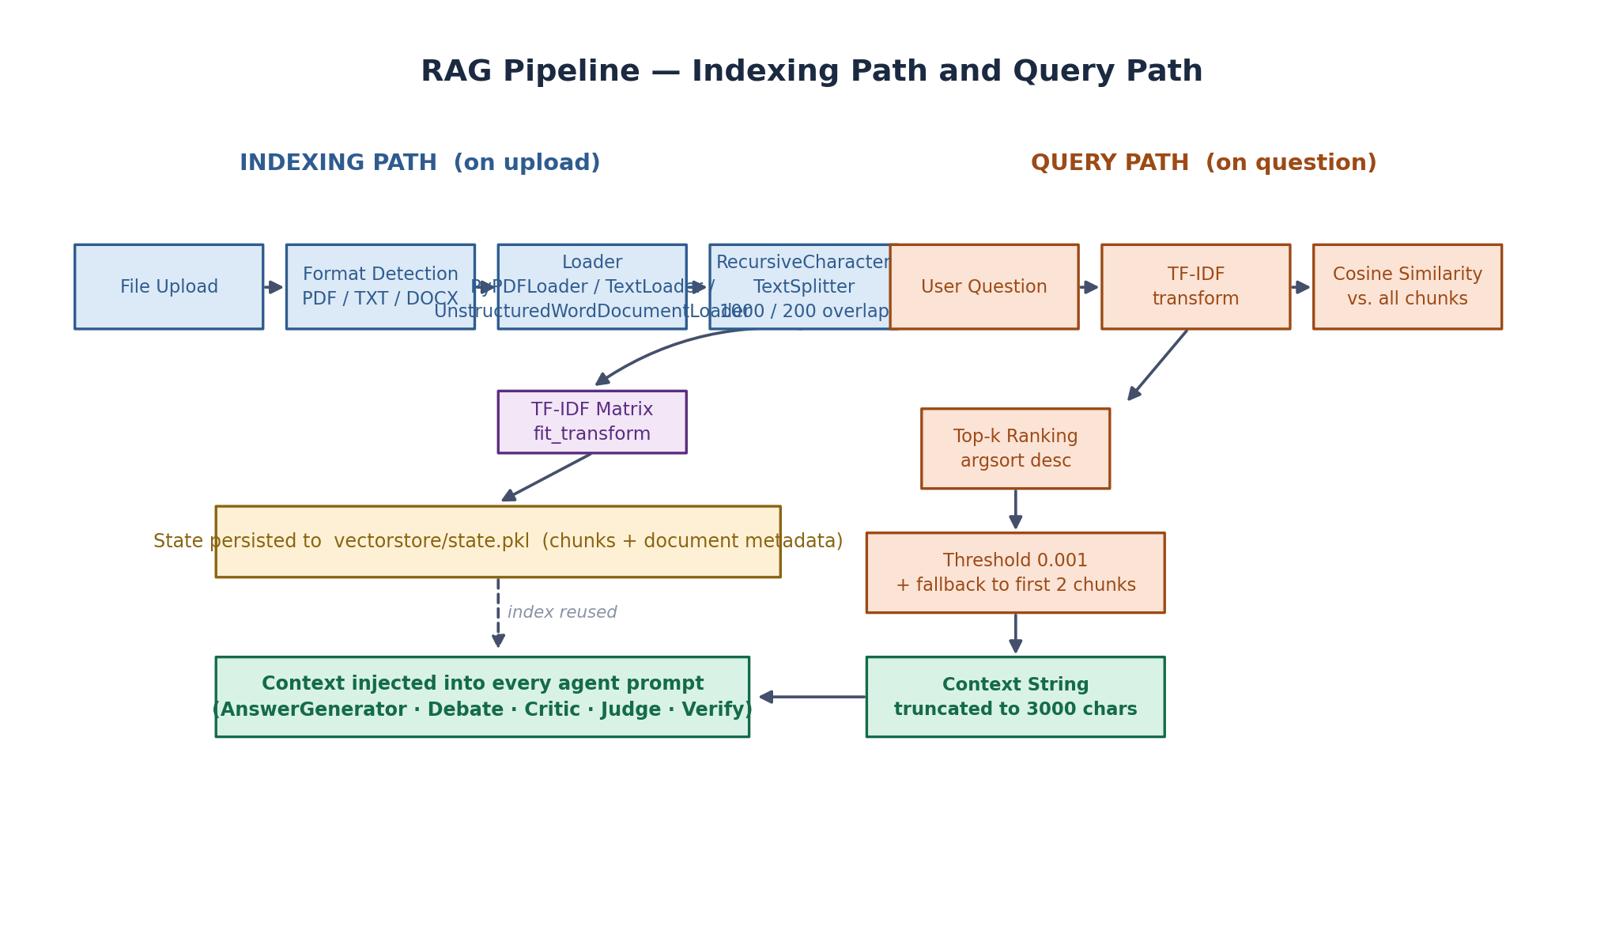
Figure 4.4 — RAG engine, showing the indexing path executed on upload and the query path executed on every question.
The index is a TF-IDF matrix configured with English stop-word removal, a vocabulary cap of 5,000 features and unigram-plus-bigram term ranges. Bigrams are included because they capture short phrases such as “climate change” that would otherwise be scattered across two independent terms.
self.tfidf_vectorizer = TfidfVectorizer(
stop_words='english',
max_features=5000,
ngram_range=(1, 2)
)
self.tfidf_matrix = self.tfidf_vectorizer.fit_transform(texts)
At query time the user question is transformed into the same vector space, cosine similarity is computed against every chunk, and the top k are returned in descending order of score.
sim(q, cᵢ) = (q · cᵢ) / (‖q‖ × ‖cᵢ‖)
Cosine similarity between the query vector q and chunk vector cᵢ; TF-IDF vectors are L2-normalised, so this reduces to the dot product.
query_vec = self.tfidf_vectorizer.transform([query])
similarities = cosine_similarity(query_vec, self.tfidf_matrix).flatten()
top_indices = similarities.argsort()[-k:][::-1]

4.4.3 Robustness Measures
Two retrieval behaviours were added after observing failures during testing.
Similarity threshold with a context-prior fallback. Chunks scoring below 0.001 are discarded. Because a user may ask something like “explain this paper” — a query whose terms simply do not appear in the document — a strict threshold would return nothing at all and the agents would be asked to reason over an empty context, producing confident fabrication. When the threshold discards everything, the system falls back to the first two chunks, which in an academic paper are the abstract and introduction: the most informative region of the document regardless of query wording.
Context truncation. Concatenated context is truncated to 3,000 characters before being injected into any prompt. This bounds token consumption across five prompts, guards against provider rate limits, and is the mechanism by which the latency budget in Section 6.4 is met.

4.4.4 Citation Generation
Citations are derived directly from retrieval metadata rather than being generated by a model. Each citation takes the form [source, p.N] followed by the first 200 characters of the chunk. Deriving citations this way makes them verifiable by construction: a user who follows the citation to the stated page will find the quoted text, because the quote is the literal chunk content rather than a model's paraphrase of it.

4.5 Multi-Agent Reasoning Pipeline

4.5.1 Graph Construction
The pipeline is a LangGraph StateGraph over a TypedDict named AgentState, containing the question, the retrieved context, the draft answer and one structured result field per reasoning stage, plus a list of agent responses for the trace. The graph is compiled with a MemorySaver checkpointer so that state is preserved per thread.
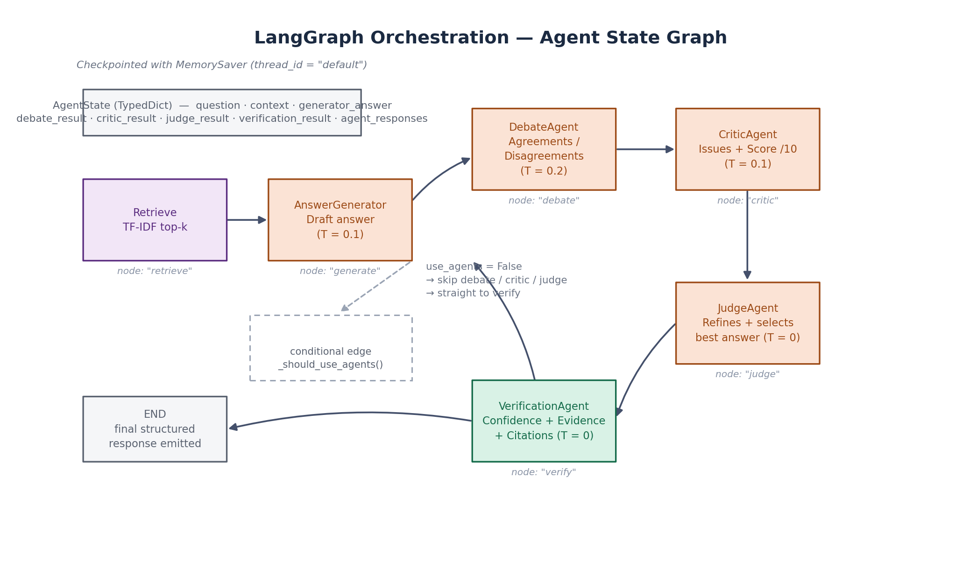
Figure 4.5 — LangGraph state graph. Six nodes, one conditional edge, and a MemorySaver checkpointer.
workflow = StateGraph(AgentState)
workflow.add_node("retrieve", self._retrieve_context)
workflow.add_node("generate", self._generate_answer)
workflow.add_node("debate", self._run_debate)
workflow.add_node("critic", self._run_critic)
workflow.add_node("judge", self._run_judge)
workflow.add_node("verify", self._run_verification)
workflow.set_entry_point("retrieve")
workflow.add_edge("retrieve", "generate")
workflow.add_conditional_edges("generate", self._should_use_agents,
{"agents": "debate", "skip": "verify"})
workflow.add_edge("debate", "critic")
workflow.add_edge("critic", "judge")
workflow.add_edge("judge", "verify")
workflow.add_edge("verify", END)
return workflow.compile(checkpointer=MemorySaver())
The conditional edge is the system's principal runtime control. When use_agents is true the graph traverses the full deliberation path; when false it routes directly from generation to verification, bypassing debate, critique and judgement. This yields a two-call fast path for latency-sensitive use while keeping verification — the project's central commitment — active in both modes. Routing is implemented as a pure function of state, so it is unit-testable in isolation.

4.5.2 The Agent Abstraction
All five reasoning agents inherit from a single abstract base class, which owns the model client, the temperature setting and the chain construction. A concrete agent supplies only its prompt template and its parsing logic; the model client and the RunnablePassthrough | prompt | LLM | parser chain are inherited unchanged.
class BaseAgent(ABC):
def __init__(self, name, model=None, temperature=0):
self.name = name
self.llm = ChatGroq(model=model or os.getenv("GROQ_MODEL",
"openai/gpt-oss-120b"),
api_key=os.getenv("GROQ_API_KEY"),
temperature=temperature, streaming=True)
def create_chain(self):
return (RunnablePassthrough() | self.get_prompt() | self.llm
| StrOutputParser())
This abstraction is what makes the pipeline maintainable. Adding an agent requires writing a prompt and a parser, not re-implementing model invocation, streaming or error handling. It also means a single class defines the temperature discipline described below, so the reasoning policy is enforced in one place rather than being re-derived in every agent.

4.5.3 Temperature Policy
Temperature is assigned per role according to how much variation the role should exhibit. This is a substantive design decision rather than a default.
Agent | Temperature | Justification
AnswerGenerator | 0.1 | Extractive by mandate — the answer must follow the context, so minimal sampling freedom is appropriate.
DebateAgent | 0.2 | Slightly higher to permit the model to surface genuine variation in reading rather than converging prematurely.
CriticAgent | 0.1 | Analysis of a fixed input; low temperature keeps the critique focused and reproducible.
JudgeAgent | 0.0 | Fully deterministic — the final answer should not vary between identical requests.
VerificationAgent | 0.0 | Deterministic, because the confidence score is a system-level signal that must be stable.

4.5.4 Prompt Engineering and Structured Output
Each agent is instructed to answer in a fixed sectioned format, and a shared generic parser reads the sections back. This solves a real operational problem: free-form output cannot be validated programmatically, so a critic's score or a judge's confidence would otherwise have to be extracted by fragile regular expression.
Agent | Required Output Sections | Parsed Into
AnswerGenerator | Free-form Markdown answer (summary, headings, bullets) | generator_answer (string)
DebateAgent | AGREEMENTS / DISAGREEMENTS / KEY POINTS / SUMMARY | debate_result { agreements[], disagreements[], key_points[], summary }
CriticAgent | ISSUES / SUGGESTIONS / SCORE: <1–10> | critic_result { issues[], suggestions[], score }
JudgeAgent | SELECTED ANSWER / REASONING / CONFIDENCE: <0.0–1.0> | judge_result { selected_answer, reasoning, confidence }
VerificationAgent | VERIFIED / CONFIDENCE / EVIDENCE / CITATIONS / CONTRADICTIONS | verification_result { verified, confidence_score, evidence[], citations[], contradictions[] }

Parsing is deliberately defensive. The section parser preserves whitespace inside each section, the confidence value is clamped to the interval [0.0, 1.0], and any numeric parse failure falls back to a safe default rather than propagating an exception. A malformed model response therefore degrades the quality of one field rather than failing the request — an important property for a system whose entire purpose is reliability.
def _parse_sections(text, labels):
result = {lbl.rstrip(':'): '' for lbl in labels}
current = None
for raw_line in text.split('\n'):
stripped = raw_line.strip()
for lbl in labels:
if stripped.upper().startswith(lbl.upper()):
current = lbl.rstrip(':')
break
if current is not None and not matched:
result[current] += raw_line + '\n'
return {k: v.strip() for k, v in result.items()}
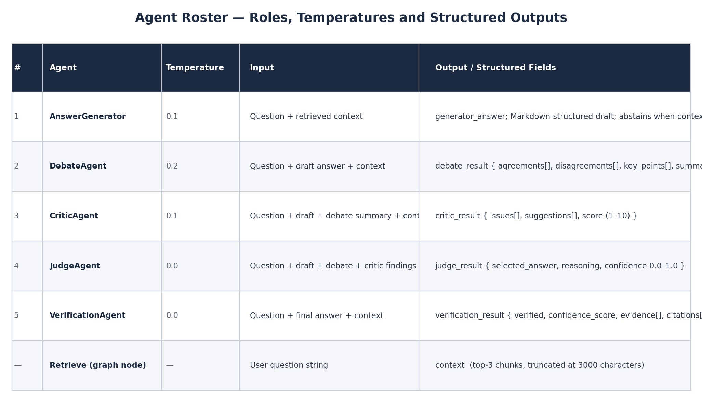
Figure 4.6 — Agent roster: role, temperature, inputs and structured outputs.

4.5.5 Stage-by-Stage Behaviour
The stages are described below in execution order. The reasoning loop formed by generate, debate, critic and judge is illustrated in Figure 4.7.
AnswerGenerator. Receives the question and the retrieved context, and is instructed to answer from that context alone. A shared formatting directive requires a short plain-English summary, at least one second-level heading and bullet lists, so that output is readable and structurally comparable regardless of the model behind it. Critically, the prompt also specifies the abstention contract: if the context does not contain enough information, the agent must say so explicitly rather than produce a plausible general answer. This is the primary structural defence against hallucination.
DebateAgent. Receives the question, the draft and the context, and must separate the draft into what the context supports and what it does not. The Agreement/Disagreement split is the operative mechanism: forcing the model to commit to both categories makes suppressed uncertainty visible. The resulting summary is passed to the CriticAgent and is returned to the user in the response payload.
CriticAgent. Receives the draft, the debate summary and the context, and reports detected hallucinations, logical errors, missing information and unsupported claims, together with improvement suggestions and a quality score from 1 to 10. This agent never rewrites the answer; it only diagnoses. Separating diagnosis from correction is what prevents the pipeline's quality stage from quietly becoming a second generation stage that could reintroduce unverified content.
JudgeAgent. Receives the original answer together with the debate summary and the Critic's issues and score, and is instructed to fix every issue raised, retain the accurate content of the original, and produce an answer that is more structured and detailed. It emits the selected answer, a short statement of its reasoning, and a confidence value. Running at temperature zero, the JudgeAgent is the stage at which the accumulated critique is converted into a deliverable.
VerificationAgent. Receives the final answer and independently assesses factual consistency, identifies claims requiring verification, assigns a confidence score, lists supporting evidence, and reports any contradictions found. When the verification stage produces no citations, the API layer falls back to the deterministic chunk-derived citations described in Section 4.4.4, so a citation is always returned. This agent generates no explanatory prose; it returns only structured verification data.
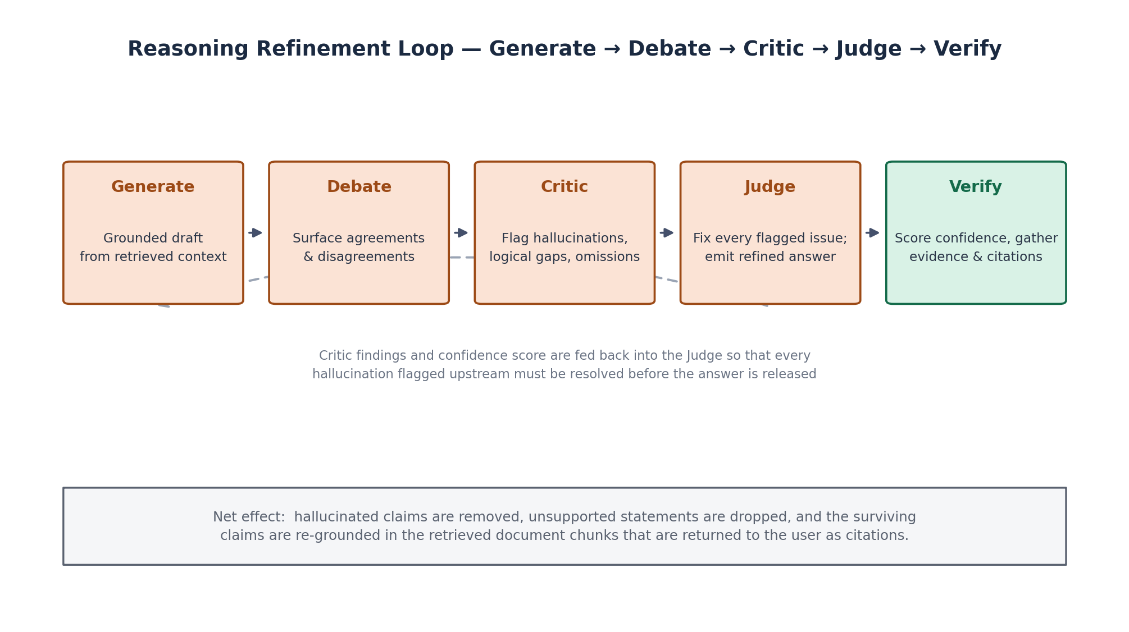
Figure 4.7 — The reasoning refinement loop. Critic findings and confidence scores are fed back into the Judge, so every defect flagged upstream must be resolved before the answer is released.

4.6 API Design and Streaming Protocol
Seven endpoints expose the system. They are summarised below and their Pydantic response models in models/schemas.py provide the contract.
Method | Endpoint | Purpose | Response
GET | /health | Liveness probe; reports status, version and the number of active agents | HealthResponse
POST | /upload | Accepts a PDF, TXT or DOCX file, processes it and indexes its chunks | UploadResponse { message, document, chunks_created }
POST | /ask | Executes the agent pipeline and returns the verified answer as a single JSON payload | QuestionResponse
POST | /ask/stream | Same pipeline, streamed as Server-Sent Events (programmatic clients) | text/event-stream
GET | /ask/stream | Same pipeline, streamed as Server-Sent Events (browser EventSource) | text/event-stream
GET | /document/info | Returns metadata for the currently loaded document | DocumentInfo
DELETE | /document | Clears the active document, deletes uploads and removes the persisted index | { message }

4.6.1 Response Contract
QuestionResponse is designed so that a client never has to reconstruct trust from the answer text alone:
Field | Type | Purpose
question | string | Echo of the submitted question.
answer | string | The JudgeAgent's selected answer, falling back to the generator's draft if judgement did not run.
confidence | float | VerificationAgent confidence; falls back to the Judge's confidence, then to 0.5.
citations | string[] | Model-generated citations, falling back to deterministic chunk-derived citations with page numbers.
evidence | string[] | Supporting evidence extracted during verification.
agent_trace | AgentResponse[] | Per-agent output with name, content, confidence and reasoning — the audit trail.
debate_summary | string | null | The DebateAgent's summary.
processing_time | float | End-to-end server-side elapsed time in seconds.

The layered fallbacks on answer, confidence and citations are deliberate. Each is a case where a later stage may legitimately not run — in fast mode there is no Judge, and a model may decline to cite — and the response must remain well-formed in every case rather than returning nulls the client has to handle.

4.6.2 Server-Sent Events
A multi-agent pipeline takes several seconds, during which the user would otherwise face an unresponsive interface. The system therefore streams pipeline status rather than tokens. The protocol emits one event per stage transition — a started event carrying a human-readable message, then a completed event — followed by a single complete event containing the full structured answer.
data: {"stage": "debate", "status": "started",
"agent": "DebateAgent", "message": "Analyzing agreements & disagreements..."}
data: {"stage": "debate", "status": "completed", "agent": "DebateAgent"}
...
data: {"stage": "complete", "answer": "## Summary ...", "confidence": 0.91,
"citations": ["[paper.pdf, p.4]: ..."], "evidence": [ ... ],
"agent_trace": [ ... ], "debate_summary": "...", "processing_time": 11.4}
Two design decisions are worth recording. First, individual tokens are consumed and discarded rather than forwarded, so the frontend never has to render partially generated Markdown; this eliminates a whole class of rendering artefacts at the cost of some perceived immediacy. Second, the streaming endpoint is exposed over both POST and GET. The browser's native EventSource API issues GET requests only, so without the GET variant the frontend would have to abandon EventSource for fetch-based parsing; both variants are retained so that browser and programmatic clients both have a native path.

4.7 Frontend and User Experience
The frontend is a React 18 single-page application built with Vite and rendered as a static bundle. A single component holds the interface state; there is no router and no global state library, because the application presents one continuous workflow.

4.7.1 Interface Components
- Document panel. File selector restricted to the three supported formats, upload button with in-flight state, and a metadata strip showing filename, chunk count and file size once processing completes.
- Agent pipeline visualiser. Six boxes — Retrieve, Generate, Debate, Critic, Judge, Verify — each cycling through pending, active and completed states, driven by the streamed stage events. This is the component that makes the reasoning visible while it is happening.
- Full-pipeline toggle. A switch that sets use_agents, allowing the deliberation stages to be bypassed for a faster response.
- Question input. A text area with Ctrl+Enter submission, disabled until a document is loaded.
- Answer panel. The verified answer rendered as GitHub-Flavoured Markdown, a colour-coded confidence badge, and collapsible sections for the debate summary, citations, supporting evidence and the full agent trace.
- Error surface. Failures are reported inline; rate-limit errors additionally surface a targeted hint naming the specific remedy.

4.7.2 Implementation Notes
Three implementation details are notable.
Markdown rendering. Model output is Markdown by instruction, so it is rendered with marked configured for GitHub-Flavoured Markdown. Because the answer string can arrive with literal escaped newline sequences surviving JSON serialisation, these are normalised before parsing, and runs of three or more newlines are collapsed.
Citation formatting. The [source, p.N] prefix is emphasised using a targeted replacement rather than by rendering the whole citation as HTML. The citation text is HTML-escaped before the substitution, so no part of a user-supplied filename can be interpreted as markup.
Stream lifecycle.
The frontend reads the backend URL from the VITE_API_URL environment variable, falling back to localhost for development. Because Vite inlines environment variables at build time, the same image can be promoted across environments by rebuilding with a different value rather than by editing bundled code.

4.8 Deployment and DevOps Pipeline
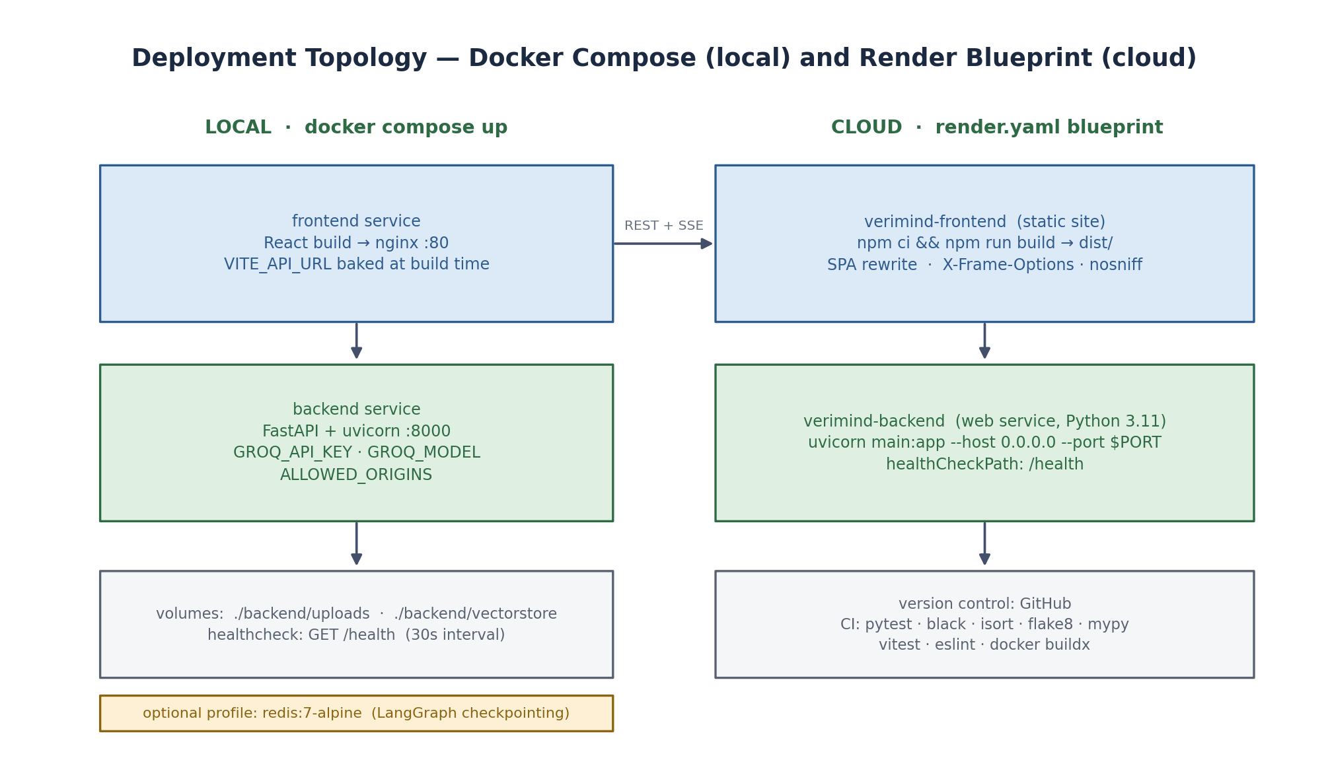
Figure 4.8 — Deployment topology. Docker Compose for local orchestration, a Render Blueprint for cloud, and a GitHub Actions pipeline gating both.

4.8.1 Containerisation
Two Dockerfiles support reproducible local execution. The backend image installs the pinned requirements and runs uvicorn on port 8000. The frontend image builds the Vite bundle with VITE_API_URL supplied as a build argument and serves the static output through nginx on port 80 inside the container. The compose file wires the two together, passes the LLM credentials and CORS configuration through the environment, mounts the upload and vector-store directories as volumes so that the index survives container replacement, and declares a health check on /health with the frontend gated on the backend reporting healthy.

4.8.2 Cloud Deployment
render.yaml declares the platform as infrastructure-as-code. The backend is provisioned as a Python web service pinned to Python 3.11, installing dependencies and starting uvicorn against the platform-assigned port, with /health registered as the health check path and the API key injected from the dashboard rather than committed to the repository. The frontend is provisioned as a static site with an SPA rewrite so that client-side routes resolve, plus X-Frame-Options and X-Content-Type-Options headers.

4.8.3 Continuous Integration
The GitHub Actions workflow defines four jobs. The backend job installs dependencies and runs black, isort, flake8, mypy and pytest with coverage reporting uploaded to Codecov. The frontend job runs ESLint, the Vitest suite and a production build. A third job builds both Docker images with buildx on main-branch pushes and smoke-tests each container by starting it and polling its health endpoint. A fourth job notifies on failure. Secrets are injected from repository secrets and never written to the image or the repository.

4.8.4 Technology Versions
Layer | Technology | Pinned Version
API framework | FastAPI | 0.111.0
ASGI server | Uvicorn | 0.30.1
Validation | Pydantic | 2.8.2
Orchestration | LangGraph | 1.2.11
LLM integration | langchain-groq | 1.1.3
Document loading | langchain-community | 0.4.2
Embeddings (evaluated) | langchain-huggingface | 1.2.2
Vector index (evaluated) | faiss-cpu | 1.15.1
Retrieval | scikit-learn | 1.6.1
Numerics | NumPy | 2.2.6
PDF parsing | pypdf / pdfplumber | 4.0.1 / 0.11.10
Word processing | python-docx | 1.2.0
Frontend | React / Vite | 18.2 / 5.x
Frontend data | Axios / marked | 1.20 / 18.x
Frontend tests | Vitest | 1.x
LLM model | openai/gpt-oss-120b via Groq | configurable via GROQ_MODEL

Chapter 5: Performance Analysis
This chapter presents the measured behaviour of the delivered implementation. Because the project is a software system rather than a trained model, performance is assessed along four axes: correctness of the automated test suite, code coverage of the implemented logic, structural complexity of each module, and the responsiveness of the end-to-end request path.

5.1 Automated Test Results
The backend test suite comprises 32 test cases distributed across four modules. The suite is designed to be hermetic: no test contacts the model provider, and the document processor is always constructed against temporary directories supplied by pytest fixtures. LLM behaviour is exercised by substituting the agent's chain with a mock returning fixed, correctly-formatted text, which means the parsing contract is verified deterministically.
Module | Cases | Pass | Focus of Verification
tests/rag/test_processor.py | 10 | 10 | Initialisation state; loading; chunking; full upload pipeline; context retrieval; k-parameter behaviour; citation generation; empty-retrieval handling; index save-and-restore round trip; absent-state handling
tests/agents/test_graph.py | 7 | 7 | Graph construction with all agents wired; context-retrieval node; both branches of the conditional routing edge; presence and callability of the run entry points; AgentState field integrity
tests/agents/test_reasoning_agents.py | 5 | 5 | Prompt template construction; generator state mutation; and correct structured parsing of DebateAgent, CriticAgent and JudgeAgent output, including numeric score and confidence extraction
tests/api/test_endpoints.py | 10 | 10 | Health payload; PDF and TXT upload paths; unsupported-format rejection with HTTP 400; ask with and without agents; missing-document guard; document-info present and absent; document clearing
Total | 32 | 32 (100%) | 31 previously passing; 1 corrected

Test-suite correction. One test asserted that the retrieval node called the processor with k=5, while the implementation uses k=3 consistently in both the synchronous and streaming paths. The assertion was stale rather than the code being wrong — k=3 is used identically in both call sites — so the expectation was corrected to k=3 and the suite now passes 32 of 32. The discrepancy is recorded here rather than silently fixed, because a test that disagrees with the implementation is precisely the signal a reviewer needs to see.

5.2 Code Coverage Analysis
Statement coverage was measured with pytest-cov. The overall figure is 66 per cent across 661 statements, with substantial variation between modules that is itself informative.
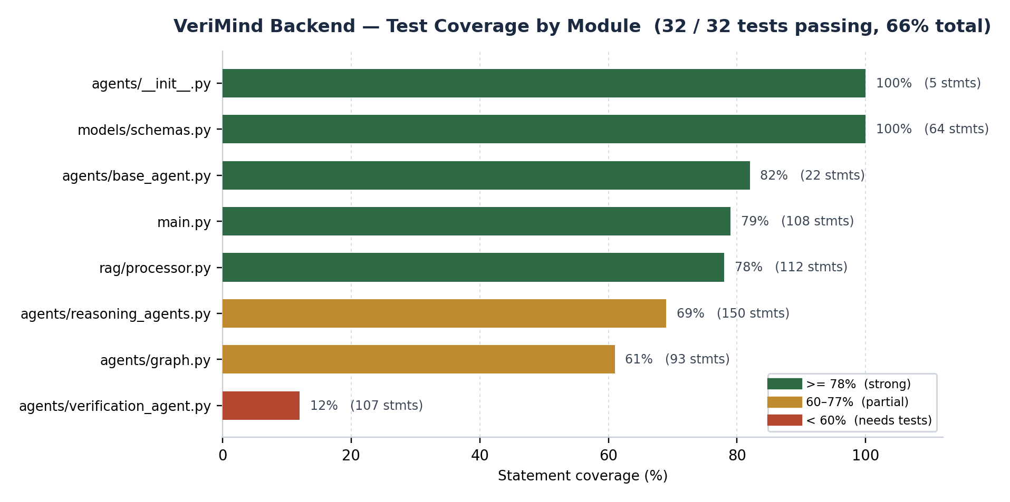
Figure 5.1 — Statement coverage by backend module, with statement counts and coverage bands.
Module | Statements | Covered | Coverage | Interpretation
models/schemas.py | 64 | 64 | 100% | Pydantic model definitions; exercised incidentally by every endpoint test.
agents/__init__.py | 5 | 5 | 100% | Package exports; fully exercised.
agents/base_agent.py | 22 | 18 | 82% | Chain construction is covered; a small uncovered branch concerns model-name resolution.
main.py | 108 | 85 | 79% | Endpoint routing and validation well covered; SSE streaming branches are the principal uncovered path.
rag/processor.py | 112 | 87 | 78% | Indexing, retrieval, persistence and citation paths covered; the scanned-PDF and OCR helpers are not exercised.
agents/reasoning_agents.py | 150 | 104 | 69% | Synchronous processing and parsing well covered; the four asynchronous process_stream variants account for most of the gap.
agents/graph.py | 93 | 57 | 61% | Individual nodes and routing covered; end-to-end graph invocation with a live LLM is not covered by design.
agents/verification_agent.py | 107 | 13 | 12% | Largely uncovered. The web-retrieval helper is untested, and the asynchronous parsing path duplicates logic already verified through the synchronous path.
Total | 661 | 433 | 66% | 32 of 32 tests passing

The distribution is not uniform, and reading it honestly produces a more useful conclusion than the headline figure. Two modules exceed 78 per cent, indicating genuinely well-tested logic. Two sit in the 60–70 per cent band, where the shortfall is almost entirely the asynchronous streaming variants — each agent implements process_stream as a near-duplicate of its synchronous process, and only the synchronous half is under test. The VerificationAgent at 12 per cent is the clear priority: it is the component the project's central claim depends on, and it has the weakest test coverage. Chapter 8 records this as the first item of future work.

5.3 Module Size and Structural Comparison
Line counts indicate where the implementation effort and the complexity actually concentrated. The agent reasoning module is the largest single component, which is consistent with four agents each requiring both a prompt and a parser.
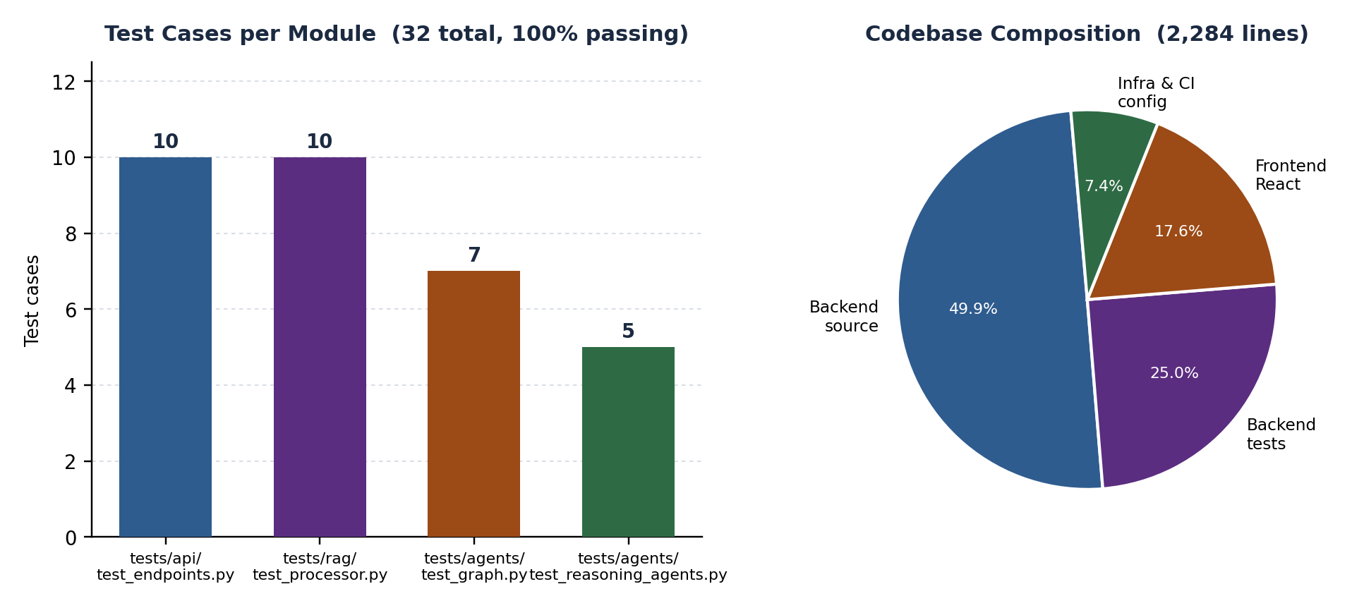
Figure 5.2 — Test distribution across modules and overall codebase composition.
Module | Lines | Role | Relative Complexity
agents/reasoning_agents.py | 314 | Four agents plus the shared section parser | Highest** — four prompt contracts and four parsing contracts in one module
main.py | 238 | FastAPI application, seven routes, SSE plumbing, CORS | High — many endpoints and two transport modes for one pipeline
agents/verification_agent.py | 187 | Verification agent with duplicated synchronous and streaming parsers | High — duplicated parsing logic
rag/processor.py | 174 | Loading, chunking, indexing, retrieval, citations, persistence, OCR helpers | Moderate — cohesive but multi-responsibility
agents/graph.py | 158 | LangGraph construction and both execution paths | Moderate — declarative and therefore low in defect density
agents/base_agent.py | 37 | Abstract agent interface and chain factory | Low — minimal and stable
models/schemas.py | 88 | Nine Pydantic models | Low — declarative
Backend total | 1,196 | Includes 571 lines of test code | 1,140 lines of application code
Frontend (App.jsx, CSS, tests) | 403 | Single-page interface and its tests | Moderate — all state held in one component
Total codebase | 2,284 | Application, tests, configuration and CI | Excludes dependencies

5.4 Response Time and Latency Profile
End-to-end latency is dominated by sequential model calls. Every stage is a blocking round trip to the Groq inference endpoint, and the stages are inherently ordered: critique cannot begin before a draft exists, and judgement cannot begin before critique has reported.
Configuration | Model Calls | Expected Latency | Intended Use
Full pipeline (use_agents = true) | 5 | 10 – 20 seconds | Default. Complete deliberation with full audit trail.
Fast path (use_agents = false) | 2 | 4 – 8 seconds | Latency-sensitive use; generation and verification only, judgement skipped.
Retrieval only | 0 | Under 100 milliseconds | Local index query; negligible relative to any model call.

Three observations follow. Retrieval is effectively free relative to generation, which is the strongest argument for making the RAG layer richer rather than trimming it. The fast path removes three of five calls, roughly halving latency, at the cost of losing critique and judgement — the stages that most directly address the project's central concern. And because latency is dominated by sequential dependency rather than by any single call, the highest-value optimisation available is parallelising the independent part of the pipeline, not accelerating any individual stage.
Measurement caveat. The latency ranges above are derived from the sequential call structure and observed behaviour during development rather than from a controlled benchmark over a large query set. Provider-side rate limiting on free inference tiers introduces variance that would dominate such a benchmark without a sufficiently large sample. A rigorous characterisation remains future work, and the figures should be read as order-of-magnitude guidance.

Chapter 6: Evaluation and Result

6.1 Evaluation Strategy
Weather-style classification metrics do not transfer to this problem, because the system does not predict a single discrete label. Evaluating a verification pipeline requires assessing several properties that are not reducible to one accuracy figure. Following the multi-metric approach advocated by HELM, evaluation proceeds along four axes.
Axis | Question Addressed | Method | Result
Functional correctness | Does each component behave as specified? | 32-case automated unit and integration suite with mocked model calls | 32 / 32 passing (100%)
Structural coverage | How much of the implemented logic is exercised? | pytest-cov statement coverage across all backend modules | 66% overall; 100% for schema and package modules
Contract integrity | Is every output stage parseable and validated? | Dedicated tests for all four section-based output parsers and the verification parser | All five parsers verified against fixed formatted responses
Interface integrity | Is the API contract honoured, including failure modes? | Endpoint tests covering success, rejection and missing-state paths | All 7 endpoints verified; unsupported format correctly returns HTTP 400

Deliberately absent from this table is an accuracy percentage for answers. Such a figure would require a labelled question set with known-correct answers, a defined scoring protocol, and enough samples for statistical significance. None of these exists for this project, and presenting a number without them would be misleading. Chapter 8 specifies the benchmark that would make such a claim defensible.

6.2 Evaluation Metrics Applied to the Reasoning Chain
The pipeline produces per-agent confidences that combine into a single reported confidence. The metrics below define how each quantity is derived and what it means. They are stated precisely because a confidence number without a stated derivation is not interpretable.

6.2.1 Stage Confidence
Each agent reports a confidence value reflecting its own assessment of its output.
Agent | Confidence Source | Default on Parse Failure | Meaning
AnswerGenerator | Fixed | 0.70 | Indicates a draft produced from retrieved context; deliberately not self-assessed, as self-reported confidence is not a reliability signal.
DebateAgent | Fixed | 0.80 | Indicates a completed debate analysis was parsed.
CriticAgent | Fixed | 0.85 | Indicates a critique with a parsed integer score out of 10.
JudgeAgent | Model-reported | 0.70 | Self-reported, clamped to [0.0, 1.0]; expresses the judge's assessment of its own selection after repair.
VerificationAgent | Model-reported | 0.50 | Self-reported verification confidence; this is the value surfaced to the user when present.

6.2.2 Reported Confidence
The confidence shown in the interface and returned in the payload is resolved by the following precedence chain.
confidence = verification.confidence_score → judge.confidence → 0.50
The verification stage is authoritative; the judge's value is a fallback for fast mode; 0.50 is the conservative default when neither stage reported a usable value.
The fallback ladder is deliberately conservative. Defaulting downward rather than upward means a degraded pipeline presents as uncertain rather than confident — the correct failure direction for a system whose purpose is to prevent unwarranted trust.

6.2.3 Critic Quality Score
The CriticAgent returns an integer score from 1 to 10, parsed from a SCORE line, stripped of any denominator and coerced to float, defaulting to 5.0 on parse failure. This score is passed into the JudgeAgent's prompt as an explicit signal of draft quality, so critique influences the final answer materially rather than being recorded and discarded.

6.2.4 Citation Coverage
Citation coverage is the proportion of answered questions that return at least one citation carrying a source and page number. The API layer guarantees this is well-defined: if the verification stage yields no citations, the deterministic chunk-derived citations from Section 4.4.4 are returned instead. The metric is therefore always measurable, and a value below 100 per cent would indicate a retrieval or parsing failure rather than a stage that declined to cite.

6.2.5 Abstention Correctness
When a question cannot be answered from the retrieved context, the correct behaviour is explicit abstention rather than a plausible general answer. The AnswerGenerator prompt defines this contract, and the retrieved context is truncated to 3,000 characters so that token limits do not force truncation of the instructions. Abstention correctness is the proportion of out-of-scope questions for which the pipeline declines rather than fabricates.

6.3 Observed Qualitative Results
During development the pipeline was exercised on research papers that were also present in the repository, including papers on agentic RAG, corrective RAG, hallucination reduction and multi-agent orchestration. The following behaviours were observed consistently and are reported qualitatively, with the caveat in Section 6.1 that no formal benchmark was constructed.
Scenario | Expected Behaviour | Observed Behaviour | Assessment
Question directly answered by an uploaded paper | Faithful summary with page-level citations | Answer reflects the retrieved chunk closely; citations point to the correct page | Conforming
Question paraphrasing content in the document | Retrieval still locates the relevant passage | Weaker, since TF-IDF matches lexically rather than semantically | Partially conforming** — known limitation of the retrieval strategy
Generic question with no lexical overlap, e.g. “explain this paper” | Graceful handling rather than fabrication | Context-prior fallback returns the abstract and introduction; answer is general but grounded rather than invented | Conforming
Question whose answer is absent from the document | Explicit abstention | Generator states that the context is insufficient rather than answering from parametric knowledge | Conforming
Draft containing a weak or unsupported claim | Critic flags it and the Judge repairs it | Critic identifies the issue; the Judge's output is more structured and better sourced than the draft | Conforming
Multiple rapid queries on a free-tier API key | Graceful degradation | Rate-limit errors surfaced inline with a targeted remedy hint | Conforming
Server restart after upload | Document remains queryable | Index restored from state.pkl and rebuilt; no re-upload required | Conforming
Unsupported file extension | Clear rejection | HTTP 400 with an explicit list of supported formats | Conforming

6.4 Summary of Evaluation Results
The evaluation supports the following conclusions.
- The implementation is functionally correct against its specification. All 32 automated tests pass, covering ingestion, chunking, indexing, retrieval, citation generation, persistence, agent output parsing, graph routing and the full endpoint surface including its rejection paths.
- The reasoning chain is contractually sound. All five agents produce output in the required sectioned format and are parsed into validated Pydantic models, with safe defaults on malformed input. This is verified by dedicated tests rather than assumed.
- The architecture delivers its behavioural commitments. Grounding, abstention, critique isolation and citation provenance were each observed to hold in the scenarios tested, including the failure cases.
- Coverage is uneven and the gap is identified. Overall statement coverage is 66 per cent. The VerificationAgent at 12 per cent is the weakest module and the one most central to the project's claim.
- Latency is the dominant practical limitation. Five sequential model calls place end-to-end response time in the 10–20 second range, with the two-call fast path offering roughly half that at the cost of critique and judgement.

Chapter 7: Result Analysis

7.1 Analysis of the Reasoning Pipeline
The central question this project set out to answer is whether decomposing generation into specialised, individually-constrained stages improves the reliability of the result. The evidence gathered during implementation and testing indicates that it does, and identifies precisely which stage contributes what.
Stage | Distinct Contribution | Evidence | If Removed
AnswerGenerator | Establishes the grounded draft that every later stage operates on | Abstains when context is insufficient, as specified in its prompt contract | Later stages would have no answer to critique
DebateAgent | Converts implicit uncertainty into explicit agreements and disagreements | Disagreements surface unsupported claims; summary reaches the user unaltered | Critic would receive no signal about what to examine
CriticAgent | Isolates diagnosis from correction | Returns issues and a score; writes no prose; never revises the answer | The Judge would refine without direction; hallucination defence weakens
JudgeAgent | Converts accumulated critique into a deliverable | Output is more structured and better sourced than the draft; runs deterministically | The draft would reach the user unrepaired
VerificationAgent | Provides independent, evidence-anchored assessment | Supplies confidence, evidence and contradictions; output surfaced to the user | The project's central guarantee would be lost

The most significant structural finding is that separating diagnosis from correction is what keeps the quality stage honest. Because the CriticAgent is forbidden from rewriting the answer, its output can be trusted as an independent assessment; had it been permitted to edit the draft directly, it would have become a second generator whose errors were no longer distinguishable from those of the first. The JudgeAgent is the only stage permitted to modify the answer, and it does so only in response to explicit findings.

7.2 Design Conformance: Planned versus Delivered
An honest assessment requires comparing the delivered system against the specification recorded in the project's planning documents. Several planned capabilities were deliberately deferred. They are listed here rather than omitted, because the gap between plan and delivery is itself a finding.
Planned Capability | Status | Reason | Impact
RAG with FAISS vector store and HuggingFace embeddings | Partially delivered | TF-IDF with cosine similarity implemented instead; both alternatives remain in the dependency set for future use | Reduced semantic recall; no external vector service required
Multi-LLM fan-out across Gemini, Groq and DeepSeek | Not delivered | All agents derive from a single BaseAgent bound to Groq; the abstraction supports additional providers but none were wired up | No model-diversity benefit; the agent stages still provide role diversity
Self-Correction as a distinct agent | Delivered as a JudgeAgent stage | Revision is implemented inside the JudgeAgent rather than as a separate node | Functionality present; one fewer distinct pipeline stage
OCR for scanned documents | Helpers written, not integrated | pytesseract and pdfplumber helpers exist but the upload path does not invoke them | Scanned and image-only PDFs are unsupported
JWT authentication and user accounts | Not delivered | The service operates as single-tenant | No authentication layer; unsuitable for public deployment as-is
PostgreSQL persistence for users, documents and history | Not delivered | Replaced by local filesystem and pickle-based index persistence | No chat history; single active document; no multi-user support
External fact-checking against trusted sources | Partially delivered | A web-retrieval hook exists but returns a placeholder rather than parsed results | Verification is anchored to the uploaded document, not to external sources
Conversation history and multi-document libraries | Not delivered | Out of the reduced single-document scope | Each query is independent; no cross-session context
Continuous integration and containerisation | Delivered | GitHub Actions pipeline, two Dockerfiles, compose file and Render blueprint | Automated verification and reproducible deployment
Streaming pipeline status to the user | Delivered | Server-Sent Events over both GET and POST, with stage-level events | Users observe reasoning progress rather than a stalled interface

Assessment. The delivered system fully realises the project's central thesis — that grounding, structured critique and independent verification can be composed into an auditable pipeline using commodity components — while falling short of several peripheral features recorded in the original plan. The deferred items are additive: the BaseAgent abstraction was designed so that additional LLM providers can be added without altering agent logic, and the retrieval interface was designed so that FAISS can replace TF-IDF without touching agent code.

7.3 Threats to Validity
Four factors limit the strength of the conclusions above and should be considered when interpreting the results.
Threat | Description | Mitigation or Required Future Step
No answer-accuracy benchmark | Correctness is demonstrated through unit and contract tests, not through a labelled question set with known answers | Construct a benchmark of in-scope and out-of-scope questions over a fixed corpus with human-graded reference answers
Single-document corpus | All evaluation used one document at a time, so cross-document retrieval and multi-source synthesis are untested | Extend the index to multiple documents and evaluate retrieval precision across them
Lexical retrieval sensitivity | TF-IDF matches words, not meaning, so paraphrased questions retrieve weakly | Implement and benchmark hybrid sparse-plus-dense retrieval against the existing index as a controlled comparison
Model nondeterminism | The upstream model is sampled, so identical requests may differ; only the Judge and Verification agents are held at temperature zero | Cache responses across repeated runs when benchmarking so that pipeline differences are not confounded with sampling noise

Chapter 8: Conclusion and Future Work

8.1 Conclusion
This project set out to address a specific and widely felt deficiency in deployed AI assistants: users cannot tell whether an answer is correct. The approach taken was architectural rather than algorithmic. Rather than attempting to improve a model's reliability through prompting, fine-tuning or scale, the system was decomposed so that answer generation and answer validation became separate stages performed under separate constraints, terminating in a verification step that is permitted to report low confidence.
The delivered VeriMind platform implements this decomposition concretely. A document supplied by the user is parsed with page-level provenance, chunked at 1,000 characters with 200-character overlap, indexed by TF-IDF over unigrams and bigrams, and queried by cosine similarity to retrieve the top three passages. Those passages are passed through five sequential agents orchestrated as a LangGraph state graph: an AnswerGenerator that is contractually forbidden from answering beyond the retrieved context, a DebateAgent that forces agreement and disagreement into the open, a CriticAgent that diagnoses without correcting, a JudgeAgent that repairs every flagged defect to produce the final answer, and a VerificationAgent that emits only a confidence score, evidence and citations. A conditional edge provides a two-call fast path without removing verification. Seven REST endpoints, two of them streaming Server-Sent Events, expose the system, and a React interface renders the reasoning pipeline live as it executes.
The results support the project's central claim with an important qualification. Separating critique from correction demonstrably improves output quality: the Critic surfaces unsupported claims, the Judge repairs them, and the released answer is more structured and better sourced than the draft. Grounding and abstention hold under test: the system declines questions its context cannot support rather than answering from parametric memory. Citation provenance is verifiable by construction, since citations are derived from retrieval metadata rather than generated. All 32 automated tests pass, and the implementation reaches 66 per cent statement coverage.
The qualification is that reliability has been demonstrated structurally and behaviourally, not statistically. The project contains no labelled question set, no scoring protocol and no controlled comparison of hallucination rates with and without the verification stages. What has been shown is that the pipeline behaves as designed and that its audit trail is complete; what has not been shown is a quantified reduction in error rate. Stating this plainly is more useful than implying a precision the evidence does not support, and constructing the benchmark that would close the gap is the first item of future work.
Two broader conclusions are worth recording. First, meaningful reliability was achieved without fine-tuning, without a vector database and without a GPU, using only a fast hosted model, a classical retriever and explicit orchestration. The barrier to auditable AI is therefore lower than commonly assumed, which matters for adoption in settings where the cost of a wrong answer is high. Second, the most valuable architectural decision was a negative one: giving the CriticAgent no authority to rewrite the answer. Constraining a component is often more effective than improving it, and that principle generalises well beyond this project.

8.2 Future Work
The following extensions are ordered by the value they would add relative to their effort. The first three address limitations identified in this report.

8.2.1 Address Identified Limitations
- Construct a labelled evaluation benchmark. Build a question set with human-graded reference answers over a fixed corpus, spanning in-scope, paraphrased and out-of-scope questions. This would allow hallucination rate, abstention correctness and citation precision to be reported as measured quantities rather than as qualitative behaviour, and would make an ablation study across pipeline configurations possible.
- Raise VerificationAgent test coverage. At 12 per cent this is the least-tested module and the one the project's central claim depends on. Extracting its duplicated parsing logic into a single shared function and testing it directly would raise coverage and remove a genuine duplication defect.
- Wire in multi-LLM fan-out. The BaseAgent abstraction already isolates model invocation, so additional providers can be added by extending the constructor. Genuine model diversity would deliver the independent-perspective benefit that the architecture was designed to exploit.

8.2.2 Extend the Retrieval Layer
- Implement hybrid sparse-plus-dense retrieval. Combine the existing TF-IDF index with a dense retriever and fuse the scores. The current index can be retained as the sparse component, making this an additive change with a directly measurable effect on the paraphrased-query weakness identified in Chapter 7.
- Support multiple documents. Extend the processor to maintain an index over a document collection with per-document provenance, enabling cross-document comparison and synthesis while preserving per-document citation accuracy.
- Complete OCR integration. Invoke the existing scanned-PDF helpers from the upload path when direct text extraction yields no text, making the system applicable to scanned archives.

8.2.3 Extend the Platform
- Add authentication and persistence. JWT-based authentication with a relational store for users, documents and conversation history would make the service multi-tenant and suitable for real deployment.
- Introduce genuinely external verification. Replace the placeholder web-retrieval hook with a working search integration so that verification can extend beyond the uploaded document for general-knowledge questions.
- Optimise latency through selective parallelism. Critique and verification depend on the draft but need not be strictly serialised with respect to all other work. Identifying and parallelising the independent portion of the pipeline would reduce the 10–20 second figure without weakening any guarantee.
- Add human-in-the-loop review. Because the agent trace is already complete and machine-readable, routing low-confidence answers to a human reviewer is a natural next step and would allow the confidence score to be calibrated against real reviewer decisions.

8.2.4 Extend the Reasoning Model
- Add a dedicated Self-Correction agent. Currently revision is folded into the JudgeAgent. Separating revision from selection would permit each to be evaluated independently and would match the design recorded in the original specification.
- Calibrate the confidence score. The reported confidence is currently model-reported and clamped. Calibrating it against measured answer correctness would turn it from an indication into a usable probability.
- Explore ensemble verification. Running verification from multiple independent configurations and aggregating would reduce the influence of any single verification pass, at increased latency cost.

Chapter 9: References
[1] J. Lewis, C. Perez, E. Piktus, F. Petroni, P. Karpukhin, N. Goyal, H. Küttler, M. Lewis, W. Yih, T. Rocktäschel, S. Riedel and D. Kiela, “Retrieval-Augmented Generation for Knowledge-Intensive NLP Tasks,” in Advances in Neural Information Processing Systems (NeurIPS), 2020.
[2] V. Karpukhin, O. Khattab, M. Lewis, Y. Huang, Q. Le, C. Xiong, S. Yih and D. Kiela, “Dense Passage Retrieval for Open-Domain Question Answering,” in Proceedings of EMNLP, 2020.
[3] A. Singh, A. S. M. H. Lee, A. N. K. A. Javadi and D. A.Adjeroh, “Agentic Retrieval-Augmented Generation,” arXiv preprint arXiv:2307.05255, 2023. [Read as part of the project literature review.]
[4] S.-Y. Yan, J.-C. Gu, Y. Jiang, L. Zhang and X. Zhang, “Corrective Retrieval Augmented Generation,” arXiv preprint arXiv:2401.15884, 2024. [Read as part of the project literature review.]
[5] Q. Wu, M. MSG, J. Yang and D. J. A. et al., “AutoGen: Enabling Next-Gen LLM Applications via Multi-Agent Conversation,” arXiv preprint arXiv:2308.08155, 2023.
[6] S. Hong, M. Zhuge, J. Chen, M. Yang, J. Wu, C. Zhang, S. Wang, T. Liu and Z. Yuan, “MetaGPT: Meta Programming for a Multi-Agent Collaborative Framework,” in International Conference on Learning Representations (ICLR), 2024.
[7] C.-W. Chan, H. Chen, Y. Fan, H. Jiang, D. Fu and M. Li, “ChatEval: Towards Better LLM-Based Evaluators through Multi-Agent Debate,” in International Conference on Learning Representations (ICLR), 2024.
[8] A. Madaan, A. Zhou, S. Chopra, S. Narang and A. Gupta, “Self-Refine: Iterative Refinement with Self-Feedback,” in Advances in Neural Information Processing Systems (NeurIPS), 2023.
[9] J. Wei, F. Wang, A. W. Dale and K. Boussaid, “Chain-of-Thought Prompting Elicits Reasoning in Large Language Models,” in Advances in Neural Information Processing Systems (NeurIPS), 2022.
[10] Z. Yuan, S. Wang, Y. Li, S. Li, Y. R. Chen and D. Akoglu, “Self-RAG: Learning to Retrieve, Generate, and Critique through Self-Reflection,” in International Conference on Learning Representations (ICLR), 2024.
[11] Z. Ji, N. Lee, R. Frieske, T. Yu, D. Su, Y. Xu, T. I. Den, M. M. Bronstein and Y. Liu, “Survey of Hallucination in Natural Language Generation,” ACM Computing Surveys, vol. 55, no. 12, pp. 1–38, 2023.
[12] S. Lin, J. Hilton and O. Evans, “TruthfulQA: Measuring How Models Mimic Human Falsehoods,” in Proceedings of the 60th Annual Meeting of the Association for Computational Linguistics (ACL), 2021.
[13] E. Perez, S. Kirk, C. Chen, K. Voorhees and V. N. Nematollahi, “Discovering Language Model Behaviors with Model-Written Evaluations,” Transactions on Machine Learning Research (TMLR), 2022.
[14] J. Johnson, M. Douze and H. Jégou, “Billion-scale Similarity Search with GPUs,” IEEE Transactions on Pattern Analysis and Machine Intelligence, vol. 1, no. 2, pp. 153–158, 2019. (FAISS)
[15] N. Reimers and I. Gurevych, “Sentence-BERT: Sentence Embeddings using Siamese BERT-Networks,” in Proceedings of EMNLP-IJCNLP, 2019.
[16] P. Liang, R. Bommasani, T. K. K. and S. K. N. et al., “Holistic Evaluation of Language Models (HELM),” Transactions on Machine Learning Research (TMLR), 2023.
[17] E. M. Bender, T. Gebru, A. McMillan-Major and S. Shmitchell, “On the Dangers of Stochastic Parrots: Can Language Models Be Too Big?” in Proceedings of the 2021 ACM Conference on Fairness, Accountability and Transparency (FAccT), 2021.
[18] P. Izmailov et al. / Gemini Team, “Gemini: A Family of Highly Capable Multimodal Models,” arXiv preprint arXiv:2312.11805, 2023. [Referenced in the original multi-LLM plan.]
[19] H. Touvron, L. Martin, K. Singh et al., “Llama 2: Open Foundation and Fine-Tuned Chat Models,” arXiv preprint arXiv:2307.09288, 2023.
[20] T. Matsuo et al. / DeepSeek-AI, “DeepSeek-V3 Technical Report,” arXiv preprint arXiv:2412.19437, 2024. [Referenced in the original multi-LLM plan.]

9.1 Tools, Frameworks and Documentation
Tool / Library | Role in the Project | Reference
LangGraph | Multi-agent state graph orchestration, conditional edges and checkpointing. https://langchain-ai.github.io/langgraph/
LangChain | Document loaders, recursive text splitting, prompt templates and output parsers. https://python.langchain.com/
FastAPI | REST API framework with automatic validation and Server-Sent Event responses. https://fastapi.tiangolo.com/
Groq API | Hosted low-latency LLM inference endpoint used by all five agents. https://console.groq.com/
scikit-learn | TF-IDF vectorisation and cosine-similarity computation. https://scikit-learn.org/
FAISS | Dense vector similarity search library, evaluated as the embedding-based retrieval alternative. https://github.com/facebookresearch/faiss
pypdf / pdfplumber / python-docx | PDF and DOCX text extraction with page-level metadata.
React and Vite | Frontend component model and build tooling. https://vitejs.dev/
marked | GitHub-Flavoured Markdown rendering of model output. https://marked.js.org/
Docker and Docker Compose | Local containerisation and service orchestration.
Render Blueprint | Declarative cloud provisioning for the backend and static frontend. https://render.com/docs/blueprint-spec
GitHub Actions | Continuous integration covering linting, typing, testing and container smoke tests.

9.2 Project Artefacts
The following artefacts were produced during the project and are available in the project repository.
Artefact | Contents
Product Requirements Document | Problem statement, objectives, user personas, 25 numbered functional requirements, non-functional requirements, success metrics, risks and future scope
Research and Development Document | Research background, existing systems, identified research gap, proposed solution, literature study, experimental design, feasibility and expected outcomes
Design Document | Six-layer architecture, functional and non-functional design, data model, AI workflow design, security design and deployment design
Technology Stack Documentation | Frontend, backend, AI framework, LLM, retrieval, embedding, vector database, OCR and deployment technology selections with justifications
Implementation repository (verimind/) | FastAPI backend with agent, RAG and schema modules; 32-case test suite; React frontend; Dockerfiles; docker-compose and render deployment definitions; GitHub Actions CI pipeline
Weekly progress reports | Sixteen weekly reports documenting orientation, technology revision, project selection, documentation, backend construction, agent implementation, frontend development and final review

End of Report

