Infosys Springboard Virtual Internship 6.0 Completion Report
Team Details
Batch Number: 13
Start date: 02 Feb,2026
Name: Aditya Prajapati
Internship Duration: 8 Weeks
Project Title
Smart Pet Care
Project Objective
The goal of the internship project was to create a full digital platform for managing and providing pet healthcare services. The goal of the project was to make it easier for pet owners, veterinarians, and administrators to communicate with each other through a single interface.
The system's main goal is to help pet owners keep track of their pets' profiles, medical history, schedule vet visits, and buy pet-related items through a single marketplace. The platform gives veterinarians tools to keep track of appointments, patient records, and talk to pet owners. An administrative panel also makes sure that users, doctor approvals, marketplace inventory, and system operations as a whole are all under control.
The project's goals were to:
- Set up role-based access for pet owners, vets, and administrators.
- Allow pets to have their health tracked and monitored all the time.
- Use digital records to make managing your pet's health care easier.
- Make it easier to get to veterinary services by letting people book appointments online.
- Create a place on the same platform where people can buy and sell pet-related items

Project Description
During my internship, I worked on developing a project called Smart PetCare, which is a full-stack web application designed to simplify and organize pet healthcare and related services in one place.
The main idea behind this project was very practical — pet owners often struggle to keep track of their pet’s health records, appointments, and other needs. At the same time, veterinarians don’t always have easy access to a pet’s history, and there is no single platform that connects all these services together. So, this project was built to solve that problem by creating a centralized system where everything related to pet care can be managed efficiently.
What the Project Does
The platform connects three types of users:
- Pet Owners
- Veterinarians
- Admin
Each of them gets their own dashboard and features based on their role.
As a pet owner, a user can:
- Create and manage their pet’s profile (name, breed, age, etc.)
- View medical history and past consultations
- Book appointments with veterinarians
- Get reminders for vaccinations or checkups
- Buy pet products through the marketplace
- Track orders and appointments
For veterinarians, the platform allows them to:
- Manage appointments and schedules
- View pet medical records before consultation
- Add notes, diagnosis, and follow-up instructions
- Handle patient history more efficiently
The admin has full control over the system, such as:
- Managing users and verifying doctors
- Controlling marketplace products and inventory
- Monitoring appointments and platform activity
Key Feature I Focused On
One important part of the system is the pet health record section, where all medical history is stored digitally. Instead of relying on paper records, everything is saved and can be accessed anytime. This makes it easier for both pet owners and vets to stay updated.
Another major feature is the appointment system, where users can book a vet and even have follow-up visits without rebooking or paying again within a given time period.
The marketplace module was also implemented, where users and vets can purchase pet-related products, while the admin manages inventory and stock.
Technology Used
The project was built using:
- Frontend: React.js with Tailwind CSS for UI
- Backend: Java Spring Boot for APIs and business logic
- Database: Relational database (like MySQL)
- Authentication: JWT-based login system
Week | Activities Planned | Activities Completed
Week 1 | Understand project requirements, plan features | Understood project idea, decided modules (Owner, Vet, Admin)
Week 2 | Design UI and start frontend | Built landing page, login, signup UI
Week 3 | Work on authentication system | Connected frontend with backend, implemented login/signup APIs
Week 4 | Develop profile and dashboard | Created profile page and basic dashboard UI
Week 5 | Add pet management and health records | Built pet profile UI and health records section
Week 6 | Implement marketplace and cart | Developed marketplace UI, cart, checkout flow
Week 7 | Add order tracking and improvements | Created order history, tracking UI, improved design
Week 8 | Testing and final improvements | Fixed bugs, improved UI, completed project
Time Overview
Key Milestone

Milestone | Description | Date Achieved
Project Kickoff | Started internship and understood project scope
Prototype/First Draft | Basic UI (login, signup, landing page) ready
Mid-Term Review | Backend integration + core features working
Final Submission | Full project completed with all modules
Presentation | Project explanation and demo

Project Execution
The project was executed in a structured and step-by-step manner, starting from understanding the problem to building a working full-stack application.
Initially, I began by understanding the requirements of the system. The main goal was to create a platform that could handle multiple functionalities like pet profile management, appointment booking, health records, and a marketplace. After identifying these requirements, I divided the project into smaller modules so that each part could be developed and tested independently.
Planning and Design
In the beginning, I planned the overall structure of the application. This included deciding:
- What features each user (pet owner, vet, admin) should have
- How the data would be stored and managed
- How different parts of the system would interact with each other
I also designed the basic flow of the application, such as how a user registers, adds a pet, books an appointment, and views records. This planning phase helped in avoiding confusion during development.
Frontend Development
I started with the frontend using React and Tailwind CSS. The initial focus was on building clean and responsive UI pages such as:
- Landing page
- Signup and login pages
- User dashboards
- Marketplace
- Pet profile and health records
Each component was built separately and then connected together. I made sure the UI was user-friendly and followed a consistent design across all pages. Later, I improved the UI to make it look more like a modern SaaS application.
Backend Development
After setting up the frontend structure, I worked on the backend using Java Spring Boot. I created REST APIs for:
- User authentication and role management
- Pet profile creation and updates
- Appointment booking and management
- Marketplace product handling
- Order management
I connected the backend to a database and ensured that all data was stored properly. I also implemented JWT-based authentication to secure user sessions.

Database Integration
The database was designed in a way that avoids redundancy. For example:
- Pet data is stored in a single table
- Other modules like appointments and medical records refer to the pet using pet_id
This helped in maintaining consistency and avoiding conflicts when data is updated.
Integration of Frontend and Backend
Once both frontend and backend were ready, I connected them using API calls. This included:
- Sending user data during login/signup
- Fetching pet details and medical history
- Submitting appointment requests
- Updating profile information
I also handled responses and errors properly to ensure smooth user interaction.
Testing and Debugging
After integration, I tested each feature step by step:
- Checked authentication flow
- Verified data storage and retrieval
- Tested appointment booking and updates
- Ensured marketplace functionality works correctly
Whenever issues occurred, I debugged them by checking API responses, console logs, and database entries.
Screenshots
Landing Page
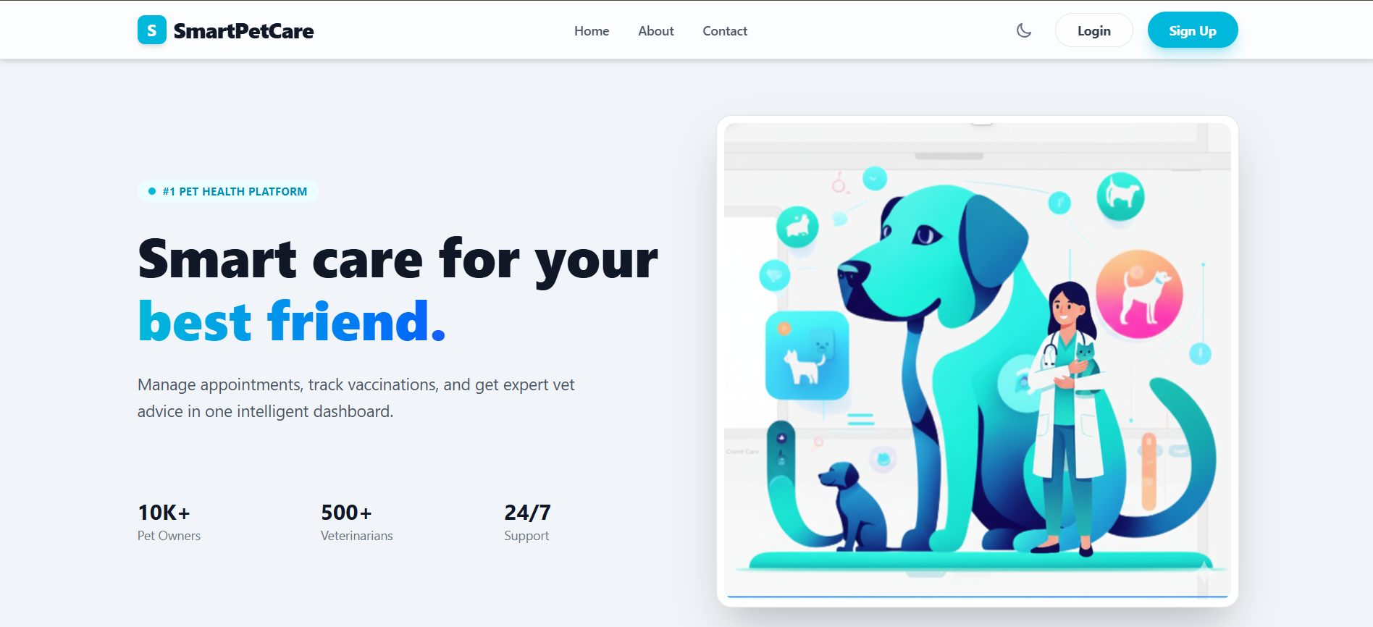

Owner Dashboard
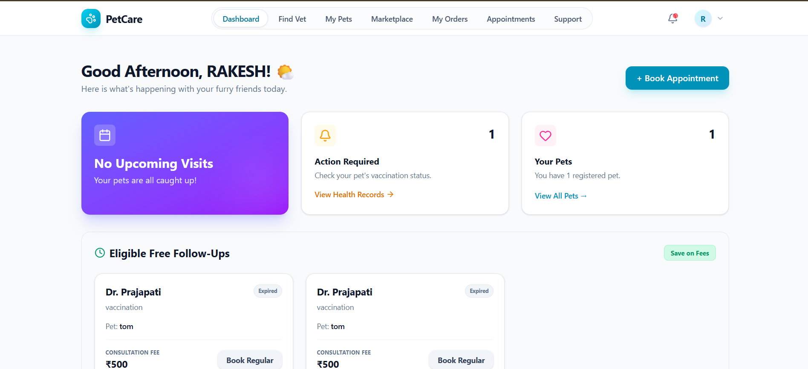

Vet Dashboard
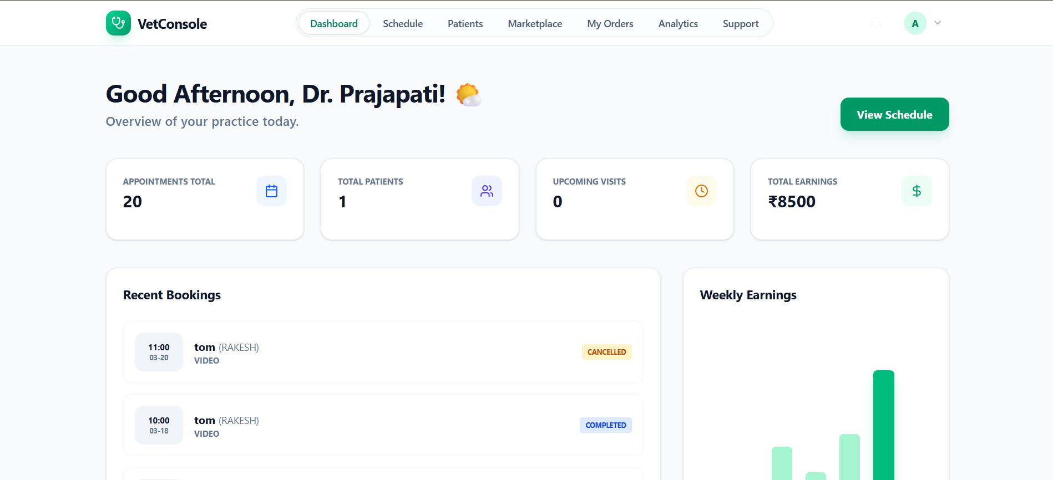

Admin Dashboard
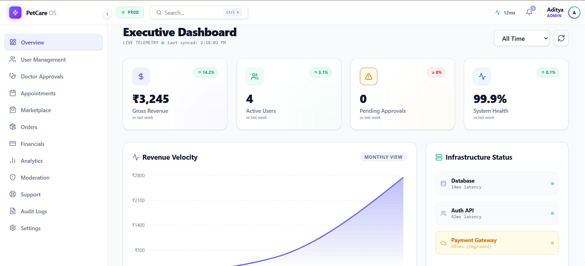

Pet Profile
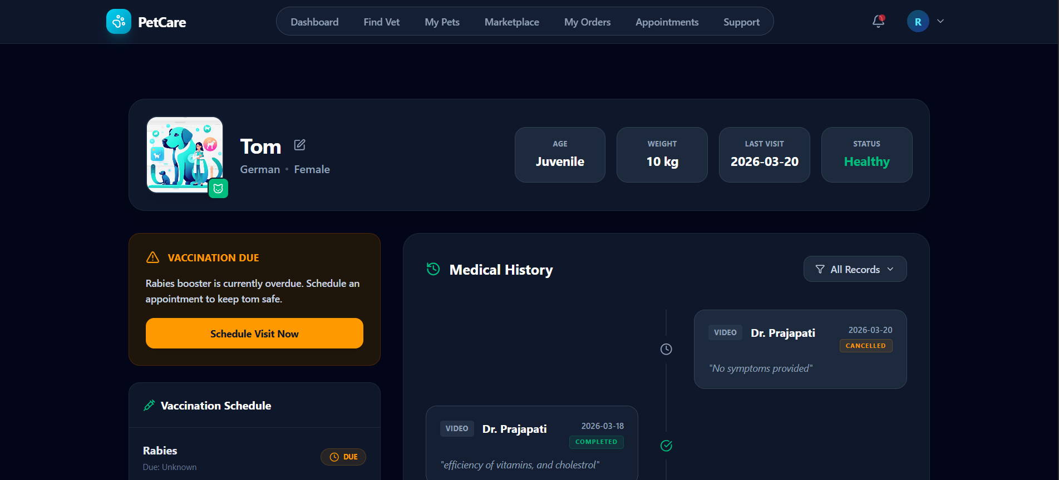

Challenges Faced
During the development of this project, I faced several technical and practical challenges. These challenges helped me understand real-world development issues and improved my problem-solving skills.
1. Designing a Scalable Structure
At the beginning, one of the biggest challenges was deciding how to structure the project properly. Since the platform included multiple modules like pet profiles, appointments, marketplace, and admin panel, it was confusing to organize everything in a clean and scalable way.
How I resolved it:
I broke the project into smaller modules and followed a role-based structure (Owner, Vet, Admin). This made the system easier to manage and helped in maintaining clarity while developing different features.
2. Frontend–Backend Integration
Another major challenge was connecting the frontend (React) with the backend (Spring Boot). Initially, I faced issues with:
- API calls not working correctly
- Data not being displayed properly
- Handling asynchronous requests
How I resolved it:
I carefully checked API endpoints, used console logs and Postman for testing, and improved my understanding of how data flows between frontend and backend. Gradually, I was able to establish smooth communication between both.
3. Database Design and Data Consistency
While designing the database, I initially struggled with how to store data without creating redundancy. For example, whether to store pet details in multiple tables or not.
How I resolved it:
I learned to use relational mapping with IDs (like pet_id) instead of duplicating data. This helped in maintaining consistency and avoiding conflicts when updating records.
Learning and Skills Acquired
During this internship, I gained a lot of practical experience that went beyond just writing code. Working on a full-stack project helped me understand how real-world applications are built and managed.
Technical Skills
One of the biggest takeaways was improving my understanding of full-stack development. I worked with:
- React.js for building the frontend
- Tailwind CSS for designing responsive and modern UI
- Java Spring Boot for backend development
- REST APIs for communication between frontend and backend
- Database integration for storing and managing data
I also learned how to implement JWT-based authentication, which gave me a clear idea of how secure login systems work in real applications.
Frontend Development & UI Skills
I improved a lot in frontend development, especially in:
- Creating reusable components
- Managing state using React hooks
- Designing clean and responsive layouts
- Improving UI to match modern SaaS-style applications
I also learned that good UI is not just about looks, but also about user experience and usability.
Backend & API Development
On the backend side, I learned how to:
- Build REST APIs
- Handle requests and responses properly
- Connect backend with the database
- Manage authentication and authorization
This gave me confidence in building complete backend systems.
Problem-Solving & Debugging
Throughout the project, I faced many issues like API errors, UI bugs, and integration problems. Solving these helped me:
- Improve my debugging skills
- Understand how to read errors and fix them
- Think logically when something doesn’t work
Conclusion
This internship was a very valuable learning experience for me. It gave me the opportunity to work on a real-world project and understand how different parts of an application come together to form a complete system. Instead of just learning concepts theoretically, I was able to apply them practically while building the Smart PetCare platform.
Throughout the internship, I worked on both frontend and backend development, which helped me gain confidence in full-stack development. I also learned how to handle real challenges like debugging errors, integrating APIs, designing a proper database structure, and improving the user interface to make it more usable and professional.
This experience had a strong impact on my understanding of software development. It helped me move from a beginner level to a more practical, problem-solving mindset. I also realized the importance of writing clean code, designing scalable systems, and focusing on user experience.
In terms of my academic and career goals, this internship aligns perfectly with my aim of becoming a full-stack developer. It strengthened my foundation in web development and gave me clarity on how real industry-level projects are built. It also motivated me to continue learning advanced concepts and work on more complex applications in the future.
Overall, this internship was not just about completing a project, but about growing as a developer and gaining confidence to work on real-world problems.
Acknowledgement
I would like to express my sincere gratitude to the organization for providing me with the opportunity to work on this project. This internship gave me valuable exposure to real-world development and helped me understand how industry-level applications are built.
I am especially thankful to my mentor for their continuous guidance, support, and feedback throughout the internship. Their insights helped me improve both my technical skills and my approach to problem-solving.

