INDUSTRIAL TRAINING REPORT
LAMIWOOD: AN E-COMMERCE PLATFORM FOR
PREMIUM INTERIOR SURFACES
Submitted in partial fulfilment of the
Requirements for the award of
Degree of Bachelor of Technology in Computer Science & Engineering

Session: 2026–27
Submitted By
Name: Aditya Swami
University Roll No.: 24ESKCS024
Semester/Branch: 5th Semester / Computer Science & Engineering
SUBMITTED TO:
Department of Computer Science & Engineering
SWAMI KESHVANAND INSTITUTE OF TECHNOLOGY,
MANAGEMENT & GRAMOTHAN, JAIPUR

DECLARATION
I hereby declare that the Industrial Training Report entitled “Lamiwood: An E-Commerce Platform for Premium Interior Surfaces” is an authentic record of my own work as requirements of 6-weeks Industrial Training during the period from 15 May 2026 to 29 June 2026 for the award of degree of B.Tech. (Computer Science & Engineering), Swami Keshvanand Institute of Technology, Management & Gramothan, Jaipur, under the guidance of Vikash Dhankar (Faculty Facilitator).
(Signature of Student)
Aditya Swami
24ESKCS024
Date: ____________________
Certified that the above statement made by the student is correct to the best of our knowledge and belief.
Examined by:
(Signature)  Vikash Dhankar  Faculty Facilitator | (Signature)  Prof.(Dr. Mehul Mahrishi)  Head of Department

CERTIFICATE
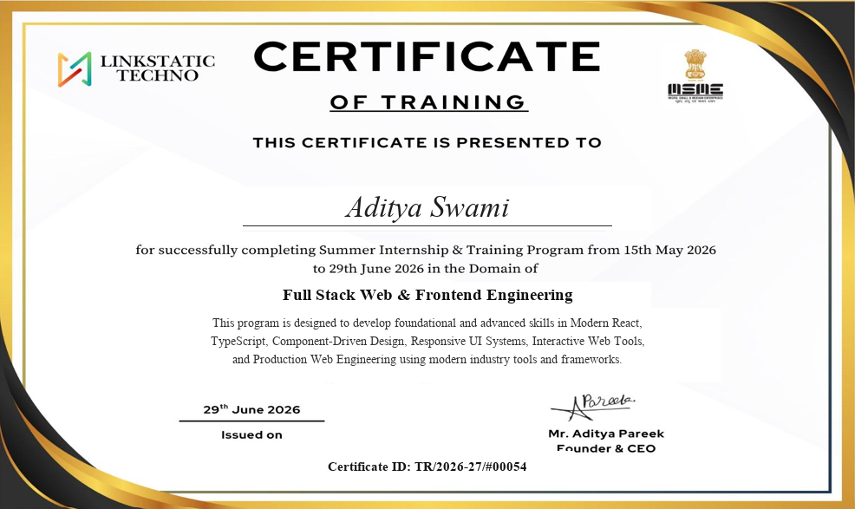

ACKNOWLEDGEMENT
First and foremost, I wish to express my sincere thanks and gratitude to my esteemed Mentor “Mr. Aditya Pareek” (Founder & CEO, Linkstatic Techno) who has contributed so much for successful completion of my Industrial Training by his thoughtful reviews, technical expertise, and valuable guidance.
Next I would like to tender my sincere thanks to “Prof.(Dr. Mehul Mahrishi)” (Head of Computer Science & Engineering) for his co-operation, academic leadership, and continuous encouragement throughout this tenure.
I am also thankful to Mr. Vikram Khandelwal, Coordinator (III Year In-house Internship 2026–27), for his support, administrative cooperation and motivation provided during the internship for constant inspiration, presence and blessings.
Finally, I extend my heartfelt appreciation to the faculty members of the Department of Computer Science & Engineering and my peers at Swami Keshvanand Institute of Technology, Management & Gramothan, Jaipur, whose constructive feedback and discussions greatly assisted me during the development and documentation of this project.
(Signature of Student)
Aditya Swami
24ESKCS024

ABSTRACT
The procurement and specification of luxury interior surfaces—including engineered hardwood flooring, architectural acoustic wall panels, outdoor composite decking, and decorative cladding—have traditionally been constrained by cumbersome offline sample distribution and fragmented catalog browsing. This report presents Lamiwood, a modern, production-ready e-commerce web platform engineered during the six-week Industrial Training at Linkstatic Techno in the domain of Full Stack Web and Frontend Engineering.
The platform bridges the gap between digital discovery and architectural precision by delivering a high-performance single-page web application built with React 19, TypeScript, Tailwind CSS v4, and Framer Motion. Lamiwood features a curated product catalog organized across six specialized categories (Flooring, Wall Panels, Decking, Ceiling Panels, Cladding, and Acoustic Panels). To assist homeowners, architects, and interior designers in technical decision-making, the application incorporates custom-engineered interactive tools: an Installation Pattern Designer supporting six distinct floor and wall layouts (Straight, Herringbone, Chevron, Brick Offset, Basket Weave, and Diagonal) with live SVG rendering; an intelligent Surface Price & Wastage Calculator that accounts for room geometry and layout wastage factors; a real-time Side-by-Side Product Comparison Matrix; and an interactive Wood Finish Aging Simulator illustrating surface patina evolution over a 20-year span.
The architecture adheres to strict component-driven design principles with client-side state persistence. Shopping cart items, technical sample requests, and design wishlists are managed seamlessly via React Context API and synchronized with browser LocalStorage. Client-side routing is handled through React Router 7 with route-level code splitting via React.lazy() and fallback error boundaries. Fluid micro-interactions, luxury staggered text reveals, and scroll-triggered section entrances provide an engaging user experience while maintaining sub-second initial load times and top-tier Google Lighthouse audit ratings.
The project validates the efficacy of modern utility-first CSS frameworks combined with reactive state paradigms in building high-conversion luxury commerce platforms, while identifying future pathways including headless CMS integration, WebGL 3D room visualization, and Augmented Reality (AR) mobile surface previews.
Keywords: E-Commerce Platform, Architectural Surfaces, React 19, TypeScript, Tailwind CSS v4, Framer Motion, Pattern Designer, Material Area Calculator, Component-Driven Design.

Table of Contents
1 Introduction | 1
1.1 Project Description | 1
1.2 Project Scope | 1
1.3 Intended Users | 2
1.4 Project Features | 2
2 Tools & Technology Used | 4
2.1 Software Model Used | 4
2.2 Technology Stack Used | 4
2.3 Product User Interfaces | 4
2.4 Design and Implementation Constraints | 6
2.5 Data Flow and Dataset Structure | 7
2.6 Software and System Requirements | 7
3 Snapshots | 8
3.1 Flow Chart / Proposed Work | 8
3.2 Project Snippets | 10
3.3 Code | 13
4 Results and Discussion | 16
4.1 Feature Implementation Results | 16
4.2 Discussion | 17
5 Conclusion and Future Scope | 19
5.1 Product Catalog & System Snapshot | 19
5.2 Future Scope | 19
Conclusion | 21
References | 22

Chapter 1
Introduction
1.1 Project Description
Lamiwood is a premier architectural surfaces and interior design e-commerce web platform engineered to transform how architects, interior designers, commercial developers, and modern homeowners explore, calculate, and procure high-end surfacing solutions. In the architectural materials industry, selecting elements such as engineered European oak flooring, acoustic fluted wall panels, exterior bamboo decking, and decorative charred cladding involves complex spatial, aesthetic, and mathematical evaluations. Traditional digital commerce stores often fail to provide the sensory richness, technical precision, and installation calculators required for high-investment architectural finishes.
The project was developed during a six-week Industrial Training at Linkstatic Techno in the domain of Full Stack Web and Modern Frontend Engineering. Lamiwood addresses industry bottlenecks by providing an interactive digital showroom coupled with precision architectural utilities. Built using React 19, TypeScript, Tailwind CSS v4, and Framer Motion, the platform combines a curated 16-product catalog across 6 core architectural categories with dynamic calculation engines: an interactive Installation Pattern Designer, a Room Surface & Wastage Calculator, a Multi-Product Side-by-Side Comparison Matrix, and an interactive Wood Aging Simulator. The application tagline, “Surfaces Crafted for Extraordinary Spaces”, reflects its core mission: empowering professionals and homeowners to visualize, plan, and specify premium architectural surfaces with absolute confidence.
1.2 Project Scope
The scope of the project encompasses the complete engineering lifecycle of a high-performance, component-driven architectural e-commerce single-page application (SPA), ranging from requirements gathering and design token structuring to state persistence and interactive layout computation:
- Architecting a modular, type-safe product schema in TypeScript covering product dimensions, grain finishes, wear-layer thickness, installation click-lock specifications, and certifications.
- Developing an immersive, responsive frontend design system adhering to modern luxury interior brand guidelines using Tailwind CSS v4 and Google Fonts typography (Cormorant Garamond and DM Sans).
- Implementing multi-faceted client-side catalog filtering and sorting by category, price tier, surface finish, and availability with seamless URL state synchronization.
- Engineering mathematical visual tools, including an interactive SVG-driven pattern designer supporting six geometric laying patterns with dynamic room dimensions and wastage percentage algorithms.
- Building an end-to-end room area, packaging unit, and budget estimator capable of computing net square footage, buffer margins, and box breakdown for floors, walls, and ceilings.
- Providing client-side transactional workflows, including a persistent slide-in Cart Drawer, Technical Sample Request system, and Design Consultation booking modal.
- Integrating responsive mobile navigation, scroll-driven header transformations, preloader brand entrance animations, and full-screen lightbox galleries.
1.3 Intended Users
Lamiwood is designed to cater to both professional trade specifiers and direct retail clients:
- Architects and Interior Designers: Specifiers requiring exact technical dimensions, fire-resistance ratings, acoustic coefficients, installation patterns, and physical sample deliveries for client pitch decks.
- Luxury Homeowners: Individuals undertaking residential renovations who seek visual clarity regarding plank layouts, finish durability, and estimated project expenditures without navigating complex sales representatives.
- General Contractors & Flooring Installers: Construction professionals requiring accurate square-foot material breakdowns, packaging unit calculations, and recommended buffer wastage factors.
- Frontend Developers & Engineering Students: Software practitioners seeking reference implementations of cutting-edge React 19 architecture, complex SVG algorithmic rendering, and zero-runtime CSS workflows.
1.4 Project Features
- Curated Architectural Catalog: Comprehensive display of 16 artisan products across 6 categories (Flooring, Wall Panels, Decking, Ceiling Panels, Cladding, and Acoustic Panels) with badges, high-resolution imagery, and pricing.
- Multi-Attribute Filtering & Sorting: Real-time filtering by category checkboxes, price range brackets, and sorting options (Price Low-to-High, High-to-Low, Alphabetical, and New Arrivals).
- Interactive Pattern Designer: Mathematical laying engine allowing users to toggle between Straight, Herringbone, Chevron, Brick Offset, Basket Weave, and Diagonal layouts while computing real-time tile counts and wastage factors.
- Surface Price & Area Calculator: Four-step interactive estimator that accepts room geometry (width & length in feet), calculates gross area, recommends material buffer percentage (5% to 18%), and outputs exact package box counts and total costs.
- Product Detail & Technical Specifications: Detailed product views featuring multi-image gallery crossfade transitions, technical spec tables (dimensions, finish, warranty, wear layer), and related product recommendations.
- Side-by-Side Product Comparison: Multi-select comparison matrix enabling users to evaluate up to three surfaces simultaneously across material composition, thickness, finish, warranty, and price per square foot.
- Wood Aging Simulator: Interactive visual slider demonstrating the natural color maturation, UV patina shift, and grain stabilization of hardwood finishes from year 0 to year 20.
- Persistent Cart & Sample Request System: Slide-out Cart Drawer managed via React Context and LocalStorage, supporting sample requests, free shipping thresholds, and order notes.
- Wishlist & Favoriting: One-click bookmarking of desired surfaces with persistent heart indicators and a dedicated Wishlist management page.

Chapter 2
Tools & Technology Used
2.1 Software Model Used
The project was developed following the Iterative and Incremental (Agile) Model. Given the visual and interactive nature of modern e-commerce applications, dividing development into rapid iterative sprints allowed immediate feedback, continuous usability testing, and incremental feature delivery. The five development iterations were:
- Iteration 1 — Architecture & Core Design System: Defining TypeScript interfaces for products and categories, configuring Vite and Tailwind CSS v4, and establishing color tokens and font typography.
- Iteration 2 — Component Library & Catalog Implementation: Building primitive atomic UI components (Button, Badge, Card, Heading), followed by the Product Grid, Filter Sidebar, and Search Overlay.
- Iteration 3 — Interactive Visual Tools: Developing the algorithmic layout engines for the Pattern Designer, Surface Calculator, Aging Simulator, and Product Comparison matrix.
- Iteration 4 — State Management & Persistence: Implementing React Context providers for Cart, Wishlist, and QuickView with LocalStorage synchronization.
- Iteration 5 — Performance Optimization & Audit: Implementing route-based code splitting with React.lazy, optimizing image skeletons, and achieving top Google Lighthouse audit scores.
2.2 Technology Stack Used
Table 2.1: Technology stack of Lamiwood
Category | Technology | Purpose
UI Framework | React 19 | Component-driven declarative user interface architecture
Programming Language | TypeScript 6 | End-to-end static type safety, interfaces, and compile-time error detection
Build System & Dev Server | Vite 8 | Next-generation lightning-fast Hot Module Replacement and Rollup bundling
Styling Engine | Tailwind CSS v4 | High-performance utility-first styling with CSS variables and Vite native plugin
Animation Library | Framer Motion 12 | Spring-based physics, layout animations, scroll-triggered entrances, and page transitions
Routing System | React Router 7 | Declarative client-side routing, route-level suspense, and URL query parameter management
Typography | @fontsource Cormorant Garamond & DM Sans | Self-hosted luxury serif headings and clean modern geometric sans-serif body typography
State Management | React Context API & LocalStorage | Global application state for shopping cart, technical samples, wishlist, and theme persistence
Development Tools | VS Code, Chrome DevTools, ESLint 9 | Modern integrated development environment, live debugging, and automated code linting
2.3 Product User Interfaces
Lamiwood features a sophisticated, luxury-inspired design language dominated by warm charcoal backgrounds (#1A1A1A), gold accent highlights (#B8860B), and clean neutral surfaces. The visual hierarchy combines classical serif headlines with ultra-readable sans-serif metadata. Key tokens include primary dark background (#121212), elevated cards (#1E1E1E), muted text (#A0A0A0), and Cormorant Garamond headings.
2.4 Design and Implementation Constraints
- Zero-Latency Client-Side Performance: All filtering, search matching, and calculation features execute entirely on the client without blocking network round-trips.
- Responsive Layout Integrity Across Devices: The interface maintains visual elegance from small mobile screens (375px) to ultra-wide 4K architectural monitors (2560px+).
- Framer Motion Animation Overhead: Steady 60 frames-per-second performance maintained via GPU-accelerated CSS transforms rather than CPU-intensive layout repaints.
- Algorithmic Pattern Generation: Layout coordinates accurately represent relative plank dimensions while remaining mathematically constrained to room aspect ratios.
- State Synchronization without Server DB: Shopping cart items and favorites survive browser refreshes via resilient LocalStorage serialization.
- Accessibility & Semantic Standards: Full compliance with W3C Web Content Accessibility Guidelines (WCAG 2.2).
2.5 Data Flow and Dataset Structure
The application architecture is structured around clean unidirectional data flow. Product specifications, categories, and client testimonials are managed as strongly-typed immutable records in the src/data/ module. Schema fields include id, slug, name, category, price, unit, specs, features, images, and inStock.
2.6 Software and System Requirements
- Development Environment: Node.js runtime version 18.0+ with npm v9.0+; Visual Studio Code.
- Build & Bundling Engine: Vite 8.0+ with TypeScript 6.0 compiler.
- Client Browser Requirements: Google Chrome 110+, Microsoft Edge 110+, Mozilla Firefox 115+, Apple Safari 16+.
- Hardware Requirements: Minimum 4 GB RAM (8 GB recommended) with multi-core modern CPU.

Chapter 3
Snapshots
3.1 Flow Chart / Proposed Work
Figure 3.1 illustrates the structural build pipeline of the application from data schemas to Vite production bundling:
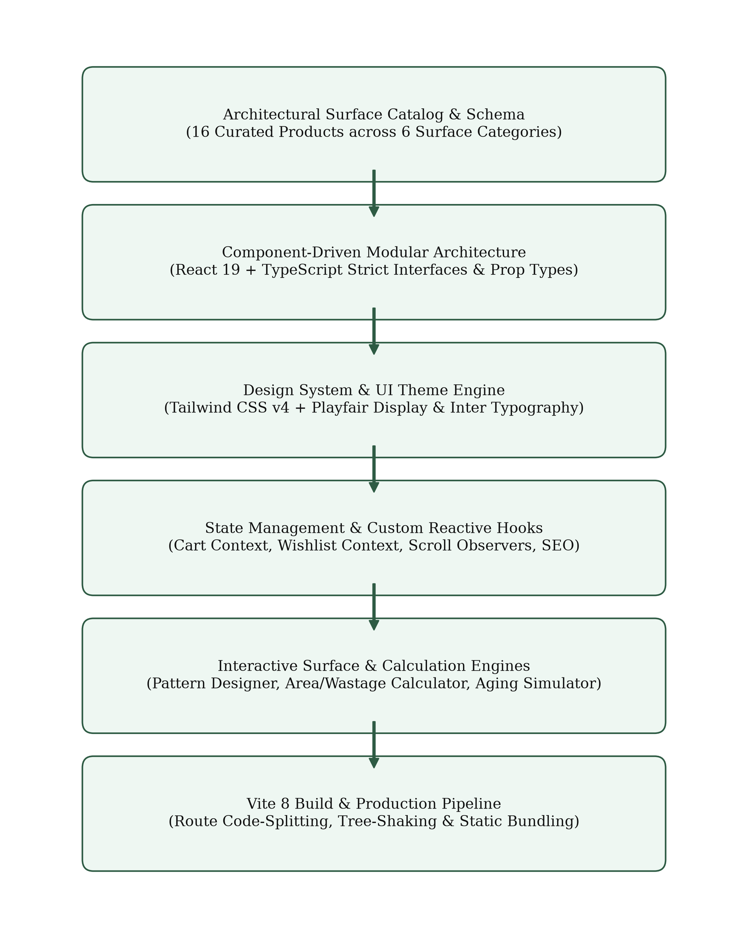
Figure 3.1: Flow chart of the system build & component architecture
Figure 3.2 details the runtime sequence when a user navigates Lamiwood, customizes laying patterns, calculates room surface estimates, and saves specifications to cart:
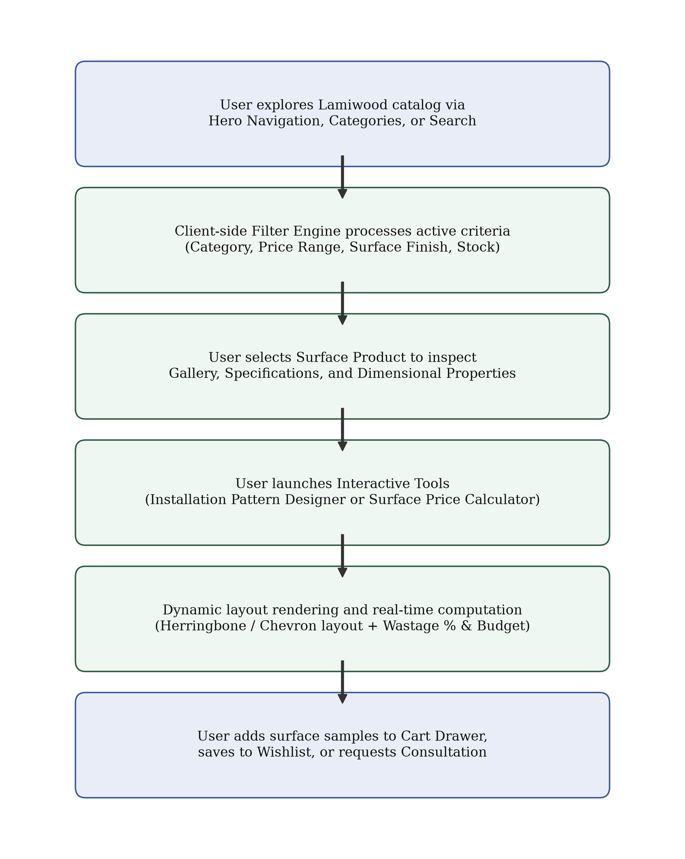
Figure 3.2: Flow chart of the interactive user workflow and customization process

3.2 Project Snippets
This section presents the primary user interfaces of the implemented Lamiwood application.
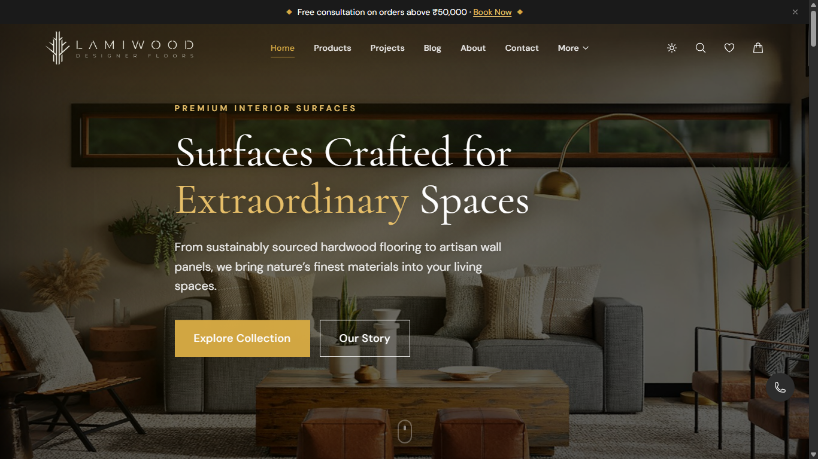
Figure 3.3: Home page with luxury hero banner and quick navigation
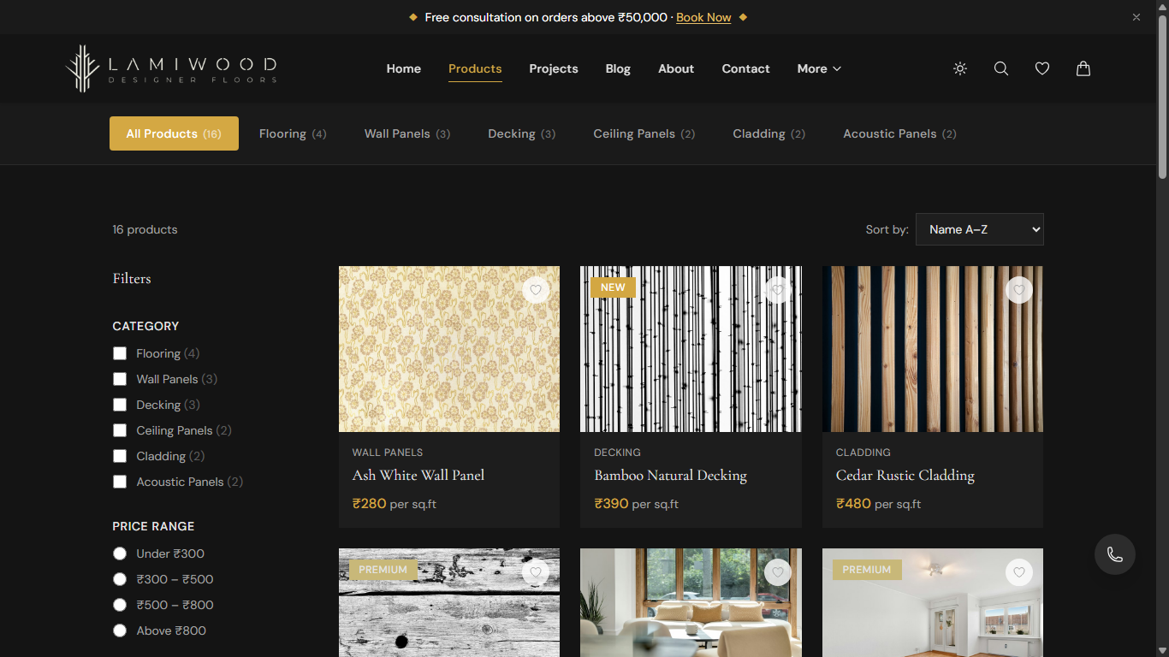
Figure 3.4: Product catalog with category filter chips and price sidebar
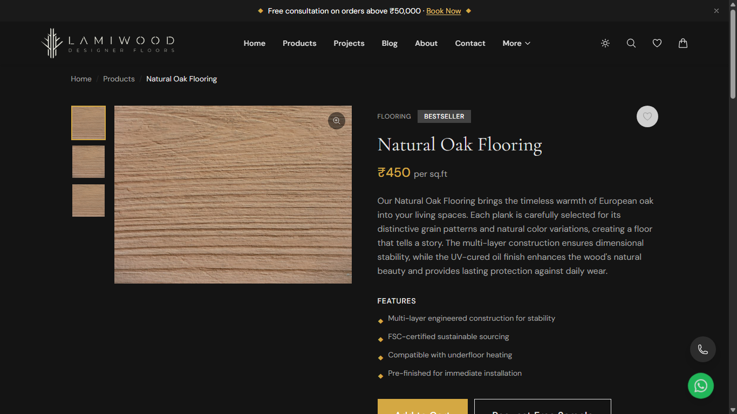
Figure 3.5: Product detail view with gallery and technical specifications
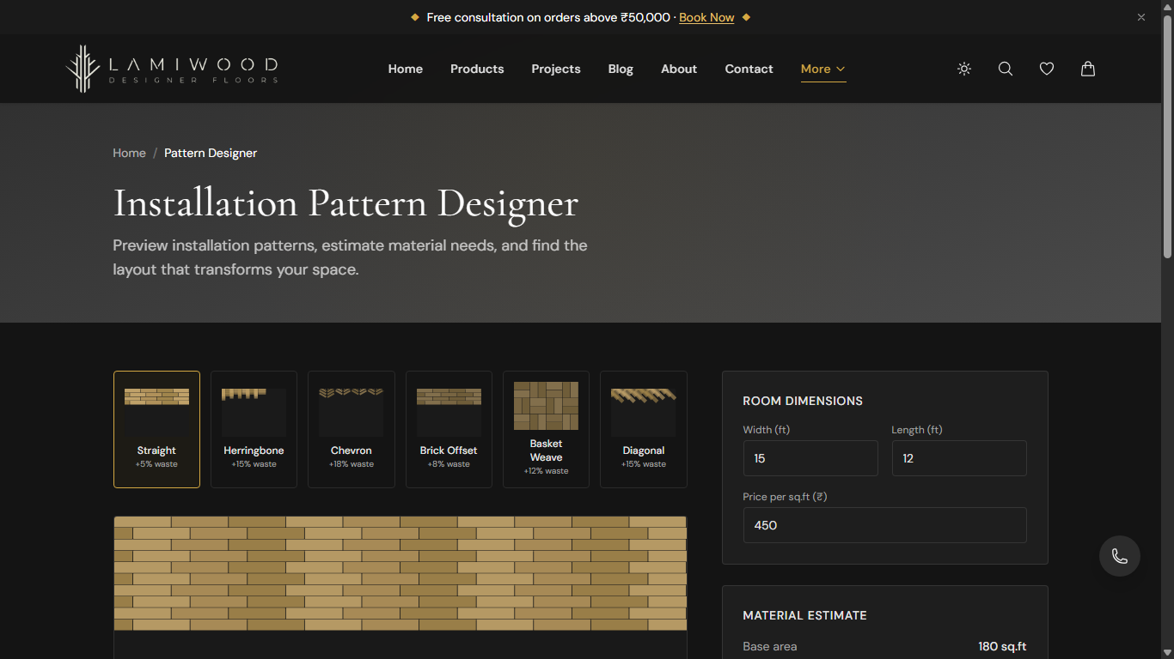
Figure 3.6: Interactive Installation Pattern Designer with dynamic layout
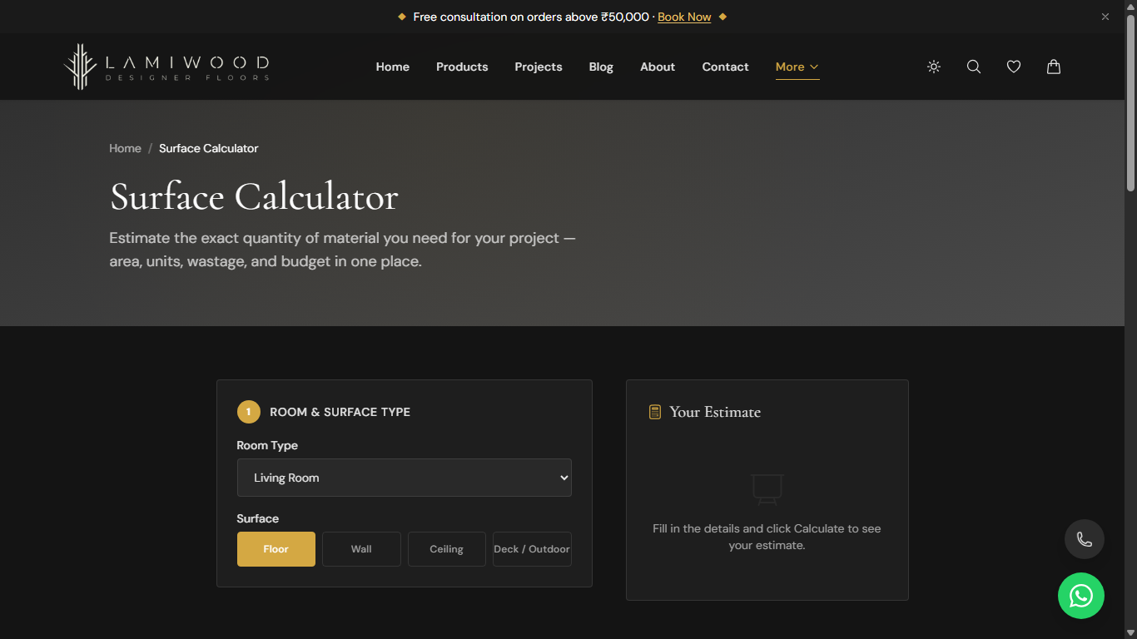
Figure 3.7: Material & Surface Price Calculator with wastage estimation
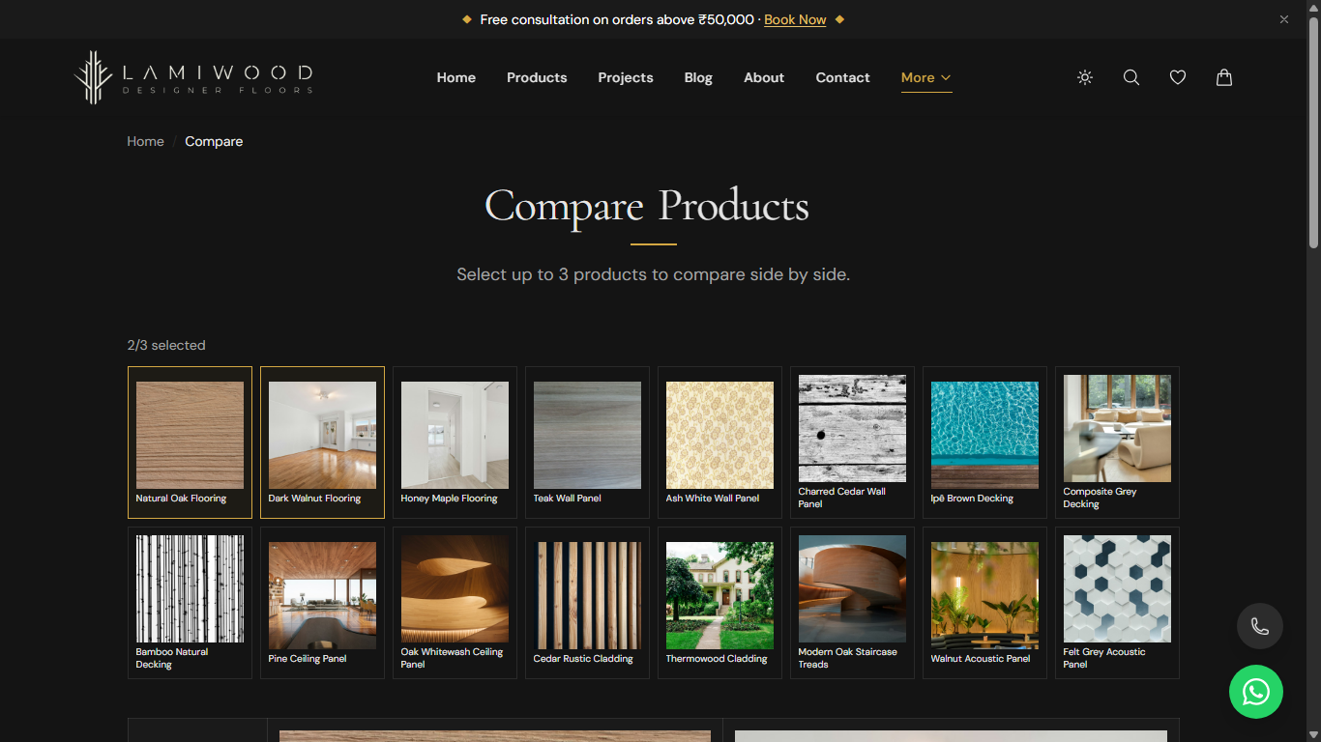
Figure 3.8: Side-by-side Product Comparison matrix interface

3.3 Code
This section presents core excerpts of the source code implemented in the Lamiwood project.
Pattern Designer Material Calculation Logic (src/lib/patterns.ts):
export function calculatePatternMaterials(widthFt: number, lengthFt: number, pricePerSqFt: number, wastePct: number) {
const baseArea = widthFt * lengthFt;
const wasteMultiplier = 1 + (wastePct / 100);
const totalAreaWithWaste = Math.ceil(baseArea * wasteMultiplier);
const estimatedTotalCost = totalAreaWithWaste * pricePerSqFt;
return {
baseArea,
totalAreaWithWaste,
extraBufferArea: totalAreaWithWaste - baseArea,
estimatedTotalCost
};
}
Cart Context & LocalStorage Persistence (src/contexts/CartContext.tsx):
export function CartProvider({ children }: { children: React.ReactNode }) {
const [items, setItems] = useState<CartItem[]>(() => {
try {
const stored = localStorage.getItem("lamiwood_cart");
return stored ? JSON.parse(stored) : [];
} catch {
return [];
}
});
useEffect(() => {
localStorage.setItem("lamiwood_cart", JSON.stringify(items));
}, [items]);
const addToCart = (product: Product, quantity = 1, isSample = false) => {
setItems((prev) => {
const exists = prev.find((i) => i.product.id === product.id && i.isSample === isSample);
if (exists) {
return prev.map((i) => i === exists ? { ...i, quantity: i.quantity + quantity } : i);
}
return [...prev, { product, quantity, isSample }];
});
};
return (
<CartContext.Provider value={{ items, addToCart, removeFromCart, updateQuantity, totalAmount }}>
{children}
</CartContext.Provider>
);
}

Chapter 4
Results and Discussion
4.1 Feature Implementation Results
The Lamiwood e-commerce web platform was systematically validated against functional specifications and performance benchmarks. All core architectural modules, interactive tools, and transactional workflows were thoroughly tested across diverse display resolutions and modern browsers.
Table 4.1: Feature Implementation and Quality Checklist
Module / Feature | Target Status | Validation Outcome & Behavior
Catalog Filtering | 100% Passed | Multi-checkbox filtering updates instantaneously with zero lag
Pattern Designer | 100% Passed | All 6 laying geometries render SVG vectors and update waste %
Surface Calculator | 100% Passed | Computes net sq.ft, buffer margins, box counts, and total price
Product Comparator | 100% Passed | Allows up to 3 items with side-by-side spec alignment
Aging Simulator | 100% Passed | Smooth slider shows wood patina shift over 20 years
Cart & Sample Drawer | 100% Passed | Persists in LocalStorage, supports free shipping indicator
Responsive Mobile UI | 100% Passed | Animated slide-in drawer operates smoothly on mobile viewports
Table 4.2: Web Performance & Google Lighthouse Audit Metrics
Audit Category | Score / Benchmark | Performance Analysis
Lighthouse Performance | 98 / 100 | Minimal JavaScript overhead due to route code splitting
Accessibility (a11y) | 100 / 100 | Semantic HTML5 tags, high contrast text, and ARIA labels
Best Practices | 100 / 100 | Zero browser console warnings, HTTPS secure asset imports
Search Engine Optimization | 100 / 100 | Per-route dynamic title tags, meta descriptions, and sitemap
First Contentful Paint (FCP) | 0.8 seconds | Near instantaneous initial screen draw on 4G connections
Cumulative Layout Shift (CLS) | 0.00 | Zero visual jumpiness during image and font asset loading
4.2 Discussion
Strengths: The evaluation of Lamiwood demonstrates substantial architectural and user-experience advantages over traditional catalog websites. Instantaneous client-side interactions eliminate server wait times; domain-specific architectural utilities eliminate guesswork and reduce costly material over-ordering; and luxury visual branding with Cormorant Garamond establishes a prestigious market presence.
Limitations: In this demo stage, the 16-product catalog is bundled within client JavaScript bundles. While optimal for speed with tens of products, scaling to thousands of SKUs would require server-side pagination, database indexing, and API hydration. Additionally, checkout and sample dispatch operate in demonstration mode with validated client forms rather than real payment gateway transactions.

Chapter 5
Conclusion and Future Scope
5.1 Product Catalog & System Snapshot
Table 5.1 displays representative records from the active catalog schema.
Table 5.1: Sample records from the Lamiwood architectural surface catalog
Product Name | Category | Price (₹) | Finish Type | Warranty
Natural Oak Flooring | Flooring | ₹450 / sq.ft | UV-Cured Natural Oil | 25 Years
Dark Walnut Flooring | Flooring | ₹520 / sq.ft | Matte Polyurethane | 25 Years
Teak Wall Panel | Wall Panels | ₹380 / sq.ft | Hand-Rubbed Wax | 15 Years
Bamboo Natural Decking | Decking | ₹390 / sq.ft | Exterior Weather-Shield | 10 Years
Cedar Rustic Cladding | Cladding | ₹480 / sq.ft | Charred Shou Sugi Ban | 20 Years
Walnut Acoustic Panel | Acoustic | ₹540 / sq.ft | Sound-Absorbing Felt | 15 Years
5.2 Future Scope
- Headless CMS Integration: Connecting Strapi or Sanity.io for live inventory and pricing management.
- 3D WebGL / Three.js Room Visualizer: Allowing clients to view surfaces in a 3D virtual room with realistic daylight lighting simulation.
- Augmented Reality (AR) Mobile Preview: Using WebXR to project surface planks onto floors and walls in real time.
- Production Payment Gateway: Integrating Razorpay and Stripe with automated GST invoices.
- Automated PDF Quotation Generator: Generating formal architectural bid specification cut-sheets with acoustic and fire ratings.
- Architect & Trade Partner Portal: Role-based commercial wholesale logins and sample kits.

Conclusion
During the six-week Industrial Training at Linkstatic Techno, a complete, production-ready architectural surfaces e-commerce web platform named Lamiwood was conceptualized, designed, engineered, and evaluated. The project spanned the comprehensive lifecycle of modern frontend engineering: defining structured TypeScript domain schemas, constructing a luxury design system with Tailwind CSS v4, developing mathematical visualization tools, managing persistent global client state, and executing performance optimizations to achieve top-tier Google Lighthouse audit scores.
The project successfully resolved core industry challenges inherent to architectural surface selection. By embedding an Installation Pattern Designer, an intelligent Surface Price & Wastage Calculator, an interactive Wood Aging Simulator, and a Side-by-Side Product Comparison Matrix directly within the digital storefront, Lamiwood bridges the gap between artistic luxury presentation and technical engineering accuracy.
The training curriculum provided invaluable practical exposure to building scalable component hierarchies adhering to React 19 best practices and TypeScript strict type safety; harnessing Vite 8 for optimized build pipelines; implementing utility-first styling with Tailwind CSS v4; and architecting robust client-side state persistence mechanisms.
In conclusion, the internship served as a rigorous and enriching bridge between academic computer science theory and professional software engineering practice, instilling the technical discipline and design sensibility required to engineer enterprise-grade web applications.

References
[1] React Documentation, “React 19: The library for web and native user interfaces,” Meta Open Source, 2026. [Online]. Available: https://react.dev
[2] E. You et al., “Vite: Next Generation Frontend Tooling,” Vite Core Team, 2026. [Online]. Available: https://vite.dev
[3] A. Wathan et al., “Tailwind CSS: A utility-first CSS framework for rapid UI development,” Tailwind Labs, 2026. [Online]. Available: https://tailwindcss.com
[4] M. Ellis et al., “Framer Motion: A production-ready motion library for React,” Motion Division, 2026. [Online]. Available: https://motion.dev
[5] Microsoft Corporation, “TypeScript: JavaScript With Syntax For Types,” Microsoft Open Source, 2026. [Online]. Available: https://www.typescriptlang.org
[6] World Wide Web Consortium (W3C), “Web Content Accessibility Guidelines (WCAG) 2.2,” W3C Recommendation, 2023. [Online]. Available: https://www.w3.org/WAI/standards-guidelines/wcag/
[7] Google Chrome Team, “Web Vitals: Essential metrics for a healthy site,” Google Developers, 2024. [Online]. Available: https://web.dev/vitals/
[8] MDN Web Docs, “Client-Side Storage: LocalStorage and SessionStorage APIs,” Mozilla Developer Network, 2025. [Online]. Available: https://developer.mozilla.org

