Human Development Index (HDI) Data Analysis Report

Concepts and Technologies of AI
5CS037

Student Name: Aditya Shiwakoti
Student ID: 2501408
Date of Submission: 8 January, 2026

Contents
1. Introduction 3
2. Problem 1A - Single Year HDI Exploration 4
Methods / Approach 4
Key Results 5
Visualizations and Tables 5
Interpretations & Discussion 5
3. Problem 1B – HDI Trend Analysis (2020–2022) 5
Methods / Approach 5
Key Results 6
Visualizations and Tables 6
Interpretations & Discussion 6
4. Problem 2 - Sophisticated HDI Exploration 7
Methods / Approach 7
Key Results 7
Visualizations and Tables 7
Interpretations & Discussion 7
5. Problem 3 - Comparative Regional Analysis South Asia vs Middle East 8
Methods / Approach 8
Key Results 8
Visualizations and Tables 8
Interpretations & Discussion 8
6. Conclusion 9
7. References 10

1. Introduction
The Human Development Index (HDI) is a well-known composite index that was introduced by the United Nations Development Program (UNDP) to measure the general development of human life in nations. It assesses development based on three key dimensions: health, which is measured by life expectancy at birth; education, which is represented by the mean years of education and expected years of education; and economic well-being for which Gross National Income (GNI) per capita (National Human Development Program 2009) is used. By erasing together these indicators, HDI proposes an extra scholarly approach to development past economic measures alone. (Klugman, 2009)
The main goal of this report is to analyze the values of HDI for different countries and also to compare the dissimilar changes over a period of time as well as different regions of development. The analysis involves in-depth study of HDI for a single year, trend study from the year 2020 to 2022, advanced exploration of the components of HDI and comparative regional study focuses on South Asia and the Middle East.

2. Problem 1A - Single Year HDI Exploration

Methods / Approach
For the purpose of this analysis, a selected year in time of HDI data was extracted from the data set. The data cleaning process was performed to deal with missing data and make the data uniform for each of the variables. Countries were then ranked based on their HDI scores and descriptive statistics were computed to gain understanding of distribution of development levels.

Key Results
The results showed that there is great variance in the scores of the HDI across countries. Nations with higher values of HDI consistently performed well on both health indicators, education, and income. In contrast, countries with lower scores in the HDI showed weaker results in terms of education level, life expectancy and income level.

Visualizations and Tables
Riva 2008: "Population Pyramid" Excel File Key Statistics Table 1: Countries with the highest and lowest HDI scores
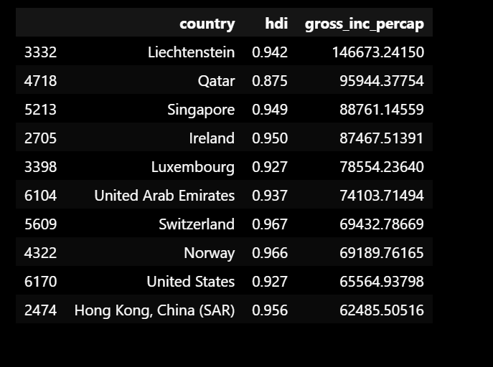

Interpretations & Discussion
The results suggest tremendous differences in human development between countries. High-HDI countries have sustained investments in the provision of social services and a stable economic system, while low-HDI economic systems often have long structural and developmental obstacles to surmount.

3. Problem 1B – HDI Trend Analysis (2020–2022)

Methods / Approach
HDI values between 2020 and 2022 were studied to strengthen the change over time. Line graphs were used to visualize trends and percentage changes were calculated for identifying improvements or decline in the performance of HDI.

Key Results
Overall, changes in HDI values were steady over the three-year period. While some countries demonstrated a steady improvement, others have seen stagnation or slight declines, which may have been caused by global disruptions, such as the Covid-19 pandemic.

Visualizations and Tables
Line graph showing the HDI trends from the year 2020 to 2022
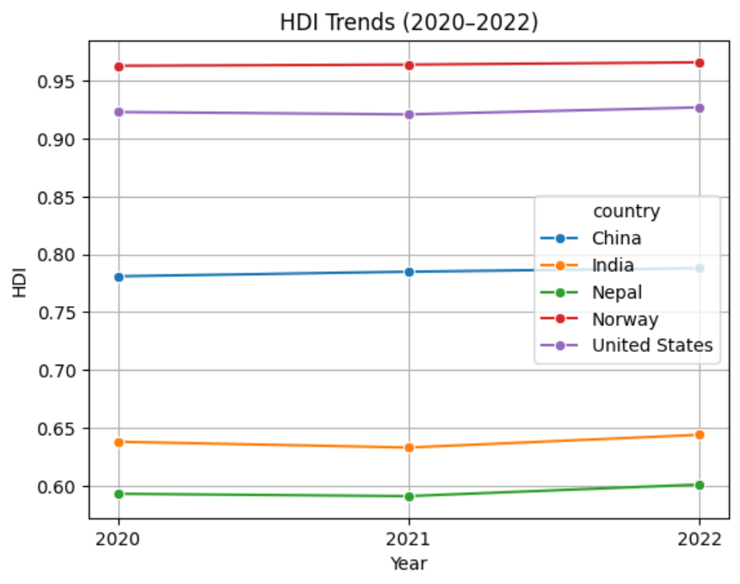

Interpretations & Discussion
The trend analysis is presented to show that human development improvements have usually been incremental and prone to global and regional crises. Countries that had better social and economic frameworks were able to sustain or improve their HDI levels during this time.

4. Problem 2 - Sophisticated HDI Exploration

Methods / Approach
To analyze the relationship between HDI and its main components, such as income and education indicators advanced analytical techniques were used. Correlation analysis and scatter plots were used to assess the magnitude and direction of these relationships.

Key Results
There was a strong positive relation between HDI and other indicators such as GNI per capita and education level. Countries that have more income, and that are better educated, tend to have a higher HDI score.

Visualizations and Tables
• Scatter plot of HDI and GNI per capita
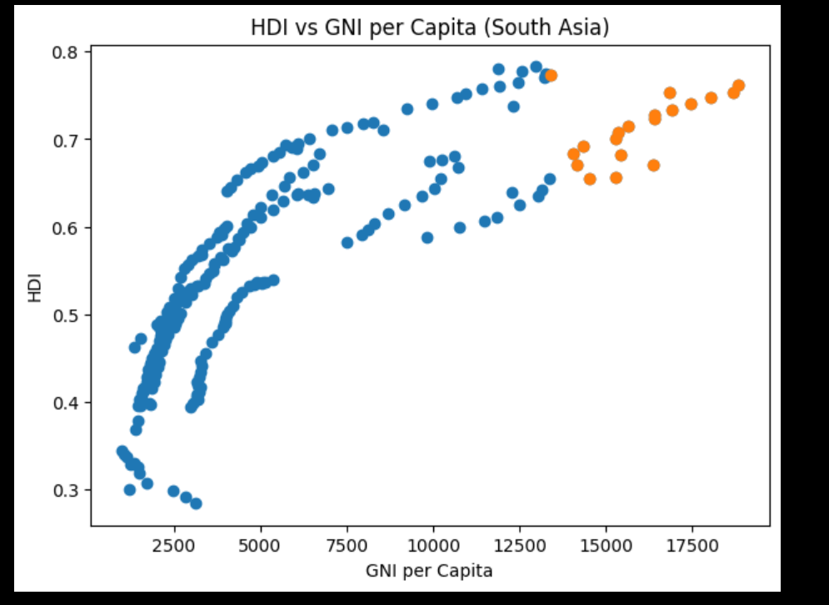

Interpretations & Discussion
These findings confirm that while income is important in human development, there is equal or greater importance in the development of health and education. Economic growth alone cannot insure high levels of overall human development.

5. Problem 3 - Comparative Regional Analysis South Asia vs Middle East

Methods / Approach
Countries were divided in South Asia and Middle East to make a regional comparison. Average HDI values and distribution pattern were analyzed by using bar charts and box plots.

Key Results
On average, the Middle East countries had higher HDI scores than the South Asian countries. However, a significant variation was found within both regions, implying unequal development of countries in the same region.

Visualizations and Tables
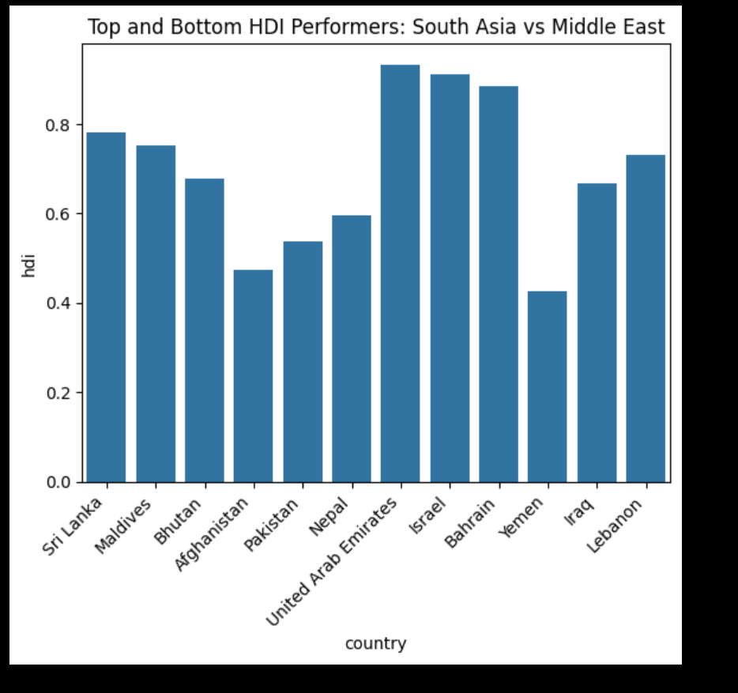
Top and button HDI performer of south Asia vs Middle East.

Interpretations & Discussion
The regional analysis evidences different developmental paths. The higher levels of income contribute to better HDI performance in many Middle East countries and South Asian countries show gradual improvements due to investments in the health, education sectors. Reducing inequalities within regions is a major development challenge.

6. Conclusion
This report used the HDI data to examine single-year performance, investigate trends over time, address advanced relationships between features of the HDI, and compare regional patterns of development. The results underscore the fact that human development is multidimensional and that it requires a balanced development in terms of health, education and income. Although global HDI levels are steadily improving, large disparities prevail between and within regions. Addressing these gaps will involve inclusive policies, international challenge resilience, and sustained human capital investment.

References
Klugman, J., 2009. Human Development Report 2009. Overcoming Barriers: Human Mobility and Development. United Nations Development Programme - HDRO, p. 229.

