Knowledge Transfer Partnership Project Foundation and Feasibility Study

Contents

I. Project Title: AI-Driven MES-IoT Platform for Advanced Steel Fabrication Services 6

II. Project Background: 6

III. Executive Summary 6

IV. Company Background and Strategic Context 6

1. Project Objectives 8

1.1. Manufacturing Execution System Integration 8

1.2. IoT Infrastructure Implementation 8

1.3. Predictive Maintenance Framework 8

1.4. Advanced Customer Engagement Platform 9

1.5. Generative AI Integration 9

2. Technical Scope Components (SCOPE) 10

2.1. Machine Connectivity Infrastructure 10

2.2. Production Tracking and Traceability 10

2.3. AI-Powered Quotation Engine 10

2.4. Interactive Customer Portal 10

2.5. Marketing and Business Intelligence Integration 10

3. Innovation Framework and Technological Advancement 11

3.1. Industry 4.0 Implementation 11

3.2. Artificial Intelligence Applications 11

3.2.1. Machine Learning for Cost Estimation (Instant Quotation) 11

3.2.2. Computer Vision for Drawing Analysis 11

3.2.3. Natural Language Processing for Customer Interaction 11

3.3. Proprietary Technology Development 11

3.3.1. Adaptive Manufacturing Scheduling 11

3.3.2. Quality Prediction and Control 12

3.3.3. Energy Optimization Integration 12

4. Technical Architecture and Implementation Strategy 13

4.1.1. System Integration Framework 13

4.1.2. Data Layer Architecture 13

4.1.3. Communication Protocols 13

4.1.4. Security and Reliability Framework 13

5. Development Methodology 14

5.1. Agile Implementation Approach 14

5.2. Phased Deployment Strategy 14

5.3. Continuous Learning Integration 14

6. Market Analysis and Competitive Advantage 15

6.1. Industry Context and Opportunities 15

6.2. Digital Transformation Demand 15

6.3. Sustainability Requirements 15

7. Competitive Positioning 16

7.1. Technology Leadership 16

7.2. Service Differentiation 16

7.3. Scalability Advantages 16

8. Resource Requirements and Expertise 17

8.1. Knowledge Transfer Associate Profile 17

8.2. Technical Competencies 17

8.3. Engineering Knowledge 17

9. Infrastructure and Equipment 18

9.1. Development Environment 18

9.2. Sensor and Connectivity Hardware 18

9.3. Software Licensing and Tools 18

10. Risk Assessment and Mitigation Strategies 19

10.1. Technical Risks 19

10.1.1. Integration Complexity 19

10.1.2. AI Model Performance 19

10.1.3. Cybersecurity Vulnerabilities 19

10.2. Business Risks 19

10.2.1. Market Acceptance 19

10.2.2. Competitive Response 19

10.2.3. Operational Disruption 19

11. Financial Projections and Return on Investment 20

11.1. Investment Requirements 20

11.2. Revenue Impact Projections 20

11.2.1. Immediate Benefits 20

11.2.2. Medium-term Growth 20

11.2.3. Long-term Strategic Value 20

11.3. Cost Reduction Opportunities 20

11.3.1. Operational Efficiency 20

11.3.2. Administrative Streamlining 21

11.3.3. Quality Improvement 21

12. Implementation Timeline and Milestones 22

12.1. Phase 1: Foundation Development (Months 1-12) 22

12.1.1. MES Core Implementation 22

12.1.2. IoT Infrastructure Deployment 22

12.1.3. AI Framework Establishment 22

12.2. Phase 2: Advanced Capabilities (Months 13-24) 22

12.2.1. Customer Portal Development 22

12.2.2. Predictive Maintenance Implementation 22

12.2.3. CAD Integration and Automation 22

12.3. Phase 3: AI Enhancement and Optimization (Months 25-36) 23

12.3.1. Generative AI Integration 23

12.3.2. Marketing Intelligence Platform 23

12.3.3. System Optimization and Scaling 23

13. Success Metrics and Evaluation Criteria 24

13.1. Quantitative Performance Indicators 24

13.1.1. Operational Efficiency Metrics 24

13.1.2. Customer Satisfaction Indicators 24

13.1.3. Financial Performance Measures 24

13.2. Qualitative Assessment Criteria 24

13.2.1. Technology Leadership Recognition 24

13.2.2. Market Position Enhancement 24

13.2.3. Organizational Development 24

13.3. Long-term Strategic Impact and Future Opportunities 24

13.3.1. Industry Transformation Leadership 24

13.3.2. Expansion and Scaling Potential 25

13.3.3. Innovation Ecosystem Development 25

14. Conclusion and Recommendation 26

# Project Title: AI-Driven MES-IoT Platform for Advanced Steel Fabrication Services

# Project Background:

ECAM Engineering Limited, a 56-year-old precision engineering specialist based in Cheadle, Staffordshire, seeks to revolutionize its manufacturing capabilities through an ambitious digital transformation initiative. Building upon the successful completion of their previous KTP project focused on MRP system development and business digitization, this proposed 30 - 36 month Knowledge Transfer Partnership with Birmingham City University aims to create an industry-leading integrated manufacturing platform that combines Manufacturing Execution Systems (MES), Internet of Things (IoT) connectivity, artificial intelligence, and advanced customer engagement technologies.

# Executive Summary

This project represents a strategic evolution from ECAM Engineering's current digital infrastructure toward a fully integrated Industry 4.0 manufacturing ecosystem. The initiative will extend the company's existing in-house MRP system to encompass comprehensive shop floor connectivity, real-time production monitoring, predictive maintenance capabilities, and AI-powered customer service automation. The platform will enable instant quotation generation, automated scheduling, and seamless integration between customer requirements and production execution.

The project addresses critical market demands for faster response times, enhanced customization capabilities, and improved operational efficiency while positioning ECAM Engineering as a technology leader in the precision engineering sector. With projected revenue growth from £4.4 million to £10 million over five years, this initiative represents a transformational investment in the company's future competitiveness.

# Company Background and Strategic Context

ECAM Engineering Limited operates as a comprehensive steel fabrication specialist, offering laser cutting, CNC machining, welding, painting, and metal fabrication services across construction, railway, automotive, and medical sectors. The company's recent investments include £1 million in digitization initiatives, £700,000 in automated laser cutting technology, £250,000 in horizontal machining centers, and the implementation of robotic welding systems that have replaced manual processes equivalent to six operators.

Under Managing Director Phil Arme's leadership, the company has demonstrated consistent growth and technological advancement, achieving record turnover performance through strategic automation investments. The successful completion of their previous KTP project with Birmingham City University established a foundation of digital processes and business systems that now require extension into advanced manufacturing execution and customer engagement capabilities.

# Project Objectives

## Manufacturing Execution System Integration

Development of a comprehensive MES platform that connects all shop floor machinery through standardized communication protocols, enabling real-time production monitoring, automated data collection, and seamless integration with the existing MRP system.

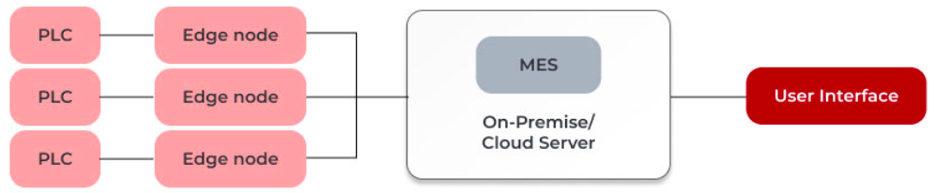

## IoT Infrastructure Implementation

Establishment of machine-to-machine connectivity across ECAM's three-site operation, incorporating sensors for CNC machines, Cutting Machines (HD Plasma & Gas Cutter), welding robots, and fabrication tools (Lathe, Grind, Shot Blast, Bend units, Weld Bays) to enable continuous monitoring of production parameters, equipment health, and process optimization.

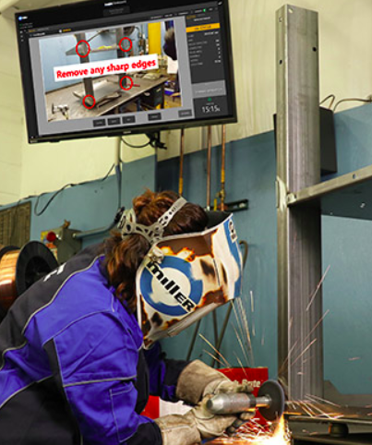

## Predictive Maintenance Framework

Implementation of AI-driven predictive maintenance algorithms that analyse equipment performance data to forecast maintenance requirements, minimize unplanned downtime, and optimize maintenance scheduling based on actual usage patterns and component wear indicators.

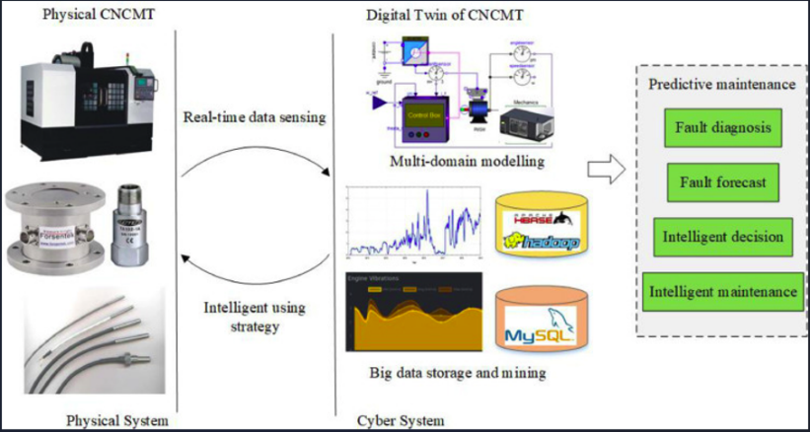

## Advanced Customer Engagement Platform

Creation of an intelligent e-commerce system featuring AI-powered quotation generation, interactive CAD tools, and automated order processing that enables customers to upload drawings, specify requirements, and receive instant pricing with confirmed delivery schedules.

## Generative AI Integration

Development of text-to-CAD conversion capabilities using generative artificial intelligence to transform customer descriptions into technical drawings, supported by machine learning algorithms trained on ECAM's extensive project database and industry standards.

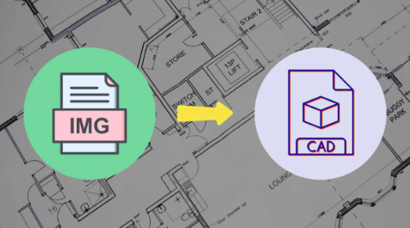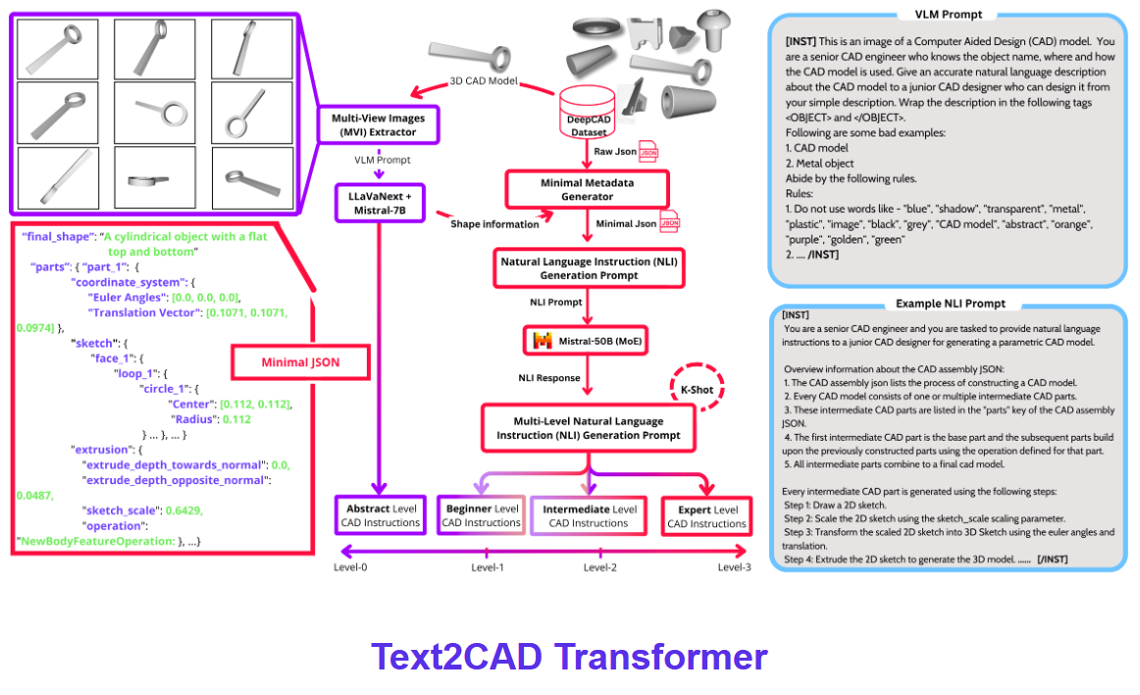

# Technical Scope Components (SCOPE)

## Machine Connectivity Infrastructure

Implementation of MT Connect protocols for CNC machinery alongside custom connectivity solutions for welding robots, laser cutting systems, and fabrication equipment. This will establish a unified communication framework enabling real-time data exchange between all production assets and the central MES platform.

## Production Tracking and Traceability

Development of comprehensive stock and work-in-progress tracking systems using RFID, barcode, and sensor technologies to monitor material flow, production stages, and quality checkpoints throughout the manufacturing process.

## AI-Powered Quotation Engine

Creation of machine learning algorithms capable of analysing customer drawings, specifications, and requirements to generate accurate cost estimates, material requirements, and production schedules automatically, reducing quotation time from days to minutes.

## Interactive Customer Portal

Development of a web-based platform featuring simplified CAD tools, material selection interfaces, and real-time pricing calculators that enable customers to design, modify, and order custom fabricated products without requiring technical expertise.

## Marketing and Business Intelligence Integration

Implementation of customer relationship management capabilities, market analysis tools, and proprietary product optimization algorithms that support ECAM's marketing initiatives and enable data-driven business development strategies.

# Innovation Framework and Technological Advancement

## Industry 4.0 Implementation

This project positions ECAM Engineering at the forefront of Industry 4.0 adoption within the precision engineering sector. The integration of MES, IoT, and AI technologies creates a smart manufacturing ecosystem that responds dynamically to customer requirements, production constraints, and market conditions. The platform will enable mass customization capabilities while maintaining the efficiency and quality standards of traditional manufacturing processes.

## Artificial Intelligence Applications

### Machine Learning for Cost Estimation (Instant Quotation)

Advanced algorithms will analyse historical project data, material costs, processing times, and complexity factors to generate highly accurate quotations automatically. The system will continuously learn from completed projects to improve estimation accuracy and incorporate market fluctuations in real-time.

### Computer Vision for Drawing Analysis

Implementation of computer vision technologies to automatically interpret customer drawings, extract dimensions, identify features, and determine manufacturing requirements without manual intervention. This capability will significantly reduce quotation preparation time and eliminate human error in specification interpretation.

### Natural Language Processing for Customer Interaction

Development of conversational AI interfaces that can understand customer requirements expressed in natural language and translate them into technical specifications and manufacturing instructions. This technology will democratize access to custom fabrication services for customers without technical expertise.

## Proprietary Technology Development

### Adaptive Manufacturing Scheduling

Creation of intelligent scheduling algorithms that optimize production sequences based on material availability, machine capacity, operator skills, and delivery requirements. The system will automatically adjust schedules in response to changing conditions and priority modifications.

### Quality Prediction and Control

Implementation of predictive quality control systems that monitor production parameters in real-time and predict potential quality issues before they occur. This proactive approach will reduce waste, improve customer satisfaction, and enhance ECAM's reputation for reliability.

### Energy Optimization Integration

Extension of the solar-powered structure concepts from the previous project into comprehensive energy management systems that optimize production scheduling based on renewable energy availability and grid demand patterns.

# Technical Architecture and Implementation Strategy

### System Integration Framework

The proposed platform will build upon ECAM's existing MRP infrastructure, extending functionality through modular components that integrate seamlessly with current operations. The architecture employs microservices design principles to ensure scalability, maintainability, and flexibility for future enhancements.

### Data Layer Architecture

Implementation of a unified data warehouse that consolidates information from production systems, customer interactions, financial processes, and external market data sources. This centralized approach ensures data consistency and enables comprehensive analytics capabilities.

### Communication Protocols

Standardization of machine communication using MT Connect for CNC equipment, OPC-UA for industrial automation systems, and custom APIs for legacy equipment. This multi-protocol approach ensures comprehensive connectivity while maintaining compatibility with existing investments.

### Security and Reliability Framework

Implementation of industrial-grade cybersecurity measures including network segmentation, encrypted communications, and redundant data storage to protect sensitive customer information and maintain production continuity.

## Development Methodology

## Agile Implementation Approach

The project will employ agile development methodologies with regular sprint cycles, continuous integration, and iterative testing to ensure rapid progress and early identification of potential issues. This approach enables flexibility in responding to changing requirements and emerging opportunities.

## Phased Deployment Strategy

Implementation will proceed through carefully planned phases, beginning with core MES functionality and gradually expanding to include advanced AI capabilities and customer-facing features. This approach minimizes disruption to ongoing operations while providing early benefits from initial implementations.

## Continuous Learning Integration

The system will incorporate machine learning capabilities that improve performance over time, learning from production data, customer interactions, and market feedback to enhance accuracy and efficiency continuously.

# Market Analysis and Competitive Advantage

## Industry Context and Opportunities

The precision engineering sector faces increasing pressure for faster response times, enhanced customization capabilities, and improved cost competitiveness. Traditional manufacturers struggle to balance efficiency with flexibility, often requiring significant lead times for quotations and custom work. ECAM's proposed platform addresses these challenges directly, creating substantial competitive advantages.

## Digital Transformation Demand

Manufacturing customers increasingly expect digital interaction capabilities similar to consumer e-commerce experiences. The ability to upload drawings, receive instant quotations, and track production progress in real-time represents a significant differentiator in the B2B manufacturing market.

## Sustainability Requirements

Growing emphasis on environmental responsibility creates opportunities for companies that can demonstrate efficient resource utilization, waste reduction, and energy optimization. The integrated platform will provide comprehensive sustainability reporting and optimization capabilities.

# Competitive Positioning

## Technology Leadership

Implementation of this comprehensive platform will position ECAM as a technology leader within the regional precision engineering sector, attracting customers who value innovation and advanced capabilities.

## Service Differentiation

The combination of instant quotations, real-time production tracking, and AI-powered customer support creates a unique service proposition that competitors will find difficult to replicate without significant investment.

## Scalability Advantages

The platform's modular architecture enables rapid scaling to accommodate growth without proportional increases in administrative overhead, supporting ECAM's ambitious revenue expansion targets.

# Resource Requirements and Expertise

## Knowledge Transfer Associate Profile

The project requires a highly skilled associate with interdisciplinary expertise spanning mechanical engineering, software development, artificial intelligence, and manufacturing systems. Essential qualifications include advanced understanding of CAD systems, machine learning algorithms, industrial automation protocols, and customer experience design.

## Technical Competencies

Proficiency in multiple programming languages including Python for AI development, C++ for real-time systems, JavaScript for web applications, and SQL for database management. Experience with machine learning frameworks, computer vision libraries, and industrial communication protocols is essential.

## Engineering Knowledge

Comprehensive understanding of manufacturing processes, materials science, quality control principles, and production optimization techniques. Familiarity with precision engineering practices and steel fabrication processes will enable effective integration with ECAM's existing operations.

# Infrastructure and Equipment

## Development Environment

Establishment of comprehensive development and testing facilities including simulation environments for manufacturing processes, AI training infrastructure, and customer experience testing platforms.

## Sensor and Connectivity Hardware

Procurement and installation of industrial sensors, communication modules, and networking equipment to enable comprehensive machine connectivity and data collection across ECAM's three-site operation.

## Software Licensing and Tools

Acquisition of necessary software licenses for development tools, AI frameworks, CAD integration libraries, and industrial automation platforms required for platform development and deployment.

# Risk Assessment and Mitigation Strategies

## Technical Risks

### Integration Complexity

The challenge of integrating diverse manufacturing equipment with varying communication capabilities presents potential technical difficulties. Mitigation involves thorough equipment assessment, prototype development, and phased implementation with fallback options for critical systems.

### AI Model Performance

Machine learning algorithms may require extensive training and refinement to achieve acceptable accuracy levels for quotation generation and drawing interpretation. Risk mitigation includes comprehensive data preparation, multiple model approaches, and human oversight during initial deployment phases.

### Cybersecurity Vulnerabilities

Increased connectivity and data sharing create potential security risks that could compromise sensitive customer information or disrupt production operations. Comprehensive security frameworks, regular audits, and employee training will address these concerns.

## Business Risks

### Market Acceptance

Customer adoption of new digital interaction methods may proceed more slowly than anticipated, potentially delaying return on investment. Mitigation strategies include comprehensive user experience design, customer training programs, and gradual feature rollout.

### Competitive Response

Competitors may develop similar capabilities or alternative approaches that reduce ECAM's competitive advantage. Continuous innovation, patent protection where appropriate, and rapid feature development will maintain market leadership.

### Operational Disruption

Implementation of new systems could temporarily impact production efficiency or quality. Careful planning, parallel system operation, and comprehensive testing will minimize operational risks.

# Financial Projections and Return on Investment

## Investment Requirements

The total project investment encompasses KTP associate costs, equipment procurement, software licensing, infrastructure development, and ongoing operational expenses over the 30-36 month implementation period. With 67% funding support from Innovate UK, ECAM's direct investment represents exceptional value for the transformational capabilities being developed.

## Revenue Impact Projections

### Immediate Benefits

Implementation of automated quotation systems and improved customer engagement capabilities will enable ECAM to pursue significantly more opportunities with reduced administrative overhead. Conservative estimates suggest 25-30% increase in quotation volume within the first year of deployment.

### Medium-term Growth

Enhanced production efficiency, predictive maintenance capabilities, and improved customer satisfaction will support ECAM's target growth from £4.4 million to £10 million turnover over five years. The platform's scalability ensures that growth can be accommodated without proportional increases in operational complexity.

### Long-term Strategic Value

The proprietary technology platform will create sustainable competitive advantages and potential licensing opportunities, generating additional revenue streams beyond ECAM's core manufacturing operations.

## Cost Reduction Opportunities

### Operational Efficiency

Automated production scheduling, predictive maintenance, and optimized material utilization will reduce operational costs by an estimated 15-20% through improved efficiency and waste reduction.

### Administrative Streamlining

Automated quotation generation and order processing will significantly reduce administrative overhead, enabling reallocation of human resources to higher-value activities.

### Quality Improvement

Predictive quality control and real-time monitoring will reduce rework, warranty claims, and customer service costs while enhancing ECAM's reputation for reliability.

# Implementation Timeline and Milestones

## Phase 1: Foundation Development (Months 1-12)

### MES Core Implementation

Development of basic manufacturing execution system functionality including machine connectivity, data collection, and production monitoring capabilities. Integration with existing MRP system and establishment of real-time dashboard functionality.

### IoT Infrastructure Deployment

Installation of sensors and communication equipment across all production facilities, implementation of data collection protocols, and establishment of centralized monitoring capabilities.

### AI Framework Establishment

Development of machine learning infrastructure, data preparation processes, and initial algorithm training using historical project data and customer requirements.

## Phase 2: Advanced Capabilities (Months 13-24)

### Customer Portal Development

Creation of web-based customer interaction platform including drawing upload capabilities, material selection interfaces, and real-time quotation generation functionality.

### Predictive Maintenance Implementation

Deployment of predictive maintenance algorithms, establishment of maintenance scheduling integration, and implementation of automated alert systems for equipment health monitoring.

### CAD Integration and Automation

Development of automated drawing analysis capabilities, integration with customer portal, and implementation of simplified CAD tools for customer use.

## Phase 3: AI Enhancement and Optimization (Months 25-36)

### Generative AI Integration

Implementation of text-to-CAD conversion capabilities, natural language processing for customer requirements, and advanced computer vision for drawing interpretation.

### Marketing Intelligence Platform

Development of customer relationship management capabilities, market analysis tools, and business intelligence dashboards for strategic decision support.

### System Optimization and Scaling

Performance optimization, scalability enhancements, and preparation for potential licensing or expansion opportunities.

# Success Metrics and Evaluation Criteria

## Quantitative Performance Indicators

### Operational Efficiency Metrics

Measurement of quotation generation time reduction (target: 90% reduction from current levels), production scheduling optimization (target: 20% improvement in throughput), and maintenance cost reduction (target: 25% decrease in unplanned downtime).

### Customer Satisfaction Indicators

Tracking of customer response times, order accuracy, delivery performance, and satisfaction scores through comprehensive feedback systems and performance monitoring.

### Financial Performance Measures

Monitoring of revenue growth, profit margin improvement, cost reduction achievements, and return on investment calculations throughout the implementation period and beyond.

## Qualitative Assessment Criteria

### Technology Leadership Recognition

Industry recognition, award nominations, and peer acknowledgment of ECAM's technological advancement and innovation leadership within the precision engineering sector.

### Market Position Enhancement

Assessment of competitive positioning, market share growth, and customer acquisition success resulting from enhanced capabilities and service differentiation.

### Organizational Development

Evaluation of employee skill development, process improvement, and organizational capability enhancement resulting from technology adoption and digital transformation.

## Long-term Strategic Impact and Future Opportunities

### Industry Transformation Leadership

This project positions ECAM Engineering as a catalyst for digital transformation within the precision engineering sector. The comprehensive platform will serve as a model for other manufacturers seeking to enhance competitiveness through technology adoption, potentially creating consulting and licensing opportunities.

### Expansion and Scaling Potential

The modular platform architecture enables expansion into adjacent markets, additional service offerings, and geographic growth opportunities. The technology foundation supports rapid scaling without proportional increases in operational complexity or administrative overhead.

### Innovation Ecosystem Development

Successful implementation will establish ECAM as an innovation hub, attracting partnerships with technology providers, academic institutions, and industry leaders seeking collaborative development opportunities.

# Conclusion and Recommendation

This Knowledge Transfer Partnership represents a transformational opportunity for ECAM Engineering Limited to establish industry leadership through comprehensive digital transformation. The project's ambitious scope, combining MES integration, IoT connectivity, artificial intelligence, and advanced customer engagement capabilities, addresses critical market demands while creating sustainable competitive advantages.

The technical feasibility is well-established through ECAM's successful previous KTP experience and demonstrated commitment to technological advancement. The financial projections support strong return on investment, while the risk mitigation strategies address potential challenges comprehensively.

Birmingham City University's expertise in digital transformation, combined with ECAM's manufacturing excellence and growth ambitions, creates an ideal partnership for achieving these ambitious objectives. The 30-36 month timeline provides sufficient duration for comprehensive development while maintaining momentum toward early benefit realization.

This project will not only transform ECAM's operational capabilities but also contribute significantly to the advancement of Industry 4.0 adoption within the UK manufacturing sector, demonstrating the potential for traditional manufacturers to embrace digital transformation successfully.