|  |
| --- |
|  |
| Instructions for Operation and Admin |
| Process Time Tracker |
|  |
|  |
|  |

Contents

Contents 2

1 Quick Guide 4

1.1.1 Loading admin page 4

1.1.2 Adding a job 5

1.1.3 Users 5

1.1.4 Clocking On and Off 5

2 Usage Guide 6

2.1 Locations 6

2.1.1 Adding Scanner Locations 7

2.1.2 Deleting Locations 7

2.2 Routes 8

2.2.1 Adding new routes 9

2.2.2 Editing routes 9

2.2.3 Renaming Route 9

2.2.4 Deleting routes 9

2.3 Adding jobs 9

2.3.1 Adding a job manually 9

2.3.2 Adding a job with CSV files 10

2.4 Managing users 11

2.4.1 Adding users 11

2.4.2 Deleting users 11

2.5 Products 12

2.5.1 Add product 12

2.6 Problem Reasons 13

2.6.1 Adding problem reason 13

2.7 Work hours 14

2.7.1 Lunch Period Times (configuration option at install) 14

2.8 Time sheets 15

2.9 Clocking On and Off 16

2.9.1 Clocking On and Off in App 16

2.9.2 Failure to clock off 19

2.9.3 Viewing currently clocked on users 19

2.10 Recording Problems 20

2.11 Current jobs 21

2.11.1 System overview 21

2.12 Job Record 22

2.12.1 Updating job details 22

2.12.2 Delete job 22

2.12.3 Duplicating a record 23

2.12.4 Marking a Job as Complete 23

2.12.5 Problems Log 23

2.12.6 Work Log 23

2.12.7 Work Log Record 25

2.13 Record Quantity Completed (configuration option at install) 26

2.13.1 Recording Quantity 26

2.13.2 Reviewing Quantity Records 26

3 Trouble shooting 27

3.1 Work time or duration negative 27

3.2 Add Jobs with CSV “No Request” message 27

3.3 QR code not present when linked clicked 27

# Quick Guide

This Process Time Tracker records the amount of time a job spends at different stages of production, for example, how long a product is worked on at the welding location and then at the painting location.

### Loading admin page

To load the admin pages in a browser, on a network connected to the server, navigate to:

*<Server IP Address>/timelogger/pages/overview_client.php*

replacing ‘*<Server IP Address>*’ with the relevant IP address for the server set up on the network. Along with ‘http://’ as prefix. Example: http://192.168.0.140

Figure 1: : Overview page & Server IP Address with the present software version & Android app Settings Page picture

As shown in the figure 1, in the app we can either enter the Sever IP Address manually on the blank under heading ‘Server IP Address’ or by clicking the toggle on and clicking the button Find Server Now system fetches the Server IP Address automatically.

### Adding a job

On the Add Jobs page jobs can be added manually or by uploading a CSV file containing information for multiple jobs.

To add jobs manually enter the details required for the job and press the ‘Add job’ button.

If adding jobs using a CSV file first create a CSV file with the relevant headers, a template of which can be downloaded from the Add Jobs page. Browse for the file and press the ‘Upload file’ button. A list of jobs will be displayed including any jobs that could not be added, with the reason it was not added.

If a Job ID is not entered one will be generated automatically and displayed.

### Users

On the Users page users can be added, deleted and their QR code downloaded. To add a user, enter their name into the input box and press the ‘Add User’ button, a unique ID will be generated as well as a QR code which should be downloaded and printed.

### Clocking On and Off

A user can clock onto or off a job using the app. This is done by selecting a location from the dropdown menu, which will display locations specified through the web interface, and then using the camera view displayed in the app to scan a user QR code and a job QR code. The current status of the job at the selected location (work in progress, stage complete, or (job) complete) should be chosen from the dropdown.

Once the details entered are correct, press the send button to submit them. The server will determine whether the user is clocking on or off, and an appropriate message will be displayed at the bottom of the app.

# Usage Guide

## Locations

Each production area should have a location name associated with it, for example welding, assembly or painting.

Multiple scanners (phone or tablets) can have the same location name so that, for example, if a large area of the factory floor is being utilised for welding, with more than one scanner named welding, the staff can clock on through one unit and clock out of another.

Alternatively each user can carry a phone or tablet with them and select what location they are clocking on or off from.

Figure 2: Scanners Page & Scanners Page with Active Scanner Stations

When the app (mobile or tablet) has scanner locations selected then it will show under active scanner stations.

### Adding Scanner Locations

Scanner locations are the location names that the app will use. To add additional location names:

* Using the navigation bar navigate to the Scanners page.
* Enter the location name into the New Location Name text box.
* Click Add New Location Name. If this succeeds the Existing Scanner Location Names table gets updated with the newly added Location Name with the Delete Location Name button beside that.

### Deleting Locations

Extra location names may be deleted from the system.

* Using the navigation bar navigate to the Scanners page.
* Press the ‘Delete Location Name’ button beside the desired Location Name from the Existing Scanner Location Names table. Once this is complete the Existing Scanner Location Names table gets updated without the Location that was deleted.

## Routes

A Route is a list of stations and their order of usage that a product follows to reach its completed state.

For example, a part might be processed at a CNC station, assembly station and a painting station in that order. Such a part’s route could be called ‘Main_Production_Route’ and would be as follows:

Figure 3: Routes Page

A route may be built up by adding the names of locations. Locations are specified on the Scanners page.

By using routes the current production stage recorded for the job, as shown on the Overview page, will display the current stage in the route that a job has progressed to. The current production stage will not show any locations that are not on the route or activity on previous stations in the route after it has progressed beyond it.

If the requireStageComplete configuration option was selected at installation an entry in the time log must be marked as stage complete at a location before the current production stage will indicate the next stage in the route. (By default this option is not selected)

Notes:

-Routes are an optional feature and do not have to be used for the system to function fully and correctly.

-Route names are case sensitive.

### Adding new routes

* Enter the name of the new route in the ‘Route Name’ box.
* Choose the name of the location to be added to the route from the ‘Add Route Stage’ dropdown and press ‘Append to list’ button.
* Add all locations required in the order they are to be visited.
* Press ‘Save this route’ before navigating away from the page or changing route name selection.

### Editing routes

* Select route to be edited from ‘Load Existing Route’ dropdown.
* To add a location, select from the ‘Add Route Stage’ dropdown and press ‘Append to list’.
* To change a Route’s order locations must be removed accordingly using ‘Delete last stage’ button and then added in the required order. Route locations can only be removed using the last stage button.
* Press ‘Save this route’ before navigating away from page or changing route name selection.

### Renaming Route

* Select route to be renamed from ‘Load Existing Route’ dropdown.
* Enter the new name of the route in the ‘Route Name’ box.
* Press ‘Save this route’ before delete the old route name from the current routes

### Deleting routes

* Select route to be deleted from ‘Load Existing Route’ drop down.
* Press ‘Delete this route’ before navigating away from the page or changing route name selection

## Adding jobs

Figure 4: Add New Jobs Page

### Adding a job manually

* Enter job details:
  + all input fields are optional
  + if a Job ID is not entered one will generate automatically and display in the Job ID input box once the job has been created
  + a Job ID can only be made up of letter, numbers and underscores. It must also not start with any of the prefixes the system uses which are ‘Job_’, ‘user_’, ‘stpg_’ and ‘prtd_’.
  + changing a Route Description on this page will change the actual route unless a new route name is entered.
* Press ‘Add Job Details’ before navigating away from the page.
* Download and print the QR code, this can also be done from this job’s Record page, accessible from the current job’s table. It is advised that when printed QR codes should be no smaller than 15mm.

### Adding a job with CSV files

* Create CSV following the format described below.
* Populate all details required for the jobs into the CSV file.
* On the Add New Jobs page, on the right-hand side, press the ‘Browse…’ button, select the new CSV file and press ‘Upload File’.
* The jobs will be displayed including any jobs that could not be added with the reason it was not added.
* Format

The headings for the CSV file are:

jobId,expectedDuration,description,routeName,dueDate,totalChargeToCustomer,unitCount,totalParts,productId,priority,customerName

These **exact headings** must be used, they are case sensitive, their order does not matter. Headers must be on row 1, immediately followed by data and no other data information should be included below jobs.

The values entered in the CSV file must meet the conditions:

* jobId- 20 characters or less, made up of letters, numbers and underscores. It must also not start with any of the prefixes the system uses which are ‘Job_’, ‘user_’, ‘stpg_’ and ‘prtd_’.
* expectedDuration- given in the form HH:MM
* description- 200 characters or less
* routeName- an existing route when adding jobs from a CSV file
* dueDate- in the form YY/MM/DD or YYYY/MM/DD or YY-MM-DD or YYYY-MM-DD
* totalChargeToCustomer- as ££.pp pounds & pence or pounds ££ and cannot be negative
* unitCount- cannot be negative
* totalParts- cannot be negative
* productId- existing product
* priority- number 0-4 (None-0, Low-1, Medium-2, Hight-3, Urgent-4)
* customerName- 50 characters or less

## Managing users

Figure 5: Managing users

### Adding users

* Enter the user name to be displayed for the employee.
* Press ‘Add user’, a user ID will be assigned automatically by the system.
* Download and print QR code using generated link or Existing Users table.

It is advised that when printed QR codes should be no smaller than 15mm.

### Deleting users

* Confirm that they are not clocked on.
* In the existing users table locate the user.
* Press the ‘Delete user’ button on the relevant row.

Notes:

-Clock on events of deleted users in Works Logs will be listed as ‘User Deleted’.

## Products

Figure 6: Products Page

Products can be used if a particular job is to be run repeatedly so that a new QR code does not have to be printed each time. A QR code for a product can be used like a job QR code, however, all the time logged will be placed on that product’s Current Job.

When adding jobs select the product from the drop down or enter it into the CSV file. When a new job is added for a product it is set as its Current Job, consequently a product can only have a single job being worked on at a time, the previous job should be complete before adding another.

### Add product

* Enter the ID for the product; it can only be made up of letters, numbers and underscores.
* Press ‘Add Product’ and a QR code download link should appear.
* Download and print QR code using generated link or Existing Products table.

It is advised that when printed QR codes should be no smaller than 15mm.

Notes:

-Products are an optional feature and do not have to be used for the system to function fully and correctly.

## Problem Reasons

Figure 7: Problem Reasons Page

The Problems functionality can be used to log the time, location and reason for problems on a job. A list of problems recorded for a job can be viewed on a job’s record page. A problem can be recorded at a scanner using a problem reason QR code from a set located at the scanner and a job QR code or on a job’s record page.

### Adding problem reason

* Enter a name for the problem reason.
* Press ‘Add Reason’, a Problem ID will be assigned automatically by the system.
* Download and print QR code using generated link or Existing Problem Reasons table.

It is advised that when printed QR codes should be no smaller than 15mm.

Notes:

-Problems are an optional feature and do not have to be used for the system to function fully and correctly.

## Work hours

Figure 8: Work Hours Page

Work hours are used so that the time workers spend outside normal operating hours on a particular job can be recorded as ‘Overtime’. The amount of overtime spent on a job is shown on the Overview page table and on the job’s record page. If a day is not normally a work day, the start and end times should be set to 00:00. In this case, any time on that day will be considered overtime.

### Lunch Period Times (configuration option at install)

If the addLunchBreak configuration option was selected at installation (by default not selected) then times for a lunch period can be selected on this page. If a user clocks on before the lunch period starts and only clocks off after lunch, a break will be added for the defined lunch period. Adding a break will split the entry in two separate entries in the time log the first ending at the start of lunch and the second entry starting at the end of lunch.

If in addition to addLunchBreak trimLunch configuration option is also selected then any work time is prevented from being added to jobs during lunch. If a user clocks off during lunch the time recorded will be altered to the start of lunch. Similarly if a user clocks on during the lunch period this will be altered to start at the end of the lunch. Finally if a user clocks on and off during lunch they will be recorded as clocking off at the same time they clocked on so that zero time will be added to the job.

Notes:

-The system does not support a 24 Hr operating schedule.

-It is recommended to only make changes to these settings when no users are clocked on.

## Time sheets

The system can produce timesheets for users. This will show the total time spent on jobs for each day in the selected time period. The generated table of times can be downloaded as a CSV file.

Figure 9: Timesheet generation

To generate a timesheet for a user:

* Select a user from the select user dropdown menu
* Select start and end dates that the timesheet will be generated for
* Click fetch time sheet
* Additionally Timesheet Display Options can be used to exclude Product IDs & Aggregate Worked Time columns by clicking in the Exclude Product IDs checkbox and Exclude Aggregate Worked Time checkbox.

Figure 10: Timesheet generation with Timesheet Display Options

## Clocking On and Off

### Clocking On and Off in App

#### Select a Station

If not using the App as a static station select the correct station from the drop down.

Figure 11: Selecting Station

#### Scan or Enter User Id

Using the camera code scanner or by entering the code manually to fill the User Id field. If entering manually then the ‘user_’ prefix does not need to be enter, only the 4 digit number e.g. ‘0052’ has to be entered.

Figure 12: Scanning (left) and manually entering (right) User ID

#### Scan or Enter Job Id

Using the camera code scanner or by entering the code manually to fill the Job Id field. Any prefix MUST be included

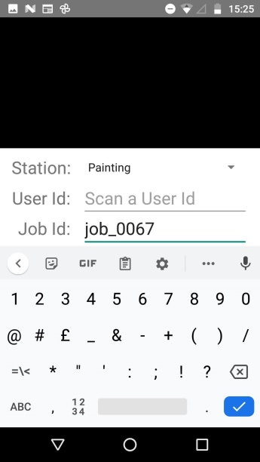

Figure 13: Manually entering Job Id code

#### Select Status

If clocking off a job select a job status from the three available options. (When clocking on job status will always automatically be set to work in progress no matter what is selected)

Work in progress- All work has NOT been finished at the current stage of production.

Stage Complete- All work has been finished at the current stage of production. (if server configuration option requireStageComplete is set to true then the routes current stage will not progress until the previous stage has an entry marked Stage Complete)

Complete- All work has been finished on the job.

Figure 14: Selecting Work Status

#### Send and Wait for response

Once the details entered are correct press the send button to submit it and wait for confirmation message which will indicate if you clocked on or off.

Figure 15: Clocked ON (left) and Clocked OFF (right)

#### Enter Quantity Complete

If the ‘Record Quantity Complete’ app settings option is switched on and the user has just clocked off a pop up will be shown asking them to enter the number of units complete while they were clocked on.

Figure 16: Quantity Complete Dialogue Box

### Failure to clock off

If a user fails to clock off they will automatically be clocked off at midnight and recorded as clocking off at the same time as they clocked on so that the duration for the record will be shown as 00:00. In the event of an automatic clock off at midnight no time will be added to the Total Worked Time for the job and the Job Status at station for this record will be recorded as ‘Unknown’.

### Viewing currently clocked on users

To view users currently clocked on and which jobs they are working on, navigate to the ‘Clocked On Users’ page.

Users can be individually clocked off jobs by admin from this page by pressing the ‘Clock Off’ button for that user. The work status in the log will be recorded as “Unknown” when clocked off by admin in this way.

Figure 17: Current Users Page

## Recording Problems

The app is also capable of recording problems, using the QR codes downloaded from the add problems screen (see section 2.6). To do this first use the app to scan a problem QR code, as shown in Figure 18.

Figure 18: scan Problem QR code

When the Problem QR code is scanned, the User ID field of the app changes to show the problem description, and the status field changes to offer “unresolved” and “resolved” as options.

Scan the job ID QR code and then select the status of the Problem (unresolved or resolved). Once all the details are correct, press send to send the problem data to the server.

When a problem is recorded by the server, the app will display problem recorded message indicating screen will come as this problem has occurred, shown in Figure 19 (Left) when that problem is recorded off by the server the app will display problem recorded message indicating screen will come as this problem has resolved, shown in Figure 19 (right). Recording a problem will not clock users off. This must be done separately.

The problem will be displayed on the overview table and on the job details page. Multiple problems may be recorded, including from the same location. Each “resolved” problem will resolve one corresponding issue on the details page.

Figure 19: Problem Breakdown ON (left) and Problem Breakdown OFF (right)

## Current jobs

### System overview

* On the system Overview page all jobs in the system can be viewed in table form.
* Jobs can be sorted, searched and filtered using start/end date, search text, completed and priority etc.
* Under Display options use the top two check boxes to select which jobs to highlight.

If ‘Highlight jobs with close/overdue deadline’ is checked, use the ‘Close deadline day count’ to highlight jobs with deadlines within the specified number of days.

* Subsequent check boxes select which columns to include in the table.
* Problems column shows the reason and location of the last two unresolved problems.
* To access a jobs record page and logs, click on the relevant row in the table.
* The display options selection can be retained using the last check box. This will cause the overview table column selection to be stored and used next time the overview page is loaded.

Figure 20: Overview Page

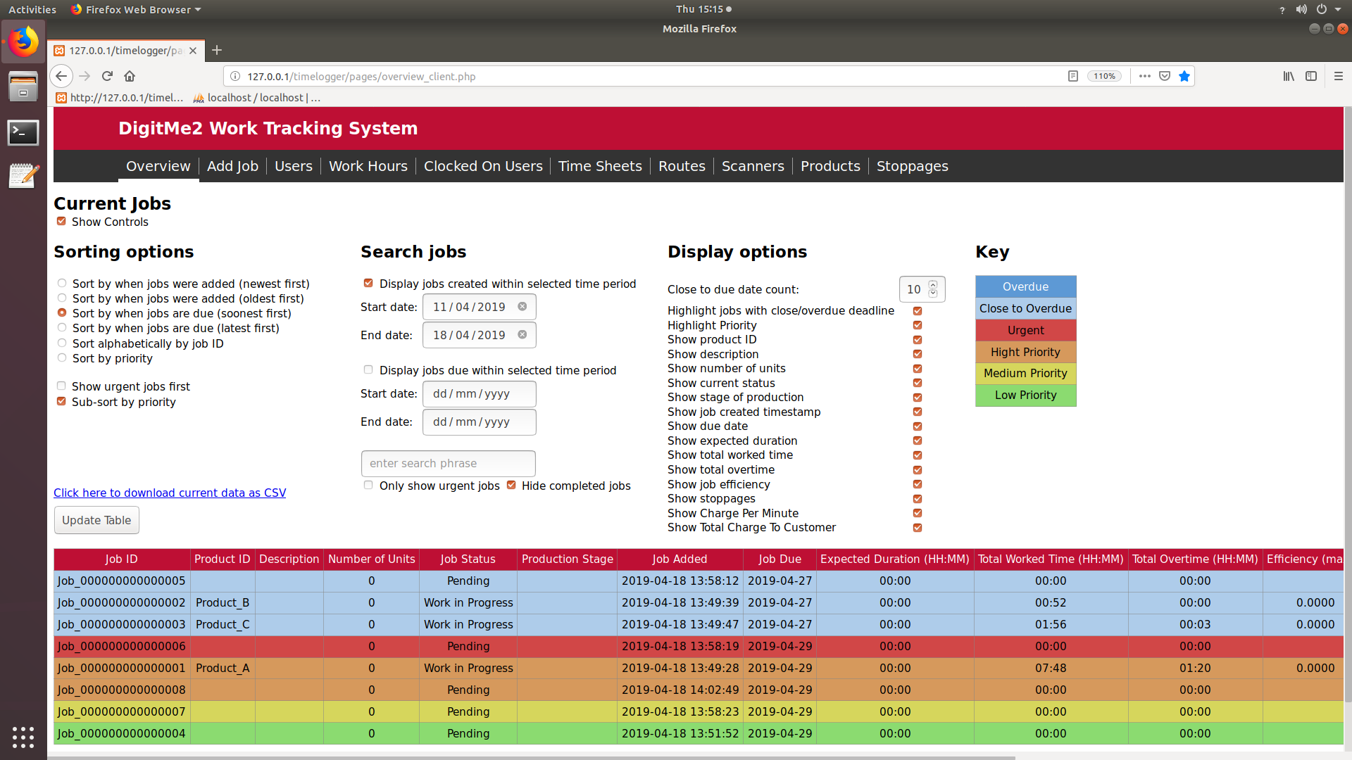

Figure 21: Jobs table with jobs close to overdue and priority

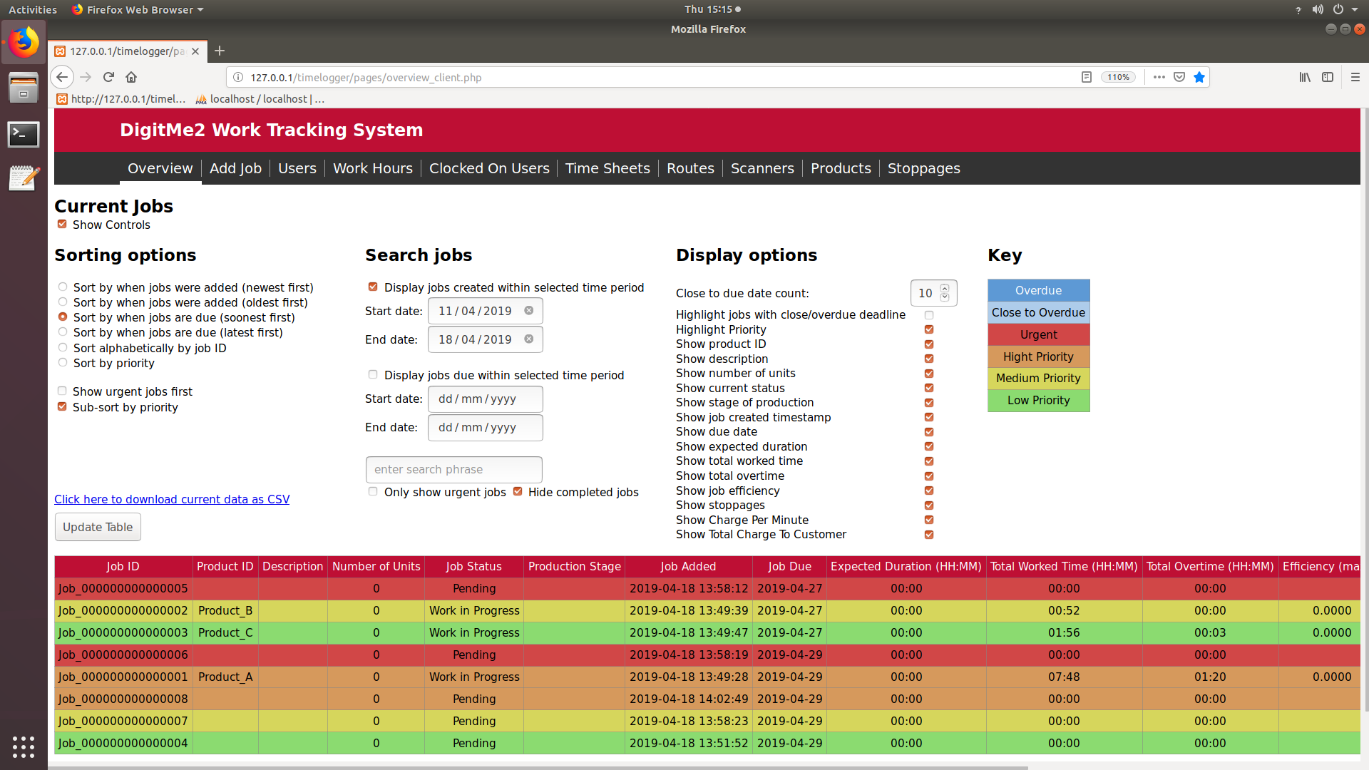

Figure 22: Jobs table ordered by due date and sub sorted by priority

## Job Record

From a job’s record page, the details of the page can be viewed and edited, the list of problems can be viewed, a problem can be recorded and a log of time spent clocked onto the job can be viewed.

To access, click on the relevant entry in the table on the system overview page.

Figure 23: Job Record Page

### Updating job details

To update details, amend the required information and press ‘Save’

before navigating away from page.

#### Changing job ID

If the job ID is changed the QR code will also change and will need to be reprinted.

### Delete job

Deleting a job will permanently delete all records of a job including work log and problems log.

### Duplicating a record

Duplicating a record will save any changes to the current job and copy all user changeable values to a new job with an automatically generated ID (this can be changed). Values such as worked times, problems stage and status will not be moved across to the duplicate.

### Marking a Job as Complete

To mark a job as complete the ‘Mark Job Complete’ button can be pressed on the job details page and reversed if necessary to mark the job as in progress again by pressing the same button. A job will also be marked as complete if the ‘Stage complete button on the front of a scanner is pressed when clocking of the last stage in a route.

### Problems Log

The problems log lists the location, reason, time and date of all recorded problems for the individual job.

To record problems select a station, reason and press ‘Add Problem’.

Marking a problem as resolved can be used for internal purposes and will hide this problem from being displayed on the overview page.

### Work Log

Figure 24: Work Log on Job Record Page

The work log displays a list of all the entries of users clocked on to the individual job including the location, date, durations, clock on time and clock off time.

The job status, at time of clock off, is by default “Work in Progress” but can be marked as “Stage Complete” when clocking off at a location. If a user fails to clock off and so is clocked off when clocking on another job, at midnight or by admin the status of the job for this log will be recorded as ‘unknown’.

The link directly above the table will download a csv file of the table currently displayed.

#### Collapse Records

Collapsing a job’s work log will shrink the table so entries for each individual station are reduced to a single row, the total duration and overtime spent at that station can be viewed with the last status recorded at the station.

#### Add New Work Log

When the operator forgets to clock on for a job, we can add the work log for that job using ‘Add New Work Log’ button at the Job Record Page.

By pressing the ‘Add New Work Log’ button at the Job Record Page, new Work Log Record Page will be opened with the empty records. Users and Scanner Locations can be selected using the dropdowns in that page, with date and start time.

Along with the above details end time can also be given for work that already finished, and Job status can be selected from the dropdown.

-The Quantity Complete is fully optional, can be left empty.

Figure 25: Work Log on Job Record Page With Add New Work Log Button

Figure 26: Empty Work Log Record page for adding New Work Log

### Work Log Record

Figure 27: Work log event page for a closed and open record

To view and edit an individual work log record click on its (uncollapsed) row in the work log table on the job’s record page.

When changing start or end times make sure the user was not clocked onto any other job at this time as the system will not prevent this. Changing the status of the log will not change the current status of the job, even if the log record being edited is the most recent.

#### Manually Inserting a Break

Manually adding a break will split the recorded time into two separate logs, the first ending at the start of the break and the second starting at the end of the break.

Notes:

-Both Duration and Overtime are rounded down to closest minute.

## Record Quantity Completed (configuration option at install)

The quantity of units completed can be recorded when clocking off and then reviewed in the jobs Time Log. Recording quantity is a configuration option that can be selected at install and in app settings; see installation and app instructions, a copy of which should be included in ‘Work_Tracking_Software’ folder on your server, for information on how to select configuration options.

### Recording Quantity

When clocking off at a scanner, after presenting the two QR codes, if the user was successful in clocking off the screen will prompt them to enter a quantity. Using the keypad or keyboard the user should enter the quantity of units completed while clocked on followed by pressing enter. If the user does not want to enter a quantity then they can press enter without inputting a quantity value.

#### Multi User Clock Off

If multiple user clocking has been selected as a configuration option the user will only be prompted to enter a quantity completed if a single user is scanned and they are clocking off.

Notes:

-If there is a significant delay between key presses the scanner will timeout at this point the user has already clocked off and so no more action needs to be taken.

### Reviewing Quantity Records

The number of units completed can be reviewed in the Work Log on the jobs Record page. By default the work log will show all individual records, if the “Collapse Record” option is selected it will shrink the table so entries for each individual station are reduced to a single row with the total number quantity completed at that station. When records are collapsed the additional column titled outstanding will be displayed which show the number of units for the job minus the number completed giving the number of units still to be completed at that station (this will not be displayed if a date range is being used). The quantity completed while clocked on can be edited on the logs record page by clicking on the entry in the work log while not collapsed.

# Trouble shooting

## Work time or duration negative

If a work time or duration is negative this indicates that users are not automatically being clocked off at midnight. The database uses an event called autoClockOff, which must be ENABLED. Contact DigitME2 for assistance.

## Add Jobs with CSV “No Request” message

* Close and restart the browser

## QR code not present when linked clicked

* Notify admin.
* Check that ‘Image’ and ‘qrcode’ libraries are installed on the server.