**PassersStamp**

This is my First Repository.

This is a basically a python program, but, it doesn't need any knowledge of Python for anyone working on this program.

Anyone who doesn’t know anything about Python can also work on this project easily, as it only uses the in-built “**print**” function.

**Pyhton needs to be installed in order to Execute the code.**

The syntax of the print function can be found in the “**syntax.txt**” file.

Simply just open the “**PassersStamp.py**” in a Text Editor ( even Notepad will be fine ) and write the syntax of print statement.

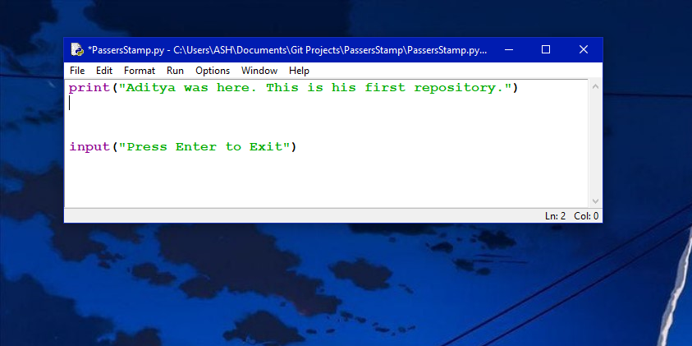

Just make sure that you write the print statement above the input statement.

You can write something like :

**<NAME> was here too.**

**So was <NAME>**

Followed by a message if you want to write any.

Something like this :

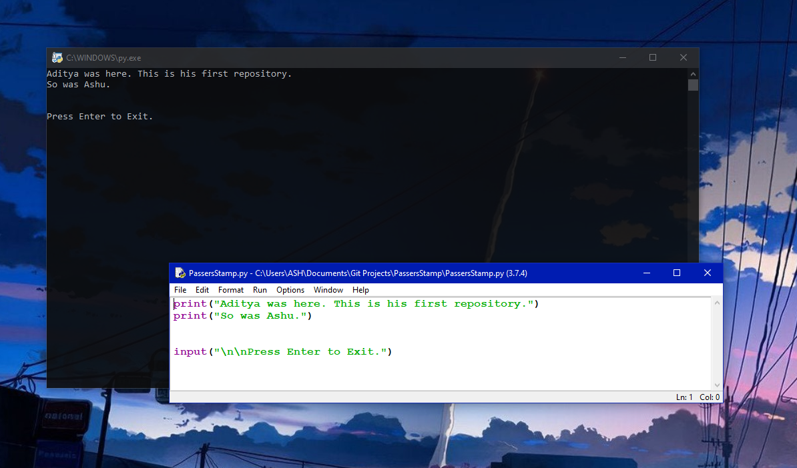

And, That’s basically just it.

Regards,

Aditya6799.