Market Campaign Insights Analysis

Data Analysis Using SQL

Created the dataset manually using the sql commands and loading it into the powerBI and making it an interactive Dashboards.

SQL Commands to analysis the data
- Show all customer records
Query:-
SELECT * FROM customers;
Output:-
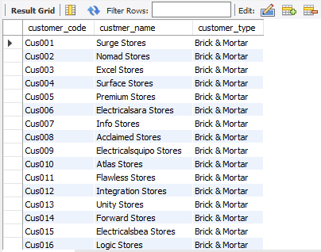

- Show total number of customers
Query:-
SELECT count(*) FROM customers;

Output:-
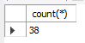

- Show transactions for Chennai market (market code for chennai is Mark001
Query:-
SELECT * FROM transactions where market_code='Mark001';
Output:-
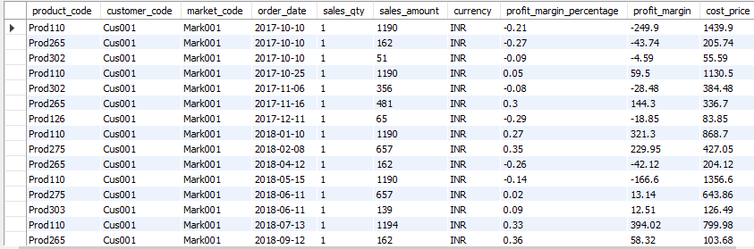
- Show distrinct product codes that were sold in chennai
Query:-
SELECT distinct product_code FROM transactions where market_code='Mark001';
Output:-
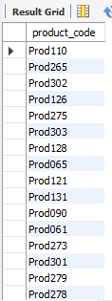
- Show transactions where currency is US dollars
Query:-
SELECT * from transactions where currency="USD"
Output:-
- Show transactions in 2020 join by date table
Query:-
SELECT transactions.*, date.* FROM transactions INNER JOIN date ON transactions.order_date=date.date where date.year=2020;
Output:-
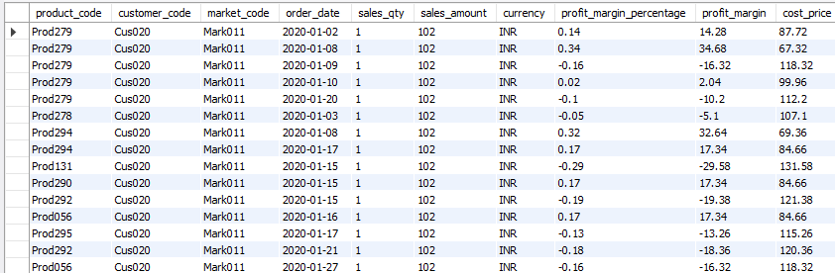
- Show total revenue in year 2020
Query:-
SELECT SUM(transactions.sales_amount) FROM transactions INNER JOIN date ON transactions.order_date=date.date where date.year=2020 and transactions.currency="INR\r" or transactions.currency="USD\r";
Output:-
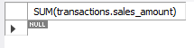

- Show total revenue in year 2020, January Month
Query:-
SELECT SUM(transactions.sales_amount) FROM transactions INNER JOIN date ON transactions.order_date=date.date where date.year=2020 and and date.month_name="January" and (transactions.currency="INR\r" or transactions.currency="USD\r");
Output:-
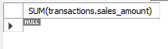
- Show total revenue in year 2020 in Chennai
Query:-
SELECT SUM(transactions.sales_amount) FROM transactions INNER JOIN date ON transactions.order_date=date.date where date.year=2020 and transactions.market_code="Mark001";
Output:-
