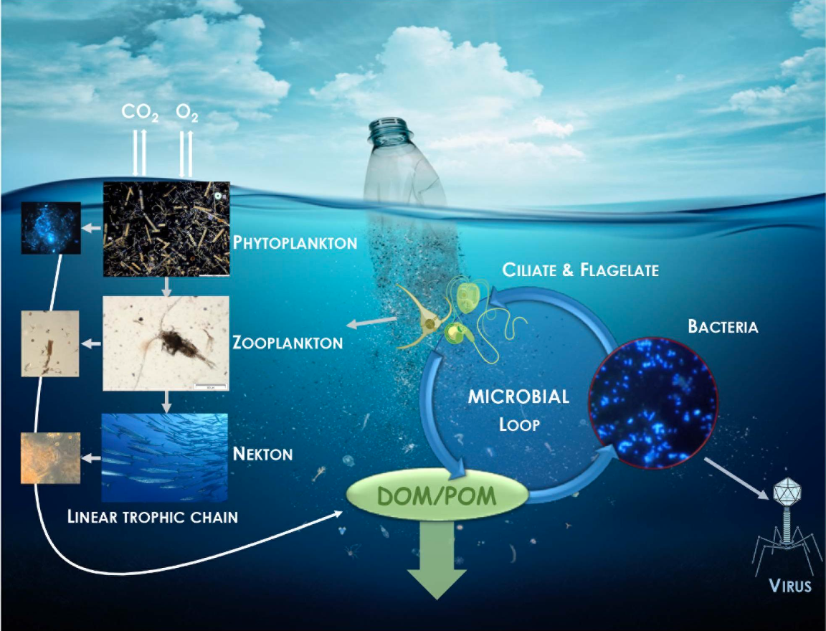

Topic: **Biodegradation of polyethylene terephthalate microplastics by bacterial communities from activated sludge**

Student’s Name: Aditya Raj Bagri

Roll No: 210107007

Group No: 18

Course name: Technical Writing & Presentation (CL311)

**ABSTRACT**

The study addresses the escalating concern surrounding the accumulation of microplastics (MPs) in aquatic environments, a pervasive issue with substantial implications for both human health and aquatic ecosystems. Current technologies for effective MP removal are insufficient, necessitating novel approaches. This research investigates activated sludge as a potential biocatalyst source for MP removal. Initially, bacterial communities in activated sludge were screened for their capability to degrade PET plastics, a widely used polymer. The consortium of bacteria displayed notable PET-degrading proficiency, especially under elevated oxygen flow rates. This signifies a potential avenue for enhancing biodegradation processes. Furthermore, the study isolated two bacterial strains, Bacillus cereus SEHD031MH and Agromyces mediolanus PNP3, both exhibiting promising PET-degrading activity. This finding holds substantial promise for the development of innovative technologies aimed at mitigating MP pollution in water bodies. It underscores the pivotal role that specific bacterial strains can play in degrading PET, offering a potential solution to the pressing issue of microplastic pollution. The study thus contributes to the advancement of sustainable and effective methods for combating this environmental challenge.

**INTRODUCTION**

The surge in man-made debris, particularly microplastics (MPs), in marine ecosystems is a pressing issue. Approximately 5.25 trillion plastic fragments, with 92.4% being MPs, are currently adrift in the open ocean. These minute particles have permeated marine life, including shellfish, and have even been discovered in human consumables like drinking water and food. Studies suggest that humans may ingest as many as 142,000 MPs annually through contaminated sustenance. Although the full extent of the risks MPs pose to human health remains uncertain, there is speculation among scientists that they may infiltrate organs, potentially inducing a prevalent polymer in MPs, presents a challenge for current removal methods in water bodies. Microbial degradation, utilizing bacteria with enzymatic capabilities, has emerged as a promising, eco-friendly approach to address PET effectively. Bacterial strains like Bacillus subtilis, Bacillus cereus, and Ideonella sakaiensis have been pinpointed for their PET-degrading prowess. Further investigations into enzymatic PET degradation have revealed susceptibility to microbial polyester hydrolases. Additionally, carboxylesterases from various bacterial and fungal species have demonstrated partial PET hydrolysis. Identifying bacteria with PET-degrading potential holds potential for advancing biotechnologies aimed at eliminating PET MPs from water and wastewater.

**MATETRIALS AND METHODS**

MPs and activated sludge characterization

Microplastics (MPs) with sizes ranging from 300 to 425 μm were obtained by physically crushing waxy solids of polycaprolactone diol (PCL) and powdered PET, followed by sifting. To remove contaminants, the PET MPs underwent a purification procedure that involved washing them with ethanol and then drying them. Both polymers' levels of total organic carbon (TOC) and carbon content (C C) were evaluated. Samples of activated sludge were obtained from the North Toronto Wastewater Treatment Plant (WWTP) secondary treatment process and examined for pH, total suspended solids (TSS), and volatile suspended solids (VSS). VSS was calculated by subtracting residues from TSS after cremation, whereas TSS was ascertained by weighing a glass fiber filter pad both before and after filtration. It was determined that 58% of the VSS was made up of the TOC..

Growth medium

The screening and biodegradation tests followed the ISO 14852 standard and utilized an optimized growth medium. This medium consisted of The pH of the solution was maintained within the range of 7.2 to 7.4. This carefully designed medium provided the necessary nutrients and conditions for the screening and subsequent biodegradation experiments.

Isolation and screening of PET-degrading bacteria

PET MP-supplemented growth medium was used to incubate a 50 mL volume of activated sludge for 60 days at 30°C. Throughout the incubation, the biomass concentration (X), measured in milligrams per liter of volatile suspended solids (mg VSS/L), was observed to assess microbial development. Using a kinetic model for microbial growth in batch cultures, the specific growth rate (μ) in days to the power of minus one (d^-1) was computed. The equation X = X0e^(μt) reflects this model, where t is the time in days and X0 is the starting biomass concentration. Three copies of the analysis were performed, and the average values were noted.

The screened samples were then subjected to an enrichment culture. During this stage, they were incubated for 20 days at 30°C in an enrichment solution that contained 400 mg of PET MPs and 200 mL of growth media. After that, some of the broth was taken out of the flask and re-injected into new enrichment medium, where it was let to sit under the same circumstances for an additional 20 days. This procedure was carried out again. To get rid of any leftover PET MPs, the enrichment culture was filtered using filter paper. After that, it was described and added to the biodegradation experiment as an inoculum.

Experimental device and biodegradation assessment

Four parallel batch bioreactors, were all part of the experimental setup (Figure 1). Aeration with CO2-free air that had been pre-treated with NaOH solution to remove CO2 was required to start the biodegradation process and regularly titrated for measurement. PET was assigned to two reactors; one was designated as a control and the other for the reference material PCL. Design parameters included a 168-day residence period, oxygen flow rates of nitrogen content of 424 mg/L, C:N ratio of 7:3, and TSS ranging from 30-1000 mg/L in the inoculum. These values were in line with ISO 14852 and previous studies.

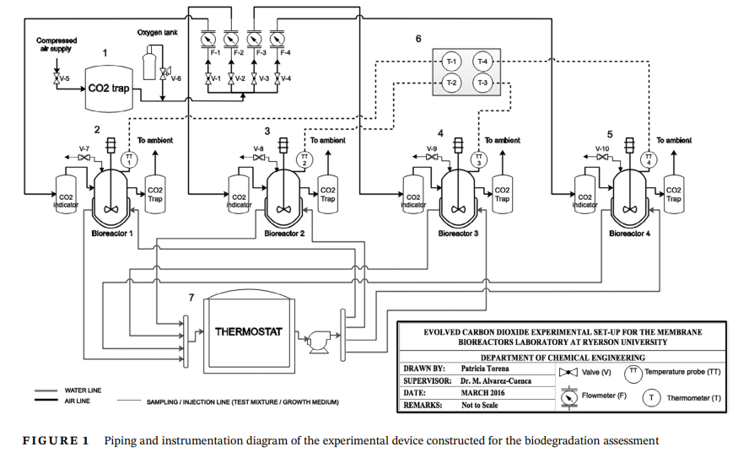

Determination of percentage biodegradation and kinetics evaluation

By contrasting the actual and predicted CO2 production, the biodegradation percentage of PET was determined. PET degradation was modeled using an empirical fitting technique with approximated MPs, treating it as a first-order process. K = -1/t ln(W/W0), where t is the incubation time, where Dt is the percentage of biodegradation, is the kinetic constant (K) for MPs reduction that was found using the first-order kinetic model. Then, using t1/2 = ln(2)/K, the half-life (t1/2) was calculated.

FTIR analysis

The MPs were treated in a series of steps, first washing in 70% ethanol and then drying at 100°C for an hour. They were then subjected to FTIR spectroscopy analysis in the 4000-450 cm-1 scanning range. The ratio of intensity at 1710 cm-1 to that at 871 cm-1 was used to compute the carbonyl index, and the ratio of peak areas at 1341 cm-1 and 1410 cm-1 was used to compute the crystallinity index. The spectra that are displayed are the mean of three different MP samples.

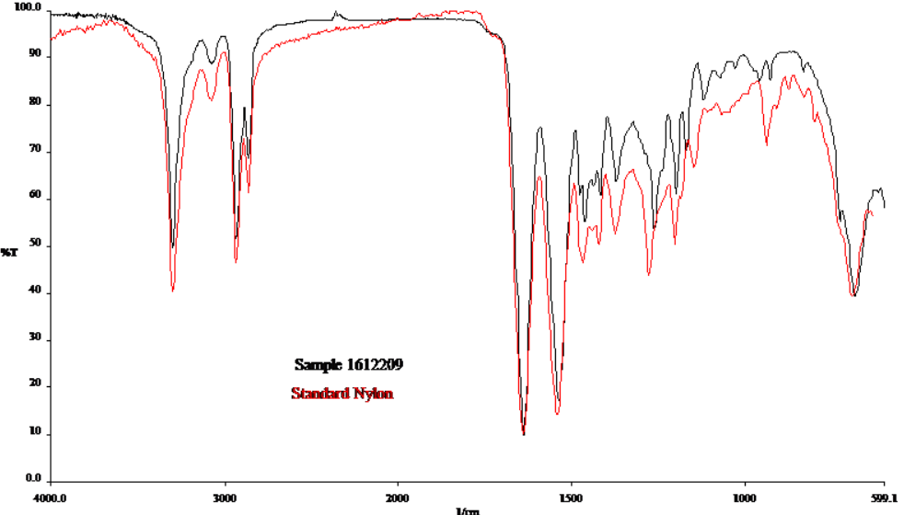

DSC analysis

Under a nitrogen atmosphere, the Perkin Elmer Pyris Diamondthe DSC analysis. To remove any prior thermal history, a 9 mg sample of PET was first heated at a from 35°C to 300°C. It was then cooled to 25°C at the same pace and heated once more in the same circumstances. The following formula was used to get the degree of crystallinity:

(ΔHm - ΔHc) / ΔH0m × 100 = %crystallinity

The heat of melting for 100% crystalline PET (140 J/g) is shown by ΔH0m in this instance, the heat of crystallization (in J/g) is represented by ΔHc, and the heat of melting (in J/g) derived from the endothermic signal area is represented by ΔHm. The thermal characteristics presented are the means from the of a minimum of two samples.

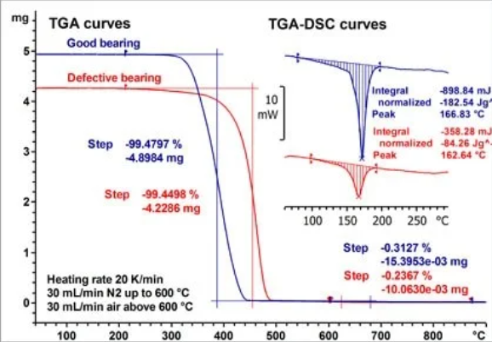

Intrinsic viscosity analysis

PET's intrinsic viscosity was measured using the ASTM D4603 standard. The Billmeyer formula, which uses a single relative viscosity measurement at The Berkowitz equation was then used to translate the obtained intrinsic viscosity values into Within the molecular weight range of 2000–200,000, the accuracy of this equation was verified, and the reported Mn values are the mean of a minimum of two different samples.

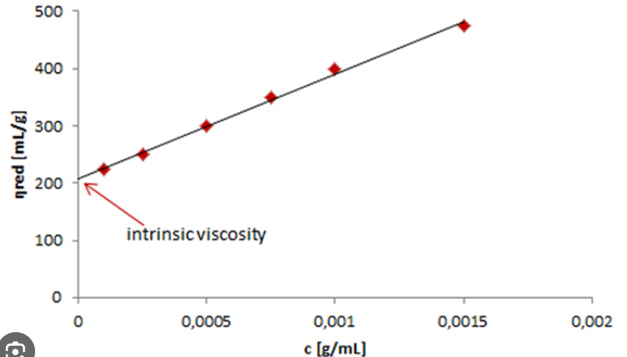

SEM analysis

The JEOL 638LV SEM model was used to closely examine PET particles in order to assess microbial adhesion and biofilm formation. The particles went through a number of processes after the CO2 evolution test, such as gold coating, washing with distilled water, and further inspection. To remove adhered cells, a second batch of particles . After that, SEM examination was performed on these particles to look for any changes in surface morphology.

Reversed- phase HPLC analysis

* The two by-products of PET breakdown, were assessed by HPLC analysis utilizing a Perkin Elmer Series 200 equipment.
* Six distinct occasions (108, 120, 128, 148, 157, and 168 days) saw the collection of liquid samples, which were then centrifuged for five minutes at 7300 rpm.
* After filtering, the supernatant was transferred to a 2 mL HPLC vial.
* A phase-reversed column The mobile phase employed in this experiment was a linear gradient combination of methanol and formic acid made by Supelco Discovery C18.
* At a wavelength of 230 nm, the eluents were found using a photodiode array detector.
* The calibration curves were built using prepared standard.Three copies of the analysis were done, and were reported

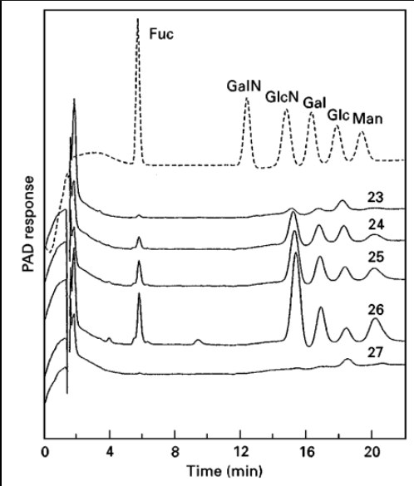

Statistical data analysis

Microsoft Excel was used to construct descriptive statistics, and the results were shown as mean, . Unfortunately, it was not possible to have duplicates for the PCL and blank in the experiment since there were not enough reactors available. Thus, the extended instrumental uncertainty is defined as the error in cumulative for these two reactors.

Microbial analysis

Microbial Cell Preservation and Dilution:

Microbial cells retrieved from the PET MPs were preserved in a solution of saline ,and glycerol at -80°C. Subsequently, they underwent serial dilution , and were plated on Luria Broth (LB) agar. After biodegradation, the MPs were subjected to FTIR analysis in the 4000 cm-1 to 450 cm-1 range to . As a result of changes in functional ,groups and the existence of oxidation byproducts, the spectra showed shifts in some bands, increased intensities in particular bands, and the appearance of new infrared bands. The increase in the crystallinity and carbonyl indices confirmed the microbial participation and PET MP biodegradation.

Isolate Characterization:

Following a 48-hour incubation at 30°C, two distinct bacterial strains (BS3 and BS11) exhibiting unique colony morphology and higher abundance were obtained. These isolates and morphology, adhering to established taxonomy from relevant literature.

Evaluation of Growth Potential:

BS3 and BS11 suspensions, at equivalent physiological stages, were cultured with PET to evaluate their proficiency in utilizing it as a carbon source. Growth kinetics were tracked by measuring . This enabled the assessment of their ability to thrive and proliferate in the presence of PET, showcasing their potential for PET biodegradation. Two different bacterial strains, designated BS3 and BS11, were extracted from activated sludge and thoroughly characterized. The growth curves of both strains showed strong exponential growth when PET was the only carbon source. Interestingly, the clear-zone test revealed that BS3 had unambiguous enzymatic activity towards PET, a characteristic absent from BS11. The organisms were identified as strain PNP3 (BS11) and Bacillus cereus strain SEHD031MH (BS3) by subsequent DNA analysis. These results demonstrate their potential for PET breakdown, which makes them interesting subjects for more research in the search for methods to eradicate microplastics.

Enzymatic Activity Assessment:

The clear-zone test is a pivotal method for assessing isolates' enzymatic activity towards PET (polyethylene terephthalate). It involves cultivating the isolates on a medium containing PET as the exclusive carbon and energy source. If the isolates possess the necessary enzymes for PET degradation, they will release these enzymes, leading to the breakdown of PET into soluble components. This enzymatic action results in a discernible clear zone forming around the microbial colony, indicating successful solubilization of the PET substrate. This test is instrumental in identifying microorganisms with PET biodegradation capabilities, critical for waste management and mitigating plastic pollution.

**RESULTS AND DISCUSSION**

Isolation and Screening of PET-Degrading Bacteria

The goal of the study was to determine whether activated sludge, a microbially rich environment, could break down PET. The parameters of this sludge, which was exposed to microplastics in wastewater, were pH 6.56, 850 mg/L TSS (SD 84), 550 mg/L VSS (SD 69), and 320 mg C/L (SD 40) of TOC. During incubation with PET MPs, the concentration of bacterial biomass increased exponentially, suggesting that both PET and PCL were effective growth media. The exponential model demonstrated promising plastic degrading capabilities by fitting both PET (R2 0.84) and PCL (R2 0.81) well. After biodegradation, the MPs were subjected to FTIR analysis in the 4000 cm-1 to 450 cm-1 range to . As a result of changes in functional ,groups and the existence of oxidation byproducts, the spectra showed shifts in some bands, increased intensities in particular bands, and the appearance of new infrared bands. The increase in the crystallinity and carbonyl indices confirmed the microbial participation and PET MP biodegradation.

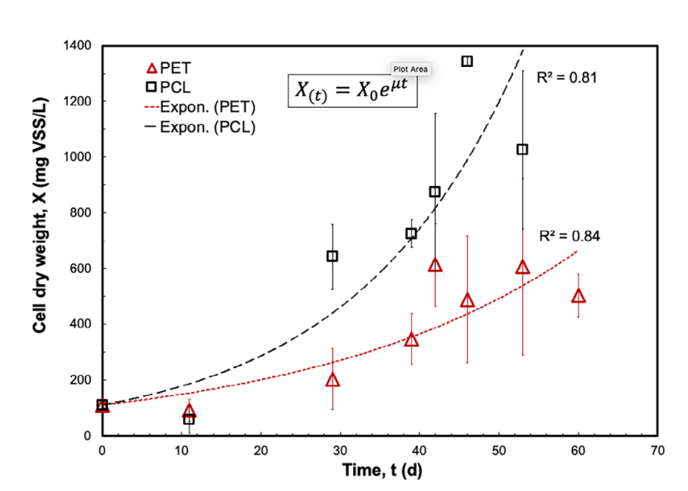

Biodegradation Results

A standard biodegradable polymer was PCL. When exposed to microbial consortia, the data showed a 17% drop in PET mass and a more significant 34% reduction in PCL mass. Due to its aliphatic makeup, PCL degraded more quickly than PET, which was more resistant. Particular growth rates added to the evidence for PET decay. A key factor was the oxygen flow rate, with more oxygen availability resulting in enhanced biodegradation. When compared to normally occurring bacteria, the microbial consortia demonstrated better PET breakdown. According to studies, microbial populations have an impact on PCL biodegradation. Overall, the work demonstrates the potential for PET biodegradation by microbial consortia, which is regulated by oxygen levels, with implications for bioremediation strategies.

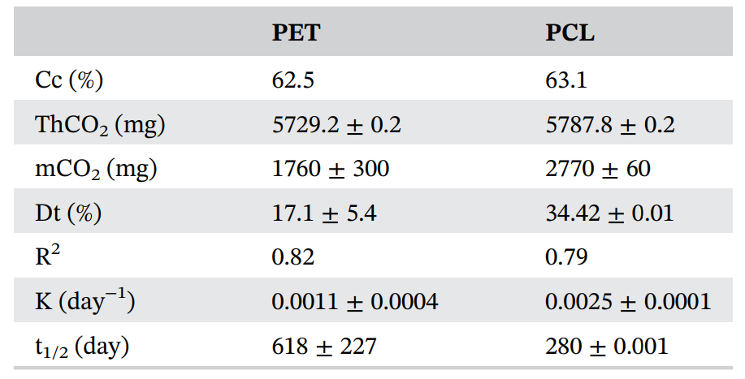

Analytical Results

FTIR Analysis

After biodegradation, the MPs were subjected to FTIR analysis in the 4000 cm-1 to 450 cm-1 range to . As a result of changes in functional ,groups and the existence of oxidation byproducts, the spectra showed shifts in some bands, increased intensities in particular bands, and the appearance of new infrared bands. The increase in the crystallinity and carbonyl indices confirmed the microbial participation and PET MP biodegradation. Two different bacterial strains, designated BS3 and BS11, were extracted from activated sludge and thoroughly characterized. The growth curves of both strains showed strong exponential growth when PET was the only carbon source. Interestingly, the clear-zone test revealed that BS3 had unambiguous enzymatic activity towards PET, a characteristic absent from BS11. The organisms were identified as Agromyces mediolanus strain PNP3 (BS11) and Bacillus cereus strain SEHD031MH (BS3) by subsequent DNA analysis. These results demonstrate their potential for PET breakdown, which makes them interesting subjects for more research in the search for methods to eradicate microplastics.

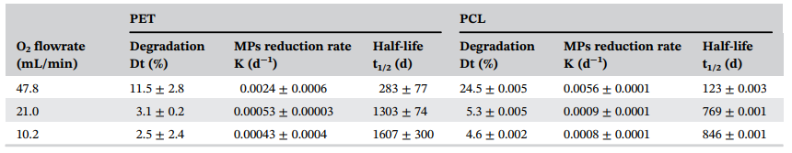

DSC Analysis

DSC analysis was utilized to examine any changes in PET's thermal, properties after biological treatment. When the microbial population was added, PET's melting point did not change from 245°C. However, there was an increase in PET's crystallinity from 25% to 32%. This increase in crystallinity is consistent with what the FTIR study showed. Some researchers suggest that this increased polymer crystallinity after degradation may result from chain scission in the polymer's amorphous areas, which releases shorter chain ,segments that then rearrange and crystallize.

Intrinsic Viscosity Analysis

The number-average, molecular weight (Mn) of PET was evaluated in order to determine whether or not the polymer fragmented into smaller molecules throughout the biodegradation process. The Mn of PET decreased somewhat after being exposed to the microbial consortia, however this difference was not statistically significant. This suggests that, contrary to the bulk erosion commonly seen in hydrolyzable polymers, PET breakdown mostly happened via surface erosion. Similar to the biodegradation of other polymers including PCL, polycarbonates, and PET films, the biodegradation of PET microplastics (MPs) included enzyme activity on the surface of each particle.

SEM Analysis

To evaluate surface alterations and the presence of a biofilm on PET particles, SEM examination was used. This technique is frequently used to measure the extent to which microbes are biodegrading plastic. The SEM images showed that the PET particles were covered in a biofilm and showed signs of partial erosion. Micrographs showed a change in surface characteristics from smooth to rough, with bacterial biofilm present and indentations. These surface modifications and the formation of biofilms show how important the bacterial population is to the breakdown of polymers. Some reports connect biological deterioration to the formation of fractures and indentations on polymer surfaces. Furthermore, the development of a biofilm is thought to be a necessary step in the breakdown of polymers.

Reversed-Phase HPLC Analysis

To investigate the possible existence of BHET and TPA as breakdown byproducts of PET, HPLC analysis was used. Chromatograms were produced using samples that were collected throughout the incubation period at different times. Unfortunately, no appreciable peaks that corresponded to TPA or BHET were found, suggesting that these compounds were not particular breakdown products. It's critical to recognize that this study did not evaluate or identify additional by-products, such as MHET. Previous research has shown that during the enzymatic breakdown of PET film/powder, MHET + TPA emerges.

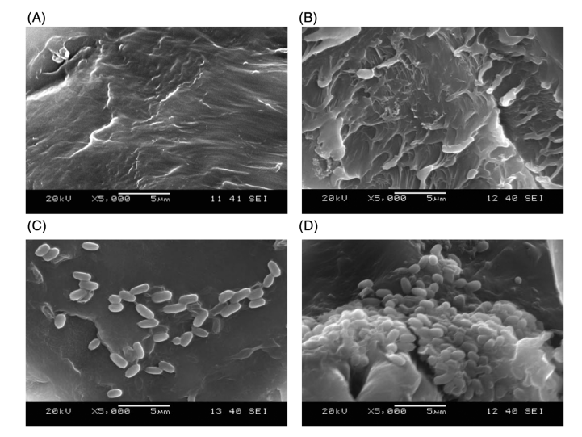

Microbial Analysis

Two different bacterial strains, designated BS3 and BS11, were extracted from activated sludge and thoroughly characterized. The growth curves of both strains showed strong exponential growth when PET was the only carbon source. Interestingly, the clear-zone test revealed that BS3 had unambiguous enzymatic activity towards PET, a characteristic absent from BS11. The organisms were identified as Agromyces mediolanus strain PNP3 (BS11) and Bacillus cereus strain SEHD031MH (BS3) by subsequent DNA analysis. These results demonstrate their potential for PET breakdown, which makes them interesting subjects for more research in the search for methods to eradicate microplastics.

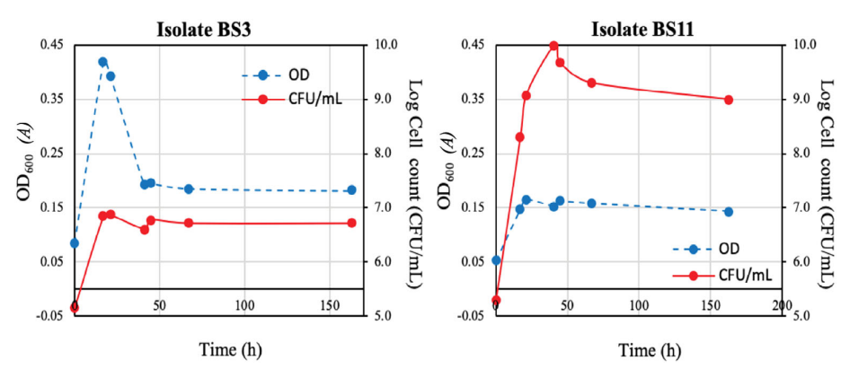

**CONCLUSION**

This study investigated activated sludge's potential as a source of powerful ,biocatalysts for the removal of microplastic (MP) from water. After screening bacterial communities in the activated sludge, it was shown that MPs from PET might be the only carbon and energy source needed for the communities to flourish in a mineral medium. Using batch bioreactors that complied with ISO 14852, the microbial consortium's PET biodegradation ability was evaluated; the degradation of PET MPs was 17%. Analysis using FTIR, SEM, and DSC confirmed how much biodegradation had occurred. Interestingly, there was no statistically significant change in the number-average, molecular weight (Mn) of PET during biodegradation, suggesting a degradation mechanism based on surface erosion. Higher oxygen flow rates were able to increase PET biodegradation rates, suggesting a possible optimization method. A. mediolanus PNP3 and B. cereus SEHD031MH, two distinct bacterial strains, showed the ability to degrade PET, with B. cereus displaying enzymatic activity in a clear-zone test. These results highlight the significant MP biodegradation capacity of activated sludge bacteria, addressing the urgent need for bioremediation techniques to mitigate MP contamination in water. More study and use of B. cereus and A. mediolanus in MP removal through cutting-edge technologies, such as the development of effective large-scale reactors for the treatment of household and commercial wastewater, appear promising.