CHAPTER 1
INTRODUCTION
  - System Study
This powerful software program is specifically designed for theater owners, to sell tickets online. This intuitive visual interface makes day-to-day aspects of selling, exchanging, refunding, and reporting fast and easy for both the user and administrators. Theater management controls all back-end functionalities like, movie details, ticket rate and show time, customer information and sales history saved in a database, etc. Theater admin manages the report details like counter wise report, daily, weekly, monthly report and movie report etc.
1.1.1 Objective of The Project
Cinema-going is one of the most popular out-of-home cultural activities, affecting a serious of social, economic and cultural phenomena in modern societies. Cinemas are considered to be an integral part of cities and they contribute to the definition of a local geography and identity.
They also contribute to the preservation of the collective memory, since they constitute a significant social and cultural practice linked to a specific place, which acts as a common reference or landmark for many individuals. Through this project we present a comprehensive solution for ticket booking in multiplexes. Theater management system, an online ticket selling software that is easy to understand, easy to use and offers the simplicity of fast point-and-click service to the customers.
This powerful software program is specifically designed for theater owners, to sell tickets online. This intuitive visual interface makes day-to-day aspects of selling, exchanging, refunding, and reporting fast and easy for both the user and administrators. Theater management controls all back-end functionalities like, movie details, ticket rate and show time, customer information and sales history saved in a database, etc. Theater admin manages the report details like counter wise report, daily, weekly, monthly report and movie report etc.
1.1.2 Scope Of Project
This project will useful for those users who will watch the movie it will enables the user to book a movie tickets just by some clicks by avoiding the hectic jobs
  - System Analysis
Feasibility study
Feasibility study is done so that an ill-conceived system is recognized early in definition phase. During system engineering, however, we concentrate our attention on four primary areas of interest. This phase is really important as before starting with the real work of building the system it was very important to find out whether the idea thought is possible or not.

- Economic Feasibility: An evaluation of development cost weighted against the ultimate income or benefit derived from the developed system.

- Technical Feasibility: A study of function, performance and constraints that may affect the ability to achieve an acceptable system.

- Operational Feasibility: A study about the operational aspects of the system.

Economic analysis
Among the most important information contained in feasibility study is Cost Benefit Analysis and assessment of the economic justification for a computer based system project. Cost Benefit Analysis delineates costs for the project development and weighs them against tangible and intangible benefits of a system. Cost Benefits Analysis is complicated by the criteria that vary with the characteristics of the system to be developed, the relative size of the project and the expected return on investment desired as part of company’s strategic plan. In addition, many benefits derived from a computer-based system are intangible (e.g. better design quality through iterative optimization, increased customer satisfaction through programmable control etc.)As this is an in-house project for the company, to be used for its own convenience and also it is not that big a project. So neither it requires a huge amount of money nor any costly tools or infrastructure need to be set up for it.
Technical Analysis
During technical analysis, the technical merits of the system are studied and at the same time collecting additional information about performance, reliability, maintainability and predictability.
Technical analysis begins with an assessment of the technical viability of the proposed system.
- What technologies are required to accomplished system function and performance?
- What new materials, methods, algorithms or processes are required and what is their development risk?
- How will these obtained from technical analysis form the basis for another go/no-go decision on the test system? If the technical risk is severe, if models indicate that the desired function cannot be achieved, if the pieces just won’t fit together smoothly-it’s back to the drawing board.

As the software is very much economically feasible, then it is really important for it to be technically sound. The software will build among:
- MS SQL SERVER as Back End
- ASP.NET as Front End
Operational feasibility
The project is operationally feasible. This project is being made for the convenience of the patients and doctors only. This system will greatly reduce a huge burden of doctors. So because of the above stated advantages the users of the system will not be reluctant at all.
SYSTEM ANALYSIS
Introduction:
System analysis is the process of studying the business processors and procedures, generally referred to as business systems, to see how they can operate and whether improvement is needed.
This may involve examining data movement and storage, machines and technology used in the system, programs that control the machines, people providing inputs, doing the processing and receiving the outputs.
Investigation phase
The investigation phase is also known as the fact-finding stage or the analysis of the current system. This is a detailed study conducted with the purpose of wanting to fully understand the existing system and to identify the basic information requirements. Various techniques may be used in fact-finding and all fact obtained must be recorded.
A thorough investigation was done in every effected aspect when determining whether the purposed system is feasible enough to be implemented.
Investigation
As it was essential for us to find out more about the present system, we used the following methods to gather the information: -

1. Observation: - Necessary to see the way the system works first hand.

2 Document sampling: - These are all the documents that are used in the system. They are necessary to check all the data that enters and leaves the system.

3 Questionnaires: - These were conducted to get views of the other employees who are currently employed in the system.
Analysis of the investigation
Strengths of the System
1. No complex equipment: -
The equipment that is used is very simple and no special skills have to be mastered to be able to operate the system. Therefore no training is required for the employees.
2. Low cost: -
There is little money spent in maintaining the present system other than buying the necessary office equipment and the ledgers.
Constraints and limitations
The constraints and limitation within a system are the drawbacks that occur during the implementation of the system. These limitations and constraints can crop up in almost every system; the most important fact is to find a way to overcome these problems.
Software design is the first of three technical activities – design, code generation, and test that are required to build and verify the software. Each activity transforms information in manner that ultimately results in validated computer software.
The design task produces a data design, an architectural design, an interface design and component design.
The design of an information system produces the details that clearly describe how a system will meet the requirements identified during system analysis. The system design process is not a step by step adherence of clear procedures and guidelines. When I started working on system design, I face different types of problems; many of these are due to constraints imposed by the user or limitations of hardware and software available. Some times it was quite difficult to enumerate that complexity of the problems and solutions thereof since the variety of likely problems is so great and no solutions are exactly similar however the following consideration I kept in mind during design phased.
Design objectives:-
The primary objective of the design is to deliver the requirements as specified in the feasibility report. These are the some of the objectives, which I kept in mind.

- Practicality: The system is quite stable and can be operated by the people with average intelligence.
- Efficiency: I tried to involve accuracy, timeliness and comprehensiveness of the system output.
- Cost: It is desirable to aim for the system with a minimum cost subject to the condition that it must satisfy the entire requirement.
- Flexibility: I have tried that the system should be modifiable depending on the changing needs of the user. Such modifications should entail extensive reconstructing or recreation of software. It should also be portable to different computer systems.
- Security: This is very important aspect which I followed in this designing phase and tried to covers the areas of hardware reliability, fallback procedures, and physical security of data.
Initial study
Introduction:
The first step in the Software Development Life Cycle (SDLC) is the preliminary investigation to determine the feasibility of the system. The purpose of the preliminary investigation is to evaluate project requests. It is not a design study nor does it include the collection of details to describe the business system in all aspect. Rather it is the collection of the information that helps committee members to evaluate the merits of the project request and make an informed judgment about the feasibility of the proposed project.
The preliminary investigation should accomplish the following objectives.

- Clarify and understand the project request.
- Determine the size of the project.
- Assess costs and benefits of alternative approaches.
- Determine the technical and operational feasibility of alternative approaches.
- Report the findings to management; with recommendations outlining the acceptance or rejection of the proposal.
Requirement And Feasibility Analysis
Introduction:
What Is A Feasibility Study?
Prior to stating whether the system we have to develop is feasible or not we believe that we should emphasize on what is implied by the word “Feasibility”. Feasibility is the measure of how beneficial or practical the development of the system will be to the organization. It is a preliminary survey for the systems investigation. It aims to provide information to facilitate a later in-depth investigation.
The report produced at the end of the feasibility study contains suggestions and reasoned arguments to help management decide whether to commit further resources to the proposed project.
Within the scheduled duration we were assigned to study both the positive and negative aspects of the current manual system, in which we have come up with a number of drawbacks that prevent the progress of the clinic if it is continued to function manually.
Having gone through all measures of feasibility we report to the management to figure out if the objectives of the new system are met.
For e.g. - Is the system within the budget allowed for it?
Will the organizations needs, be met by the new proposed system as
Originally envisaged?
If and when the objectives of the system are met and the new system is approved, then the more specific details in the proposal should be considered and approved.
Types Of Feasibility
There are various measures of feasibility that helps to decide whether a particular project is feasible or not. These measures include-
- Operational Feasibility
- Technical Feasibility
- Economical and Financial Feasibility
Each of these types will be explained in detail throughout the project report.

Operational Feasibility
A proposed system is beneficial only if it can be turned into an information system that will meet the operational requirements of an organization. A system often fails if it does not fit within existing operations and if users resist the change.

Important issues a systems developer must look into are:
  - Will the new system be used if implemented in an organization?
  - Are there major barriers to implementation or is proposed system accepted without destructive resistance?

The whole purpose of computerizing the Placement System is to handle the work much more accurately and efficiently with less time consumption. There will be additional work to be completed, because now the students and the companies can update their resumes and profiles online. Their database is maintained separately.
Compared to the semi-computerized system the chances of avoiding errors in a computerized system is much higher because the user need not stress himself unnecessarily resulting in recklessness. Unlike the semi-computerized system there would be backup data for all the information concerning the daily transactions occurred within the organization.
If we are considering the performance and response time for each task, it is very much faster since there is less paper work to be completed. When entering data into the system to relieve the user from additional work and typing incorrect data, the system provides options such as combo boxes, check boxes, option buttons and etc. if the users type in incorrect data they would be informed immediately about the error by the error detection control.
Another important fact to be regarded is the security control, which is handled by the system. Since data regarding each student and the company is confidential, security is a key issue. Information falling into the wrong hands could jeopardize the entire organization. Unlike in semi-computerized systems the proposed system offers adequate control to protect the organization against fraud and embezzlement and guarantees the accuracy and security of data and information. This is handled by the system providing each department and individuals with separate login names and passwords.
The new system is more user-friendly, which enables the end-user to complete his/her work efficiently and accurately with interest. After taking the above fact into consideration we can state the operating of the proposed system within the organization is feasible.

In this phase of the feasibility study the following two main topics
- Technical Performance Aspect
- Acceptance within the organization

Technical performance aspect is explained in the technical feasibility report and there is no new information is needed in this to explain it again, but as for the acceptance within the organization the following points are important and those are explained according to the topics
- Whether the system provides right information to the right place.

In the current system which is the semi computerized system the information may be lost in the process of sending from one place to another. This is mainly due to human interaction in the process of the transferring information from one place to another.
- Whether the new system affect the current users in the system The new proposed system will affect the users in the following areas
  - Accuracy
  - Efficiency
  - Productivity
  - Robustness
  - Lesser time consuming
System Security
System security is a vital aspect when it comes to developing a system. The system should ensure the facility of preventing unauthorized personnel from accessing the information and the data within the system. The system should provide total protection for each user’s information so that the integrity of data is sustained and also prevent hackers from hacking the system.
The proposed system ensures the security and the integrity of data. This is done by providing a password login system for each authorized users. And for example the System Administrator has access to all kinds of information. By providing this facility information is properly managed and information is protected. For example the system administrator’s day to day tasks are lessened and easier because he doesn’t have to have a constant eye on the system and worry about hackers hacking the system.
Economical And Financial Feasibility
In making recommendations a study of the economics of the proposed system should be made. The proposed system must be justifiable in terms of cost and benefit, to ensure that the investment in a new/changed system provide a reasonable return.
Cost-benefit analysis of information is complicated by the fact that many of the systems cost elements are poorly defined and that benefit can often be highly qualitative and subjective in nature.
In our proposed system various costs are evaluated. Even though finding out the costs of the proposed project is difficult we and assume and estimate the costs and benefits as follows.
According to the computerized system we propose, the costs can be broken down to two categories.
- Costs associated with the development of the system.
- Costs associated with operating the system.
Software Requirement Specification
The software requirement specification is produced at the culmination of the analysis task. The function and performance allocated to software as part of system engineering are refined by establishing a complete information description, a detailed functional description, a representation of system behavior, an indication of performance requirement and design constraints appropriate validation criteria, and other information pertinent to requirement.
The introduction to software requirements specification states the goals and objectives of the software, describing it in the context of the computer based system.
The Information Description provides a detailed description of the problem that the software must solve. Information content, flow and structure are documented.
A description of each function required to solve the problem is presented in the Functional Description.
Validation Criteria is probably the most important and ironically the most often neglected section of the software requirement specification.
Software requirement specification can be used for different purpose. Here are the major uses.
    - Existing System
- Manual
- Time consuming
- Dependent on employee
- Insecurity
1.2.2 Proposed System
- Computerized
- Time saving
- Independent of employee
- Security

1.1.3 Hardware and Software Specification
Server side:
- 250 GB of Hard Disk
- Intel core i3 processor
- 1 GB RAM or above
Client side:
- Pentium 4 processor or above
- 1 GB RAM or above
Database:
Microsoft SQL server 2008
Tools used:
Microsoft visual studio 2010
Microsoft SQL server 2008

Technologies used:
ASP.NET (C#) : Microsoft visual studio 2010
Microsoft SQL server 2008

CHAPTER 2
DOCUMENT ANALYSIS
  - Data Flow Diagram
0-Level DFD

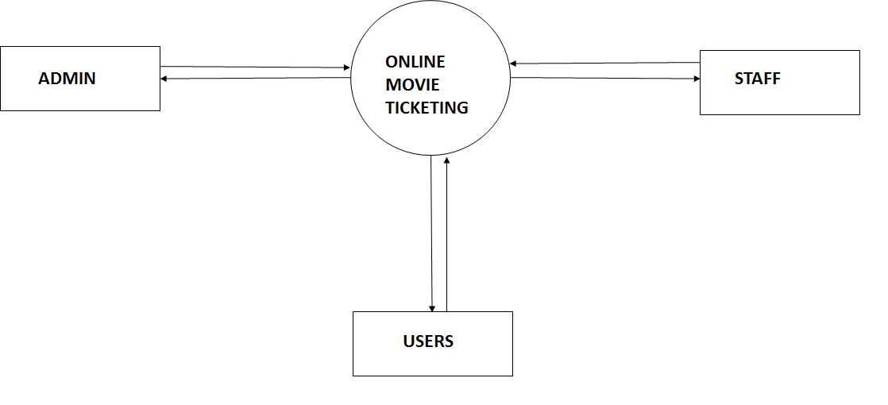
DFD Level 0

1-Level DFD
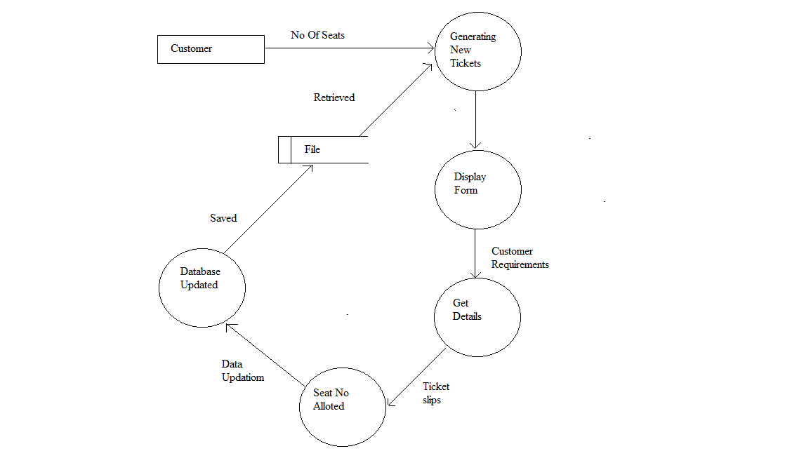
DFD Level 1

2-Level DFD
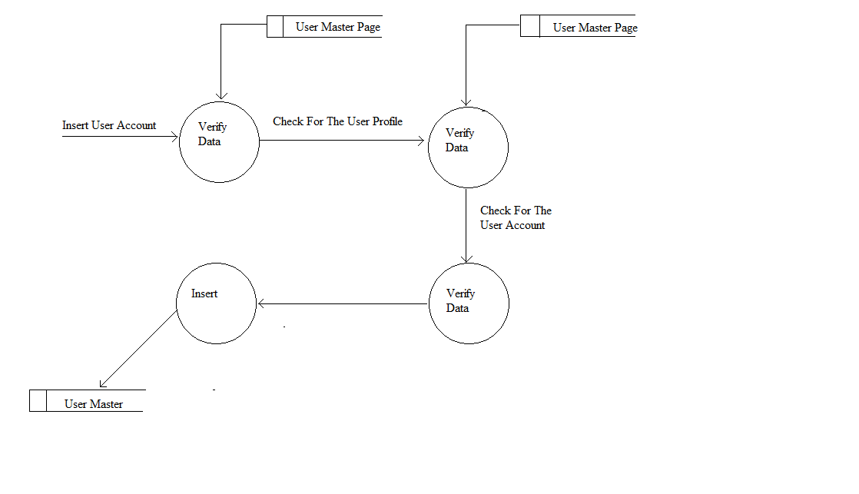
DFD Level 2

  - .1 Entity Relationship Diagram

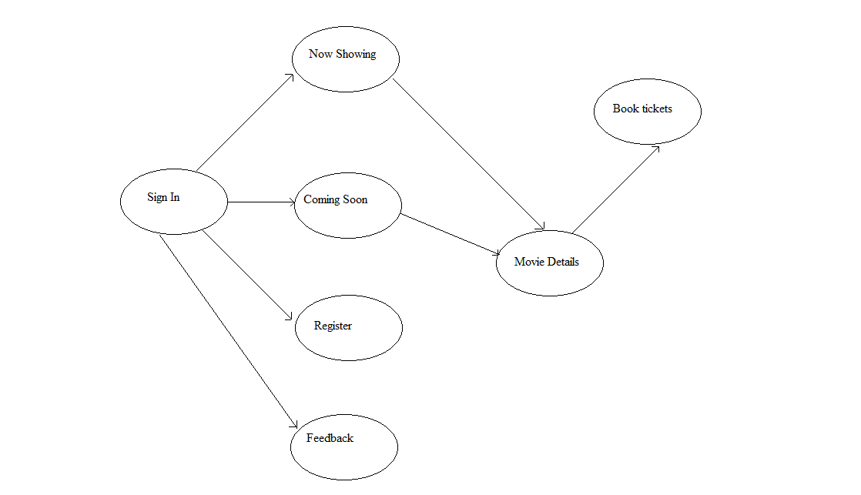
ER-Diagram

2.2.2Entity Relationship Diagram

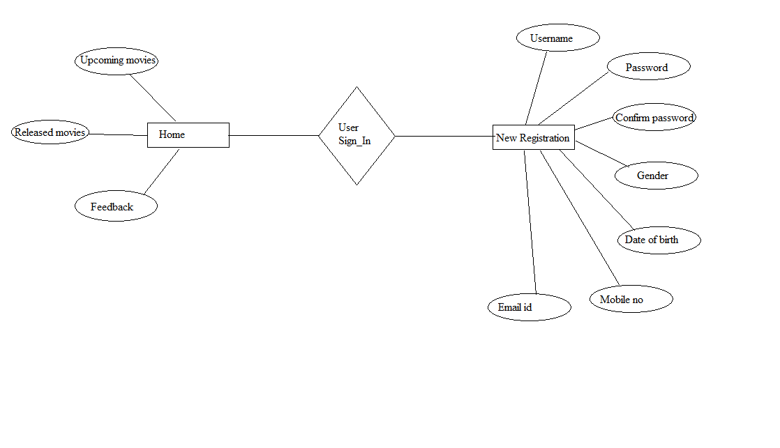

ER- Diagram

  - Use Case Diagram
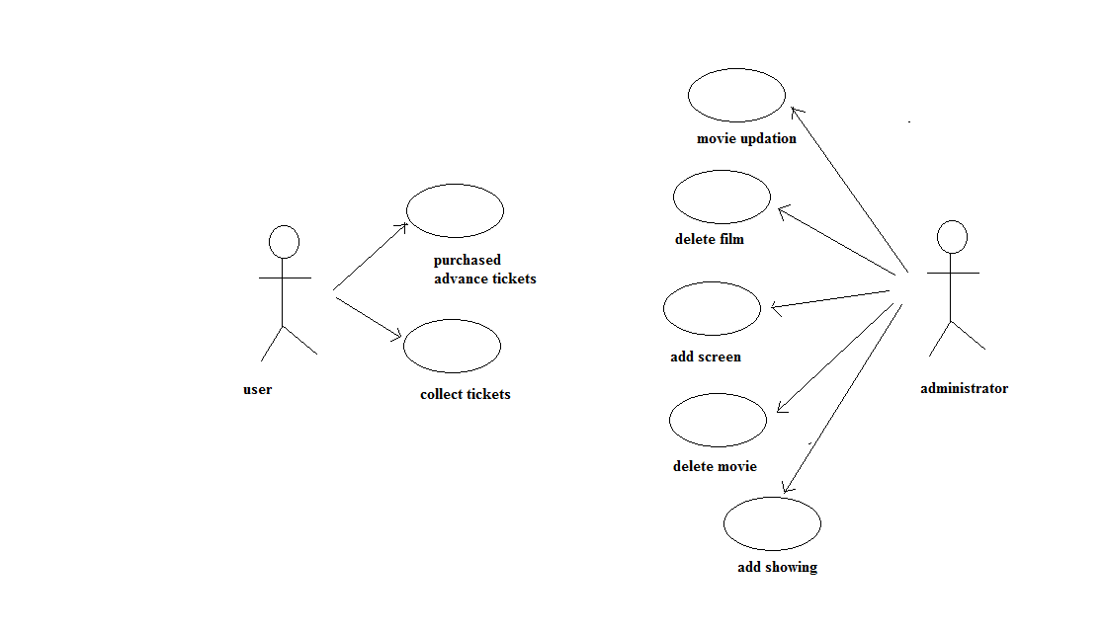
Use Case Diagram

  - Database Table
1 User Login
COLLUMN NAME | DATATYPE | CONSTRAINTS
ID | INT | PRIMARY KEY
USERNAME | VARCHAR (50) | NOT NULL
PASSWORD | NCHAR (10) | NOT NULL

2 User Registration
COLLUMN NAME | DATATYPE | CONSTRAINTS
ID | INT | PRIMARY KEY
USERNAME | VARCHAR (50) | NOT NULL
EMAILID | VARCHAR (50) | NOT NULL
PASSWORD | NVARCHAR (50) | NOT NULL
GENDER | VARCHAR (50) | NOT NULL
DATE_OF_BIRTH | DATE | NOT NULL
MOBILE_NO | NUMERIC (18,0) | NOT NULL

3. Booking
COLLUMN NAME | DATATYPE | CONSTRAINTS
ID | INT | PRIMARY KEY
MOVIE_NAME | VARCHAR (50) | NOT NULL
CITY | VARCHAR (50) | NOT NULL
THEATER_NAME | VARCHAR (50) | NOT NULL
DATE | VARCHAR (50) | NOT NULL
TIME | VARCHAR (50) | NOT NULL
NO_OF_SEATS | VARCHAR (50) | NOT NULL
NET_PAYABLE | VARCHAR (50) | NOT NULL

4.Payment
COLLUMN NAME | DATATYPE | CONSTRAINTS
ID | INT | PRIMARY KEY
USERNAME | VARCHAR (50) | NOT NULL
EMAIL_ID | VARCHAR (50) | NOT NULL
NAME_ON_CREDIT_  DEBIT_CARD | VARCHAR (50) | NOT NULL
NO_ON_CREDIT_  DEBIT _CARD | BIGINT | NOT NULL
CVV | NUMERIC (18,0) | NOT NULL
EXPIRATION_DATE | DATE | NOT NULL
MOBILE_NO | NUMERIC (18,0) | NOT NULL
STATE | VARCHAR (50) | NOT NULL
CITY | VARCHAR (50) | NOT NULL
ZIP | NUMERIC (18,0) | NOT NULL

5. Feedback
COLLUMN NAME | DATATYPE | CONSTRAINTS
ID | INT | PRIMARY KEY
USERNAME | VARCHAR (50) | NOT NULL
EMAIL_ID | VARCHAR (50) | NOT NULL
MOBILE_NO | NUMERIC (18,0) | NOT NULL
SUBJECT | VARCHAR (MAX) | NOT NULL
COMMENT | VARCHAR (MAX) | NOT NULL

6. Admin login
COLLUMN NAME | DATATYPE | CONSTRAINTS
ID | INT | PRIMARY KEY
USERNAME | VARCHAR (50) | NOT NULL
PASSWORD | NCHAR (10) | NOT NULL

7. Admin registration
COLLUMN NAME | DATATYPE | CONSTRAINTS
ID | INT | PRIMARY KEY
ADMINNAME | VARCHAR (50) | NOT NULL
EMAILID | VARCHAR (50) | NOT NULL
PASSWORD | NVARCHAR (50) | NOT NULL
CONFIRM_PASSWORD | NVARCHAR (50) | NOT NULL
GENDER | VARCHAR (50) | NOT NULL
MOBILE_NO | VARCHAR (50) | NOT NULL
DATE_OF_BIRTH | VARCHAR (50) | NOT NULL

7. Movie update
COLLUMN NAME | DATATYPE | CONSTRAINTS
ID | INT | PTIMARY KEY
SELECT_STATE | VARCHAR (50) | NOT NULL
SELECT_CITY | VARCHAR (50) | NOT NULL
THEATER_NAME | VARCHAR (50) | NOT NULL
TIME | VARCHAR (50) | NOT NULL
SCREEN_NO | VARCHAR (50) | NOT NULL

CHAPTER 3
DOCUMENT DESIGN
3.1 Input Form’s
1. User Login
The user login form enables the user to login for the ticket booking process and helps to maintain the security. In this module all fields should be field i.e. Username and Password. The program will compare these values to the value in the database if its match then user can move towards the booking process otherwise he/she should enter the correct values only. If the user has no account then he/she can simply create an account by selecting the USER REGISTRATION from the menu of home page

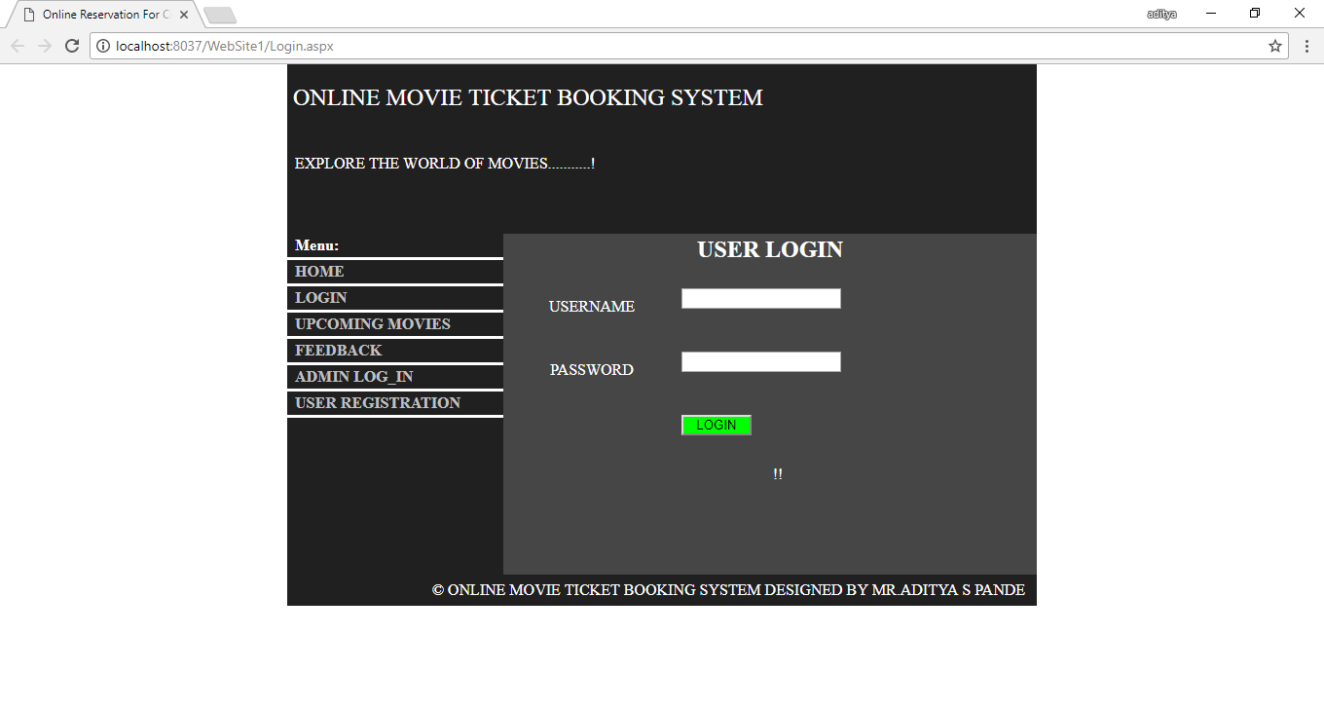

2. User Registration Form
This module enables New User to create an account by providing some details such as Username, Email id, Password, Confirm Password, Gender, Date Of Birth, Mobile no etc. Once the user created the account he/she can proceed to the booking process. In this module all the fields should be filled properly by the user until and unless he can’t create an account.

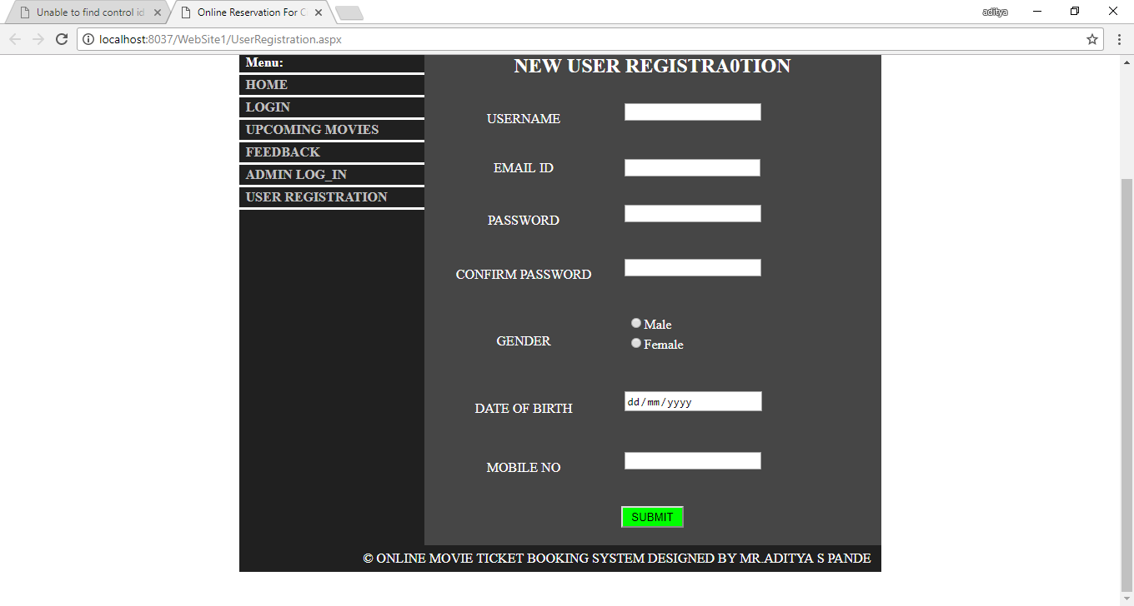

3. Booking Form
Booking form is like heart to this project where user can book tickets as per his needs or choice by specifying some information like Movie Name, Theater Name Show time, City, No of Seats, Date, Time etc. Once the user has enter the No of Seats the total amount that should be pay by user to complete booking process will be displayed in the Net Payable field after that user can proceed to the Payment. All the fields in this module should be filled properly.

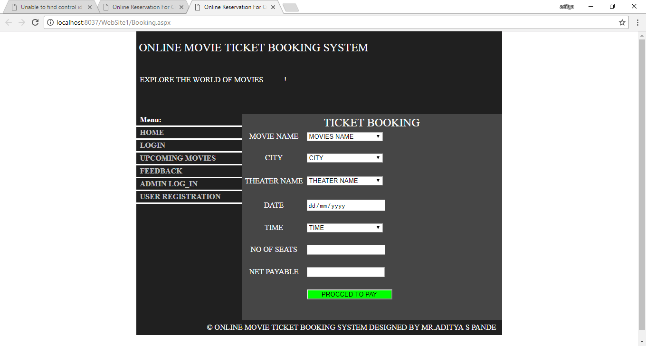

4. Payment Form
The payment module comes after the booking process once the user click on the procced to payment button the payment module comes out where can pay online via credit/debit card. By specifying Name on credit/debit card, No on credit/Debit card, CVV, Username, Email id, Mobile no etc. all the fields of the module should be filled user cant left any field blank once the user has done the specifying information there is an agreement checkbox where user have click for the payment.

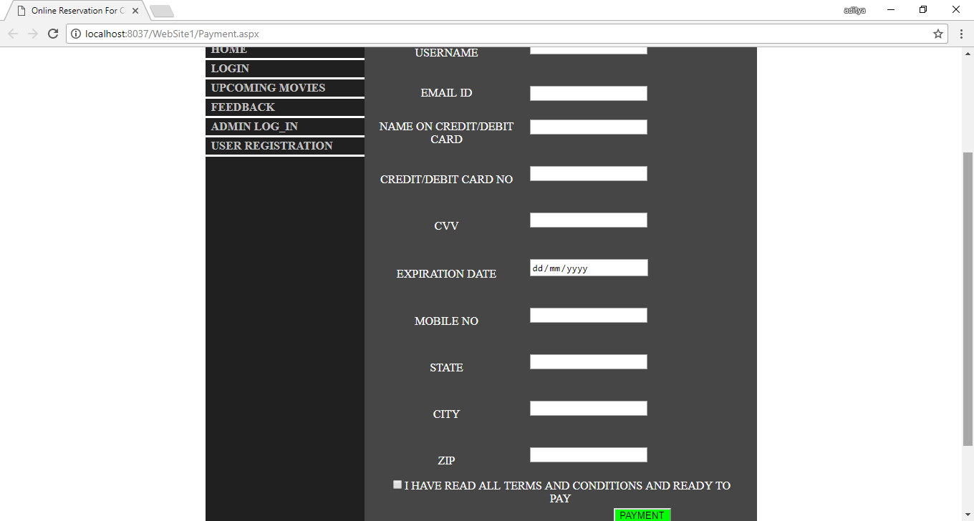

5. Feedback Form
The feedback form in this system is for the system evaluation. Where user’s can give their valuable opinions for the enhance development of the system. The user can submit his feedback by specifying Username, Email id, Mobile no, Subject and Comment. The fields like Username, Email id, Comment have the validations they should not left blank by the user. This module helps the admin to solve the user’s problem and make the system users friendly.

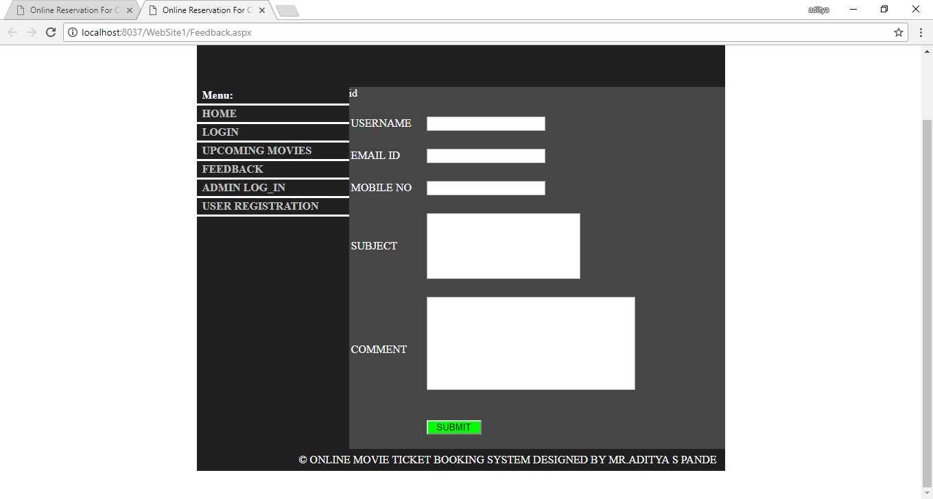

6. Admin Login Form
This form is only for the admin purpose where admin can access his account by specifying his Admin Name and password this fields should not be kept blank by the admin

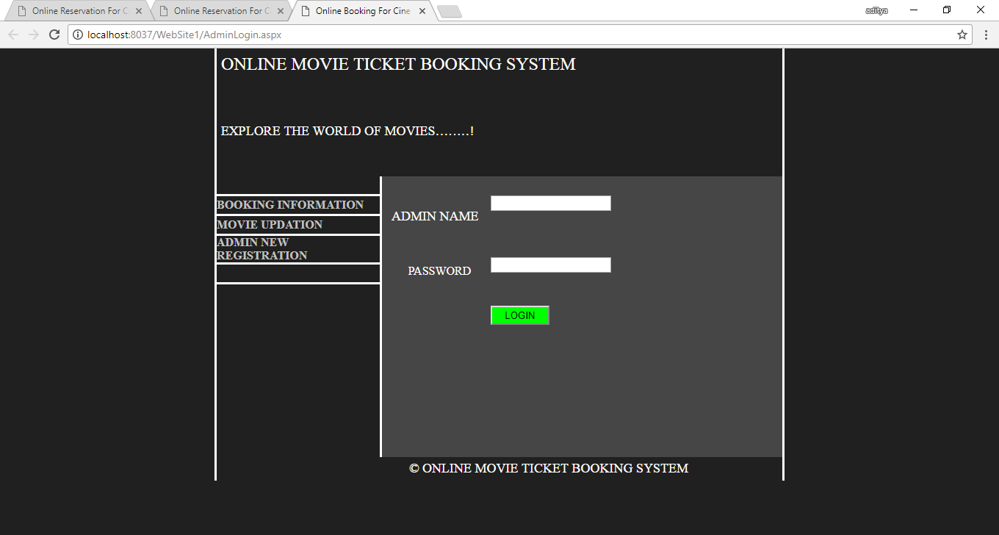

7. Admin Registration Form
This module enable new admin to create his account by Specifying Admin name, Email id, Password, Date of Birth, Mobile no etc. but this requires the permission of the developer to create an account

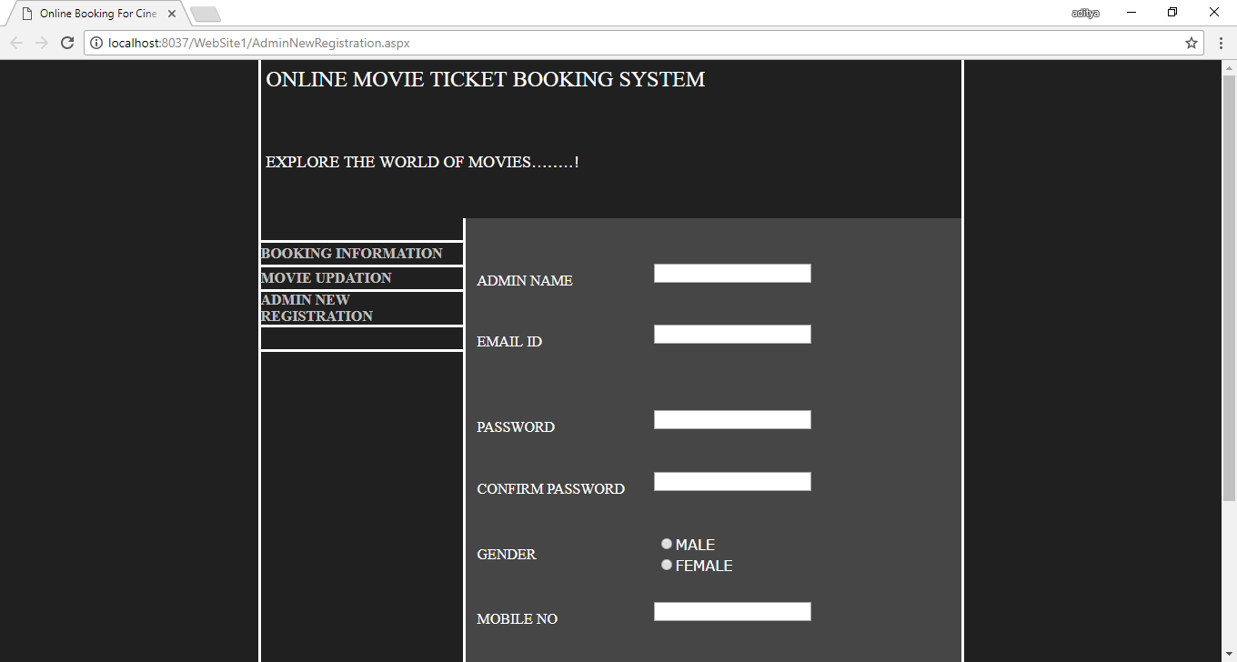

8. Movie Update
This page is for the movie update purpose where admin can add the new movie information. By specifying Movie name, City, Show time, Theater name.

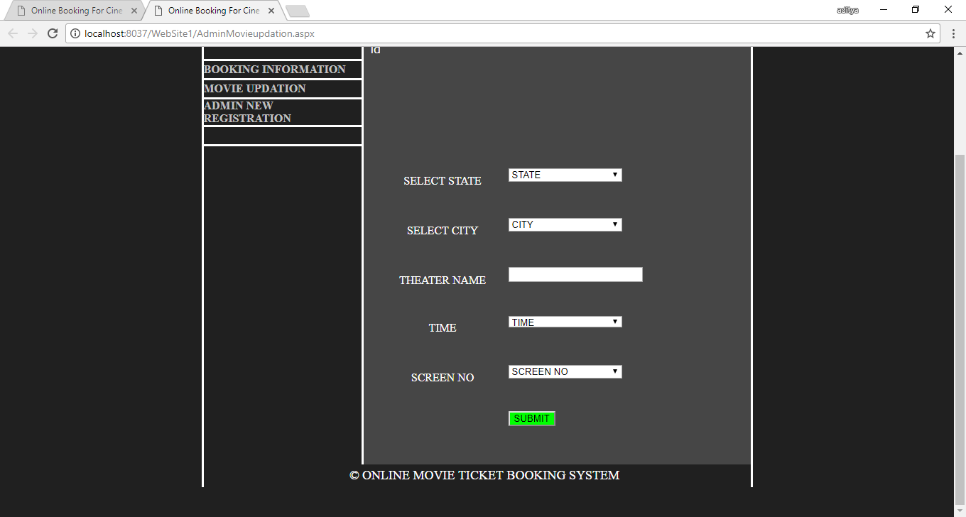

3.2 Output Form’s
1. Home Page
This page is the first page of the system where user can see the Released movies posters and Menu list. Menu list contains User Login, Upcoming Movies, User Registration, Feedback and the Admin Login.

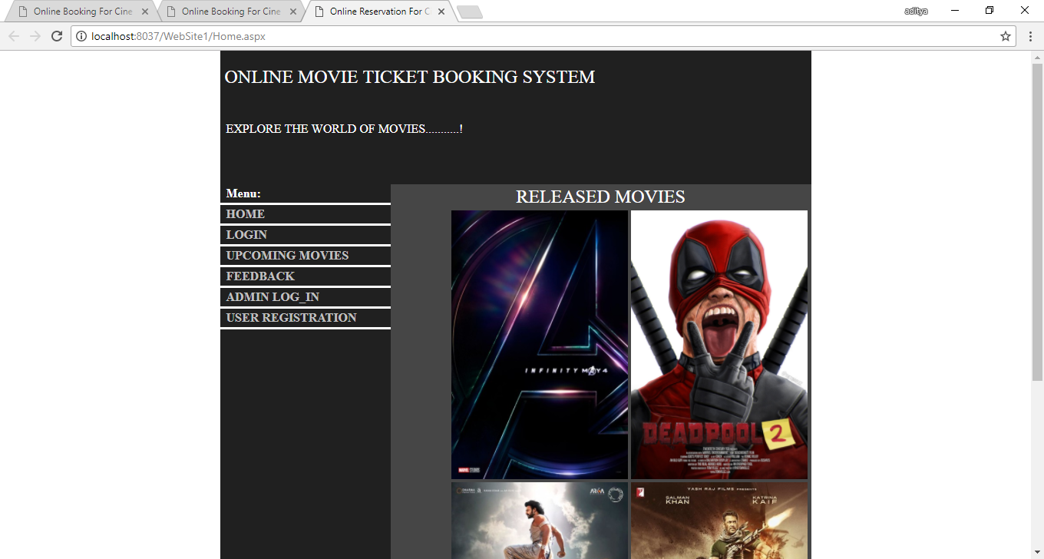

2. Upcoming Movies Page
This page displays the upcoming Movies Poster which will released in the future.

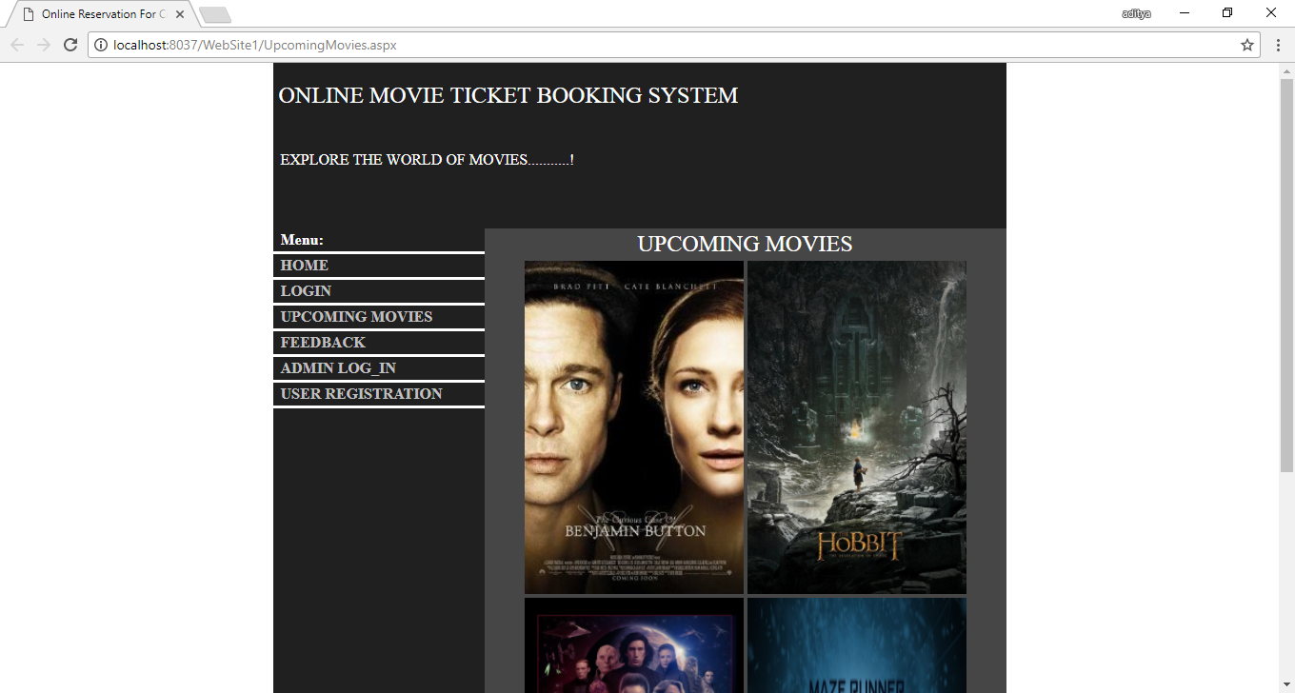

3. After Feedback Form
This form will Be displayed when the User Submits his feedback this is the short note about the submitted feedback

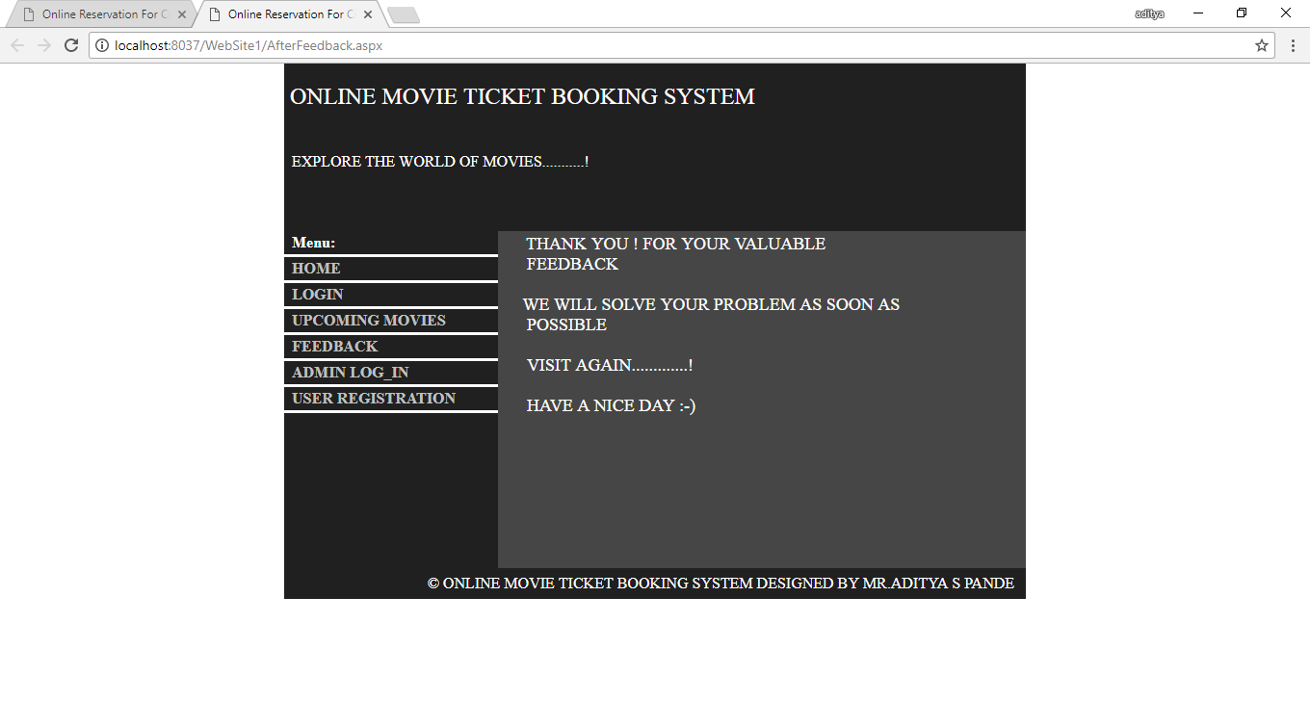

3.3 Report Forms
1. After Payment Form
This is the only printable form in the system contains the booking information about the ticket user has been booked such as the Movie Name, Time , Date etc.

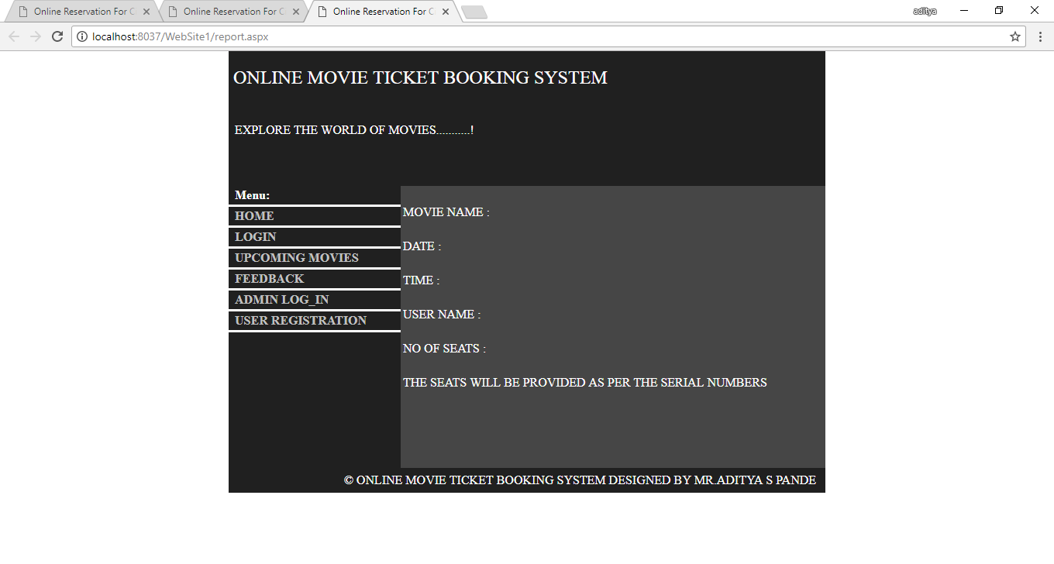

CHAPTER 4
TESTING AND IMPLEMENTATION
System testing is the stage of implementation. This is to check whether the system works accurately and efficiently before live operation commences. Testing is vital to the success of the system is subject to a variety of tests: online response, volume, stress, recovery, security and usability tests. A series of tests are performed for the proposed system is ready for user acceptance testing.

The Testing Steps are:
UNIT TESTING
- It is a method of testing that verifies the individual units of source code.
- A unit is the smallest testable part of an application.
- This is also known as “module testing”.

Implementation in our project
- After writing code of each module like design of all forms and apply validations, we separately checked whether the result generated is correct or not.
- ex-If input value is numeric and user giving character then proper message will display in message box.

- We have applied these testing on a single form for testing purposes.
- Each module is tested many times till the integration is done.
INTEGRATION TESTING
- ‘Integration Testing’ (sometimes called Integration and Testing, abbreviated I&T) is the phase of software testing in which individual software modules are combined and tested as a group.

Implementation in our project
- This testing has been done in our project to test the combination of two, three forms and consider it’s as a module. such as in payment process -Payment form and Credit Card form are tested to check whether it’s is working in group correctly or not.

- We have taken input modules which have been unit tested and grouped them in large scale tests as defined in an integration test plan to those aggregates, and then the output is obtained as an integrated system, ready for system testing.
SYSTEM TESTING
- System testing of software or hardware is testing conducted on a complete, integrated system to evaluate the system’s compliance with its specified requirements. System testing falls within the scope of black-box testing, and as such, should require no knowledge of the inner design of the code or logic.

Implementation in our project
- A series of testing are done before the system is ready for accepting the final test. Each of the modules like login, payment, shipping have been tested on different compatible systems.
- Effort was done to maximize the number of iterations of all modules testing to remove all the errors.
Black Box Testing:

Black Box testing also called behavioral testing, focuses on the functional requirements of software. This testing approach enables the software engineer to derive the input conditions that will fully exercise all requirements for a program, Black box testing attempts to find the error like:

- Incorrect or missing Function.
- Interface error.
- Error in data structures or external database access.
- Behavior or performance error.
- Initialization and termination error.

In Black Box Testing software is exercise over a full range of inputs and outputs are observed for correctness.

White Box Testing:

White Box Testing is also called Glass Box testing is a test case design control; structure of the procedural design to derive test cases using white box testing method, the software engineer can derive the test cases that guarantee that all independent path within the module have been exercised at least once. Exercise all logic decisions on their true or false sides. Execute all loops at their boundaries and within their operational bounds. Exercise internal data structure to ensure their validity.

Acceptance testing:
In software development, user acceptance testing (UAT) - also called beta testing, application testing, and end user testing - is a phase of software development in which the software is tested in the "real world" by the intended audience. UAT can be done by in-house testing in which volunteers or paid test subjects use the software or, more typically for widely-distributed software, by making the test version available for downloading and free trial over the Web. The experiences of the early users are forwarded back to the developers who make final changes before releasing the software commercially.

Alpha testing:

This is a form of internal acceptance testing performed mainly by in-house software QA and testing teams. Alpha testing is the last testing done by test teams at development site after the acceptance testing and before releasing the software for beta test. Alpha testing can also be done by potential users or customers of the application. But still this is a form of in-house acceptance testing.

Beta testing:
This is a testing stage followed by internal full alpha test cycle. This is the final testing phase where companies release the software for few external user groups outside the company test teams or employees. This initial software version is called as beta version. Most companies gather user feedback in this release.
Schedule 1:
Date:2 Feb 2017
Module: User Registration page
Admin Login Page
User Registration page: This page is used to fill the personal details of user to create a user account.
Validation: In this module all the fields are compulsory but there are some limitations for inputting the values.

These limitations for:
1.username
2.Password
Expected Result: All the Values which we are inputting these values are stored in the database.
Customer Feedback:
1.Apply some limitations for field.
2.Change the display for booking the seats.
3.create record for users.

Schedule 2:
Date:1 March 2017
Module: Admin Login Page
Show Booking Form
Payment Form
Admin Login Page: This page is used to login the admin account. after creating the account the admin can modify all the changes he wants related to the project.
Validation: In this module all fields are compulsory to validate they are as follows.
1. Username
2. Password
Expected Result: All the values which we are inputting these values are stored in the database.
Customer Feedback: In Payment section user should inputted their adhar no.
Payment section must display on users account

Unit Testing:
Test Case ID | Objectives | Test Data | Expected Result | Actual Result | Status of The Test Case
Registration | Users data should be filled up in to data base | Test data with validation and don’t allow blank field | Data should successfully inserted in to data- base | Data Successfully added | Successful
Admin Login | Only Admin are allowed | Check Username And Password for admin | Only Admin Allows for the further pages | If admin is user then allowed if not the denied | Successful
Check Availability | User can check the movie date and other information | After login user can search movie from movie list | It shows the movie details | Result shows successfully | Successful
Book Ticket | User can book ticket by specifying username and password. then selected no. of seats has to be book. | The seats is to be booked | This module book the tickets | Tickets Book Successfully | Successful
Table Unit Testing
CHAPTER 5
FUTURE SCOPE AND LIMITATIONS
5.1 Future Scope
It may help collecting perfect management in details. In a very short time, the collection will be obvious, simple and sensible. It will help a person to know the management of passed year perfectly and vividly. It also helps in current all works relative to College. It will be also reduced the cost of collecting the management & collection procedure will go on smoothly.
The present project has been developed to meet the aspirations indicated in the modern age. An attempt has been made through this project to do all work ease & fast. It provide current add, Update, Move Next ,Move Previous, Move Last, Find & Delete all facilities to accomplish the desired objectives.
5.2 Limitations
Our project has the following limitations:
- In this system the customer will not select seat number. The authorized people in this process will be the employee who works at the theater.
- In this system the customer can book the tickets only for the present day.
- Also, a printing system will not be in this project
- Once the payment is done user cannot cancel the ticket booking.

CHAPTER 6
CONCLUSION
Nowadays, traditional reservation ways of cinema ticketing is dying. It’s new age where technology dominates human life. With the software and technological devices, exceptions are reduced and even terminated. Also, people prefer easy, quick and safe way for every part of his life. This project is designed to meet the requirements of a cinema ticket booking system. It has been developed in PHP and the database has been built in My SQL server keeping in mind the specifications of the system. In our project: with this cinema ticketing system; cinema companies can satisfy comfortable facilities to their customers. The relationship between cinema manager, employee, and customer satisfy a good communication to complete ticketing process. With this platform we developed, we are hoping to reduce time wasting, avoid misunderstandings, provide easy data flow, customer pleasure, and less hard work. We believe that we have accomplished our goals and satisfied with the code we developed.

CHAPTER 7
REFERENCES / BIBLIOGRAPHY
7.1 References
1.ASP.NET (BIBLE)
-MRUDULA PARIHAR.
2. Mastering SQL Server 2000 by
- Gunderloy,Jorden BPB Publications
3. Beginning SQL Server 2000 by
- Thearon Willis wrox publications
4.SOFTWARE ENGINEERING (THEORETICAL APPROACH)
-ROGER S PRESSMEN, T. Mc. GH.
5.C#.NET
-PROFESSIONAL VISUAL BASIC.NET
-WROX PUBLICATIONS.
6. MSDN LIBRARY.NET -WWW.MICROSOFT.COM

7.2 Bibliography
- www.csharpcorner.com
- www.freeprojectz.com
- www.1000projects.com

