ADITYA VASHIST,IKG-PTU

Vinodadi987@gmail.com

Abstract

[Draw your reader in with an engaging abstract. It is typically a short summary of the document.   
When you’re ready to add your content, just click here and start typing.]

Under the guidance of

Guide :

Dr.Sarwan Singh

Nelit Insititute Chandigarh

*[Grab your reader’s attention with a great quote from the document or use this space to emphasize a key point. To place this text box anywhere on the page, just drag it.]*

Project report on CALORIES BURNT Predection System

AIML six week course at NIELIT Ropar

Contents

Chapter 1 : 3

AI Ecosystem 3

1.1. Introduction 3

1.2. benefits of incorporating AI ecosystems 4

Chapter 2: 6

Python Programming 6

2.1 Introduction 6

2.2 Why Python? 6

2.3 Python programming with Colab 7

Chapter 3 : 9

Numpy 9

3.1 Introduction 9

Chapter 4 : 10

EDA with Pandas 10

4.1 Introduction 10

Chapter 5: 11

Machine Learning 11

5.1 Introduction 11

Chapter 6 12

Diabetes Prediction System 12

6.1 About Project 12

6.2 Dataset 12

6.3 Pre-Processing Data 12

6.3.1 Import the packages 12

6.3.2 reading the CSV file 12

6.3.3 cleaning the data - Numpy/Pandas 12

6.3.4 Visualize the clean data - matplotlib... 12

6.3.5 Machine learning 12

6.4 Front End 13

6.4.1 : HTML / CSS/ Javascript 13

6.4.2 Web server Development using Flask 14

6.5 Project walkthrough 14

References / Bibliography 16

List of Figures

Figure 1:AI Ecosystem 3

Figure 2: AI Tools 4

Figure 3 : colab 7

Figure 4: Pie chart (student Result column) 12

List of Program Code

ProgramCode 1 : first machine learning code 6

# Chapter 1 :

# AI Ecosystem

## Introduction

An AI ecosystem is a network of people, organizations, and technologies that work together to advance the field of artificial intelligence (AI). This can include AI researchers and engineers, AI-focused companies, academic institutions, and government agencies. The goal of an AI ecosystem is to create an environment that fosters innovation, collaboration, and the sharing of ideas and resources.

An AI ecosystem typically includes a variety of different components, such as:

* Data: AI algorithms need large amounts of data to learn and make predictions. An AI ecosystem includes organizations that collect and curate data, as well as tools and infrastructure for storing, accessing, and analyzing data.
* 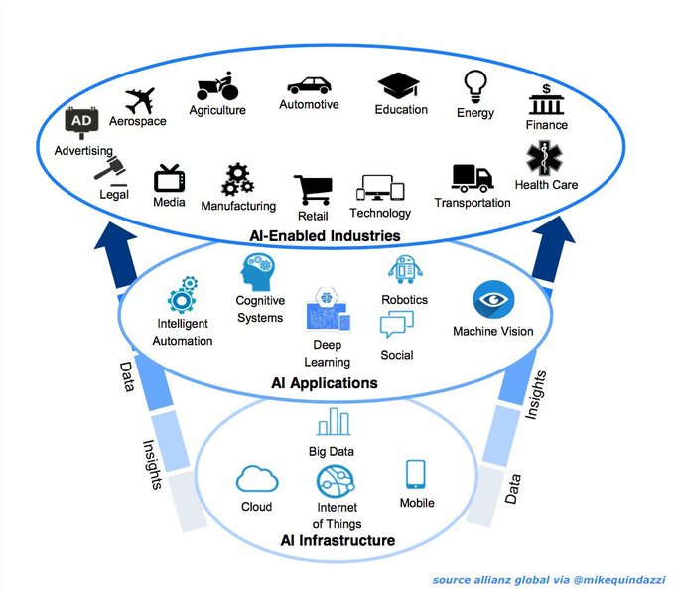Computation: AI algorithms require significant computational power to process data and make predictions. An AI ecosystem includes organizations that develop and provide access to high-performance computing resources, such as cloud-based AI platforms and specialized hardware like graphics processing units (GPUs).

Figure 1:AI Ecosystem

* Algorithms and models: AI algorithms are the building blocks of AI systems, and they are developed by researchers and engineers. An AI ecosystem includes organizations and individuals that develop and share new algorithms and models, as well as tools and frameworks for creating and deploying AI systems.
* Applications: AI algorithms are used to solve a wide range of problems, from image recognition and natural language processing to autonomous vehicles and personalized medicine. An AI ecosystem includes organizations that develop and deploy AI-powered applications in various industries, as well as tools and platforms for creating and deploying AI applications.

Overall, an AI ecosystem is a dynamic and evolving environment that plays a critical role in driving innovation and progress in the field of AI.

## benefits of incorporating AI ecosystems

MSPs can gain many benefits from replacing time-intensive, manual tasks with AI-based solutions. When successfully implemented, AI-enabled solutions enhance cost savings, service delivery, network upkeep and security, customer support, scalability, and orchestration in the following ways:

* **Cost savings:** Automating repetitive tasks frees up resources, allowing for better allocation of manpower, ultimately leading to cost savings.
* 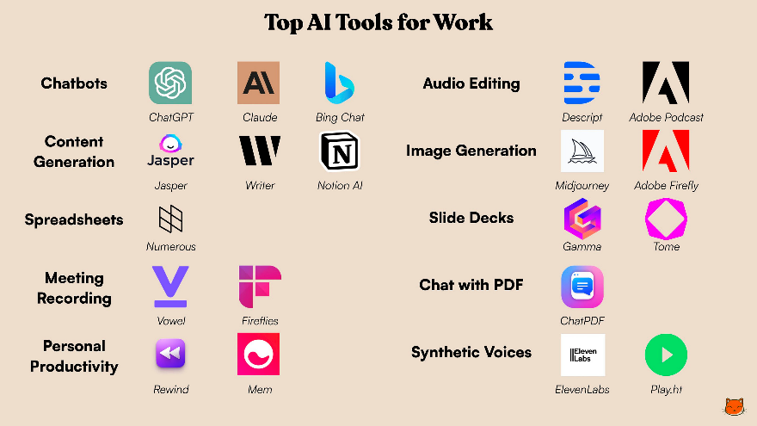**Faster and better service delivery:** Automation of repetitive tasks results in improved response times and overall efficiency, leading to consistent service standards and better customer experiences.

Figure 2: AI Tools

* **Network upkeep and security:** AI-based maintenance and monitoring activities enhance security by detecting and addressing threats promptly, as well as identifying and updating outdated devices.
* **Improved support quality:** Automated processes are less prone to human error, ensuring higher quality support. Any errors can be identified and rectified during the initial testing phases.
* **Enhanced scalability:** AI-based processes can be efficiently scaled to various business areas, leading to faster growth and the ability to maintain service quality even with increased business volume.
* **Orchestration and hyperautomation:** AI-based processes enable sequential task orchestration, streamlining entire processes. The integration of AI, analytics, and robotic process automation (RPA), known as hyperautomation, further enhances efficiency and effectiveness.

Integrating AI into vital business areas introduces transformative changes that benefit MSPs. By harnessing the power of automation, they can not only streamline their workflows and boost efficiency but also unlock greater potential for client satisfaction.

# Chapter 2:

# Python Programming

## Introduction

Python is a popular programming language. It was created by Guido van Rossum, and released in 1991.

It is used for:

* web development (server-side),
* software development,
* mathematics,
* system scripting.

What can Python do?

* Python can be used on a server to create web applications.
* Python can be used alongside software to create workflows.
* Python can connect to database systems. It can also read and modify files.
* Python can be used to handle big data and perform complex mathematics.
* Python can be used for rapid prototyping, or for production-ready software development.

## Why Python?

* Python works on different platforms (Windows, Mac, Linux, Raspberry Pi, etc).
* Python has a simple syntax similar to the English language.
* Python has syntax that allows developers to write programs with fewer lines than some other programming languages.
* Python runs on an interpreter system, meaning that code can be executed as soon as it is written. This means that prototyping can be very quick.
* Python can be treated in a procedural way, an object-oriented way or a functional way.

Good to know

* The most recent major version of Python is Python 3, which we shall be using in this tutorial. However, Python 2, although not being updated with anything other than security updates, is still quite popular.
* In this tutorial Python will be written in a text editor. It is possible to write Python in an Integrated Development Environment, such as Thonny, Pycharm, Netbeans or Eclipse which are particularly useful when managing larger collections of Python files.

Python Syntax compared to other programming languages

* Python was designed for readability, and has some similarities to the English language with influence from mathematics.
* Python uses new lines to complete a command, as opposed to other programming languages which often use semicolons or parentheses.
* Python relies on indentation, using whitespace, to define scope; such as the scope of loops, functions and classes. Other programming languages often use curly-brackets for this purpose.

## Python programming with Colab

Colab, or "Colaboratory", allows you to write and execute Python in your browser, with

* 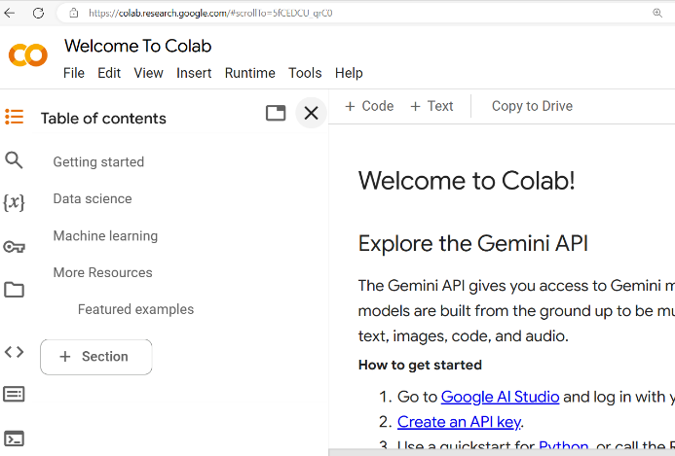Zero configuration required

Figure 3 : colab

* Access to GPUs free of charge
* Easy sharing

Whether you're a **student**, a **data scientist** or an **AI researcher**, Colab can make your work easier.

My first Colab code file

[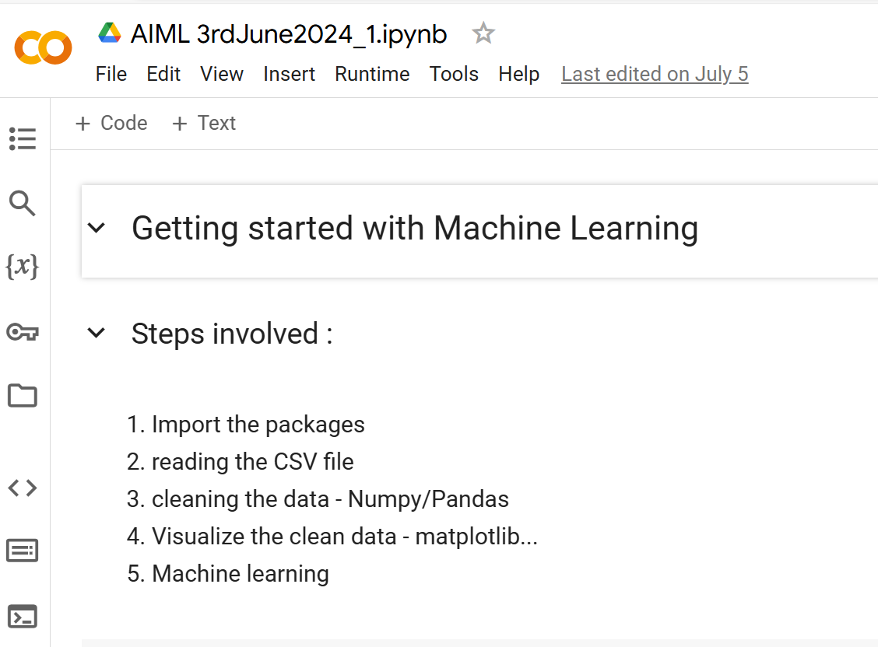](https://colab.research.google.com/drive/1LhKHeu4FCpBER1x6VIf4UFDgHgd3NdNB?usp=sharing)

ProgramCode 1 : first machine learning code

<https://colab.research.google.com/drive/1LhKHeu4FCpBER1x6VIf4UFDgHgd3NdNB?usp=sharing>

# Chapter 3 :

# Numpy

## 3.1 Introduction

# Chapter 4 :

# EDA with Pandas

## 4.1 Introduction

# Chapter 5:

# Machine Learning

## 5.1 Introduction

# Chapter 6

# Diabetes Prediction System

## 6.1 About Project

## 6.2 Dataset

## 6.3 Pre-Processing Data

### 6.3.1 Import the packages

### 6.3.2 reading the CSV file

### 6.3.3 cleaning the data - Numpy/Pandas

### 6.3.4 Visualize the clean data - matplotlib...

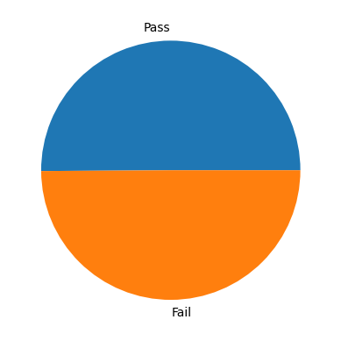

Figure 4: Pie chart (student Result column)

### 6.3.5 Machine learning

## 6.4 Front End

### 6.4.1 : HTML / CSS/ Javascript

[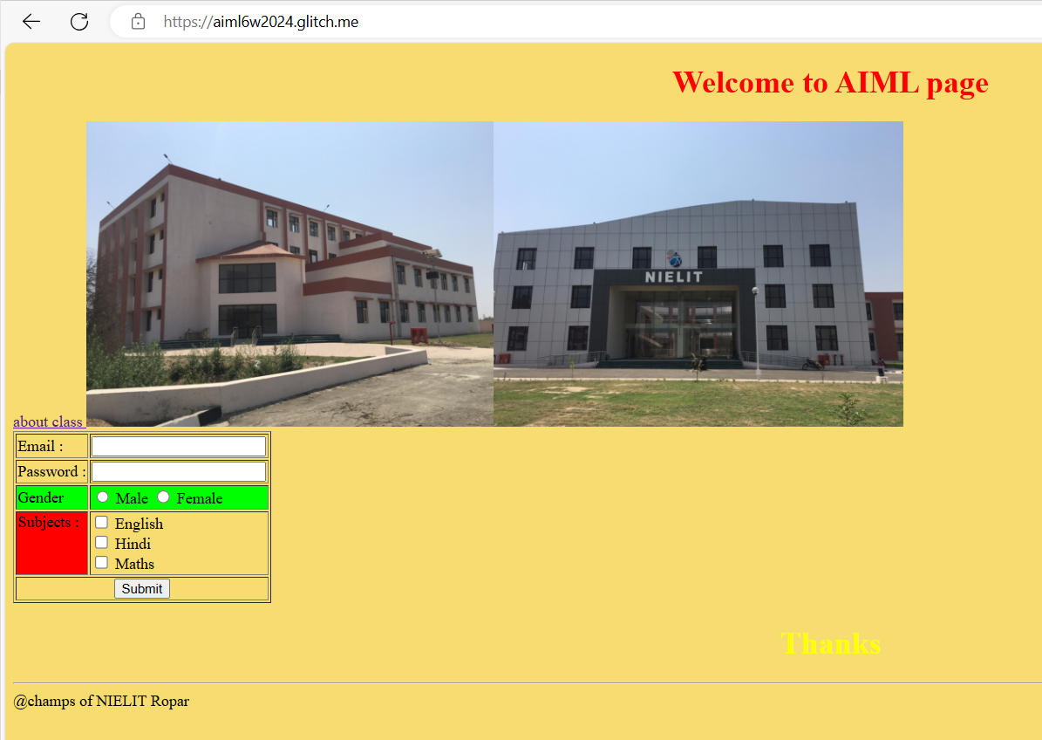](https://aiml6w2024.glitch.me/)

[AIML page (aiml6w2024.glitch.me)](https://aiml6w2024.glitch.me/)

### 6.4.2 Web server Development using Flask

[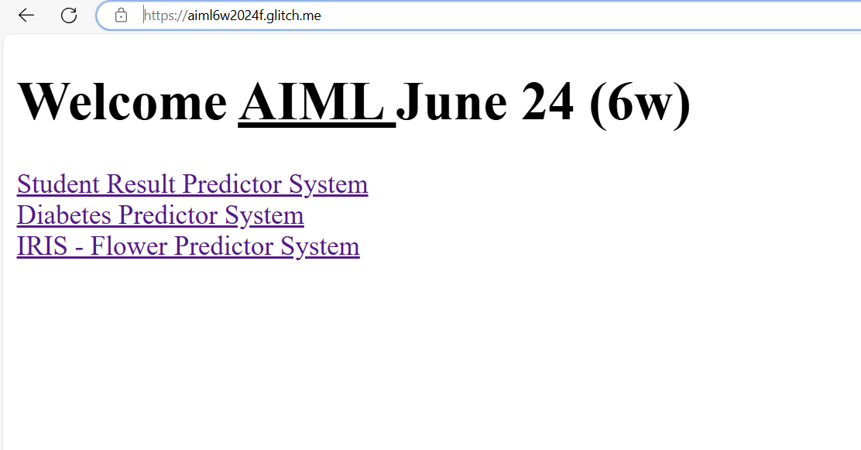](https://aiml6w2024f.glitch.me/)

[AIML (Flask) Predictor Project (aiml6w2024f.glitch.me)](https://aiml6w2024f.glitch.me/)

## 6.5 Project walkthrough

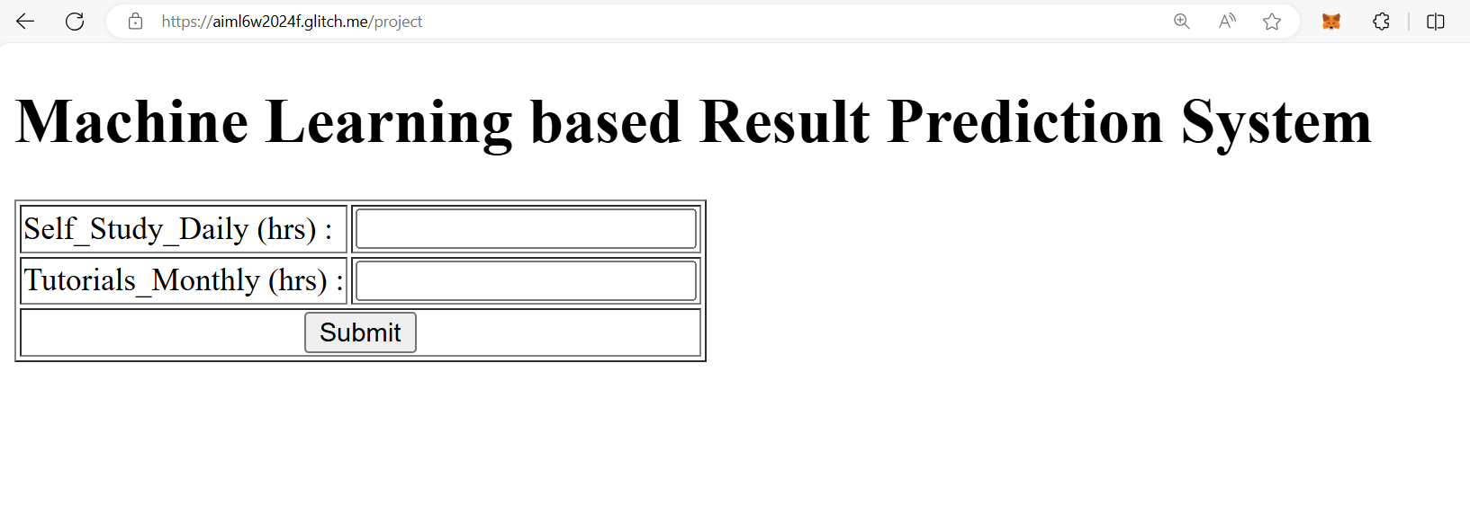

\

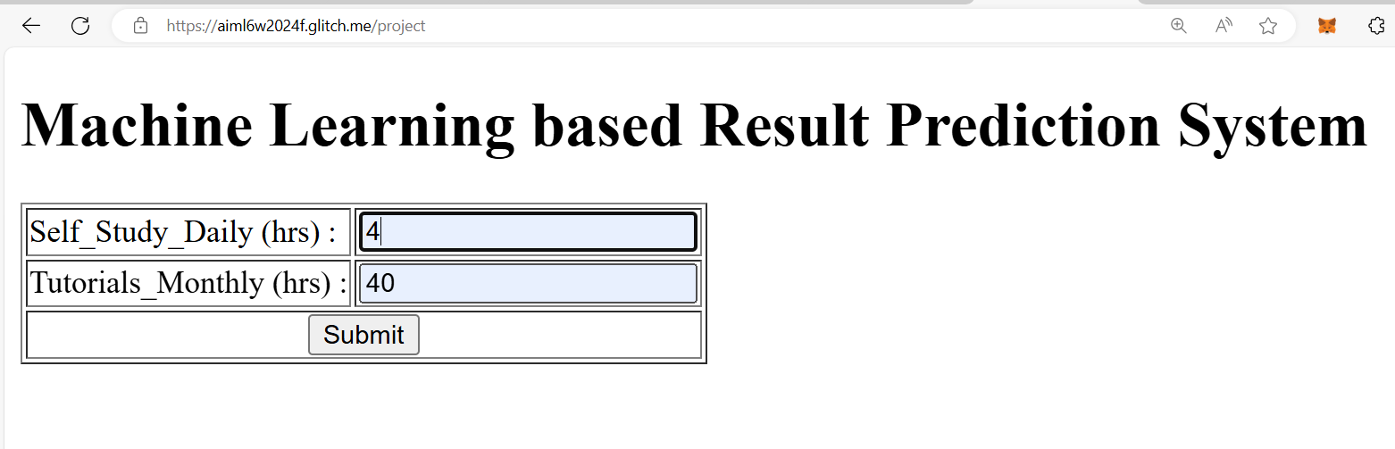with Data

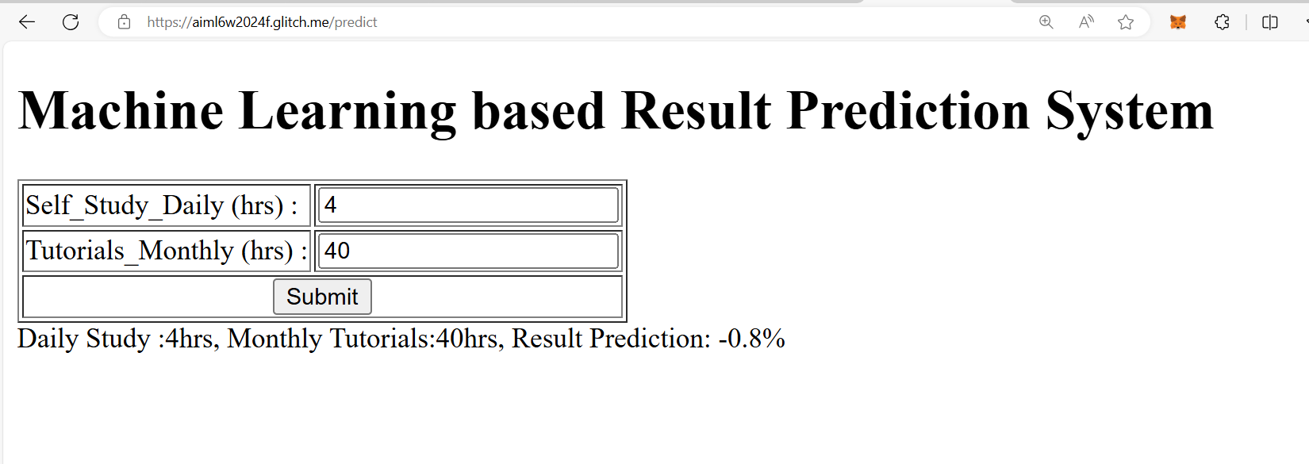Predicted Result

# References / Bibliography

* [W3Schools Online Web Tutorials](https://www.w3schools.com/)
* [Glitch: The friendly community where everyone builds the web](https://glitch.com/)