Table of Contents

1. Introduction
2. Dataset Description
3. Objectives
4. Methodology
5. Data Cleaning & Preprocessing
6. Exploratory Data Analysis & Results
7. Key Insights
8. Conclusion
9. Technologies Used
10. References

1. Introduction
The Indian Premier League (IPL) is one of the most popular Twenty20 cricket leagues in the world, running annually since 2008. Over nearly two decades, the tournament has generated a rich body of match data covering team performance, player contributions, venues, and match outcomes. This project applies data analytics techniques to a structured dataset of IPL matches spanning the 2008 to 2026 seasons in order to uncover patterns and trends in team success, toss strategy, scoring behavior, and player performance.
The analysis was performed using Python's data science stack (pandas, numpy, matplotlib, and seaborn) within a Jupyter Notebook environment, following a standard exploratory data analysis (EDA) workflow: data loading, cleaning, descriptive analysis, visualization, and insight extraction.

2. Dataset Description
The dataset, IPL_Matches_Data_2008_2026.csv, contains one row per IPL match with 31 columns describing match metadata. Key fields include:
- Match identifiers: event_name, season, match_number, date
- Location: city, venue
- Teams & toss: team1, team2, toss_winner, toss_decision
- Scores: team1_runs, team1_wickets, team2_runs, team2_wickets
- Result: winner, result_type, win_by_runs, win_by_wickets
- Officials: player_of_match, match_referee, umpire1, umpire2, tv_umpire, reserve_umpire
- Format: match_type, overs_limit, balls_per_over, gender, team_type
- Squads: team1_players, team2_players (comma-separated playing XI)
The dataset spans 19 seasons and contains the following overall statistics:

Total Matches Analyzed | 1243
Seasons Covered | 19 (2008–2026)
Unique Teams (franchise-normalized) | 15
Unique Venues | 60
Unique Host Cities | 38
Tied Matches | 16
No-Result Matches | 9

3. Objectives
- Understand how match volume has evolved across IPL seasons.
- Identify the most successful teams by total wins and win percentage.
- Analyze toss decision trends and their relationship with match outcomes.
- Study the distribution of team innings totals across the tournament's history.
- Identify the most frequently used venues and most awarded players.
- Examine typical winning margins to assess competitiveness.

4. Methodology
The project follows a standard EDA pipeline:
- Data Loading: Import the CSV file into a pandas DataFrame.
- Data Cleaning: Normalize renamed franchises, parse dates, and inspect missing values.
- Descriptive Analysis: Compute aggregate statistics (counts, percentages, distributions) using pandas groupby and value_counts operations.
- Visualization: Generate bar charts, pie charts, and histograms using matplotlib and seaborn to visually communicate trends.
- Insight Extraction: Interpret the resulting charts and statistics to draw conclusions about team performance and match dynamics.

5. Data Cleaning & Preprocessing
Two data quality issues were addressed before analysis:
- Franchise renames: Several teams changed names while remaining the same franchise (e.g., Delhi Daredevils → Delhi Capitals, Kings XI Punjab → Punjab Kings, Royal Challengers Bangalore → Royal Challengers Bengaluru, Rising Pune Supergiant → Rising Pune Supergiants). These were mapped to a single canonical name so that win totals are not artificially split.
- Date parsing: The date column, stored as dd-mm-yyyy text, was converted into pandas datetime objects for potential time-series analysis.
- Missing values: The winner column is null for the 16 tied matches and 9 no-result matches — this is expected and reflects genuine match outcomes rather than a data quality defect, so these rows were retained rather than dropped or imputed.

6. Exploratory Data Analysis & Results

6.1 Matches per Season
The number of matches played each season has grown as the league expanded from 8 to 10 franchises, with a visible dip during the COVID-affected 2020/21 season.
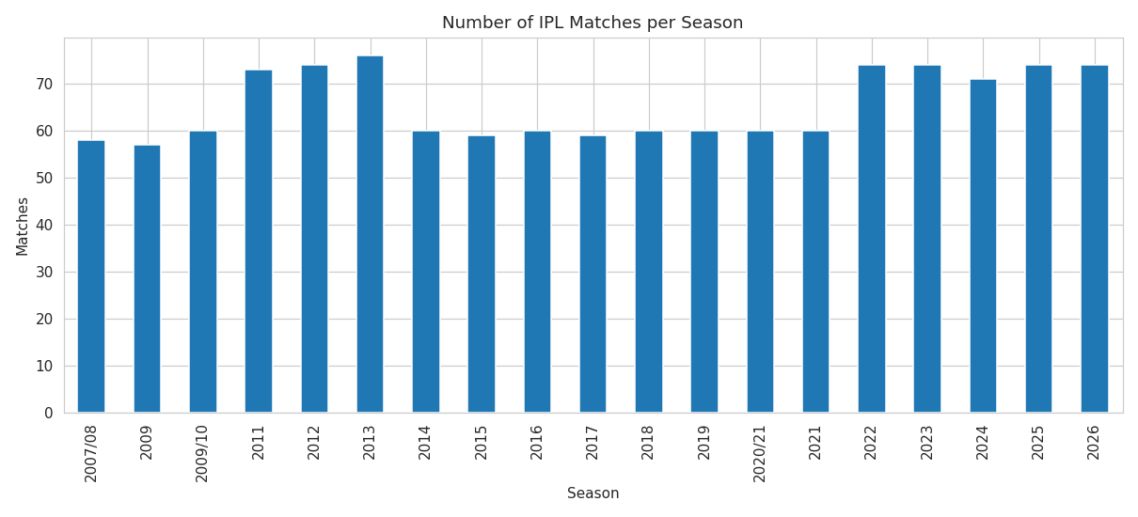
Figure 1: Number of IPL matches played per season.

6.2 Team Performance
Mumbai Indians lead the league with 155 total wins across IPL history, narrowly ahead of Chennai Super Kings and Royal Challengers Bengaluru.

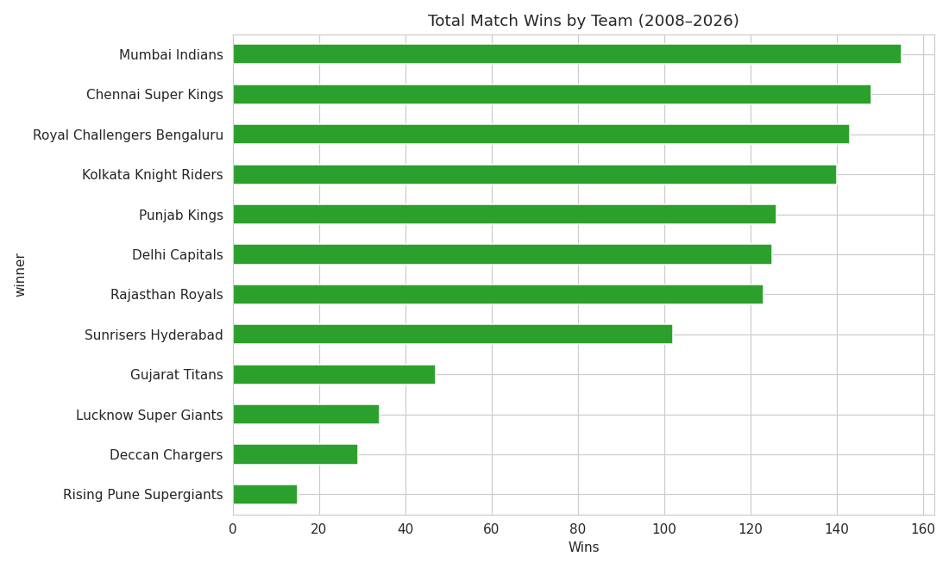
Figure 2: Total match wins by team (2008-2026).
When normalized for the number of matches played, Gujarat Titans post the best win percentage (61%) among teams with at least 30 matches, reflecting a strong recent run of form since their debut.

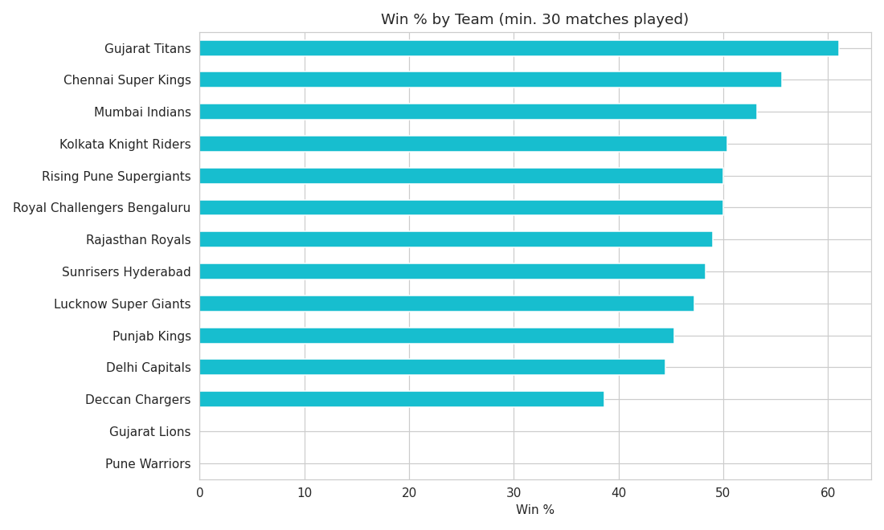
Figure 3: Win percentage by team (minimum 30 matches played).

6.3 Toss Analysis
Captains chose to field first after winning the toss 66.4% of the time, versus 33.6% choosing to bat — reflecting the widely-held belief that chasing under lights is advantageous in T20 cricket.
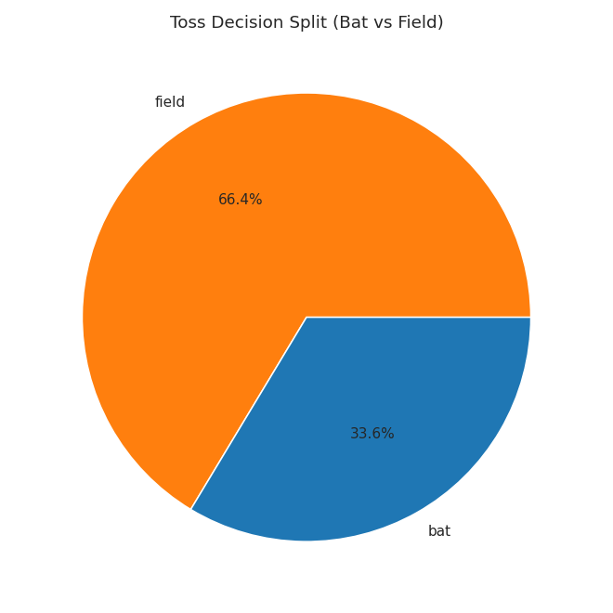
Figure 4: Toss decision split (bat vs. field).
Overall, the toss winner also wins the match 51.6% of the time. Breaking this down by decision: teams that chose to field first won 54.7% of the time, compared to 45.3% for teams that chose to bat first — a modest but consistent edge for chasing sides.
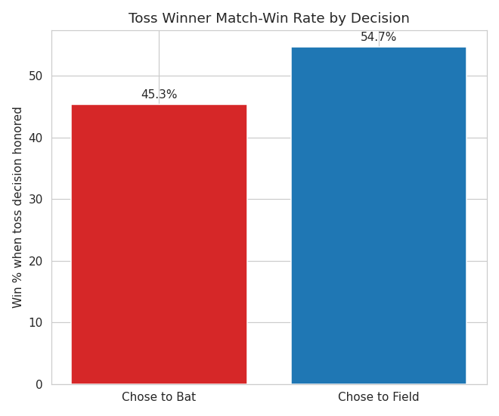
Figure 5: Match-win rate for the toss winner, split by their decision.

6.4 Scoring Analysis
Across all innings in the dataset, team totals average 161.6 runs, with the highest recorded total reaching 287 runs. The distribution is roughly bell-shaped, centered in the 150-180 run range typical of T20 cricket.
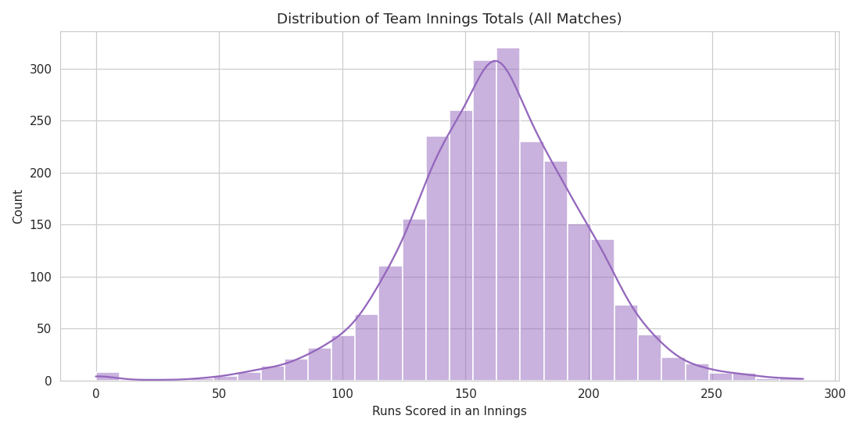
Figure 6: Distribution of team innings totals across all matches.

6.5 Venue Analysis
Eden Gardens has hosted the most matches (77) in the dataset, consistent with it being a home venue for a franchise with a long, continuous IPL history.
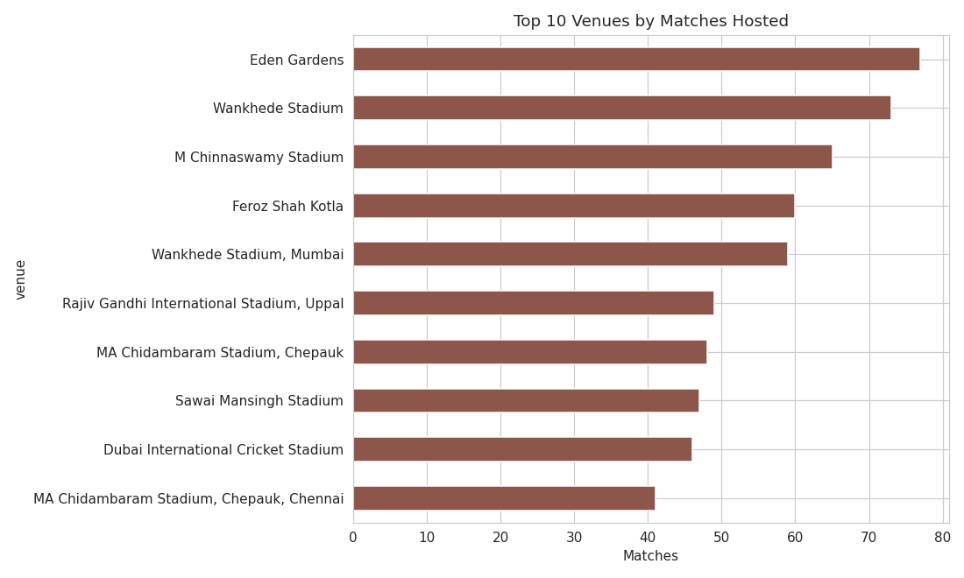
Figure 7: Top 10 venues by number of matches hosted.

6.6 Player of the Match Analysis
AB de Villiers holds the record for the most "Player of the Match" awards (25) in the dataset, reflecting a long and consistently impactful IPL career.
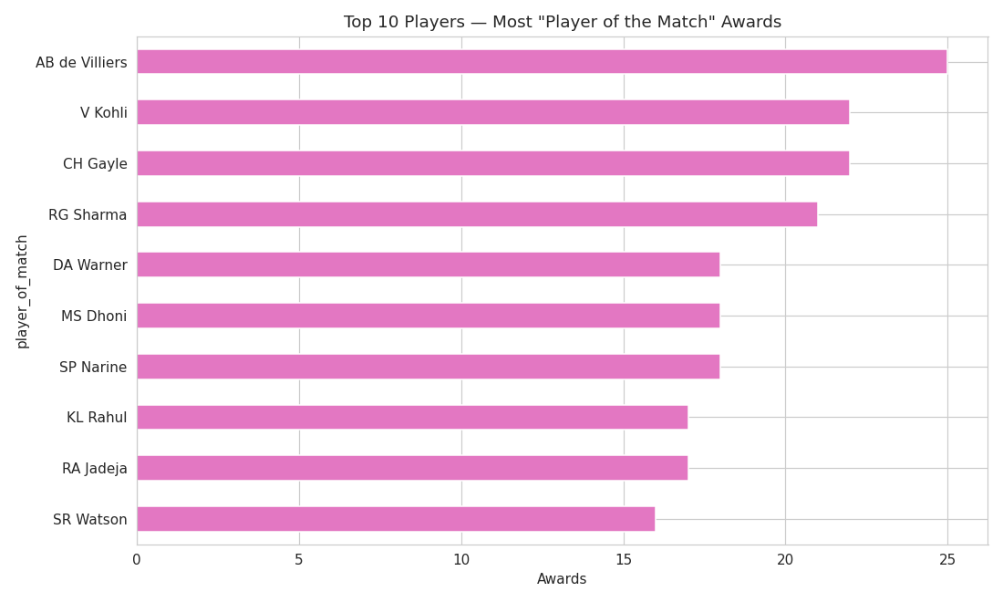
Figure 8: Top 10 players by Player of the Match awards.

6.7 Win Margin Analysis
Matches won by the team batting first are measured in a runs margin, while matches won while chasing are measured in a wickets margin. Most wins fall in moderate ranges rather than extreme blowouts, indicating that the majority of IPL matches are closely contested.
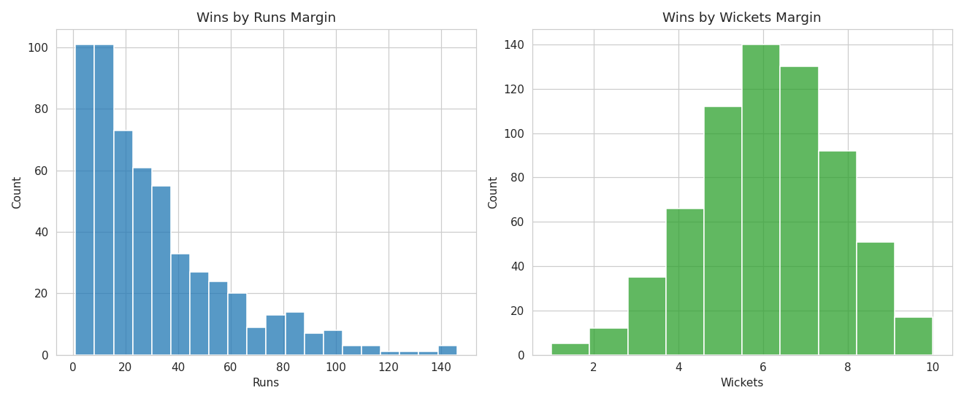
Figure 9: Distribution of winning margins by runs (batting first) and wickets (chasing).

7. Key Insights
Most Successful Team (total wins) | Mumbai Indians (155 wins)
Best Win % (min. 30 matches) | Gujarat Titans (61%)
Toss Decision Split | Field 66.4% / Bat 33.6%
Toss Winner → Match Winner Rate | 51.6%
Win Rate When Choosing to Field | 54.7%
Win Rate When Choosing to Bat | 45.3%
Most-Used Venue | Eden Gardens (77 matches)
Most Player-of-the-Match Awards | AB de Villiers (25 awards)
Highest Innings Total | 287 runs
Average Innings Total | 161.6 runs

- Mumbai Indians and Chennai Super Kings are the most consistently dominant franchises across IPL history.
- Newer, well-managed franchises like Gujarat Titans can achieve a higher win percentage than several long-established teams.
- The toss matters, but only modestly — fielding first after winning the toss offers a slight statistical edge, not a guaranteed advantage.
- IPL scoring has stayed broadly consistent over the years, centered around 160 runs per innings.
- Match outcomes are generally competitive, with most wins decided by moderate margins rather than routs.

8. Conclusion
This project successfully applied exploratory data analysis techniques to nearly two decades of IPL match data, revealing meaningful patterns in team performance, toss strategy, scoring trends, and player impact. The findings align with popular cricketing intuition (e.g., the preference for chasing) while also surfacing quantitative confirmation of team dominance and venue usage patterns. Future work could extend this analysis with ball-by-ball data to study phase-wise scoring (powerplay, middle overs, death overs), player-level batting and bowling metrics, and head-to-head team rivalries.

9. Technologies Used
- Python 3 — core programming language
- pandas & numpy — data manipulation and aggregation
- matplotlib & seaborn — data visualization
- Jupyter Notebook — interactive development environment

10. References
- Dataset: IPL_Matches_Data_2008_2026.csv (project-provided dataset).
- pandas documentation: https://pandas.pydata.org/docs/
- matplotlib documentation: https://matplotlib.org/stable/
- seaborn documentation: https://seaborn.pydata.org/

