DEPARTMENT OF COMPUTER SCIENCE & ENGINEERING
ABES ENGINEERING COLLEGE, GHAZIABAD

SOFTWARE REQUIREMENTS
SPECIFICATION (SRS)
HOTEL REVENUE MANAGEMENT DASHBOARD
Data Analytics and Business Intelligence Project

SUBMITTED BY | UNDER THE GUIDANCE OF
Student Name: Aditya Kumar  Roll No.: 2400320100077  Section: CSE 12  B.Tech CSE | Academic Year: 2026–2027 | Project Guide: ______________________  Designation: _________________________  Department of CSE  Date of Submission: 30/09/2026

Document Version: 1.0 | Prepared: 30 September 2026

Document Revision & Approval History
Version | Date | Description / Major Changes | Prepared By | Reviewed By
0.1 | 30-Sep-2026 | Initial project scope and requirement baseline | Aditya Kumar | Project Guide
1.0 | 30-Sep-2026 | SRS aligned to dashboard and supplied model screenshots | Aditya Kumar | Project Guide

Table of Contents
Section | Title
1 | Introduction
2 | Overall Description
3 | System Features and Functional Requirements
4 | External Interface Requirements
5 | Non-Functional Requirements
6 | System Design and Analysis Models
7 | Academic Review & Sign-Off

Project note: This SRS describes the Power BI dashboard shown in the supplied report screenshot and its associated data model. It is an analytical reporting solution, not a reservation transaction or payment-processing system.

1. Introduction

1.1 Purpose
The purpose of this Software Requirements Specification is to define the scope, functional behavior, data requirements, interfaces, quality attributes, and validation criteria of the Hotel Revenue Management Dashboard. This document serves as a common reference for the student development team, project guide, evaluators, and intended dashboard users.

1.2 Scope of the System
The proposed system uses Microsoft Power BI to transform hotel reservation and performance data into an interactive dashboard. It presents revenue and operating indicators, including average discount, average occupancy, average room capacity, available rooms, total revenue, room revenue by region and hotel, and maintenance-room analysis. Users can inspect the information through visual comparisons and report filters.
In-scope capabilities:
- Importing structured data from the configured Excel workbook.
- Data cleaning, transformation, and semantic data modeling.
- DAX-based KPI calculations and hotel, city, region, and period comparisons.
- Interactive report filtering, cross-highlighting, tooltips, and report refresh.
- Supported report export or controlled sharing through Power BI.
Out-of-scope boundaries: Creating or cancelling reservations, processing payments, directly changing hotel inventory, connecting to live property-management systems, and autonomous revenue decisions.
Expected benefits: Centralized reporting, reduced manual aggregation, clearer hotel comparisons, and improved access to operational and revenue indicators.

1.3 Definitions, Acronyms, and Abbreviations
Term | Definition
SRS | Software Requirements Specification.
BI | Business Intelligence; methods and tools for analyzing business data.
KPI | Key Performance Indicator.
DAX | Data Analysis Expressions, used for calculations in Power BI.
Power Query | Data connection and transformation component in Power BI.
ADR | Average Daily Rate; requires room revenue and rooms-sold data.
RevPAR | Revenue per Available Room; requires room revenue and available room-nights.
Slicer | Interactive report control used to filter visuals.

1.4 References
- IEEE Std 830-1998, IEEE Recommended Practice for Software Requirements Specifications (academic structure reference).
- Microsoft Power BI documentation covering Power Query, data modeling, DAX, report visuals, and sharing.
- Supplied Power BI dashboard screenshot and data-model screenshot provided for this project.

1.5 Document Overview
Section 2 describes the product, users, operating environment, constraints, and assumptions. Section 3 lists functional requirements. Section 4 defines user, software, hardware, and communication interfaces. Section 5 specifies non-functional requirements. Section 6 presents the dashboard and model views, use cases, KPI rules, and acceptance tests. Section 7 provides review and sign-off fields.

2. Overall Description

2.1 Product Perspective
The product is a Power BI reporting layer built over structured hotel data. The report contains KPI cards and charts for revenue, discounts, occupancy, capacity, availability, regional performance, maintenance rooms, and hotel comparisons. The supplied model view shows Reservations, Hotels, Monthly Performance, and Daily Performance tables, along with Booking Channels, Data Dictionary, and Read Me tables. The dashboard is refreshed from its configured source rather than serving as a live hotel operations database.

2.2 User Classes and Characteristics
User Role / Persona | Proficiency | Responsibilities
Hotel Manager | Basic to intermediate | Review revenue and room indicators; compare hotel or city performance.
Revenue Analyst | Intermediate | Interpret revenue, occupancy, discount, ADR, and period comparisons.
Operations / Maintenance User | Basic to intermediate | Review maintenance-room counts and room availability context.
Report Maintainer | Intermediate to advanced | Prepare data, validate measures, refresh model, and maintain visuals.

2.3 Operating Environment
Development and report authoring are performed in Microsoft Power BI Desktop on a supported Windows environment. The data source is a structured Excel workbook. Power Query supports data preparation, the Power BI semantic model manages relationships, and DAX provides measures. Power BI Service may be used for online publication if enabled and appropriately licensed.

2.4 Design and Implementation Constraints
- The dashboard is limited to the fields, data quality, and time granularity of the available dataset.
- Measures must use documented aggregation rules, especially for room counts and repeated daily or monthly records.
- Visuals must remain readable at the report page size and should use consistent number formats and labels.
- Sharing, scheduled refresh, and access governance depend on the configured Power BI environment and licensing.

2.5 Assumptions and Dependencies
The supplied Excel data is assumed to be the authoritative initial source. Hotel identifiers and date fields are expected to be sufficiently consistent to support relationships and time analysis. The user is assumed to have access to the Power BI report. Correct interpretation of occupancy, available rooms, revenue, and maintenance measures depends on confirmation of the dataset's business definitions.

3. System Features and Functional Requirements
Requirements are grouped by data preparation, analytics, and reporting modules. Priority indicates the importance of the capability for the stated dashboard scope.

3.1 Module 1: Data Ingestion and Preparation
Req ID | Feature Description | Input / Validation Rule | Priority
FR-1.1 | Excel data import | Load configured workbook and required worksheets; confirm headers and data types. | High
FR-1.2 | Data cleaning | Identify blanks, duplicates, invalid dates, and malformed numeric values; document handling. | High
FR-1.3 | Data transformation | Standardize field names, categories, date formats, and numeric units using Power Query. | High
FR-1.4 | Data model refresh | Refresh prepared tables from the configured source and surface refresh errors. | High

3.2 Module 2: KPI Calculation and Core Analysis
Req ID | Feature Description | Input / Validation Rule | Priority
FR-2.1 | Revenue metrics | Calculate total revenue and room revenue using selected revenue fields and approved aggregation. | High
FR-2.2 | Discount analysis | Display average discount as a percentage; define simple or weighted average. | High
FR-2.3 | Occupancy analysis | Display occupancy percentage from source or calculate only from valid occupied/available room data. | High
FR-2.4 | Room capacity and availability | Display average capacity and available rooms with compatible units and date context. | High
FR-2.5 | Maintenance-room analysis | Summarize maintenance rooms by hotel or city; avoid double-counting repeated snapshots. | High
FR-2.6 | Hotel and regional comparison | Compare room revenue and total revenue by hotel, region, and city where dimensions exist. | High
FR-2.7 | Period analysis | Support daily or monthly performance views when valid date and period fields exist. | Medium

3.3 Module 3: Reporting, Visualization and Administration
Req ID | Feature Description | Input / Validation Rule | Priority
FR-3.1 | KPI dashboard | Present headline KPIs as cards with clear names, units, and number formats. | High
FR-3.2 | Interactive filtering | Provide available filters such as City, Region, Hotel, Booking Date, or Month. | High
FR-3.3 | Chart interaction | Support appropriate cross-filtering, highlighting, sorting, and tooltips. | High
FR-3.4 | Report export | Allow export through supported Power BI report functions and permissions. | Medium
FR-3.5 | Model maintenance | Allow authorized maintainer to update queries, relationships, measures, and visuals. | Medium
FR-3.6 | Data dictionary / guidance | Provide definitions for key fields and KPIs through documentation or an information page. | Medium

3.4 Key Dashboard Components
Component | Requirement / Intended Use
KPI cards | Show Average Discount (%), Average Occupancy (%), Average Room Capacity, Room Available, and Total Revenue.
Regional revenue chart | Compare average room revenue by region.
Hotel maintenance visual | Compare room capacity and maintenance-room measures by hotel, with labels and a clear legend.
Maintenance by city | Show distribution of maintenance rooms by city where supported by data.
Hotel-level comparison | Compare room capacity, room revenue, or total revenue by hotel.
City / hotel selectors | Filter the report to a selected city or hotel and update relevant visuals.

Current Dashboard Report View
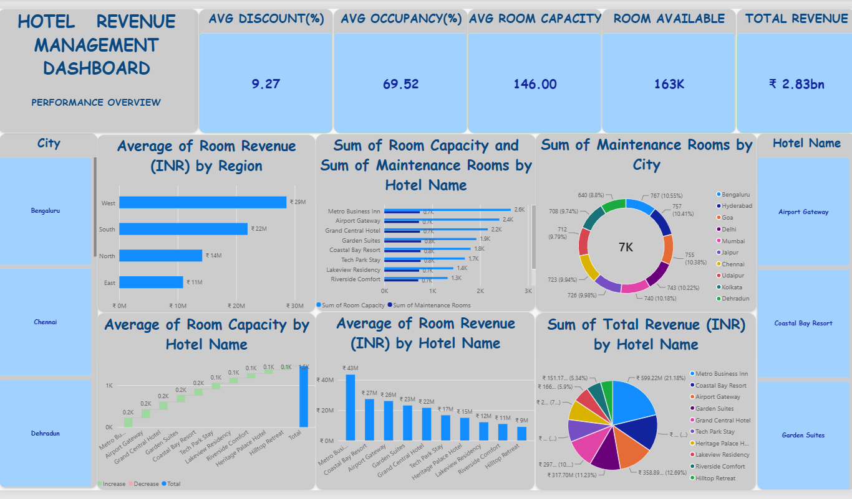
Figure 1. Updated Hotel Revenue Management Dashboard supplied by the project team.

4. External Interface Requirements

4.1 User Interfaces (UI)
The report interface shall provide a performance overview with clearly grouped KPI cards and supporting charts. Titles should describe the metric and grouping dimension. Values should use consistent currency, percentage, and room-count formats. Legends and data labels should be displayed where they improve interpretation. Filters should be clearly labeled and should not obscure the charts.

4.2 Hardware Interfaces
The system does not require specialized hardware. Standard computer input and display peripherals are sufficient for report authoring and viewing. A display capable of presenting the Power BI report at a readable resolution is recommended.

4.3 Software Interfaces
Software / Interface | Purpose
Microsoft Excel | Source workbook containing reservation and hotel performance data.
Power Query | Data ingestion, cleaning, type conversion, and transformation.
Power BI semantic model | Tables, relationships, and filter propagation.
DAX | Measures for revenue, occupancy, discounts, capacity, availability, and maintenance.
Power BI Desktop | Dashboard development, validation, and local report viewing.
Power BI Service (optional) | Publication, controlled sharing, and scheduled refresh where supported.

4.4 Communication Interfaces
For the desktop-only workflow, communication is primarily between Power BI Desktop and the configured local or network data source. If the report is published, access and refresh communication use the protocols and security mechanisms supported by the Microsoft Power BI environment. No custom REST API or payment gateway is required by the current project scope.

5. Non-Functional Requirements (NFRs)
Attribute | Target / Standard | Verification Method
5.1 Usability | KPI names, units, chart titles, and filters are understandable to intended users. | User walkthrough and visual inspection.
5.2 Performance | Common filters and page interactions should respond within an acceptable time for dataset and hardware. | Measure refresh and interaction times.
5.3 Accuracy | KPI values reconcile with independently calculated results from validated source records. | Sample-based calculation and reconciliation.
5.4 Reliability | Refresh errors and invalid source data are detectable; no silent substitution of incorrect values. | Test valid and invalid source scenarios.
5.5 Maintainability | Queries, measures, and relationships use clear names and documented definitions. | Review model structure and documentation.
5.6 Scalability | Additional valid hotel records can be incorporated without rebuilding the full report. | Append test records and refresh.
5.7 Security | Only authorized users can access published reports and underlying data, subject to platform controls. | Review sharing and workspace permissions.
5.8 Compatibility | Report operates in the selected supported Power BI Desktop / Service environment. | Open, refresh, and inspect in target environment.
5.9 Accessibility | Text remains legible and meaning is not communicated by color alone. | Contrast and readability review.

6. System Design and Analysis Models

6.1 Data Model / Relationship View
The supplied model screenshot shows a Hotels table connected to reservation and performance-related tables. The final model should retain appropriate one-to-many relationships from hotel identifiers to fact tables, with deliberate filter direction and date relationships. Booking Channels, Data Dictionary, and Read Me should be classified as lookup or documentation tables as appropriate; unused or disconnected tables should be reviewed.
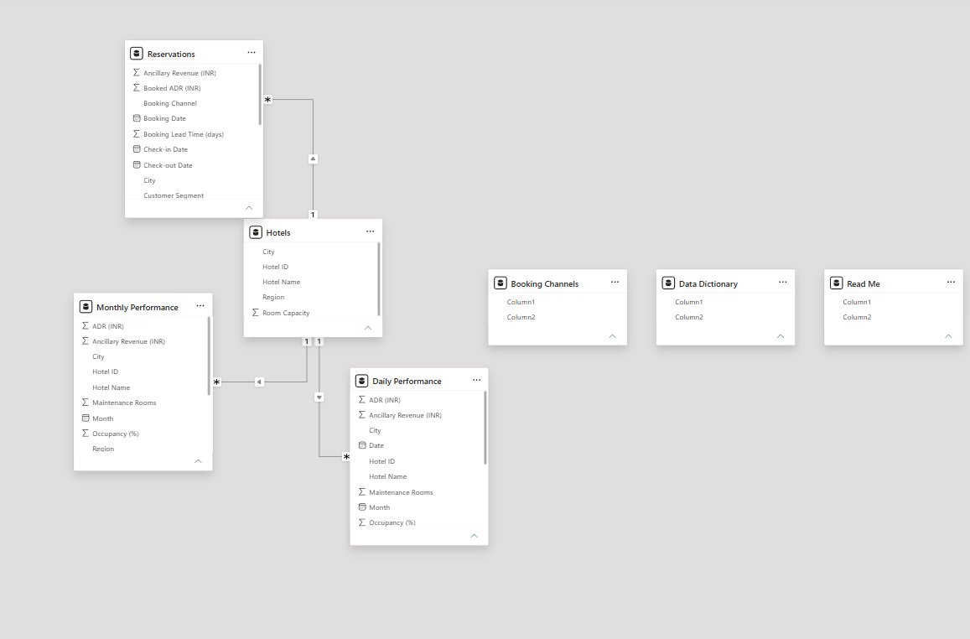
Figure 2. Power BI model view supplied by the project team.

6.2 Logical Data Flow
Stage | Description | Output
1. Source | Read hotel reservation and performance records from the workbook. | Raw tables
2. Prepare | Clean, standardize, validate, and assign data types in Power Query. | Prepared tables
3. Model | Create relationships using hotel IDs, dates, and appropriate dimensions. | Semantic model
4. Calculate | Create DAX measures using approved definitions and filter context. | KPIs and analytical values
5. Visualize | Display cards, charts, slicers, tooltips, and comparisons. | Interactive report
6. Consume | Users filter, inspect, and export or share the report as permitted. | Business analysis

6.3 Primary Use Cases
Use Case | Actor | Main Flow | Postcondition
UC-01: Review performance | Hotel Manager | Open report → review KPI cards → select city / hotel / period → inspect updated visuals. | Filtered performance view is displayed.
UC-02: Analyze maintenance | Operations User | Open maintenance visual → compare hotels or cities → inspect counts and capacity context. | Maintenance-room comparison is reviewed.
UC-03: Analyze revenue | Revenue Analyst | Select region or hotel → compare revenue chart → inspect supporting metrics and tooltips. | Revenue distribution is reviewed.
UC-04: Refresh report | Report Maintainer | Validate source workbook → refresh queries → review errors → reconcile sample KPIs. | Updated dataset and report are available.

6.4 KPI and Data Rules
Metric | Definition / Rule
Total Revenue | Sum of the approved total-revenue field in the current filter context.
Average Discount (%) | Average of discount values, or weighted average if required by the business definition; method must be documented.
Average Occupancy (%) | Use source occupancy measure or calculate occupied rooms divided by available rooms for a compatible period.
Average Room Capacity | Average capacity at the intended grain; do not sum repeated hotel capacity snapshots.
Room Available | Use the source field if reliable; otherwise derive only where capacity and maintenance refer to the same hotel and time period.
Maintenance Rooms | Sum or snapshot measure according to source grain; prevent repeated daily/monthly records from inflating totals.
ADR / RevPAR | Optional metrics only if rooms sold, room revenue, and available room-nights are present and defined.

6.5 Validation and Acceptance Criteria
Test ID | Test | Acceptance Criteria
AT-01 | Data import | Required sheets and columns load with expected types.
AT-02 | KPI reconciliation | Selected KPI values match independently calculated source-data results.
AT-03 | Filter interaction | City, hotel, and period filters affect intended visuals consistently.
AT-04 | Maintenance analysis | Maintenance counts reflect defined data grain and do not double-count snapshots.
AT-05 | Visual quality | Titles, units, labels, and legends are readable and consistent.
AT-06 | Refresh | A valid source update can be refreshed without unintended data loss.
AT-07 | Export / sharing | Authorized user can export or share through available Power BI features.

7. Academic Review & Sign-Off
This SRS is submitted as the requirements baseline for academic review. Approval confirms that the scope and requirements are understood; it does not replace validation of the implemented dashboard against the source dataset.
Project Coordinator / Student | Project Guide | Internal Examiner / HOD
Name: Aditya Kumar  Signature: __________________  Date: 30/09/2026 | Name: ______________________  Signature: __________________  Date: __________________ | Name: ______________________  Signature: __________________  Date: __________________

Conclusion: The Hotel Revenue Management Dashboard provides an interactive reporting solution for reviewing hotel revenue and room-operation indicators. This SRS defines the project boundaries, required functionality, interfaces, quality expectations, model considerations, and acceptance checks. Final measures must be verified against the actual dataset definitions before the dashboard is treated as an authoritative management report.
— End of Software Requirements Specification —

