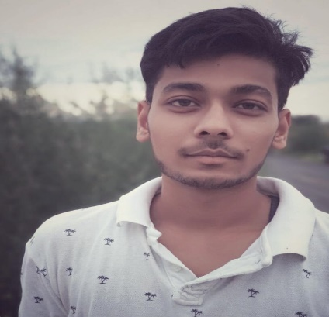

**ADITYA**

**Web Developer, Front-End Developer**

**PROFILE**

**EDUCATION**

**INDIRA GANDHI NATIONAL OPEN UNIVERSITY**

**Master of Computer Application**

**(Pursuing)**

**MAHARSHI DAYANAND UNIVERSITY**

**Bachelor of Commerce**

**2018-2021**

**C.DOT COMPUTER EDUCATION**

**Diploma in Computer Application**

**2017-2018**

**Positive Attitude towards career Life in a Professional Approach to get the best result in the interest of organization ability to meet all sort of challenges in the course of Responsibility.**

**In Front-End Development using HTML, Cascade Style Sheet (C.S.S), Java Script (J.S). As well as in designing using Adobe Photoshop, Well-organized person, problem solver.**

**SKILLS**

**CONTACT**

067-phone.png

**HTML**

**CSS**

**Java Script**

**Photoshop**

**Bootstrap**

+91 9991754595

391-mail4.png

aditya8814955719@gmail.com

001-home.png



Dharuhera, Rewari, Haryana .123106

**HOBBIES**

Driving

Coding

032-book.png018-music.png  

Reading

Music