[1]

Hybridization of Moth Flame Optimization and Gravitational Search Algorithm and its application on detection of Food Quality

A. Bhutani, Aditya A.S, and L. Goel Birla Institute of Technology and Science, Pilani

*Abstract*— **F**

**ood items are often stored in huge storage facilities. These food items are not preserved in the proper condition and are thus spoilt much faster than anticipated. This work is motivated from this prevalent problem of food spoilage. We thus aim to build a vision and gas sensor based model to detect the degree of rottenness of the food item.**

**Gravitational Search Algorithm is an optimization algorithm inspired by the Newton's law of gravitation and Newton's laws of motion. Moth Flame Algorithm is another optimization algorithm inspired by the moth's locomotion around a light source. Both these algorithms have their limitations and strengths. Through creating a hybrid, we aim to cover each one's limitations through the other's strengths. Additionally, we plan to use the hybrid optimization algorithm to segment images, and thus we propose improved segmentation algorithms and present the results of experiments performed on the apple dataset.**

# INTRODUCTION

Gravitational Search Algorithm is an optimization algorithm inspired by the Newton law of Gravitation and the Newtons laws of motion. Moth Flame Optimization is another optimization algorithm, motivated by the locomotion of moths around a light source. Both these algorithms, have tried to model the search agents, and alter the agents’ associated properties like mass, gravitational constant, fitness, location, etc. in order to find the most optimal value. The optimization algorithms usually solve only a class of problems, and therefore the search for a faster, and more comprehensive algorithm is always on. By combining the Moth Flame Optimization and Gravitational Search Algorithm, the performance is expected to improve across various measures. This phenomenon is then applied to find the class of disease in apples. This will help decrease the monetary losses due to food storage, through early detection of spoilage of food. This hybrid optimization algorithm is used in improving the results of segmentation. It has successfully been applied over K-means and Multi-level thresholding. On application of the optimization algorithm to K-means clustering, we aim to reduce the mean squared error from each data point to the centroid of the cluster. Since the initialization of the cluster centers is random in the original algorithm, the mean squared error varies with each application, even on the same dataset. Through the application of optimization algorithm, it is expected to reduce down the mean squared error and bring uniformity to the application of K-Means clustering. For Multi-level Thresholding, the brute force approach to finding the thresholds for multiple clusters, where each threshold could be a value anywhere between 0 and 255, is a very expensive task computationally. Also, this is mostly a manual process. However, the optimization algorithm aims to bring down this complexity by using multiple search agents, each trying to find the most optimal threshold value, while communicating to each other the most optimal value. This reduces the algorithm complexity, and in turn automates the whole process of finding the right values. This has multiple applications as the problem complexity increases as the dimensions or color space changes. Moreover, this method can be extended to multiple color spaces, finding the best threshold values for each color space parallelly. Analysis is done through these improved segmentation techniques and then texture analysis techniques like Grey Level Co-Occurrence Matrix, Local Binary Pattern etc. are explored and applied to detect the food quality. Section II gives an overview of the previous work done in food safety. Section III discusses the working of the Moth Flame Optimization and Gravitational Search Algorithm in brief. Section IV provides the inspiration and an explanation of the working of the proposed hybrid algorithm.

# RELATED WORK

With respect to food safety and food quality inspection systems, a lot of research has taken place on variety of food items like apples[1][2], bread[6], cookies[3] and vegetables[7], meat and fish[] to name a few.

Broadly, research in this field can be classified as one of two types, 1. Sensor based techniques 2. Vision based techniques. Sensor based techniques primarily constitute odour sensors, devices like e-nose and e-tongue and recently, nano-sensors. Estimation of concentration of a specific gas is the most important factor considered when using odour based sensors. Researchers working on food contaminant detection have used nano-particle based technology like silver based nano-particles, cerium oxide nano-particles, gold based nano particles etc [5]. Bio-sensors[8] have also been used for food safety and food monitoring. Methods for detecting microbial contamination, pesticides, metal contaminants and mycotoxins has been explained.

Vision based techniques use concepts of extracting visual features of images like texture, size, shape, presence of spots, etc. In some scenarios, advanced techniques like multi spectral imaging can also be used[9]. On the multi spectral images, segmentation techniques are applied and then texture related features have been extracted and studied through statistical classifiers for grading apples and disease [2]. In one of the earliest research on beef, the muscle "longissimus dorsi" was located and characteristics of the longissimus dorsi were used for beef grading. Wide variety of techniques have been used in this field, both with respect to classification and feature extraction. Neural Networks, Fuzzy Classifiers, Support Vector Machines have thoroughly used as classifiers. With respect to feature extraction, experiments by using variety of color spaces like La*b*, HSV and RGB have been done. Several features like Local Binary Patterns, size, color, Grey Scale Covariance Matrix, etc have also been studied.

# Optimization Algorithms

A wide range of optimization algorithms exist where each has its own method of arriving onto the optimal value. However, each algorithm solves only a class of problems. Thus, the quest for finding new optimization algorithms continues. Swarm based optimization algorithms are popular because of their inherent property to avoid local extrema. Some population based optimization algorithms include Moth Flame Optimization[], Gravitational Search Algorithm[], Particle Swarm Optimization[], Bio-geography Based Optimization[] etc.

## Gravitational Search Algorithm

Gravitational Search Algorithm (GSA) is a nature inspired optimization algorithm based on the Newton's law of Gravitation and Newtonian laws of motion. In this algorithm, the candidate solutions are masses spread across the hyperspace and each has an associated mass. This mass dictates the motion of the search agents, which eventually converge to the most optimal value, according the fitness function.

The algorithm starts by initializing search agents at random positions with some mass associated with each search agent. The mass of a search agent denotes how fit the agent is, i.e. the greater the mass, the greater the possibility that the mass is closer to the solutions. Gravitational Search Algorithm is a global algorithm, every search agent experience gravitational attraction to every other search agent in the search space, but since bigger masses move more slowly than smaller masses, as the iterations go on smaller masses will move towards the larger and more fitter masses and thus closer to the solution.

The notation for gravitational search algorithm involves three kinds of masses:

* Active gravitational mass, Ma: Ma, is a measure of the strength of the gravitational field due to a particular object. Gravitational field of an object with small active gravitational mass is weaker than the object with more active gravitational mass.
* Passive gravitational mass, Mp: Mp, is a measure of the strength of an object’s interaction with the gravitational field. Within the same gravitational field, an object with a smaller passive gravitational mass experiences a smaller force than an object with a larger passive gravitational mass.
* Inertial mass, Mi: Mi is a measure of an object resistance to changing its state of motion when a force is applied. An object with large inertial mass changes its motion more slowly, and an object with small inertial mass changes it rapidly

With the above notation in mind, Newton's Force of Gravity when applied, gives the following equations:

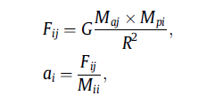

Once the forces, and accelerations on each search agent is calculated, it is time for motion. Each search agent will move in the direction of the resultant that it experiences. Gravitational Search Algorithm has randomization involved in the distances the search agents travel and also the direction. Each force component the agent experiences is multiplied by a random number and the magnitude of the distance is also multiplied by a random number, ranging between 0 to 1. It is using this randomization that Gravitational Search Algorithm avoid local optimum values. This randomization also adds to the exploration phase of the optimization algorithm.

## Moth Flame Optimization

Moth Flame Optimization is yet another Nature Inspired Swarm Optimization Algorithm, based on the navigation patterns of moths around flames, also called as traverse orientation. By nature, Moths maintain a fixed angle with the moon while travelling thereby moving in a straight-line path. But this gets disturbed when an external source of light, say a flame is introduced near the moth. The moth then starts maintaining a fixed angle with the flame, thereby travelling in spirals, and finally dies when it reaches the flame.

The MFO algorithm uses this spiraling of moths around flames to solve optimization problems. The algorithm starts out with 'N' number of moths and 'N' number of flames, Moth traversal is guided by the flames. Fitness is associated to each flame, using a fitness function that is suitable for the problem at hand. As the algorithm continues in iterations, only the fitter flames are made to remain and the unfit flames are removed, thereby guiding the moths to the fittest flame, finally. When only one flame remains, it means that the solution has been found.

The MFO algorithm like all other optimization algorithms consists of two phases: Exploration and Exploitation. The moths that are initialized are given random co-ordinates. This randomization constitutes for the exploration phase. As the iterations of the algorithm go on., the number of flames are gradually reduced, so that finally only one remains, this is the Exploitation phase of the algorithm. As the number of flames reduce, the moths will start converging slowly. Fitness of flame depends on the specific function being optimized. Fitness of a moth is defined as the inverse of its distance to the closest flame i.e., the closer a moth is to a flame, the fitter it is and vice versa.

# Hybrid of Moth Flame Optimization and Gravitational Search Algorithm

The algorithm exploits the exploratory nature of the moth flame optimization (MFO), and utilizes the exploitation of the gravitational search algorithm (GSA). The intuition behind this approach to hybridize these two algorithms is that the MFO utilizes the logarithmic spiral for exploration, while the GSA uses the linear motion for locomotion. This enables the hybrid algorithm to exploit both the properties of the individual algorithm and therefore fit together. The fitness measure is mass of each search agent for GSA while the fitness measure for MFO is distance to the fittest flame. This adds the variability to exploit both the behavior in a single algorithm, thus rendering the hybrid as a better fit. MFO makes the search agent go around the fittest flame, while GSA ensures faster convergence. The flow of the algorithm is as follows:

* First, the population is initialized to random positions in the search domain.
* Next, the fitness is calculated for each search agent.
* Then the moths are associated with their serial order to the fittest flame. The first moth in the list is associated with the fittest flame, second in serial with second best flame and so on.
* Now the search agents rotate around their associated flames in the spiral trajectory. After that, the moths attract each other and come closer to the fitter flames.

This process is repeated until the maximum number of iterations.

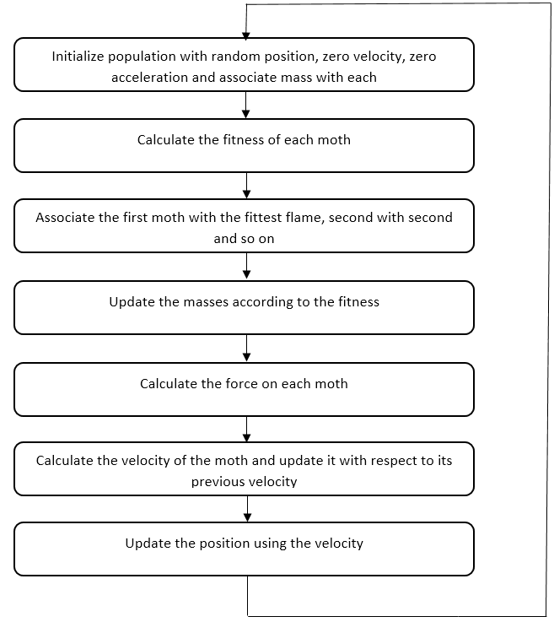

Figure 1: Flowchart for hybrid optimization algorithm

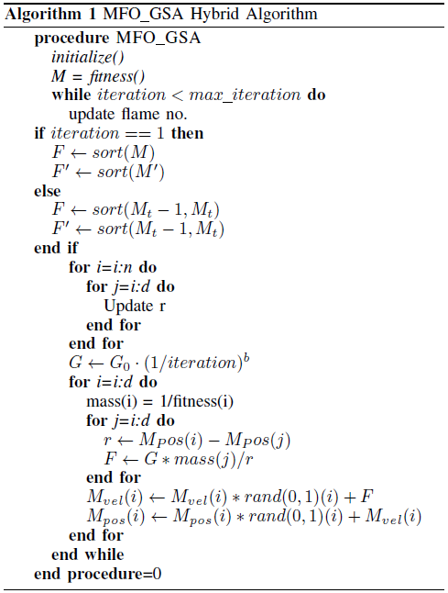

Pseudo code for MFO_GSA Hybrid

## Optimizing K-means Segmentation

We have proposed an Optimized K-means Segmentation algorithm, that improves upon the standard K-means algorithm to find better clusters.

We use the proposed hybrid optimization technique. The K cluster centroids are treated as search agents (moths). Broadly, the optimized K means segmentation consists of the following steps:

1. Parameter initialization: The initial K-mean points are initialized randomly from the set of pixels provided. The value of each pixel in each dimension is chosen randomly from the set of existing points, for this reason the initial K – mean points may not represent actual points in the image. But their components would be definitely being available in the image.
2. Hard Assignment of Pixel to Clusters: Given that each of the K clusters has a mean point, every point in the set of data points is assigned to the cluster to which it is most similar. Similarity is calculated based on Euclidean distance between pixels. After this, every point is assigned to exactly one cluster Ck.
3. Parameter Re-computation: The new means of the clusters are computed based on the points assigned to the cluster in the first iteration.

Steps 2 and 3 are repeated till convergence, which typically means that no pixel shifts from one cluster to another between iterations.

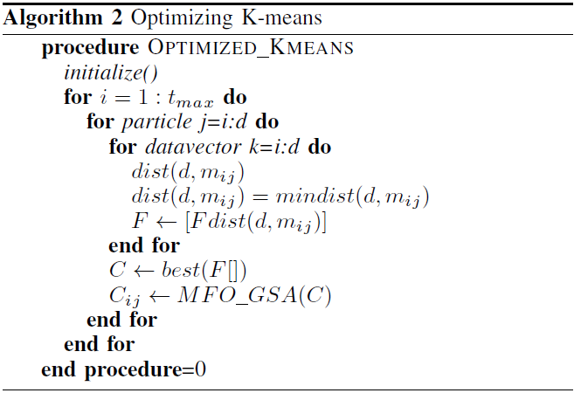

## Thresholding using MFO_GSA Hybrid Optimization

In this method, the hybrid algorithm is adopted to the segmentation problem. In this method, the given image is first made noisy by adding uniformly distributed noise to the original image i.e. Fij = fij + nij

The basic steps of the algorithm are given as follows:

1. Initial population generation: For any pixel (i, j) the value, choose pixel value of the initial population as the value of the original pixel at (i,j) or the value of noise at (i,j). Thus, the initial population is a mixture of images with a mixture of original image values / noise values. Such a selection of the initialization helps in the exploratory phase of the optimization algorithm Fitness evaluation: Fitness function is defined based on the following principle. Inter cluster similarity should be as less as possible and intra cluster similarity should be as large as possible. Thus, the fitness is defined as a ration of Sintercluster/ Sintracluster.
2. Locomotion operations: In each iteration, the moths which represent images / potential solutions of segmentation, move due to the MFO_GSA motion i.e. both linear as well as spiral motion. From these newly formed moth positions along with the old moth positions, the best k moths are chosen. The flames are reduced through the iterations and finally only one moth, i.e. the solution remains. This represents the segmented image.

Handling of larger images: Divide image into sub images, and final best sub images using optimization and fitness and merge them to create final segmented image.

# Results and Analysis

## Benchmark Functions

To measure the effectiveness of the optimization algorithms, the algorithms are tested against mathematical functions. The benchmark functions form the sample for evaluating the optimization algorithms. The functions are split across two types of functions: unimodal functions and multi-modal functions. The unimodal functions test the exploitation of the optimization functions. On the other hand, the multimodal functions test the exploration aspect of the optimization algorithms, where it is tested that the optimization function is not stuck around a local minimum.

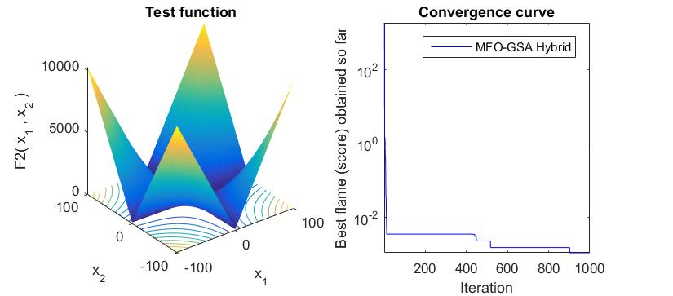

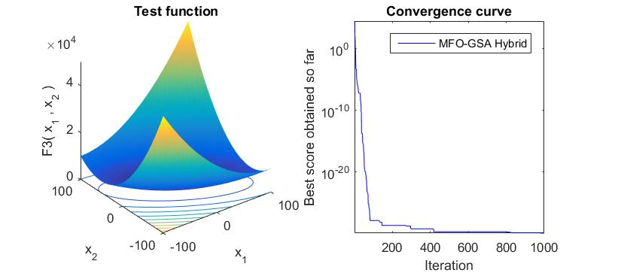

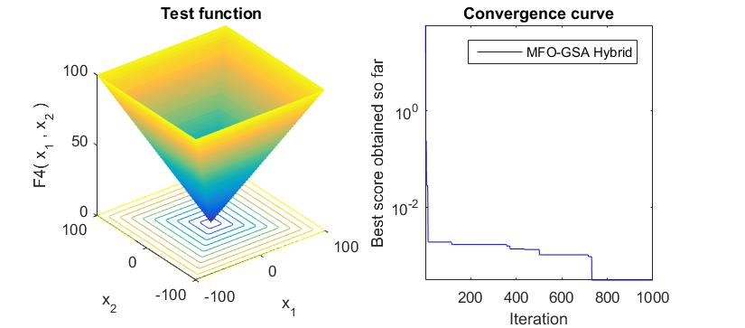

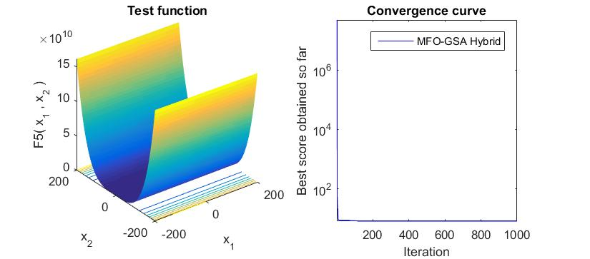

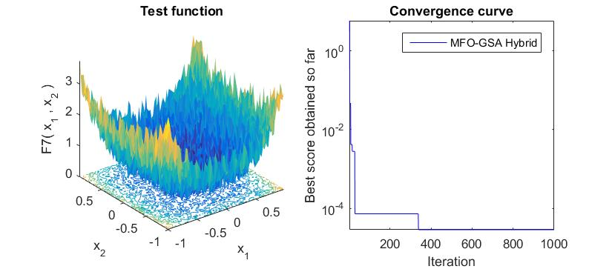

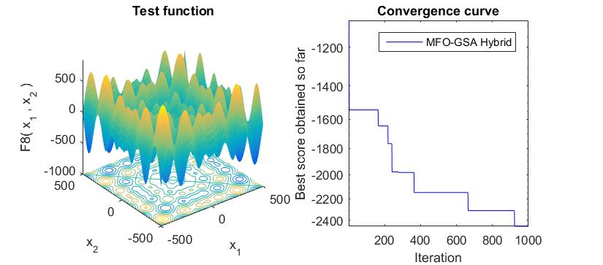

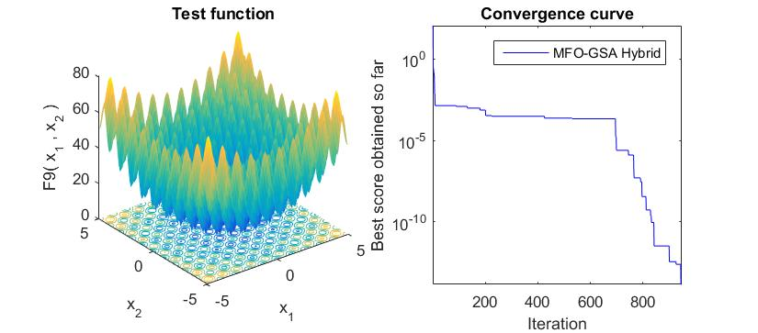

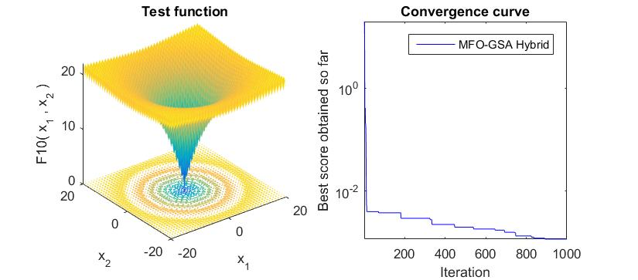

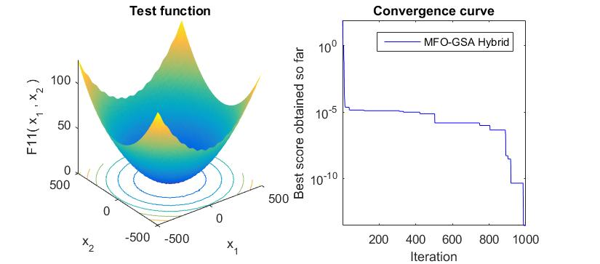

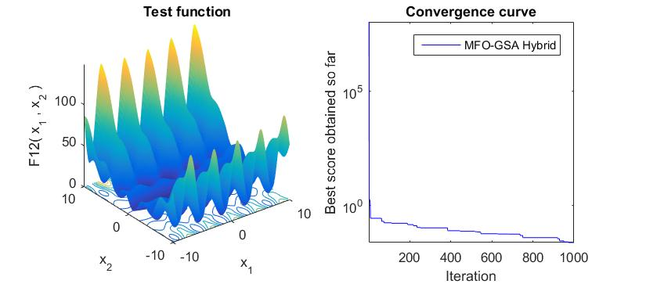

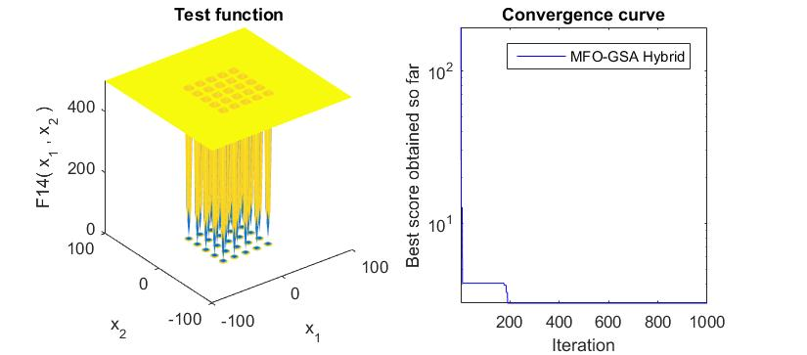

*Figure 2: a-k Function and convergence curve for benchmark functions*

## Optimized K-Means

Mean Squared Error (MSE) is calculated for standard datasets. It is clearly evident that the optimized k-means is performing better than normal k-means, as the error is less than or equal to the normal k-means.

Table: Comparing MSE of K-means and Optimized K-means

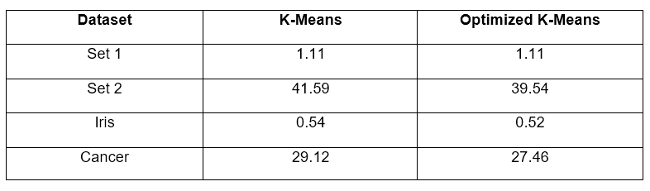

The Optimized K-means segmentation technique was applied on the apple dataset. The images below show the results for various types of diseased apples.

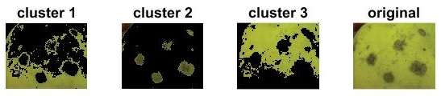

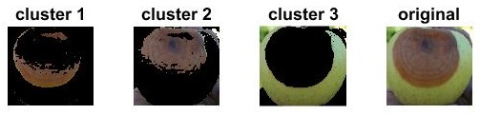

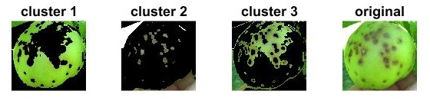

Figure 3: Segmentation results of optimized K-means on blotch, rot and scab

## Analysis of Multilevel Thresholding using Optimization

Multi-Level Thresholding using optimization algorithm has the following advantages:

1. It performs better than the K-means algorithm used above as it does not involve the factor of randomization and searches the whole search domain for the best thresholds. This reduces the error rate, and makes the algorithm more robust.
2. For grayscale images, the pixel values range from 0-255. This search space being fairly limited makes this algorithm work very fast, producing the desired results in a very small amount of time.
3. It automates the whole process of thresholding. Thresholds are often calculated through the image and real time filters. However, that is a manual process. By automating this process, we remove the role of human, and thus improve upon the efficiency of the thresholding process.
4. As the role of human is removed, the human error associated is also completely removed from the process of thresholding.

This thresholding can be expanded to any of the known color spaces, RGB, LAB, HSV etc. Since thresholding is a very common computer vision technique, this automation results in an improvement over the current algorithms.

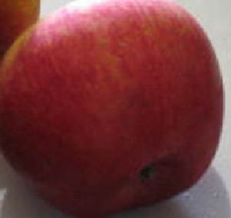

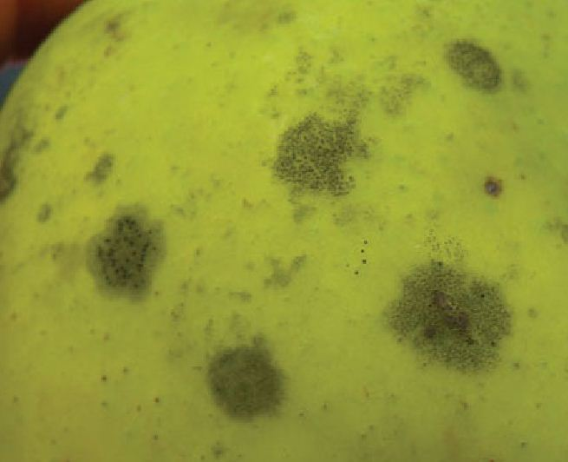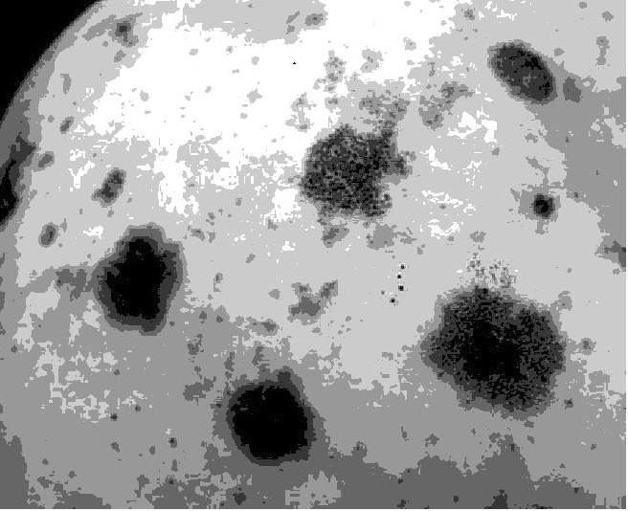

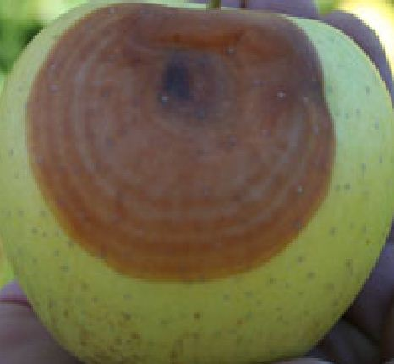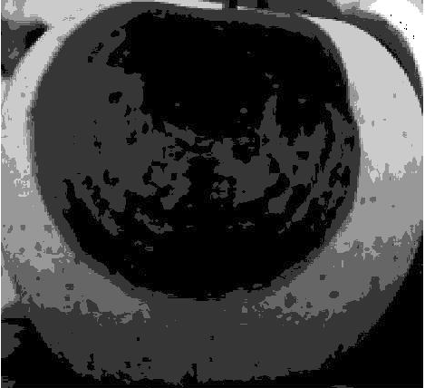

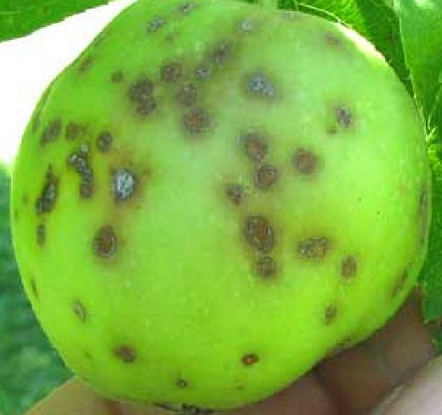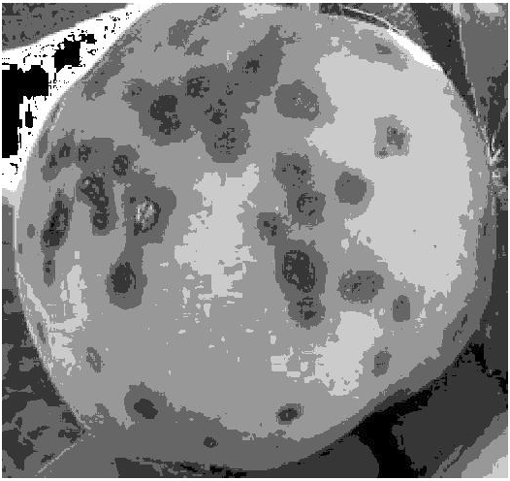

Figure 4: Segmentation: Optimized multilevel thresholding

# Feature Generation

## Local Binary Patterns

Local Binary Pattern (LBP) is a texture analysis technique. It assigns binary values to each pixel. These values are generated through analysis of its neighbors. It is computationally inexpensive and yet effective that it finds its application in multiple computer vision problems like facial recognition. It is a robust algorithm for it works even in different illuminations and environments.

LBP describes two dimensional textures, based on the surface in the image. One is the local spatial patterns, and the other is the grey level contrast.

## Gray Level Co-occurance matrix

The grey level co occurrence matrix is a distribution matrix which represents the co-occurring values in the vicinity. It signifies the relationship of a sub-image of a fixed size to its surroundings. It calculates the frequency of a pixel value occurring in its vicinity either horizontally or vertically or diagonally.

Once we have the GLCMs, one can extract information out through various statistical measures like the following:

* Contrast: measures the contrast between the pixel and its surroundings.
* Correlation: measures how much a pixel is correlated to its surroundings.
* Energy: calculates sum of elements raised to the power of 2.
* Homogeneity: calculates the closeness of the GLCM to its neighbors.

# CLASSIFICATION RESULTS

Multi class SVM has been used for classification. The data set has been divided into the following classes: normal, scab, rot, blotch. After segmenting using Optimized K-means and applying color based features, the following results were obtained:

The blotch class does not have good enough features and overlaps with rot and scab. Thus, it has been excluded from the final classification.

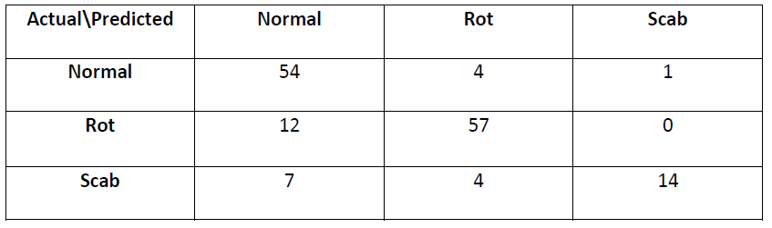

Table: Confusion matrix for normal, rot and scab

If we analyze the multiclass model, with scab, rot and normal classes, the accuracy is 81.69%. There are a couple of reasons why the model is not as accurate: there are a few overlaps in the diseases, and not a clear distinction sometimes. On doing some literature survey, it was found that the diseases can occur together, and the visual signs are often legions. For these legions to clearly depict the correct disease, it sometimes takes some time to mature.

References

[1] - Nanda, Satyasai Jagannath, and Ganapati Panda. "A Survey on Nature Inspired Metaheuristic Algorithms for Partitional Clustering." *Swarm and Evolutionary Computation* 16 (2014): 1-18.

[2] - Hatamlou, Abdolreza, Salwani Abdullah, and Hossein Nezamabadi-Pour. "Application of Gravitational Search Algorithm on Data Clustering." Rough *Sets and Knowledge Technology Lecture Notes in Computer Science* (2011): 337-46.

[3] - Hatamlou, Abdolreza, Salwani Abdullah, and Hossein Nezamabadi-Pour. "A Combined Approach for Clustering Based on K-means and Gravitational Search Algorithms." *Swarm and Evolutionary Computation* 6 (2012): 47-52.

[4] - Osuna-Enciso, Valentı´n, Erik Cuevas, and Humberto Sossa. "A Comparison of Nature Inspired Algorithms for Multi-threshold Image Segmentation." *Expert Systems with Applications* 40.4 (2013): 1213-219.

[5] - Bülbül, Gonca, Akhtar Hayat, and Silvana Andreescu. "Portable Nanoparticle-Based Sensors for Food Safety Assessment." Sensors 15.12 (2015): 30736-0758.

[6] - Duncan, Timothy V. "Applications of Nanotechnology in Food Packaging and Food Safety: Barrier Materials, Antimicrobials and Sensors." *Journal of Colloid and Interface Science* 363.1 (2011): 1-24.

[7] - Yang, Tao, Huifen Huang, Fang Zhu, Qinlu Lin, Lin Zhang, and Junwen Liu. "Recent Progresses in Nanobiosensing for Food Safety Analysis." Sensors 16.7 (2016): 1118.

[8] - Mutlu, Mehmet. Biosensors in Food Processing, Safety, and Quality Control. Boca Raton: CRC, 2011.

[9] - Ropodi, A.i., E.z. Panagou, and G.-J.e. Nychas. "Data Mining Derived from Food Analyses Using Non-invasive/non-destructive Analytical Techniques; Determination of Food Authenticity, Quality & Safety in Tandem with Computer Science Disciplines." *Trends in Food Science & Technology* 50 (2016): 11-25.

[10] - Brosnan, Tadhg, and Da-Wen Sun. "Improving Quality Inspection of Food Products by Computer Vision––a Review." *Journal of Food Engineering* 61.1 (2004): 3-16.

[11] - Abdullah, Mohd Zaid, Sabina Abdul Aziz, and Abdul Manan Mohamed. "Quality Inspection Of Bakery Products Using A Color-Based Machine Vision System." Journal of Food Quality J Food Quality 23.1 (2000): 39-50.

[12] - Du, Cheng-Jin, and Da-Wen Sun. "Learning Techniques Used in Computer Vision for Food Quality Evaluation: A Review." Journal of Food Engineering 72.1 (2006): 39-55.

[13] - Ma, Ji, Da-Wen Sun, Jia-Huan Qu, Dan Liu, Hongbin Pu, Wen-Hong Gao, and Xin-An Zeng. "Applications of Computer Vision for Assessing Quality of Agri-food Products: A Review of Recent Research Advances." *Critical Reviews in Food Science and Nutrition* 56.1 (2014): 113-27.

[14] - Ding, Zhuqing, Ruoyu Zhang, and Za Kan. "Quality and Safety Inspection of Food and Agricultural Products by LabVIEW IMAQ Vision." Food Analytical Methods Food Anal. Methods 8.2 (2014): 290-301.

[15] - Miraglia, M., H.j.p. Marvin, G.a. Kleter, P. Battilani, C. Brera, E. Coni, F. Cubadda, L. Croci, B. De Santis, S. Dekkers, L. Filippi, R.w.a. Hutjes, M.y. Noordam, M. Pisante, G. Piva, A. Prandini, L. Toti, G.j. Van Den Born, and A. Vespermann. "Climate Change and Food Safety: An Emerging Issue with Special Focus on Europe." *Food and Chemical Toxicology* 47.5 (2009): 1009-021.

[16] - "In Brief: Achieving a Transparent, Actionable Framework for Public–Private Partnerships for Food and Nutrition Research." *Journal of the Academy of Nutrition and Dietetics* 115.8 (2015): 1318-319.

[17] - Goel, Lavika, Daya Gupta, V. K. Panchal, and Ajith Abraham. "Taxonomy of Nature Inspired Computational Intelligence: A Remote Sensing Perspective." *2012 Fourth World Congress on Nature and Biologically Inspired Computing* (NaBIC) (2012): n. pag.

[18] - [Babak E. Bejnordi](http://profiles.spiedigitallibrary.org/summary.aspx?DOI=10.1117%2f12.2081768&Name=Babak+E.+Bejnordi) [; Geert Litjens](http://profiles.spiedigitallibrary.org/summary.aspx?DOI=10.1117%2f12.2081768&Name=Geert+Litjens) [; Meyke Hermsen](http://profiles.spiedigitallibrary.org/summary.aspx?DOI=10.1117%2f12.2081768&Name=Meyke+Hermsen) [; Nico Karssemeijer](http://profiles.spiedigitallibrary.org/summary.aspx?DOI=10.1117%2f12.2081768&Name=Nico+Karssemeijer) [and Jeroen A. W. M. van der Laak](http://profiles.spiedigitallibrary.org/summary.aspx?DOI=10.1117%2f12.2081768&Name=Jeroen+A.+W.+M.+van+der+Laak). " A multi-scale superpixel classification approach to the detection of regions of interest in whole slide histopathology images ", *Proc. SPIE 9420, Medical Imaging 2015: Digital Pathology*, 94200H (March 19, 2015);

[19] - [Hong-Min Zhu](https://www.hindawi.com/75754321/) and [Chi-Man Pun](https://www.hindawi.com/76156725/). "An Adaptive Superpixel Based Hand Gesture Tracking and Recognition System"

[20] Zhao, Mingru, Hengliang Tang, Jian Guo, and Yuan Sun. "Data Clustering Using Particle Swarm Optimization." *Lecture Notes in Electrical Engineering Future Information Technology* (2014): 607-12.

[21] - Li, Haiyang, Hongzhou He, and Yongge Wen. "Dynamic Particle Swarm Optimization and K-means Clustering Algorithm for Image Segmentation." Optik - *International Journal for Light and Electron Optics* 126.24 (2015): 4817-822.

[22] - Koonsanit, Kitti. "Determination of the Initialization Number of Clusters InK-means Clustering Application Using Co-OccurrenceStatistics Techniques for Multispectral Satellite Imagery." *International Journal of Information and Electronics Engineering IJIEE* (2012): n. pag.

[23] - Kumar, Tara Sai, Mahesh Chandra M, and Sreenivasa Murthy P. "Colour Based Image Segmentation Using Fuzzy C-Means Clustering." *Int. Jour. Intel. Elec. Sys. International Journal on Intelligent Electronic Systems* 5.2 (2011): 47-51.

[24] - Dubey, Shiv Ram, and Anand Singh Jalal. "Adapted Approach for Fruit Disease Identification Using Images." *International Journal of Computer Vision and Image Processing* 2.3 (2012): 44-58.

[25] - Zhang, Y.j. "A Survey on Evaluation Methods for Image Segmentation." Pattern Recognition 29.8 (1996): 1335-346.

[27] - Ahmadyfard, Alireza, and Hamidreza Modares. "Combining PSO and K-means to Enhance Data Clustering*." 2008 International Symposium on Telecommunications (2008)*: n. pag.

[30] - Narwade, Jyoti, and Binod Kumar. "Local and Global Color Histogram Feature for Color Content-Based Image Retrieval System*." Proceedings of the International Congress on Information and Communication Technology Advances in Intelligent Systems and Computing* (2016): 293-300.

[31] - Huang, Di, Caifeng Shan, Mohsen Ardabilian, Yunhong Wang, and Liming Chen. "Local Binary Patterns and Its Application to Facial Image Analysis: A Survey." *IEEE Transactions on Systems, Man, and Cybernetics, Part C (Applications and Reviews)* 41.6 (2011): 765-81.

[32] - Szeliski, Richard. Computer Vision: Algorithms and Applications. London: Springer, 2011.

1.