Report on

**Hybridization of Moth Flame Optimization and Gravitational Search Algorithm and its application on detection of Food Quality**

By

**Anirudh Bhutani** (2013A7TS114P)

**A.S. Aditya** (2013A7TS079P)

Under the Supervision of

**Dr. Lavika Goel**

Submitted under partial fulfilment of the requirements of Mid semester examination of

**BITS F421T: Thesis**

**CS F367: Design Oriented Project**



Contents

**1** **Abstract** 3

**2** **Problem Statement** 3

**3** **Literature Review** 3

3.1.1 Image processing Techniques: 3

3.1.2 Nature Inspired Algorithms 4

3.1.3 Previous Research in Food Safety 4

3.1.4 Previous Research in Food Safety using Nature Inspired Algorithms 5

3.1.5 Computer Vision 6

3.1.6 Bakery Products 7

3.1.7 Meat and Fish 7

3.1.8 Fruit 7

3.1.9 Vegetables 7

**4** **Optimization Algorithms** 8

**4.1** **Moth Flame Optimization** 9

**4.2** **Gravitational Search Algorithm** 10

**4.3** **Hybrid Algorithm** 10

4.3.1 Justification for hybridization 11

4.3.2 Pseudo Code 12

**5** **Testing on Benchmarks and Results** 13

**6** **Conclusion** 15

7 **References** 16

# **Abstract**

Gravitational Search Algorithm is an optimization algorithm inspired by the Newton law of Gravitation and the Newton’s laws of motion. Moth Flame Optimization is another optimization algorithm, motivated by the locomotion of moths around a light source. Both these algorithms, have tried to model the search agents, and altered its properties like mass, Gravitational constant, fitness, location etc. in order to find the most optimal value. The optimization algorithms usually solve only a class of problems, and therefore the search for a faster, and more comprehensive algorithm is always on. By combining the Moth Flame Optimization and Gravitational Search Algorithm, the performance is expected to improve across various measures.

Project Food Sense aims to use this improvement in order to find the degree of rottenness of various food items. This will help decrease the losses in food storage, and early detection of spoilage of food, in order to minimize monetary losses due to food and storage. This hybrid optimization algorithm will be used to find the optimal hyper parameters of the learning model which will efficiently classify the food items.

# **Problem Statement**

Hybridize Moth Flame Optimization and Gravitational Search Algorithm to improve its results and apply this technique to detect the quality of food items.

# **Literature Review**

### Image processing Techniques:

Artificial Neural Networks: Inspired from the biological neural system, this machine learning technique tries to simulate the human intelligence. Here, the physical properties extracted from the images can act as quality factors. It results in near human level performance in areas of color, content, shape, and texture inspection. This has been applied in many food categories like fishery, fruits, vegetables, grain and meat and has resulted in accuracy of detection nearly 90%.

Optimization Techniques: Classification can also be done using optimization techniques. Appropriate fitness function needs to be chosen and optimized accordingly. Rule sets can be generated in order to do classification of test data.

Color Space:

Color spaces are representations of different colors using different models. There are wide variety of color spaces to choose from each having its own benefits.

RGB: Widely used color space, since it works in a way similar to human vision. Views each color as a mixture of red, green and blue in different proportions.

1. HSV: Unlike RGB it separates luma(illumination information) from chroma(color information). Mainly used when dealing with variable illumination. HSV images can be easily segmented.
2. LAB: The components of this color space are Luminance, a and b(color opponent dimensions). This color space is efficient in digital image manipulations i.e. handles shadows, noise etc well.

3.1.2 Nature Inspired Algorithms

There has been research going on in this area for a long time now and there have been several algorithms that are inspired from nature like the human mind, ants, bees, Geo sciences etc. A subset of nature inspired techniques in Swarm Intelligence. Swarm Intelligence refers to the collective behaviour of several individual agents communicating with each other. It is a totally decentralized mechanism. Agents share knowledge among themselves by communicating. This is one of the most used techniques for optimization. There are algorithms like Ant Colony Optimization, Swarm Particle Optimization, Bee Clustering Algorithm, Gravitational Search and Moth Flame Optimization each algorithm mimicking the swarm behaviour found in nature.

### Previous Research in Food Safety

 Shape, size, and position can be consistently and rapidly measured using computer vision. With the recent developments of algorithms and the improvement of computer hardware, the sensitivity and ranges have been widened for samples of larger size and more complex shapes. Therefore, computer vision has been extensively applied for food-quality assessment.

Mechanisms for food safety already exist in almost all countries but most of them involve manual inspections which in turn take time and resources. Below are examples of food products that have been studied extensively.

Apples: Quality of bicoloured foods has been evaluated extensively. Multispectral imaging has been employed to evaluate the quality of bicoloured apples (Unay et al., 2011). Geometrical and textural properties are invaluable in identifying defects in food. Kang and Sabarez have also worked on a new segmentation algorithm to analyze dried apple slices. There has also been research to predict the color changing process of a freshly cut apple.

Oranges: Skin defects especially help in identifying defects in oranges. Multivariate image analysis approach has been combined with computer vision to detect skin defects in oranges. Blasco et al, 2009 identified 11 types of defects in five spectral areas.

Bananas: During ripening process bananas exhibit a gradual transformation in colour and texture. At a rapid speed, banana peel degrade form greenish-yellow to dark spotting. (Quevedo et al, 2008) showed that fractal texture analysis based on spectral Fourier analysis was a potential and promising method for evaluating spots in banana peels.

There has been research going with respect to various other food products such as Potatoes, Meat, Berries, Dates Mangoes, Pears etc.

Recently nature inspired algorithms which comprise of algorithms modelling the human mind, artificial immune system, swarm intelligence and geo science based computing have emerged as efficient techniques to handle a diverse set of problems. Fuzzy Set Theory, Genetic Algorithms, Swarm Intelligence based Algorithms, etc are examples of Nature Inspired Techniques. Nature Inspired Algorithms have been applied to a wide variety of fields ranging from Computer Vision, Clustering, Learning, General Optimization Problems to name a few.

Nature Inspired Metaheuristic Algorithms have been used extensively for Partitional Clustering. Genetic Algorithms and Swarm Intelligence based algorithms have been proven to give good results in partitional clustering. An in depth survey of nature inspired metaheuristic algorithms used for partitional clustering  can be found[1].

There have also been approaches like [2] where the Gravitational Search Algorithm has been used for for data clustering. In this algorithm, some candidate solutions for clustering problem are created randomly and then interact with one another via Newton’s gravity law to search the problem space. The performance of the presented algorithm is compared with three other well-known clustering algorithms, including k-means, genetic algorithm (GA), and particle swarm optimization algorithm (PSO) on four real and standard datasets. Experimental results confirm that the GSA is a robust and viable method for data clustering.

There have also been hybrid approaches combining nature inspired algorithms with the classical algorithms like in [3] where a combined hybrid approach of the famous K-means algorithm along with Gravitational Search Algorithm is presented. The quality of the clusters and convergence speed of the GSA has been enhanced by incorporating a k-means algorithm in generating the initial population for GSA. It is important to create a good initial population because the performance of GSA and most of the population-based algorithms are affected by the quality of the initial population. In the proposed algorithm, we try to incorporate the advantage of the k-means algorithm into GSA. K-means is a simple and fast algorithm that is able to find a near optimal solution in a reasonable amount of time. The generated solution by k-means later will be used by GSA as one of the candidate solutions.

Nature Inspired algorithms also have found applications in computer vision and related areas, Multi Threshold Segmentation for example. There have been approaches where segmentation process is considered as an optimization problem[4]  approximating the 1-D histogram of a given image by means of a Gaussian mixture model whose parameters are calculated through the DE, the PSO and the ABC algorithm. The statistical analysis of the results showed a superior performance of DE not only in minimizing the Hellinger distance between the original and the candidate histogram but also performing such a minimization in less evaluations of the mentioned cost function based on distance.

### Previous Research in Food Safety using Nature Inspired Algorithms

With consumer concerns increasing over food quality and safety, the food industry has begun to pay much more attention to the development of rapid and reliable food quality estimation systems. Computer Vision, being a non intrusive, non destructive approach has the potential to estimate the characteristics of food products with advantages like speed, ease of use and minimal sample preparation. Specifically with Computer vision systems are capable of classifying foods into different grades, detecting defects and estimate properties like color, shape, texture and surface defects etc.

#### Nanotechnology

The paper discusses the use of  low-cost portable Nanoparticle -based technology for rapid assessment of food safety[5]. The use of Gold, Silver, Cerium Oxide Nanoparticles as well as Low cost platforms for the detection of biological and chemical contaminants Methods for detecting Microbial Contamination, Pesticides, Metal Contaminants and Mycotoxins has been explained.The challenges for practical implementation as well as the direction of future research have also been discussed.

It also discusses about the uses of Nanotechnology in Food packaging and food safety. Several applications of nanomaterials for food packaging and food safety are reviewed[6]. Silver nanoparticles as potent antimicrobial agents, and nanosensors and nanomaterial-based assays for the detection of food relevant analytes (gasses, small organic molecules and food-borne pathogens). Techniques involving surface based raman scattering for identification and detection of organic molecules have also been discussed. SERS using nanoscale substrates has proven to be a useful platform for the detection of food-related analytes. For instance, Mengshi Lin and coworkers have pioneered the use of fractal-like or patterned gold nanostructures as substrates to detect compounds of interest to food safety.

The paper speaks about recent progress in food safety analysis using nano biosensing. The paper talks about the various roles nanomaterials can play in food safety analysis. Toxins, Pathogens, Pesticides and Antibiotics are some of the many contaminants detected by nano bio sensing[7].

### Computer Vision

This  paper talks about a variety of sensors such as hyperspectral and multispectral imaging, vibrational spectroscopy, as well as biomimetic receptors[9]. Data is acquired by any or a mixture of the above methods. The resulting data acquired from the above-mentioned sensors require the application of various case-specific data analysis methods for the purpose of simple understanding and visualization of the acquired high-dimensional dataset, but also for classification and prediction purposes.

Vibrational Spectroscopy, Hyperspectral Imaging and Multispectral Imaging , Biomimetic Sensors are nature inspired array of sensors designed to mimic the olfactory and gustatory systems of humans called E-nose and E-tongue respectively. Acquiring data from one or more of the previously introduced sensors results in multivariate datasets, i.e. a large number of variables (x-data) connected to an observed value or category (y-data).

Chemometrics, Machine Learning and Evolutionary Computing methods are used to extract information from the data extracted. Supervised as well as Unsupervised learning is applied to generate models which are then validated later on. The paper then goes on to talk about the sensor quality, external features, bruise detection and other quality parameters.

The journal talks about the kind of hardware used for a standard computer vision setup and goes on to talk about the computer vision techniques used for food safety of Bakery products, Vegetables, Fruit, Grain, Prepared Consumer foods[10].

### Bakery Products

The appearance of baked products is an important quality attribute, correlating with product flavour and influencing the visual perceptions of consumers. There have been a variety of approaches in this regard. For example, Scott (1994) described a system which measures the defects in baked loaves of bread, by analysing its height and slope of the top. The internal structure (crumb grain) of bread and cake was also examined by machine vision. Automated visual inspection of muffins has also been performed by use of a system developed by Abdullah, Aziz, and Dos-Mohamed (2000)[11].  In a more recent study, digital images of chocolate chip cookies were used to estimate physical features such as size, shape, baked dough colour and fraction of top surface area that was chocolate chip (Davidson, Ryks, & Chu, 2001). Four fuzzy models were then developed to predict consumer ratings based on three of the features examined.

### Meat and Fish

Visual inspection is used extensively for the quality assessment of meat products applied to processes from the initial grading through to consumer purchases. McDonald and Chen (1990) investigated the possibility of using image-based beef grading in some of the earliest studies in this area. They discriminated between fat and lean in longissimus dorsi muscle based on reflectance characteristics, however poor results were reported. Greater accuracy was found in a study by Gerrard et al. (1996) where R2 (correlation coefficient) values of 0.86 and 0.84 for predicted lean colour and marbling were recorded, respectively, for 60 steaks using image analysis. Li et al. (1997) measured image texture as a means of predicting beef tenderness. Colour, marbling and textural features were extracted from beef images and analysed using statistical regression and neural networks.

### Fruit

Computer vision has been used for such tasks as shape classification, defect detection, quality grading and variety classification. Defect segmentation on Golden Delicious apples was performed by CMV (Leemans et al., 1998). A colour model developed was used as a standard for comparison with sample images. The transform converts a spherical object image to a planar object image allowing fast feature extraction, giving the system an inspection capacity of 3000 apples/min from the three cameras, each covering 24 apples in the field of view.

### Vegetables

The necessity to be responsive to market needs places a greater emphasis on quality assessment resulting in the greater need for improved and more accurate grading and sorting practices. Computer vision has shown to be a viable means of meeting these increased requirements for the vegetable industry. Shape, size, colour, blemishes and diseases are important aspects which need to be considered when grading and inspecting potatoes. Machine vision systems have been developed for grading potatoes using a HSI (hue, saturation, and intensity) colour system. The system was able to differentiate between good and greened potatoes with an accuracy of 90% by representing features with hue histograms and applying multivariate discriminant techniques. Computer vision has also been applied for the automated inspection and grading of mushrooms. The features considered were colour, shape, stem cut and cap veil opening.

Similarly a paper presents a review of various computer vision approaches applied for food safety of meat, fish, vegetables, fruits etc[13].  
This paper especially talks about the kind of learning techniques applied in food safety algorithms. They range from Artificial Neural Networks used for classification of cereal grains, fruits especially apples and fish and meat and vegetables, Segmentation is discussed as a preprocessing step where in ANN is applied on the segmented image. Statistical Learning, Decision Trees and their applications to various food products has been discussed[14].

# **Optimization Algorithms**

Optimization problems refer to the process of finding the best possible solution for a given problem. This can be finding the minimum value, if the problem is a minimization problem, or the maximum value if the problem is a maximization problem.

Given that the nature of arriving to the optimal value differs greatly for each optimization algorithm, each is able to solve only a subset of optimization problems well. Thus the wide range of the optimization problems, and with the increasing complexity of them, calls for development of new optimization problems. They might solve a different class of problems more efficiently than others, or may improve upon the time taken to converge to the final optimal value. Both of these measures are marked as improvement over the existing algorithms.

Optimization problems also often encounter the problem of local minima. This is when the optimal value returned by the optimization algorithm is some local minima instead of the global minima. Thus the quest to find algorithms which successfully evade this problem is still a challenge to the scientific community.

A proposed heuristic to curb the problem of local minimum is to use swarm intelligence, where the search agents are spread across the domain, and they communicate some information in each iteration, in order to reach the global minimum. Such algorithms are usually divided into 2 phases:

* **Exploratory phase**

The first phase of the multi-agent search, where the search agents are spread across the solution domain. This is often done randomly, in order to increase the chances of search agents being spread across the whole domain, ensuring better chances of avoiding the local minima. The search agents then communicate their information, usually through their fitness values, to the others.

* **Exploit phase**

This is the later phase of the swarm based optimization algorithm. This happens after some iterations of the exploratory phase, when the search agents have certain amount of information about the fitness of the other agents. This is when the search agents start to converge around the fittest search agents. The search agents then assume to role of finding the optimal value around the fitter moths.

There is no clear distinction between the two phases, and may overlap. Additionally, there is no heuristic to mark the transition between the two, and is dependent on the algorithm to switch form the exploratory phase to the exploitation phase. If the algorithm takes more time to explore, the chances of returning some local minima reduces. However, it may lead more time, i.e. number of iterations, to converge to the optimal value. It is therefore a trade-off between the accuracy of the result and the time taken to reach an optimal value.

## **Moth Flame Optimization**

Moth Flame Optimization (MFO)[16] is a nature inspired algorithm which is motivated by the navigation of moths in night. Moths use the moon as reference to travel through the night. This mechanism of navigation is called as Transvers Orientation. In this method, the moths move at a fixed angle with respect to the moon. Since the moon is at a very large distance, the motion is effectively linear.

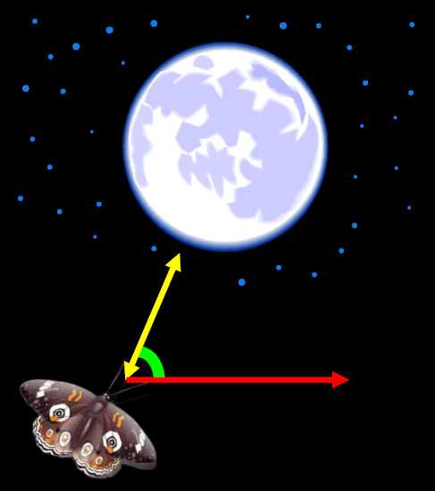

However, in an experiment, it was observed that in presence of a light source extremely close to the moth, leads to the moth confusing the light source with the moon, and navigates similarly with respect to the light source, as it does with respect to the moon. However, since the light source is too close, the moth falls into a deadly spiral, converging into the flame.

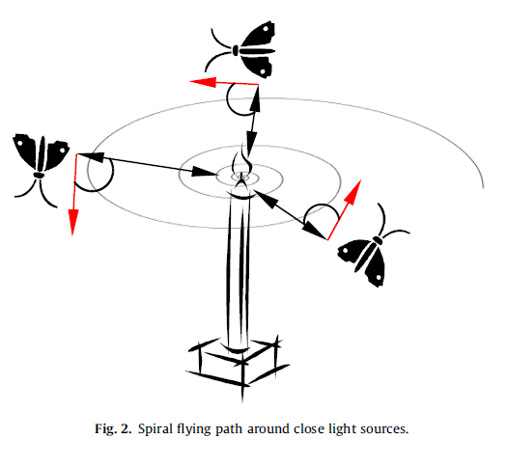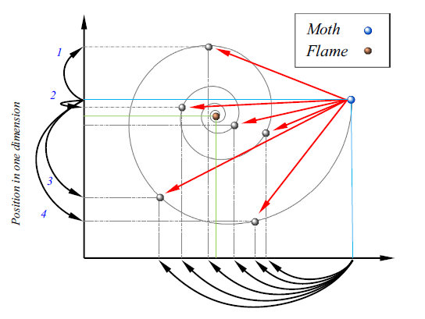

In this algorithm the candidate solutions (search agents) are the moths. The problem’s variables are the positions of the moths in the hyperspace.

## **Gravitational Search Algorithm**

Gravitational Search Algorithm (GSA)[17] is another nature inspired algorithm which is motivated by the Newton’s law of Gravitation, and the laws of motion. It is based on the concept that two masses in space attract each other with a force.

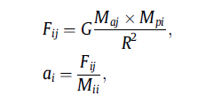

In this algorithm, the candidate solutions are the masses, spread across the hyperspace and each has an associated mass, which dictates the motion of all the search agents, which eventually converge to the most optimal value.

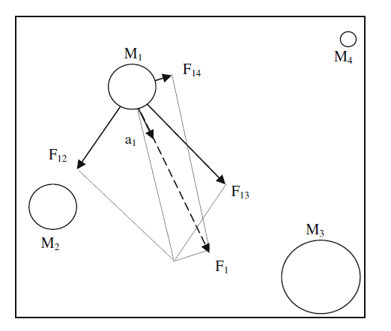

## **Hybrid Algorithm**

The algorithms are themselves very powerful. By using multiple search agents, and adding some degree of randomness in the locomotion, avoid local minima to a large extent. However, the hybrid algorithm seeks for faster convergence, while maintaining the exploration of both the algorithms. This is expected to be achieved through the combined locomotion in every iteration.

MFO, due to its spiral locomotion avoids the local minima, as the agents are not directly attracted towards the optimal flame in a linear trajectory. On the other hand, the locomotion is in a logarithmic spiral, which lets other moths explore the domain, for better optimal value.

GSA, on the other hand, uses a linear force on the search agents while it seeks to converge to the most optimal value. This typically introduces a dominance of the exploitation over exploration.

Thus, in the hybrid algorithm, the exploration of MFO and the exploitation of GSA is exploited, in order to achieve better results, while maintaining the integrity of the optimization algorithms individually, and evading the convergence to any local minima.

### Justification for hybridization

The algorithm exploits the nature of the moth flame optimization, by using its exploratory in nature, and utilizes the exploitation of the gravitational search algorithm. The intuition behind this approach to hybridize these two algorithms is that the MFO utilizes the logarithmic spiral for exploration, while the GSA uses the linear motion for locomotion. This enables the hybrid algorithm to exploit both the properties of the individual algorithm and therefore fit together, covering what the other fails to cover.

The fitness measure is mass for GSA while the fitness measure for MFO is distance to the fittest flame. This adds the variability to exploit both the behavior in a single algorithm, thus rendering the hybrid as a better fit. MFO makes the search agent go around the fittest flame, while GSA ensures faster convergence by bringing all the search agents closer to the fittest search agent. Thus, these algorithms are compatible, and produce the desired effect.

Initialize population with random position, zero velocity, zero acceleration and associate mass with each

Update the position using the velocity

Calculate the velocity of the moth and update it with respect to its previous velocity

Calculate the force on each moth

Update the masses according to the fitness

Associate the first moth with the fittest flame, second with second and so on

Calculate the fitness of each moth

### Pseudo Code

initialize moth_position, moth_velocity, moth_acceleration

calculate initial fitness for each moth

while(iteration < max_iteration)

update flame_number

if (iteration == 1)

F = sort(M)

OF = sort(OM)

else

F = sort(Mt-1, Mt)

OF=sort(Mt−1, Mt);

end

for i=1: n

for j=1: d

Update r and t

D(i) = |F(i) – M(i)|

M(i) = D(i) . ebt . cos(2∏t) + F(j)

end

end

G = G0(1/iteration)^b

for i=1:n

mass(i) = 1/fitness(i)

for j=1:n

r = moth_position(i) – moth_position(j)

F = G*mass(j)/r

End

Moth_velocity(i) = moth_velocity(i)*rand(0,1) + F

Moth_position(i) = moth_position(i)*rand(0,1) + moth_velocity(i)

end

end

# **Testing on Benchmarks and Results**

|  |  |  |
| --- | --- | --- |
| Function | MFO | Hybrid |
| F1 | 6.6092e-21 | 5.9991e-17 |
| F2 | 2.6592e-15 | 0.0010437 |
| F3 | 7.2411e-09 | 2.2439e-17 |
| F4 | 0.0043443 | 0.00031035 |
| F5 | 15.7733 | 8.0849 |
| F6 | 0.12108 | 0.32572 |
| F7 | 0.0046347 | 2.8854e-05 |
| F8 | -2879.4219 | -2471.4722 |
| F9 | 10.9445 | 0 |
| F10 | 4.4409e-15 | 0.00011668 |
| F11 | 0.22639 | 2.9199e-14 |
| F12 | 8.4387e-32 | 0.024027 |
| F13 | 1.992 | 2.9821 |

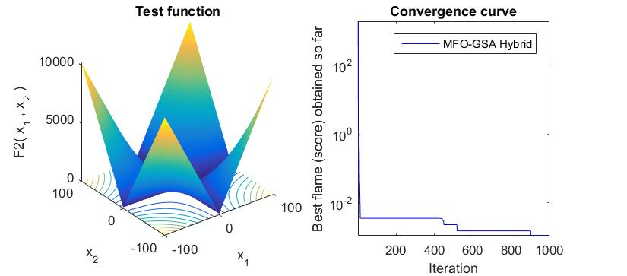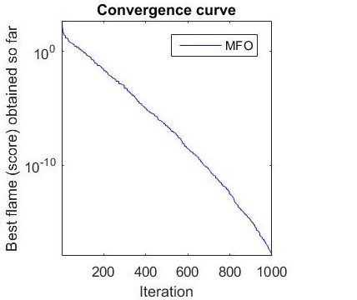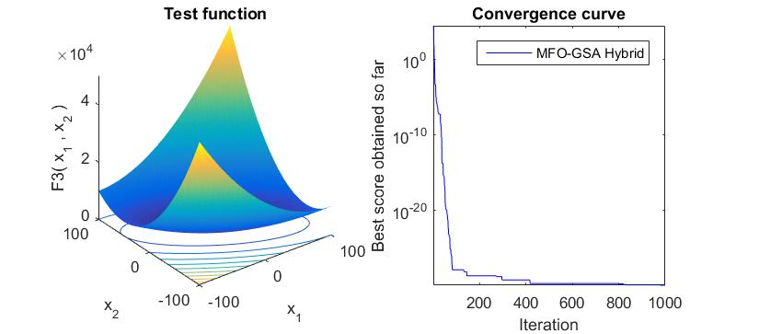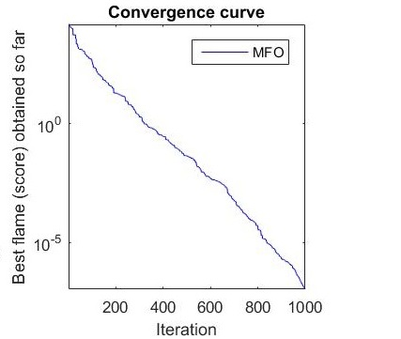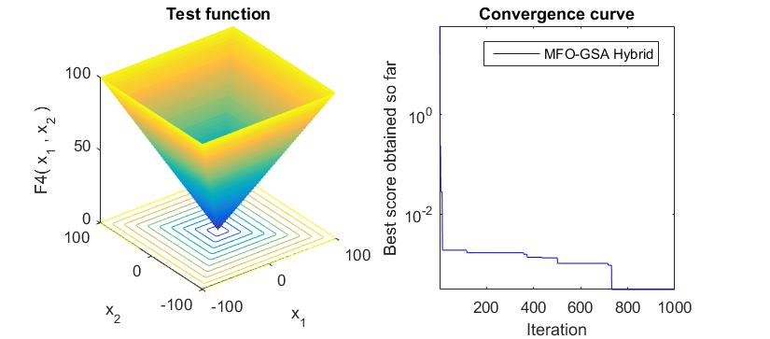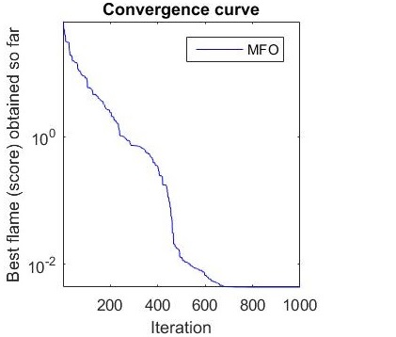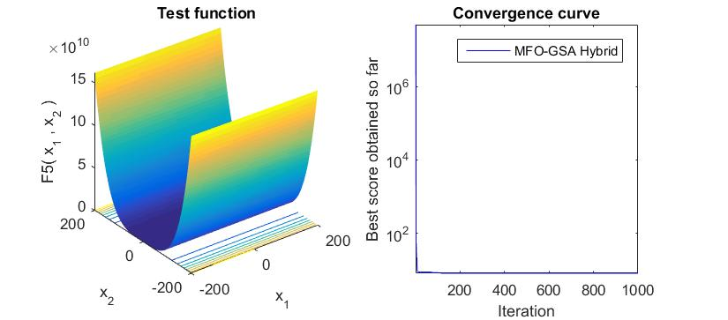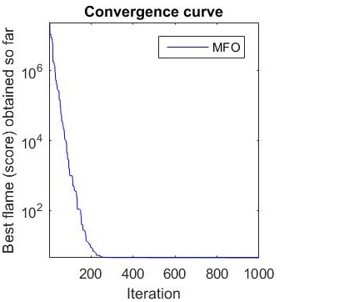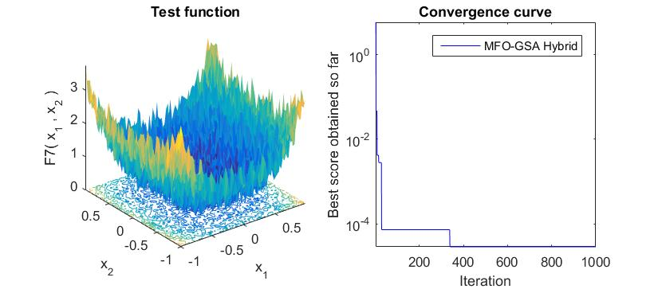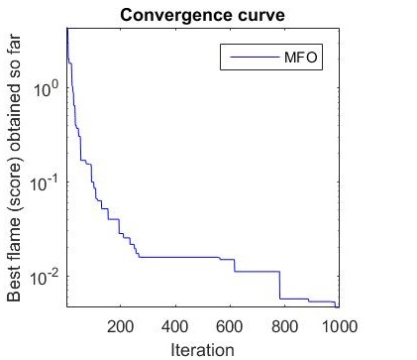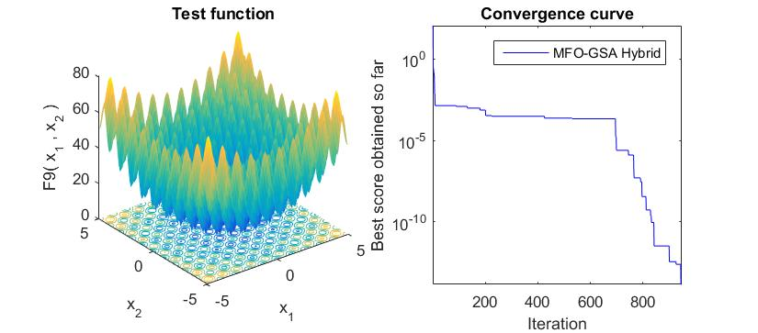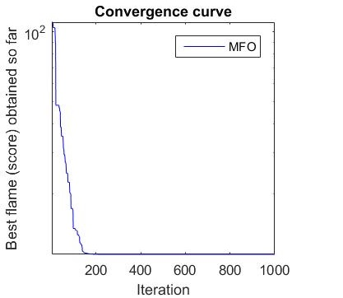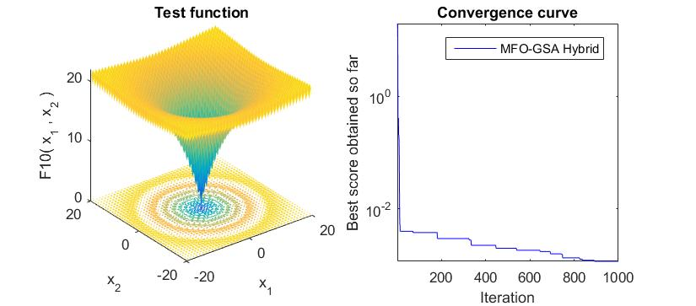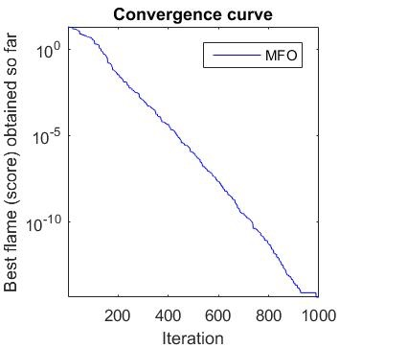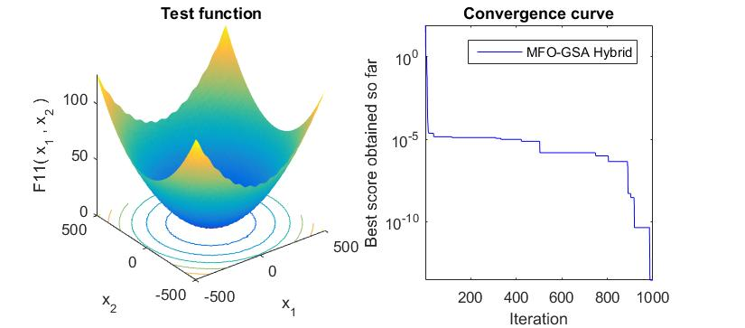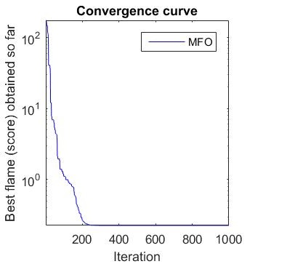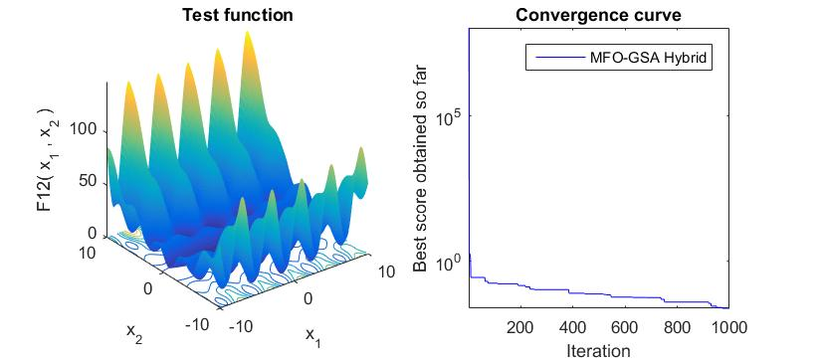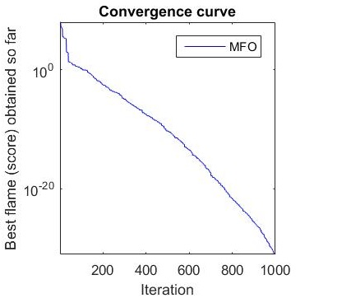

Figure: Comparison between Hybrid and MFO

# **Conclusion**

As evident from the results, the hybrid algorithm performs better in F3, F4, F5, F7, F8, F9 and F11 by reaching a more optimal value. However, the values are comparable in other functions except F1, F2 and F12. However, as seen in the graphs, the convergence is much faster in those cases, where the values are comparable. Therefore, our algorithm shows considerable improvement over MFO alone.

# **References**

[1] - Nanda, Satyasai Jagannath, and Ganapati Panda. "A Survey on Nature Inspired Metaheuristic Algorithms for Partitional Clustering." Swarm and Evolutionary Computation 16 (2014): 1-18. Web.

[2] - Hatamlou, Abdolreza, Salwani Abdullah, and Hossein Nezamabadi-Pour. "Application of Gravitational Search Algorithm on Data Clustering." Rough Sets and Knowledge Technology Lecture Notes in Computer Science (2011): 337-46. Web.

[3] - Hatamlou, Abdolreza, Salwani Abdullah, and Hossein Nezamabadi-Pour. "A Combined Approach for Clustering Based on K-means and Gravitational Search Algorithms." Swarm and Evolutionary Computation 6 (2012): 47-52. Web.

[4] - Osuna-Enciso, Valentı´n, Erik Cuevas, and Humberto Sossa. "A Comparison of Nature Inspired Algorithms for Multi-threshold Image Segmentation." Expert Systems with Applications 40.4 (2013): 1213-219. Web.

[5] - Bülbül, Gonca, Akhtar Hayat, and Silvana Andreescu. "Portable Nanoparticle-Based Sensors for Food Safety Assessment." Sensors 15.12 (2015): 30736-0758. Web.

[6] - Duncan, Timothy V. "Applications of Nanotechnology in Food Packaging and Food Safety: Barrier Materials, Antimicrobials and Sensors." Journal of Colloid and Interface Science 363.1 (2011): 1-24. Web.

[7] - Yang, Tao, Huifen Huang, Fang Zhu, Qinlu Lin, Lin Zhang, and Junwen Liu. "Recent Progresses in Nanobiosensing for Food Safety Analysis." Sensors 16.7 (2016): 1118. Web.

[8] - Mutlu, Mehmet. Biosensors in Food Processing, Safety, and Quality Control. Boca Raton: CRC, 2011. Print.

[9] - Ropodi, A.i., E.z. Panagou, and G.-J.e. Nychas. "Data Mining Derived from Food Analyses Using Non-invasive/non-destructive Analytical Techniques; Determination of Food Authenticity, Quality & Safety in Tandem with Computer Science Disciplines." Trends in Food Science & Technology 50 (2016): 11-25. Web.

[10] - Brosnan, Tadhg, and Da-Wen Sun. "Improving Quality Inspection of Food Products by Computer Vision––a Review." Journal of Food Engineering 61.1 (2004): 3-16. Web.

[11] - Abdullah, Mohd Zaid, Sabina Abdul Aziz, and Abdul Manan Mohamed. "Quality Inspection Of Bakery Products Using A Color-Based Machine Vision System." Journal of Food Quality J Food Quality 23.1 (2000): 39-50. Web.

[12] - Du, Cheng-Jin, and Da-Wen Sun. "Learning Techniques Used in Computer Vision for Food Quality Evaluation: A Review." Journal of Food Engineering 72.1 (2006): 39-55. Web.

[13] - Ma, Ji, Da-Wen Sun, Jia-Huan Qu, Dan Liu, Hongbin Pu, Wen-Hong Gao, and Xin-An Zeng. "Applications of Computer Vision for Assessing Quality of Agri-food Products: A Review of Recent Research Advances." Critical Reviews in Food Science and Nutrition 56.1 (2014): 113-27. Web.

[14] - Ding, Zhuqing, Ruoyu Zhang, and Za Kan. "Quality and Safety Inspection of Food and Agricultural Products by LabVIEW IMAQ Vision." Food Analytical Methods Food Anal. Methods 8.2 (2014): 290-301. Web.

[15] - Miraglia, M., H.j.p. Marvin, G.a. Kleter, P. Battilani, C. Brera, E. Coni, F. Cubadda, L. Croci, B. De Santis, S. Dekkers, L. Filippi, R.w.a. Hutjes, M.y. Noordam, M. Pisante, G. Piva, A. Prandini, L. Toti, G.j. Van Den Born, and A. Vespermann. "Climate Change and Food Safety: An Emerging Issue with Special Focus on Europe." Food and Chemical Toxicology 47.5 (2009): 1009-021. Web.

[16] - "In Brief: Achieving a Transparent, Actionable Framework for Public–Private Partnerships for Food and Nutrition Research." Journal of the Academy of Nutrition and Dietetics 115.8 (2015): 1318-319. Web.

[17] - Goel, Lavika, Daya Gupta, V. K. Panchal, and Ajith Abraham. "Taxonomy of Nature Inspired Computational Intelligence: A Remote Sensing Perspective." 2012 Fourth World Congress on Nature and Biologically Inspired Computing (NaBIC) (2012): n. pag. Web.