1Q. Look at the sum of profits for each Product Sub-Category. Which sub-category is $31,069 below the average profit across all categories?

1. Plot Profit vs Product- Sub Category
2. Calculate the average of all and add a reference band (Avg = 77202)
3. Add Calculation field SUM(PROFIT)-77202

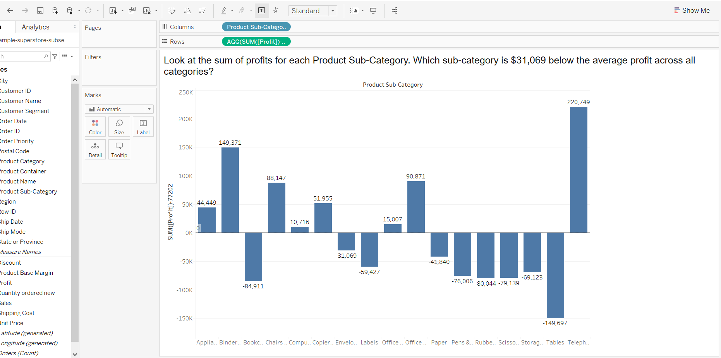

2Q. In the Technology Product Category, which unprofitable state is surrounded by only profitable states?

1. Get the profits of the states and find the unprofitable state surrounded by profitable states

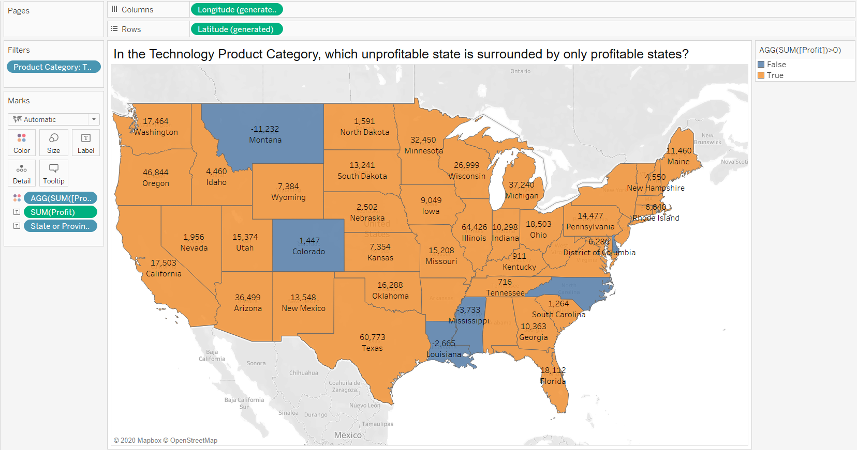

3Q. In which Region do all Product Categories fall beneath the overall average profit?

1. Over the region and the profits add a reference band which calculates the average of the overall table. Thus south category falls beneath.

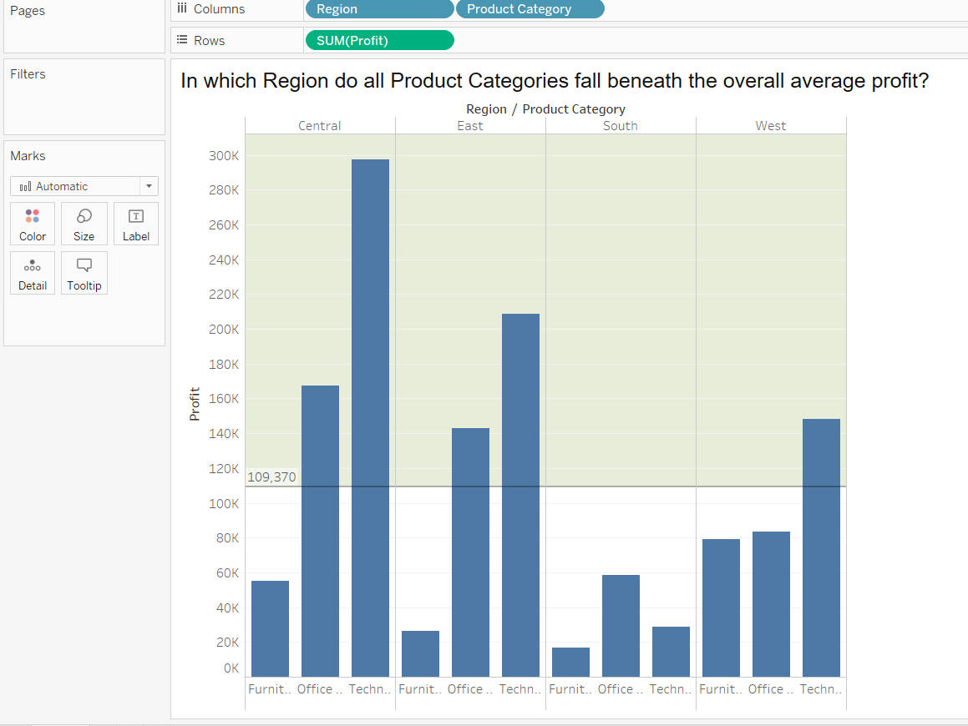

4Q. Upload my file

5Q. Find the customer with the lowest overall profit. What is his/her profit ratio?

1. Plot customer name vs profit. Find the profit ratio (Profit/sales) and sort arranging to the lowest
2. Change the view of the ratio to percentage. Thus Dean Solomon has less ratio.

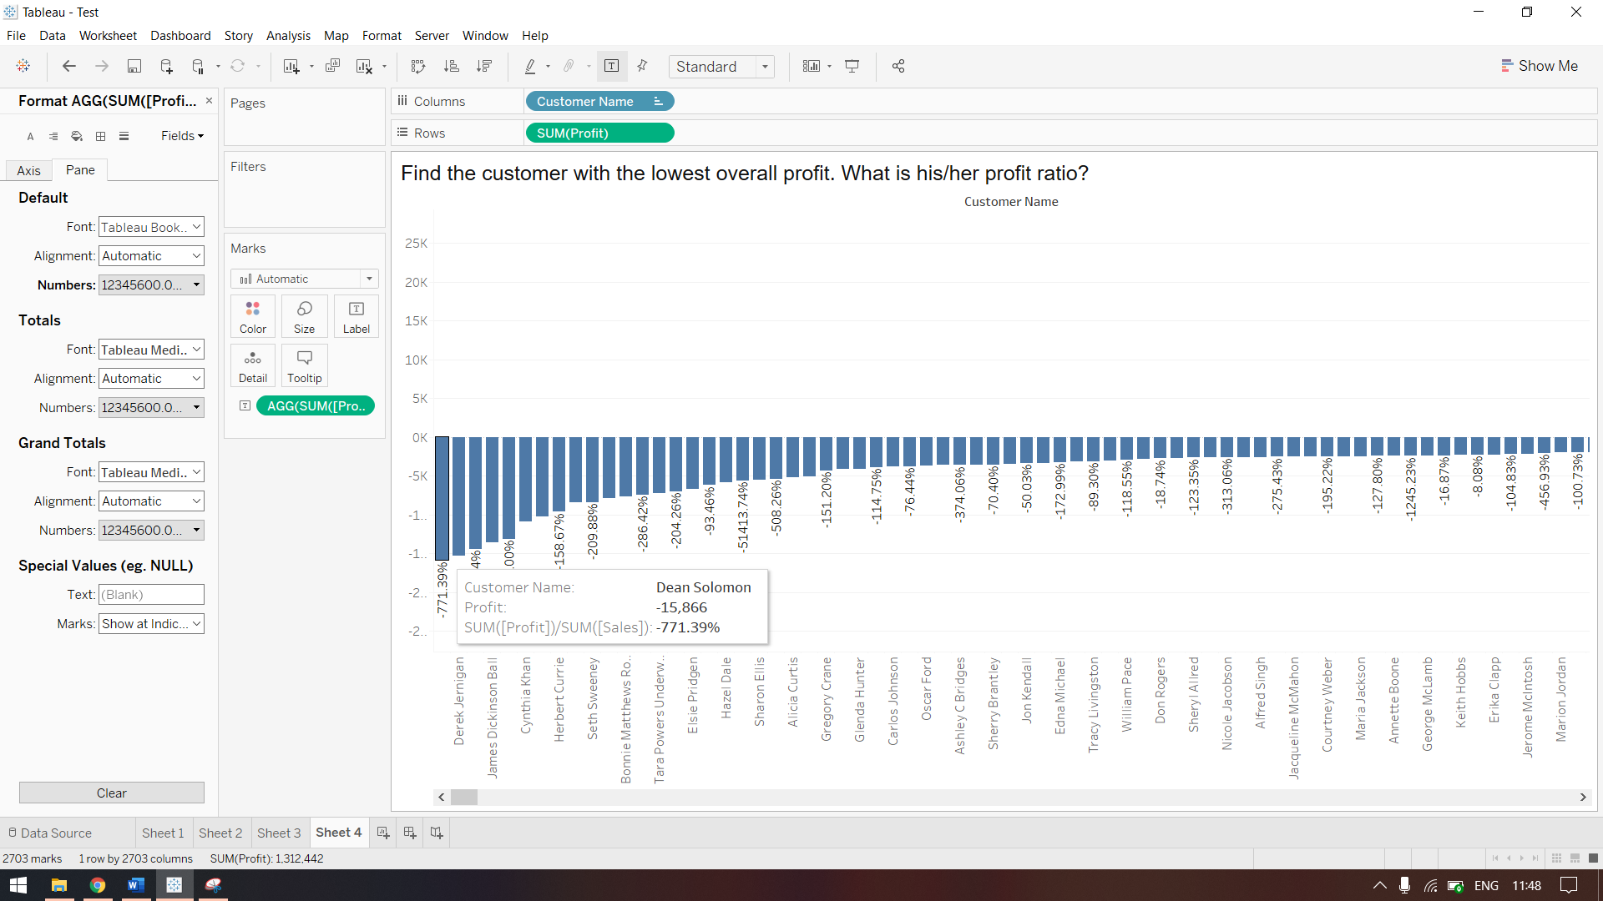

6Q. What is the percent of total Sales for the Home Office Customer Segment in July of 2012?

1. Plot customer segment Vs Sales. You will be getting the overall sales over the years. Add a filter of the order dates (For July 2012 only).
2. Add a calculation field for calculating the percentage of total or go for quick table calculation

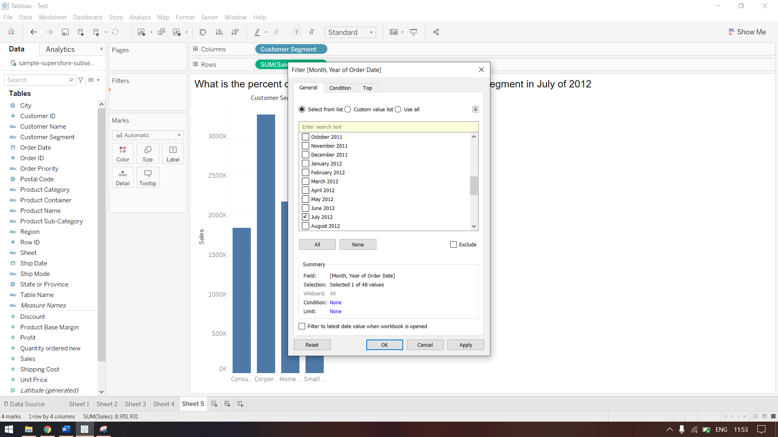

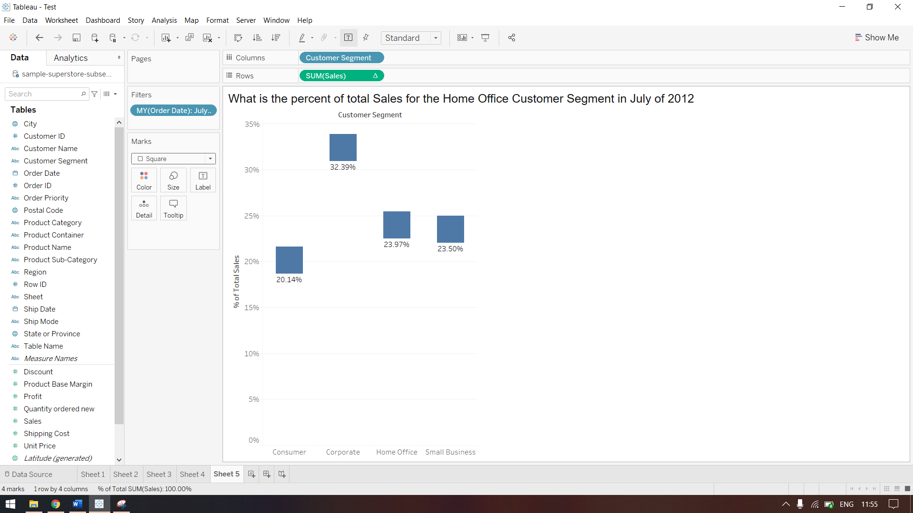

7Q. What was the Moving Average of Sales in June of 2012, including six months prior and six months after?

1. Plot Orderdate ( as Month year) Vs Sales Calculate the moving average by quick table calculation.
2. Edit this calculation field as 6months previous and 6month after. Now the new moving average is displayed and you can view your July moving average in the year 2012.

