Software Requirements Specification

for

Medical Shop Automation (MSA)
Version 1.0 approved
Prepared by
Dampuri Sasi Kumar 19CS10026
Athithya Prakash R 19CS30010
Aditya Anantwar 19CS10006

Table of Contents
Table of Contents ii
Revision History ii
1. Introduction 1
1.1 Purpose 1
1.2 Document Conventions 1
1.3 Intended Audience and Reading Suggestions 1
1.4 Product Scope 1
1.5 References 1
2. Overall Description 2
2.1 Product Perspective 2
2.2 Product Functions 2
2.3 User Classes and Characteristics 2
2.4 Operating Environment 2
2.5 Design and Implementation Constraints 2
2.6 User Documentation 2
2.7 Assumptions and Dependencies 3
3. External Interface Requirements 3
3.1 User Interfaces 3
3.2 Hardware Interfaces 3
3.3 Software Interfaces 3
3.4 Communications Interfaces 3
4. System Features 4
4.1 System Feature 1 4
4.2 System Feature 2 (and so on) 4
5. Other Nonfunctional Requirements 4
5.1 Performance Requirements 4
5.2 Safety Requirements 5
5.3 Security Requirements 5
5.4 Software Quality Attributes 5
5.5 Business Rules 5
6. Other Requirements 5
Appendix A: Glossary 5
Appendix B: Analysis Models 5
Appendix C: To Be Determined List 6

Revision History
Name | Date | Reason For Changes | Version

Introduction

Purpose
This document is meant to delineate the features of Medical Shop Automation, so as to serve as a guide to the developers on one hand and a software validation document for the prospective client on the other. This project is used mainly for medical stores to maintain the details of medical stores such as stock and accounts. This Medical Shop Automation software is so designed as to ease the workload of medical shop professionals. The main feature includes inventory and stock control, accounting, client management

Document Conventions
There are no document conventions as such. Any person reading the document should be easily able to understand its contents.

Intended Audience and Reading Suggestions
This document is intended to assist the users when they use the software and for developers and the project managers to plan their project and implement the software required. This Software Requirement Specification document is divided into five subsections.
Section 1: Introduction
Section 2: Overall Description of the Software giving information about functions, user classes, operating environment, constraints and documentation.
Section 3: External Interface Requirements giving a brief introduction to user, hardware, software and communications interfaces.
Section 4: Gives functional requirements of different features.
Section 5: Provides a list of non-functional requirements
Section 6: Other requirements

Product Scope
Medical Shop Automation is a flexible and adaptive software suited to medical shops. This software accommodates two types of shop owners and employees.
• The shop owner should be able to order items as soon as the number of items in the inventory reduces below a threshold value and at the end of the day the software should be able to generate the items to be ordered.
• The shop owner should be able to store the name, address, and the code numbers of the medicines that each vendor deals with.
• The shop owner should also be able to enter the item code number, quantity, batch number, expiry date, and the vendor number for new supplies and the software should print out a cheque favouring the vendor for the items supplied.
• The shop owner would also be able to enter the code number of each medicine and the corresponding quantity sold and the software should print out the cash receipt.
• Finally, the shop owner should be able to see the revenue and profit for any given period.

Whereas the employees can also be able to do all the functions except he cannot create the new user and cannot view the revenue and profit.

References
IEEE.IEEE Std 830-1998 IEEE Recommended Practice for Software Requirements Specification. IEEE Computer Society, 1998.

Overall Description

Product Perspective
A medical shop Automation needs to maintain its inventory using a computerized system so that it maintains the records of purchases, sales , medicines, vendors and stock details.

Medical Shop Automation is a self-contained product which is designed to ease the workload of medical shop professionals .The main objective for this MSA project is to reduce the workload of the user by easing in the order of medicines whenever some medicines expire or the quantity falls below the threshold value and during billing the software produces a bill which includes the purchased medicines list and its details and the amount to be paid.

2.2 Product Functions
The following functions are provided by the software:
- Login
- Add new user
- Adding new medicines
- Adding new vendors
- Adding Stocks
- Sell medicine
- Listing the expired medicines
- Medicines List(all the medicines )
- Purchase Medicine list (list of medicines that are less than a threshold value)
- Vendor list
- View users
- Sales list
- Revenue and Profit

User Classes and Characteristics

The software has the following user classes:
- Owner (or admin) :
The owner can create an account by entering his ID, name and contact no etc. He can perform all the functions described above and also has access to see the sales records and can also view the profit and revenue.
- Employee :
The employee can login by entering his name and password but cannot create any new account. The employee can only be added by an owner . Employees can access various functions like Adding new medicines , Adding new vendors , Adding Stocks, Sell medicine ,Listing the expired medicines, Medicines List,Order list , Vendor list but cannot have access to view the revenue and profit.

Operating Environment
Operating System: Ubuntu, Windows 7,8,10
Language: The front-end has been designed using
HTML, CSS and JavaScript and the database used for the development of this software is MySQL .
Medical shop Automation is a web-based system. It will have a server which will perform all the functions and the details of the medicines as well as the information about various medicine-vendors will be stored in databases

Design and Implementation Constraints

- Employees and Owners must login themselves in order to access the system features.
- Passenger ID and password will be required at the time of login.
- The Employees user id and password should be provided by the owner.
- The price of a particular medicine is assumed to be constant unless it is modified by the owner of the medical shop ,that is, no dynamic pricing algorithm is used by the software.
- Advanced security measures have not been implemented to protect the database.
- The employees or owners ensure that the information is entered correctly.
2.5 User Documentation
License and User Manual will be provided along with the software.

Assumptions and Dependencies
- The user must be familiar with the internet.
- The user must be connected to the internet to use the software.
- The accuracy of the personal information entered by the customer shall be the responsibility of the customer.

External Interface Requirements

User Interfaces
Medical Shop Automation System incorporates an interactive website which is easy to navigate and use. The interface mainly consists of forms, buttons and tables. Any errors are displayed using alerts or extra divisions clearly stating the error. Also extra information is also shown via pop-up modals or alerts depending on the use case.
Upon opening the URL for the website, the user sees a login page with the fields of username and password. The site is meant to be used by two types of users, admin and employee. The type of user is automatically detected by the website based on login credentials.
After successful login, all the features of the website will be accessible to the user based on the type of the user.
Admin:
All features including the ability to check revenue and profits over a duration. The admin also has the ability to create a new user.
Employee:
All features except the ability to check the revenue and profits.
Following are the concept diagrams of various interfaces that the users will see for the various features: -
1. Login Page
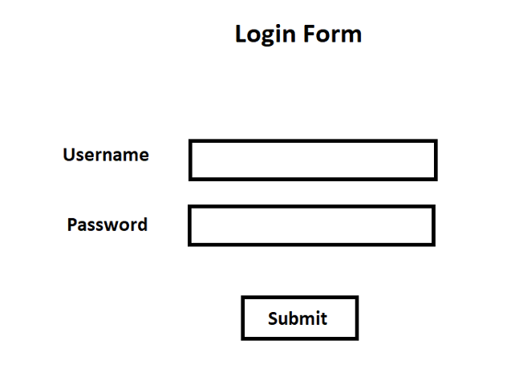
The submit button submits the entered username and password for validation
2. Add User
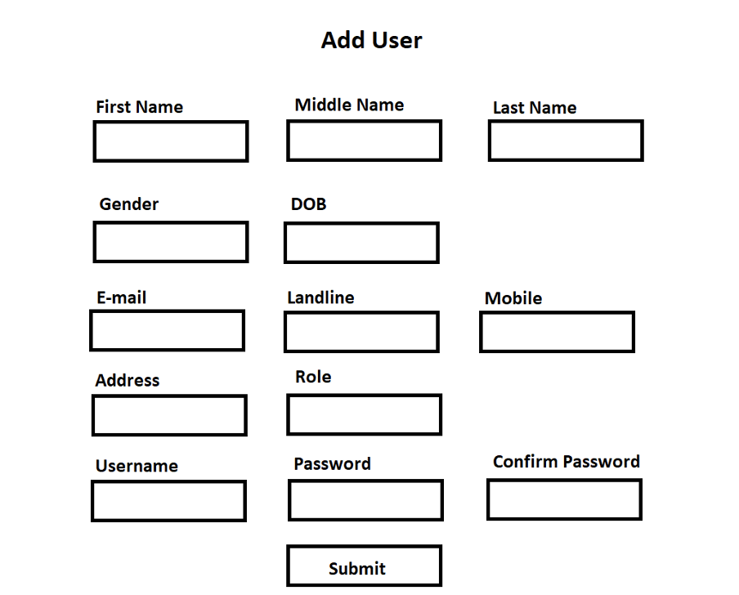
The admin can add new employees or admins from here. Enter the data in the form fields and then submit the data. It is checked whether password and confirm password match. If yes, the data is added to the database in the appropriate table. If not, an error message pops up.
3. Add New Medicine
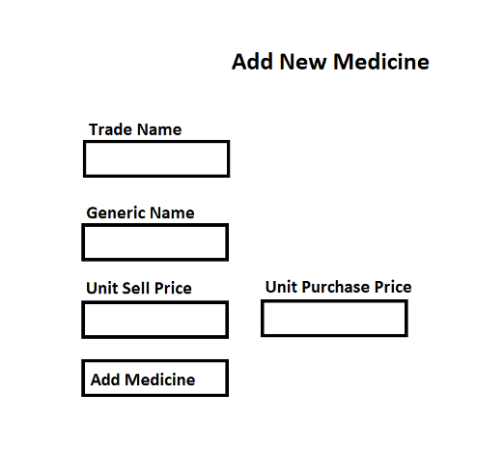

Enter the appropriate information in the labelled fields and then submit the data by clicking the Add Medicine button. On submitting the data a pop-up will show the medicine ID for the newly added medicine which can be noted by the user for labelling the rack for the new medicine.
4. Add new Vendor
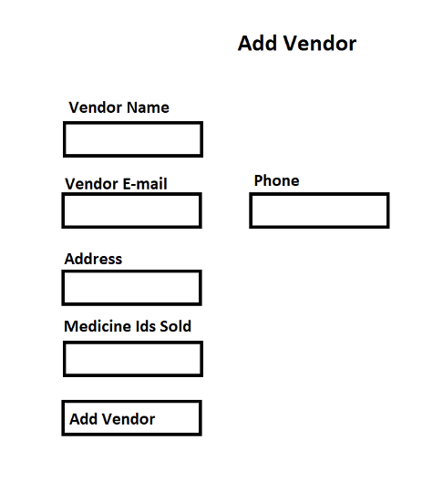
Enter the details for the vendor and submit the data by clicking on the Add Vendor button. After submitting the data a pop-up window shows the vendor ID which can be noted for future reference.

5. Add Stock
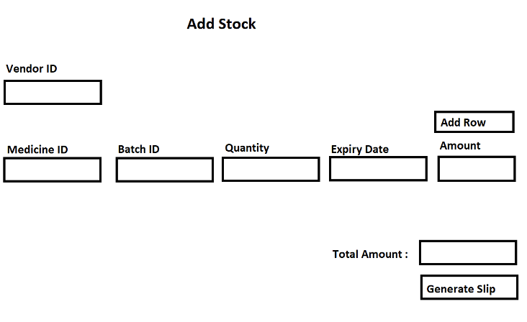
When new stock is purchased, details corresponding to the same can be added in the form fields. If more than one type of medicine is purchased, the Add Row button can be clicked to add another row. The total amount is calculated for the entire purchase based on the purchase price in the database corresponding to each medicine ID purchased. Then the generate slip button can be pressed to generate the cheque for the stock in the name of the vendor.
6. Sell Medicine

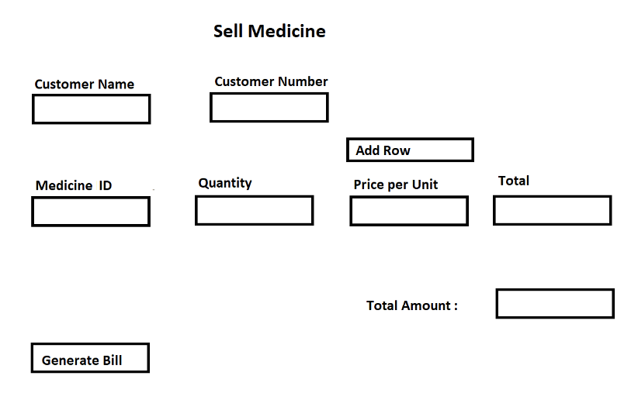
When selling medicine, the medicine ID and quantity can be entered by the employee. The corresponding selling price per unit is taken from the database and the total for the medicine is calculated and displayed. Add Row adds another row for another medicine ID. The Total amount is calculated and a bill can then be generated by clicking the Generate Bill button. This will submit the data to the database and will create a pdf for the bill and also save on the server for future reference.
7. View Expired Medicine
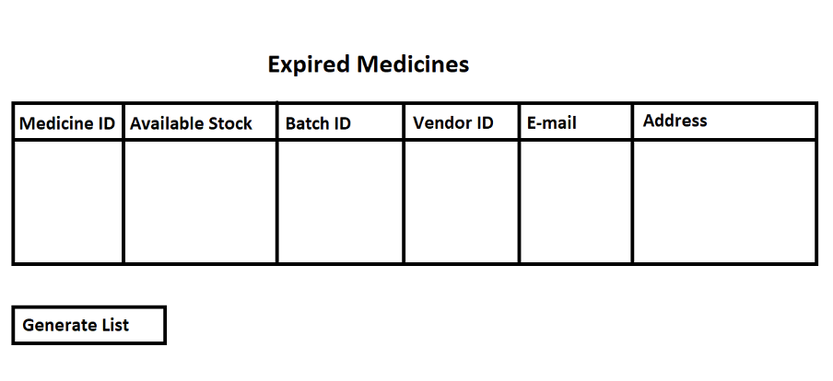
If any medicine in stock is expired, it is displayed in the table above along with the vendor details who supplies the particular medicine. Then a list can be generated for these medicines by clicking the Generate List Button. This deletes the particular batch of medicines from the database and creates a pdf with the vendor IDs and details for each medicine.

8. Order List

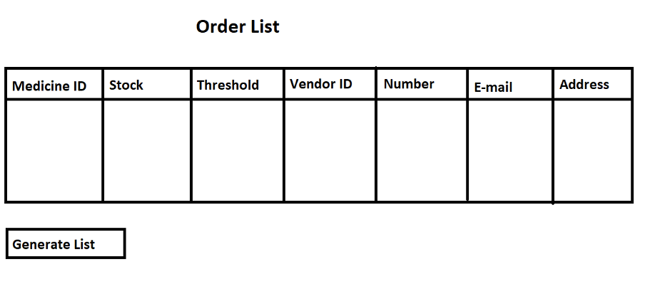
Each medicine has a certain weekly threshold and the stock should ideally be above this threshold value. If the stock ever drops below the threshold value, the medicine ID along with the vendor details can be seen in this table. Clicking on the generate List buttons creates a pdf with all the medicine IDs and the corresponding vendor details so that the owner can order a restock.

9. Sales List
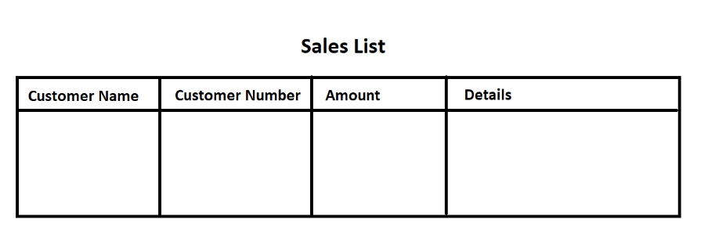

This table shows the details for every sale that has occurred. The details column stores the URL to the bill.
10. Medicines List
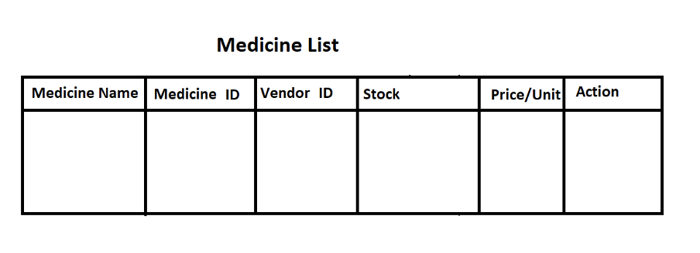
The list of all the medicines sold by the store is in this table. A functionality to search the medicines in the table using the generic name may be added for quick reference. The action column has the option to edit the details corresponding to a medicine. Clicking on the edit button deletes the entry for the corresponding medicine in the database and redirects to the add-new-medicine page.
11. Vendor List
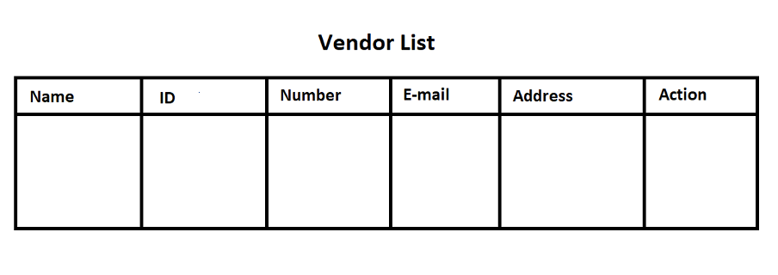
The list of all the vendors supplying the store is available in this table. A functionality to search vendors based on their id may be added for quicker reference. The action column gives an option to edit details corresponding to a vendor. On clicking edit the data of the vendor is deleted from the table and the page redirects to the add new vendor page
12. Revenue and Profit
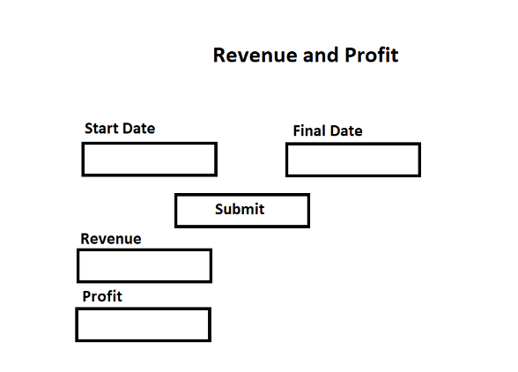
The revenue generated over a period of time can be seen by the user. The admin can enter the start date and the final date. After clicking the submit button, the data is submitted and the corresponding revenue and profit are calculated and displayed to the admin.
13. List Users
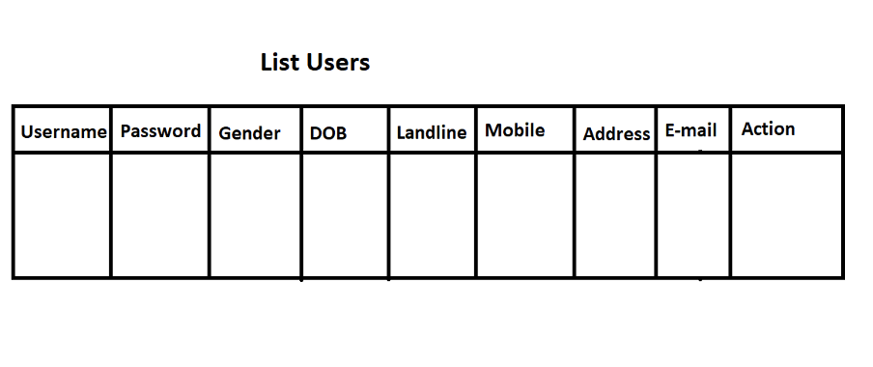
The users added by the admin are visible in this table. The users options can be edited by clicking the edit button in the actions column.

Hardware Interfaces
The working of the website requires a server where the database and the webpage accompanying the backend are hosted. For the user, they will need a desktop or mobile phone with a compatible browser (all top browsers like Chrome, Firefox, etc.) to run the website.

Software Interfaces
The website requires a standard browser to run on like Google Chrome, Mozilla Firefox, Microsoft Edge, Safari, etc. Additional software interfaces used for the development of this product include:
Back-End:
Medical Shop Automation System interfaces with a Database Management System(DBMS). The database used for the development of this software is MySQL. The database has multiple tables to full-fill the wide array of functionality offered by the system. The database can store data and appropriate APIs have been designed to respond to queries to achieve the various functionalities of the system.
Front-End:
The front-end has been designed using HTML, CSS and JavaScript.
Web-framework:
The web framework used is Django 3.1.7.

Communications Interfaces
The communication architecture must follow the client-server model. Communication between the client and server should utilize a REST-compliant web service and must be served over HTTP Secure (HTTPS). The client-server communication must be stateless. A uniform interface must separate the client roles from the server roles.

System Features

This subsection provides details about the identified functional requirements of the software.

4.1 Login

4.1.1 Description and Priority

Takes username and password from the user and checks whether the credentials are valid. This is a High Priority feature as it controls who can use the software.

4.1.2 Stimulus/ Response Sequence

After the user clicks the submit button, the entered credentials are validated. If the user exists and the password is correct, the user gets access to the website and is redirected to the home page. Else a pop-up stating the credentials are incorrect shows up.

4.1.3 Functional Requirements

REQ 1: The user should see two form fields on the screen, one which takes string input while the other takes password input.

REQ 2: The user should be able to submit the entered credentials on clicking a SUBMIT button.

REQ 3: On clicking the SUBMIT button, the entered credentials should be validated using a POST request to the server backend which authenticates the login based on user data in the database. On successful validation, the users page should redirect to the home page. On failure, a pop-up should show up stating login credentials were invalid.

4.2 Create New User

4.2.1 Description and Priority

Used to add a new user for the system. Has a form which takes as input first name, middle name, last name, gender, date of birth, e-mail, address and username as CharFields(string). It also takes landline number and mobile number as long integer fields. Role is a dropdown field to choose whether the added person is an admin or an employee. Password and confirm password are password fields.

This is a High Priority feature as it is necessary to add new employees for the system.

4.2.2 Stimulus/ Response Sequence

The entered data is submitted when the user clicks the SUBMIT button. It is checked whether the password and confirm password fields match, if yes the data is added to the database. Else a pop-up shows that the password and confirm password fields did not match.

4.2.3 Functional Requirements

REQ 1: The user should be able to see a form with all the required fields.

REQ 2: On clicking the submit button, the data should be sent for validation where the password and confirm password fields should be matched.

REQ 3: If both the passwords are equivalent, then the new users data should get stored in the database in the appropriate table and the page should refresh. If the passwords are not equivalent, a pop-up window should show up stating the same.

4.3 Add New Medicine

4.3.1 Description and Priority

Used to add a new medicine to the stores list of medicines. It has a form which takes as input trade name and generic name as CharFields(string) and unit sell price and unit purchase price as integer values.

This is a High Priority feature as the store needs medicines in its inventory to sell them.

4.3.2 Stimulus/ Response Sequence

The entered data is submitted when the user clicks the ADD MEDICINE button. After submitting the data, it is added to the appropriate table in the database and a unique Medicine ID is generated which is returned as an HTTP Response. This is then displayed as a pop-up so that the user can save it as a label to the rack where this new medicine will be stored.

4.3.3 Functional Requirements

REQ 1: The user should be able to see the form with the necessary fields.

REQ 2: On clicking the ADD MEDICINE button, the data should be sent for validation. The system should check whether the medicine already exists in the database. If no, the data is added to the database and a new Medicine ID is generated. If yes, then a pop-up is displayed that the medicine already exists.

REQ 3: After the medicine is successfully added to the database, a pop-up should display the Medicine ID of the newly added medicine.

4.4 Add New Vendor

4.4.1 Description and Priority

Used to add a new vendor (supplier) to the store for medicines. It has a form which takes as input the vendor name, vendor e-mail and address as CharFields(string) and the phone as an integer field. The medicine ids sold are comma separated medicine ids for medicines already in the database which are sold by the vendor.

4.4.2 Stimulus/ Response Sequence

On pressing the ADD VENDOR button, the data of the form is submitted. After submitting the data, it is added to the database in the appropriate table if it is not a duplicate. After adding the vendor details to the table, a unique Vendor ID is generated and returned as an HTTP response which is displayed as a pop-up to the user.

4.4.3 Functional Requirements

REQ 1: The user should be able to see the form with the necessary fields.

REQ 2: On clicking the ADD VENDOR button, the data would be sent for validation. The system checks whether the vendor already exists in the database. If no, then the data is added to the database in the appropriate table and a unique Vendor ID is generated and returned as response. If yes, then a pop-up shows that the vendor already exists.

REQ 3: After the vendor is successfully added to the database, a pop-up shows the unique Vendor ID for the newly added vendor.

4.5 Add Stock

4.5.1 Description and Priority

Used to add stock of existing medicines after they have been delivered. It takes as input the medicine id, batch id, quantity and expiry date as input. It has provisions to add multiple types of medicines at the same time. It calculates the amount per batch using the purchasing price of the corresponding medicine and totals up the amount to be paid to the vendor. It can then be used to draw a cheque in the name of the vendor.

This is a high priority feature.

4.5.2 Stimulus/ Response Sequence

On pressing the Generate slip button, the data is submitted. If any medicine ID or the vendor ID is not found in the database, then an error is raised as a pop-up and the stock is not updated. If no error is generated, the stock for the corresponding medicines is increased by the quantity supplied. Then a cheque pdf is generated which can then be printed by the user to give to the vendor.

4.5.3 Functional Requirements

REQ 1: The user should be able to see the form with all the necessary fields.

REQ 2: Clicking on the ADD ROW button should add a row for cases where more than one medicines are supplied.

REQ 3: On clicking the generate Slip button, the amounts corresponding to each row and the total amount to be paid should be calculated and displayed if there is no error. If the vendor id or some medicine id is not found, the appropriate error is raised in a pop-up window.

REQ 4: The user should then be able to generate a cheque in the name of the vendor.

4.6 View Expired Medicine

4.6.1 Description and Priority

At the end of each day the user can see what medicines have expired and need replacement as a table on this page. The table gives the medicine id, the available stock (other than the expired batch), the batch id that has expired, the vendor id and their email and address for getting the replacement.

4.6.2 Stimulus/ Response Sequence

When the user clicks the Generate List button, all the batches of medicines which are displayed and are expired get deleted from the database and a pdf is generated with the medicine ids and vendor details who can be contacted to replace the respective medicines.

4.6.3 Functional Requirements

REQ 1: The user should be able to view the table containing the medicine id and vendor details.

REQ 2: When the Generate List button is clicked, the database should be appropriately updated and a pdf should be generated to help the user to replace these medicines.

4.7 View Order List

4.7.1 Description and Priority

The store should have an inventory of medicines higher than a certain threshold at all times. Any medicines whose stock in the inventory has gone below a pre-decided threshold are shown in the table in the order list along with the vendors who can supply the medicines.

This is a Medium Priority Feature.

4.7.2 Stimulus/ Response Sequence

When the user clicks the generate list button, a pdf is generated with the medicine ids and the corresponding vendor details who can supply the particular medicine. This helps the user to get the stock back up conveniently.

4.7.3 Functional Requirements

REQ 1: The system should be able to calculate what the threshold for each medicine would be. It does this by initially assuming a value of 100 and then updating itself according to weekly sales.

REQ 2: The user should be able to see the table with all the medicines and vendor details necessary.

REQ 3: When the user clicks generate list, the system should generate a pdf with the medicine ids, stock, threshold and vendor details for each medicine.

4.8 Revenue and Profit

4.8.1 Description and Priority

This page is available only to admins. The admins can enter any two dates and calculate the revenue generated between these two dates and the profits.

This is a Low Priority Feature.

4.8.2 Stimulus/ Response Sequence

When the admin enters the start date and the end and submits the data by clicking the Get Revenue button, the data is submitted to the backend. Then it is checked whether the start and end dates are valid. If yes, the revenue is calculated based on the total sales and profit is calculated by subtracting the purchase price and the cost of expired medicines. Then this data is displayed to the admin.

4.8.3 Feature Requirements

REQ 1: Only admins should be able to access the page. In case an employee tries to open the page, they should get a pop-up stating the page is only for admins.

REQ 2: The admin should be able to enter the start and end dates.

REQ 3: The date submitted should be checked whether they are valid. If yes, the revenue and profits should be calculated and the the data should be sent as a response to the page.

4.9 Medicine List

4.9.1 Description and Priority

A table showing the details of all the medicines available in the inventory of the store. It also has an option to edit an entry. I the future, it may get a search bar for quick access.

It is a Low Priority feature.

4.9.2 Stimulus/ Response Sequence

If the edit option is clicked the page redirects to the add-new-medicine page where we can re-enter the details for the medicine with the necessary changes. This updates the corresponding row in the database table with data regarding all medicines.

4.9.3 Feature Requirements

REQ 1: The user should be able to see a table of all the medicines in the inventory.

REQ 2: The edit option for each row should allow editing the medicine in the database.

REQ 3: A search option, where the medicine can be searched by the generic name, may be added in the future.

4.10 Vendor List

4.10.1 Description and Priority

A table showing the information regarding all the vendors who supply the store. It has an option to edit the details regarding every vendor. In the future, a feature to search the vendor by name may be added.

It is a Low Priority Feature.

4.10.2 Stimulus/ Response Sequence

If the edit option is pressed, the page redirects to the add-new-vendor page where the user can enter the new vendor details and then the corresponding details of the vendor will be updated in the database.

4.10.3 Feature Requirements

REQ 1: The details of all the vendors supplying the store should be shown in a table.

REQ 2: The edit option for each row should allow editing the vendor in the database.

REQ 3: A search option, where the vendor can be searched by the vendor name, may be added in the future.

4.11 List Users

4.11.1 Description and Priority

A table showing the information regarding all the users (admins and employees) of the system. It has the order to edit the details regarding all the users. Only admins can access this page.

It is a Low Priority Feature.

4.11.2 Stimulus/ Response Sequence

If the edit option is pressed/ the page redirects to the add new user page where the user can enter the details of the person and then the corresponding data in the database will be updated.

4.11.3 Feature Requirements

REQ 1: This page should only be available to the admins. If an employee opens this, a pop-up should tell that the page is accessible only to admins.

REQ 2: The edit option for each row should allow editing the users in the database.

Other Nonfunctional Requirements

Performance Requirements
• The product should be based on a local server.
• The product requires access to different databases.
• The response time of the software should be less than 2 seconds most of the time. Response time refers to the waiting time while the system accesses, queries and retrieves data from the databases.
• The performance depends on hardware components.
• The software shall show no visible deterioration in response time as the number of medicines increases.

Safety and Security Requirements
• Medical Shop Management System shall be able to recover from hardware failures, power failures and other natural catastrophes and rollback the databases to their most recent valid state.
• Since it is a web based application, there will definitely be chances of internet based threats such as viruses. The software should try and minimize these threats as much as possible.
• Only the administrator has the right to manage and make changes to the database parameters.The system is secure and will protect the database.

Software Quality Attributes
Availability:
Medical Shop Automation will be available 24 hours a day, 7 days a week.
Correctness:
Medical Shop Automation shall provide real time data.
Maintainability:
Various versions of the product should be easy to maintain. For development it should be easy to add new code to the system, modify the existing code or incorporate new features to the software.

Robustness:
The software shall be robust enough to have a high degree of fault tolerance. For example, the system should not crash if the user enters an invalid input. It should display a suitable error message.
Usability:
• Medical Shop Automation shall provide an easy to use graphical interface similar to existing reservation systems so that users don’t need to adapt to new interface features.
• The interface should be interactive and easily navigable. Users should be able to understand the menu and other features of the software.
Any error message displayed by the software shall be polite and clear

Business Rules
This software should be used only after a proper contract agreement with the company developing it.
In case of any problems the user should immediately contact the project manager. The software should not be outsourced to any third party without prior permission.

Other Requirements
· Licensing requirements: Applicable
· Legal, Copyright and Other notices: All rights reserved by our organization.
· Applicable Standards: It should be as per the industry standards

