**1st Hands On Exercise**

App.js

import *logo* from './logo.svg';  
import './App.css';  
  
function App() {  
 return <h1>Welcome to the first session of React</h1>  
}  
  
export default App;

App.css

h1 {  
 text-align: center;  
}

Output



**2nd Hands On Exercise**

App.js

import './App.css';  
import { Home } from "./components/Home";  
import { About } from "./components/About";  
import { Contact } from "./components/Contact";  
  
function App() {  
 return (  
 <>  
 <div className="container">  
 <Home/>  
 <About/>  
 <Contact/>  
 </div>  
 </>  
 )  
}  
  
export default App;

Home.js

import { Component } from "react";  
  
export class Home extends Component {  
 render() {  
 return (  
 <div>  
 <h3>Welcome to the Home page of Student Management Portal</h3>  
 </div>  
 )  
 }  
}

About.js

import { Component } from "react";  
  
export class About extends Component {  
 render() {  
 return (  
 <div>  
 <h3>Welcome to the About page of Student Management Portal</h3>  
 </div>  
 )  
 }  
}

Contact.js

import { Component } from "react";  
  
export class Contact extends Component {  
 render() {  
 return (  
 <div>  
 <h3>Welcome to the Contact page of Student Management Portal</h3>  
 </div>  
 )  
 }  
}

App.css

.container {  
 display: flex;  
 flex-direction: column;  
 align-items: center;  
  
}



**Q3) Hands On Exercise**

App.js

import './App.css';  
import { CalculateScore } from "./components/CalculateScore";  
  
function App() {  
 return (  
 <CalculateScore  
 Name={"Steeve"}  
 School={"DNV Public School"}  
 total={284}  
 goal={3}  
 />  
 )  
}  
  
export default App;

CalculateScore.js

import '../Stylesheets/mystyle.css'  
  
const percentToDecimal = (decimal) => {  
 return (decimal.toFixed(2) + '%')  
}  
const calcScore = (total, goal) => {  
 return percentToDecimal(total / goal)  
}  
  
export const CalculateScore = ({Name, School, total, goal}) => (  
 <div className="formatstyle">  
 <h1><font color="Brown">Student Details:</font></h1>  
 <div className="Name">  
 <b> <span> Name: </span></b>  
 <span>(Name)</span>  
 </div>  
 <div className="School">  
 <b> <span> School: </span> </b>  
 <span>{School}</span>  
 </div>  
 <div className="Total">  
 <b><span>Total:</span> </b>  
 <span>{total}</span>  
 <span>Marks</span>  
 </div>  
 <div className="Score">  
 <b>Score:</b>  
 <span>  
 {calcScore(total, goal)}  
 </span>  
 </div>  
 </div>  
)

myStyle.css

.Name {  
 font-weight: 300;  
 color: blue;  
}  
  
.School {  
 color: crimson;  
}  
  
.Total {  
 color: darkmagenta;  
}  
  
.formatstyle {  
 text-align: center;  
 font-size: large;  
}  
  
.Score {  
 color: forestgreen;  
}

Output –



**Q4) Hands On Exercise**

App.js

import './App.css';  
import { Posts } from "./components/Posts";  
  
function App() {  
 return (  
 <Posts />  
 )  
}  
  
export default App;

Posts.js

import { Component } from "react";  
  
export class Posts extends Component {  
 constructor(props) {  
 super(props);  
 this.state = {  
 posts: [],  
 }  
 }  
  
 loadPosts() {  
 fetch("https://jsonplaceholder.typicode.com/posts")  
 .then(res => res.json())  
 .then(res => {  
 *console*.log("Posts loaded", res);  
 this.setState({posts: res});  
 })  
 }  
  
 componentDidMount() {  
 this.loadPosts()  
 }  
  
 componentDidCatch(error, errorInfo) {  
 *console*.log("Error", error);  
 }  
  
 render() {  
 return <>{this.state.posts.map(post => <p key={post.id} >{post.body}</p>)}</>  
 }  
  
}

Post.js

export class Post {  
 constructor(id, title, body) {  
 this.id = id;  
 this.title = title;  
 this.body = body;  
 }  
}

Output –

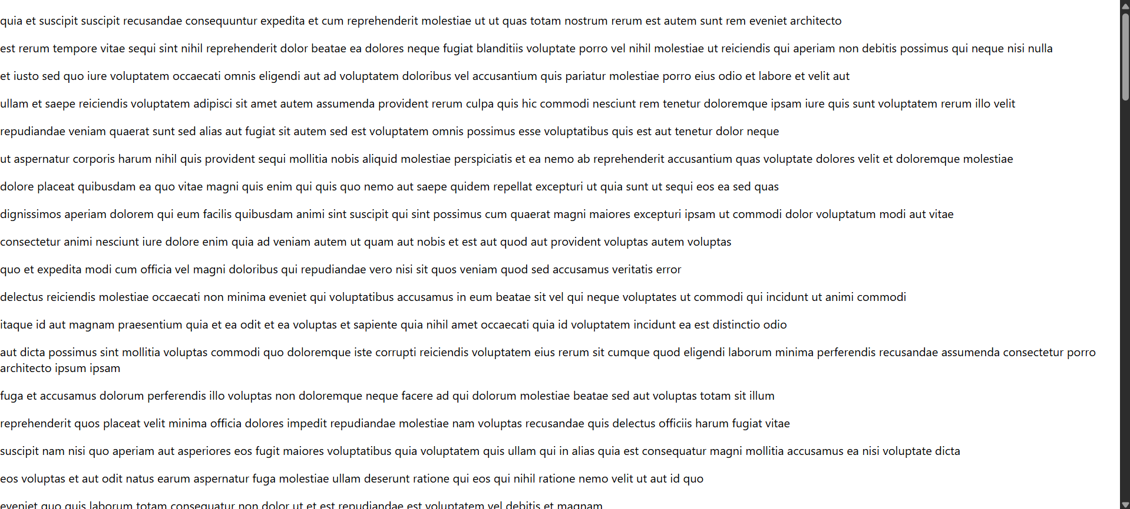

**Q5) Hands On Exercise**

CohortDetails.module.css

.box {  
 width: 300px;  
 display: inline-block;  
 margin: 10px;  
 padding: 10px 20px;  
 border: 1px solid black;  
 border-radius: 10px;  
}  
  
dt {  
 font-weight: 500;  
}

CohortDetails.js

import React from "react";  
import styles from "./CohortDetails.module.css";  
  
const CohortDetails = ({ name, status }) => {  
 const headingColor = status === "ongoing" ? "green" : "blue";  
  
 return (  
 <div className={styles.box}>  
 <h3 style={{ color: headingColor }}>{name}</h3>  
 <dl>  
 <dt>Status:</dt>  
 <dd>{status}</dd>  
 </dl>  
 </div>  
 );  
};  
  
export default CohortDetails;

App.js

import React from "react";  
import CohortDetails from "./CohortDetails";  
  
function App() {  
 return (  
 <div>  
 <CohortDetails name="React Bootcamp" status="ongoing" />  
 <CohortDetails name="Spring Boot Camp" status="completed" />  
 </div>  
 );  
}  
  
export default App;

Output –

