Q9) React hands on exercise

import { ListofPlayers } from "./components/ListofPlayers";  
import { EvenPlayers, OddPlayers } from "./components/OddPlayers";  
import { ListOfPlayersMerged } from "./components/ListOfPlayersMerged";  
  
function App() {  
  
 const flag = false  
  
 const T20Players = ["Player A", "Player B", "Player C"];  
 const RanjiTrophyPlayers = ["Player D", "Player E", "Player F"];  
  
 const IndianPlayers = [...T20Players, ...RanjiTrophyPlayers]  
  
 if (flag) {  
 return (  
 <ListofPlayers/>  
 )  
 }  
  
 return (  
 <>  
 <h1>Indian team odd players</h1>  
 <OddPlayers arr={IndianPlayers} />  
  
 <h1>Indian team even players</h1>  
 <EvenPlayers arr={IndianPlayers} />  
  
 <h1>List of players merged</h1>  
 <ListOfPlayersMerged arr={IndianPlayers} />  
 </>  
 )  
  
}  
  
export default App;

import React from "react"  
  
export function ListOfPlayersMerged({arr}) {  
 return (  
 <>  
 {arr.map(item => <li>{item}</li>)}  
 </>  
 )  
}

import React from 'react';  
  
export const ListofPlayers = () => {  
 const players = [  
 {name: "Virat", score: 90},  
 {name: "Rohit", score: 65},  
 {name: "Gill", score: 72},  
 {name: "Rahul", score: 68},  
 {name: "Surya", score: 88},  
 {name: "Pant", score: 45},  
 {name: "Hardik", score: 81},  
 {name: "Jadeja", score: 67},  
 {name: "Ashwin", score: 30},  
 {name: "Bumrah", score: 10},  
 {name: "Shami", score: 25}  
 ];  
  
 const lowScorers = players.filter(player => player.score < 70);  
  
 return (  
 <div>  
 <h2>All Players</h2>  
 <ul>  
 {players.map((player, i) => (  
 <div key={i} >  
 <li>Mr. {player.name} {player.score}</li>  
 </div>  
 ))}  
 </ul>  
  
 <h2>{"Players with Score < 70"}</h2>  
 <ul>  
 {lowScorers.map((player, idx) => (  
 <li key={idx}>{player.name} - {player.score}</li>  
 ))}  
 </ul>  
 </div>  
 );  
};

import React from "react"  
  
export function OddPlayers({arr}) {  
 const [first,,third,,fifth] = arr;  
  
 return (  
 <div>  
 <li>First: {first}</li>  
 <li>Third: {third}</li>  
 <li>Fifth: {fifth}</li>  
 </div>  
 )  
  
}  
  
export function EvenPlayers({arr}) {  
 const [, second, ,fourth, , sixth] = arr;  
  
 return (  
 <div>  
 <li>Second: {second}</li>  
 <li>Fourth: {fourth}</li>  
 <li>Sixth: {sixth}</li>  
 </div>  
 )  
  
}

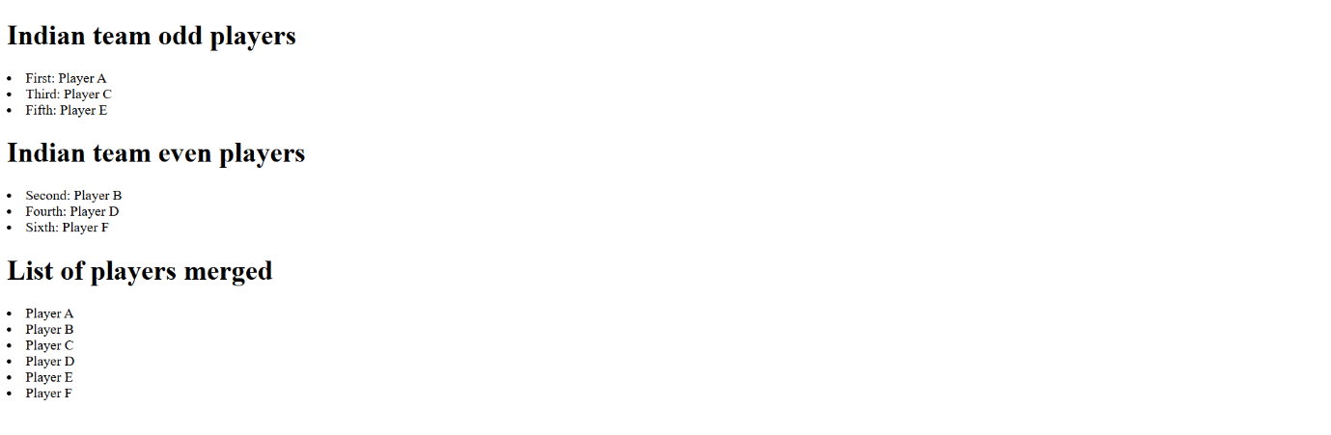

Q10) React hands on exercise

function App() {  
  
 const element = "Office Space "  
  
 const src = "https://assets.executivecentre.com/assets/Banner-Product-PrivateOffice.jpg"  
  
 const itemName = {name: "DBS", rent: 50000, address: "Chennai"}  
  
 return (  
 <>  
 <h1>{element}, at Affordable Range</h1>  
 <img src={src} alt={"Office Space"} width="25%" height="25%" />  
 <h1>Name: {itemName.name}</h1>  
 <h1 style={{color: itemName.rent < 60000 ? "red" : "green"}} >Rent: {itemName.rent}</h1>  
 <h1>Address: {itemName.address}</h1>  
 </>  
 )  
  
}  
  
export default App;

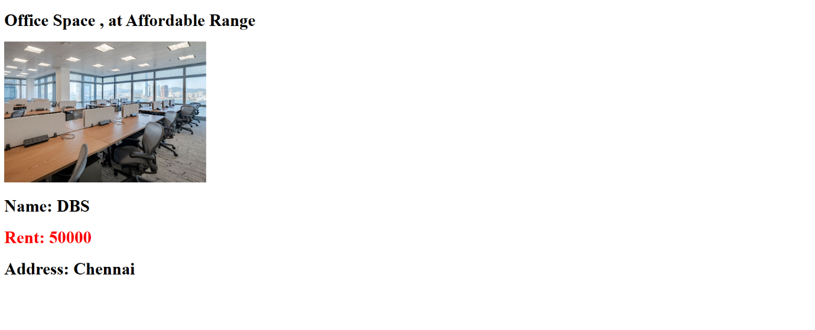

Q11) React hands on exercise

import { useState } from "react";  
  
function App() {  
  
 const [number, setNumber] = useState(0);  
 const [currency, setCurrency] = useState(0);  
  
 const staticMessage = "John"  
  
 function welcome() {  
 alert(`Hello ${staticMessage}!`);  
 }  
  
 function increment() {  
 setNumber(prev => prev + 1);  
 welcome();  
 }  
  
 function decrement() {  
 setNumber(prev => prev - 1);  
 welcome()  
 }  
  
 function clickEventHandler() {  
 alert("button was clicked!");  
 }  
  
 function convert() {  
 alert(currency \* 80);  
 }  
  
 return (  
 <>  
 <h1>{number}</h1>  
 <button onClick={increment}>increment</button> <br />  
 <button onClick={decrement}>decrement</button> <br />  
 <button>Say Welcome</button> <br />  
 <button onClick={clickEventHandler} >Click on me</button> <br />  
  
 <h1 style={{color: "red"}} >Currency Convertor</h1>  
 <input onChange={e => setCurrency(Number(e.target.value))} />  
 <br />  
 <textarea value={"Euro"} />  
 <br />  
 <button onClick={convert} >Convert</button>  
  
 </>  
 )  
  
  
}  
  
export default App;

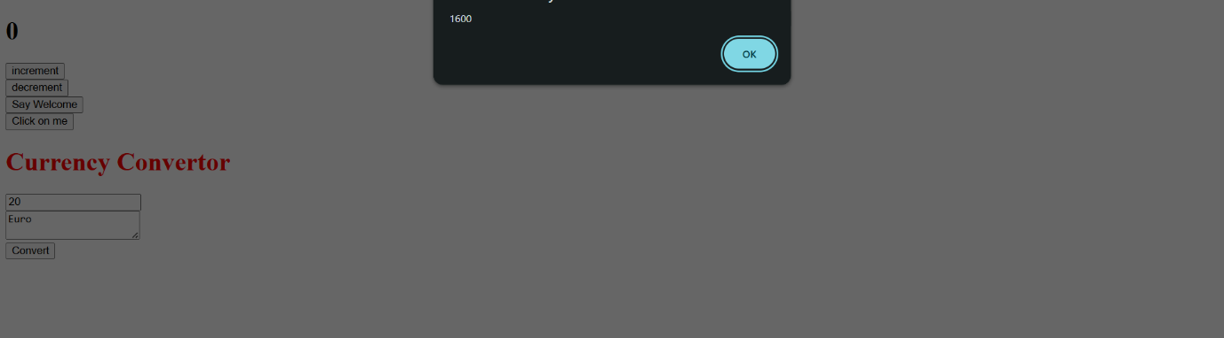

Q12) React hands on exercise

import { Greeting } from "./components/Greeting";  
  
function App() {  
  
 return <Greeting isLoggedIn={false} />  
  
}  
  
export default App;

import React, { useState } from "react"  
import { UserGreeting } from "./UserGreeting";  
import { GuestGreeting } from "./GuestGreeting";  
  
export function Greeting(props) {  
  
 const [isLoggedIn, setLoggedIn] = useState(props.isLoggedIn)  
  
 function onClick() {  
 setLoggedIn(prev => !prev)  
 }  
  
 if( isLoggedIn ) {  
 return <UserGreeting onClick={onClick} />  
 }  
  
 return <GuestGreeting onClick={onClick} />  
}

import React from "react";  
  
export function UserGreeting({onClick}) {  
 return (  
 <>  
 <h1>Welcome back</h1>  
 <button onClick={onClick} >Logout</button>  
 </>  
 )  
}

import React from "react";  
  
export function GuestGreeting({onClick}) {  
 return (  
 <>  
 <h1>Please Sign Up</h1>  
 <button onClick={onClick} >Login</button>  
 </>  
 )  
}

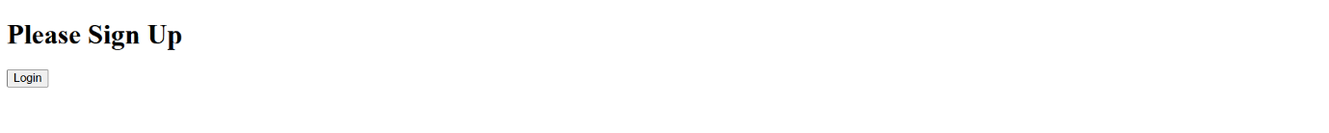

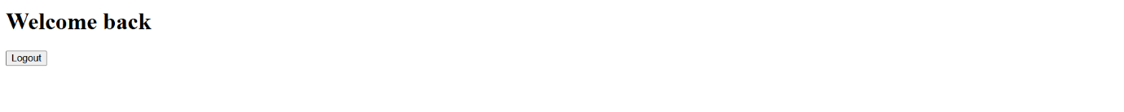

Q13) React hands on exercise

import React from 'react';  
import './App.css';  
  
const books = [  
 { id: 101, bname: 'Master React', price: 670 },  
 { id: 102, bname: 'Deep Dive into Angular 11', price: 800 },  
 { id: 103, bname: 'Mongo Essentials', price: 450 },  
];  
  
const BookDetails = (props) => (  
 <ul>  
 {props.books.map((book) => (  
 <div key={book.id}>  
 <h3>{book.bname}</h3>  
 <h4>{book.price}</h4>  
 </div>  
 ))}  
 </ul>  
);  
  
function App() {  
 return (  
 <div className="container">  
 <div className="section">  
 <h2>Course Details</h2>  
 <div>  
 <strong>Angular</strong>  
 <p>4/5/2021</p>  
 </div>  
 <div>  
 <strong>React</strong>  
 <p>6/3/20201</p>  
 </div>  
 </div>  
  
 <div className="section">  
 <h2>Book Details</h2>  
 <BookDetails books={books} />  
 </div>  
  
 <div className="section">  
 <h2>Blog Details</h2>  
 <div>  
 <strong>React Learning</strong>  
 <p><b>Stephen Biz</b></p>  
 <p>Welcome to learning React!</p>  
 </div>  
 <div>  
 <strong>Installation</strong>  
 <p><b>Schwezdenier</b></p>  
 <p>You can install React from npm.</p>  
 </div>  
 </div>  
 </div>  
 );  
}  
  
export default App;

.container {  
 display: flex;  
 justify-content: space-around;  
 padding: 20px;  
}  
  
.section {  
 padding: 10px;  
 border-left: 3px solid green;  
}  
  
.section h2 {  
 font-weight: bold;  
 margin-bottom: 10px;  
}  
  
.section div {  
 margin-bottom: 20px;  
}

