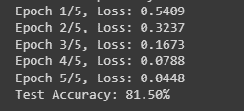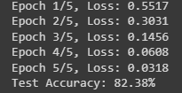

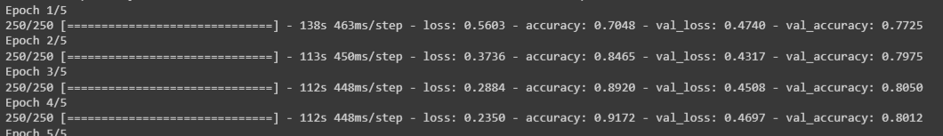

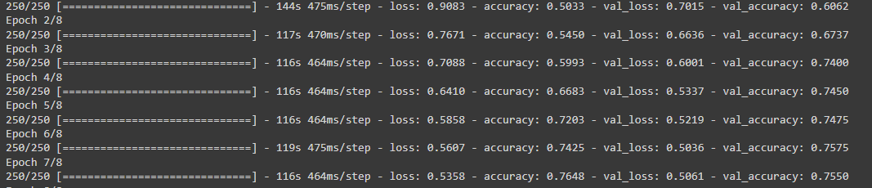

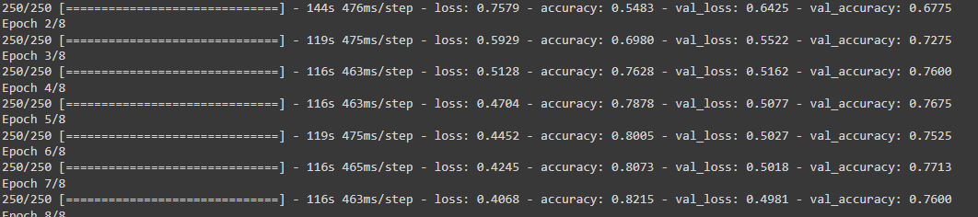

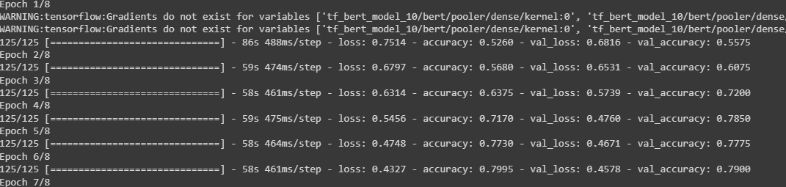

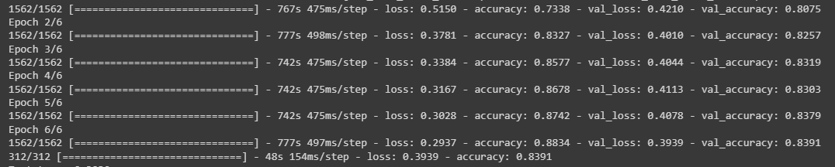

LATEST:

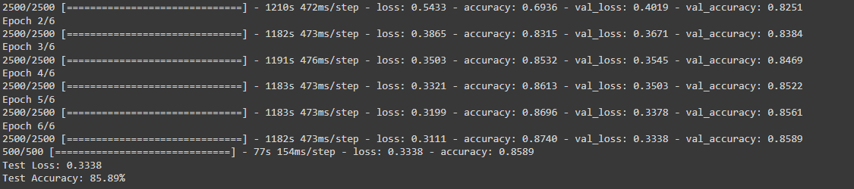

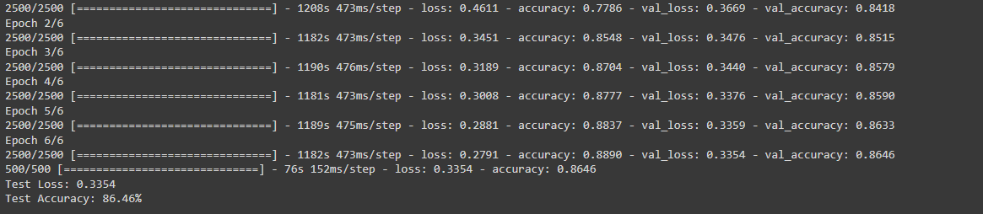

Reddit -0 p-2k neg-2k

Imdb-0 p-4k neg-4k

Twitter-0 p-4k neg-4k 25 25 25

Finance-1 p-500 neg-500 n-1k

Amazon-amazon-0 p-6k neg-6k

Amazon-1 p-6k neg-6k n-10k

Amazon-1 p-3k neg-3k n-142

Emotion n-5k

Email n-9k