WEEK 5 CD LAB
Aditya Aryan Sahu 230905560

CSE –B
Roll- 64

Questions:

Q1. Count the number of vowels and consonants in the given input.

CODE:
%{
#include<stdio.h> int vow=0;
int cons=0;
%}

%%
[aeiouAEIOU] {vow++;} [a-zA-Z] {cons++;}
\n {return 0;}
. {;}
%%

int yywrap() { return 1;} int main()
{

char stat[20]; printf("Enter your input: ");
//scanf("%s",stat);
yylex(); //reads ther input(no need of scanf) printf("vpw= %d copns= %d",vow,cons);
}

OUTPUT:

Q2. Count the number of words, characters, blanks and lines in each text.

CODE:
%{
#include<stdio.h> int w=1;
int c=0; int bl=0; int line=1;
%}

%%
\n {line++;w++;} " " {bl++;w++;}
\t {bl++;}
. {c++;}
%%

int yywrap() { return 1;} int main()
{

char stat[20]; printf("Enter your input: ");
//scanf("%s",stat);
yylex(); //reads ther input(no need of scanf)
printf("\nwords= %d characters= %d blanks=%d lines=%d",w,c,bl,line);
}

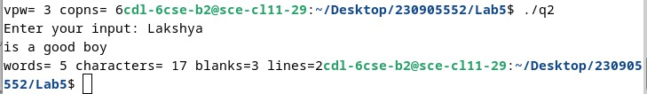
OUTPUT:

Q3. Find the number of positive integer, negative integer, positive floating positive number and negative floating point number.

CODE:
%{
#include<stdio.h>
int p=0,n=0,pf=0,nf=0;
%}

%%
[-][0-9]+ {n++;}
[0-9]+ {p++;}
"-"[0-9]+\.[0-9]+ {nf++;}
[0-9]+\.[0-9]+ {pf++;}
%%

int yywrap() { return 1;} int main()
{

char stat[20]; printf("Enter your input: ");
//scanf("%s",stat);
yylex(); //reads ther input(no need of scanf)
printf("\npositive= %d negative= %d pos_float=%d neg_float=%d",p,n,pf,nf);
}

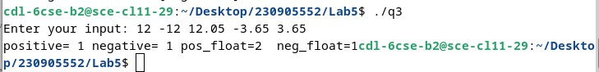
OUTPUT:

Q4. Given a input C file, replace all scanf with READ and printf with WRITE statements also find the number of scanf and printf in the file.

CODE:
%{
#include<stdio.h> int s_count=0;
int p_count=0;
%}

%%
"scanf" { s_count++; printf("READ"); } "printf" { p_count++; printf("WRITE"); }
. { printf("%s", yytext); }
\n { printf("%s", yytext); }
%%

int yywrap() { return 1; }

int main()
{

FILE *fp;
printf("Enter file name: "); char str[100]; scanf("%s",str);
fp = fopen(str, "r"); if(fp==NULL)
{
printf("Error haha"); return 1;
}
yyin=fp; yylex();

printf("Number of scanf: %d\n", s_count); printf("Number of printf: %d\n", p_count);

return 0;
}

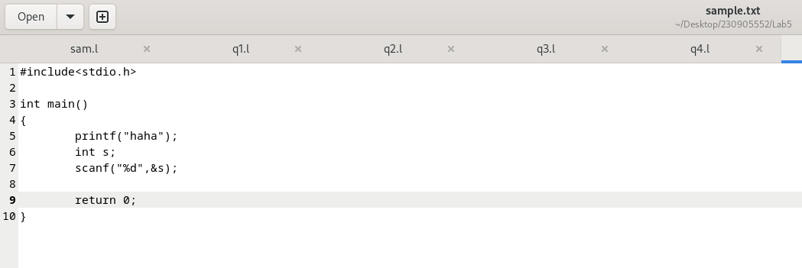
INPUT FILE:

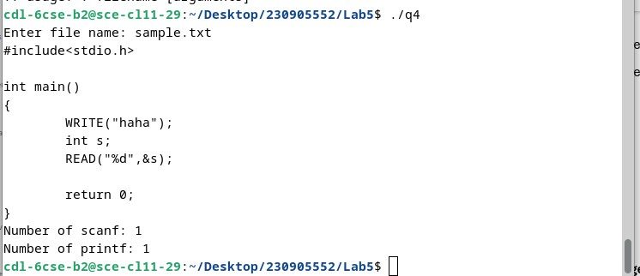
OUTPUT:

Q5. That changes a number from decimal to hexadecimal notation.

CODE:
%{
#include <stdio.h> #include <stdlib.h>
%}

%%
[0-9]+ {

int decimal = atoi(yytext); //str to int conv

printf("%X", decimal);
}

. { printf("%s", yytext); }
\n { printf("%s", yytext); }
%%

int yywrap() { return 1;
}

int main() {
printf("Enter decimal numbers:\n"); yylex();
return 0;
}

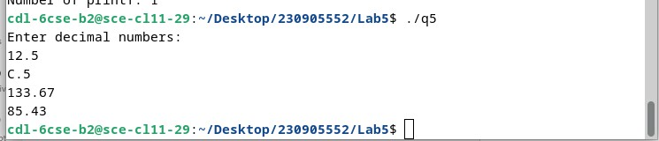
OUTPUT:

Q6. Convert uppercase characters to lowercase characters of C file excluding the characters present in the comment.

CODE:
%{

#include<stdio.h> int s_count=0; i
nt p_count=0;

%}

%%

[a-z] {printf("%c",yytext[0]-32); }

[A-Z] {printf("%c",yytext[0]+32); }

/* "//"[a-z]* { char c; while ((c = input()) != '\n' CC c != 1); printf("%s",yytext); }*/ "//" { printf("%s", yytext);
char c;

while ((c = input()) != '\n' CC c != 0)

{

putchar(c);

}

if (c == '\n') putchar('\n'); }
. { printf("%s", yytext); }

\n { printf("%s", yytext); }

%%

int yywrap() { return 1; } int main() {
FILE *fp;

printf("Enter file name: "); char str[100]; scanf("%s",str);
fp = fopen(str, "r"); if(fp==NULL)
{ printf("Error haha"); return 1; }

yyin=fp; yylex();

//printf("Number of scanf: %d\n", s_count);

// printf("Number of printf: %d\n", p_count); return 0;

}

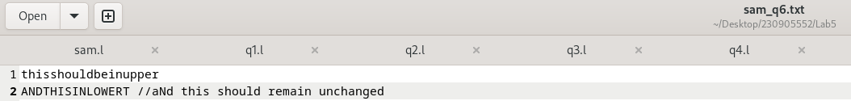
INPUT FILE:

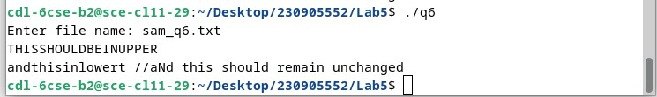
OUTPUT:

