AI/ML-Based Adaptive CPU Scheduling Algorithm for Dynamic Workload Optimization
Operating System (BCSE303P) | Project Report
Faculty: Dr. Anisha M. Lal
Team Members: Aditya Avva (24BAI0048); Ribhav Aggarwal (24BAI0246)

Abstract
CPU scheduling determines how ready processes receive processor time. FCFS, SJF, Priority Scheduling and Round Robin each have different trade-offs, and a single fixed policy may not suit every workload. This project implements a simulation of these four algorithms and an adaptive prototype that classifies a generated workload as CPU-intensive, I/O-intensive or mixed. A lightweight nearest-centroid classifier selects a scheduling policy, and the simulator reports waiting time, turnaround time, response time, throughput and CPU utilization. The prototype is intended for controlled comparison; it does not modify an operating-system kernel, and no universal performance improvement is assumed.

1. Introduction and Problem Statement
Scheduling decisions affect responsiveness, waiting time, turnaround time and resource utilization. Traditional algorithms rely on fixed rules or assumptions about burst duration and priority. This project investigates whether workload classification can guide policy selection across different synthetic workload categories.

2. Objectives
- Implement FCFS, non-preemptive SJF, non-preemptive Priority, and Round Robin.
- Generate CPU-intensive, I/O-intensive and mixed process sets.
- Extract simple workload features and classify workload type.
- Map the predicted class to a scheduling policy and simulate execution.
- Compare standard scheduling metrics and discuss overhead, fairness and limitations.

3. Design and Methodology
The program generates processes with arrival time, CPU burst and priority. Workload features are mean CPU burst, burst-time standard deviation, fraction of bursts at most five time units, and normalized arrival-time span. A nearest-centroid classifier is fitted on synthetic labelled examples. It predicts the workload class, after which an explicit policy map selects SJF for CPU-intensive, Round Robin for I/O-intensive, and Priority for mixed workloads.
FCFS runs processes in arrival order. SJF chooses the available process with the shortest burst and is non-preemptive. Priority scheduling chooses the available process with the smallest numeric priority and is non-preemptive. Round Robin cycles through the ready queue using a configurable time quantum.

4. Metrics
- Waiting time = turnaround time − CPU burst time.
- Turnaround time = completion time − arrival time.
- Response time = first CPU start − arrival time.
- Throughput = completed process count / elapsed workload duration, measured from the first process arrival to the last completion.
- CPU utilization = total CPU service demand / elapsed workload duration x 100, using the same first-arrival-to-last-completion window.
Idle gaps between process arrivals are included in the workload window and reduce utilization; any idle time before the first arrival is excluded. These are simulated metrics, not live operating-system measurements.

5. Experimental Results
The included results were generated by the current program with workload seed 42, classifier seed 123, 10 processes per workload, and Round Robin quantum 4. They are reproducible simulation results, not measurements from a real operating system. Results vary with workload configuration. The adaptive policy is reported alongside the four fixed algorithms; it is not assumed to be the winner on every metric. The CSV also records throughput, utilization, configuration, predicted class, and selected policy.
Workload | Algorithm | Avg wait | Avg turnaround | Avg response | CPU util.
CPU-intensive | FCFS | 60.60 | 74.50 | 60.60 | 100.0%
CPU-intensive | SJF | 49.60 | 63.50 | 49.60 | 100.0%
CPU-intensive | Priority | 60.70 | 74.60 | 60.70 | 100.0%
CPU-intensive | Round Robin | 92.10 | 106.00 | 17.20 | 100.0%
I/O-intensive | FCFS | 10.50 | 12.90 | 10.50 | 100.0%
I/O-intensive | SJF | 6.00 | 8.40 | 6.00 | 100.0%
I/O-intensive | Priority | 10.80 | 13.20 | 10.80 | 100.0%
I/O-intensive | Round Robin | 12.00 | 14.40 | 9.10 | 100.0%
Mixed | FCFS | 33.60 | 41.50 | 33.60 | 100.0%
Mixed | SJF | 22.60 | 30.50 | 22.60 | 100.0%
Mixed | Priority | 33.70 | 41.60 | 33.70 | 100.0%
Mixed | Round Robin | 44.60 | 52.50 | 14.20 | 100.0%
For the included seed-42 run, throughput is 0.071942 processes/time unit for CPU-intensive, 0.416667 for I/O-intensive, and 0.126582 for mixed workloads; simulated CPU utilization is 100% for each. These values describe this generated workload only, not a general performance claim.
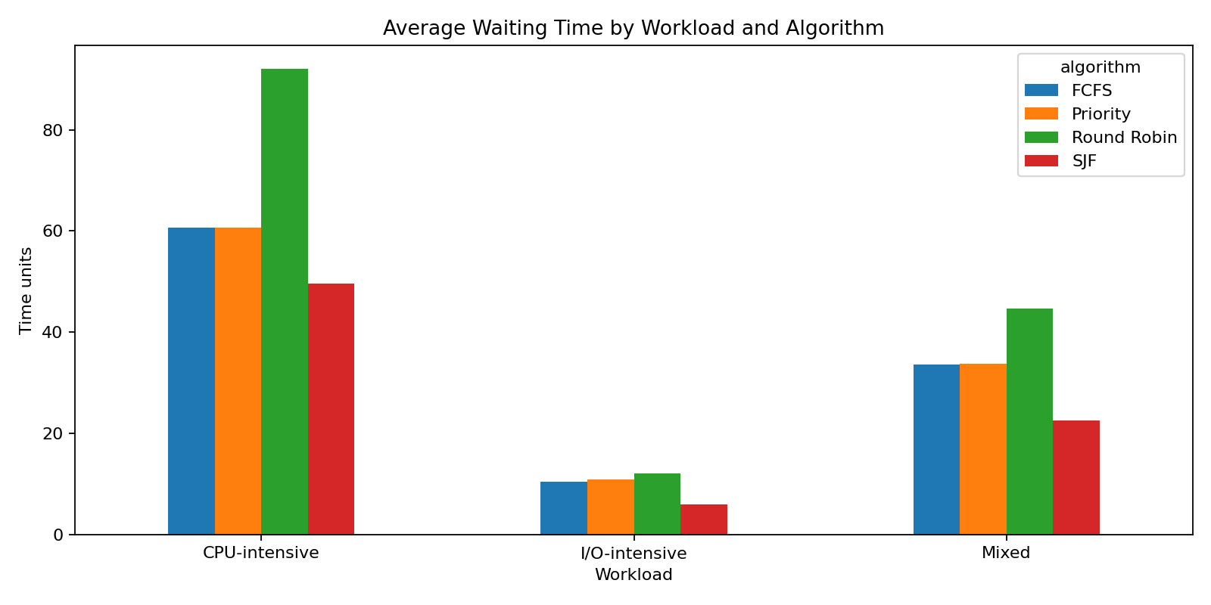
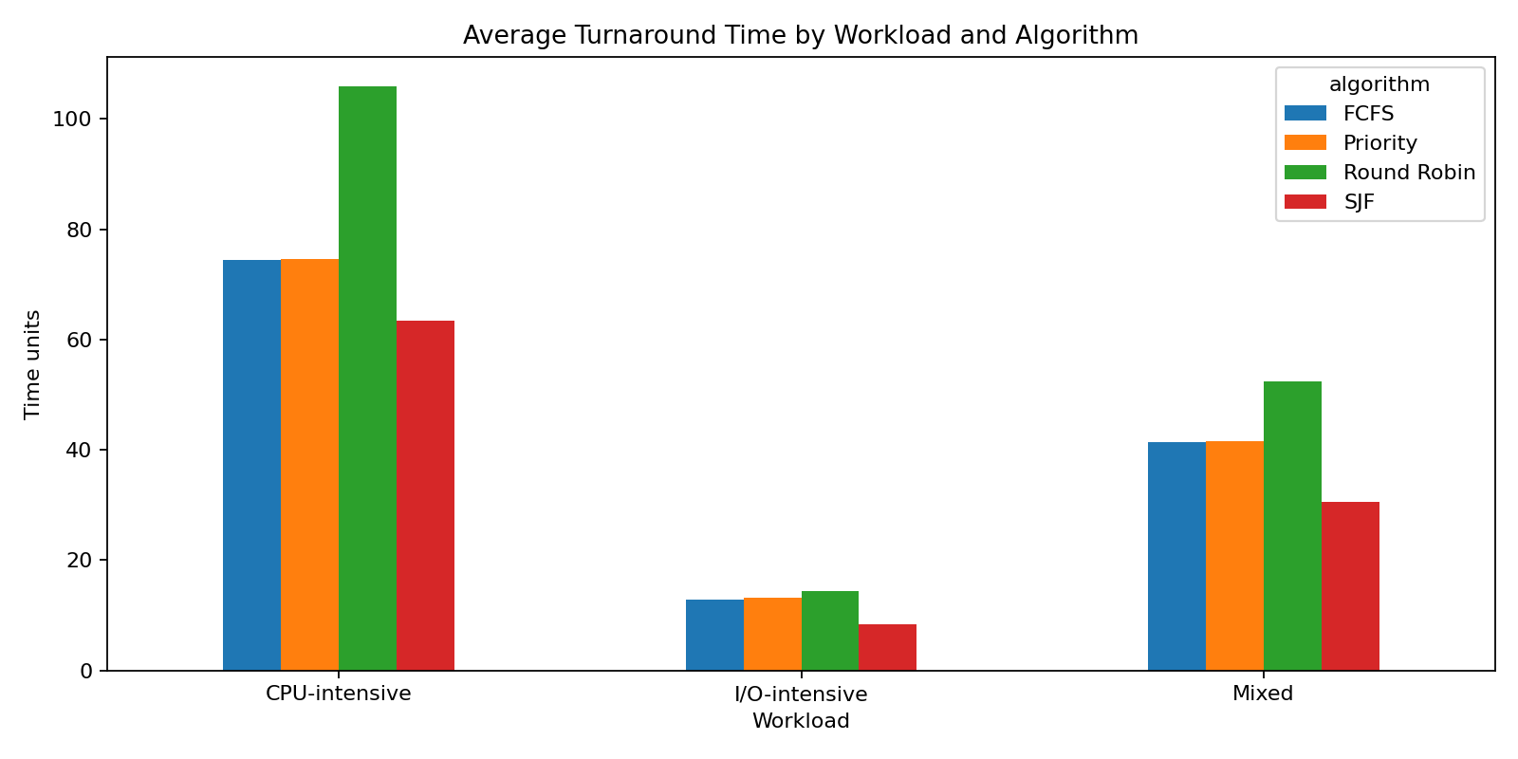

6. Discussion
The simulation makes it possible to compare algorithms under identical generated process sets. Shortest-job-first can reduce waiting time for some burst distributions, while Round Robin can provide earlier first responses for longer jobs. These trade-offs depend on arrivals, burst lengths and quantum. The adaptive prototype is a policy-selection demonstration; the quality of its predictions and mapping must be evaluated on held-out workloads before claiming a general advantage.

7. Limitations and Future Work
- The current model uses synthetic workloads and a simple nearest-centroid classifier.
- I/O-intensive behavior is approximated by short CPU bursts; explicit I/O blocking is not modelled.
- No real kernel integration is attempted.
- Future work: add multi-burst CPU/I/O process models, a held-out test set and confusion matrix, fairness/starvation metrics, decision overhead, and stronger statistical evaluation.

8. Conclusion
A simulation-based adaptive CPU scheduling prototype was implemented with four conventional algorithms, synthetic workload generation, a lightweight classifier and metric reporting. It provides a reproducible base for investigating workload-aware policy selection while keeping the limitations of synthetic data and simplified process behavior explicit.

References
- Silberschatz, A., Galvin, P. B., & Gagne, G. Operating System Concepts. Wiley. Consulted edition to be specified.
- Tanenbaum, A. S., & Bos, H. Modern Operating Systems. Pearson. Consulted edition to be specified.
- Sutton, R. S., & Barto, A. G. (2018). Reinforcement Learning: An Introduction (2nd ed.). MIT Press.
- Harchol-Balter, M. (2013). Performance Modeling and Design of Computer Systems: Queueing Theory in Action. Cambridge University Press.

