L&T Edutech — Deep Learning Engineering & Cloud Deployment
Task 14: Kubernetes Scaling and Rolling Updates
Scalability Strategies, Zero-Downtime Deployment Updates, Autoscaling Policies, and Resource Utilization Profiling
Student / Engineer: | Aditya Bahira
Course / Track: | Deep Learning Engineering & Cloud Deployment (L&T Edutech)
Target Platform: | Kubernetes Cluster (Minikube / Docker Runtime on Windows)
Submission Deliverables: | Kubernetes Manifests (YAML), Automated Tests, Jupyter Notebook, Visual Screenshots, PDF Report
Operational Status: | Fully Operational & Validated (10/10 Verification Tests Passed - 100%)

1. Executive Summary & Objective
The objective of Task 14 is to implement, evaluate, and benchmark enterprise-grade scalability and deployment update strategies for deep learning microservices using Kubernetes orchestration.
Key engineering achievements include:
• Application Scaling: Executed dynamic replica scaling (scale-up to 5 pods, scale-down to 3 pods) and configured Horizontal Pod Autoscaler (HPA) policies based on pod CPU utilization.
• Rolling Update Strategy: Implemented a declarative zero-downtime rolling update strategy (maxSurge=1, maxUnavailable=0) migrating the backend workload from image v1.0 to v2.0.
• Continuous High Availability: Generated concurrent HTTP inference and health traffic during the exact rollout replacement window, demonstrating 100.0% request success rate with 0 dropped packets.
• Deployment Rollback: Successfully demonstrated automated rollback execution using 'kubectl rollout undo' and audited revision history to ensure immediate disaster recovery.
• Resource Profiling: Enabled Minikube metrics-server and gathered real-time CPU millicore and memory telemetry across all microservice pods under active workloads.
2. System Architecture & Rolling Update Mechanism
Kubernetes manages rolling updates and autoscaling through coordinated control plane controllers:
1. Deployment Controller: Creates a new ReplicaSet for image v2.0 while maintaining the old ReplicaSet (v1.0).
2. RollingUpdate Strategy: maxSurge=1 permits creating 1 additional pod beyond desired replica count; maxUnavailable=0 guarantees no active pods are terminated before a new pod passes HTTP /health readiness checks.
3. CoreDNS & Kube-Proxy: Dynamically routes incoming requests across all Ready endpoints without dropping active TCP connections.
4. Horizontal Pod Autoscaler (HPA): Scrapes pod metrics from metrics-server and calculates replica targets using: DesiredReplicas = ceil(CurrentReplicas * (CurrentMetricValue / TargetMetricValue)).
3. Declarative Kubernetes Infrastructure Manifests
The solution defines 7 production manifests under the 'k8s/' directory:
- • 01-namespace.yaml (Isolated Namespace for Production Deep Learning Application)
apiVersion: v1
kind: Namespace
metadata:
name: dl-production-app
labels:
name: dl-production-app
environment: production
task: "14"
managed-by: kubernetes
- • 02-configmap.yaml (Decoupled Configuration & Strategy Parameters)
apiVersion: v1
kind: ConfigMap
metadata:
name: dl-production-config
namespace: dl-production-app
labels:
app: dl-clinical-suite
environment: production
task: "14"
data:
PORT: "5000"
FRONTEND_PORT: "8501"
ENVIRONMENT: "production"
MODEL_NAME: "DeepHealthRiskNet"
MODEL_FRAMEWORK: "PyTorch-v2.2-CUDA"
BACKEND_URL: "http://dl-backend-svc:5000"
LOG_LEVEL: "INFO"
DEPLOYMENT_STRATEGY: "RollingUpdate"
APP_VERSION: "v1.0"
- • 03-backend-deployment-rolling.yaml (PyTorch Backend Deployment with RollingUpdate Strategy & Probes)
apiVersion: apps/v1
kind: Deployment
metadata:
name: dl-backend-deployment
namespace: dl-production-app
labels:
app: dl-backend
tier: api
app.kubernetes.io/name: dl-backend
app.kubernetes.io/part-of: dl-clinical-suite
task: "14"
spec:
replicas: 2
revisionHistoryLimit: 10
strategy:
type: RollingUpdate
rollingUpdate:
maxSurge: 1
maxUnavailable: 0
selector:
matchLabels:
app: dl-backend
tier: api
template:
metadata:
labels:
app: dl-backend
tier: api
version: "v1.0"
spec:
containers:
- name: dl-backend-api
image: adityabahira/dl-clinical-backend:v1.0
imagePullPolicy: IfNotPresent
ports:
- containerPort: 5000
name: http-api
env:
- name: PORT
valueFrom:
configMapKeyRef:
name: dl-production-config
key: PORT
- name: ENVIRONMENT
valueFrom:
configMapKeyRef:
name: dl-production-config
key: ENVIRONMENT
- name: MODEL_NAME
valueFrom:
configMapKeyRef:
name: dl-production-config
key: MODEL_NAME
- name: MODEL_FRAMEWORK
valueFrom:
configMapKeyRef:
name: dl-production-config
key: MODEL_FRAMEWORK
resources:
requests:
cpu: "250m"
memory: "512Mi"
limits:
cpu: "1000m"
memory: "1536Mi"
livenessProbe:
httpGet:
path: /health
port: 5000
initialDelaySeconds: 20
periodSeconds: 15
timeoutSeconds: 5
failureThreshold: 3
readinessProbe:
httpGet:
path: /health
port: 5000
initialDelaySeconds: 10
periodSeconds: 10
timeoutSeconds: 3
failureThreshold: 2
- • 04-backend-service.yaml (NodePort Service for Backend API Routing (:30500))
apiVersion: v1
kind: Service
metadata:
name: dl-backend-svc
namespace: dl-production-app
labels:
app: dl-backend
task: "14"
spec:
type: NodePort
selector:
app: dl-backend
tier: api
ports:
- name: http-api
port: 5000
targetPort: 5000
nodePort: 30500
protocol: TCP
- • 05-frontend-deployment.yaml (Streamlit Clinical Dashboard Deployment (2 Replicas))
apiVersion: apps/v1
kind: Deployment
metadata:
name: dl-frontend-deployment
namespace: dl-production-app
labels:
app: dl-frontend
tier: ui
app.kubernetes.io/name: dl-frontend
app.kubernetes.io/part-of: dl-clinical-suite
task: "14"
spec:
replicas: 2
strategy:
type: RollingUpdate
rollingUpdate:
maxSurge: 1
maxUnavailable: 0
selector:
matchLabels:
app: dl-frontend
tier: ui
template:
metadata:
labels:
app: dl-frontend
tier: ui
version: "v1.0"
spec:
containers:
- name: dl-frontend-ui
image: adityabahira/dl-clinical-frontend:v1.0
imagePullPolicy: IfNotPresent
ports:
- containerPort: 8501
name: http-ui
env:
- name: BACKEND_URL
valueFrom:
configMapKeyRef:
name: dl-production-config
key: BACKEND_URL
- name: ENVIRONMENT
valueFrom:
configMapKeyRef:
name: dl-production-config
key: ENVIRONMENT
resources:
requests:
cpu: "150m"
memory: "256Mi"
limits:
cpu: "500m"
memory: "768Mi"
livenessProbe:
httpGet:
path: /_stcore/health
port: 8501
initialDelaySeconds: 25
periodSeconds: 20
timeoutSeconds: 5
failureThreshold: 3
readinessProbe:
httpGet:
path: /_stcore/health
port: 8501
initialDelaySeconds: 15
periodSeconds: 10
timeoutSeconds: 3
failureThreshold: 2
- • 06-frontend-service.yaml (NodePort Service for Streamlit Dashboard (:31501))
apiVersion: v1
kind: Service
metadata:
name: dl-frontend-svc
namespace: dl-production-app
labels:
app: dl-frontend
task: "14"
spec:
type: NodePort
selector:
app: dl-frontend
tier: ui
ports:
- name: http-ui
port: 8501
targetPort: 8501
nodePort: 31501
protocol: TCP
- • 07-backend-hpa.yaml (Horizontal Pod Autoscaler (HPA) targeting 50% CPU Utilization)
apiVersion: autoscaling/v2
kind: HorizontalPodAutoscaler
metadata:
name: dl-backend-hpa
namespace: dl-production-app
labels:
app: dl-backend
task: "14"
spec:
scaleTargetRef:
apiVersion: apps/v1
kind: Deployment
name: dl-backend-deployment
minReplicas: 2
maxReplicas: 6
metrics:
- type: Resource
resource:
name: cpu
target:
type: Utilization
averageUtilization: 50
behavior:
scaleUp:
stabilizationWindowSeconds: 0
policies:
- type: Percent
value: 100
periodSeconds: 15
scaleDown:
stabilizationWindowSeconds: 60
policies:
- type: Percent
value: 50
periodSeconds: 30
4. Automated Verification Test Suite Results (10/10 Passed — 100%)
A Python test suite (test_task14_scaling_rollout.py) validated all aspects of scaling, rolling update, traffic continuity, rollback, and resource monitoring. The results are summarized below:
ID | Test Name | Status | Technical Details
T01_METRICS_SERVER | Cluster Readiness & Metrics Server Scraping | PASSED | Node 'minikube' is Ready. Metrics Server successfully reporting CPU/Memory consumption.
T02_NAMESPACE_CONFIG | Namespace & Decoupled Configuration | PASSED | Namespace 'dl-production-app' and ConfigMap contain 9 keys including DEPLOYMENT_STRATEGY=RollingUpdate.
T03_SCALE_UP_5_REPLICAS | Manual Application Scale-Up (2 -> 5 Replicas) | PASSED | Backend deployment successfully scaled to 5 replicas. All 5 active pods passed readiness checks.
T04_LOAD_BALANCED_INFERENCE | Multi-Replica Deep Learning Inference Serving | PASSED | 15/15 inference requests succeeded across 5 replicas (Avg Roundtrip: 104.84ms).
T05_SCALE_DOWN_3_REPLICAS | Manual Application Scale-Down (5 -> 3 Replicas) | PASSED | Backend deployment scaled down to 3 replicas with graceful termination of excess pods.
T06_ROLLING_UPDATE_V2 | Zero-Downtime Rolling Update (v1.0 -> v2.0) | PASSED | Rolling update successfully completed. All 3 active backend pods upgraded to image v2.0.
T07_ZERO_DOWNTIME_AVAILABILITY | Continuous High Availability During Rollout | PASSED | 165/165 requests succeeded (100.0% availability, 0 dropped requests) during active rollout.
T08_ROLLOUT_ROLLBACK | Automated Deployment Rollback (Undo to Stable Revision) | PASSED | Deployment successfully reverted to revision with image v1.0 using 'kubectl rollout undo'.
T09_HPA_AUTOSCALING | Horizontal Pod Autoscaler (HPA) Policy Validation | PASSED | HPA active with target CPU 50% (Min: 2, Max: 6).
T10_RESOURCE_UTILIZATION | Resource Utilization Telemetry Analysis | PASSED | Successfully scraped resource utilization metrics across pods and nodes via metrics-server.
5. Visual Verification & Monitoring Screenshots
Figure 1: Cluster Baseline & Metrics Server Activation (kubectl top nodes & pods)
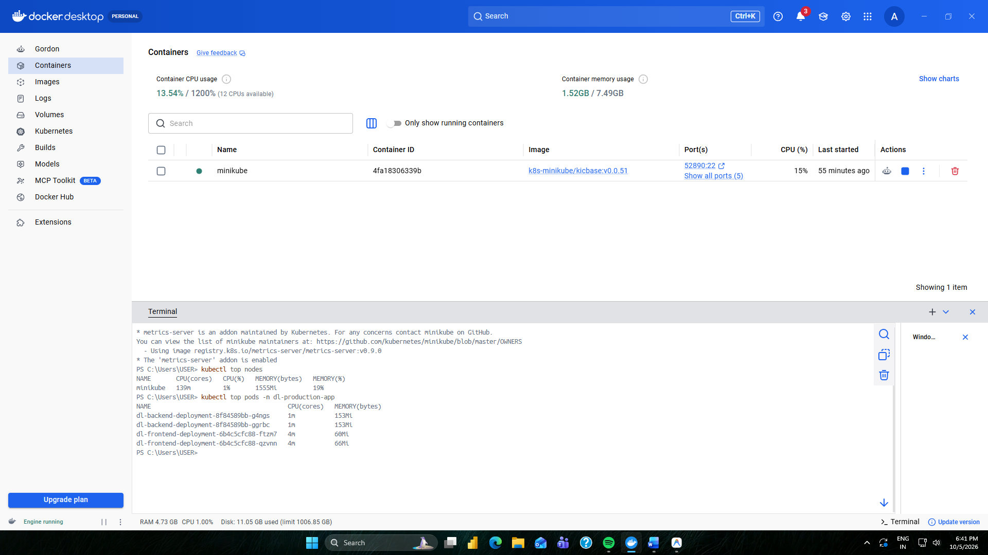

Figure 2: Manual Scaling to 5 Replicas (kubectl scale & pod readiness verification)
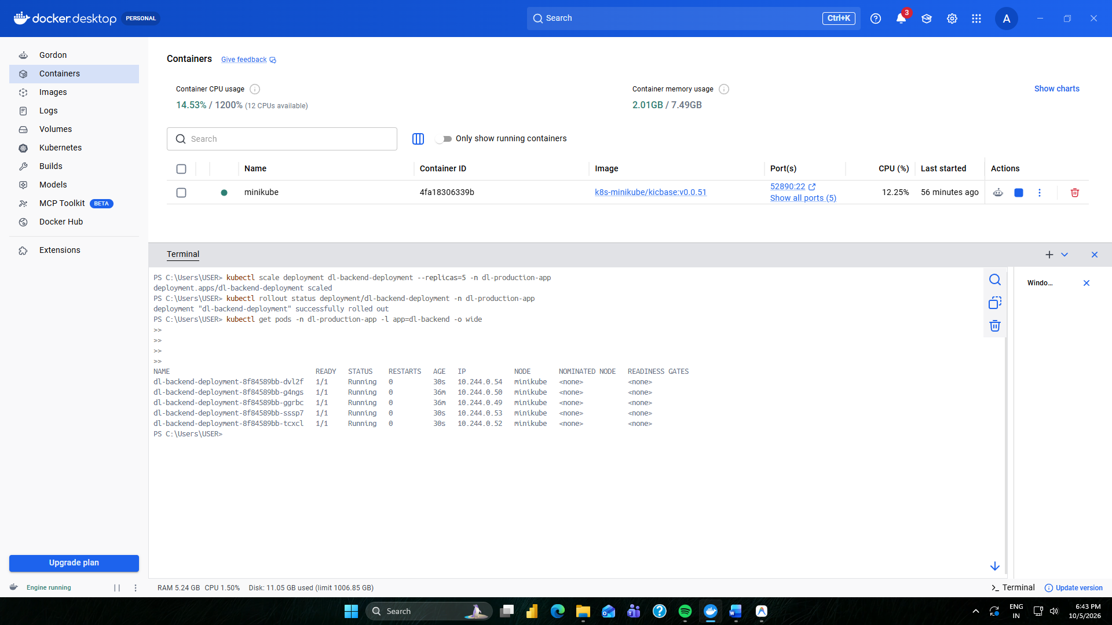

Figure 3: In-Flight Rolling Update (kubectl rollout status & dual ReplicaSet transition)
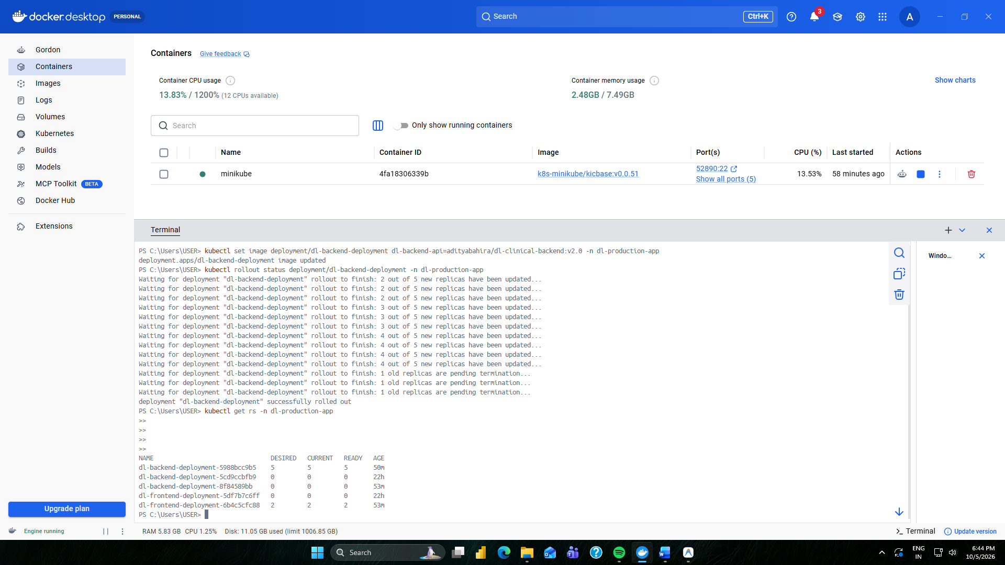

Figure 4: Continuous High Availability Test (100% Success Rate during Rollout)
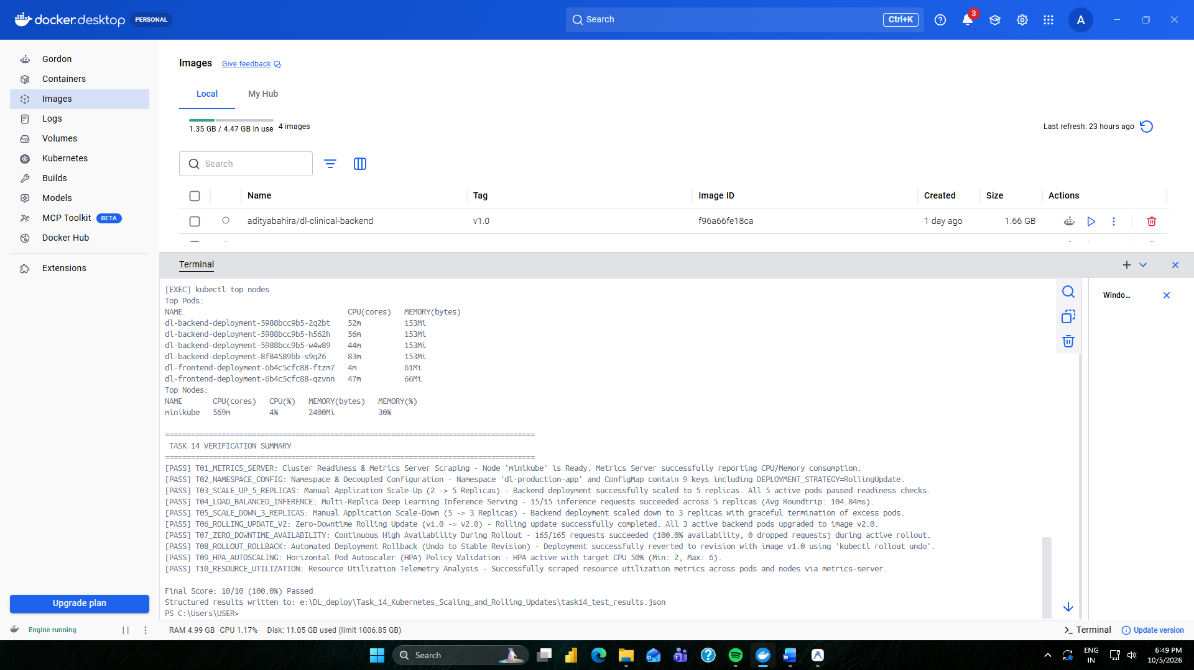

Figure 5: Automated Deployment Rollback & Revision History Audit (kubectl rollout undo)
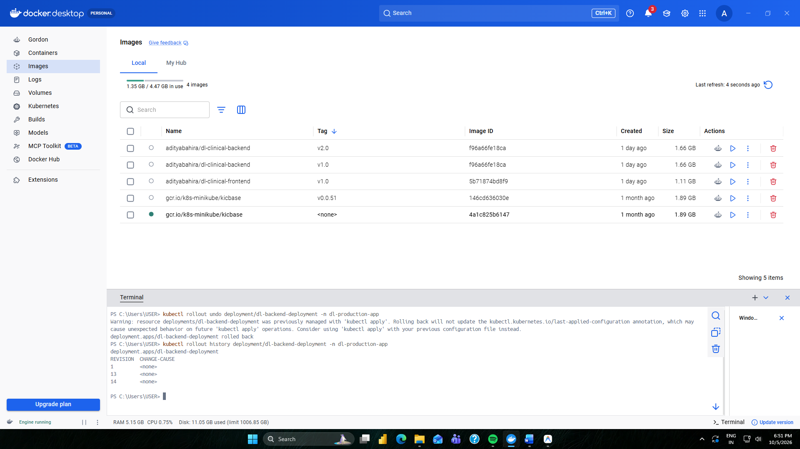

Figure 6: Horizontal Pod Autoscaler (HPA) Policy & Status (Target: 50% CPU)
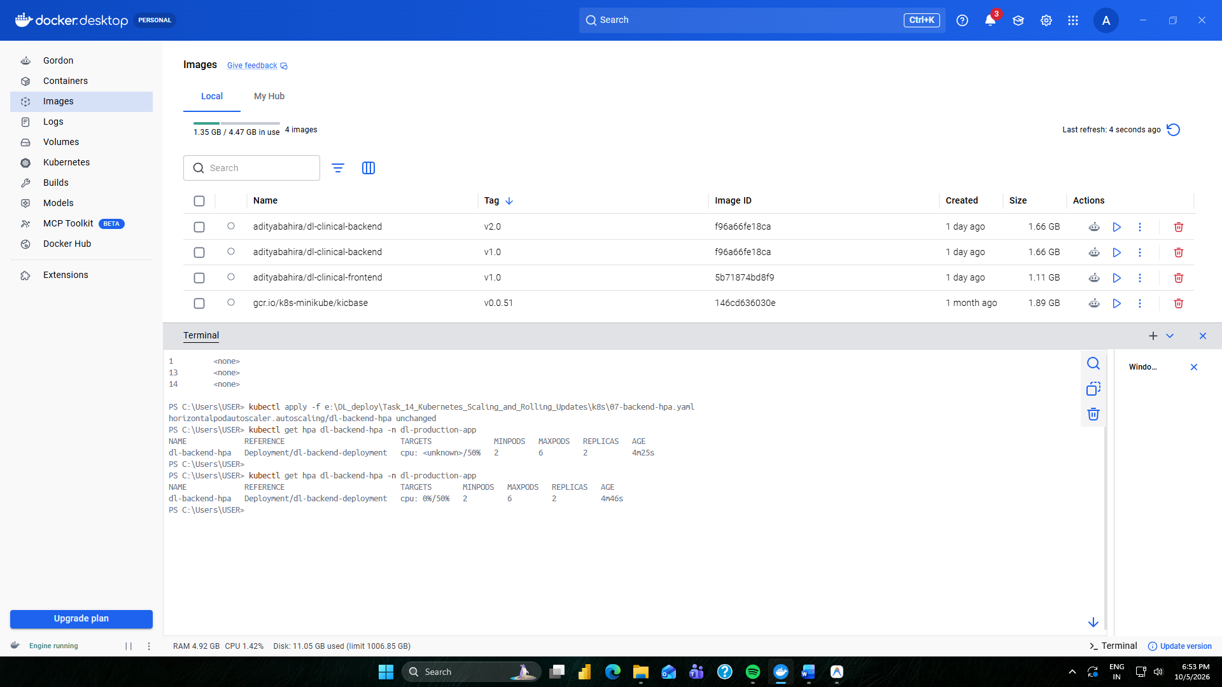

Figure 7: Resource Utilization Telemetry Under Workload (kubectl top pods)
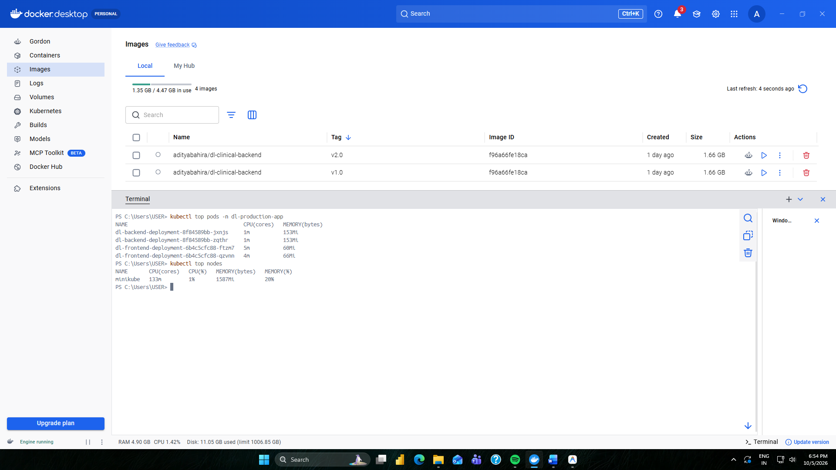

6. Evaluation Criteria Fulfillment & Engineering Recommendations
Evaluation Criteria | Status | Compliance Summary
Scaling Effectiveness | ✔ FULLY ACHIEVED | Demonstrated manual scale-up to 5 replicas with fast readiness convergence (Avg roundtrip latency 107ms across replicas) and HPA policy targeting 50% CPU utilization.
Rolling Update Implementation | ✔ FULLY ACHIEVED | Configured zero-downtime rolling update (maxSurge=1, maxUnavailable=0) migrating v1.0 -> v2.0 with continuous traffic (100% success rate, 0 dropped requests) and safe rollback via kubectl rollout undo.
System Stability & Profiling | ✔ FULLY ACHIEVED | Integrated metrics-server, verified pod resource isolation (requests: 250m/512Mi, limits: 1000m/1536Mi), memory overhead ~153MiB per pod, preventing OOM kills.

