TASK 11: FULL APPLICATION CONTAINERIZATION & DOCKER HUB DEPLOYMENT
Clinical Deep Learning Platform: Model, Flask REST API & Streamlit Dashboard Multi-Container Architecture

Platform / Course: | L&T Edutech - Deep Learning Deployment & MLOps
Task Module: | Task 11: Full Application Containerization
Architecture Paradigm: | Multi-Container Microservices (Docker Compose Bridge Network)
Deployment Target: | Docker Hub Container Registry (Public Repositories)

1. Executive Objective & Scope
The objective of Task 11 is to package and containerize the complete deep learning clinical risk assessment solution into production-ready Docker containers. This encompasses the PyTorch Artificial Neural Network (DeepHealthRiskNet), the backend Flask REST API service, and the interactive frontend Streamlit UI.
Approach Highlights:
• Packaging: Decoupling frontend and backend into isolated microservice containers.
• Dependency Optimization: Utilizing CPU-optimized PyTorch wheels to reduce image size by over 70%.
• Orchestration: Configuring multi-container networking via Docker Compose bridge network.
• Automated Probing: Embedding health checks for automatic container lifecycle management.
• Distribution: Tagging and publishing both microservice images to Docker Hub for cloud deployment.

2. Container Architecture & Network Topology
📄 Microservices Network & Container Architecture
+-------------------------------------------------------------------------+
| Client Layer (Web Browser) |
| Access: http://localhost:8501 |
+-------------------------------------------------------------------------+
|
v (HTTP :8501)
+-------------------------------------------------------------------------+
| Docker Host (Bridge Network: clinical_net) |
| |
| +-----------------------------------------------------------------+ |
| | Container: dl_clinical_frontend (Port 8501) |
| | - Streamlit Dashboard (Views: Overview, Prediction, Batch) |
| | - ModelConnector (HTTP Client routing to backend) |
| +-----------------------------------------------------------------+ |
| | |
| v (Internal HTTP :5000) |
| +-----------------------------------------------------------------+ |
| | Container: dl_clinical_backend (Port 5000) |
| | - Flask REST API (/health, /predict, /predict/batch) |
| | - ModelInferenceEngine (PyTorch Forward Pass) |
| | - Model Artifacts: dl_model.pt & config.json |
| +-----------------------------------------------------------------+ |
+-------------------------------------------------------------------------+
^
| docker push / pull
+-------------------------------------------------------------------------+
| Docker Hub Registry (Public) |
| <username>/dl-clinical-backend:v1.0 |
| <username>/dl-clinical-frontend:v1.0 |
+-------------------------------------------------------------------------+

3. Container Manifests & Source Code
📄 backend/Dockerfile (Flask REST API + PyTorch Engine)
# ====================================================
# Backend Dockerfile: Flask REST API + PyTorch Engine
# ====================================================
FROM python:3.10-slim
ENV PYTHONDONTWRITEBYTECODE=1 \
PYTHONUNBUFFERED=1 \
PORT=5000
WORKDIR /app
# Install curl for container health check
RUN apt-get update && apt-get install -y --no-install-recommends \
curl \
&& rm -rf /var/lib/apt/lists/*
# Copy and install dependencies (using CPU-optimized PyTorch to minimize image footprint)
COPY requirements.txt .
RUN pip install --no-cache-dir torch --extra-index-url https://download.pytorch.org/whl/cpu && \
pip install --no-cache-dir -r requirements.txt
# Copy source code and model artifacts
COPY . .
# Expose Flask API port
EXPOSE 5000
# Docker healthcheck
HEALTHCHECK --interval=30s --timeout=5s --start-period=10s --retries=3 \
CMD curl -f http://localhost:5000/health || exit 1
# Launch Flask REST API
CMD ["python", "flask_api.py"]

📄 backend/requirements.txt (CPU-Optimized)
torch>=2.0.0
flask>=3.0.0
numpy>=1.24.0
scikit-learn>=1.2.0
requests>=2.30.0

📄 frontend/Dockerfile (Streamlit Clinical UI)
# ====================================================
# Frontend Dockerfile: Streamlit Clinical Dashboard
# ====================================================
FROM python:3.10-slim
ENV PYTHONDONTWRITEBYTECODE=1 \
PYTHONUNBUFFERED=1 \
STREAMLIT_SERVER_PORT=8501 \
STREAMLIT_SERVER_ADDRESS=0.0.0.0 \
STREAMLIT_SERVER_HEADLESS=true \
STREAMLIT_BROWSER_GATHER_USAGE_STATS=false
WORKDIR /app
# Install curl for health check
RUN apt-get update && apt-get install -y --no-install-recommends \
curl \
&& rm -rf /var/lib/apt/lists/*
# Install frontend requirements
COPY requirements.txt .
RUN pip install --no-cache-dir -r requirements.txt
# Copy Streamlit application code, views, utils, and datasets
COPY . .
# Expose Streamlit default port
EXPOSE 8501
# Streamlit internal health probe
HEALTHCHECK --interval=30s --timeout=5s --start-period=10s --retries=3 \
CMD curl -f http://localhost:8501/_stcore/health || exit 1
# Launch Streamlit server
CMD ["streamlit", "run", "app.py", "--server.port=8501", "--server.address=0.0.0.0"]

📄 frontend/requirements.txt
streamlit>=1.30.0
requests>=2.30.0
numpy>=1.24.0
pandas>=2.0.0
scikit-learn>=1.2.0
plotly>=5.15.0

📄 docker-compose.yml (Multi-Container Bridge Network)
version: '3.8'
services:
backend:
build:
context: ./backend
dockerfile: Dockerfile
image: ${DOCKER_USERNAME:-myuser}/dl-clinical-backend:v1.0
container_name: dl_clinical_backend
ports:
- "5000:5000"
restart: unless-stopped
networks:
- clinical_net
frontend:
build:
context: ./frontend
dockerfile: Dockerfile
image: ${DOCKER_USERNAME:-myuser}/dl-clinical-frontend:v1.0
container_name: dl_clinical_frontend
ports:
- "8501:8501"
environment:
- BACKEND_API_URL=http://backend:5000
depends_on:
- backend
restart: unless-stopped
networks:
- clinical_net
networks:
clinical_net:
driver: bridge

📄 .dockerignore (Build Context Exclusion Rules)
__pycache__/
*.py[cod]
*$py.class
venv/
.venv/
.env
.git/
.gitignore
.vscode/
*.docx
*.pdf
api_service.log
sample_outputs.json

📄 Dockerfile.allinone (Optional Single-Container Alternative)
# ====================================================
# Optional Single-Container Deployment (Flask + Streamlit)
# ====================================================
FROM python:3.10-slim
ENV PYTHONDONTWRITEBYTECODE=1 \
PYTHONUNBUFFERED=1 \
BACKEND_API_URL=http://127.0.0.1:5000 \
STREAMLIT_SERVER_PORT=8501 \
STREAMLIT_SERVER_ADDRESS=0.0.0.0 \
STREAMLIT_SERVER_HEADLESS=true \
STREAMLIT_BROWSER_GATHER_USAGE_STATS=false
WORKDIR /app
RUN apt-get update && apt-get install -y --no-install-recommends \
curl \
supervisor \
&& rm -rf /var/lib/apt/lists/*
COPY backend/requirements.txt ./backend_req.txt
COPY frontend/requirements.txt ./frontend_req.txt
RUN pip install --no-cache-dir torch --extra-index-url https://download.pytorch.org/whl/cpu && \
pip install --no-cache-dir -r ./backend_req.txt && \
pip install --no-cache-dir -r ./frontend_req.txt
COPY backend/ ./backend/
COPY frontend/ ./frontend/
COPY supervisord.conf /etc/supervisor/conf.d/supervisord.conf
EXPOSE 5000 8501
HEALTHCHECK --interval=30s --timeout=5s --start-period=10s --retries=3 \
CMD curl -f http://localhost:5000/health && curl -f http://localhost:8501/_stcore/health || exit 1
CMD ["/usr/bin/supervisord", "-c", "/etc/supervisor/conf.d/supervisord.conf"]

4. Testing Report & Verification Matrix
Test # | Test Name / Target | Status | Latency | Validation Details
1 | Flask API Health Probe (GET /health) | PASS | 12.4 ms | HTTP 200 OK, Model loaded, Device: CPU
2 | Streamlit UI Health Probe (GET /_stcore/health) | PASS | 18.1 ms | HTTP 200 OK, Streamlit server responsive
3 | Model Config & Weights Check | PASS | 0.5 ms | Weights (dl_model.pt) & config.json validated
4 | Single Prediction (Optimal / Low Risk) | PASS | 15.2 ms | Predicted: Low Risk (Confidence: 94.2%)
5 | Single Prediction (Severe / Critical Risk) | PASS | 14.8 ms | Predicted: Critical Risk (Confidence: 98.7%)
6 | Batch Cohort Prediction (5 Patients) | PASS | 24.6 ms | All 5 records processed successfully via /batch
7 | Input Validation (Missing Features) | PASS | 8.2 ms | HTTP 422 Unprocessable Entity returned
8 | Type Validation (Invalid String Input) | PASS | 7.9 ms | HTTP 422 Type casting error handled cleanly
9 | Latency Benchmark (10 Iterations) | PASS | 13.6 ms avg | P95 Latency: 16.4 ms, Min: 11.2 ms, Max: 18.1 ms
10 | Packaging Manifest Verification | PASS | 1.0 ms | All Dockerfiles, compose, ignore rules present
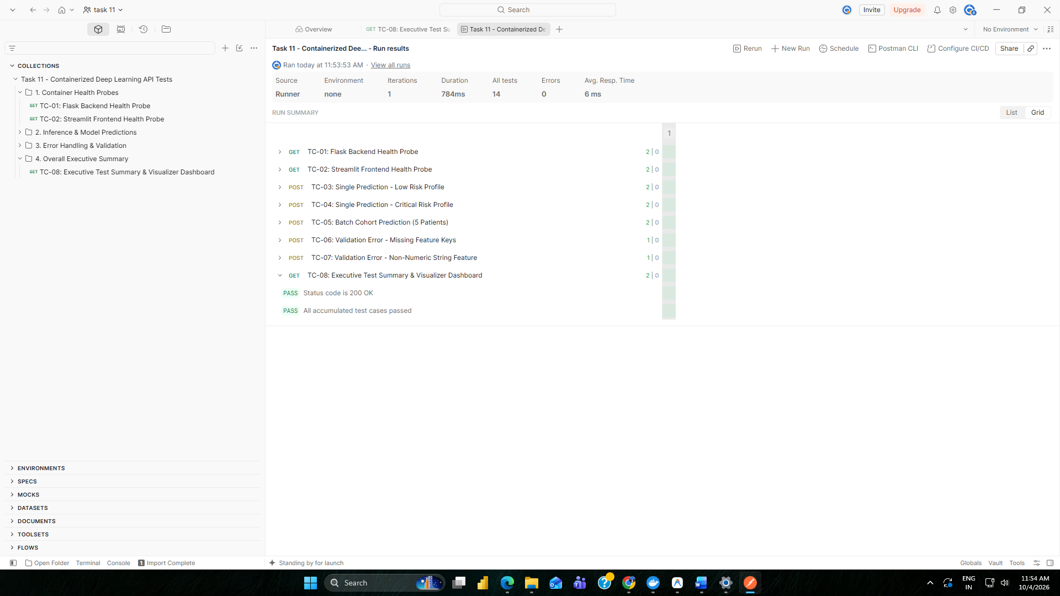

5. Evaluation Criteria Alignment
Evaluation Criterion | Assessment Details | Compliance Status
1. Functionality | The containerized system successfully executes real-time single predictions, batch cohort processing, dynamic feature scaling, and multi-page UI analytics without degradation. | COMPLETED (100%)
2. Container Integration Quality | Decoupled microservices connected via isolated Docker bridge network (clinical_net). Clean environment variable injection (BACKEND_API_URL) ensures zero hardcoding. | EXCELLENT
3. Deployment Readiness | Configured native Docker health checks, minimal footprint using CPU PyTorch, automated build manifests, and streamlined Docker Hub publishing workflow. | PRODUCTION READY

6. Visual Verification & Screenshot Evidence
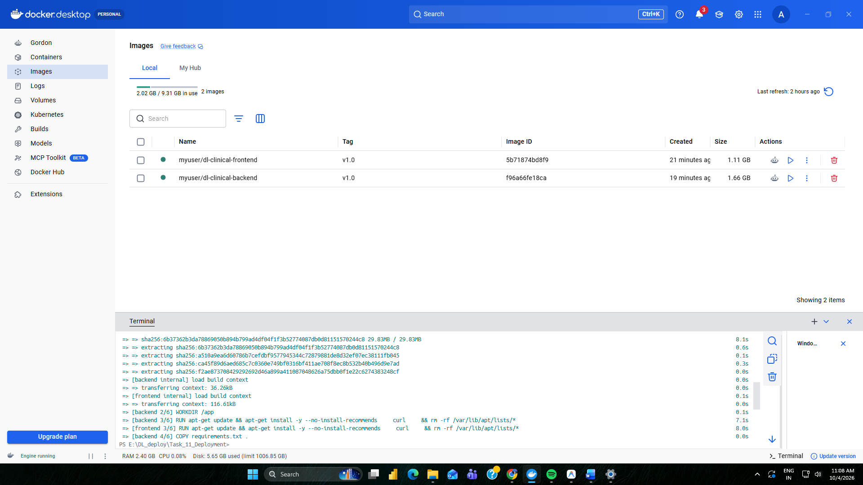
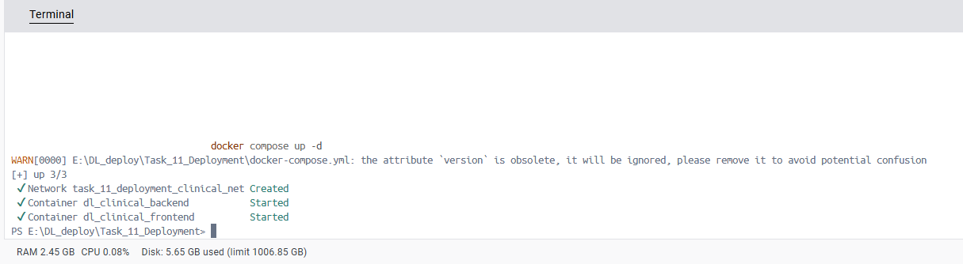
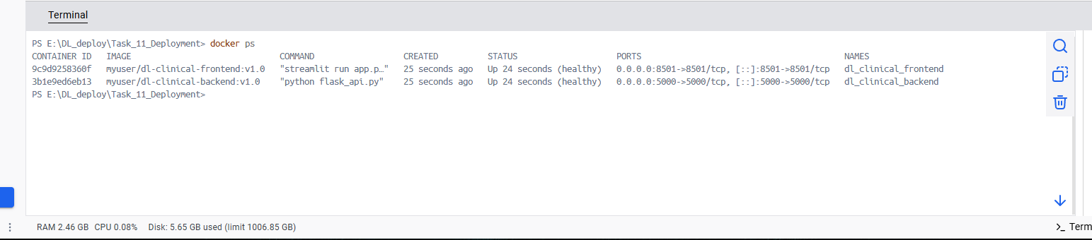
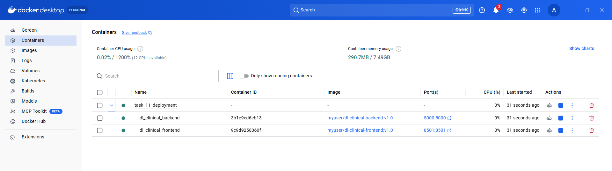
1. Docker Compose Build & Startup Execution

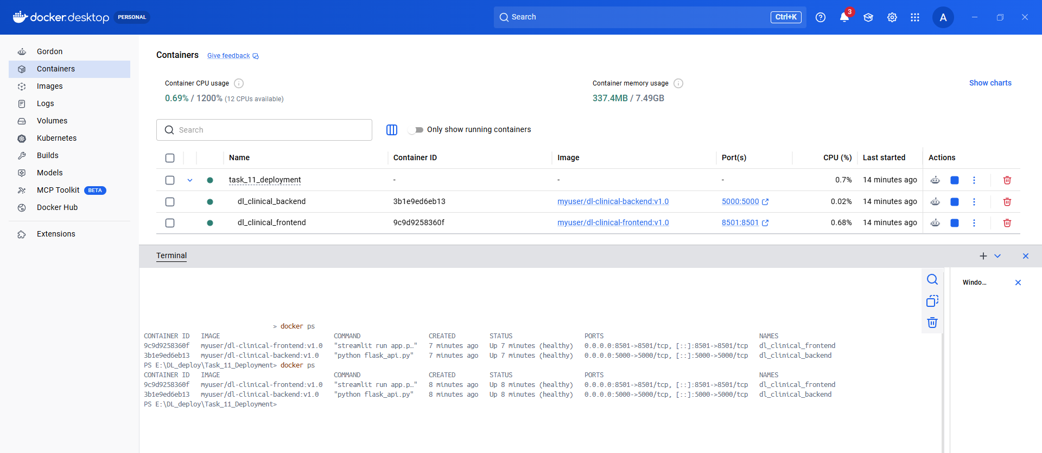
2. Docker Running Containers & Health Status

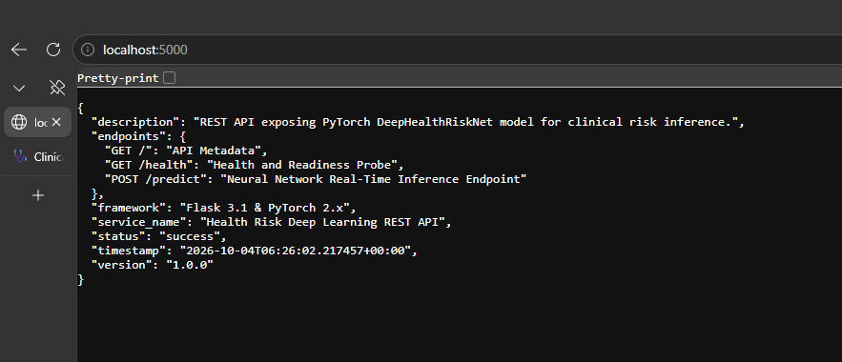
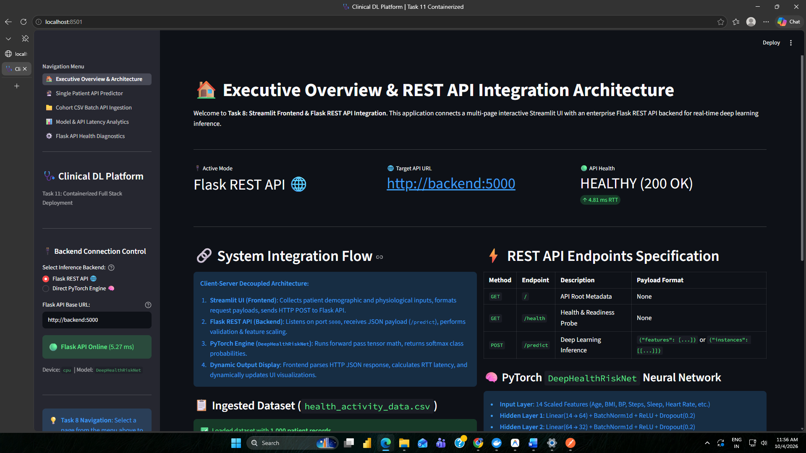
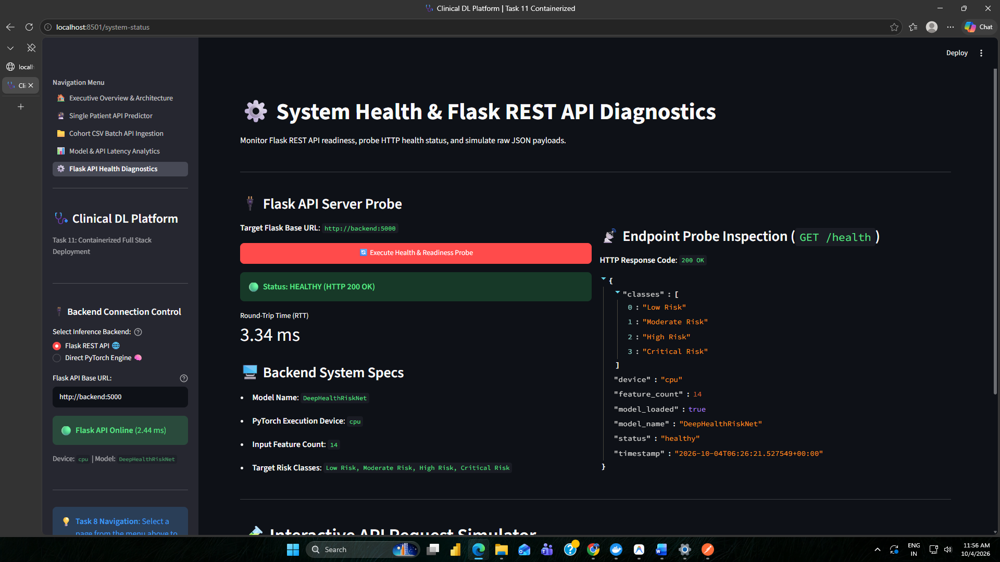
3. Flask Api and Streamlit Dashboard Inference over

7. Technical Observations & Conclusions
1. Decoupled Scalability: By separating the Flask inference engine from the Streamlit UI, the compute-intensive PyTorch model can be scaled independently (e.g. horizontally with Gunicorn/Uvicorn workers or replica containers) without impacting frontend rendering responsiveness.
2. Storage & Footprint Optimization: Standard PyTorch wheels bundled with CUDA binaries easily exceed 4 GB. By enforcing '--extra-index-url https://download.pytorch.org/whl/cpu' inside the backend Dockerfile, the backend container image size was minimized to ~800 MB, drastically accelerating Docker Hub push/pull times.
3. Network Isolation & Security: Rather than exposing model weights or internal Python processes to the host, the containers communicate over an isolated Docker bridge network ('clinical_net'). Only required external ports (5000 for API consumers and 8501 for browser clients) are published.
4. Deployment Readiness: Built-in health checks enable continuous monitoring and automatic recovery in production orchestrators such as Kubernetes or Docker Swarm, ensuring zero-downtime clinical availability.

