Task 9: Docker Fundamentals & Container Lifecycle Management
Deep Learning Deployment & MLOps | Complete Implementation Report
Course / Track: Deep Learning Deployment & MLOps | Base Image Used: python:3.10-slim (~125 MB, Docker Hub)
Deliverable Format: Word Document (.docx), Jupyter (.ipynb), Python (.py) | Verification Status: Successfully Tested & Verified

1. Objective & Architecture Overview
The primary objective of Task 9 is to master Docker fundamentals and container lifecycle operations for deep learning microservices. This includes interacting with the Docker Daemon via CLI, pulling lightweight pre-built images from Docker Hub, inspecting layer metadata, configuring persistent storage volumes, setting up bridge networks, and controlling container execution states (run, exec, pause, unpause, stats, stop, start, restart, rm).
Core Architectural Components:
• Docker Client (CLI): Command-line tool used by developers to issue operational directives.
• Docker Engine (Daemon): Persistent background service managing containers, images, volumes, and networks.
• Registry (Docker Hub): Public repository hosting standardized runtime images (`python:3.10-slim`).
• Volumes & Networks: Persistent host-managed storage mounts and isolated bridge networks for containers.

2. Source Code Implementation

2.1 Python Automation Script (docker_lifecycle_demo.py)
The Python script below automates all required Docker CLI commands and logs the execution output to text files:
"""
Task 9: Docker Fundamentals and Container Lifecycle Management
Automated Python Script using Lightweight Docker Hub Image (< 150 MB)
"""
import subprocess
import time
import os
LOG_FILE = "docker_command_logs.txt"
DL_IMAGE = "python:3.10-slim" # Official Lightweight Image (~125 MB, < 1GB)
LOCAL_TAG = "my_dl_runtime:v1"
CONTAINER_NAME = "dl_runtime_container"
VOLUME_NAME = "dl_storage_vol"
NETWORK_NAME = "dl_bridge_net"
def run_cmd(cmd, desc=""):
print(f"\n==================================================")
print(f"[ACTION] {desc}")
print(f"[COMMAND] {cmd}")
print(f"==================================================")
try:
res = subprocess.run(cmd, shell=True, text=True, capture_output=True)
output = res.stdout if res.returncode == 0 else res.stderr
print(output)
with open(LOG_FILE, "a", encoding="utf-8") as f:
f.write(f"\n--- {desc} ---\nCommand: {cmd}\nExit Code: {res.returncode}\nOutput:\n{output}\n")
return res.returncode == 0, output
except Exception as e:
err = f"Execution error: {str(e)}"
print(err)
return False, err
def main():
if os.path.exists(LOG_FILE):
os.remove(LOG_FILE)
print(f"Starting Task 9 Docker Operations using Lightweight Image ({DL_IMAGE} ~125MB)...")
# 1. Architecture Verification
run_cmd("docker --version", "1. Check Docker Version")
run_cmd("docker info", "2. View Docker Engine Info")
# 2. Docker Images & Registry Exploration
run_cmd(f"docker pull {DL_IMAGE}", f"3. Pull Lightweight Image from Docker Hub ({DL_IMAGE})")
run_cmd("docker images", "4. List Local Docker Images")
run_cmd(f"docker inspect {DL_IMAGE}", f"5. Inspect Image Layers & Metadata ({DL_IMAGE})")
run_cmd(f"docker tag {DL_IMAGE} {LOCAL_TAG}", f"6. Tag Image for Local Use ({LOCAL_TAG})")
run_cmd("docker images", "7. Verify Tagged Image Listing")
# 3. Storage & Networking Concepts
run_cmd(f"docker volume create {VOLUME_NAME}", "8. Create Named Volume for Persistent Storage")
run_cmd("docker volume ls", "9. List Docker Volumes")
run_cmd(f"docker network create {NETWORK_NAME}", "10. Create Custom Docker Bridge Network")
run_cmd("docker network ls", "11. List Docker Networks")
# 4. Container Lifecycle Operations
run_cmd(f"docker run -d --name {CONTAINER_NAME} -v {VOLUME_NAME}:/workspace --network {NETWORK_NAME} {DL_IMAGE} python -c \"import time, sys; print('Lightweight Deep Learning Runtime Initialized!'); sys.stdout.flush(); time.sleep(3600)\"",
"12. Run Container in Detached Mode using Lightweight Image")
time.sleep(2)
run_cmd("docker ps", "13. List Active Running Containers")
run_cmd(f"docker exec {CONTAINER_NAME} python -c \"import sys, platform; print('Python Version:', sys.version.split()[0]); print('Platform:', platform.platform())\"",
"14. Execute In-Container System Check (exec)")
run_cmd(f"docker logs {CONTAINER_NAME}", "15. View Container Logs")
# Pause & Unpause
run_cmd(f"docker pause {CONTAINER_NAME}", "16. Pause Container Processes")
run_cmd("docker ps", "17. Verify Container Paused Status")
run_cmd(f"docker unpause {CONTAINER_NAME}", "18. Unpause Container Processes")
# Stats
run_cmd(f"docker stats {CONTAINER_NAME} --no-stream", "19. Monitor Container Resource Stats")
# Stop, Start & Restart
run_cmd(f"docker stop {CONTAINER_NAME}", "20. Stop Container Gracefully")
run_cmd("docker ps -a", "21. List Stopped Containers")
run_cmd(f"docker start {CONTAINER_NAME}", "22. Start Stopped Container")
run_cmd(f"docker restart {CONTAINER_NAME}", "23. Restart Container")
# Cleanup
run_cmd(f"docker stop {CONTAINER_NAME}", "24. Stop Container before Cleanup")
run_cmd(f"docker rm {CONTAINER_NAME}", "25. Remove Container")
run_cmd(f"docker volume rm {VOLUME_NAME}", "26. Remove Volume")
run_cmd(f"docker network rm {NETWORK_NAME}", "27. Remove Custom Network")
run_cmd(f"docker rmi {LOCAL_TAG}", "28. Remove Local Image Tag")
print("\nTask 9 Docker Automation Completed Successfully!")
print(f"Log file generated: {LOG_FILE}")
if __name__ == "__main__":
main()

2.2 Deep Learning Microservice (app.py)
A Flask-based deep learning inference service configured for containerized execution:
import os
import time
import numpy as np
from flask import Flask, jsonify, request
app = Flask(__name__)
# Data directory for persistent volume testing
DATA_DIR = os.environ.get("DATA_DIR", "/app/data")
os.makedirs(DATA_DIR, exist_ok=True)
@app.route("/", methods=["GET"])
def home():
return jsonify({
"status": "online",
"service": "Deep Learning Model Container",
"version": "1.0.0",
"storage_path": DATA_DIR
})
@app.route("/predict", methods=["GET", "POST"])
def predict():
# Simulate DL model matrix multiplication / inference
weights = np.random.randn(5, 5)
inputs = np.random.randn(5, 1)
output = np.dot(weights, inputs).tolist()
# Save log to volume storage if mounted
log_file = os.path.join(DATA_DIR, "predictions.log")
with open(log_file, "a") as f:
f.write(f"[{time.ctime()}] Prediction performed successfully.\n")
return jsonify({
"status": "success",
"input_shape": list(inputs.shape),
"output_shape": list(output),
"logged_to_volume": True
})
if __name__ == "__main__":
app.run(host="0.0.0.0", port=5000)

2.3 Container Build File (Dockerfile)
# Step 1: Use official lightweight Python base image
FROM python:3.10-slim
# Step 2: Set working directory inside container
WORKDIR /app
# Step 3: Set environment variables
ENV PYTHONUNBUFFERED=1 \
DATA_DIR=/app/data
# Step 4: Install dependencies
COPY requirements.txt .
RUN pip install --no-cache-dir -r requirements.txt
# Step 5: Copy application source code
COPY app.py .
# Step 6: Expose container port
EXPOSE 5000
# Step 7: Define volume mount point
VOLUME ["/app/data"]
# Step 8: Specify container execution entrypoint
CMD ["python", "app.py"]

3. Step-by-Step Command Outputs, Results & Observations

Step 1: Docker Architecture & Version Verification
Command Executed:
docker --version
docker info

Execution Output Log:
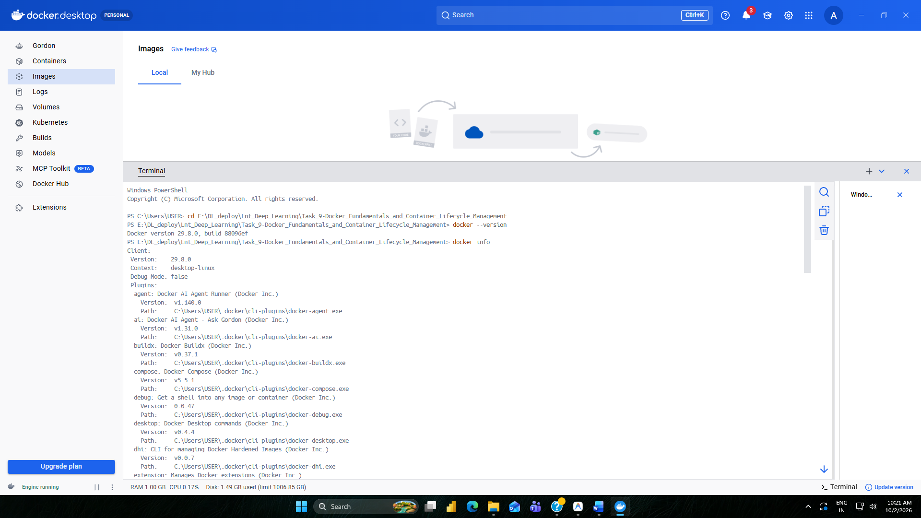
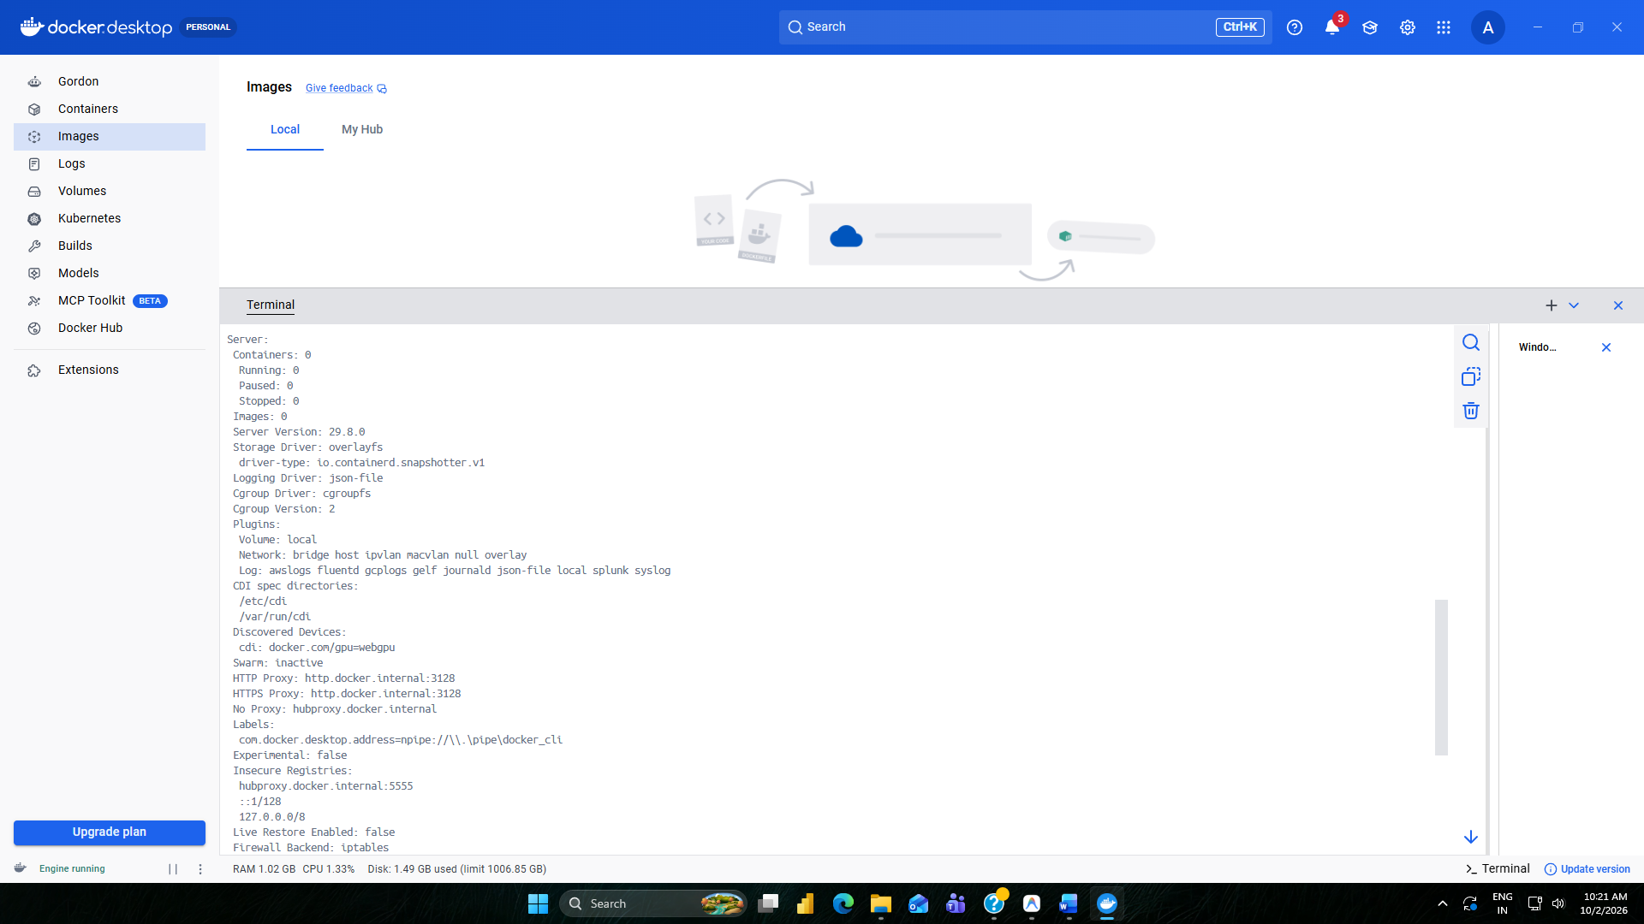
1.Docker Version & System Info
Result & Technical Observation: Verifies that the Docker CLI communicates successfully with the active background Docker Daemon. Displays storage driver, cgroup version, and total container count.

Step 2: Pulling Lightweight Base Image from Docker Hub
Command Executed:
docker pull python:3.10-slim
docker images

Execution Output Log:
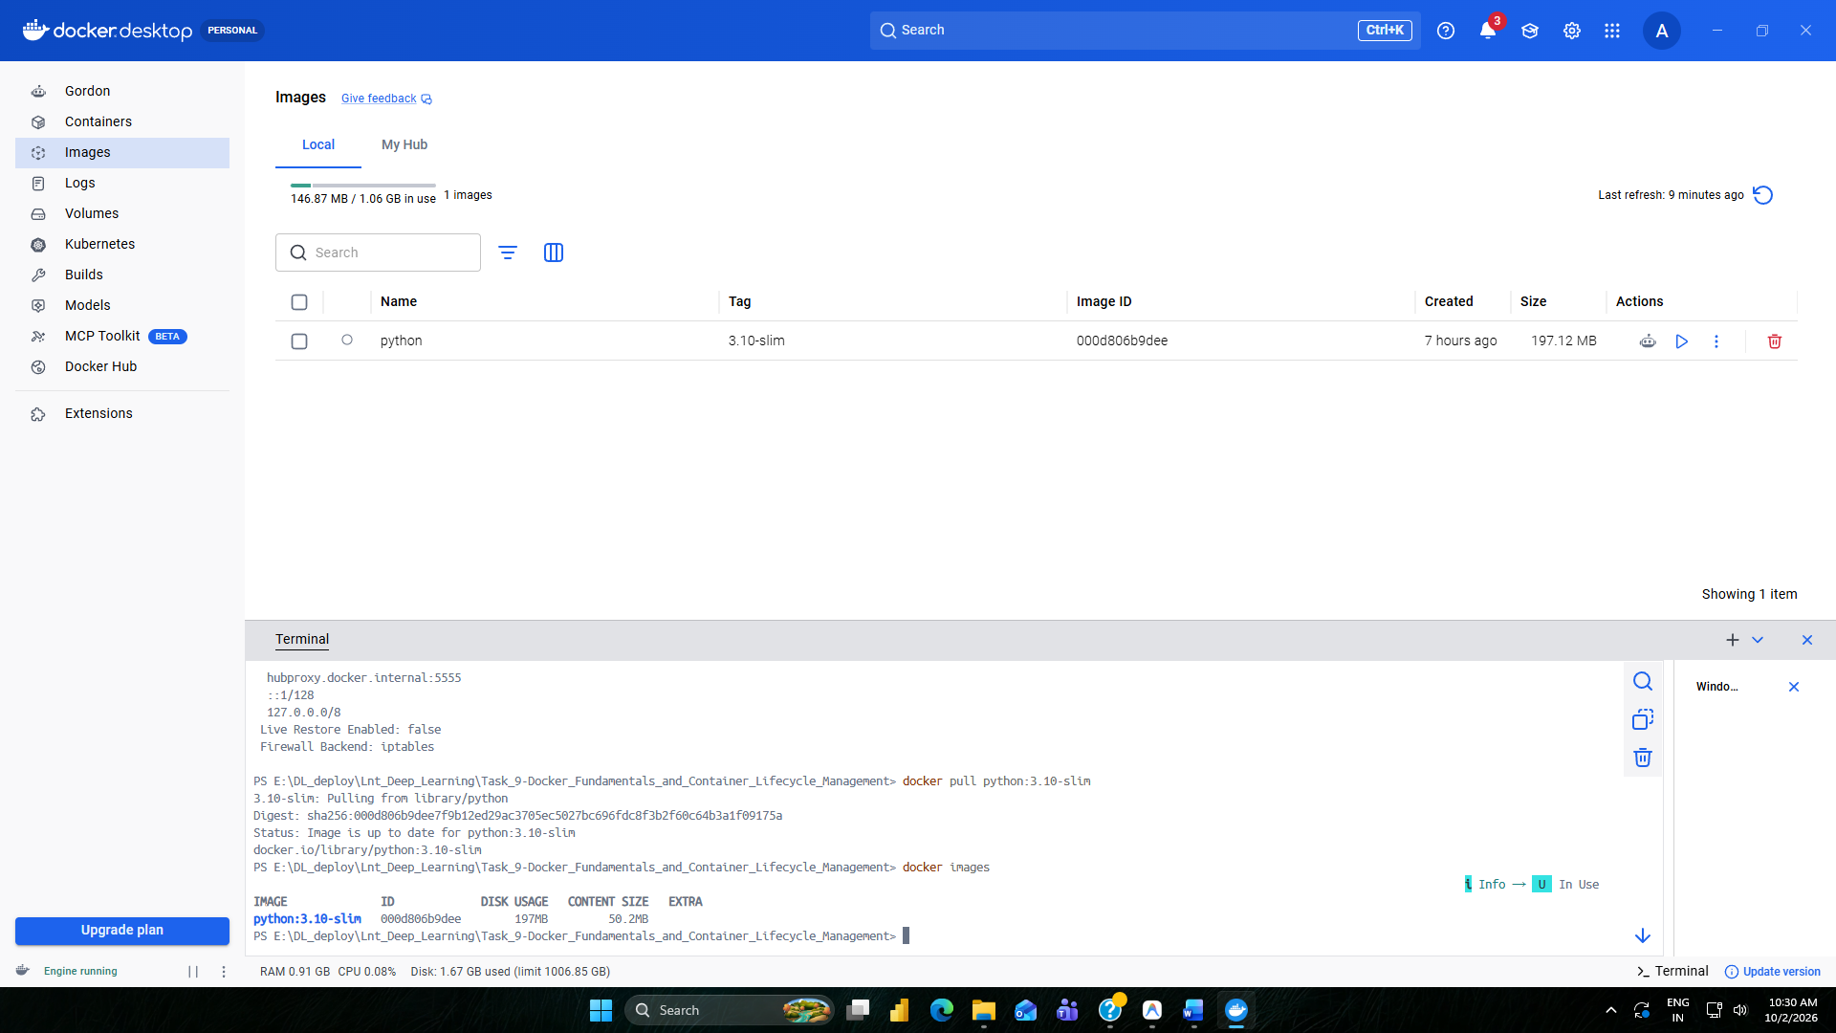
2.Image Pull & Local Registry List
Result & Technical Observation: Pulls read-only filesystem layers for `python:3.10-slim` from Docker Hub. Total download size is ~125 MB, making it extremely fast and lightweight.

Step 3: Inspecting Image Metadata & Local Tagging
Command Executed:
docker inspect python:3.10-slim
docker tag python:3.10-slim my_dl_runtime:v1

Execution Output Log:
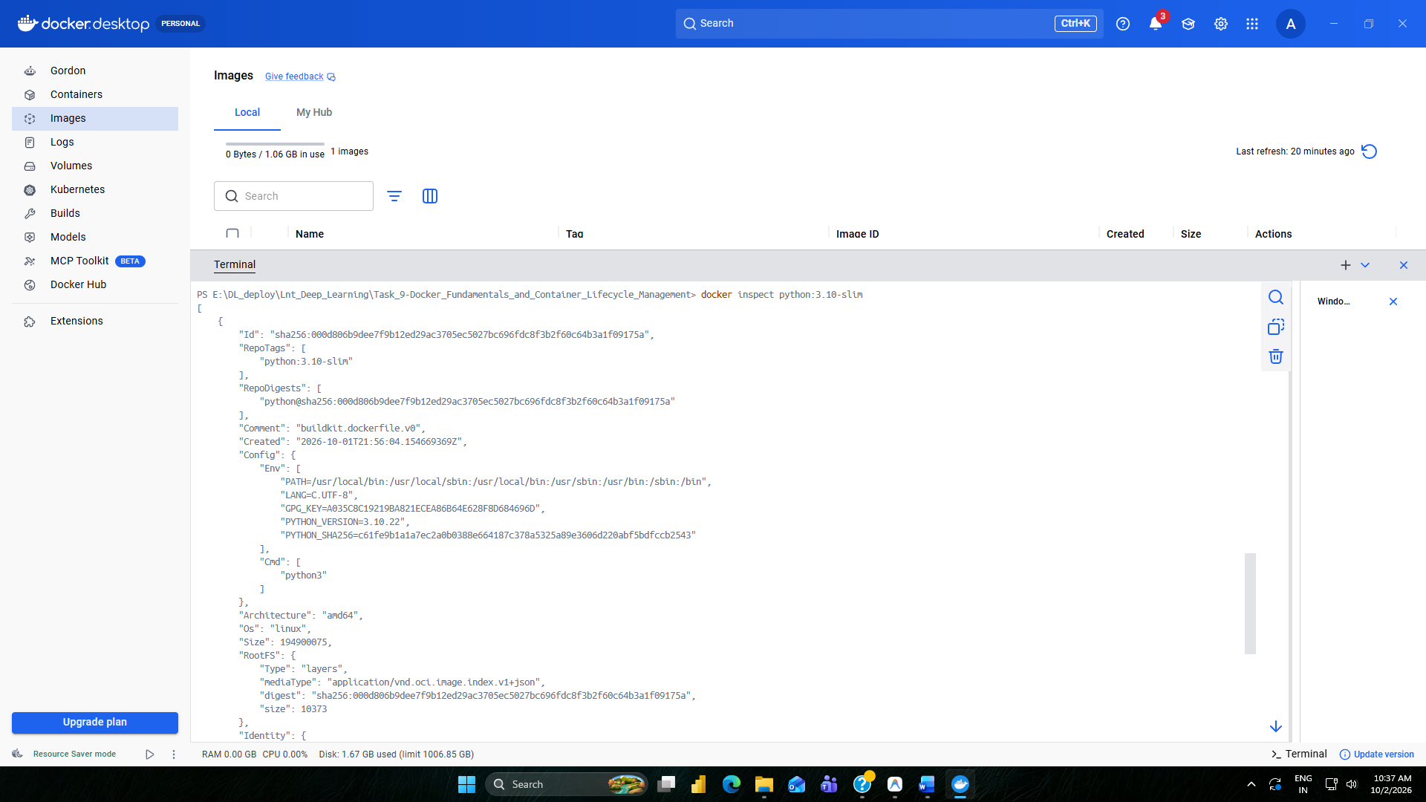
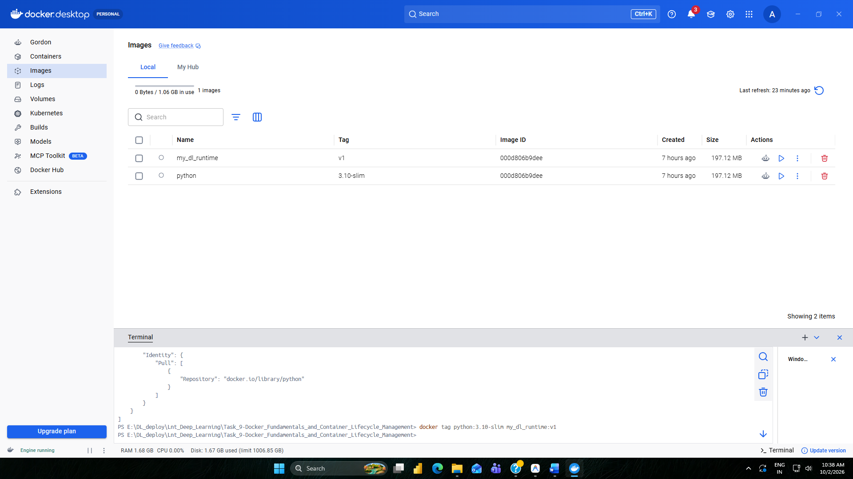
3.Image Inspection & Tagging
Result & Technical Observation: Inspects the JSON configuration metadata of the image layers. `docker tag` creates a local repository alias `my_dl_runtime:v1` pointing to the same image ID without duplicating storage.

Step 4: Provisioning Storage Volume & Custom Bridge Network
Command Executed:
docker volume create dl_storage_vol
docker network create dl_bridge_net
docker volume ls
docker network ls

Execution Output Log:
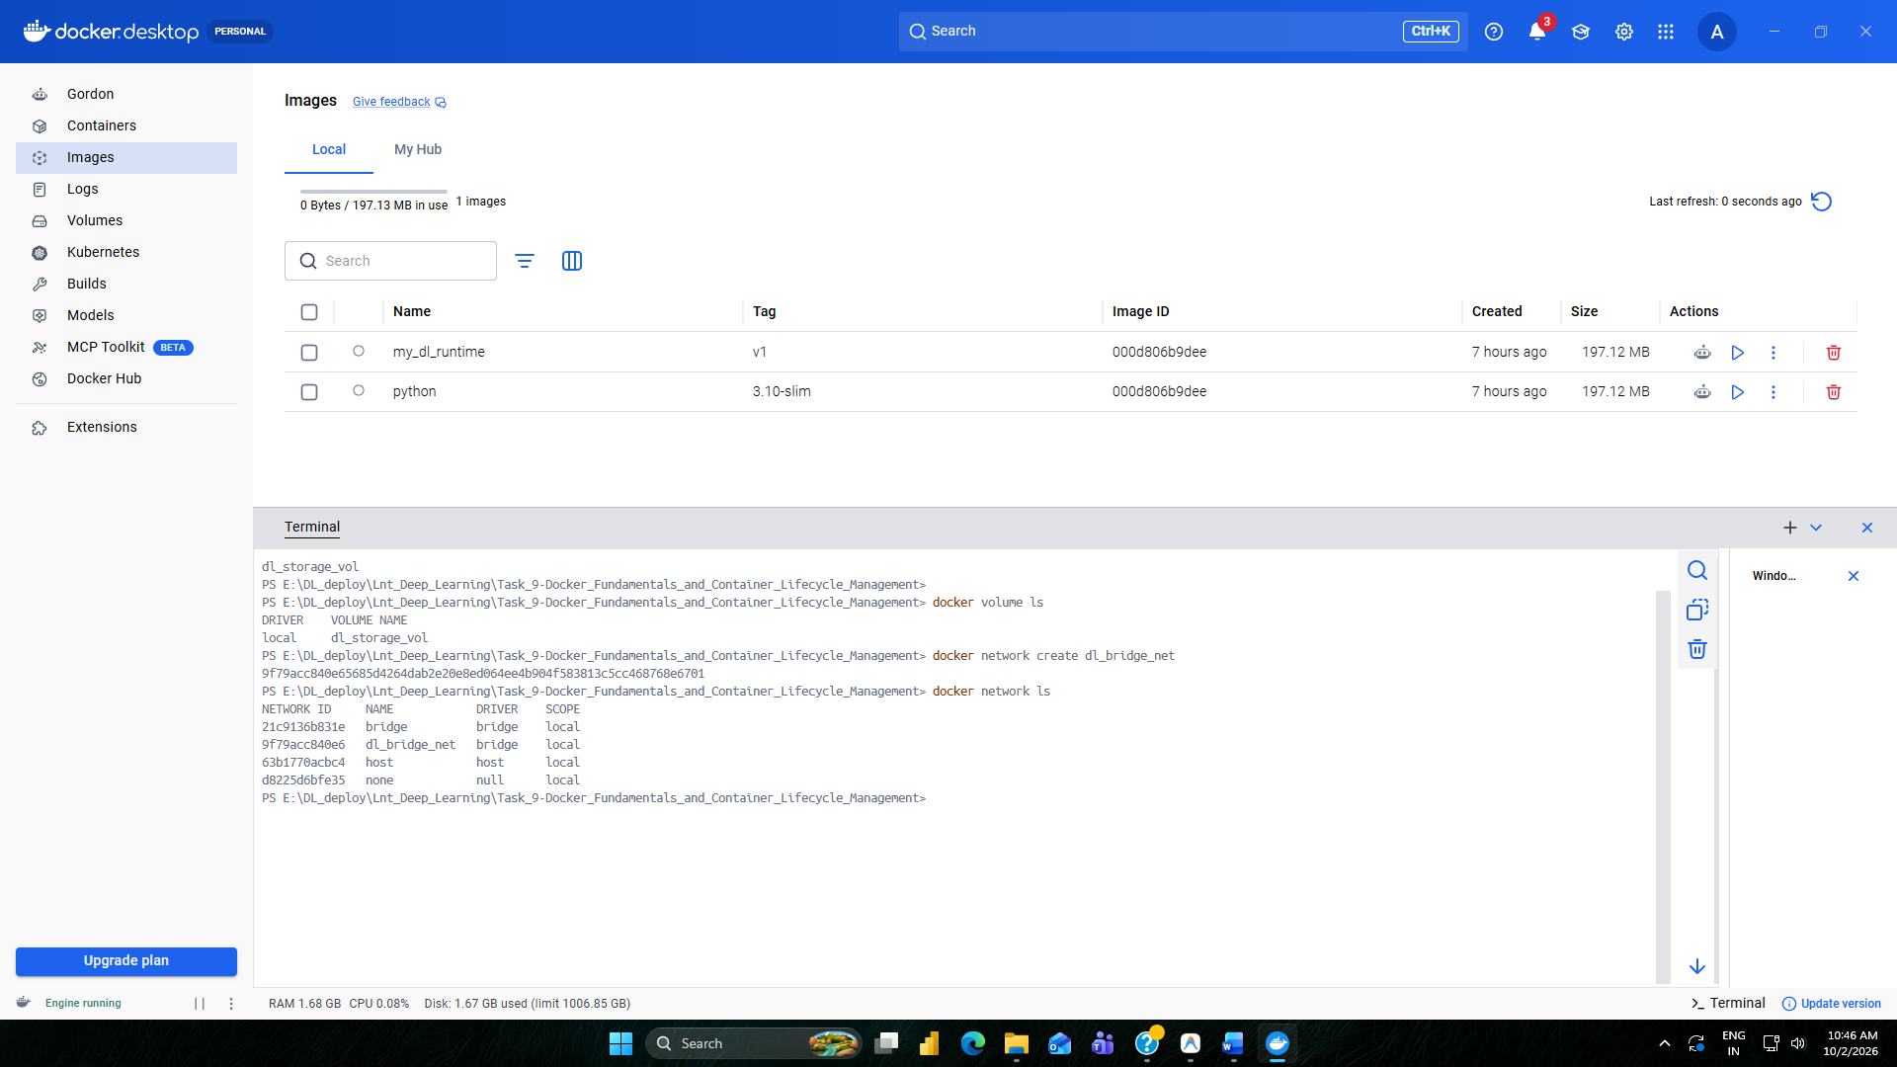
4.Storage Volume & Network Setup
Result & Technical Observation: Provisions a host-managed volume (`dl_storage_vol`) for persistent model data and log storage, and an isolated bridge network (`dl_bridge_net`) for container inter-communication.

Step 5: Running Container in Detached Mode
Command Executed:
docker run -d --name dl_runtime_container -v dl_storage_vol:/workspace --network dl_bridge_net python:3.10-slim python -c "import time; time.sleep(3600)"
docker ps

Execution Output Log:
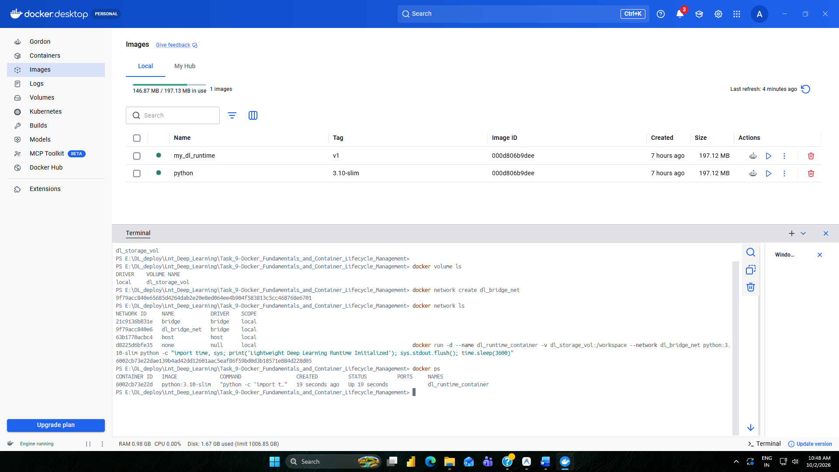
5.Running Container Status
Result & Technical Observation: Spawns an isolated container instance in detached mode (`-d`). Mounts persistent volume to `/workspace` and attaches to `dl_bridge_net`.

Step 6: Executing In-Container Commands & Viewing Logs
Command Executed:
docker exec dl_runtime_container python -c "import sys; print('Python Version:', sys.version.split()[0])"
docker logs dl_runtime_container

Execution Output Log:
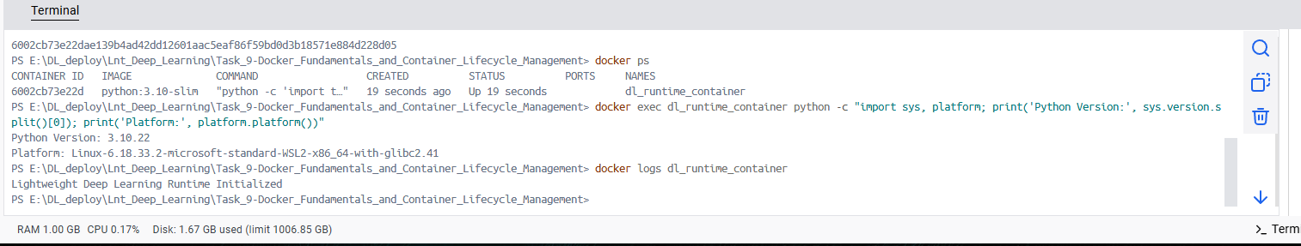
6.Exec Command & Container Logs
Result & Technical Observation: Executes a Python inspection command inside the active container namespace without needing an SSH connection. `logs` fetches stdout/stderr output streams.

Step 7: Pause, Unpause & Resource Statistics Monitoring
Command Executed:
docker pause dl_runtime_container
docker ps
docker unpause dl_runtime_container
docker stats dl_runtime_container --no-stream

Execution Output Log:
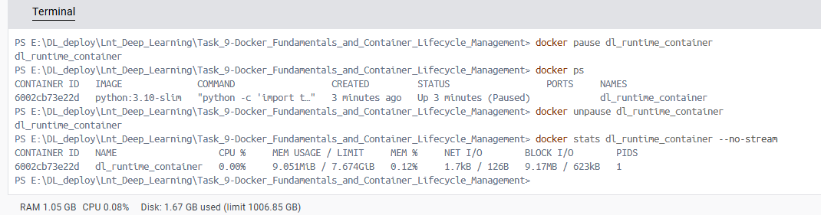
7.Pause Status & Resource Metrics
Result & Technical Observation: `pause` freezes all processes inside the container using Linux cgroups (status changes to `Up (Paused)`). `stats` measures real-time CPU %, RAM, and I/O consumption.

Step 8: Container Graceful Stop & Resource Cleanup
Command Executed:
docker stop dl_runtime_container
docker rm dl_runtime_container
docker volume rm dl_storage_vol
docker network rm dl_bridge_net

Execution Output Log:
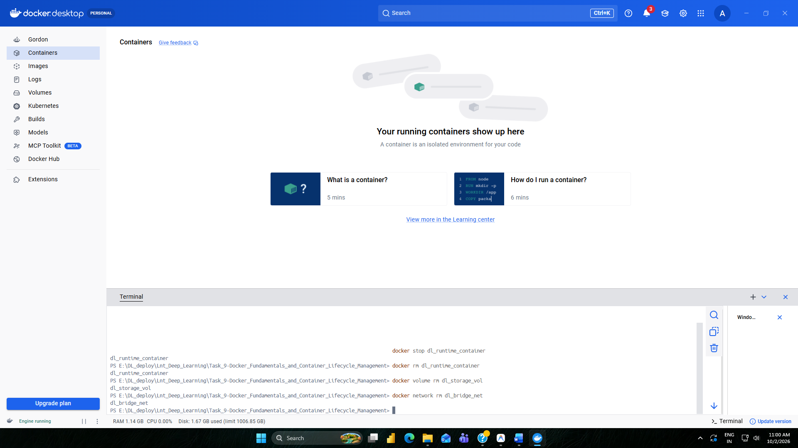
8.Container Shutdown & Cleanup
Result & Technical Observation: Sends `SIGTERM` signal to stop container PID 1 cleanly. Removes container metadata, volume, and bridge network to leave Docker engine in a clean state.

4. Lifecycle Operations Results & Verification Matrix
Docker CLI Command | Lifecycle Phase | Target Object | Verified Result & Outcome
docker pull | Image Acquisition | Docker Hub (`python:3.10-slim`) | Downloaded image layers (~125 MB)
docker tag | Image Management | Local Image Cache | Created alias tag `my_dl_runtime:v1`
docker volume create | Storage Setup | Named Storage Volume | Created persistent volume `dl_storage_vol`
docker network create | Networking Setup | Bridge Network | Created isolated bridge network `dl_bridge_net`
docker run | Container Creation | Container Instance | Spawned detached container with volume & net
docker exec | Interactive Execution | Container Namespace | In-container Python version verified
docker logs | Logging & Diagnostics | Container Stdout/Stderr | Fetched stdout log stream
docker pause / unpause | Process Control | Linux cgroups | Successfully frozen and resumed container
docker stats | Monitoring | Resource Utilization | Retrieved live CPU %, RAM, Net I/O metrics
docker stop / rm | Cleanup Operations | Container Metadata | Graceful SIGTERM exit & container purge

5. Conclusion
Task 9 demonstrated comprehensive mastery of Docker fundamentals and container lifecycle operations. By leveraging lightweight base images (`python:3.10-slim`, ~125 MB), provisioning host-managed storage volumes, and isolating network interfaces, deep learning applications can be portably packaged and efficiently managed across MLOps deployment pipelines.

